Finite Element Analysis of Laser Irradiated Metal Heating
and Melting Processes

Dharani Sowdari and Pradip Majumdar
Department of Mechanical Engineering
Northern Illinois University
DeKalb, Illinois 60115
USA

Abstract

An enthalpy-based computational model is developed for analyzing laser heating and melting of metals. The solution to the problem is obtained by using a finite element code and the results are validated by comparing the results with that given by an analytical solution available for a limiting case problem. A solution algorithm and a code are developed to estimate the temperature distribution, solid-liquid interface location and shape and size of the molten pool.

Nomenclature

I Laser Beam Intensity
D_{o} Laser Beam Diameter
P_{o} Laser Power
Cp Specific heat
k Thermal conductivity
t Time
u Velocity vector
A Area
Q Heat Generation
T Temperature
α Coefficient of thermal
expansion
ρ Density
Δt Time step
h Heat transfer Coefficient
h_{ig} Latent heat of Vaporization
α_{ο} Surface Absortivity
X Global x-coordinate
Y Global y-coordinate
Z Global z-coordinate
K_{x} Thermal Conductivity in x
direction
K_{y} Thermal Conductivity in x
direction
K_{z} Thermal Conductivity in x
direction
T∝ Ambient Temperature
h∝ Ambient heat transfer
Coefficient
φ Liquid Fraction

1. Introduction
For past few decades, laser technology has shown tremendous growth due to its demands in material processing and manufacturing. Material processing using lasers has various applications like cutting, welding, drilling, cladding and surface treatment. In laser surface treatment, the material properties at the surface are altered through surface alloying and transformation hardening. The main beneficial aspects of laser surface melting are enhancement of the mechanical properties at the surface, better resistance to wear and corrosion at selected locations, controlled heat input, self-quenching of material, narrow HAZ and Kerf, and minimal environmental impact
In laser surface alloying the surface is selectively coated with suitable alloy powders followed by melting and intermixing of the coating and the underlying substrate using the laser beam as the heat source. In laser transformation hardening, materials are heated and melted in a desired thin layer at the surface material using laser beam and then quenched creating changes in grain structures. The Figure 1 shows the schematic diagram of laser installation.
The laser beam is transmitted through a focusing lens and then it converges to a narrow beam around the focal point of the lens. A coaxial assisted gas stream, often oxygen, argon, or nitrogen, is used to achieve higher thermal coupling between the laser beam and the material during the heating period. The incident laser beam is absorbed by the material and rapidly heat the thin layer of the material surface and forms thin layer of molten pool. The shape and size of the molten pool depends on the laser beam characteristics, material optical properties, heat diffusion phenomena involving moving solid-liquid interface and material thermo-physical properties. A mathematical model is essential to analyze such a phase-change moving boundary heat diffusion phenomena driven by high energy laser beam, and to develop a simulation model for precise control and prediction of the surface treatment process.
Many theoretical studies have been done on the laser surface processing. Most of the mathematical models proposed by the researchers are based on the solution of the conventional heat conduction equation.
Anthony and Cline [1] did the first quantitative work and proposed the theory and mathematical model for the laser heating and melting with Gaussian power distribution and a constant moving velocity. They co-related the cooling rate distribution and the depth of the melting with the size, the velocity and the power level of the spot. Chan et al [2] considered a two-dimensional transient model of laser melting. Movement of the heat source was taken into consideration by co-ordinate transformation. Quantitative effects of different parameters on the surface velocity, surface temperature, pool shape and cooling rate were presented.
Chan et al’s [3] work evidently shows the effect of the fluid flow on the total heat transfer during the laser melting. In the subsequent work, Chan et al analyzed a steady state laser-melting problem with a stationary beam in the cylindrical coordinate system. They validated their model by comparing experimental results to that obtained from the model.
Tokarev and Kaplan [5] defined the analytical model for a time dependent problem of pulsed laser melting. The one-dimensional time dependent heat conduction equation for surface heating and a phase boundary (the so-called classical Stefan problem) has been solved in the absence of vaporization. For a constant laser pulse and material properties, useful solutions have

Figure 1. Schematic representation of the laser

melting along with the geometry

been determined for melt depth as a function of time both during and the following the pulse. Based on the model, the intensity dependence of the melt depth is investigated.
Basu and Date [6] analyzed mathematical model for rapid solidification following the laser melting of pure metals. Also, they studied the pool and solidification characteristics. For a fixed laser radius (2.0mm), the studies are carried out with various beam power densities between 10⁸ W m⁻² and 10⁹ W m⁻². According to their study, there is melting even after the laser is removed and the amount of post melting is related to the amount of the superheat of the pool.
Xie and Kar [7] studied a one-dimensional heat conduction problem to investigate the melting rate during laser material processing. The problem was solved approximately to obtain a correlation among melt depth, power density, and laser irradiation time. Based on this, the dynamics of melting, a relationship between the melt depth and power density and an average melting velocity were expressed by simple analytic formulas.
The objective of this study is to develop a finite element based computational model to determine the temperature distribution at the solid/liquid interface and study the melt pool characteristics. The model is based on a multi-dimensional unsteady state heat transfer equation along with heat losses by convection. The enthalpy-based field equation will be solved using commercial finite element code. An analysis code will also be developed to evaluate the temperature distribution, solid-liquid interface and the shape and size of the molten pool.

2. Mathematical Formulation

The mathematical model presented here illustrates the state equations of the applied heat flux, the heat generated, temperature distributions and thermal effects in the material due to the absorbed heat. The schematic of the laser heating-melting installation for surface treatment is shown in Figure 1. The physical processes involved in laser surface treatment are basically thermal in nature. It involves selecting appropriate laser beam power characteristics so as to form the desire shape and size of the melt pool. The physical statement of the problem is specified as follows. A laser beam with a Gaussian power distribution is incident on the surface of the material.
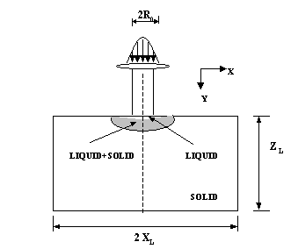
As the laser beam is incident at the center of the surface, the heat is absorbed at the surface based on the absorptivity of the material. The energy formed evolves as heat and the material gets heated up as the heat is dissipated to the cooler regions of the specimen. When the heat exceeds the melting temperature of the material, the three phase states can be viewed i.e. solid, liquid and solid +liquid. The main region of solid-liquid interface is determined the melting temperature of the material. As the temperature increases, the material starts melting. A significant amount of this heat is lost due to convection at the sides of the material.

2.1 Laser Beam Characteristics

The laser beam intensity which hits the surface of a work piece is expressed as

$I=I_{o}∗e^{−\frac{(x^{2}+y^{2})}{R_{o}^{2}}}$ (1)
Where the total power of the beam is given as

$P_{o}=\int_{A}{I(x)\text{dA}}$ (2)
$I_{o}$ = Laser beam density at the center (W/m²),
$P_{o}$ = Laser Power (W),
$R_{0}$= Effective Laser Beam radius

2.2 Heat Transfer Model
Following assumptions are made with respect to the description of the heat transfer model: 1. The material and the incident laser beam, both are stationary; 2. The constant heat transfer coefficient depicts the heat lost due to convection and radiation; 3. The material is opaque with energy absorption at the surface; 4. The net heat input to the material is the heat flux absorbed at the surface with constant absorptivity; 5. The heat transfer and the fluid flow are primarily in the x and z direction; 6. Absorbed laser intensity is not high enough to cause evaporation from solid to vapor; 7. The inert gas is transparent and does not affect the laser beam; The material is considered to be isotropic.

Initially the material is at a constant initial temperature, T_{i.} A transient heat flux is applied at the center of the top surface. The heat loss is by convection from all the sides of the plate.

Governing Equation:

The enthalpy model is used to eliminate the computational difficulties that are associated with the solid-liquid moving boundary nature of the problem. The mathematical temperature model in terms of the enthalpy can be expressed as follows:

$\frac{∂}{∂x}\left(A_{x}\frac{∂h}{∂x}\right)+\frac{∂}{∂y}\left(A_{x}\frac{∂h}{∂y}\right)+\frac{∂}{∂z}\left(A_{x}\frac{∂h}{∂z}\right)=ρ\frac{∂h}{∂t}$ (3)

Where,$A_{x}=\frac{K_{\text{xx}}}{C_{p}}$,$A_{y}=\frac{K_{\text{yy}}}{C_{p}}$and$A_{z}=\frac{K_{\text{zz}}}{C_{p}}$

Boundary Conditions

The top surface of the material is divided into two different regions. The region RI is at the center of the surface material at which the Gaussian laser beam is applied where the melting and heating of the specimen takes place. The region RII is the surface on either sides of the region RI that are not prone to laser flux, and there is no melt formed.
The boundary conditions for the enthalpy-based governing equation are given as

1. At z = 0,$−R_{o}≤x≤R_{o}$, and$−R_{o}≤y≤R_{o}$

(4)

\\\2. At z = 0, $−x_{L}≤x≤−R_{o}$, $R_{o}≤x≤x_{L}$
and and
(5) 3. At $z=z_{L}$,$−x_{f}≤x≤x_{L}$
and $−y_{L}≤y≤y_{L}$

(6)

4. At $x=−x_{L}$and $x=x_{L}$
$A_{x}\frac{∂h}{∂x}=\frac{h_{c}}{C_{p}}(h_{∞}−h)$ (7)
5. At $y=−y_{L}$and $y=y_{L}$
(8)

3. Numerical Solution Method

The mathematical model presented is solved numerically. Details of the numerical computations for the temperature distribution as well as the melt pool shape and size are presented. The enthalpy-based heat model is first solved using the commercial code ANSYS. The enthalpy data is subsequently used in a computational algorithm for estimating the fraction of liquid, interface location and temperature distributions in the sold and liquid phases of the material. A computational algorithm is also implemented to take into account of the nonlinear distribution of the laser beam power intensities.

3.1 Finite Element Formulation

The commercial code ANSYS is used for the numerical solution of enthalpy based heat equation. Use of the mixed finite element formulation leads to the global system of equations as
(9)

The first order time derivative equation is approximated by the weighted average of the time derivative of a dependent variable is approximated at two consecutive time steps as

for (10)

In order to use the semi-implicit Crank-Nicholson scheme, is used in the study. The simultaneous set of equations (9) generated by the finite element solution method is solved by a Preconditioned Conjugate Gradient (PCG) solver, which is well suited for problems with very large sparse matrices as those encountered in the computational study.

3.2 Mesh Generation and Mesh Refinement

Mesh generation of the model is done using four-node quadrilateral elements and mapped mesh technique, which provides easier control over the location and selection of nodes. Figure 2 shows a pictorial representation of the mesh model. The mesh is coarse at the end points and is more refined near the central region where the Gaussian laser flux is applied. The fine mesh density is analyzed as.
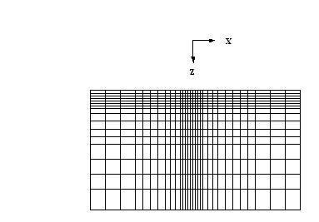

Figure 2. Finite element mesh model

3.4 Evaluation of Temperature Field and
Solid-Liquid Interface Location

A computational algorithm is developed to estimate the temperature field and the location of the solid-liquid interface. The latent heat evolution during the phase changes is incorporated into the energy equation using the following definition of enthalpy. The location of the solid-liquid interface is determined by the distribution of the liquid fraction, φ in the material. For each phase, enthalpy is defined as
$H=\int_{0}^{t}{C_{p}\text{dT}}+φ∗L$ (11)

The enthalpy distribution from the FEM code is used as an input for this solution algorithm. This input serves the purpose for computing the values of liquid fraction and temperature. For the isothermal phase change, the liquid fraction is determined from the melting temperature$T_{\text{melt}}$, which is estimated as
$T_{\text{melt}}=\frac{H_{\text{melt}}}{C_{p}}$ (12)
Where
$H_{\text{melt}}$= enthalpy at $T_{\text{melt}}$
$C_{p}$= specific heat of the material

The liquid volume fraction, $φ$ can be calculated at each node of the mesh based on the following equations:
$μ_{i,j}=\frac{H_{i,j}−H_{\text{melt}}}{H_{\text{ig}}}$ (13)
$φ_{i,j}=0$, for , (14a)
$φ_{i,j}=1$, for $μ_{i,j}≥1$ (14b)
and
$φ_{i,j}=μ_{i,j}$ for and (14c)

Based on these calculated values of the liquid fraction at each node of the mesh, the temperature distribution in the sub-regions of solid and liquid phases of the computational domain are given as.

$T_{i,j}=\frac{H_{i,j}}{C_{p}}$ for $H_{i,j}≤H_{\text{melt}}$ (15a)

$T_{i,j}=\frac{H_{i,j}−φ_{i,j}∗H_{\text{ig}}}{C_{p}}$ for $φ_{i,j}≥1$ (15b)

and

$T_{i,j}$ = $T_{\text{melt}}$ Otherwise (15c)

5. Results and Discussions

The finite element computational code is used to study the effects of laser heating and melting of metals. The results presented in this section include mesh refinement study; validation of the numerical solution by comparing the results with that given by a limiting case analytical solution, and a parametric study investigate the effects of various operating parameters. A grid refinement study was first conducted so as to select the finest mesh for accurate evaluation of the numerical model.
In the parametric study, the temperature distribution and liquid fraction variation at each node is studied, so as to evaluate the heating rate, heat affected region (HAZ), and penetration of melt region with varying operating parameters such as the laser beam intensity, the laser beam diameter and the convection heat transfer coefficient. Finally, the shape and size of the molten pool is correlated with laser beam parameters so that the computational model can be used as predictive tool for laser irradiated surface treatment process. The material evaluated for this study is Aluminum. The Table 1 shows the tabulated operating parameters used for computation of the finite element solution.

Table 1. Thermo physical and laser operating properties

Material properties
Evaporation Temperature, T_{ev} (K) 933
Latent heat of evaporation, h_{ig} (J/kg)3.88 × 10⁵

Surface absorptivity, α ₀ 0.15
Density, ρ (kg / m³) 2700
Thermal diffusivity, α (m2/ sec)
0.961 × 10⁻⁴
Conductivity, K (w/m.k) 237

Laser

Laser Power, P (w) 300
Beam Radius, R (0) (m) 0.1 × 10⁻³
Air

Convective heat transfer
coefficient, h (w/ m². k) 20

Surrounding fluid temperature,
T∞ ºC 20

5.1 Mesh Refinement
In order to check the sensitivity of the mesh size distribution on the accuracy of the converged solution, the mesh is refined in both the z and x directions to configure the accurate mesh. The number of mesh size distributions are studied along x and z directions starting from 25x15 to 85x85. The critical area of the model is the central region where the laser beam intensity is applied. More refine mesh is concentrated on this region. The study of grid refinement is done along first in x-direction and then in z-direction.
The percent relative error for temperature at selected points on the top surface and along the mid section with varying mesh size distribution are presented in Figs. 3 and 4 respectively. Figure 5 show that as mesh is refined in x- direction from 25x15 to 85x15, percent relative errors for temperature on the top surface fluctuate and that along the mid section show convergence as number of elements are increased With further refinement of the mesh in z-direction from 45x45 to 85x85 as depicted in Fig. 6, the distribution on the top as well as in mid section progressively marched towards convergence. Temperature at all points converges to values with percent relative error found to be less than 0.63% for the mesh 85x85. The rest of the analysis is carried out based on this mesh size distribution.

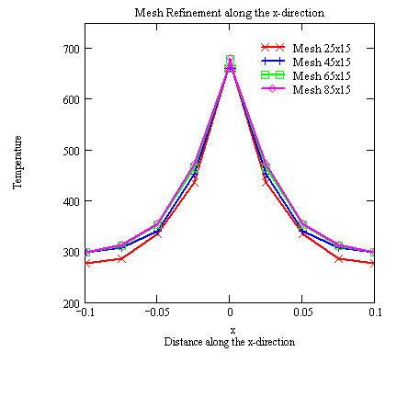
(a)
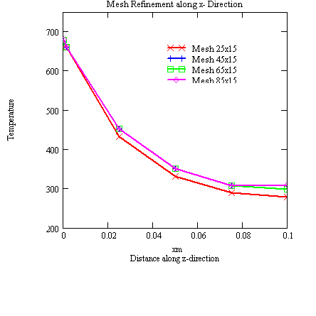
(b)
Figure 3. Mesh refinement along the x
direction: (a) top surface b) mid-section

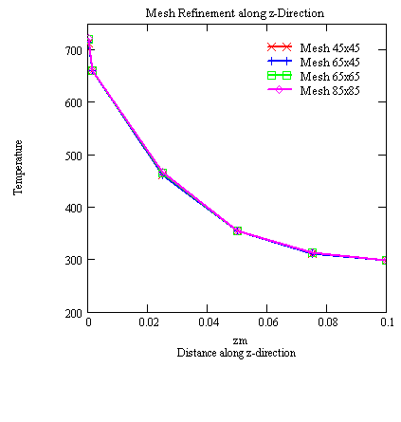
(b)
Figure 4. Mesh refinement along the
z- direction: (a) top surface b) mid
section

  - Validation of the Computational
Model
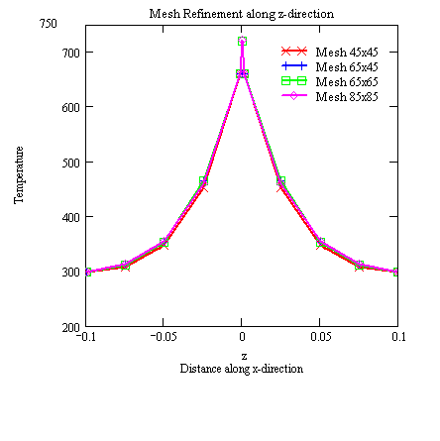
The results obtained from the finite element model were compared with a steady state analytical solution for the limiting case problem presented in the previous section. The temperatures on the top surface of the model at various x-locations are compared with the analytical solution. The Fig. 5 shows the plots of the FEM solution at different time steps and the analytical steady state solution. Results show that FEM solution approaches steady state at around 10-12s and match steady state analytical solution very closely.

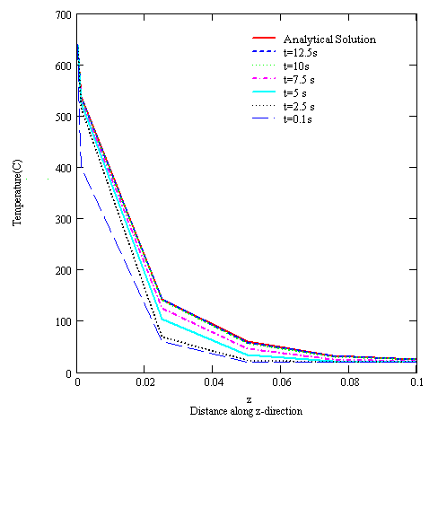

Figure 5. Temperature plot at the mid
section for the FEM solution at different
time

  - Analysis of Melt and Thermal regions

Results for laser heating and melting of metal are analyzed for base heating conditions given in Table 1. The heating period is monitored in such a way that the incident flux intensity creates a melt pool without excessive undesirable overheating of the liquid pool. The contour plots of the enthalpy with increase in time up to 120s are shown in the Fig. 6. Results show continuous penetration of the thermal front and growth of the melt pool with increase in time.

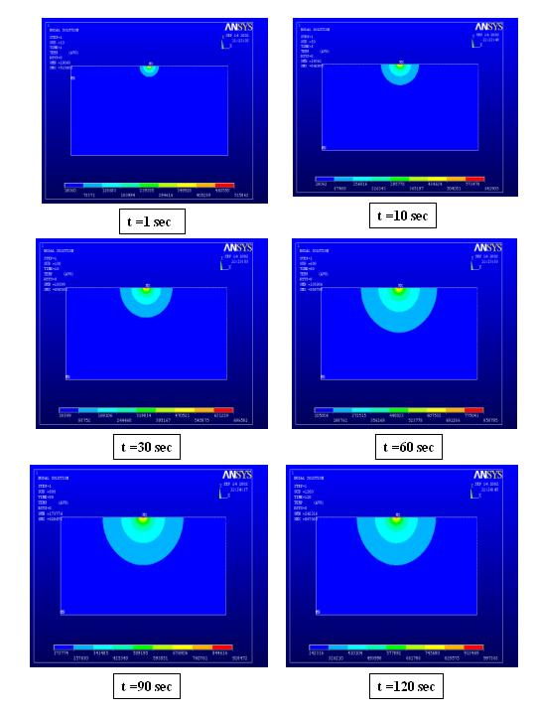

Figure 6. Enthalpy contour plots of the
FEM model solution at different time
steps

Temperature distributions at the top surface and at the midsection along the depth are presented in Figs 7 and 8. Results show a quick rise and penetration of the thermal front at the top surface at the mid section. A close look near the center region show that with further increase in time, the melt pool forms at the surface when temperature remains constant during melting and then overheats above the melting point. As the melt pool grows near the surface the thermal front continuously penetrates inside.

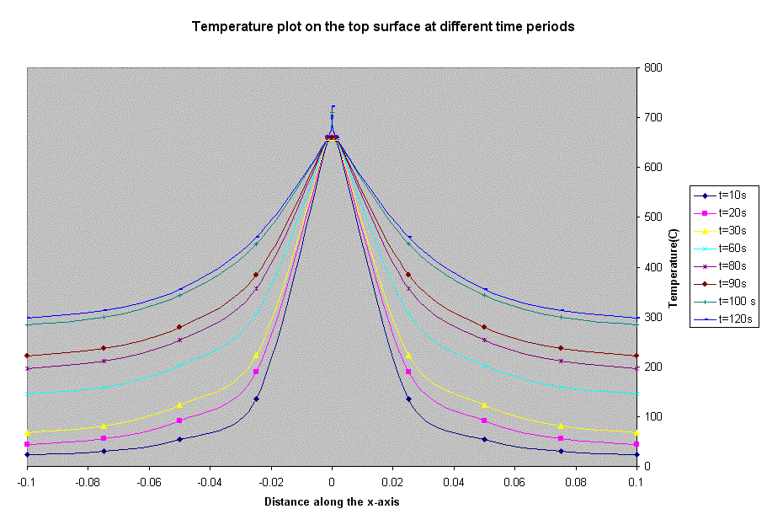
Figure 7. Temperature plot on the top
surface at various time steps
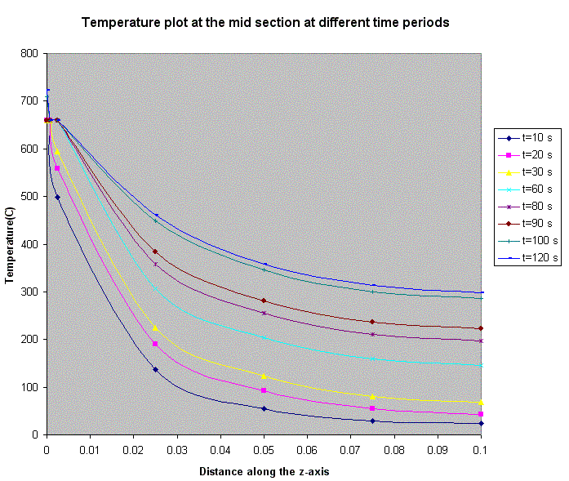Figure 8. Temperature plot at the mid section at various time steps

Figure 9 and 10 show the variation of liquid fraction on the top surface and at the mid section along the depth. It can be studied that the liquid fraction value increases and the HAZ widens as the time rise.

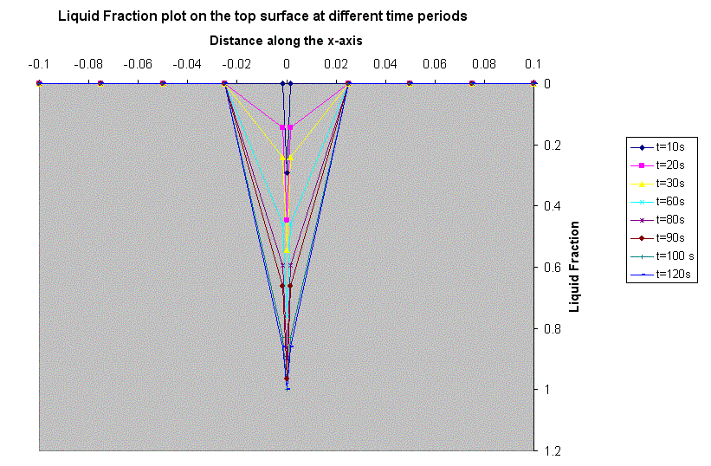 Figure 9. Liquid fraction plot on the top surface at various time steps

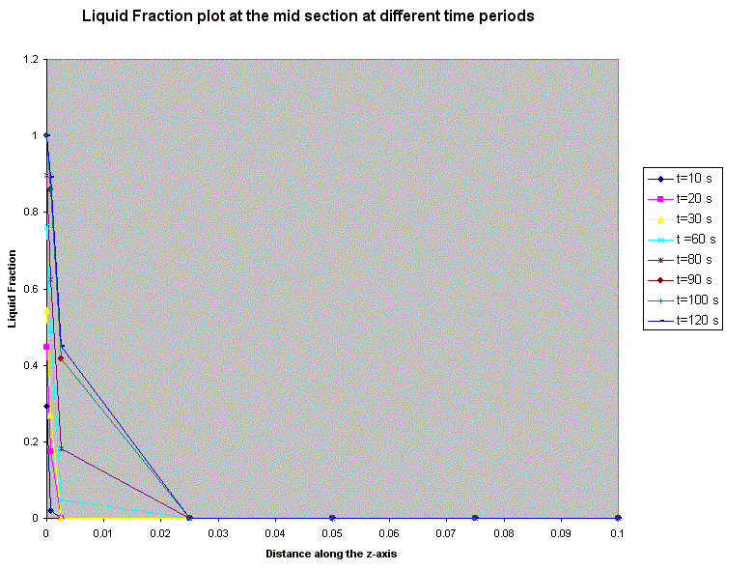Figure 10. Liquid fraction plot at the mid section at various time steps

Figure11. shows distribution of temperature at different time steps along the x-direction and at z = 0,0.075, 0.05, 0.025, 0.1 locations. Results show high heating rate leading to melting at the surface near center region. At all the other locations of z the temperature is below the melting point.

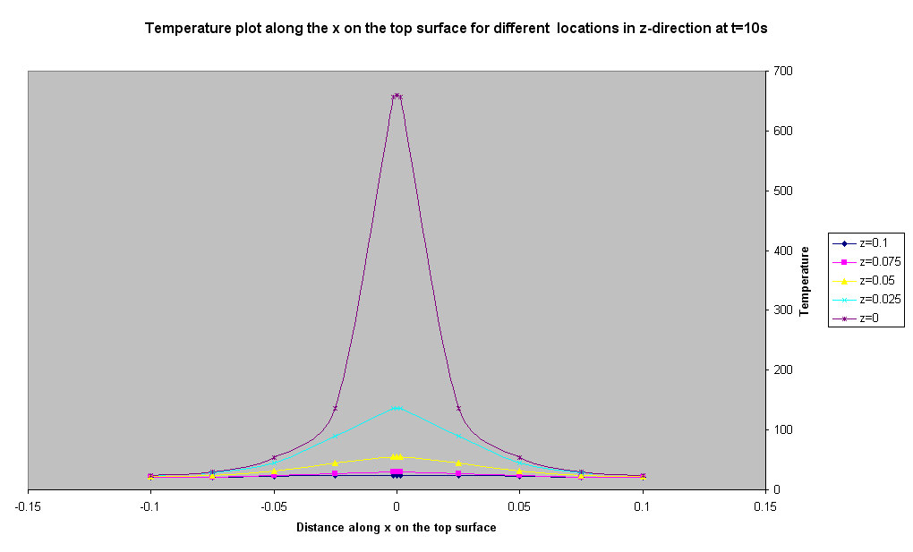
(a)
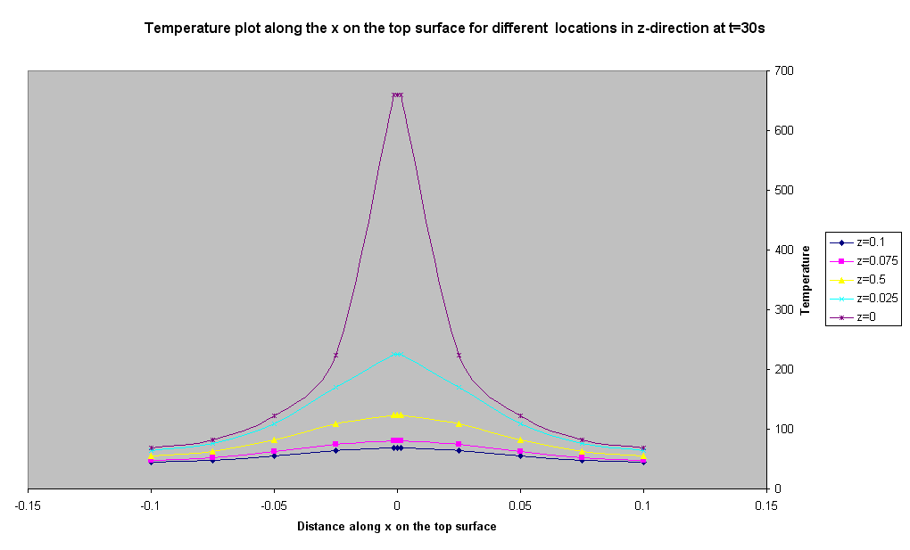
(b)

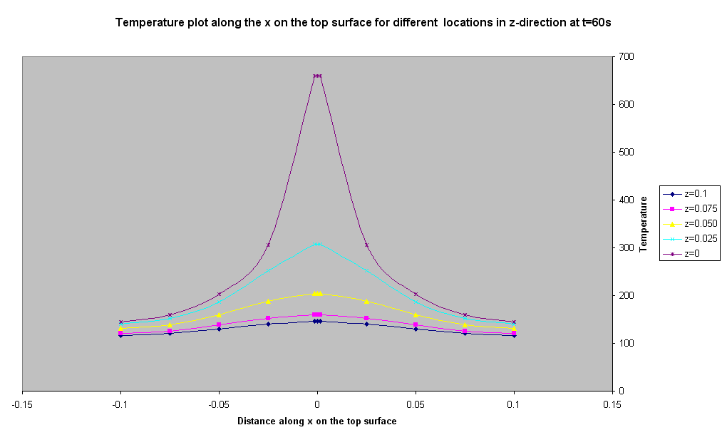

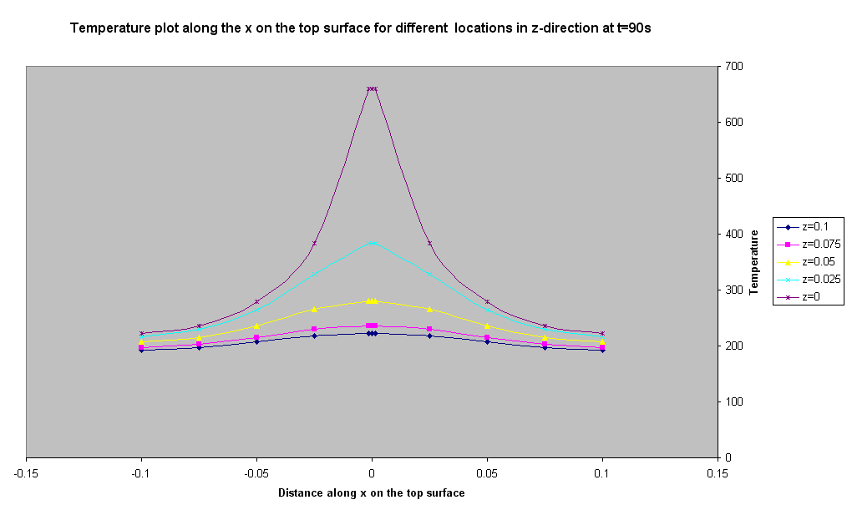
(d)
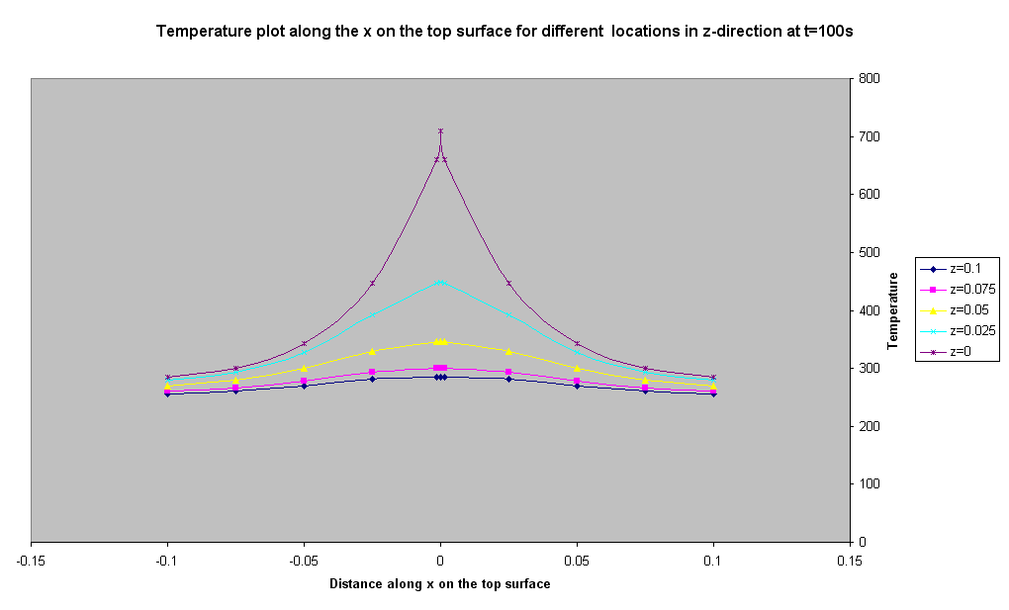
(e)
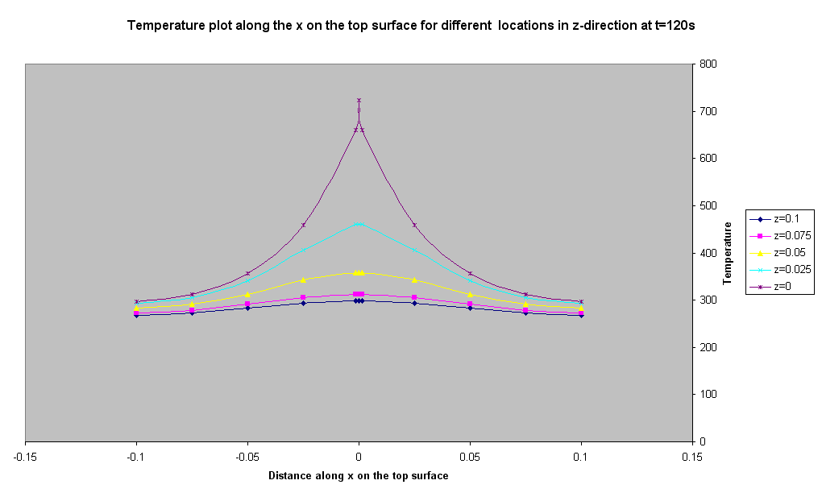
(f)
Figure 11. Temperature plot on the top surface (a) t =10 sec , (b) t =30 sec, (c) t = 60 sec, (d) t = 90 sec (e) t =100 sec, (f) t =120 sec

Figure 12 shows the temperature distribution along the midsection for different z-locations. Surface right below the laser beam reaches melting point in less than 2 seconds and temperature remains constant for about 96 seconds during the completion of the melting process. With further increases in time, it overheats above melting temperature. Similar trends are noticed at other interior points near the surface, indicating the increase in depth and width of the melt pool, but at a reduced rate. It can be noticed that the temperatures at these interior points are not prominent at the initial time steps, but time grater than 10s the temperature rises linearly indicating a steady heating rate.

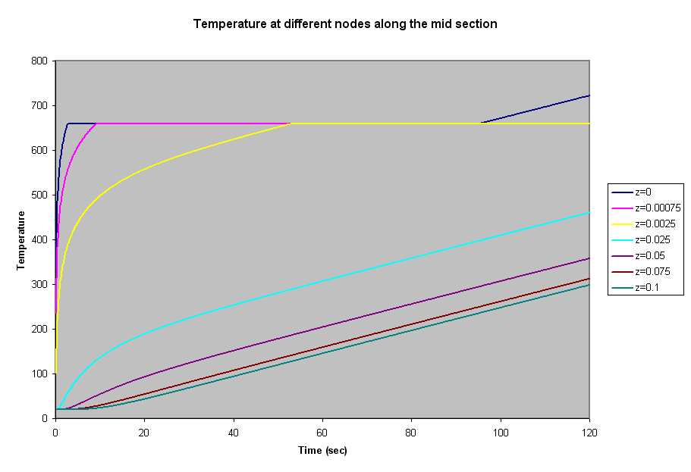Figure 12. Temperature variation for different nodes along midsection

6. Conclusions
An enthalpy-based finite element model has been developed for analyzing heating and melting of metals subjected to a high-energy laser beam. A numerical solution algorithm has also been developed to compute the temperature distribution, location of the solid-liquid interface and shape and size of the molten pool.

7. References

[1] Anthony, T. R., & Cline, H. F. (1977). Surface rippling induced by surface-tension gradients during laser surface melting and alloying. Journal of Applied Physics, 48, 3888-3894.

[2] Chan, C., Mazumder, J., & Chen, M. M. (1984). A two-dimensional transient model for convection in laser melted pool. Metall. Trans., 15A, 2175-2184.

[3] Chan C. L., Mazumder, J., & Chen M. M. (1985). Laser Processing of materials. Mukherji, K and Mazumder, J. (Eds). New York: Metall. Soc. AIME, 3-16.

[4] Kar, A., & Mazumder, J. (1989). Three-dimensional transient thermal analysis for laser chemical vapor deposition on uniformly moving finite slabs. Journal of Applied Physics, 65, 2923-2934.

[5] Tokarev, V. N., & Kaplan, A. F. H. (1999). An analytical modeling of time dependent pulsed laser melting. Journal of Applied Physics, 86, 2836-2846.

[6] Basu, B., & Date, A. W. (1992). Rapid solidification following laser melting of pure metals – I. Study of flow field and role of convection. International Journal of Heat Mass Transfer, 35, 1049-1058.

[7] Xie, J., & Kar, A., (1997). Mathematical modeling of melting during laser materials processing. Journal of Applied Physics, 81(7), 3015-3022.

[8] Rectenwald, G. W. (2000). Numerical methods with MATLAB. 612-615

[9] Carslaw, H. S. & Jaeger, J. C. (1980). Conduction of Heat in Solids (2nded.),166-168.

[10] Basu, B., & Date, A. W. (1990). Numerical study of steady state and transient laser melting problems – II. Effect of the process parameters. International Journal of Heat Mass Transfer, 33, 1165-1175.

[11] Lacroix, M. (1993). Numerical simulation of melting and re-solidification of a phase change material around two cylindrical heat exchangers. Numerical heat transfer, 24, 143-160.

