Simulation of room air conditioning strategies for hospital operation theatres

KARTHIKEYAN P, MURALIDHARAN K, ANAND SAMUEL
Department of Mechanical Engineering,
Vellore Institute of Technology,
Deemed university,
Vellore,
Tamil Nadu, Pin code-632014.
INDIA.

Abstract: Hospitals have not always been fully air conditioned, except for new buildings in urban areas where ambient noise and atmospheric pollution necessitate having closed, double glazed windows. Air conditioning has been restricted by economic considerations and has been confined to places where it was essential, for example operating theatres. Many operating theatres have been air-conditioned using conventional methods of turbulent air distribution but, as with clean rooms, this proves unsatisfactory in the prevention of airborne contamination. This paper emphasizes different types of air-conditioning strategies, their advantages and disadvantages in the case of operation theatres. It also brings out the impact of computational fluid dynamics codes in Indoor air flow simulation.

Keywords: Operation theatres, Air conditioning systems, operating room air distribution, Room air-conditioning strategies, Air- quality & computational fluid dynamics.

1.Introduction
There are three sources of bacterial contaminations: the supply of air to the theatre; the surgical team; and the emissions of bodily vapors and organisms from the patient. To deal with these and to prevent turbulent air movement and convection currents from lifting pathogens, mixing them by entrainment with the supply air and depositing them on the patient, the best steps to take are as follows:
- Provide special body exhaust suits for the surgical team, with extract openings at the crotch, armpits and nose, or body exhaust systems each comprising a face mask with a removable transparent visor, a hood and a gown of low permeability material from which air under the hood and upward beneath the gown. Flexible hoses, are attached to the backs of such body exhaust ensembles and a microphone is fitted in each facemask. Members of surgical team are kept refreshed by the continuous flow of conditioned air and fatigue is diminished.
- Provide an exhaust system at the operating table itself, for the removal of the emission and organisms from the patient, in the vicinity of the wound.
- Provide a laminar down flow systems of air distribution over the patient, the surgical team and the operating table, at a mean speed of between 0.3-04ms⁻¹ which is high enough to away any pathogens that may be deposited. It has been found by Howarth (1972) that velocities as 0.6ms⁻¹ are unsatisfactory because the exposed internal tissues of the patient are over-cooled and dried out by evaporation.
- Provide terminal HEPA filters to remove virtually all dust particles above 0.3 μm in size. It is also necessary to install local exhaust in the vicinity of the anesthetist vapors away from him or her.

2.Room air conditioning strategies
A new strategy approach has been introduced for the room air conditioning including classification and terminology. The classification of ideal room air conditioning strategies is summarized in Figure 1.). As the focus of the proposed classification differs from the present practice it is necessary to explain the terminology used. The aim of the room air conditioning is to maintain desired conditions, target levels, in the room during different operating conditions in the most economical way (energy, cost efficiency). Depending on the design criteria the designer has different strategies to choose in order to achieve specified targets. The room air conditioning strategy is a fundamental scheme that describes the targeted temperature, humidity and contaminant distributions as well as air flow patterns within the air-conditioned room. The room air conditioning system consists of different methods and their controls that all together create the system performance. The system performance is evaluated by comparing the reached conditions to the chosen strategy.

The operating theatre environment depends on the airflow velocity, turbulence level, temperature and relative humidity. Optimum design of air-conditioning in surgical operating theatres requires more careful control of flow and temperature characteristics to achieve sterile conditions.

2.1 Piston strategy:
The highest effectiveness can be achieved with the piston strategy. The contaminant concentration, temperature or humidity and the local effectiveness are functions of the location and the power of the sources in relation to the supply and exhaust openings. With the homogeneous distribution of sources the contaminant concentration and temperature change linearly between supply and exhaust openings that are located in opposite ends of the room. With the local sources, the concentration upstream of the sources is very low. It is an expensive strategy mostly used in semiconductor industry.

2.2 Stratification Strategy:
A similar temperature and contaminant distribution throughout the room is reached with stratification as with piston. The driving forces of the two strategies are, however, completely different and the distribution of parameters is in practice different. While in piston the uniform flow pattern is created by the supply air, in stratification it is caused only by the density differences inside the room. As a result, the contaminant removal and temperature effectiveness is more modest than with piston air conditioning strategy

2.3 Zoning strategy
The idea of the zoning air conditioning strategy is to have control over the certain area or volume of the room, while the rest of the room is left with less attention. In most cases the accumulation heat, concentration or humidity outside the controlled zone is desired and utilized. The room airflows are controlled both by the supply air jets and the buoyancy sources.

2.4 Mixing strategy
The aim of mixing air conditioning strategy is to provide uniform conditions through out the air-conditioned room. The contaminant removal and the temperature effectiveness in the mixing strategy are equal to one. In practical installations incomplete mixing in the room and unfavorable temperature gradient and location of the exhaust openings in relation to the air supply may, however, cause short-circuiting of supply air into the exhaust openings and the efficiency may remain below one.

3. Application of the strategies in operation theatres
Studies of operating room air distribution equipments and careful installations of clean rooms indicated that the supply of the air from the ceiling, with the downward flow movement to several exhaust ports located on the opposite walls yielded, probably, the most effective airflow pattern maintaining the concentration of contamination to a minimum acceptable level. Mixing air-conditioning strategy is the ideal strategy for Indian conditions where modern air-conditioning systems fail to provide uniform conditions through out the air-conditioned room. Airflow simulation is a useful tool to analyze air movements in non-standard operating room situations. In India, most of the air-conditioning systems go for side wall mounted inlet and exhaust systems. Even though these systems are different from systems with conventional terminologies. They provide uniform conditions through out the air-conditioned room. Modern computational fluid dynamics (CFD) models are used to predict the air velocity, turbulence level, air temperature and relative humidity. One such standard model is used in this work to validate the air distribution for mixing strategy.

The room dimensions used are as follows: Length = 6.6m; Width = 4.0m & Height = 3.0m. FLUENT 6.1 was used in the CFD analyses, the room model was discretised into a nonunifrom grid of hybrid cells (containing a mixture of tetrahedral, triangular and hexahedral cells). The inlet and exhaust opening sizes were taken from a standard handbook. (The inlet and exhaust opening sizes are of same size, 0.46m x 0.102m). Two different mixing strategies were analyzed the first one is a room model having air supply with directing jets and the second, a concentrating air supply. The numerical algorithm used was SIMPLE (Semi-Implicit Method for Pressure Linked Equation). A modified K-epsilon model represented the turbulence characteristics. The supply air conditions were given as 0.31m/s and 19.5 degree Celsius (292.5 K). The profiles of velocity, temperature & turbulent kinetic energy of the two models are shown in the figures attached. The two different strategies were found to give uniform conditions for the operation theatres.

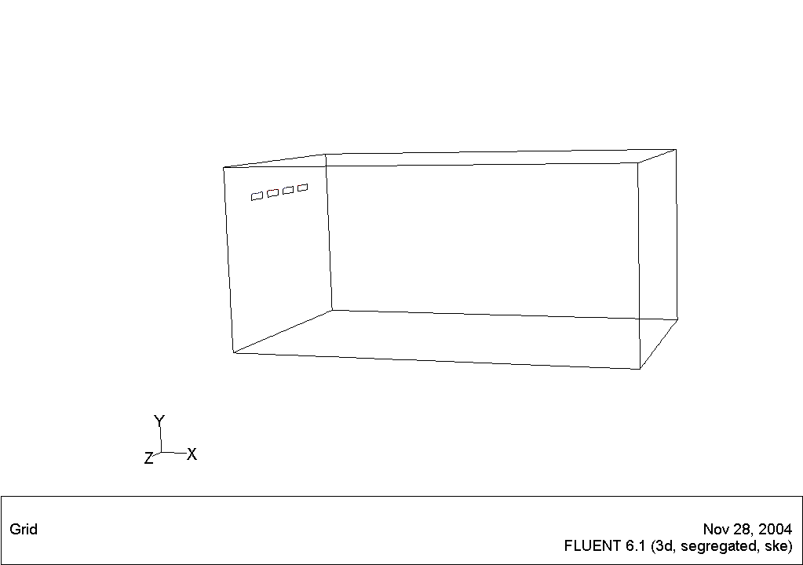

AIR DISTRIBUTION FOR MIXING STRATEGY
(INLETS AND EXHAUSTS PLACED ALTERNATIVELY ON THE SIDE WALL)

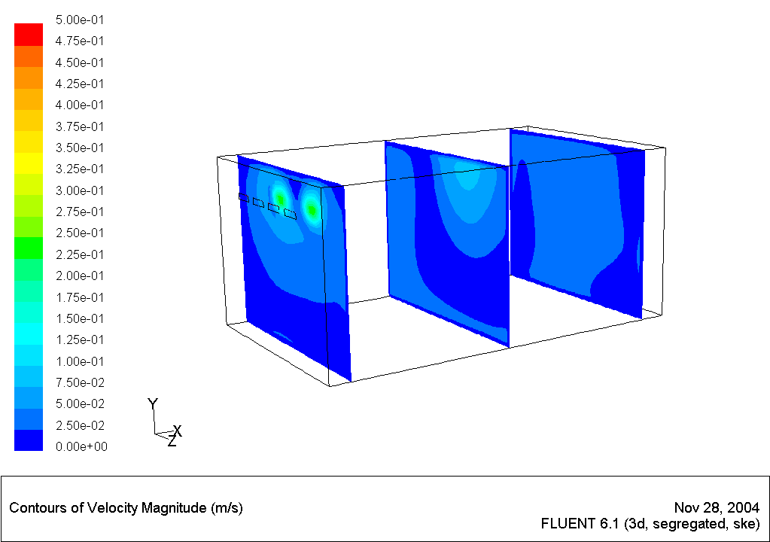

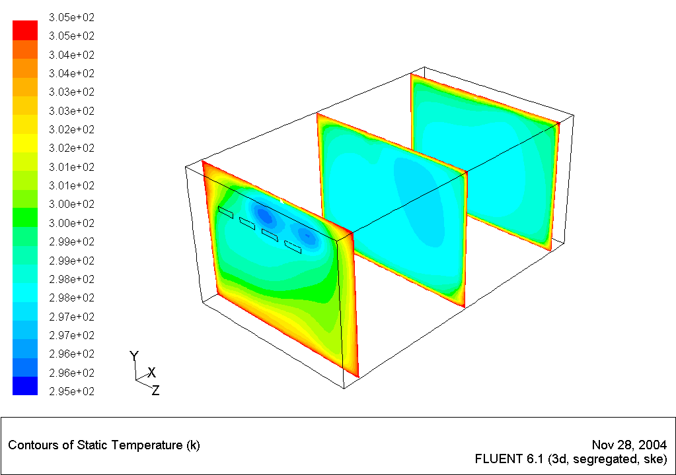

AIR DISTRIBUTION WITH MIXING STRATEGY
INLETS AND EXHAUSTS ON THE OPPOSITE SIDE WALLS

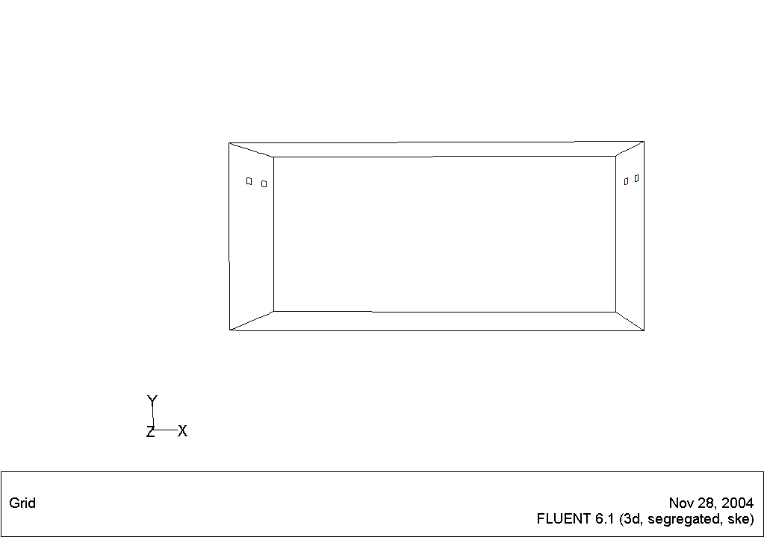
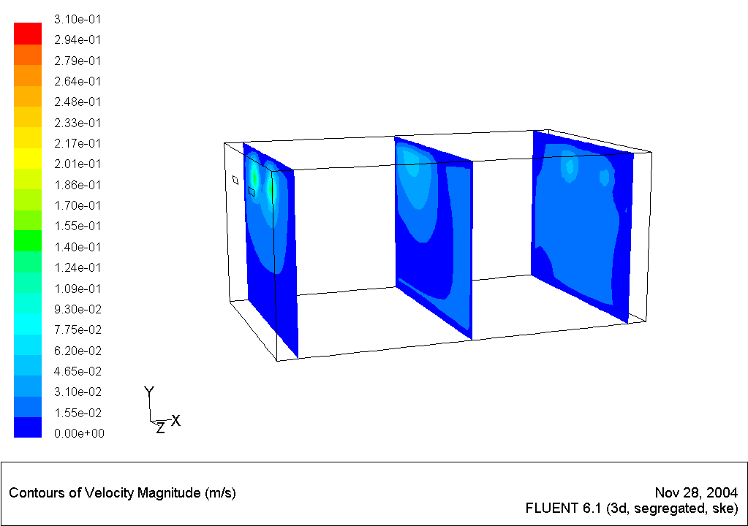

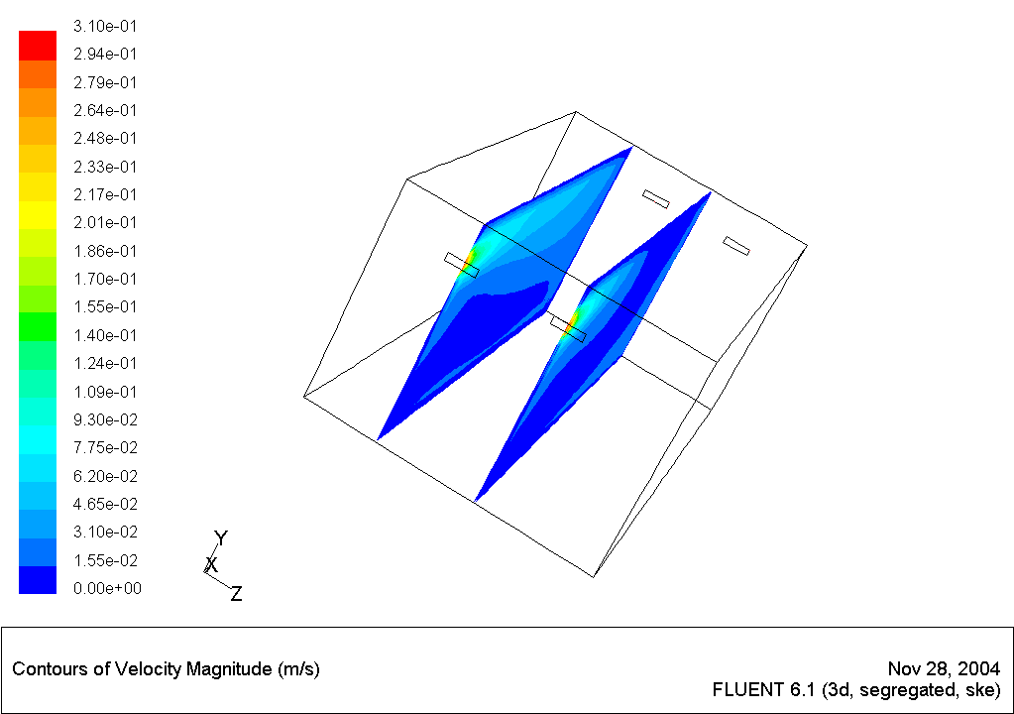

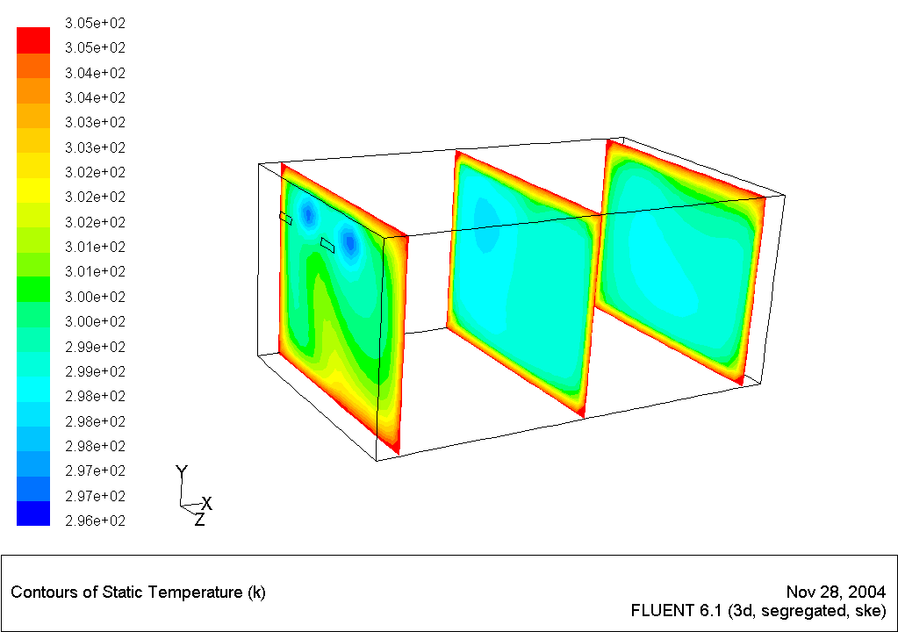
4. CONCLUSION:
The mixing room air-conditioning strategy can be used as a target for design and construction of the operating room air-conditioning systems. Any HVAC design for an operation theatre should succeed in isolating the operating area. The operating area should provide proper comfort conditions for the medical crew and the patient as per recommended standards.

References:
- K.Hagstorm, E.sandberg, H.Koskela, T.Hautalampi, ‘Classification of the room air conditioning strategies, Building and environment 35(2000) 699-707
- Kameel.R, Khalil .E, ‘ Predictions of flow, Turbulence, heat transfer and humidity patterns in operating theatres’ –Room Vent ‘2002.
- Kameel.R, Khalil .E, ‘ Predictions of turbulence behavior using K-ε model in operation theatres’- Room vent ‘2002.
- Kameel.R, Khalil .E, ‘ Experimental investigations of airflow regimes in air-conditioned operation theatres’- Room vent 2002.
- Pfost .J.F, ‘ A re-evaluation of laminar airflow in hospital operating rooms, ASHRAE Transactions, Vol 87(2): Page, 729-739.

