A computer simulation of the fate of an oil spill in marine environments

^{M.G. PSALTAKI, N.C.MARKATOS}
School of Chemical Engineering
National Technical University of Athens
Iroon Polytexneiou 9 Zographou Campus 15780
GREECE

Abstract: Assessment of the risk of an oil spill in the marine environment is absolutely necessary as a great amount of petroleum is transported by cargo ships and pipelines through the marine environment.Furthermore, the increase in offshore oil exploration, and the drilling and production activities enhance the potential for oil spills that damage marine ecosystems, given that oil toxicity creates major environmental problems. The mathematical modelling of oil spills is a very important tool for impact assessment studies, as oil toxicity creates major environmental problems.This paper describes briefly a deterministic model developed to simulate the time-dependent behavior of hypothetical oil spills near coastal regions. The model solves the full Navier-Stokes equations for a two phase,3-D turbulent flow, heat and mass transfer including many aspects of the physical, chemical and biological processes that govern the behavior of oil slicks at sea.

Keywords: Oil spill, computational fluid dynamics, turbulence, simulation, RNG (k-ε) turbulence model

1 Introduction
The mathematical modelling of oil spills is a very important tool for impact assessment studies, as the effects of oil toxicity on the marine ecosystem create major environmental problems. Oil toxicity depends on the physical and chemical characteristics of the spilled oil, more toxic being the oils with a significant fraction of aromatics. The impact of oil toxicity on marine organisms depends on the organism itself and its age, on oil concentration, on the water salinity its temperature and pH, and the presence of nutrients, pollutants (sulfides, phenols, detergents) and/or dispersants. Furthermore, the shore damage will also depend on the contact duration of the slick with the coastline [1,2].

2 Problem Formulation
The spill is considered to be initially circular, formed under the action of gravity, inertia, viscous and surface tension forces.
The sequential balances, in time, among pairs of these forces allow for an estimate of the respective diameter, D, of the spill (Eqns (1a,1b,1c)) and of its thickness, provided that the spilled oil volume is known.

Gravity-Inertia:
$D=2k_{1}{\left(\frac{ρ_{w}−ρ}{ρ_{w}}{\text{gVt}}^{2}\right)}^{1/4}$ (1a)
Gravity-Viscous: $D=2k_{2}{\left(\frac{\frac{ρ_{w}−ρ}{ρ}{\text{gV}}^{2}t^{3/2}}{V_{w^{1/2}}}\right)}^{1\text{.}6}$ (1b)
Surface tension-viscous :
$D=2k_{3}{\left(\frac{f_{n^{2}}t^{3}}{ρ_{w^{2}}}V_{w}\right)}^{1/4}$ (1c)

Here $ρ_{w}$ is the water density, $ρ$ the oil density, $V$ the oil volume, $ν_{w}$ the water kinematic viscosity, $f_{n}$ is the oil-water surface tension and $k_{1}$=1.14,$k_{2}$=1.45, $k_{3}$=1.6 [2].

At subsequent times, the spill, while advected by the hydrodynamic field and subjected to various weathering processes, takes arbitrary shapes which are predicted by the present model.
The model utilizes an Eulerian two-phase flow approach [3,6 ]. The two phases are considered as “interpenetrating continua, i.e. the two phases occupy the same space (although not necessarily at the same time), their share of space being measured by their “volume fractions” $r_{i}$ It is, therefore, obvious that for two -phase flows:
$r_{1 }+ r_{2} = 1$ (2)
A complete set of equations is formulated for each phase present, the phase equations being linked together through the processes of interphase momentum/heat and mass transfer. All differential equations can be cast in the following general form:
$\frac{∂}{∂t}\left(r_{i}ρ_{i}φ_{i}\right)+\text{div}\left(ρ_{i}r_{i}V_{i}φ_{i}\right)=\text{div}\left(r_{i}Γ_{φ_{i}}{\text{gradr}}_{i}φ_{i}\right) + S_{φ_{i}}$ (3)

where i takes the values 1 and 2 for the two phases (1 for the water and 2 for the oil phase); for particular phase i, the dependent variable φ_{i} denotes either u, v, w, the three velocity components, or the turbulence kinetic energy k, or the turbulence dissipation rate ε; φ_{i} = 1 reproduces the continuity equation; r_{i} is the volume fraction, ρ_{i} is the density of the respective phase, ${\vec{U}}_{i}$is the hydrodynamic velocity vector; $Γ_{φ_{i}}$ is an effective exchange coefficient [3] and $S_{φ_{i}}$ is a proper source or sink term (i.e. for the momentum equations.: the terms representing interphase friction, gravitational acceleration, Coriolis force, surface tension and pressure gradient).
The model employs a version of the RNG (k-ε) turbulence scheme [6], modified properly to incorporate the aspects associated with the presence of waves, wave breaking, natural dispersion of oil mass, etc. The model is implemented in the CFD code PHOENICS -V.3.1, which utilizes the SIMPLEST algorithm to solve the Navier-Stokes equations for transient, two phase, 3-D turbulent flow. The model also employs some simple expressions for describing the slick advection by the wind and wave-induced currents, the presence of waves in the form of a source term in the respective momentum equations, and the impact of breaking waves on the dispersion of oil mass in the water column. The surface wind- and wave-induced currents, $U_{\text{sa}}$ and $U_{\text{sw}}$, that advect the oil slick along with other permanent currents maybe given by the following simple expressions [2,7]:
$U_{s_{a}}=0\text{.}\text{01}\text{exp}(1\text{.}\text{03}+0\text{.}\text{14})U_{α}$
$U_{s_{w}}=0\text{.}\text{015}U_{α}$ (4a,b)
where $U_{a}$is the wind speed measured at some elevation above the mean sea level (usually 10 m). Tidal Currents are also included in the advection scheme of oil slicks, (for the application presented below Evvoikos bay is influenced [8] by M_{2,} S_{2,} K_{1,} O₁ tides).
The evaporation rate$Ε$ is estimated by a simple relation of the form: $Ε={\text{kU}}_{a}P$, where$Ρ$ the oil vapor pressure and $k$a relevant coefficient [2].
The rate of the natural dispersion of the oil, that is the rate Q at which oil entrains in the water column, is estimated according to an expression proposed in [9,10].
$Q = c_{\text{oil}}V_{\text{oil}}f_{\text{bw}}D_{e}^{0\text{.}\text{57}}$ (5)
here :$c_{\text{oil}}$represents a factor that can be experimentally calculated, $V_{\text{oil}}$ is estimated as:
$V_{\text{oil}}∝ \int_{d_{\text{min}}}^{d_{\text{max}}}{N(δ)δ^{3}dδd}$,$N(d)=N_{0}(d/{d_{0}})^{−2\text{.}3}$ (6)
where $D_{e}$ is the wave energy dissipation due to breaking , per unit time and unit area. According to [9] $D_{e}$ is estimated as:
$D_{e} = 0\text{.}\text{0034}ρ{\text{gH}}_{\text{rms}}^{2}$,
$H_{\text{rms}} = {H_{s}}/{\sqrt{2}} , H_{s} = 4\sqrt{m_{0}}$ (7a,b, c) where $m_{0}$ is the sea surface variance (= $\overline{η^{2}}$)where η is the water surface displacement from the mean water level. The wave energy is given as $ρ_{w}$g$\overline{η^{2}}$.

Photo-oxidation is estimated according to an expression proposed in [11]. The oil volume change due to photo-oxidation is given by:
$\frac{\text{dV}}{\text{dt}}=−k_{p}ξV$ (8)
where $ξ$=$\text{exp}(T−\text{20})\text{ln}(k_{t}){\text{IOS}}/({\text{IOD}}_{\text{max}}\text{RD})$, T is the temperature of the oil, $\text{IOS}$ is the total photosynthetically activated radiation,${\text{IOD}}_{\text{max}}$the maximum photosynthetically activated radiation, and$\text{RD}$ the relevant daily light constant $k_{t}=1\text{.}\text{05}$ and $k_{p}$is a coefficient.

Emulsification is estimated by an expression proposed in [12], namely:
$\frac{\text{dY}}{\text{dt}}={\text{kU}}^{2}(\frac{Y}{Y_{f}})$ (9)
where $Y$ is the water volume entrainment to the oil spill and$Y_{f}$is the maximum amount of water in the emulsion; $k$=1.6x10⁻⁶ .As an interim approach, ADIOS2 uses a simple model which relates sedimentation rate to oil stickiness, oil droplet concentration, sediment concentration, and dissipation energy rate for surface water
$Q_{\text{sed}}=k_{a}\sqrt{\frac{D_{e}f_{\text{bw}}C_{0}C_{\text{sed}}}{H_{\text{rms}}ρ_{w}v_{w}}}$ (10)
where C₀ is the entrained oil volume concentration and C_{sed} is the suspended sediment volume concen-

tration. k_{a} is a sticking parameter that depends on
the type and size of the sediment particles.
Dissolution is estimated by the following expression [13]:
$M_{d}=K_{d}\text{AtXS}$ (11)
where $M_{d}$ is the dissolved amount of oil (moles), $K_{d}$ a coefficient (=3.0Χ10⁻⁶), $X$ the mole fraction,$A$ oil surface (m ²), $S$ solubility.

3 Problem solution
The model capabilities are demonstrated by applying it in two regions of different topography and bathymetry, in the framework of impact assessment studies. These two regions are near Carava (Figure 1), at the island of Lesvos, and near Eretria (Figure 2) , in the Evvoikos bay, both being in the Aegean sea. The first region has an extend of 12x9.5 km² and a maximum depth of 55m, whereas the second occupies an area of 10x18 km² and has a maximum depth of 25 m. Also, the model simulates the behaviour of hypothetical oil spills with a density of 830 kg/m³, 860 kg/m³ and 880kg/m³, assumed to occur in the above two regions.
The model predicts the position of the centre of mass and the shape of the oil spill in time, as it spreads under the action of hydrodynamic dispersion and turbulence diffusion, both at the sea surface and throughout the water column, while it is being advected by wind and wave-induced or other currents.
The effects of evaporation, natural dispersion, dissolution, emulsification and photo-oxidation on the spilled oil are also considered in this work. Furthemore, the model also handles the enhanced turbulence diffusion, caused by surface wave breaking, and the impact of breaking waves on the dispersion of oil in the water column.
The spill is considered to be initially circular, formed under the action of gravity, inertia, viscous and surface tension forces.
A time step of 750s proved to be adequate for time-step independent solutions while using 100 iterations per time step. The grids of 120x95x16 and of 90x50x10 which does not necessarily generate grid-independent solutions and the above time step were used for all final runs. However, more grid-refinement studies are required in the future.
The runs were performed on Silicon Graphics Origin 200 (4 CPU R 10000). A typical run using a 120x95x16 grid for 20 time steps and 23.200 secs real time requires 12 hrs on the above machine.
The hydrodynamic field was predicted considering a NW /NE wind of 10 m/s and assuming a logarithmic wind profile, at the coast. Figure 3 shows the above wind profile.

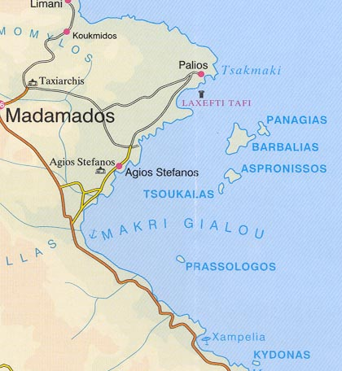
Figure 1. The region of Carava area

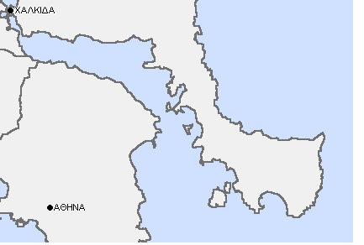

Figure 2. The region of Evvoikos bay

Figure 3. The wind profile

The above fields were simulated first under steady-state and single phase flow conditions, using the RNG (k-ε) turbulence model for the water phase only. Then, the fate of hypothetical oil spills was simulated, under transient, two-phase flow conditions. Three cases were considered in the Carava area and two in the Evvoikos bay. Figure 4 shows the fate of an oil spill, a few minutes after a spill of 830 m³ had occurred at a distance of 50 m from the upper eastern coast of the three islands which are located in the region of Carava. Figure 5 shows the fate of the oil spill in the above field 6.5 hrs after the accident. All the above simulation cases, were conducted using salt water and meteorological /oceanographical data of a given period of time.

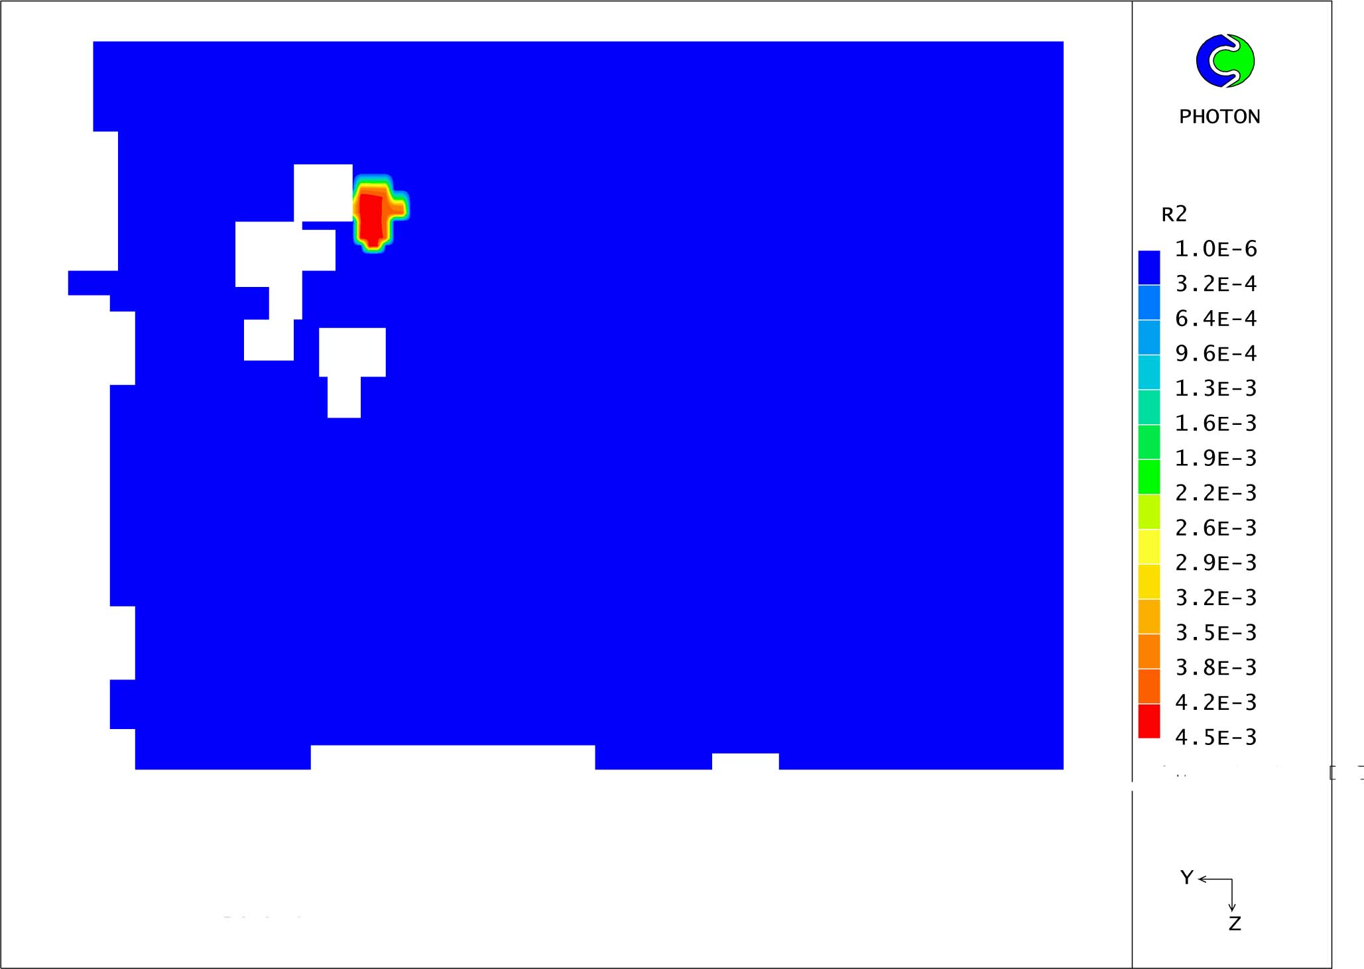
Figure 4. The spill 10s after the accident

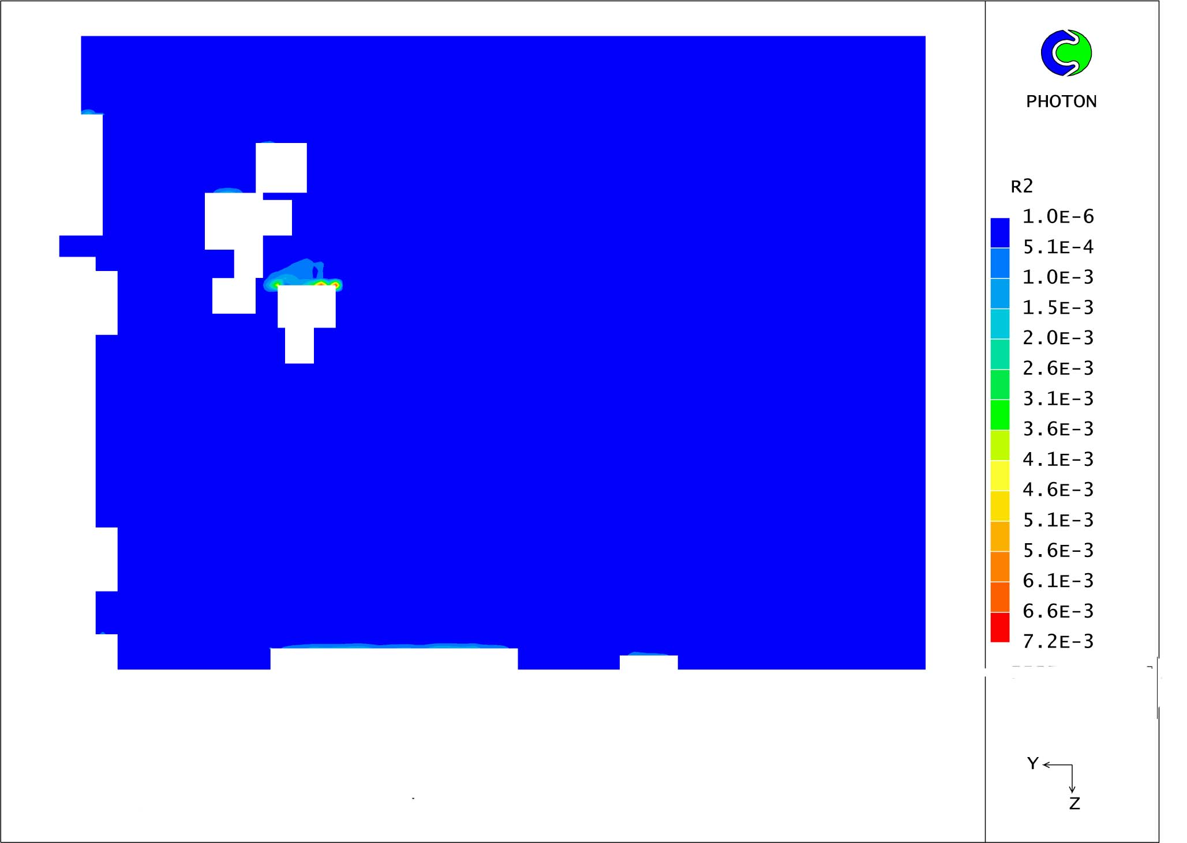
Figure 5. The oil spill 6.5 hrs after the accident

Figure 6 shows the variation of the oil volume volume fraction (r₂) versus depth in the above field. It is characteristic the dramatic decrease of

F fraction with the depth from the sea surface.
Figure 6. Oil Volume fraction versus depth

Figure 7 shows the fate of an oil spill, a few minutes after a spill of 830 m³ had occurred at a distance of 200 m from the upper western coast of Prasologos, a small island and a region of rather shallow waters, considering a NE wind of 10m/s.

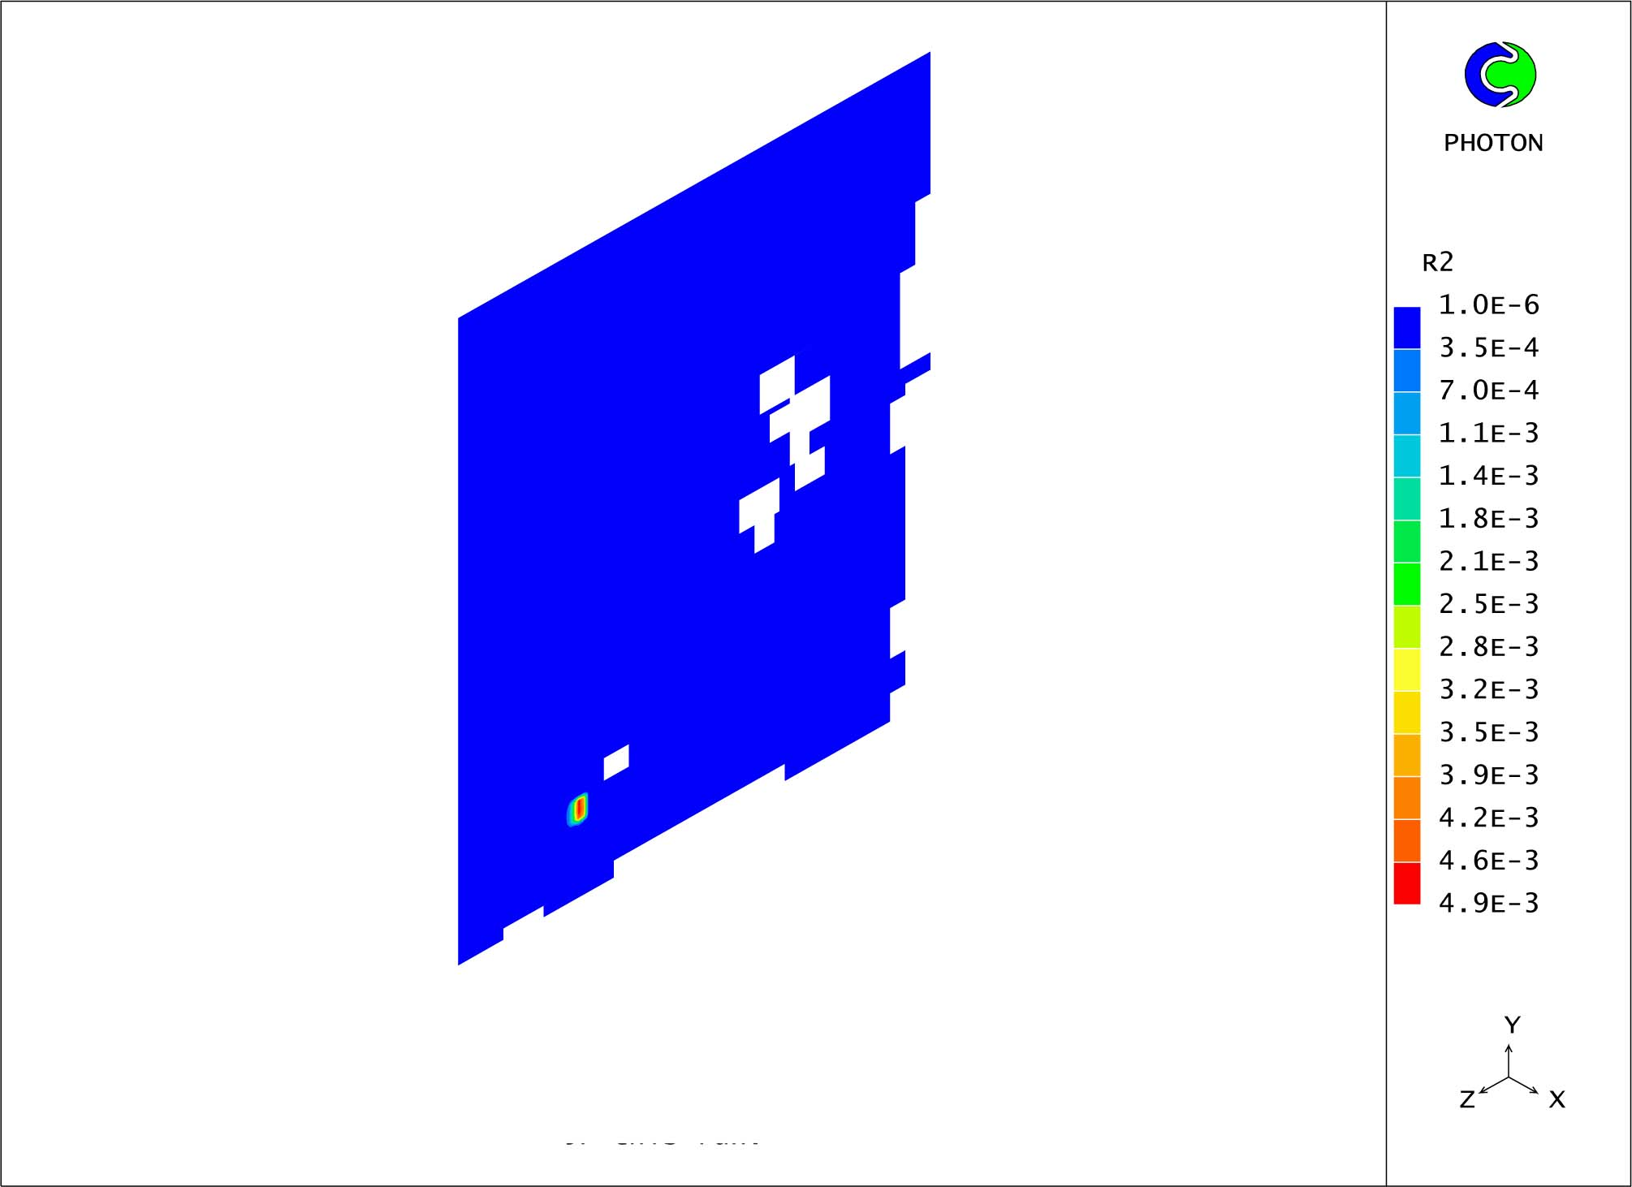
Figure 7. The spill 10s after the accident

Figure 8 shows the fate of the above spill at the surface 6 hrs after the accident, while Figure 9 shows the oil spill at a depth of 20m, 6 hrs after the accident.
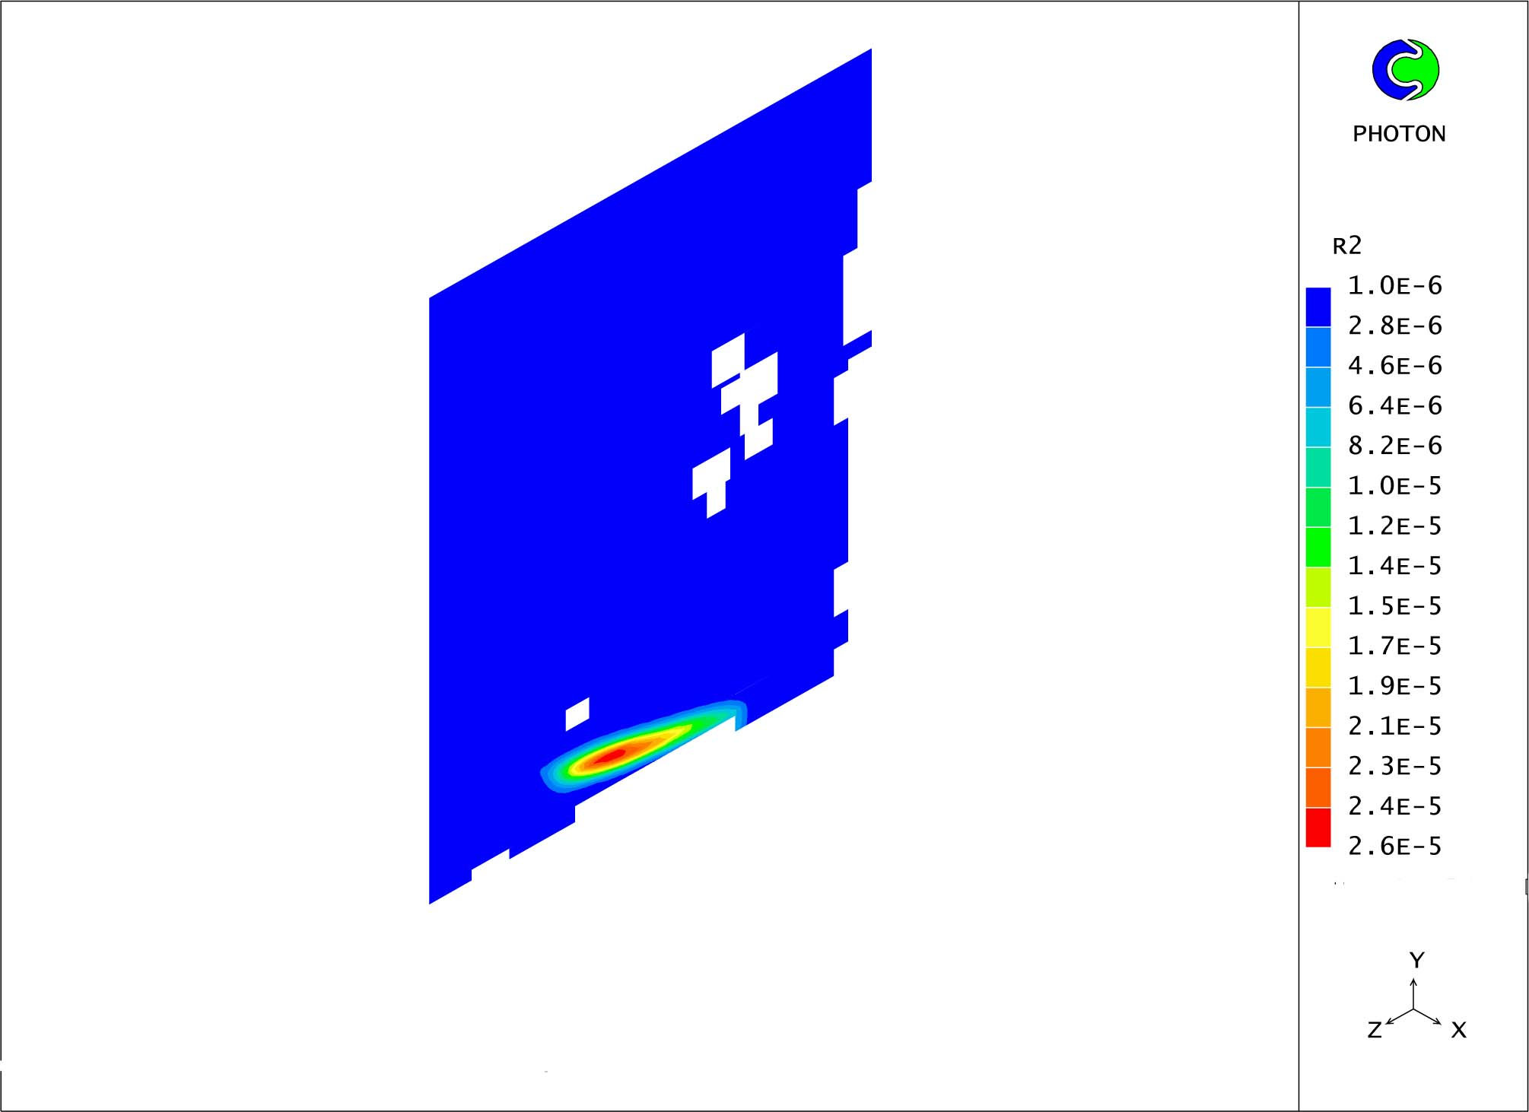
Figure 8. The spill at the surface 6 hrs after the accident
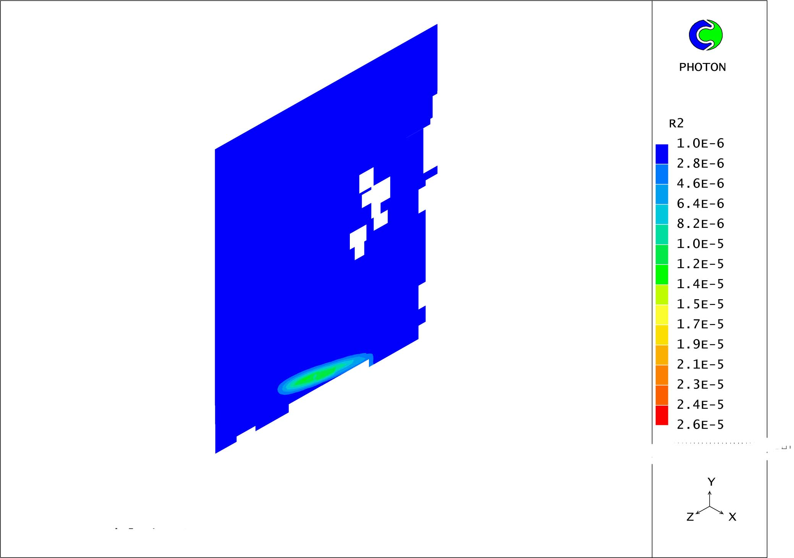
Figure 9. The spill at a depth 20m after the accident
Figure 10 shows the fate of an oil spill, a few minutes after a spill of 830 m³ had occurred at a distance of 3000m from the eastern coast of the three islands in the field of Carava area of Lesvos island.
Figure 11 shows the fate of the oil spill 10 hrs after the accident, considering a NW wind of 10m/s and an oil density of 830kg/m³

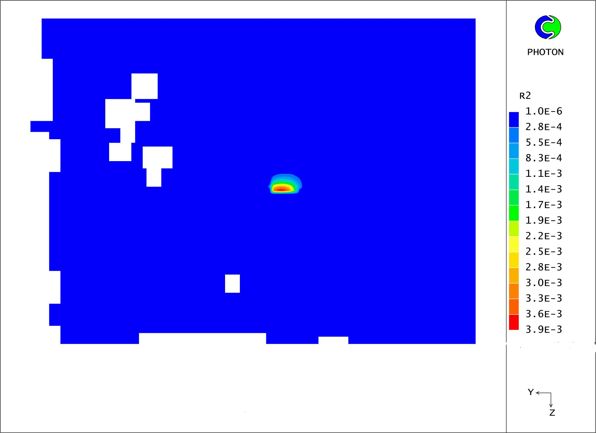
Figure 10. The spill 10s after the accident
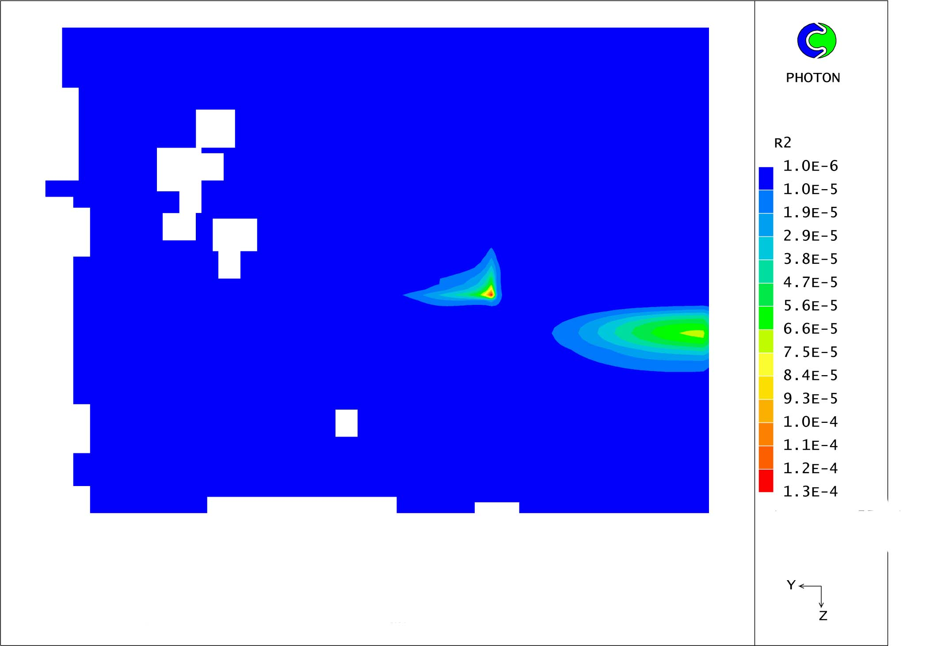
Figure 11. The spill at the surface 10hrs after the accident

F Figure 12 shows the variation of the oil volume fraction (r₂) versus depth in the above field
Figure 12: Oil volume fraction versus depth

Figure 13 shows the fate of the spill 10s after a hypothetical accident 500m southwestern of Eretria, a region of Evvoikos bay, considering a NW wind of 10m/s and an oil density of 860kg/m³.
Figure 14 shows the fate of the above spill 12 hrs after the accident.
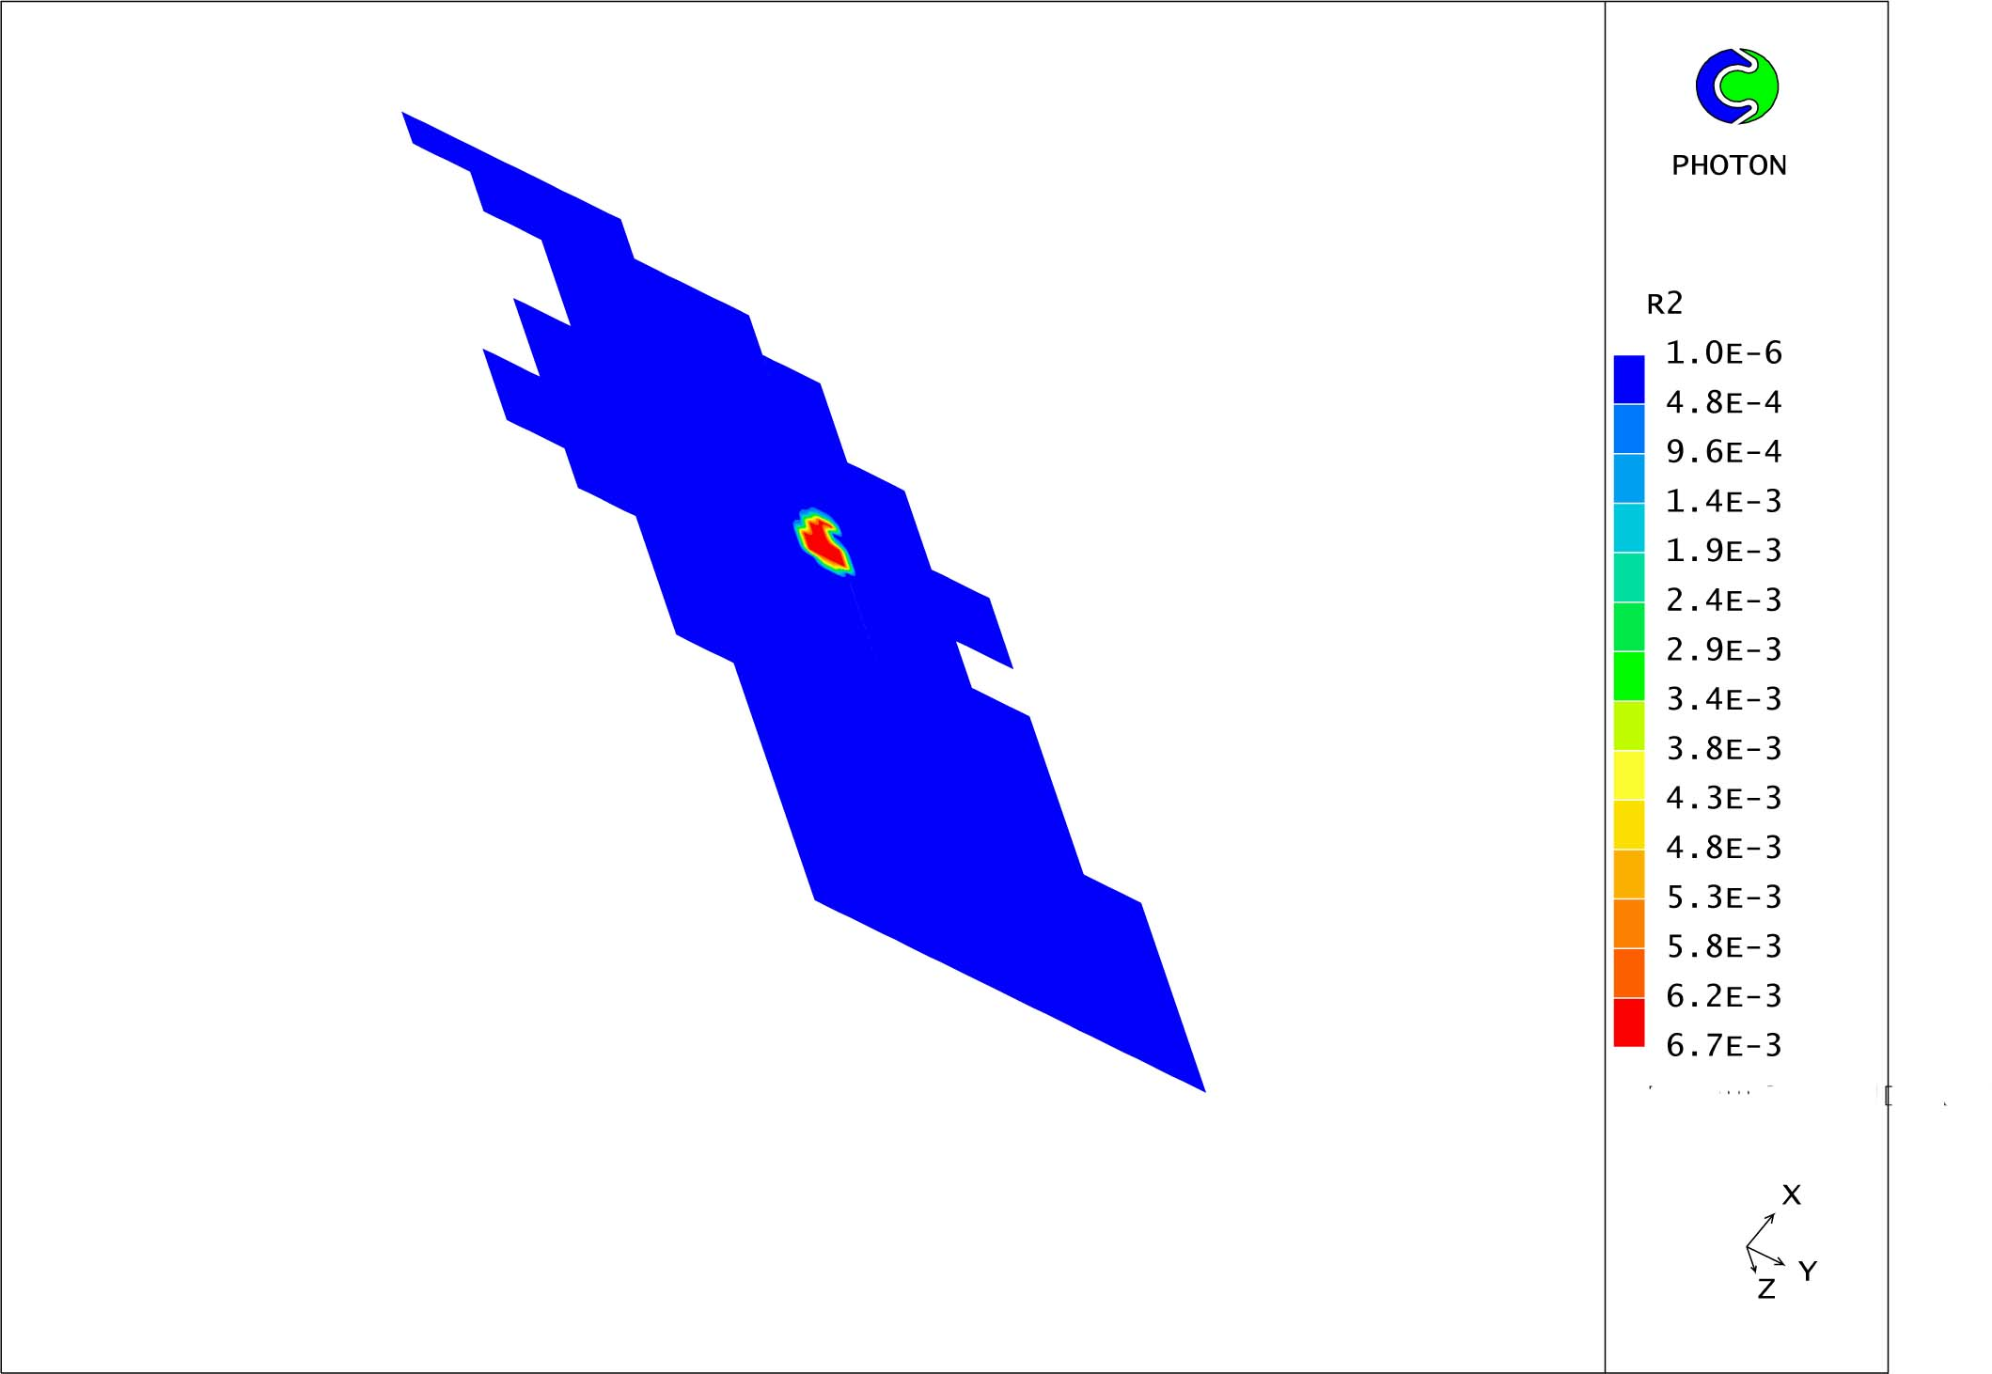
Figure 13. The spill 10s after the accident

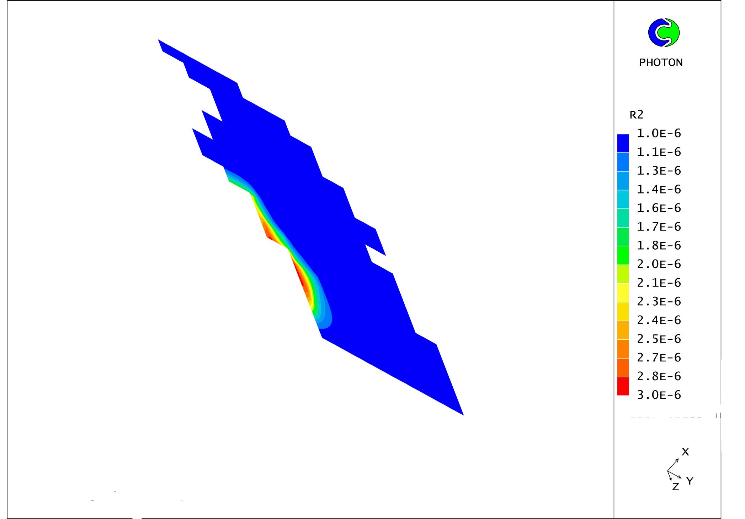
Figure 14. The spill at the surface 16 hrs after the accident
Figure 15 shows the variation of the oil volume fraction (r₂) in relation with the oil density in the above field.

Figure 15. Oil Volume fraction versus depth
F Figure 16 shows the variation of the oil volume fraction of (r₂) in relation with the oil density in the above field.

Figure 16. Oil volume fraction versus oil density

The above figure shows the variation of oil volume fraction versus depth at the surface (black line) and at a depth of 15m (red line).
Figure 17 shows the fate of the spill 10s after a hypothetical accident 300m western of Eretria, a region of Evvoikos bay, considering a NE wind of 10m/s and an oil density of 880kg/m³.
Figure 18 shows the emulsion 16 hrs after the accident.
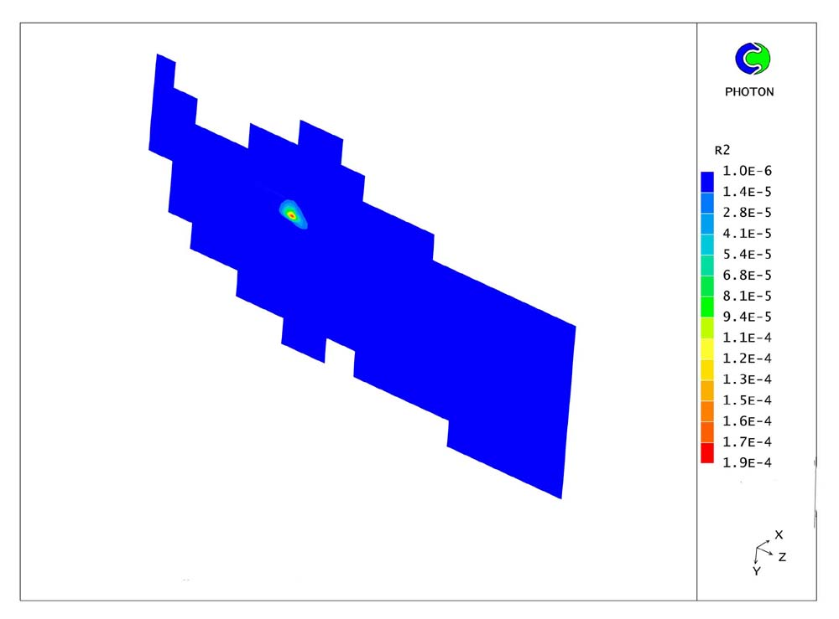
Figure 17. The spill 10s after the accident
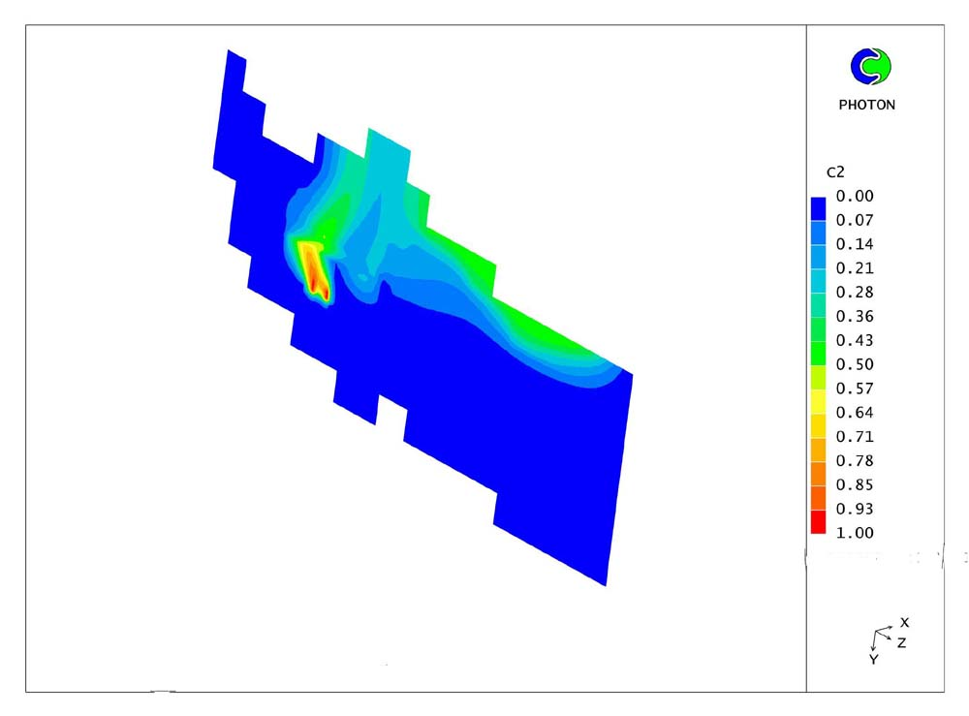
Figure 18. The emulsion at the surface 16hrs after the accident

4 Conclusions
The model developed and used in this work incorporates many of the physical processes, that are considered necessary for the particular application, given the conditions of each simulation (depth, oil density, etc). Yet, it has a general structure that can accommodate any other processes deemed necessary.
Furthermore, the model covers the general circulation, the wave field and the processes that govern the fate of an oil spill in a marine environment. So, it is not necessary to be coupled with other models (e.g. wind models, general circulation models, etc.), in order to simulate the behaviour of the oil spill in the marine environment.
The results of the simulations near coastal regions indicate that oil turbulence diffusion and dispersion are larger closer to the coasts than in deeper waters, and decay with depth away from the surrounding islands. These results are in accordance with observations, as turbulence diffusion and dispersion follow a similar trend. Also, the model can simulate the fate of the oil spill under special conditions. For example, in the simulation case of Figure 4 (a region with a strong recirculation field), where the spill is very close to the surrounding coasts, the volume fraction of the oil spill is rather high at the surface and becomes dramatically less with the depth. Moreover, in the simulation case of Figure 11 (far from the coast), the oil spill breaks into two parts due to spreading and surface tension forces.
It may then be concluded that the prediction of the time dependent behaviour of oil spills in complicated 3D environments is feasible and can be accomplished within practical computer resources.

Refereneces
[1]Findikakis A.N., A.W.K. Law &. Y.Papadimitrakis (1998), “Assessment of the risk of shore contamination by offshore oil spills model formulation” Proc. of 1st Int. Conf. Oil and Hydrocarbon Spills Modelling Analysis and Control (Oil Spill ’98). Edited by. Garcia -Martinez, C.A. Brebbia, pp 209-220.
[2]Stolzenbach K.D., O.S Madsen,. E.E..Adams, A.M. Pollack & C.K.Cooper (1977) “ A Review and Evaluation of basic techniques for predicting the behavior of surface oil slicks”, R.M.Parsons, Laboratory for Water Massachusetts Institute of Technology, Cambridge Massachusetts. Resources and Hydrodynamics, Dept. Of Civil Engineering, M.I.T Sea Grant Program
[3]Spalding D.B. (1981), “A general purpose computer program for multi-dimensional one-and two –phase flow”. Maths and Computers in Simulation, North Holland Press, Vol. 13 pp.267-276.
[4]Markatos N.C. (1993), “Mathematical modelling of single-and two-phase flow problems in the process industries”, Revue de l’Institut Francais du Petrole 48 (6) 631-661.
[5]Markatos N.C. (1986.),“Modelling of two –phase transient flow and combustion of granular propellants”, Int. J.Multiphase Flow, Vol.12, (6), pp 913-933,
[6]Yakhot V.and S.Orszag, S.Thangam, T.B Gatski and. C.G.Speziale (1992) “Development of turbulence models for shear flows by a double expansion technique”,Physical Fluids A,Vol. 4,No 7
[7]Sobey R.J & C.H Barker.(1997) “Wave-driven transport of Surface Oil”,Journal of Coastal Research, 13(2),490-496.
[8]Tsimplis M.N (1997) “Tides and Sea-level Variability at the Strait of Euripus”, Estuarine, Coastal and Shelf Science, Volume 44,Issue 1, , pp.91-101
[9]Papadimitrakis Y., “Oil Natural Dispersion in the water column due to wave breaking”, Proc. Of the 2nd Panhellenic Conference “Management and amelioration of coastal zones” School of Civil Eng., NTUA, 2002

[10]G.A.L Delvigne & C.E. Sweeney (1988) “Natural Dispersion of Oil”, Oil and Chemical Pollution 4pp.281-310.
[11]Lehr W,. R. Jones, M. Evans, D. Simecek- Beatty & R. Overstreet (2001) “ADIOS, ADIOS2, Revisions of the ADIOS oil spill model”, National Oceanic & Atmospheric Environment (NOAA)-HAZMAT, 7600, Sand Point Way NE, Seattle,WA 98115,USA
[12]Lintrup M. J & A. K. VintherFalk, Bengtssen G. & N. Torneman (2000) “Oil Spill modelling in ORESUD-the influence of seasonal variation of photo-oxidation on the distribution of a spilled oil slick”, DHI-Water & Environment, Denmark, Dept. of Ecology, Lund University, Sweden.
[13]Xiaobo Chao, N.Jothi Shankar, Cheong Hin Fat (2001) “Two -and three-dimensional oil spill model for coastal waters”, “Ocean Engineering”28 pp.1557-1573

