Algorithm for the Determination of Human Organ Functions

MANFRED DOEPP, GABRIELE EDELMANN, and ALEXANDER BELJAEV
Holistic DiagCenter
52 Buchbichl, D 83737 Irschenberg
GERMANY
http://www.diagcenter.de

Abstract: - Up to now no method existed to determine organ functions digitally and reproducibly using electro-physiological principles. The reason was that the human skin contains inductive and capacitive resistances and does not follow physical or technical laws. A new algorithm was developed in order to take into consideration the three variables determining the flow of current impulses, the surface, the inner volume, and the ions movements and separations. This algorithm was programmed and a device (“Amsat”) was produced using six electrodes with 22 connections/channels. It allows the detection of the functions and the sol-gel states of 60 different organs, systems or structures. An examination takes several seconds only and works without side effects. It is suitable especially for screening purposes.

Key-Words: - Diagnostic algorithm, complementary medicine, electro-physiology, organ functions

1 Introduction

In medicine the problem exists that no method exists which is able to determine the organ functions without a load of rays or other possible side effects. Laboratory determinations can test single and specific functions, however, not of all organs, and in case of a holistic approach they are expensive. So, for screening purposes a combination has to be made of blood tests, ultrasound, X-rays, and nuclear magnetic resonance investigations, altogether taking almost one week. Wide-ranged popular screenings cannot be performed thus, and a repeated survey of risk groups is not possible. In former publications between 1974 and 1994 several authors mentioned a method called “segmentary-electrography” or “decoder-dermography” claiming to perform evaluations of the health state [1, 2, 5, 7, 9, 10].

The devices based upon those theories, however, were uncomfortable to handle and the results difficult to be interpreted [4] and in spite too simplified. All attempts were identical by using six electrodes: two on the forehead, one in each hand, and one under each foot sole. Electric impulses were put into the body between rotating plus and minus poles. The hypothesis was that the conductance of electric current of the body tissues between two poles should be representative for several organ characteristics.

The main problem is that the skin is characterized by morphological and functional heterogeneity, it works as an inductive and as a capacitive resistance and in this way cannot be compared with technical resistances. The human skin is built similar to a capacitor and keeps and leads direct current and higher frequency impulses or rays on its surface (“skin effect”). Only currents or rays within some “frequency windows” may penetrate the skin. The behaviour of the body does not follow the laws of Ohm and Kirchhoff. An utilized current flow will be distributed between the surface of the skin and the inner volume of the body in different ways depending on its frequency and modulation.

The human body can be imagined as a system of oscillatory circuits (figure 1), consisting of electromotive forces and conductors which are characterized as active, reactive, and reactance resistances. These resistances depend on the frequency the investigation is performed with.

Therefore, several problems had to be investigated, on the side of the input the best values of the current, the voltage, the amperage, and the modulation and frequencies, and on the side of the output the best evaluation methods combined with mathematical filters. However, the first problem was to describe an algorithm, which should be able to produce results connected to the functions of the organs and to the milieu in the extracellular space (mesenchyma, matrix) [8].

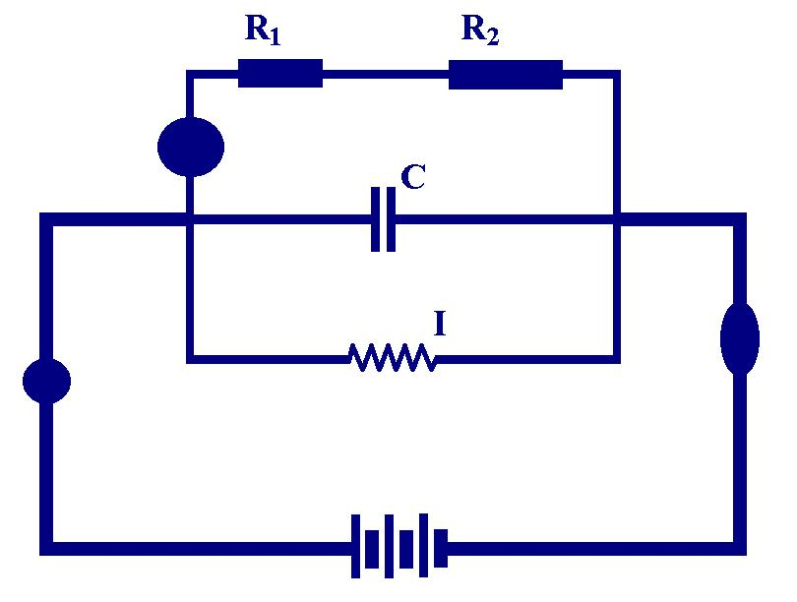

Figure 1. The human body as a system of oscillating circuits.

2 Problem Formulation

Two physical laws are valid concerning biological tissues, too: a) electric current takes the shortest way, and b) electric current takes the way with the lowest resistance. So, the following parameters have to be taken into consideration by an algorithm:

the path over the skin surface with high resistance, including areas of lower resistance (known as “Head’s zones”)

the path through the body volume including different organs and extracellular spaces

the conversion of the electrons (coming from a negative electrode) into ions movements esp. of the H+ ions as the smallest and fastest ones, representing the sol-gel state

Concerning the data acquisition it is the question if a standardization of absolute values is possible, or if an individualization is necessary. This would need a big data bank considering sex, age, weight, and height. The greatest mathematical problem is the analysis of the ions movements. For this purpose the gained analogue voltage-time-curves are digitalized by an AD-converter. Not a simple voltage reduction represents the capacity but the characteristics of the curve.

Afterwards the theoretical approaches have to be controlled by the reality of patient results with different defined states of dysfunctions.

3 Problem Solution
  - Results

An algorithm (table 1) was produced which takes into consideration the prerequisites mentioned. There are three paths of the current: 1) the body volume (R1+R2+R3), 2) the skin (R4+R5+R6), and 3) the ions movements (capacity). The inductive resistances of 1) and 2) are measured by a volt- and an ampèremeter. The capacitive resistance (deficit of H+ ions) is measured by the integral under the curve of the first amplitude peak as a kind of mathematical filtering.

It was found out that the absolute values are not sufficient for a diagnosis as their variations are too high. There are enormous inter-individual differences of the water, the fat, and the muscle contents of the body. Furthermore the resistances change in correlation with the sex (women have lower values), the age (the older, the higher the resistance), the body weight and height (together forming the body mass index: fat is a good current conductor). A data bank of healthy people was built up and secondly a data bank of defined pathological cases. Individual deviations from the normal values are shown.

Table 1
Algorithm for the electro-physiological diagnostics of the human organs and structures.

Concerning the optimization of the instrumental parameters the results are: direct current of 6.7 V, 50 µA (= 335 µW), and 10 – 25 Hz frequency modulation. The six skin electrodes may be connected (including a pole changes) by 30 channels, however, the forehead and the feet soles are neglected and 22 channels = segments are evaluated. The reduction degree of the amperage corresponds to the functional reduction of the tissues within each channel. A fast and sinusoid current curve amplitude corresponds to a normal ions = colloidal = sol-gel state. A flat curve results from a gel increase, a steep curve from a sol increase. Functional and sol-gel states are combined to the third criterion of the risk degree (means the risk to be or to fall ill).

Each of the 22 segments contains specific organs and structures to a certain percentage. Most of the organs belong to 2 or 3 channels. The software performs a calculation by considering those partitions for every organ/system/structure which refers to quantitative deviation factors from the individual normal value.

3.2 Discussion

The results are demonstrated by numbers lists, bars, circle diagrams, and topographically using different colours (in the “Phantom image”). In the following figures (fig. 2 and 3) the case of a severely sick patient is shown as an example: a 63 years-old man, suffering from a two carcinomas: prostate and rectum, and from high blood pressure and a transitory ischaemic attack of the brain.

Figure 2
Hyper- (red) and hypofunctional (blue) deviation Hyper- (red) and hypofunctional (blue) deviation
bars for each of the 22 channels (mean = + 23%). bars for 11 systems; head is high, kidneys are low.

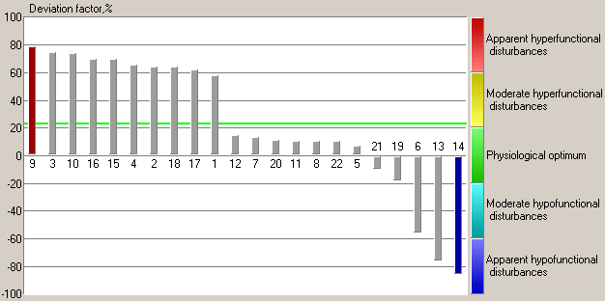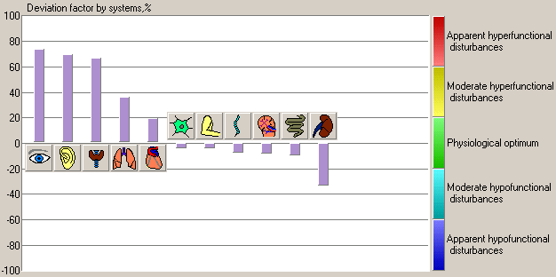

Figure 3
Phantom images = topography of the results of the organs and structures (deviations from normal).
Function deviation (red = higher, Sol-gel deviation (blue = relative Risk degree (the more lilac - the
blue = lower). increase of gel). higher the risk).

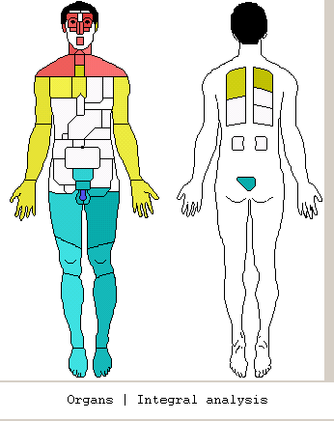
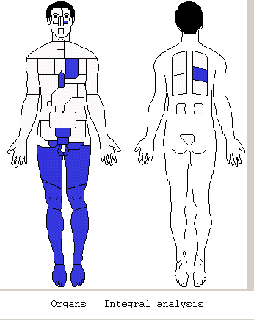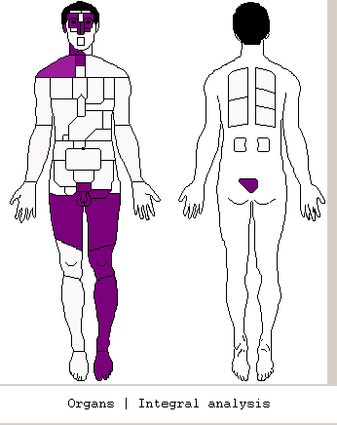

In fig. 2 (left) most channel bars are hyperactive, low are those of the urogenital system. Fig. 2 (right) shows a hyperactivity of eyes, ears, and thyroid glands. This is typical for a persisting stress situation. In fig. 3 (left) again a hyperactivity of the head (esp. of the brain) and the neck is demonstrated, and a hypofunction of the urine bladder, the prostate, the rectum and the legs (an operation took place in the left pelvic area). A gel increase (fig. 3 middle) is to be seen additionally in the heart. The highest risks (fig. 3 right) are obvious concerning the brain, the thyroid glands (a new finding), the sexual organs, the rectum and the left leg (blood and lymphatic stagnation). All results are in confirmation with the diagnoses.

After 1 year of experiences with the device “Amsat” we saw an about 80% correspondence between the clinical diagnoses and the symptoms on the one hand and the results of the segmentary diagnostics on the other hand. Findings in this analysis which were not yet known often could be confirmed by a special investigation. In about 10% of the cases no agreement was possible which is good for a testing method in medicine [3, 6]. A test procedure needs 17 seconds and – because of a wattage of less than 0.5 mW – is without side effects.

Problems of the testing principle are: 1) the connection between the electrodes and the skin must be safe, therefore a quality control of the adaption to the skin is integrated; 2) the patients need a standardization concerning eating, drinking, and the stress situation; 3) a state of regulatory rigidity (e.g. by a general acidosis) reduces the sensitivity of the analysis

4 Conclusion

An algorithm is developed for the purpose of quantitative measurements of the organ functions and of the colloidal situation in the human body together defined as the “risk factor”. The problems existing up to now for similar approaches and devices are solved by distinguishing three paths for the flow of the current impulses: the skin surface, the inner volume, and the capacity = ions attraction by the electrodes, corresponding to the sol-gel state.

The last criterion is a problematic one because of the necessary mathematical procedure. The calculation of an integral under the first peak of the time-voltage curve results as representative.
An absolute standardization of the results proved to be ineffective, therefore an individualization is performed by taking into consideration the parameters of sex, age, weight, and height. Concerning the three criteria of state of function, sol-gel state, and risk deviation factors from the individual normal values are displayed.

A device (“Amsat”) is produced for the practical working. Experiences with some hundred of patients show an 80% correspondence with the previously known symptoms and the clinical diagnoses, a 10% agreement with dysfunctions found later, and 10% of not provable findings. As in holistic medicine no “gold standard” exists, these results are acceptable.

The method proves to be excellently suitable for screening purposes.

References:
[1] Bergsmann, O., Objectivation of the Acupuncture as a Problem of Regulation Physiology, Haug, Heidelberg, 1974
[2] Bergsmann, O., Investigations and Experiments with the Parallel-Longitudinal Impulse-Dermogram, Erfahrungsheilkunde, 2, 1978
[3] Doepp, M., Opinion Based Medicine versus Energy Medicine, Med. Woche Baden-Baden, 11, 2003
[4] Grieshaber, B., Schimmel, H.W., The Segmentelectrogram (SEG), Haug, Heidelberg, 2nd ed. 1985
[5] Heim, G., Schimmel, H.W., Manual for the Computerized Segmentelectrography, Haug, Heidelberg, 2nd ed. 1987
[6] Nechorochev, M.P., Samochin, A.W., Segment-Electro-Diagnostics of Prostate Diseases, in: Schabada, A.L., Gorjunov, W.G. (eds.), Inflammation Diseases of Kidneys, Ureter, and the Male Reproductive Organs, Health Ministry of the RSFSR, Scientific Research Institute for Urology, Moscow, 1992
[7] Pflaum, H., Practical Studies of the Bioelectronic Function- and Regulation Diagnostics (BFD), Haug, Heidelberg, 1979
[8] Pischinger, A., The System of the Ground Regulation, Haug, Heidelberg, 1975
[9] Schimmel, H.W., Sauer, H., Readers-Manual for the Computerized Global Segmentelectrography (Global-SEG), VEGA KG, Schiltach, 1994
[10] Schramm, E., Extended Bioelectronical Test for the Determination of Neoplasias, Biolog. Medizin, 3, 1978

Correspondence postal address:

Dr. Manfred Doepp
Holistic DiagCenter
52 Buchbichl
D 83737 Irschenberg
Germany

