Random Access Scheme with Error Estimate and Adaptive Technique for Precise Time Integration

Yizhen Huang
School of Electronics Information & Electric Engineering
Shanghai Jiaotong University
Shanghai, 200240, P.R. China

Abstract The Random Access Scheme with a first order anterior error estimator and a fast dual binary search adaptive procedure is proposed. This scheme attributes to MN-refinement versions of the PTI method and can strike a good balance between computing expense and precision. The adaptive scheme produces results with smaller errors distributed more evenly.

Key words: Random Access Scheme, Adaptive technique, Precise Time Integration
- Introduction
Zhong proposed a Precise Time Integration (PTI) method based on the precise computation of matrix exponential [1,2] that can produce numerical results with extremely high precision for a set of homogeneous ordinary differential equations (ODEs). Besides, it is unconditionally stable [3,4,5], with zero-amplitude rate of decay, zero-period specific elongation and non-overstep [4]. This algorithm and its extensions have very broad applications in many scientific and engineering fields, such as structural dynamics, transient thermal analysis, system control, point source diffusion, multi-body dynamics etc.
For non-homogeneous ODEs, there are generally two ways: The original one is using the solution theory for ODEs [2,3,4], which first finds one particular solution and then computes the general solution. It requires computing inverse matrices, which is inefficient and induces relatively large errors. Specifically, if the matrix to be inversed is singular or approximately singular, the errors induced are considerable. Hence the newly emerged methods usually transform non-homogenous ODEs to homogenous ones by the Dimensional Expanding Technique (DET) [7,8], which was first proposed by Gu et al. [6].
It is often necessary to perform approximation to the non-homogenous terms, because in many cases, it is very difficult or even impossible to find one particular solution if adopting the solution theory for ODEs, and the precondition of the DET i.e. the derivative of the expanded state vector p can be expressed as a linear combination of p itself is also impossible to achieve. Therefore many works have been done for this: Originally, Zhong adopted a linear approximation method [1,2]. Afterwards, Lin et al. performed Fourier approximation [3]; Zhou et al. carried out Taylor approximation [7]; Huang et al. [8] introduced Legendre approximation. Huang [9] adopted 3 other orthogonal polynomial approximations and provided a comprehensive survey of the performance among the contemporary methods.
In this paper, the Random Access Scheme (RAS), which is to compute v(t) directly for an arbitrary positive time t given, is proposed. It is faster and more convenient than direct time step integration for finding v at time points that does not form an arithmetic series. Error estimate and adaptive technique have been emphasized in the recent years [11-14], and its thinking and methods are valuable to be assimilated and applied to the development of the PTI method: A first order anterior error estimator is provided based on which adaptive technique can be carried out to effectively control the precision of the RAS when t is large. This scheme attributes to MN-refinement versions of the PTI method and can strike a good balance between computing expense and precision.

2. Precise Computation of Matrix Exponential
For high order ODEs, they can be transformed into first order ODEs by variational principle. So now consider the following set of first order ODEs in matrix form:
(1)
Where v(t) is an n-dimensional vector function to be determined, A is a given n×n constant matrix, and f (t) is a given n-dimensional vector function.
We should first solve the homogeneous equations i.e. with the non-homogenous terms f (t) removed. Its solution is
(2)
The time step size is denoted as τ satisfying t₀ = 0, t₁ = τ ,…, t_{k} = k∙τ,…So the following recurrence can be derived:
(3)
Where T = exp (A∙τ).
The key is to compute the matrix exponential T. Moler and Van Loan presented up to nineteen ways to compute matrix exponential [15]. However, none of these settled the problem perfectly. Zhong’s method can produce matrix exponential with great accuracy without any special unsolvable cases [1,2,16]:
The time interval τ should be split into smaller ones. Let ∆t = τ/2^{N}, in which N is a natural number. If N is set to be 20 like it is suggested in [2], ∆t = τ/1048576 is a very small interval. Then
(4)
Such factorization should be iterated N times. This results in a series {T_{ai}} in which i = 0, 1, 2, …, N. And initially an M th order Taylor expansion is carried out:
(5)
Note that T_{a0} is extremely small. So it will almost be rounded-off if added to the unit matrix I directly. The way to avoid this is to operate on the incremental part {T_{ai}} rather than the total value {I+T_{ai}}. (I+T_{ai})² = I+2T_{ai}+T_{ai}×T_{ai} = I+T_{a(i+1)}, this yields the following recurrence:
(6)
T_{aN} is no longer small and so the addition can be done now:
(7)
Eq. (4), (5), (6) and (7) constitute the precise computation of matrix exponential.
3. Error Estimates
Precisely speaking, the RAS implies where σ [8] is the approximating step size.
The error estimates for the PTI method is customarily based on eigenvalues and the spectral mapping theorem. Assume the eigenvalues of the matrix A is μ₁, μ₂, …, μ_{n}. Let c = max{|μ₁|, |μ₂|, …, |μ_{n}|}. c is the magnitude of the dominant eigenvalue μ_{d} of A, and can be estimated by the power method easily.
The precision of the result can be controlled through two parameters: N in Eq. (4) that controls the split of the time step size and M in Eq. (5) that is up to which order the Taylor series is expanded.
Besides round-off errors from usual computer arithmetic, errors can only be induced from the power series expansion truncation in Eq. (5). Literature [16] provided error analysis and indicated that the absolute value of the relative errors from Eq. (5) for each eigenvalue μ_{j} is of the order of (|μ_{j}|t/2^{N})^{M}/(M+1)!, so the maximum is
(8)
The error analysis in [16] is not enough, because Eq. (6) enlarges the relative errors induced from Eq. (5).
By the spectral mapping theorem and Eq. (5), there is a corresponding eigenvalue
(9)
of the matrix T_{a0} and by Eq. (6) there is a corresponding eigenvalue
(10)
of the matrix T_{a(i+1)} where i = 0, 1,…, N-1. By Eq. (9) and (10), a rough estimate for λ_{ji} with the second and higher order of ∆t omitted can be obtained
(11)
The absolute value of the absolute errors and the relative errors of λ_{j0}, λ_{j1}, …, λ_{jN} are denoted as E₀, E₁, …, E_{N} and E_{r0}, E_{r1}, …, E_{rN} respectively. According to the formula of error propagation, we have
(12)
Which yield
(13)
Hence
(14)
Substituting Eq. (11) into Eq. (14) gives
(15)
Eq. (15) shows that the maximum magnification rate of the relative errors K during the process of Eq. (6) among all eigenvalues μ₁, μ₂, …, μ_{n} is about .
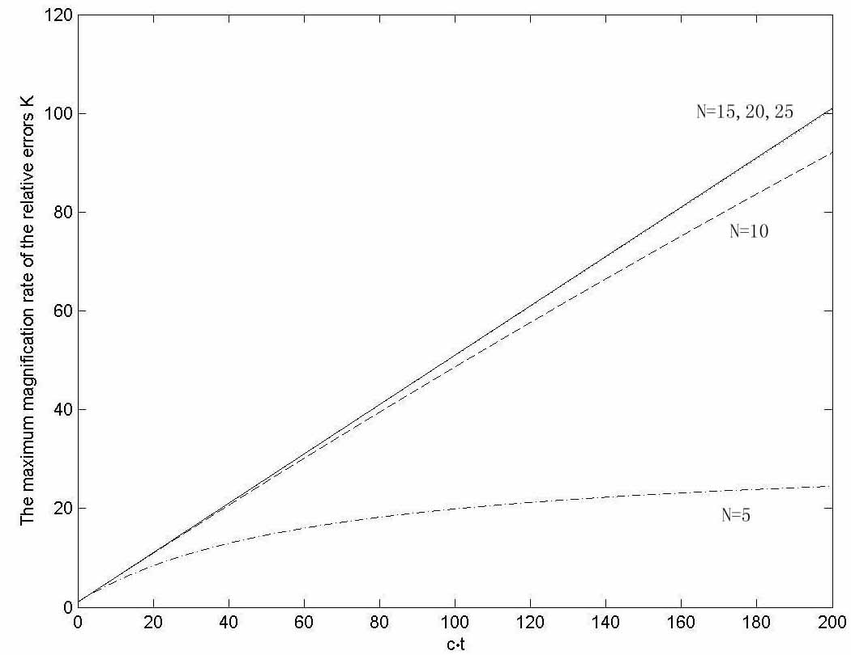
Figure 1 Diagram between K and c∙t for different N values
Figure 1 shows the diagram between K and c∙t, from which it can be seen that K ≈ c∙t /2+1 when N is large enough. This is because
(16)
2^{N+1}>> c∙t when N is large enough, so (17)
Besides, it is not difficult to prove that and .
This amount of error magnification should be taken in consideration, especially when is t large.
From the above error estimates, it can be seen that c and t are only factors determined by the problem per se and affect the precision greatly. c∙t can be considered together and termed as the difficulty of a given access.
4. Adaptive Technique
The prescribed relative error tolerance is denoted as ε. Combining Eq. (8) and Eq. (17) gives the error estimator (18)
In [8], a control flow for the PTI method with any approximation methods was given, with its complexity indicated. This control flow is applicable to the RAS and leads to a degenerated form of complexity O(ψ+(M+N)n³), in which ψ is the computing expense for function approximation and n is the dimension of the matrix A and they are both predetermined.
It can be seen that the parameters M and N not only control the precision but also the complexity. The adaptive technique based on the adjustment of M and N can be attributed to the MN-refinement versions of the PTI method.
In Eq. (5) A∆t should be multiplied for at least M times and in Eq. (6) T_{ai} should be self-multiplied for at least N times, so there are M+N times of n-dimensional matrix multiplication during the whole process of the precise computation of matrix exponential. Associated with the complexity analysis above, we denote CI=M+N as the Complexity-Indicator.
An optimal configuration of M and N should achieve to the minimum CI under the condition of Eq. (18). Nevertheless, it is difficult to solve this optimization problem directly. An economic and easily-programmable algorithm is to binary search CI since it is very obvious that, E(M,N) is strictly decreasing as CI increases.
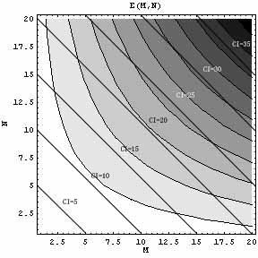
Figure 2. A contour plot of the error estimator E(M,N) when c∙t=10
The next problem is how to set M and N in order to achieve the minimum E for a given CI. It can be seen from Figure 2 that, the iso-complexity line from CI=5 to CI=35 does not coincide with the contour of E and their relationship is complicated. Fortunately we discover that dE/dM is increasing over [0,CI]. Its proof is in the next section. So binary search can be applied once again based on dE/dM and the minimum E is achieved when |dE/dM| is closest to 0.
Thus the algorithm to set M and N is a dual binary search: the outer nesting level searches CI based on E and the inner nesting level searches M based on dE/dM. The Matlab code is as follows:

function MNadaptive=f(ct,epsilon)
CI_low=2;CI_high=100;
while CI_low<CI_high
CI=floor((CI_low+CI_high)/2);
if Inner_level(ct,CI,0)<epsilon CI_high=CI;
else CI_low=CI+1;end
end
M=Inner_level(ct,CI_low,1);N=CI_low-M;
MNadaptive=[M,N];

function Inner_level=f(ct,CI,flag)
M_low=1;M_high=CI;
M=floor((M_low+M_high)/2);
while M_low<M_high
M=floor((M_low+M_high)/2);
if E(ct,M,CI-M)<E(ct,M+1,CI-M-1)
M_high=M;else M_low=M+1;end
end
if flag Inner_level=M;
else Inner_level=E(ct,M_low,CI-M_low);end

Note that in the inner level we compare E(M,N) and E(M+1,N-1) instead of computing dE/dM because M is discrete. In addition, dE/dM is costly to compute. The upper bound CI=100 is rather sufficient. The total invoking times of E(M,N) does not exceed 2(log₂100)²<98 and it is rather small and completely negligible compared to the computing expense of the PTI method.
5. A Supplementary Proof
Substitute N=CI-M and denote E(M)=U(M)/V(M) where U(M)=(c∙t+2)(c∙t)^{M}/2^{(CI-M)M+1} and V(M)=(M+1)!=Γ(M+2).
U’(M)=U(M)[ln(c∙t)+(2M-CI)ln(2)] and V’(M)=Γ’(M+2)=Γ(M+2)Ψ(M+2)=Γ(M+2)ψ₀(M+2) in which the gamma function and the digamma function Ψ(z) is a special case of the polygamma function ψ_{n}(z) i.e., so
(19)
Denote W=[ln(c∙t)+(2M-CI)ln(2)-ψ₀(M+2)], then (U/V)’=(U/V)W.So
(20)
U/V=E≥0. WR, so W²≥0. W’=2ln(2)-ψ₁(M+2)>0, because the trigamma function ψ₁(z) is strictly decreasing over R⁺ and ψ₁(2)=π²/6-1≈0.64. Therefore (U/V)’’≥0. Then we have E’=(U/V)’ is increasing. QED
6. For Non-approximating PTI and Approximating PTI
In [8], the PTI method was divided into two categories, non-approximating PTI and approximating PTI, based on whether function approximation is performed to the non-homogeneous terms. According to this classification, the PTI method for homogeneous ODEs is a special case of non-approximating PTI.
Non-approximating PTI is so precise that its precision is insensitive to the time step size τ, and this leads to the feasibility for the RAS for extremely large t and extremely small ε given.
As to non-homogeneous ODEs, the approximating step size σ is also a restriction to t. Though function approximation to the non-homogeneous terms f (t) in Eq. (1) has been improved greatly after the introduction of orthogonal polynomials [8,9], σ can only cross as long as several periods of f (t) for most good cases. When t is too large and ε is too small, the RAS does not work because of the bottleneck of the error ξ induced by function approximation. As long as function approximation is not improved, the error ξ is irreducible and unavoidable. Hence we cannot help letting ε=ξ. The estimate of ξ is obvious a research problem.
Extremely large c, which is determined by the structure of matrix A, only increases CI slowly, but does not bring any further difficulty.
7. Numerical Examples
The 2 examples illustrate one case for non-approximating PTI and another one case for approximating PTI respectively. Exact solutions for both examples are computed from the PTI method with large enough M, N and q (the order of expanded series for approximation), because their analytical solutions are very difficult to obtain.

Example 1^{[1]}
Consider the following second order ODEs presenting a 5-DOF structural dynamic system:
with initial condition and
Where
It is not difficult to turn it into first order form like Eq. (1) through variational principle:
, and .
By the power method c≈10.03. ε is set to be 1×10⁻¹². We take 10 random integers in [0,500] as t: t₁=311, t₂=68, t₃=159, t₄=212, t₅=420, t₆=49, t₇=285, t₈=419, t₉=118, t₁₀=362. The comparison between the original method in [1,2] with uniform M and N and the adaptive method is shown in Figure 3 and Table 1.
t | 311 | 68 | 159 | 212 | 420 | 49 | 285 | 419 | 118 | 362
Original | 6.28e-12 | 0 | 5.97e-13 | 6.25e-10 | 7.07e-10 | 0 | 2.47e-13 | 1.61e-11 | 5.61e-13 | 1.06e-10
Adaptive | 3.59e-13 | 1.08e-13 | 8.16e-13 | 2.89e-11 | 4.57e-11 | 8.92e-14 | 1.14e-12 | 5.36e-12 | 3.93e-13 | 6.09e-13
Table 1. The maximum of relative errors of each access in Example 1

Example 2^{[8]}
Consider the following ODEs of the 3-DOF system shown in Figure 4:
with initial condition and
Where ,
A 15th order Legendre approximation to f (t) is performed. The criterion of least square approximation is taken as a rough estimate of ξ i.e. ε=ξ =≈4.94e-7.
t | 1 | 2 | 3 | 4 | 5 | 6 | 7 | 8 | 9
Original | 0 | 1.42e-12 | 0 | 3.52e-10 | 8.01e-10 | 4.05e-9 | 3.07e-8 | 1.13e-8 | 7.64e-7
Adaptive | 0 | 1.42e-12 | 0 | 3.31e-10 | 1.76e-10 | 4.05e-9 | 6.37e-8 | 1.13e-8 | 6.64e-7
Table 2. The maximum of relative errors of each access in Example 2

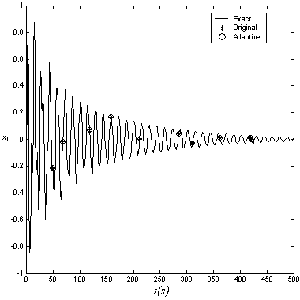
Figure 3. The displacement x₁ of the first mass in Example 1
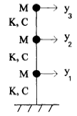
Figure 4. The 3-DOF system of Example 2

8. Conclusions
In summary, the Random Access Scheme (RAS) with a first order anterior error estimator and adaptive technique is proposed. A very fast dual binary search algorithm finds an optimal configuration of the parameters M and N according E(M,N) to and strikes a good balance between computing expense and precision.
It can be seen from the 2 numerical examples in Section 7 that, adaptive method produces results with errors distributed more averagely. The essence of adaptive technique is to allot more time resource for those more difficult accesses with larger c∙t, instead of distributing it evenly, for the sake of controllable precision and reliable results. The pursuit for more accurate and complicated error estimator E(M,N) and ξ should be further studied.

References
[1] W. Zhong, On precise time-integration method for structural dynamics, Journal of Dalian University of Technology, 34(2):131-136, 1994.
[2] W. Zhong and F.W. Williams, A precise time step integration method, Journal of Mechanical Engineering Science, 208:427-430, 1994.
[3] J. Lin, W. Shen and F.W. Williams, A high precise direct integration scheme for structures subjected to transient dynamic loading, Computers & Structures, 56(2):113-120,1995.
[4] X. Kong, Precise time integration algorithms of ordinary differential equations and application in multibody system dynamics, Ph.D. dissertation, Dalian University of Technology, Dalian, China, 1998.
[5] T.C. Fung, A precise time-step integration method by step-response and impulsive response matrices for dynamic problems, International Journal for Numerical Methods in Engineering, 40:4501-4527, 1997.
[6] Y. Gu, B. Chen, H. Zhang and Z. Guan, Precise time-integration method with dimensional expanding for structural dynamic equations, AIAA Journal, 39(12):2394-2399, 2001.
[7] G. Zhou, Y. Wang, G. Jia and J. Chen, A homogenized high precise direct integration based on Taylor Serials, Journal of Shanghai Jiaotong University, 35(12):1916-1919, 2001.
[8] Y. Huang, S. Zhang and Y. Qian, A new precise integration method with Legendre approximation and dimensional expanding for structural dynamics, In proceedings of the International Conference on Computational Mechanics 2004:298-318, 2004.
[9] Y. Huang, On function approximation methods for the precise time integration, In proceedings of the 3rd International Congress of Chinese Mathematicians, Short Presentations in Section 8 Numerical Analysis, in Press, 2004.
[10] O.C. Zienkiewicz and T. Shiomi, Dynamic behaviour of saturated porous media: The generalized Biot formulation and its numerical solution, International Journal for Numerical and Analytical Methods in Geomechanics, 8:71-96, 1984.
[11] O.C. Zienkiewicz and Y. Xie, A simple error estimator and adaptive time stepping procedure for dynamic analysis, Earthquake Engineering and Structure Dynamics, 8:871-887, 1991.
[12] L. Zeng, N.E. Wiberg, X. Li and Y. Xie, A posteriori local error estimate and an adaptive time-stepping procedure for dynamic analysis, Earthquake Engineering and Structure Dynamics, 21:555-571,1992.
[13] N.E. Wiberg and X. Li, A post-processing technique and an a posteriori error estimate for the Newmark method in dynamic analysis, Earthquake Engineering and Structure Dynamics, 22:465-489, 1993.
[14] C.K. Choi and H.J. Chung, Error estimates and adaptive time stepping for various direct time integration methods, Computers & Structures, 60:923-944, 1996.
[15] C.B. Moler and C.F. Van Loan, Nineteen dubious ways to compute the exponential of a matrix, SIAM Review, 20:801-836, 1978.
[16] W. Zhong, On precise integration method, Journal of Computational and Applied Mathematics, 163:59-78, 2004.

