High speed visualization of Slug flow in
vertical and inclined tubes
Vargas, P., Matheus, D. and López de Ramos, A.
Departamento de Termodinámica y Fenómenos de Transferencia, Grupo de
Investigación de Fenómenos de Transporte (GID10)
Universidad Simón Bolívar
Caracas, Apartado Postal 89.000
Venezuela

Abstract: - The flow pattern that appears more frequently in vertical and inclined pipe is the Slug Flow. The pressure drop, liquid and gas hold-up can be correctly predicted only if the hydrodynamic parameters are known. In this work, the behavior of the main parameters of the Slug Flow were studied, such as hold-up and length of each constitutive Slug unit, liquid film thickness and ascendant velocity of the Taylor’s bubble as a function of phase flow rates and the degree of inclination of the piping. An ascendant concurrent flow of air and water was circulated through the piping made of Plexiglas of 8.3 m of length and 0.03175 m of internal diameter. The experimental data were recorded using a high speed digital video camera with a speed recording velocity of 4500 frames per second. The high speed camera was located at 4.76 m of high from the ground. The piping was inclined from 90 up to 70º with respect to the horizontal. The liquid flow rate was changed between 0.32 and 0.90 L/s. The gas flow rate was varied between 0.71 and 1.18 L/s. The hold-up was calculated measuring the geometrical areas of the gas bubbles inside the tube by means of the digital images captured by the visualization equipment. With respect to the behavior of the ascendant velocity of the Taylor’s bubble, it was observed that this variation is minimal for the vertical flow, reaching a maximum value for the 70° inclination. The volumetric fraction of gas by sectional area of the tube changed between 0.28 and 0.66, getting the maximum value for the vertical tube position where bubbles move up slower and the liquid hold-up is minimal (especially at the gas Slug region). These values were compared with those predicted by the Ghasan et al. model [1], presenting a deviation less than 20% in the interval of inclinations and flows studied.

Key-Words: Slug Flow, Hold-up, Taylor’s Bubble, Liquid film thickness, Slug length, Visualization.

1 Introduction
Simultaneous flow of gas and liquid is frequently found in nuclear, oil and chemical industries; particularly in tubing systems, heat exchange equipments and chemical reactors. Between the flow patterns found in vertical, horizontal and inclined pipes that appear for the wider range of gas and liquid rate flows is the Slug. Its appearance has an important influence in the operation of the process plants and, in the design and construction of the pipeline systems.
The principal characteristics of the slug flow pattern are the intermittence and its non-steady behavior. Each slug unit is formed for a liquid hold-up with dispersed bubbles and a gas slug composed by an elongated bubble (Taylor’s bubble) that occupies almost all the internal diameter of the tube and has several diameters of length [2].
To enhance the performance of pipeline systems that transport gas-liquid mixtures, several works have been done in the elaboration of models that predict the behavior of multiphase flow. Between the most important there are the models based upon the mechanistic equations. They predict the pressure drop by means of closure relationships to estimate the hydrodynamic parameters more important associated to each flow regime [3] (hold-up, ascendant velocity of the Taylor’s Bubble, liquid film thickness, gas slug frequency, and slug length).
Interesting experimental works made with vertical and/or slightly inclined from vertical are presented by Barnea [4]. He presented the flow patterns and transitions for an air-water system in a 2.5 cm and 5.1 cm inner diameter pipe of 10 m long, with all the inclinations angles from 0 to 90º. Ghassan et al. [1] proposed a mechanistic model that predicts the behavior of the slug flow for all the range of inclination angles. They compared their model with a data base of 1052 cases of The University of Tulsa (TU), and found that the equation proposed to compute liquid hold-up presented a better performance than any other existing correlation at that moment. Polonsky et al. [5] studied the liquid film thickness along the Taylor’s bubble and, they found that the liquid film thickness increases as the liquid surface velocity increases.
The length of the slug is another characteristic that needs to be studied. For vertical pipes the average liquid slug length is around 8-25 times the tube diameter [6]. Van Hout et al. [7] studied the liquid and gas slug lengths for different tube inclinations and axial positions inside the pipe and, found that those values widely varied, getting, the liquid slug, a maximum value at 90º. The Taylor’s bubble has an inverse tendency, since the longest bubbles were observed when the pipe was horizontally placed.
Another important parameter for the slug flow is the upward velocity of the Taylor’s bubble. Carew et al. [8] developed a semi-empirical correlation to describe the ascendant movement of Taylor’s bubble in all the range of pipe inclinations (from 0 to 90º), finding that its length presents a maximum value between 30º to 45º.
In the study of slug flow pattern, the visualization techniques represent a very important tool, since they allow obtaining a sequence of high quality images that can be used to register with high accuracy the behavior of the principal parameter of this flow regime.
In this work the slug flow behavior was analyzed, taking into account variations of the pipe inclination and gas and liquid flow rates.

2 Experimental Procedures
2.1 Description of the equipments
The experimental equipment consists of a bank of tubes in “U” shape of 8.3 cm of height. The bank is supported by a metallic structure that can be rotated from 0 to 90° (Fig. 1). The bank has three polyethylene tubes of 0.75, 1.25 and 1.75 in of internal diameter.
Water is supplied from a 700 L to a centrifugal pump of 1/3 HP. To measure the water flow, two parallel rotameters of 0.04-0.30 L/s and 5.06x10⁻⁴-1.53x10⁻² L/s are used. The air is provided by a compressor of 4.6 HP and measured with another rotameter of 0.021-0.667 L/s. Both flows were controlled using needle valves. After the flow measurement region, the air and water are mixed in a “T” type connector.

2.2 Visualization Section
To register the behavior and the experimental observations of the flow regimen studied, a high speed velocity camera was used (up to 4500 fps at complete frame). This camera was connected to a controller where the images were storage while they were transmitted to a computer, monitor and/or VHS.

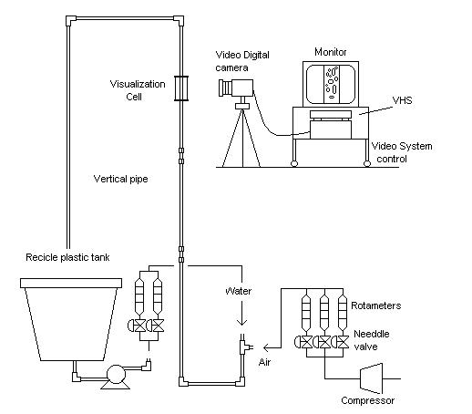
Figure 1. Experimental set-up.

In order to enhance the quality of the images, a visualization cell is positioned outside the tube (at 4.76 m of height). This cell is filled up with glycerol to match the refraction index of the Plexiglas and reduce the curvature effect of the external pipe wall.

2.3 Experimental conditions
The experiments were done in the 1.25 in tube; using an air-water system. Three flow rates were selected and showed on Table 1 (Flow 1, 2 and 3).

Table 1 Gas and Liquid flow rates used in this work
Flow | Q_{L} (L/s) | Q_{G}(L/s)
1 | 0.32 | 0.71
2 | 0.90 | 0.50
3 | 0.90 | 1.18

To determine the influence of the angle of inclination in the behavior of the slug flow regime, air and water was circulated trough the piping at different inclinations: 70, 75, 80, 85, and 90º. Each experiment was repeated, at least, three times, such as 45 visualizations were made (15 for each flow and 9 for each angle).
For each test, a digital register was performed for a complete slug unit (since the frame that shows the first Taylor’s bubble up to the next bubble). From the image sequence experimentally obtained, the liquid film thickness and the gas hold-up were estimated in the gas slug. The upward velocity of the Taylor’s bubble and the slug length were calculated using the procedure proposed by Gayon et al. [9].

3 Experimental Results
According to the combination of each of the variables in the system, the behavior of the flow regime, in terms of its most important parameters (frequency, length, upward velocity, width of the liquid film and hold up), can be completely different. This section shows the behavior of such parameters according to variations in flows of both phases and the angle of inclination of the pipe.

3.1 Taylor’s Bubble upward velocity
The upward velocity of the bubble can be studied as the contribution of two components clearly differentiated: superficial velocity of the mixture (V_{M}), and the upward velocity of bubble over the stationary liquid (V_{D}).

$V_{\text{TB}}={\text{CV}}_{M}+V_{D}$ (1)

The superficial velocity of the mixture (V_{M}), is subordinated to the flows of both phases and the value of the C coefficient, defined by Nicklin et al. [10]. It is related to the capacity that the mixture (gas-liquid) has to drag the bubble in upward direction.
In these experiments, it was verified that exists a linear relationship between the surface velocity of the mixture and the ascendant velocity of the Taylor’s Bubble. An average value of C=1.21 was obtained. This value is very similar to that reported by Nicklin et al. [10] of 1.2 (maximum deviation observed were approximately 8%).
In regard to the experiments where the effect of the inclination angle over the upward velocity is studied, all tests show the same trend: increase of upward velocity as inclination angle decreases (Fig. 2). Under these conditions, the influence of the other component of the upward velocity is studied, owed to the flotation force acting over the Taylor’s Bubble, given a constant superficial blend velocity. These results are similar to those obtained by Callie et al. [11]. The results are additionally compared to those predicted by the model of Hasan and Kabir [12], for the three flow rates in the inclination range evaluated.
The values forecasted by the model reproduce the same trend shown by the experimental data, in terms of an increase of the upward velocity with reductions in inclination versus horizontal line. The maximum deviation obtained was 9%, related to the range between 70-75º, as the model predicts more accurate results close to vertical flow.

Figure 2. Comparison of the Taylor’s Bubble upward velocity estimated by Hasan and Kabir’s model [12] with the experimental results.

3.2 Taylor’s Bubble length
In order to ensure a fully developed flow, the measurements were made at a height of 150D, to comply with the conditions established by Liu [13], who proposed lengths between 60 and 100D to get the stabilization of the flow.
Studying the average length of the Taylor’s bubbles for three flow and five inclination angles, it can be observed the shortest lengths are obtained for Flow 2, compounded by the largest liquid flow and the lowest gas flow. This can be attributed to the strong turbulence created by the great quantity of liquid, which generates a continuum break up of the bubbles, and does not allow their coalescence, making difficult the formation of large gas slugs. The biggest bubbles were found in Flow 1, (formed by a low flow of gas and liquid), in such a way that, even though the gas flow rate was almost half the level corresponding to Flow 3, the fact of having scarce amount of liquid (less turbulence) favored the formation of larger bubbles.
With regard to the inclination angle, a similar trend can be observed for Flow 2 and 3. Both show a minimum value for 80º and the length for 70º is larger than for 90º. The dispersion of values for Flow 1 is attributed to the instability of the slug flow working with those blend flow rates. Furthermore, the van Hout et al. work [7], reports a behavior similar to the one reported in this study, in terms of the dependence of the Taylor’s bubble length to the blend flow rates. Higher relation of gas to liquid rates develops larger bubble.

3.3 Hold-up in the Slug unit
The volumetric fraction of gas or liquid in the whole Slug unit is the result of the contribution of the two parts which constitute this unit, the liquid Slug and the gas Slug or Taylor’s Bubble. For a sound interpretation of the changes that take place at the Slug unit, it is important to understand the separate behavior of each of the parts, as they do not necessarily present the same trend for different flow rates and inclination angles. Following a separate analysis is presented for each part constitutive of the Slug unit.
3.3.1 Hold-up and width of the liquid film in the Taylor’s Bubble
Evaluating the tail of the gas Slug zone, it can be observed that the width of the film that surrounds the big bubble becomes thinner along it, in other terms, the volumetric gas fraction increases in the zones farther from the head of the bubble (Fig. 3). In general, the longest bubbles have higher gas hold up than the shorter bubbles, because they have a more extended zone in which the liquid film is very thin.

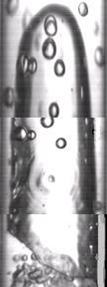
Figure 3. Taylor’s Bubble

The behavior of the liquid film widths along the Taylor’s Bubble is shown in figure 4 for vertical pipes. It can be observed that bubbles that develop under same flow rate conditions show a similar profile along it, and the difference in the gas fractions in the Slug section are exclusively determined by the difference in lengths of the gas plugs.

Figure 4. Width of the liquid film along the Taylor’s Bubble for bubbles of different lengths (Flow 2 at 90º).

When bubbles appear at different gas and liquid flow rates, the profile of the liquid film width shows a different behavior (Fig. 5). If the gas flow is low, thinner bubbles appear, and the liquid film width decreases more slowly, which translates into lower hold-up values. Figure 5 shows two effects that determine the difference in hold-up: liquid film width profiles and Taylor’s Bubbles lengths.

Figure 5. Profile of the liquid film width along the Taylor’s Bubble, for bubbles developed at different flow rates, for 90° pipes.

The results obtained for gas hold up in Taylor’s Bubbles are shown in figure 6. The highest values were registered for flows 1 and 3, which correspond to the lowest liquid flow rate - moderate gas flow rate and high gas and liquid flow rates. The lowest values were registered for Flow 2, where there is high liquid flow rate and low gas flow rate. Furthermore, it can be observed for all tests maximum H_{GTB} values for vertical flow, which decrease slightly when the inclination angle diminishes.

Figure 6. Experimental H_{GTB} values.

Figure 7 shows the evolution of the shape of the Taylor’s Bubble for different inclination angles. As the inclination diminishes, the profile of the liquid film suffers an important variation, because it ceases to be uniform in the axial direction of the pipe, developing different behavior both sides of the pipe, as the bubble always occupies the upper part of the pipe. This is more evident when the flow is close to horizontal. The liquid film which appears in the side farthest from the horizontal line is several times thicker than the film in the opposite side.
Figure 8 shows the variation in the profiles of the liquid film for different pipe deviations, for a same combination of gas and liquid flow rates. The difference in film thickness in both sides of the inclination becomes more notorious with increases in the deviation from the horizontal line. It can be observed the film thickness in one side is around three times bigger than the other by 85º angle in the tail region of the Taylor’s Bubble and seven times for a 70º angle.

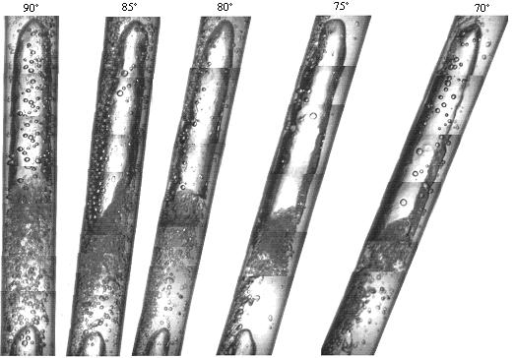
Figure 7. Evolution of the Taylor’s Bubble body for different inclination angles (Flow 2).

Figure 8. Profile of the liquid film in both sides of the inclined pipe, for 85 y 70º angles (Flow 2).

The reduction of H_{GTB} as the inclination diminishes respect to the horizontal line is due to the fact the film thickness is in average bigger than the value reported for vertical flow, even though this can be smaller in some zones. The thickness of the liquid film is much higher in the side where the inclination takes place, compared with the opposite side, as the Taylor’s Bubble gets into the upper part of the pipe.
When the inclination against the horizontal line diminishes, the forces that act over the liquid film experiment a variation, mainly the component related to weight, which diminishes in the 90 to 70º range, decreasing the velocity of descend of the liquid, which causes less withdraw of liquid from the gas Slug. This retention produces as a consequence thicker liquid films compared to vertical flow equivalents, which mean lower H_{GTB}.
The experimental results obtained were compared to the results forecasted by the Ghassan et al. model [1] for all the inclination range studied. Following a graphic comparison is made, for Flow 1 (Fig. 9).

Figure 9. Comparison of experimental H_{GTB} values to forecasted by Ghassan et al. model [1] (Flow 1).

For the Flow 1 case, the model presents a maximum deviation of 10%, corresponding to the vertical flow case. The predictive capacity of the model improves when inclination of the pipe augments. In general the average deviation percentage for all the range of inclinations studied is 6% for the Flow 1, and for the other flows (2 and 3), the model has average deviations of 18% and 3% respectively.

3.3.2 Hold-up in the liquid Slug
Each Taylor’s Bubble is followed by a liquid Slug, which presents characteristics very similar to the pattern of bubble flow. The liquid Slug flow that is located right behind the tail of the Taylor’s Bubble presents great turbulence, mainly due to the net entrance of liquid from the descent liquid film. This great turbulence prevents the bubbles from coalesce to form bubbles of bigger size. After this zone, the density of the bubbles starts to diminish in a progressive way up to the zone nearby the head of the gas plug that comes next.
The difference of the gas hold up along the liquid Slug is substantial. Values around 50-80% are found in the bubble zone associated to the Taylor’s Bubbles, up to values between 5 and 20% in the rear part of the zone (Fig. 10), the difference depends mainly of the flow rates, as the high gas flow rates are related to higher local gas hold up values, as well as the liquid flow rate.

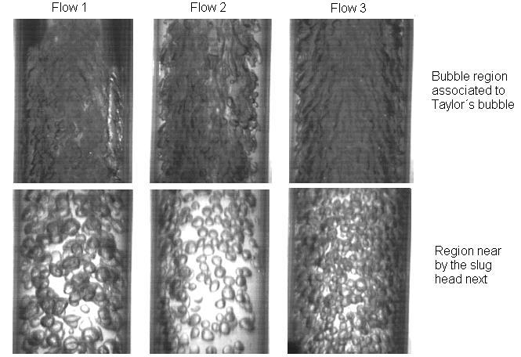
Figure 10. Liquid Slug zones for different gas and liquid flow rates.

The images show how the amount of bubbles present in the liquid Slug greatly varies with the flow rate of the involved phases. The tests related to Flow 3 (the highest amount of gas), present the highest density of bubbles in the bubble zone associated to the Taylor’s Bubble and in the zone close to the head of the following gas Slug. As the inclination increases, the gas present in the liquid Slug diminishes, as can be observed in Figure 11. As a consequence, the gas hold up in the zone decreases.

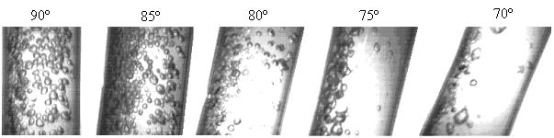
Figure 11. Variation of bubbles in the liquid Slug for the inclination angles studied (Flow 2).

The hold-up of the whole Slug unit is the result of the contribution of two zones with different proportions of gas and liquid. Values of 20 – 50% are found in the liquid Slug and between 40 to 90% are found in the zone of the Taylor’s Bubble, meaning that the values for the whole unit fit into these two limits. The form in which this contribution is provided depends on the contribution of each section of the Slug to its complete length; this is the α, the distribution factor, which defines the relation between the Taylor’s Bubble length and the Slug’s total length. The higher the α values are, the higher the H_{GT} will be, because the contribution of the Taylor’s Bubble will have more weight over the hold up of the complete Slug unit.
Figure 12 show the results of the gas hold up for the tests performed. Even though the sections of the Slug show a trend to shrink as the deviation increases, this result is not clear for the case of the complete Slug unit, due to the high dispersion of the lengths of each unit and α values. Nevertheless, the dependence of H_{GT} to the flow rates is clearly defined, the proof of the biggest gas hold up is Flow 1, where there is a low liquid flow rate and a moderate gas flow rate; the lowest value is registered for the case represented by Flow 2, where there is a high liquid flow rate and a low gas flow rate.

Figure 12. H_{GT} experimentally obtained for all the pipe inclinations studied.

With regard to the values forecasted by the Ghassan et al. model [1], in the inclination range studied, the model presents an average deviation of 15%. The discrepancy between these values can be explained by the fact the α  experimental values obtained are higher than the values predicted by the model in the studied range, causing the gas hold up estimated by the model to be smaller than the experimental data.

4 Conclusions
The analysis made by the visualization technique allowed to study in detail the evolution of the liquid film thickness along the Taylor’s bubble for all the combination of rate flows and tubing inclinations selected in this work.
The gas hold-up in the Taylor’s bubble reached the maximum values at 90˚ and diminished with the decreasing of the inclination of the pipe system.
The ascendant velocity of Taylor’s bubble kept a lineal relationship with the surface velocity of the mixture and increased with the inclination of the pipe between 90 to 70˚
The length of the Taylor’s bubble is strongly dependant of the flow rate of gas and liquid, reaching a minimal value at the maximum ratio of Q_{L}/Q_{G}.
In this work the predictable capacity of the mechanistic model of Ghassan et al. [1] was verified.

References
[1] Ghassan H., Abdul-Majeed G. and Ali M. Al Mashat, “A mechanistic model for vertical and inclined two-phase Slug Flow”, Journal of Petroleum Science Engineering, Vol. 27, 2000, pp. 59-67.
[2] Weber M., Alaire A. and Ryan, M. “Velocities of extended bubbles in inclined tubes”. Chemical Engineering Science, Vol. 41, 1986, pp. 2235-2240.
[3] Gómez L., O. Shoham and Y. Taitel. “Prediction Of Slug Liquid Holdup: Horizontal To Upward Vertical Flow”. International Journal of Multiphase Flow, Vol. 26, 1999.
[4] Barnea D., “A unified model for predicting flow pattern transition for the whole range of pipe inclinations”, International Journal of Multiphase Flow, Vol. 1, 1987, pp. 1-12.
[5] Polonsky S., Barnea D. and Shemer L., “Averaged and time-dependent characteristics of the motion of an elongated bubble in a vertical pipe”, Vol. 25, 1999, pp. 795-812.
[6] Moissis R. and Grifith P., “Entrance effects in a two phase Slug Flow”, Journal of Heat Transfer, Vol. 84, 1962, pp.29-39.
[7] van Hout R., Shemer L. and Barnea D., “Evolution of hydrodynamics and statistical parameters of gas-liquid Slug Flow along inclined pipes”, Chemical Engineering Science, Vol. 58, 2003, pp. 115-133.
[8] Carew P., Thomas N. y Johnson A. “A physically based correlation for the effects of power law rheology and inclination on slug bubble rise velocity”. International Journal of Multiphase Flow, Vol. 21, 1995, pp. 1091-1106.
[9] Gayon J. Gonzalez A. and Vargas P., “Uso de imágenes de video digitales para estimar el hold-up de liquido en tuberías verticales y reconocer los patrones de flujo”, Miniproyecto, Universidad Simón Bolívar (2003).
[10] Nicklin D., Wilkes D. and Davidson J., “Two Phase Flow in vertical tubes”, Trans. Instn Chem., Vol. 40, 1962, pp. 61-68.
[11] Callie E. Shosho and Michael E. Ryan. “An experimental study of the motion of long bubbles in inclined tubes”, Chemical Engineering Science, Vol. 56, No. 6, 2000, pp. 2191-2204.
[12] Hasan A. and Kabir C., “Two Phase Flow in vertical and inclined annuli”, International Journal of Multiphase Flow, Vol. 18, 1992, pp. 279-293.
[13] Liu TJ. “Bubble size and entrance length effects on void development in a vertical channel”, International Journal of Multiphase Flow, Vol. 19, 1993, pp. 99-113.

Acknowledgments
The authors want to thanks Rafael Alvarez and Juan Carlos Vargas for their help with the experimental set up. The financial support was provided by Decanato de Investigaciones y Desarrollo of Universidad Simon Bolivar.

Nomenclature
BT Related to Taylor’s bubble
C Constant of Eq. 1 defined by Nicklin et al., 1962, (V_{max}/V_{m}) [-]
D Tube diameter [cm]
g Gravitational constant [9.81 cm/s²]
H_{GLS} Gas hold-up in the liquid slug [-]
H_{GT} Gas hold-up in the complete slug unit [-]
H_{GTB} Gas hold-up in the Taylor’s bubble [-]
H_{LLS} Liquid hold-up in the liquid slug [-]
H_{LTB} Liquid hold-up in the Taylor’s bubble [-]
H_{LT} Liquid hold-up in the slug unit [-]
L_{TB} Taylor’s bubble length [cm]
L_{S} Liquid slug length [cm]
L Complete slug unit length [cm]
R Tube radius [cm]
V_{TB} Translational velocity of Taylor’s bubble [cm/s]
V_{D} Ascendant velocity of Taylor’s bubble through the stagnant liquid [cm/s]
V_{M} Surface velocity of the gas-liquid mixture [cm/s]
α Ratio between Taylor’s bubble length and complete unit of slug length [-]
δ Liquid film thickness [cm]
φ Inclination angle of pipe from the horizontal [º]

