The Numerical Applications of
the Axisymmetric Generalized Hydrodynamic Equations

JAE WAN AHN, OH-HYUN RHO
School of Aerospace and Mechanical Engineering
Seoul National University
Shillim-dong, Kwanak-gu, Seoul
KOREA
http://mana.snu.ac.kr

INSUN KIM
Thermal & Aerodynamics Dept.
Korea Aerospace Research Institute
45 Eoeun-dong, Youseong-gu, Daejeon
KOREA
http://www.kari.re.kr

Abstract: The 3-dimensional axisymmetric flow solver based on Eu’s generalized hydrodynamic equations has been developed and applied to the rarefied Rothe nozzle flow. The generalized hydrodynamic equations showed the results which agreed well with the Rothe’s experimental data while the Navier-Stokes equations failed to produce accurate solutions. The generalized hydrodynamic computation shows the existence of the backflow physically expected. The rarefied two phase flow containing solid particle cloud has also been solved using the Navier-Stokes and the generalized hydrodynamic equations, respectively. The difference on the particle distribution and behavior between the two equations has been observed.

Key-Words: generalized hydrodynamic equations, rarefied flow, low density flow, Rothe nozzle, gas-particle flow

1 Introduction

The rarefied flow can be characterized by the very low density. This kind of gas flows can be categorized by the value of Knudsen number which is defined as the ratio of the molecular mean free path and the characteristic length. As the flow Knudsen number increases, the flow becomes more and more rarefied and the flow solvers based on the continuum gas assumption can’t produce accurate results. The typical continuum Navier-Stokes(NS) equations cannot be satisfactory in the rarefied flow calculations, too. In order to overcome this disadvantage of NS equations, Direct Simulation Mont Carlo(DSMC)[1], the Burnett equations, and the Maxwell-Grad moment method were developed. However, these methods also contain some difficulties or disadvantages: the DSMC is not efficient in low Knudsen-number flow cases. The Burnett equation and the Maxwell-Grad method violate the second law of thermodynamics from time to time[2].
Eu has developed generalized hydrodynamic(GH) equations since 1980’s to establish an accurate and efficient rarefied flow solver. He derived the higher order evolution equation set of the flow stress and the heat flux by defining the non-equilibrium distribution function. He developed the dissipation mechanism of the molecular collisions under the restriction of the second law of thermodynamics. On the base of his GH equations, the 1-dimensional and 2-dimensional numerical codes of GH equations were developed by Myong[3]. And the 3-dimensional axisymmetirc GH solver was developed in Seoul National University. In the present paper, the axisymmetric GH code is applied to the Rothe nozzle problem and the gas-particle two phase flow problem for the observation of its performance.

2 Generalized Hydrodynamic Equations

2.1 Derivation of GH Equations

From the Boltzmann equation, the general evolution equation set can be derived. The evolution equation set includes dissipation terms and a non-equilibrium distribution function. The dissipation terms are very important in the view of the second law of thermodynamics because it explains the entropy production caused by the molecular collisions. The dissipation terms are defined by the non-equilibrium distribution function. The distribution function is the key of constructing the more accurate rarefied flow solver[2,5]. Eu defined a new function by multiplying non-equilibrium factor to the Maxwell-Boltzmann distribution function. The non-equilibrium function is

$f=\text{exp}[−β(H+H^{(1)}−μ)]$, (1)

where

$H=\frac{1}{2}{\text{mc}}^{2}$, (2)
$H^{(1)}=\sum_{α≥1}{X^{(α)}⊗h^{(α)}}$. (3)

Without the non-equilibrium term$H^{(1)}$, the non-equilibrium distribution function, Eq. (1) is reduced to the Maxwell-Boltzmann distribution function. The symbol $⊗$ represents the scalar product of tensors $X^{(α)}$ and $h^{(α)}$ of various ranks, and the $μ$ is the normalization factor and can be defined

$\text{exp}(−\text{βμ})=\frac{1}{n}\left\langle \text{exp}[β(H+H^{(1)})]\right\rangle$, (4)

where

$β=\frac{1}{k_{B}T}$. (5)

The $k_{B}$ is the Boltzmann constant. The angular bracket < > represents the integration over $v$ space.

$\left\langle \right\rangle =\int{⋯dv}$. (6)

The $h^{(α)}$’s in Eq. (1) are

$\begin{aligned}h^{(1)}=[\text{mcc}]^{(2)}, \\ h^{(2)}=\frac{1}{3}{\text{mc}}^{2}−\frac{p}{n}, \\ h^{(3)}=\left(\frac{1}{2}{\text{mc}}^{2}−\hat{h}m\right)c, \\ h^{(4)}=\text{mc}\text{.}\end{aligned}$ (7)
The $h^{(α)}$’s are used to get the stress tensor, excess stress, heat flux, and diffusion flux respectively[2].
If the non-equilibrium equation, Eq. (1), is inserted into the general evolution equation set, the generalized hydrodynamic equations can be acquired[3],

$\frac{∂}{∂t}ρ=−∇⋅ρu$, (8)
$ρ\frac{d}{\text{dt}}u=−∇⋅P$, (9)
$ρ\frac{d}{\text{dt}}E=−∇⋅Q−\text{P:}∇u$, (10)
$\begin{aligned}ρ\frac{d}{\text{dt}}\left(\frac{Π}{ρ}\right)=2[Π⋅∇u]^{(2)} \\ −\frac{p}{η}\left\{Πq(κ)+2η[∇u]^{(2)}\right\}\end{aligned}$, (11)
$\begin{aligned}ρ\frac{d}{\text{dt}}\left(\frac{Q}{ρ}\right)=−Π⋅C_{p}∇T+∇⋅(pI+Π)⋅\frac{Π}{ρ} \\ −Q⋅∇u−\frac{{\text{pC}}_{p}T}{λ}\left\{\text{Qq}(κ)+λ∇\text{ln}T\right\}\end{aligned}$, (12)

where

$q(κ)=\frac{\text{sinh}(κ)}{κ}$, (13)

and

$κ=\frac{({\text{mk}}_{B})^{1/4}}{\sqrt{2}d}\frac{T^{1/4}}{p}{\left[\frac{Π:Π}{2η}+\frac{Q⋅Q}{λ}\right]}^{1/2}$. (14)

Here $d/\text{dt}$ represents the substantial derivative and the $C_{p}$ is the specific heat at constant pressure. The symbol $[∇u]^{(2)}$ stands for the traceless symmetric part of $∇u$and its k, l components can be expressed in tensor notation

$[∇u]^{(2)}=\frac{1}{2}\left(\frac{∂u_{k}}{∂x_{l}}+\frac{∂u_{l}}{∂x_{k}}\right)−\frac{1}{3}δ_{\text{kl}}\frac{∂u_{i}}{∂x_{i}}$, (15)

where $δ_{\text{kl}}$ denotes the unit second-rank tensor. The term $[Π⋅∇u]^{(2)}$ represents the coupling between the shear stress and velocity gradient and its k, l components are

$\begin{aligned}[Π⋅∇u]^{(2)}=\frac{1}{2}\left(Π_{\text{ik}}\frac{∂u_{l}}{∂x_{i}}+Π_{\text{il}}\frac{∂u_{k}}{∂x_{i}}\right) \\ −\frac{1}{3}δ_{\text{kl}}Π_{\text{ij}}\frac{∂u_{i}}{∂x_{j}}\text{.}\end{aligned}$ (16)

The $η$ and $λ$ are the Chapman-Enskog viscosity and thermal conductivity, respectively.
The Eq. (8)-(10) are the conservation equations of mass, momentum, and energy respectively, and they are equal to those of NS equations. The Eq. (11) and (12) are the constitutive relations of GH equations, which are derived from the general evolution equations and the Eu’s non-equilibrium distribution functions. The entropy production of GH equations can be written by the dissipation factor $q(κ)$, Eq. (13).

$σ_{\text{ent}}=κ\text{sinh}(κ)$. (17)

This entropy production is the nonlinear function of the shear stress tensor and the heat flux vector. It should be noted that the entropy production is always positive so that GH equations can satisfy the second law of thermodynamics[2,3].

2.2 The Axisymmetric GH Code

The 1-dimensional and 2-dimensional GH solvers were developed by Myong[3]. By analyzing the normal shock thickness problem, he validated the 1-dimensional solver. The supersonic flat plate problem was used to validate the 2-dimensional GH solver. In his papers, the GH numerical model was simplified. Myong has separated the tangential direction flow solver and the normal direction flow solver. This means that the numerical solver requires only the stresses $Π_{\text{xx}}$, $Π_{\text{xy}}$ and the heat flux $Q_{x}$. However, the axisymmetric GH solver should be fully solved since it contains some moments such as $Π_{\text{θθ}}$, which are absent in 1 or 2-dimensional solver[4]. Thus, the constitutive relations were fully solved by Powell’s hybrid method in MINPACK[6].

2.3 Wall Boundary Conditions

In rarefied gas flows, the velocity slip and the temperature jump are observed on the solid surface. So the numerical solver must include an adequate slip model. Maxwell-Smoluchowski boundary conditions are used in general. However, as is noted by Beskok, the Maxwell-Smoluchowski boundary conditions show numerical instabilities exhibiting a sudden change of sign of a vorticity at wall. Therefore, in the present paper, Langmuir’s boundary condition was used[8].

$u_{s}={αu}_{w}+(1−α)u_{r}$, (18)
$T_{s}={αT}_{w}+(1−α)T_{r}$, (19)

where

$α=\frac{βp}{1+βp}$, (20)
$β=\frac{\text{Al}}{k_{B}T_{w}}\text{exp}\left(\frac{D_{e}}{k_{B}T_{w}}\right)$. (21)

In Eq. (21), $A$ is the mean area of a site and $D_{e}$ is the potential parameter that can be obtained from experimental data. The $l$ represents the mean free path and the subscript $r$ denotes a reference value.

3 Gas-Particle Two Phase Flow

To simulate two phase flows containing solid particle cloud, two kinds of methods can be used. One is the trajectory(or Eulerian-Lagrangian) approach and the other is the two-fluid(or Eulerian-Eulerian) approach. In this paper, two-fluid numerical model was used. To establish the numerical model, some assumptions are required: (i) The particles are solid spheres with a uniform diameter. (ii) The volume of each particle is very small and can be neglected. (iii) The gas and particles do not undergo phase changes, so there is no mass coupling. (iv) For dilute particles there are no interactions between the particles. (v) The exchange between the two particles is the Stokes drag force for momentum transfer and convection for heat transfer[9].
Since the two-fluid model regards the particle cloud as the second fluid, the governing equations for the gas phase and the particle phase are similar. The only one difference is that there is no pressure for the particle phase. The momentum and energy exchanges between the gas and solid phases are represented by the source terms. The governing equation is

$\frac{∂Q}{∂t}+\frac{∂E}{∂x}+\frac{∂F}{∂y}=\frac{∂E_{v}}{∂x}+\frac{∂F_{v}}{∂y}+H+S$, (22)

where

$Q=(ρ, ρu, ρv, ρe, ρ_{p}, ρ_{p}u_{p}, ρ_{p}v_{p},ρ_{p}h_{p})^{T}$, (23)
$\begin{aligned}E=(ρu, {ρu}^{2}+p, ρ\text{uv}, (ρe+p)u, \\ ρ_{p}u_{p}, ρ_{p}u_{p}^{2}, ρ_{p}u_{p}v_{p}, ρ_{p}h_{p}u_{p})^{T},\end{aligned}$ (24)
$\begin{aligned}F=(ρu, ρ\text{uv}, {ρv}^{2}+p, (ρe+p)v, \\ ρ_{p}v_{p}, ρ_{p}u_{p}v_{p}, ρ_{p}v_{p}^{2}, ρ_{p}h_{p}v_{p})^{T},\end{aligned}$ (25)
$E_{v}=(<\text{NS} \text{Viscous} \text{Flux} E_{v,\text{NS}}>, 0, 0, 0, 0)^{T}$, (26)
$F_{v}=(<\text{NS} \text{Viscous} \text{Flux} F_{v,\text{NS}}>, 0, 0, 0, 0)^{T}$. (27)

The $H$ is the axisymmetric term, and the source term vector $S$ is defined

$S=(0, −S_{2}, −S_{3}, −S_{4}, 0, S_{2}, S_{3}, S_{4})^{T},$ (28)

where

$S_{2}=\frac{ρ_{p}f(u−u_{p})}{τ_{V}}$, (29)
$S_{3}=\frac{ρ_{p}f(v−v_{p})}{τ_{V}}$, (30)
$\begin{aligned}S_{4}=\frac{ρ_{p}f}{τ_{V}}\left[(u−u_{p})u_{p}+(v−v_{p})v_{p}\right] \\ +\frac{\text{Nu}}{2}\frac{ρ_{p}C_{s}}{τ_{T}}(T−T_{p})\end{aligned}$. (31)

The drag factor $f$ is the ratio of the modeled drag and the Stokes drag. The $τ_{V}$ and $τ_{T}$ are the momentum response time and the energy response time, respectively[9,10].

4 Numerical Results

4.1 Rarefied Rothe Nozzle Flow Results

The Reynolds number of the rarefied Rothe nozzle flow is 590. The reservoir temperature and pressure are 300K and 3.55torr, respectively. The Knudsen number is 00025. The radius of nozzle throat is 2.55mm and the area ratio is 66. The isentropic boundary condition is used for the inflow condition, and the outflow condition is supersonic condition or extrapolation.

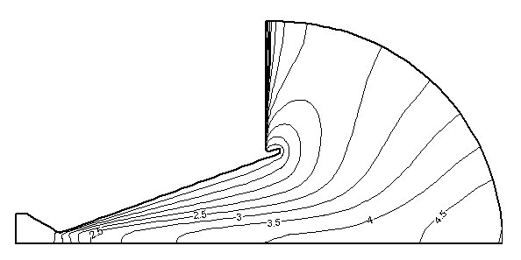
Fig. 1 Mach number contours (NS)

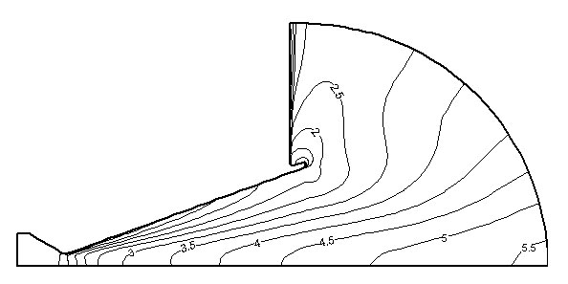
Fig. 2 Mach number contours (GH)

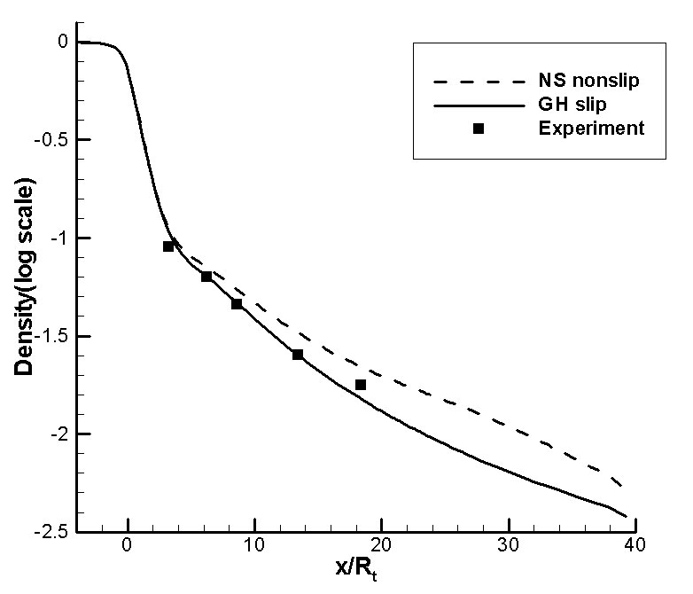
Fig. 3 density distributions along the nozzle centerline

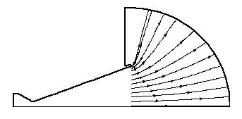
Fig. 4 selected plume streamlines (NS)

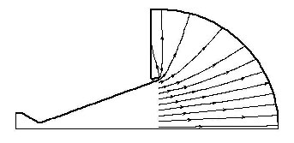
Fig. 5 selected plume streamlines (NS)

Fig. 1 and Fig. 2 show the Mach number contours calculated by the NS and GH solver, respectively. In the area out of the nozzle exit, the flow pressure and density are very low so that the flow should expand more rapidly. In Fig. 1, the Mach number of the GH result is much higher than that of the NS result.
To observe the accuracy of numerical results, the log-scaled density profiles are depicted in Fig. 3. Comparing with the experimental data by Rothe, it can be found that the GH result is much closer to the experimental data than the NS result[11].
In Fig. 4 and Fig. 5, the selected streamlines at the same positions are drawn in the plume region. Since the environment of the nozzle can be regarded as vacuum condition, there should be backflows. In the two figures, only the GH solver can predict backflows while the NS solver can’t. Thus it can be said the GH equations are more reasonable than NS equations in the physical sense.

4.2 Gas-Particle Two Phase Flow Results

The developed gas-particle two phase solver with GH constitutive relations was applied to the Rothe nozzle problem containing a solid particle cloud. The material density of particle phase is 100 times higher than that of gas phase. The particle diameter is 5μm.
Fig. 6 shows the log-scaled density contours of solid particle phase by the NS and GH solvers. In this figure, the particle-free-zone of the GH result is larger. This is because the gas phase can’t transport momentum as much as the continuum gas, in the rarefied gas case. Although the gas density is very low, NS equations transport a large amount of momentum from the gas phase to the solid particle phase.
In Fig. 7 and Fig. 8, the streamlines of solid particles by the NS and GH solvers are shown, respectively. Because the NS solver can’t predict the backflow, the particles in the Fig. 7 move along nearly straight paths. In the Fig. 8, it can be observed that the particles near the wall move along the backflow in the GH result. However, it should be noted that the most particles move through the symmetric axis area and only small amount of particles change their path direction due to the backflow.
Fig. 9 shows the Mach number distributions of the gas phase on the symmetric axis by the NS and GH solvers. The Mach number of the GH result is higher than that of the NS result. This is due to the small amount of momentum loss of the gas phase in the GH solver.
The temperature distributions of gas phase on the axisymmetirc axis calculated by the NS and GH solvers are depicted in Fig. 10. The temperature of the GH solution is lower. This may be caused by the small amount of the energy exchange between the two phases under the rarefied condition. Since the collisions between gas molecules and solid particles are not enough, the convectional heat transfer should be quite small.

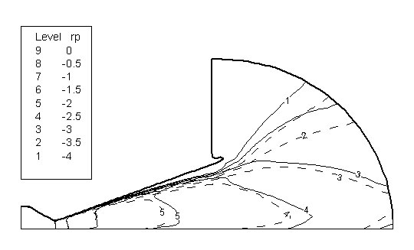
Fig. 6 the log-scaled density contours of solid the particle phase (solid line: NS, dashed line: GH)

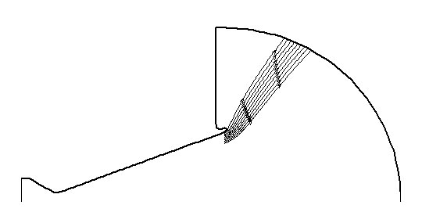
Fig. 7 the plume streamlines of the particle phase (NS)

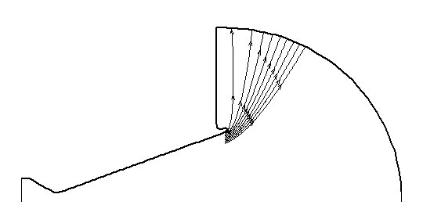
Fig. 8 the plume streamlines of the particle phase (NS)
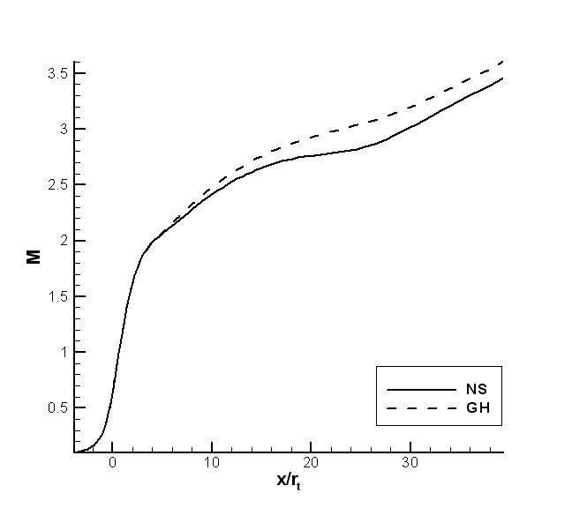
Fig. 9 the Mach number distributions
on the symmetric axis

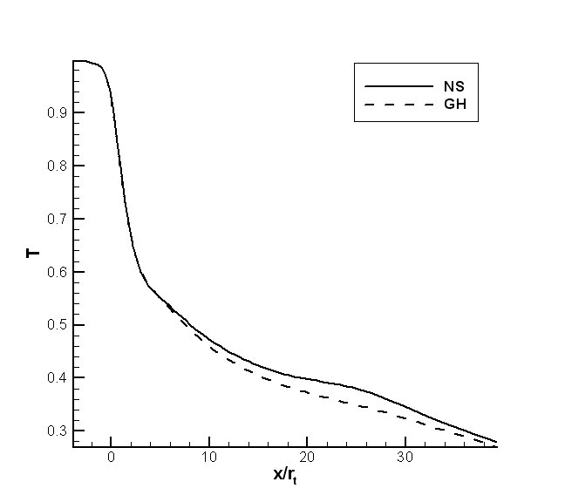
Fig. 10 the temperature distributions
on the symmetric axis

5 Conclusions

The axisymmetric GH solver based on the Eu’s generalized hydrodynamic theory was applied to the rarefied Rothe nozzle flow. The GH density results were closer to Rothe’s experimental data than the NS results. The behavior of the GH plume result showed the backflow while the NS result failed to show. Due to the nearly vacuum environment condition, the backflow must exist in the physical view point.
Additionally, the two phase flow including micro-sized solid particles was solved by the both equations. Although the flow density was very low, the NS solver couldn’t show the backflow and predicted that all solid particles move along straight paths. However, the GH result showed the existence of the backflow and also showed small amount of solid particles moved along the backflow. The behavior of the solid particles was very different from that of the NS result, that is, the particle free zone of the GH result was larger. Considering not enough collisions between two phases under the rarefied condition, it can be said that the GH equation solver is more physical and accurate than the NS solver.

6 Acknowledgement

This work has been partially supported by Korea Aerospace Research Institute and by the Academy of Science, Republic of Korea.

References:
[1] G.A.Bird, Molecular Gas Dynamics and the Direct Simulation of Gas Flows, Oxford Univ. Press, 1994
[2] B.C.Eu, Kinetic Theory and Irreversible Thermodynamics, John Wiley & Sons, Inc., 1992
[3] R.S.Myong, Thermodynamically Consistent Hydrodynamic Computational Models for High-Knudsen Number Gas Flows, Phys. Fluids, Vol.11, 1999, pp.2788-2802
[4] D.S.Chae, Numerical Investigation of Rarefied Nozzle Flows by Eu’s Generalized Hydrodynamic Equations, Ph.D. Thesis, Seoul National Univ., 2001
[5] T.I.Gombosi, Gaskinetic Theory, Cambridge Univ. Press, 1994
[6] http://www.netlib.org
[7] A.Beskok and G.E.Karniadakis, Simulation of Heat and Momentum Transfer in Complex Microgeometries, J. of Thermophysics and Heat Transfer, Vol.8, 1994, pp.647
[8] I.Langmuir, J. Am. Chem. Soc., Vol.40, 1918, pp.1361
[9] H.T.Chang, L.W.Hourng, and L.C.Chien, Application of Flux-Vector-Splitting Scheme to a Dilute Gas-Particle JPL Nozzle Flow, Int. J. for Numerical Methods in Fluids, Vol.22, 1996, pp.921-935
[10] C.T.Crowe, M.Sommerfeld, and Y.Tsuji, Multiphase Flows with Droplets and Particles, CRC Press, 1998
[11] D.Rothe, Electron Beam Studies of Viscous Flow in Supersonic Nozzle, AIAA Journal, Vol.9, 1972, pp.804

