"Earth coupled" heat pump with direct evaporation - thermodynamic analysis, heat transfer and some economical aspects

Slawomir Smolen
Department of Mechanical Engineering
Hochschule Bremen
Neustadswall 20, D 28 199 Bremen
Germany

Abstract: - The object of the analysis is a heat pump with soil as a low-grade energy source and a vertical heat exchanger in the ground. The existing testing installation that is an "earth coupled" heat pump with direct evaporation (meaning without a secondary working fluid between soil and evaporator), served as a basis for the technical investigation and for collecting preliminary data.
The principal aim of the presented article is the elaboration of mathematical models for heat transfer calculations in the ground and in the vertical heat exchanger of the heat pump. Additionally, a group of points concerning:
- the concept and installation of the "earth-coupled" heat pump with direct evaporation,
- the preliminary results of the system analysis and its efficiency,
- some aspects of economy (application in heating systems),
- the future outlook for the “earth-coupled” heat pump merit an analysis.

Key-Words: - Heat Pump, Direct Evaporation, Ground Energy, Heat Transfer.

- Introduction
One of the possibilities to use low temperature energy of the ground and hence indirectly the sun energy is heat transformation in an "earth-coupled" heat pump. The primary goal of the technical optimisation is the increase of the coefficient of performance (C.O.P.) whereas the potential measures to achieve this aim are the improvement of the internal efficiency of the energy transformation (for instance by means of direct evaporation) as well as intensifying the heat exchange in the ground (with the help of different geometric solutions for the ground heat exchangers). On the one hand the theoretical investigations prove the C.O.P. value of 4,5 for the introduced installation and propane as a refrigerant. On the other, this can be further confirmed by a collection of practical experiences derived from studies on similar systems.
Heat pumps are very important components of different energy supply systems, starting with the industrial energy supply system (e.g. "waste heat" use) and finishing with heating systems, especially those combined with the under floor heating. Good properties of soil such as a relatively constant temperature within a year (between 8° and 12°C), provide a source of low rate energy for heat pumps compression. The specific heat power of a vertical heat pipe in the ground per metre, fluctuates between 30 W/m (gravel, dry) and 60 - 70 W/m (sandstone, granite) [6,7]. The energy generated by low temperature and its transformation in a heat pump is suitable enough for heating systems, in particular floor heating or other solutions requiring a fairly low temperature level. The subject matter of the ensuing analysis are some aspects of energy transformation in "earth-coupled" heat pumps, where priority is given to the transfer of heat. Moreover, certain technical and economical aspects are taken into consideration.

2 The Concept and Installation of an "Earth Coupled" Heat Pump with Direct Evaporation
The concept and operational principle of the heat pump is shown in Fig.1. The system consists of the heat exchanger in the ground and a typical compression heat pump installation. Direct evaporation in the ground (isolated "fall-pipe" and evaporation in an "increasing-pipe" which is not detached) is a distinctive feature of the suggested solution.
The constructive details of the ground heat exchanger are not the concern of this paper and therefore can be found in other publications. The core of this article is the general mathematical model for the heat transfer in the ground and in the evaporator pipes.
The testing installation based on the schema in Fig.1 exists in the Laboratory for Energy Engineering at the Hochschule Bremen.
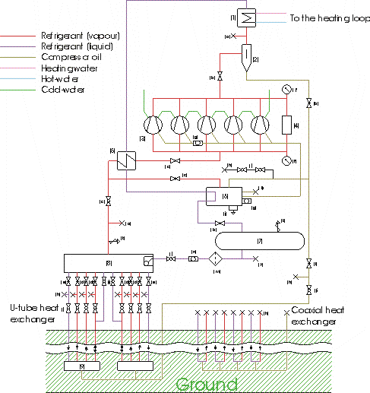

Fig.1 "Earth coupled" heat pump installation with direct evaporation and vertical heat exchanger in the ground
1 Condenser, 2 Oil separator, 3 Compressors, 4 Overpressure switch, 5 Recuperator, 6 Oil storage container, 7 High-pressure storage, 8 Refrigerant, 9 Oil storage pot of heat pipes,
a) Refrigerant filling pipe, b) Valves (3 pieces), c) Valves (3 pieces), d) Valves (3 pieces), e) Valves (2 pieces), f) Manometer, g) Oil level tube, h) Filling pipe, i) Shut-of valve, j) Outlet, k) Safety valve, l) Shut-of valve,
m) Filter dryer, n) Refrigerant level tube.

3 Heat Transfer in the Ground
The mathematical model for "quasi stationary" heat transfer in the ground was elaborated on and published in paper [9]. It based on the theory of "linear heat hollow" (Carslaw&Jaeger). The fundamental equation for the temperature field in the ground can be shown in the following form:
$DT\left(r,t\right)=\frac{1}{4ρcpa}\int_{0}^{t}{Q_{l}\left(t^{'}\right)}e^{−\frac{r^{2}}{4a\left(t−t^{'}\right)}}\frac{dt^{'}}{t−t^{'}}$ (1)
where:
r - ground material density,
c - specific heat of the ground,
a - temperature coefficient,
Q_{l} - linear heat performance (per metre),
t - time,
t’ - "active" time period (working period),
r - distance from the heat exchanger (pipe).
The final solution considers different boundary conditions and can by simplified to the equation (2):
$\begin{aligned}T\left(r,z,τ\right)=T_{0}−\frac{Q_{l}}{4ρcπa}\text{Ei}\left(−\frac{r^{2}}{4aτ}\right)+ \\ +{ΔT}_{z}\text{exp}\left(−\sqrt{\frac{ω}{2a}z}\right)\text{cos}\left(\text{ωτ}−\sqrt{\frac{ω}{2a}z}\right)\end{aligned}$ (2)
where:
z - co-ordinate (height),
T₀ - middle air temperature during the year,
ΔT_{z}- maximum temperature deviation from mean value,
w - angle-velocity of periodical temperature changing
during the year; (w = 2π [a⁻¹]).
Some calculation samples and their results were demonstrated in the afore-mentioned publication [9].

4 Heat Transfer in the Evaporator Pipe
The mathematical model for heat transfer in the ground heat exchanger pipe rests upon the co-axial geometry exemplified in fig.2. The "fall-pipe" is situated in the middle of the "increasing pipe" (two concentric pipes) while the boiling and evaporation processes take place in the ring-shaped space between the both walls of the pipe. There is no heat transfer to an isolated "fall pipe" theoretically thought of as ideal. This model can be extrapolated from alternative geometrical solutions of similar quality.
Fig.2 Geometrical base for the heat transfer calculation model
The basis for the calculations is energy balance:
(3)
where:
- rate of mass flow,
$h_{\text{fg}}$- phase change enthalpy,
x - dryness fraction,
q - rate of heat transfer per unit area,
D_{ext}- internal diameter of external pipe,
L - length.
Only after an analysis of various methods had been made was the mathematical model developed by A.F. Mills [3] chosen. As for the model itself, it corresponds to the problem proper and it gives the most realistic results. The convective heat transfer coefficient consists of two parts: “forced-convection coefficient” represented as and “two-phases coefficient” represented as $α_{\text{TP}}$ to be the latter.
$α={\left(α_{\text{TP}}^{3}+α_{\text{FC}}^{3}\right)}^{1/3}$ (4)
The "two-phases coefficient" can be calculated as:
(5)
and:
$D_{h}=\sqrt{\frac{σ}{g⋅\left(ρ_{l}−ρ_{v}\right)}}$ (6)
where:
$λ_{l}$ - conductivity of the liquid-phase,
$σ$ - surface tension of the fluid,
$ρ_{l}$ - density of the liquid-phase,
$ρ_{v}$ - density of the vapour-phase,
g = 9,81 m/s².
The Nusselt number calculation depends on the value of the parameter :
(7)
and:
$G=\frac{\overset{˙}{m}}{A}$ (8)
where:
A - area.
If > 1,6 * 10⁴ then:
$\text{Nu}=0,\text{087}⋅{\text{Re}}^{0,6}⋅{\text{Pr}}_{l}^{1,6}⋅{\left(\frac{ρ_{V}}{ρ_{l}}\right)}^{0,2}⋅{\left(\frac{λ_{\text{wall}}}{λ_{l}}\right)}^{0,\text{09}}$ (9)
where:
${\text{Pr}}_{l}$ - Prandtl number of the liquid-phase,
$λ_{l}$ - conductivity of the liquid-phase,
$λ_{\text{wall}}$- conductivity of the internal-wall,
Re - Reynolds number.
If < 1,6 * 10⁴ then is the Nusselt number to calculate as:
$\text{Nu}=7,4⋅{\text{10}}^{−3}⋅q^{−0,6}⋅p^{−0,5}⋅{\text{Pr}}_{l}^{−13}⋅{\left(\frac{λ_{\text{wall}}}{λ_{l}}\right)}^{0,\text{15}}$(10)
where:
(11)
$p^{}=\frac{p}{{\left(σ⋅g⋅\left(ρ_{l}−ρ_{v}\right)\right)}^{1/2}}$ (12)
The "forced convection coefficient" is calculated for one phase fluid (saturated liquid point).
To compare the outcomes, two possible correlations were selected – Dittus-Boelter’s (13) and Sieder-Tate’s (14).
(13)
valid for: $0,7≤\text{Pr}≤\text{160}$and $\text{Re}≤\text{10000}$and:
${\text{Nu}}_{\text{FC}}=0,\text{027}⋅{\text{Re}}_{D}^{4/5}⋅{\text{Pr}}^{1/3}⋅{\left(\frac{η}{η_{S}}\right)}^{0,\text{14}}$ (14)
valid for: $0,7≤\text{Pr}≤\text{16700}$and$\text{Re}≤\text{10000}$
($η$ is calculated for an average temperature of the fluid phase and $η_{S}$ for the temperature of a saturated point).
There is no likelihood that an analytical solution will be reached for the reason that the rate of heat transfer per unit area is unknown at the beginning. That is why the software "EES" (Engineering Equation Solver) was employed to deal with the problem numerically.

5 Exemplary Calculation Results
A group of selected calculation results having propane as a refrigerant has been shown in the form of different graphs to indicate an influence of the most significant parameter on the heat transfer process. The first graph (Fig.3) demonstrates the required pipe's length where internal pipe diameter is constant whereas the diameters of the external pipe are changing (internal diameter of external pipe). In the graph that follows the blue line demonstrates the results while taking into account the Dittus-Boelter correlation (13) in each case whilst the green line - Sieder-Tate correlation (14). The subsequent graph (Fig.4) illustrates the length of the pipe as a function for the mass flow rate in the realistic boundaries. The influence of the temperature difference between the ground and the saturation state temperature in the pipe is shown in the last graph (Fig.5). (T_{earth} and T_{fluid} in the Fig.2).
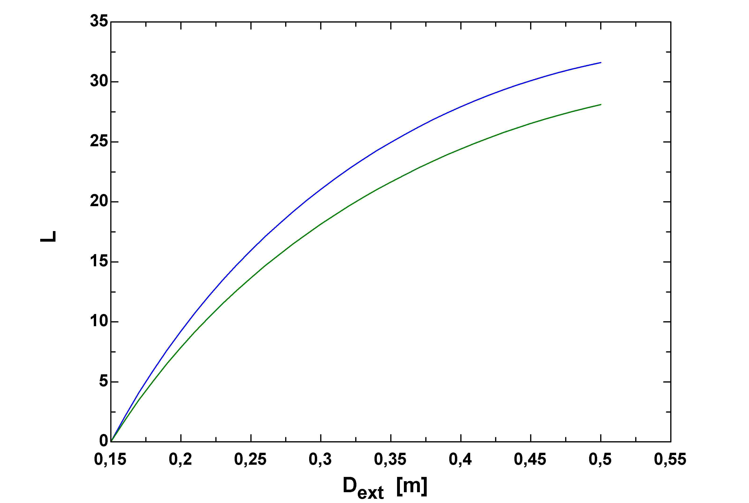
Fig.3 Required pipe length with constant diameter of internal pipe (external diameter of internal pipe 0,15m) and variable (internal) diameter of external pipe.
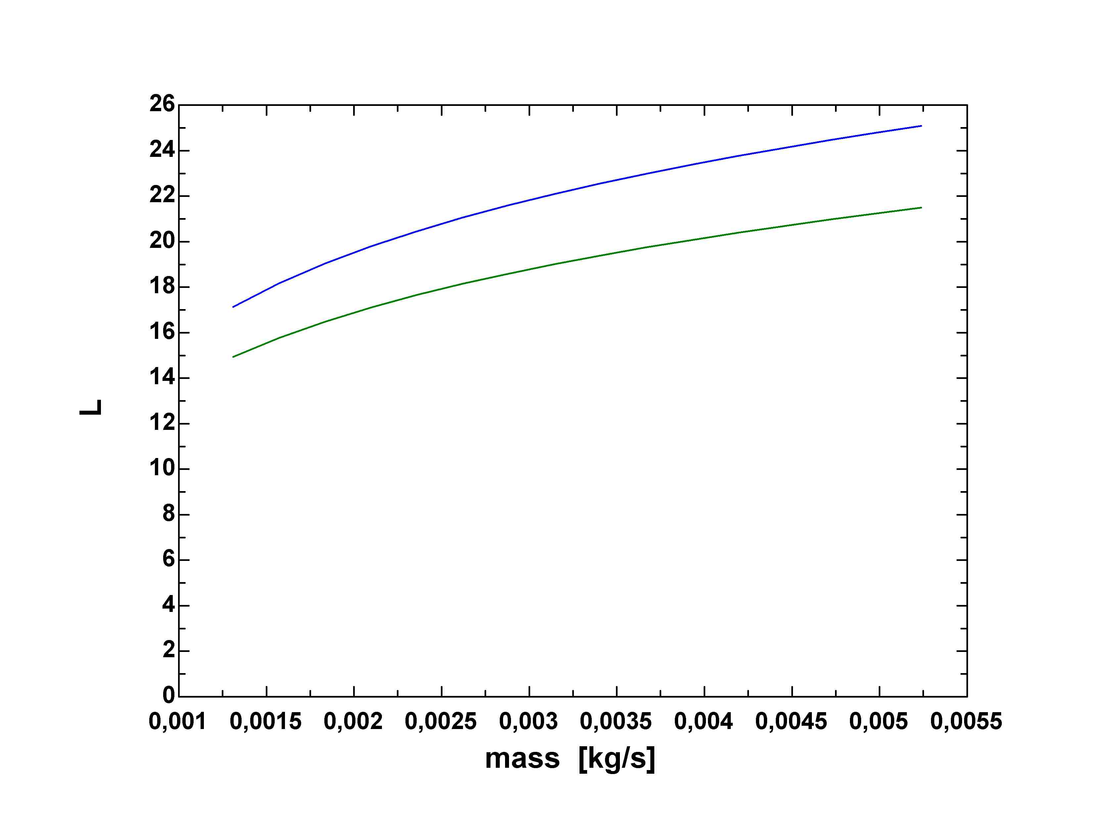
Fig.4 Pipe length as a function for mass flow rate
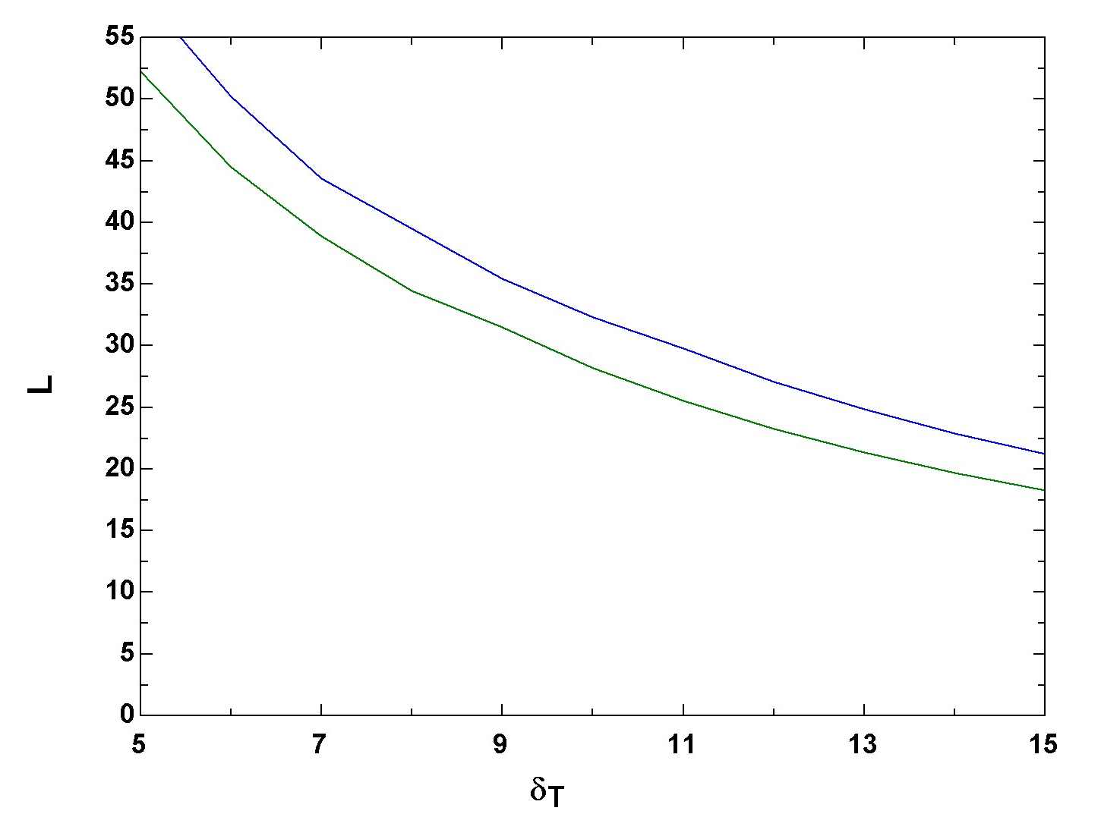
Fig.5 Pipe length with respect to changing temperature differences between the ground and the fluid (saturation state)

6 Some Aspects of Economy
The test installation described in the previous chapters was also analysed from the point of view of economy. Heating system of a detached house is where "earth coupled" heat pump is thought to be applied most probably but taking into account typical frame conditions (floor area, volume, specific heating requirements, calculations for heating power, heat energy consumption per year and others). The representative results of this examination will be the subject of presentation at the conference.

7 Conclusion
The ground as low temperature energy source possesses a collection of features that allow to use it in "earth coupled" heat pumps. This paper presents methods and representative results for heat transfer calculations in the ground, which is the most important point made by means of the thermodynamic analysis. The preliminary data result from the existing testing installation and the outcomes of the calculations correspond to the published reports of other theoretical and practical investigations in the field. The biggest concern that became evident during personal practical analyses as well as measurements are the hydraulic aspects, particularly the hydraulic calculations and regulation problems.
In addition, an aspect of economy in relation to possible "earth coupled" heat pump applications has been outlined hereby.

References:
[1] Baehr, Hans Dieter and Stephan, Karl: Heat and mass transfer, Springer Verlag, Berlin, 1998.
[2] Heinrich, G. and Najork, H. and Nestler, W., Wärmepumpenanwendung in Industrie, Landwirtschaft, Gesellschafts- und Wohnungsbau (Heat Pumps Applications in Industry, Agriculture, Social- and House Building), VEB-Verlag, Berlin, 1987.
[3] Mills, A.F.: Transferencia de calor (Heat transfer), IRWIN, Barcelona 1995.
[4] Paul, J. and Dick, H.G.:, Grundlagenuntersuchungen an Wärmepumpen (Basic Research of Heat Pumps), Part 1 and 2, Bundesministerium für Forschung und Technologie, Dezember 1980.
[5] Reuß, M. und Sanner, B.: www.ubeg.de/Downloads/Auslegung.pdf
[6] Sanner, B.: Erdgekoppelte Wärmepumpen, Karlsruhe, Fachinformationszentrum Karlsruhe XI, 1992.
[7] Sanner, B.: Potentiale und Möglichkeiten der Erdwärmenutzung, www.ubeg.de/Downloads/PotentialOberfl.pdf
[8] Sanner, B.: Wärmepumpen, http://www.ubeg.de/Downloads/WP.pdf
[9] Smolen S. and Szaflik W.: Analytisches Berechnungsverfahren zur Bestimmung der Temperaturverteilung im Boden für Wärmepumpen mit vertikalen Erdsonden (Analytic calculation method for temperature fields in the ground by heat pumps with vertical heat exchanger), Justus-Liebig-Universität Gießen, 3. Symposium: „Erdgekoppelte Wärmepumpen“, IZW-Bericht 2/97, Schloß Rauischholzhausen, 1997.
[10] Tong, L. S.: Boiling Heat Transfer and Two-Phase Flow, Wiley, New York, 1965.
[11] Warnecke H.J. (u.a.), Wirtschaftlichkeitsrechnung für Ingenieure (Economical Calculations for Engineers), Hanser Verlag, München, 1996.

