CFD Studies in the Design of Air Cooled Finned Heat Exchanger of an LMFBR

K. NATESAN, P. SELVARAJ, P. CHELLAPANDI AND S. C. CHETAL

Reactor Engineering Group
Indira Gandhi Centre for Atomic Research
Kalpakkam – 603 102
INDIA
http//www.igcar.ernet.in

Abstract: - The biggest challenge involved in the design of air cooled heat exchangers (AHX) are the management of flow bypassing that seriously affects its heat exchange capacity and uncertainty involved in the heat transfer correlations. Worldwide, experience has been that the design heat removal capacity was hardly achieved in practical conditions. When an AHX is used in a natural circulation loop, the complexity gets added due to the dependence of the estimated natural convection flow on pressure drop correlations. Computational Fluid Dynamics (CFD) tools have been employed to study and manage the above aspects and thereby to design a thermal hydraulically efficient AHX. This paper brings out the CFD studies carried out to evaluate heat transfer and pressure drop coefficients of finned tube bundle and management of flow bypassing in a typical AHX of a Liquid Metal Cooled Fast Breeder Reactor (LMFBR).

Key-Words: - CFD, LMFBR, AHX, Thermal Hydraulic analysis, Flow bypassing, Finned tube array, Flow distributor

1 Introduction
In a nuclear reactor, heat continues to be produced in the core even after reactor shut down. This heat which, decays over time (knows as decay heat) needs to be removed. In an LMFBR, normal heat removal circuit (steam water system) that involves many active components itself is used for this purpose. In case of non-availability of steam water system or off site power the decay heat removal is performed through a totally passive circuit called Safety Grade Decay Heat Removal (SGDHR) system. This circuit removes heat from a primary sodium pool where the reactor core is immersed to ambient air through an intermediate sodium circuit. The circuit comprises of a primary sodium to intermediate sodium heat exchanger called Decay Heat Exchanger (DHX) and an intermediate sodium to air heat exchanger called Air Heat Exchanger (AHX). Intermediate sodium flow and air flow in the circuit are by natural convection. A stack provided in the circuit develops the required driving force for the natural convection flow of air.
A schematic of AHX circuit is shown in Fig. 1. It is a cross flow type finned tube heat exchanger. Intermediate sodium from an inlet header flows through 116 tubes arranged in three longitudinal and 77 transverse rows to an outlet sodium header. Each tube is arranged in a serpentine layout and takes four passes in AHX. There are three unfinned U tube
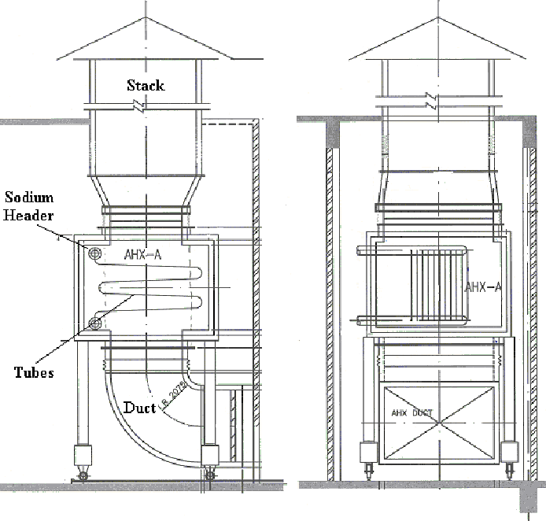
Fig. 1: Schematic of AHX circuit
bends, making the serpentine layout for each tube. Tubes in each pass are supported at their ends (just before U- bends) by hangers. Finned tubes, U-bends and sodium headers are all housed inside a single casing of AHX. Ambient air is introduced across the tube banks by natural draft generated by stack. Air enters the AHX at its bottom through a 90⁰ bend duct and exits to stack. Pneumatic and motorised air dampers are provided on the upstream and downstream of AHX. During power operation of the reactor the air dampers are kept crack open to minimise heat loss to ambient and at the same time to permit certain amount of natural circulation in the SGDHR circuit in order to enable smooth change over to DHR mode when required.
Challenging aspects involved in the design of AHX are the management of flow bypassing that seriously affects its heat exchange capacity and uncertainties involved in heat transfer correlations. Heat transfer coefficient from finned tubes to air is the major resistance governing the heat exchange between sodium and air. This heat transfer coefficient calculated based on correlations available in literature is likely to have large uncertainty mainly due to the smaller number of longitudinal rows of tubes (three) in AHX. Operating experience in some AHX is not satisfactory from heat removal capacity considerations. When an AHX is used in a natural circulation loop, the complexity gets added due to the dependence of the estimated natural convection flow on pressure drop correlations. Therefore, designing the heat exchanger with minimum flow bypass and careful use of heat transfer and pressure drop coefficients with suitable margin are very essential. Achieving this objective is becoming increasingly simpler due to the advancement in the CFD and development of computer technology. In this context, CFD studies are good substitute for experimental studies in view quick results and multiple trials. This paper brings out the CFD studies carried out to achieve desirable flow distribution of sodium and air in AHX and the evaluation of heat transfer and pressure drop coefficients of finned tube bundle.

2 Analysis Methodology
Sodium enters the inlet header through a pipe connected at one end of it and flows through 116 tubes. Sodium flow distribution among various tubes is investigated first through a hydraulic analysis of sodium flow in the header. Air enters the AHX at its bottom through a 90⁰ bend duct which causes a non-uniform velocity distribution at its exit. Therefore, hydraulic analysis of air flow in the duct has been carried out in the second step to obtain velocity distribution at the AHX air inlet. In the third step, numerical estimation of shell side heat transfer and pressure drop coefficients have been made. For this a detailed thermal hydraulic analysis of air flow in between finned tubes has been carried out. Finally, thermal hydraulic analysis of air side of AHX is carried out to establish the air flow distribution and heat exchange capacity. Sodium flow distribution obtained from the first step is used for the calculation of heat source to air flow from tubes.Velocity distribution of air at the AHX inlet obtained from the second step is used as input for this calculation. The heat transfer and pressure drop coefficients estimated from the third step are employed to model heat exchange from sodium and air and pressure drop offered by tube bundle.

3 Computational Models
3.1 Hydraulic analysis of sodium inlet header (Step 1)
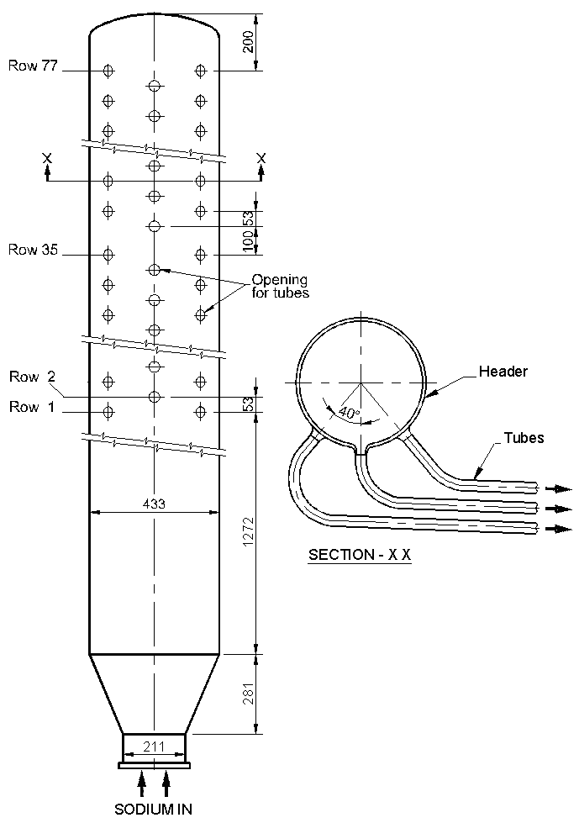
Fig. 2: Schematic of header with tubes
A schematic of the header with tubes is shown in Fig. 2. The geometry of header with tubes is symmetric about 180⁰ sector. Therefore, half of the header with 39 full and 38 half tube outlets from header is considered for the analysis. Inlet velocity boundary condition is specified at one end of the header and constant pressure (outlet) boundary conditions are specified at all the 77 tube outlet locations. Pressure drop suffered by sodium flow in each tube is modeled through an orifice resistance (baffle boundary) just before the outlet boundary in the tubes. This resistance corresponds to the total hydraulic resistance offered by tube wall friction, resistance due to the three U bends of the serpentine arrangement and resistance due to the two L bends at the header to tube connections. These hydraulic resistances are calculated based on reference [1]. The analysis has been carried out using the high Reynolds number k - ε turbulence model in the CFD code Star CD. Total number of unstructured grids employed in the model is ~ 2.5 lacks.

3.2 Hydraulic analysis of Air Duct(Step 2)
Air enters the duct horizontally and turns through a sharp 90⁰ bend to enter AHX axially from its bottom. Computational model for the hydraulic analysis of air flow in the bend duct has been developed in Star CD code. Turbulence in the flow has been modeled using high Reynolds number k - ε turbulence model.

3.3 Thermal Hydraulic Analysis of Finned Tube Bundle (Step 3)
Staggered array of three finned tubes with a length of one fin spacing as shown in Fig. 3 has been modeled in Star CD code. Cross flow of air through the bundles at various velocities have been analysed. Air at 313 K is admitted through the bundles at various velocities. The temperatures of tubes are maintained isothermal at 773 K. The analyses are carried out using laminar flow model.
Fig. 3: Schematic of the finned tube model
3.4 Thermal Hydraulic analysis of Air Side of AHX (Step 4)
A Schematic of reference design of AHX is shown in Fig. 4. Air enters the AHX at its bottom and flows across four passes of tubes arranged in three rows and exits to stack. Schematic of the mathematical model used for the analysis is shown in Fig. 5. The velocity profile at the duct exit obtained from step 2 is applied at the inlet to the domain. Pressure drop offered by the finned and un-finned tubes on the air flow are modeled through momentum sinks in the
Fig. 4: Schematic of reference design of AHX

Fig. 5: Schematic of AHX model
axial momentum balance equation. The hydraulic resistance coefficient for the above pressure drop are calculated based on the relation obtained from the above study (step 3). Heat transferred from sodium to air through the tubes is modeled by specifying heat source in the thermal balance equation at the location of tubes. The heat source at a particular tube location is calculated as:
Q = U A_{O} (T_{Sodium} – T_{Air}) (1)
Where,
U = Overall heat transfer coefficient given by
$U={\left[\frac{1}{h_{o}} + R_{o} + \left(\frac{1}{h_{i}} + R_{i}\right) \frac{A_{O}}{A_{I}} + R_{W}\right]}^{−1}$ (2)
h₀ = Shell side heat transfer coefficient
R_{o} = Fouling resistance on the sodium side
h_{i} = Tube side heat transfer coefficient
R_{i} = Fouling resistance on the air side
R_{W} = Tube wall resistance based on outside diameter of tube given by
$R_{W} = \frac{d_{o}}{2k_{T}} \text{ln}\left(\frac{d_{o}}{d_{i}}\right)$ (3)
K_{T} is the thermal conductivity of tube material
d_{o} and d_{i} are outer and inner diameter of tubes
A_{O} = Total outside heat transfer area of tube and fins
A_{I} = Inner heat transfer area of tubes
T_{Air} = Temperature of air
T_{Sodium} is the temperature of sodium, which is tracked along the tube pass between the headers based on heat transferred to air. T_{Sodium} at a particular grid location ‘N’ is calculated as:
T_{SN} = T_{S N-1} - Q_{N-1} / (m_{s} Cp) (4)
Where T_{SN} and T_{S N-1} are the temperatures of sodium at N^{th} and (N-1)^{th} grids in the tube pass. Numbering of grids is done in the direction of flow of sodium through the tubes. m_{s} is the sodium flow rate, Cp is the specific heat capacity of sodium and Q_{N-1} is the heat transferred to air at the (N-1)^{th} grid calculated based on Equation (1) above. Heat transfer coefficient at the tube side (h_{i}) is calculated based on Marcelin’s [2] correlation. Shell side heat transfer coefficient (h_{o}) is calculated based on the relation derived from the analysis (step 3). Pressure drops offered by tube supports are modeled through momentum sinks in the respective momentum balance equation. Hydraulic resistance offered by these is calculated using the porous plate correlation [3] for the equivalent porosity of opening (~ 60 %). Air flow between tubes being laminar, the analysis has been carried out using laminar flow model in PHOENICS code. Number of grids considered in the longitudinal and cross direction of tube banks are 37 and 18 respectively. The geometry of AXH being symmetric along in the third direction (i.e, along the length of sodium headers), half model is only considered in this direction with three grids.

4 Results and Discussion
4.1 Flow Distribution Among Tubes
The normalised sodium flow through various transverse rows of tubes obtained from the analysis is shown in Fig. 6. It can be observed that flow through various tubes is uniform with a maximum deviation of - 4 % to + 2 %. In sparger type flow distribution devices, when the pressure drop offered by the tubes is 10 times more than the kinetic energy of flow at the entrance, it is experimentally established [4] that the flow distribution among various branches would be uniform with a deviation of < 5 %. The present prediction matches this proposition, wherein the pressure drop offered by the ~ 14 m long, serpentine tubes is about 25 times the kinetic energy of sodium at the entry to header. Thus, the variation of sodium flow among various tubes can be ignored in subsequent calculations.
Fig. 6. Normalised flow through various tubes
4.2 Air Flow Distribution in Duct
Predicted velocity distribution in the duct is shown in Fig. 7. It can be observed that at the entrance of bend, velocity is non-uniform with maximum near the inner side of bend. Flow gets redistributed afterwards and at the exit of bend, the velocity becomes maximum at the outer side of the bend. This velocity profile at the exit of duct is considered at the AHX inlet in the subsequent calculation.
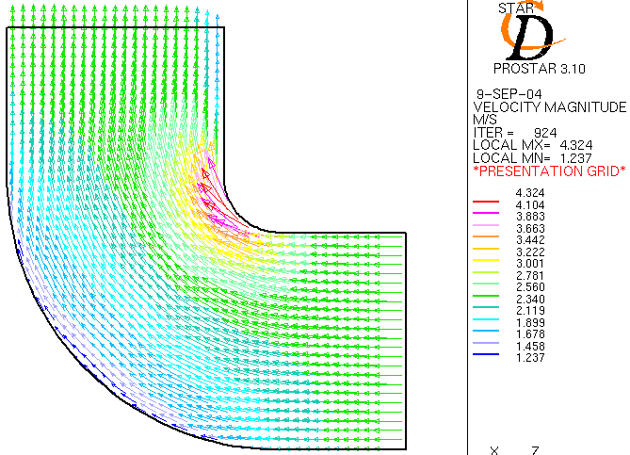
Fig. 7: Velocity profile in duct
4.3 Thermal Hydraulic Analysis of Finned Tube Bundle
For a typical case in which air enters the tube bundle at a velocity of 2.5 m/s, the predicted velocity and temperature distribution are shown in Fig. 8. Estimated pressure drop coefficient and Nusselt
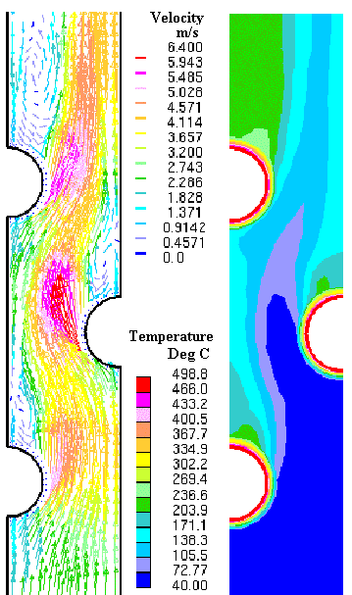
Fig. 8: Velocity and temperature distribution of air in between finned tubes
number of heat transfer of the finned tubes in various cases are tabulated in Table 1. Also shown in the same table are the pressure drop coefficients and nusselt numbers calculated based on Zukauscas correlation [5, 6] available in literature. It can be observed that the estimated loss coefficients are less than those estimated numerically. Thus, the correlation predicts conservative value of pressure drop offered by the tube bundle. Nusselt numbers obtained from the analysis for the range of air flow velocity (2 - 3 m/s) in AHX are lower than those estimated using correlation. Maximum uncertainty in the correlation is ~ 13 %. Therefore, for conservative design of AHX, an uncertainty of ~ 15 % needs to be considered on the shell side heat transfer coefficient calculated based on correlation. The heat transfer coefficient relation derived based on the analysis has been used in the subsequent calculation.
Table 1: Comparison of coefficients
Velocity m/s | K by analysis | K by correlation | Nu by analysis | Nu by correlation
0.5 | 3.55 | 4.31 | 21.0 | 16.9
1.0 | 2.91 | 3.63 | 28.8 | 26.6
1.5 | 2.55 | 3.27 | 36.7 | 34.7
2.0 | 2.30 | 3.05 | 41.5 | 41.8
2.5 | 2.08 | 2.88 | 45.3 | 48.3
3.0 | 1.90 | 2.75 | 48.5 | 54.4
4.4 Flow and Temperature Distribution of Air in AHX
Thermal hydraulic analysis of AHX has been carried out with the predicted air flow distribution at the duct exit and estimated heat transfer and pressure drop coefficients for the finned tube array. The predicted flow distribution of air in AHX is shown in Fig. 9. It can be observed that considerable amount of flow bypasses the finned region of tubes and flows across the bundle supports (~ 60 % porosity). The bypass flow through the volume between AHX wall and bundle supports which houses bare tube bends, do not contribute in the heat exchange between sodium and air in a significant manner. Apart from this, as evident from Fig. 4, about 234 mm length of tubes of each pass near the bundle support are not provided with fins and there exist about 241 mm free gap between the last row of tube in the transverse direction and AHX wall on either side. These also cause air to bypass from the desired path. Due to this flow bypassing, the heat exchange capacity of AHX under rated air and sodium flow conditions is observed to be 5.32 MW only. This is less than 8 MW, calculated by approximate calculations without considering flow bypassing.
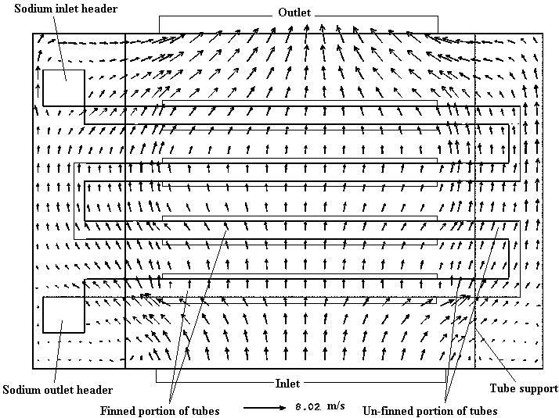
Fig. 9: Velocity profile of air in AHX
Fig. 10: Temperature profile of air and sodium
Variation in temperature of sodium in tubes and temperature of air approaching various tubes passes along their length is shown in Fig. 10. Sharp variation in the temperature of air at the location of tube pass 1 is evident in the figure. This is due to the bypass air in AHX reaching the outlet without getting heated up much from the tube bundle.
Preventing flow bypassing would improve the heat exchange capacity. For this a study has been carried out with the following design modifications as shown in Fig. 11.
- Providing fins in tubes as close to bundle support as possible thereby reducing the unfinned portion of tubes.
- Providing two baffles on either end of AHX in the region between wall and bundle support.
- Providing three baffles each on either side in the region between last transverse row of tubes and AHX wall.
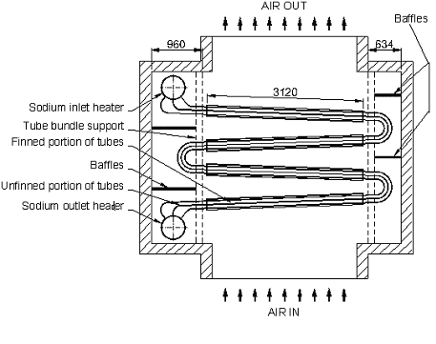
Fig. 11: Schematic of modified design of AHX
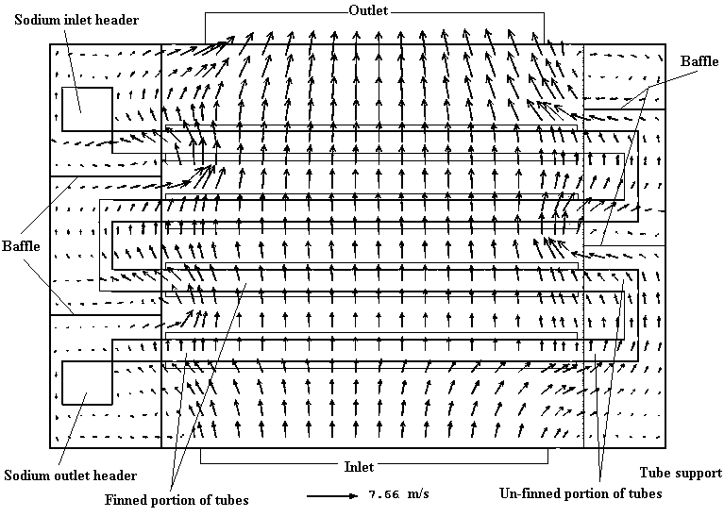
Fig. 12: Velocity profile in the modified design
Flow and temperature distribution obtained in the modified configuration of AHX is shown in Fig. 12 and 13 respectively. It can be observed that the baffles redirect air flow back to the finned region of tubes and there by enhance the heat transfer. The heat exchange capacity estimated in this case is 8.27 MW. Peak temperature reached by air in AHX is 630 K. The average outlet temperature of air is 577 K. From the temperature variation of sodium in tubes of various passes it can be inferred that the first pass of tubes transfers the minimum amount of heat to air (22.4 % of total). Maximum heat (27.2 %) is transferred by the 4th pass due to the maximum ΔT prevailing between sodium and air at its location.
Fig. 13: Temperature variation of sodium and air in the modified design

5 Conclusions
CFD studies have been efficiently employed in the design of an air cooled finned heat exchanger with minimum uncertainties in the heat transfer and pressure drop coefficients. These studies also help in arriving at a design wherein the flow bypassing is managed through proper design provisions, which in turn improves the heat exchange capacity of the exchanger from 5.32 MW to 8.27 MW.

References:
[1] I. E. Idelchik, Handbook of Hydraulic Resistance, Ed. 3, CRC Press, 1993.
[2] C. Marcellin et. al, Hydrothermic Behavior of Intermediate Heat Exchangers in a Pool Type Fast Breeder Reactor, Liquid metal engineering and technology, BNES, London, 1984.
[3] A. W. Ward Smith, Pressure Losses in Ducted Flows, Butterworths, London, 1971, pp. 188.
[4] Robert H. Perry, Chemical Engineers Hand Book, Ed. 5, Mcgraw Hill Inc., 1973.
[5] Heat Exchanger Design Hand Book, Vol. 2, Hemisphere publishing corporation, Washington, 1983.
[6] A. Zukauskas, ‘High performance single phase heat exchangers, English Edition, edited by J. Karni, Hemisphere publishing corporation, 1989.

