Global Effective Hyperspectral Cloud Property Atlas for Hyperspectral Sounder Simulator and Processor

LI GUAN∗, HUNG-LUNG HUANG#, ELISABETH WEISZ, and KEVIN BAGGETT
Cooperative Institute for Meteorological Satellite Studies
University of Wisconsin-Madison
1225 West Dayton Street, Madison, Wisconsin 53706
UNITED STATES OF AMERICA

Abstract: This companion paper describes the objective and method of the application of Minimum Local Emissivity Variance (MLEV) technique for simultaneous retrieval of cloud pressure level and effective spectral emissivity from high-spectral resolution radiances, for the case of single-layer clouds. This effort is to produce a global representative effective hyperspectral cloud property database for the Hyperspectral Sounder Simulator and Processor (HSSP) under development by University of Wisconsin in support of a broad scope of GOES-R Hyperspectral Environmental Suite (HES) activities.
The MLEV algorithm uses a physical approach, in which the local spectral variances of cloud emissivity are calculated for a number of cloud pressure levels. The optimal solution for the single-layer cloud emissivity spectrum is that having the “minimum local emissivity variance” among the retrieved emissivity spectra associated with different first-guess cloud pressure levels. This is due to the fact that the absorption, reflection, and scattering processes of clouds exhibit relatively limited localized spectral emissivity structure in the infrared long wave region.
In this paper MLEV method is used along with AIRS operational cloud clearing radiances and its associated cloud cleared soundings and co-located ECMWF global analysis field to computed the needed clear and cloudy radiances to the subsequent determination of effective cloud property such as height and emissivity spectrum from global AIRS infrared spectral measurements. Coupled with the theoretical modeling of the single scattering property of ice and water phase clouds and a fast parameterized clear and cloudy forward radiative transfer models, a global effective hyperspectral cloud atlas will be generated as a critical simulation and processing component of the HSSP to be used to emulate next generation geosynchrous hyperspectral measurements such as HES and other hyperspectral sounders as well.

Key-Words: Hyperspectral, cloud emissivity, cloud height, infrared, sounder, simulation

1 Introduction
New instruments such as the Atmospheric Infrared Sounder (AIRS), Interferometric Monitor for Greenhouse Gases (IMG), Geosychronous Imaging Fourier Transform Spectrometer (GIFTS), Cross-track Infrared Sounder (CrIS), Infrared Atmospheric Sounding Interferometer (IASI), the Hyperspectral Environmental Suite (HES) on GOES-R, and others provide researchers with the potential to make significant advancements in cloud property retrieval. This is not only a result of their high spectral resolution, but also their relatively broad spectral coverage. In this paper, we use MLEV [1] technique to derive global representative cloud heights and emissivity spectra for those cloud sensitivity spectral regions for an AIRS granule case example. In Section 2, a brief overview of HSSP is provided to demonstrate its relevance and utilities towards supporting the efforts for the instrument design, tradeoff, data processing, requirement confirmation, algorithm development, and product demonstration. In Section 3, we review the general principal of MLEV algorithm. Its sensitivity functions are shown to characterize the information content of cloud emissivity and height which are possessed by the observed radiances for a number of atmospheric conditions. Section 4 describes a preliminary case study involving the application of MLEV to measured radiances from one of the AIRS focus day in September 6, 2002. In Section 5, we discuss the overall objective of this effort and the extension of the derived cloud property for the subsequent uses in the HSSP end-to-end support to the GOES-R HES program.

2 HSSP Overview
University of Wisconsin’s Hyperspectral Sounder Simulator and Processor (HSSP) includes NWP modeling, radiative transfer modeling, instrument effect simulation, compression data set generation, sensor design trade study, calibration implementation, atmospheric retrieval algorithm development, water vapor tracking for wind derivation, and conduct simulation verification and validation. Figure 1 depicts the functional diagram of HSSP system [2].
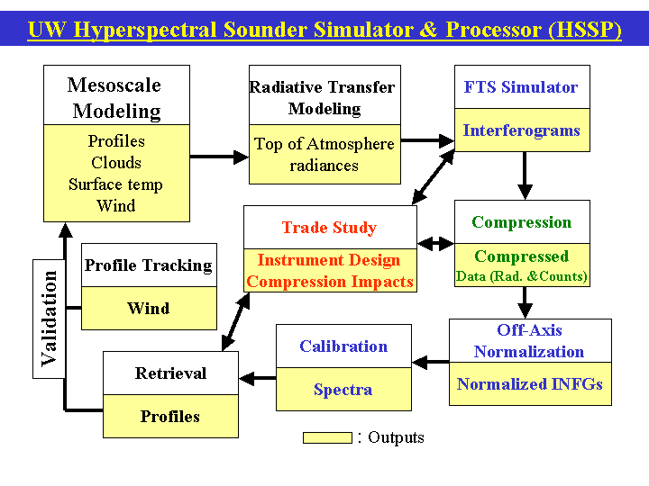
Fig. 1: Hyperspectral end-to-end model and algorithm development functional diagram.

- Numerical model simulations with very high vertical and horizontal resolution were generated using version 3.5 of the 5th generation PSU/NCAR Mesoscale Model (MM5). The MM5 is a non-hydrostatic numerical model that solves the full non-linear primitive equations on user-defined sigma levels. Prognostic variables carried by the MM5 include perturbation pressure, temperature, horizontal and vertical wind components, water vapor mixing ratio, as well as the mixing ratios of various microphysical quantities such as rain water, cloud water, snow, ice, and graupel. Three-dimensional analyses of the atmospheric state are interpolated from a latitude-longitude mesh to a moveable limited-area domain on a choice of lambert conformal, mercator, or polar stereographic projections. A 24-category topography and land use dataset with variable resolution is used to determine the albedo, roughness length, long-wave emissivity, heat capacity, and moisture availability at the land surface.
- Radiative transfer modeling is developed under the framework of Pressure Layer Optical Depth (PLOD). The clear sky fast model used at UW applies a PLOD regression to line-by-line calculations obtained with LBLRTM and the HITRAN ‘96 database. The line-by-line transmittance data were mapped to the GIFTS spectral domain using a maximum optical path difference of 0.872448 cm, with an effective spectral resolution of 0.6 cm⁻¹, and apodized prior to performing the regression analysis.
The key features of the UW-CIMSS GIFTS clear sky forward model can be summarized as follows:
1. LBLRTM v6.01 runs:
- HITRAN ‘96 + JPL extended spectral line parameters
- MTCKD5 v1.0 H₂O and 15 μm CO₂ continuum
2. Spectral Characteristics:
- ~586–2347 cm⁻¹
- ~0.8724 cm MOPD
- Kaiser Bessel #6 apodization
3. Fast Model:
- 32 profiles from NOAA database
- 6 view angles
- 100 vertical layers (equivalent to those used for AIRS)
- Three transmittance components: fixed gases, H₂O, and O₃
- AIRS PLOD predictors
4. Run time:
~0.8 sec on a 1 GHz CPU
Previous work on the HSSP forward model’s cloud component is summarized in [3]. For scattering calculations of ice clouds at infrared wavelengths, there is no single method that can cover the range of practical particle sizes. For this reason, the finite-difference time domain method (FDTD) was used for ice crystals smaller than 40 µm to calculate single-scattering properties of extinction efficiency, single-scattering albedo, and phase function. For larger particles, the newly developed stretched scattering potential method (SSPM) was used to calculate the extinction and absorption efficiencies. Furthermore, the improved geometry optical method was used to derive the phase function. In atmospheric radiative transfer calculations, the phase function can be approximated by the well-known Henyey-Greenstein phase function based on the asymmetry factor.
Cloud transmittance is defined as the complement of cloud emissivity. Above the cloud level, the total transmittance profile is set equal to the clear component transmittance. Below the cloud level, total transmittance becomes the product of the cloud and clear component transmittance.
Radiances in the presence of clouds are simulated as the sum of four components that together account for both clear and cloudy atmospheric paths.
Other HSSP components such as FTS simulator, Data Compression, Trade Study, Calibration, Profile Tracking, Retrieval and others are not related to MLEV application, to be discussed in details, and will not be included in any further discussion in this paper.

3 MLEV Technique Review
Disregarding scattering processes, which are negligible in the spectral region used in the MLEV algorithm, the upwelling radiance for a partially cloud-covered IFOV can then be written as a linear combination of clear and cloudy radiance terms:

(1)

where is the effective cloud emissivity, a product of the cloud emissivity and the cloud fractional coverage .
Recasting Eq. (1) in terms of the effective cloud emissivity, we obtain

(2)

In addition to the observed radiance , the algorithm requires an estimation of and a calculation of for each first-guess . The fundamental principle of MLEV is to identify the , out of all possible cloud levels from near-surface to 100 hPa, that minimizes the Local Emissivity Variation term

(3)
where
= (4)

The cloud pressure level associated with the minimum of is the MLEV solution [1]. The optimal summation limits and , with = 5 cm⁻¹ defining the local variance, were determined via sensitivity studies and noise considerations to be 750 and 950 cm⁻¹, respectively.
If the assumed cloud pressure level is incorrect (under- or over-estimated), will display spectral structure correlated with water and carbon dioxide absorption lines, as we will demonstrate theoretically later. A correct cloud pressure level will result in a residual local variation that is due primarily to instrument noise, with the larger scale variation being due to the variation of emissivity associated with spectral signature of different types of clouds. For further detail concerning the sensitivity and theoretical performance analysis of MLEV please refer to the paper by Huang and others, 2004 [1].

4 Preliminary MLEV Case Study Results
In this section, a demonstration of MLEV retrieval of cloud pressure level and effective emissivity using AIRS longwave infrared measurements is presented. The tropical pacific oceanic nighttime single AIRS focus day granule data are used to derive MLEV cloud heights and spectral emissivity spectra. In figure 2 AIRS window channel spectral brightness temperature measurements of 900 cm⁻¹ band (upper panel), which are highly sensitive to clouds and/or surface, range from 200 to warm than 290 degree Kevin. An indicative of spectral sensing of very cold ice clouds to warm ocean surface. Also some relative warm water clouds, and semi-transparent ice clouds (~260 to 280 K) are also exists in this scene. In the middle panel the AIRS cloud cleared brightness temperature indicates the range of scene temperature from 270 to 300 K represents the process of taking away the cloud absorption in the measurements. While white areas are for those unsuccessful and/or unsuitable cloud clearing filed of views. Cloud cleared brightness temperatures represent those areas of measurements that if there were no cloud absorption occurs. The lower panel shows the window channel brightness temperature calculated from ECMWF NWP analysis fields in the corresponding target domain. Its scene temperature ranges from 288 to 298 K.
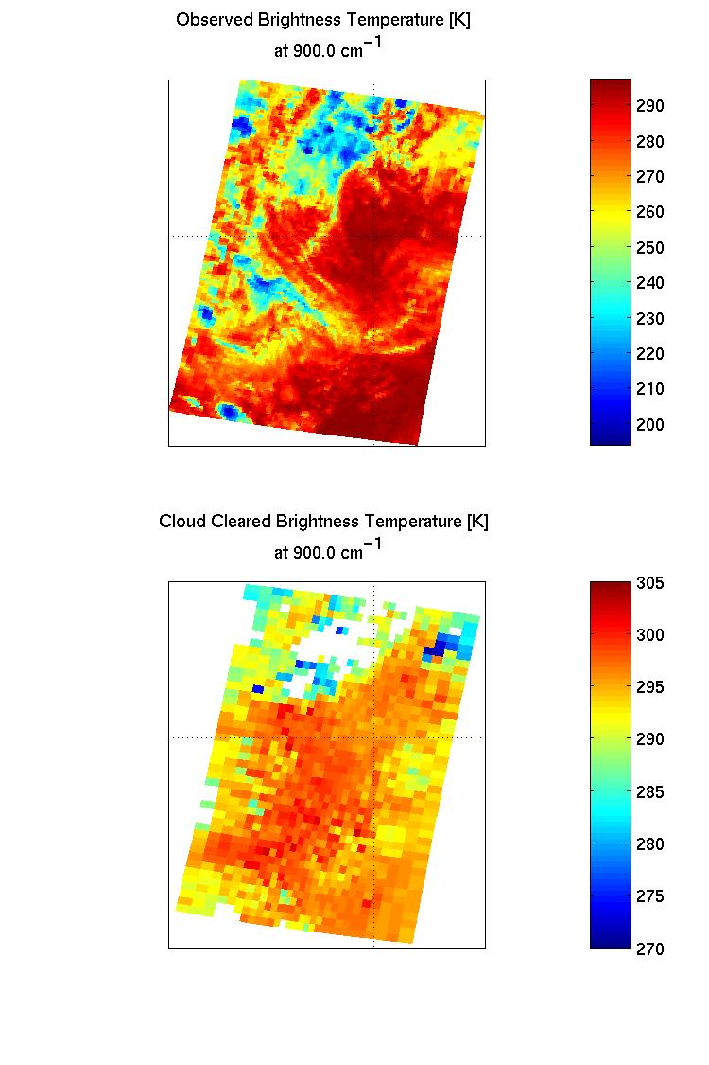
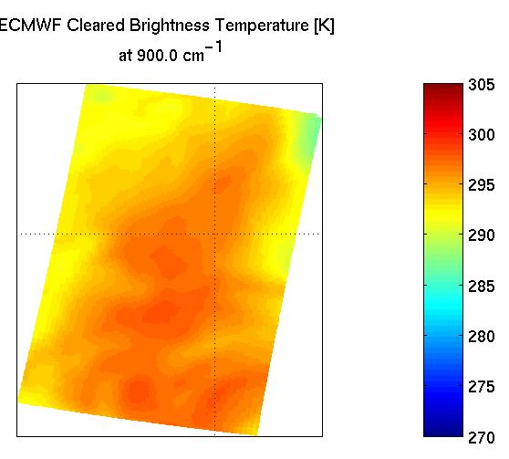
Fig. 2. Tropical Pacific oceanic night time AIRS single granule brightness temperature measurements at 900 cm⁻¹ channel (upper panel). The associated cloud cleared brightness temperature (middle panel), and same channel brightness temperature calculated from time and location co-registered ECMWF NWP model analysis (lower panel). Note that the white areas in the middle panel is due to the unsuccessful cloud cleared process.
There are two different approaches to the calculation of the effective cloud emissivity as depicted by eq. (2):
- Use of cloud cleared radiances to represents R_{clr,ν} and cloud cleared sounding profiles to compute R_{cld,ν}.
- Use of ECMWF NWP model profiles to compute both R_{clr,ν} and R_{cld,ν}.
For each single filed of view of AIRS two MLEV solutions can be inter-compared to ensure consistent cloud property information that can be achieved. Since the ultimate global representative cloud property atlas will be used to simulate any realistic hyperspectral cloudy measurements and the processing of hyperspectral observations provided by the airborne and satellite sounders and imagers.
Cloud height obtained from applications of MLEV to the AIRS single granule data described in fig.2 are shown in fig. 3 using AIRS cloud cleared radiances and soundings and forward model calculations using ECMWF NWP model profiles as described above.
Any pair of cloud height obtained by both approaches that have difference within the threshold (20 to 50 mb, dependent on cloud height) will be accepted and be included in the global atlas. Their associated cloud emissivity spectra will also be inter-compared to ensure consistent spectral signatures are also achieved. Further spectral smoothing of emissivity spectra will also be performed, using truncated principal components derived from all successful retrieved cloud emissivity spectra itself, to reduce measurement noise amplification in the MLEV process.
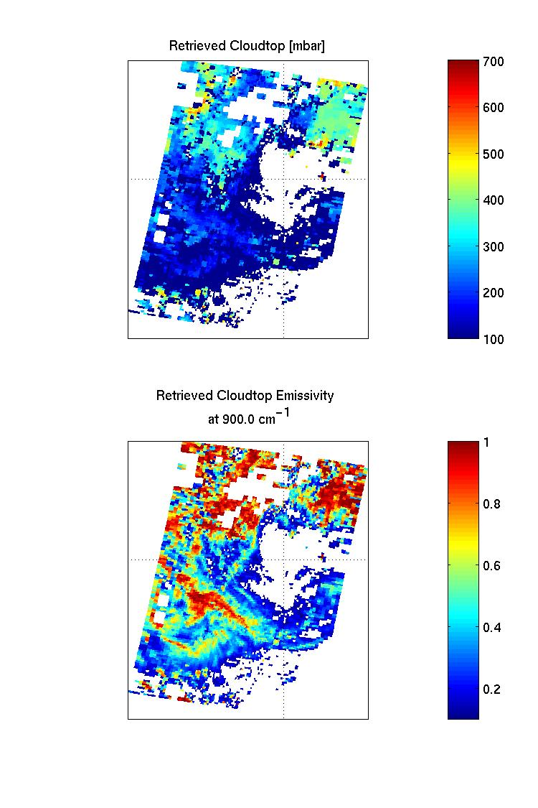
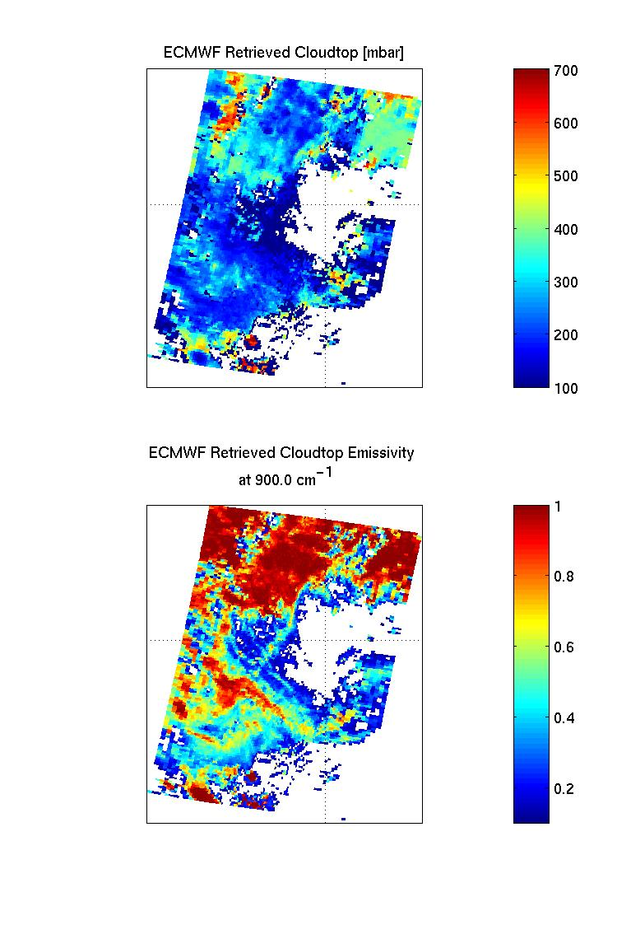
Fig. 3. Single layer effective Cloud height derived from AIRS cloud cleared radiances and soundings (upper panel), and derived from ECMWF NWP analysis profiles (lower panel).

Fig. 4 is the associated 900 cm⁻¹ band cloud emissivity images derived from the use of cloud cleared radiances and soundings (upper panel) and ECMWF NWP model profiles (lower panel). The white areas are due to missing data that are resulting from either the unsuccessful MLEV or unavailable of cloud cleared data required in MLEV process. The white areas can also be attributed to the clear areas where no cloud exists and hence no cloud emissivity is available. For those emissivity values in red color (close to 1) clouds are optical thick and effectively overcast within the AIRS single filed of view of measurement. The low emissivity values are for those clouds are either semi-transparent or partial cloud covered within the filed of view.
Fig. 4. Single layer effective Cloud emissivity of 900 cm⁻¹ band derived from AIRS cloud cleared radiances and soundings (upper panel), and derived from ECMWF NWP analysis profiles (lower panel).
Fig. 5 displays school of MLEV cloud emissivity spectra for variety of cloud phases and types, namely ice/opaque, ice/semi-transparent, and water/semi-transparent types. The high frequency component of these emissivity spectra will be processed to minimize the noise amplification in the MLEV derivation.
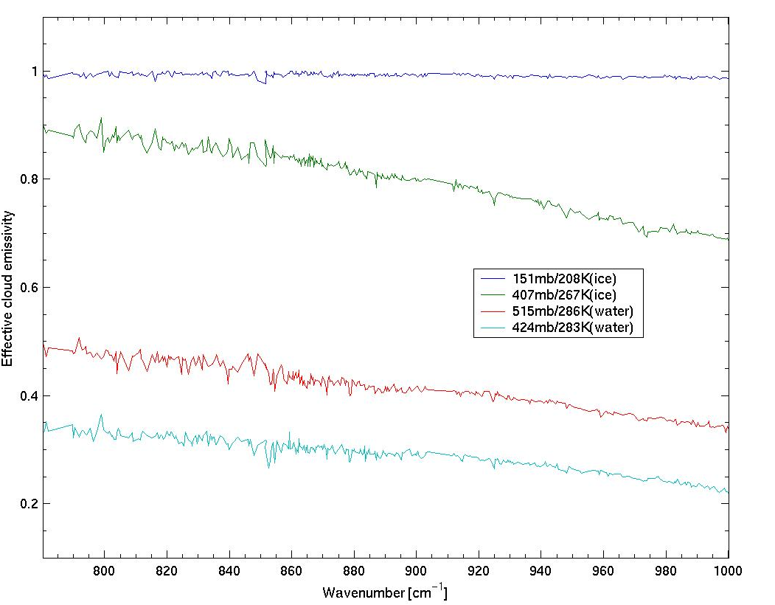
Fig.5. Selected MLEV cloud emissivity spectra for ice/opaque, ice/semi-transparent, and water/Semi-transparent cloud types.

5 Discussions and Summary
A single-layer cloud MLEV technique is used to derive global representative cloud heights and emissivity spectra as a component of HSSP to simulate and process cloud contaminated field of view measurements of the current and future hyperspectral sounders. The optimal cloud pressure level and emissivity spectrum solution derived from MLEV is that which yields the smallest local spectral variation of the derived emissivity spectrum. Since a cloud absorbs, reflects, scatters, and radiates smoothly within a localized spectral region, any abrupt high frequency feature existing in the retrieved emissivity spectrum is indicative of suboptimal cloud pressure level determination which is the dominant factor in obtaining the cloud emissivity spectrum retrieval.
In this AIRS MLEV retrieval study it is shown that the MLEV will amplify measurement noise and any measurement noise reduction processing priori to the MLEV retrieval is recommended. The future analysis will demonstrate that any enhanced results due to the noise filtering effect. Further efforts will also be directed towards the application of MLEV to derive a global represented effective cloud emissivity spectra to model wild range of cloud spectral signature and their respected measurements, i.e., creating simulated radiances of cloudy fields of view for use in other cloud radiative transfer and remote sensing studies. In addition, MLEV cloud property derived from two separated approaches (AIRS cloud cleared radiances and sounding retrievals vs. ECMWF NWP model analysis profile) ensures consistent selection and quality control of the creation of a reliable global cloud property atlas for the potential utilities of hyperspectral simulation and cloudy measurements processing.

Acknowledgements. This research was partially supported by NOAA grant NA07EC0676, and Navy MURI research grant N00014-01-0850.

References:
[1] H.L. Huang, H-L, W.L. Smith, J. Li, P. Antonelli, X. Wu, R.O. Knuteson, B. Huang, B.J. Osborne, 2004: Minimum Local Emissivity Variance Retrieval of Cloud Altitude and Emissivity Spectrum – Simulation and Initial Verification. Journal of Applied Meteorology, Vol. 43, 795-809.
[2] Huang, H.-L. C. Velden, J. Li, E. Weisz, K. Baggett, J. E. Davies, J. Mecikalski, B. Huang, R. Dengel, S. A. Ackerman, E. R. Olson, R. O. Knuteson, D. Tobin, L. Moy, J. A. Otkin, D. J. Posselt, H. E. Revercomb, and W. L. Smith, 2004: Infrared hyperspectral sounding modeling and processing: An overview. Preprints, Eighth Symposium on Integrated Observing and Assimilation Systems for Atmosphere, Oceans, and Land Surface (IAOS-AOLS), Amer. Meteor. Soc., Boston, MA, Seattle, WA.
[3] Huang, H.-L., D. Tobin, J. Li, et, al., 2003: Hyperspectral Radiance Simulator – Cloudy Radiance Modeling and Beyond. SPIE Optical Remote Sensing of the Atmosphere and Clouds III, Vol, 4891, 180-189. 25-27 Oct., 2002, Hangzhou, China.

 Visiting scientist from Nanjing University of Information Science and Technology (formerly Nanjing Institute of Meteorology)
# Corresponding author. CIMSS, University of Wisconsin-Madison, 1225 West Dayton Street, Madison WI 53706, USA. E-Mail: allenh@ssec.wisc.edu

