Advanced video coding standard H.264/AVC:
Performance vs. Complexity

DRAGORAD MILOVANOVIC⁽¹⁾, Zoran BojkoviC⁽²⁾

⁽¹⁾ Faculty of Electrical Engineering, University of Belgrade,
Bulevar Revolucije 73, 11120 Belgrade, Serbia and Montenegro
http://galeb.etf.bg.ac.yu/~dragorad

⁽²⁾Faculty of Transport and Traffic Engineering, University of Belgrade,
Vojvode Stepe 305, 11000 Belgrade,

Abstract:- The video coding standards to date have not been able to address all the needs required by varying bit rates of different applications and the at the same time meeting the quality requirements. The H.264/AVC (MPEG-4 Part 10) international video coding standard has been jointly developed and approved by the MPEG group ISO/IEC and the VCEG group of ITU-T. Compared to previous video coding standards, H.264/AVC provides an improved coding efficiency and a significant improvement in flexibility for effective use over a wide range of networks. The new coding tools of H.264/AVC when used in an optimized mode allow for bit savings of about 50% compared to previous video coding standards like MPEG-4 and MPEG-2 for a wide range of bit rates and resolutions at the cost of increased complexity. The performance vs. cost tradeoff when using RD techniques for coding mode decisions inherently depends on the other tools used. The presented complexity analysis has been performed on the executable C code produced by the JVT. In relative terms, the encoder complexity increases with more than one order of magnitude between MPEG-4 Part 2 (Simple Profile) and H.264/AVC (Main Profile) and with a factor of 2 for the decoder. The experiments have shown that, when combining the new coding features, the relevant implementation complexity accumulates while the global compression efficiency saturates. The efficient use modes are reflected in the choice of the tools and parameter settings of the H.264/AVC profiles, systematized in this paper.

Key-words: video coding tools, profiles&levels, mode optimization, implementation complexity

1 Introduction
Two international organizations (ISO/IEC and ITU-T) have been heavily involved in the standardization of image, audio and video coding methodologies. The new video coding standard Recommendation H.264 of ITU-T also known as International Standard 14496-10 or MPEG-4 Part 10 Advanced Video Coding (AVC) of ISO/IEC is the latest standard in a sequence of the video coding standards H.261 (1990), MPEG-1 Video (1993), MPEG-2 Video (1994), H.263 (1995, 1997), MPEG-4 Visual or Part 2 (1998). These previous standards reflect the technological progress in video compression and the adaptation of video coding to different applications and networks [1, 2].
ITU-T Video Coding Experts Group (VCEG) has been working on a video coding standard called H.26L since 1997. In August 1998, the first test model was ready and was demonstrated at MPEG’s open call for technology in July 2001. In late 2001, ISO/IEC Moving Picture Experts Group (MPEG) and ITU-T VCEG decided on a joint venture towards enhancing standard video coding performance – specifically in the areas where bandwidth and/or storage capacity are limited. This joint team of both the standard organizations is called Joint Video Team (JVT). The standard thus formed is called H.264/MPEG-4 Part10 (finalized in March 2003 and approved by the ITU-T in May 2003.). The main goals of JVT are: significant coding efficiency, simple syntax specifications and seamless integration of video coding into all current protocols and multiplex architectures (network friendliness).
2 Concept of standardized video coder
Conceptually, H.264/AVC consists of two layers: Video Coding Layer (VCL) and Network Abstraction Layer (NAL). VCL is the core coding layer, which concentrates on attaining maximum coding efficiency. NAL abstracts the VCL data in terms of the details required by the transport layer and to carry this data over a variety of networks. The VCL layer takes care of the coding of transform coefficients and motion estimation/compensation information. NAL provides the header information about the VCL format, in a manner that is appropriate for conveyance by the transport layers or storage media. A NAL unit (NALU) defines a generic format for use in both packet-based and bit-streaming systems.
Standardized video coding techniques like H.263, MPEG-1, 2, 4 are based on hybrid video coding. However, H.264/AVC introduces the following changes:
- in order to reduce the block-artifacts an adaptive deblocking filter is used in the prediction loop. The deblocked macroblock is stored in the memory and can be used to predict future macroblocks.
- whereas the memory contains one video frame in previous standards, H.264/AVC allows storing multiple video frames in the memory.
- in H.264/AVC a prediction scheme is used also in Intra mode that uses the image signal of already transmitted macroblocks of the same image in order to predict the block to code.
- the Discrete Cosine Transform (DCT) used in former standards is replaced by an integer transform.
Each picture is compressed by partitioning it as one or more slices; each slice consists of macroblocks, which are blocks of 16x16 luma samples with corresponding chroma samples. However, each macroblock is also divided into sub-macroblock partitions for motion-compensated prediction. The prediction partitions can have seven different sizes (16x16, 16x8, 8x16, 8x8, 8x4, 4x8, 4x4). In past standards, motion compensation used entire macroblocks or, in the case of newer designs, 16x16 or 8x8 partitions, so the larger variety of partition shapes provides enhanced prediction accuracy. The spatial transform for the residual data is then either 8x8 or 4x4. In past major standards, the transform block size has always been 8x8, so the 4x4 block size provides an enhanced specificity in locating residual difference signals. The block size used for the spatial transform is always either the same or smaller than the block size used for prediction. The hierarchy of a video sequence, from sequence, to samples is given:
sequence (pictures (slices (macroblocks (macroblock
partitions (sub-macroblock partitions (blocks (samples)))))).
Slices in a picture are compressed by using the following coding tools:
1. Intra-spatial (block based) prediction:
Full-macroblock luma or chroma prediction
8x8 (FRExt-only) or 4x4 luma prediction
2. Inter-temporal prediction (block based) motion estimation and compensation:
Multiple reference pictures
Reference B pictures
Arbitrary referencing order
Variable block sizes for motion compensation
block sizes (16x16, 16x8, 8x16, 8x8, 8x4, 4x8, 4x4)
1/4-sample luma interpolation
Weighted prediction
Frame/Field based motion estimation for interlaced scanned video
3. Interlaced coding features:
Frame-field adaptation
Picture Adaptive Frame Field (PicAFF)
MacroBlock Adaptive Frame Field (MBAFF)
Field scan
4. Lossless representation capability:
Intra PCM raw sample-value macroblocks
Entropy-coded transform-bypass lossless macroblocks
5. 8x8 or 4x4 Integer Inverse Transform.
6. Residual color transform for efficient RGB coding without conversion loss or bit expansion.
7. Scalar quantization.
8. Encoder-specified perceptually weighted quantization scaling matrices.
9. Logarithmic control of quantization step size as a function of quantization control parameter
10. Deblocking filter (within motion compensation loop).
11. Coefficient scanning Zig-Zag (Frame) or Field.
12. Lossless Entropy coding:
Universal Variable Length Coding (UVLC) Exp-Golomb
Context Adaptive VLC (CAVLC)
Context-based Adaptive Binary Arithmetic Coding (CABAC)
13. Error Resilience Tools:
Flexible Macroblock Ordering (FMO)
Arbitrary Slice Order (ASO)
Redundant Slices
14. SP and SI synchronization pictures for streaming.
15. Various color spaces supported (YCbCr, RGB,…)
16. 4:2:0, 4:2:2 and 4:4:4 color formats.
15. Auxiliary pictures for alpha-blending.
Of course, each slice need not use all of the above coding tools. Depending upon on the subset of coding tools used, a slice can be of I (Intra), P (Predicted), B (Bi-predicted), SP (Switching P) or SI (Switching I) type. B-slices come in two flavors – reference or non-reference. Reference B-slices can be used as reference for temporal prediction. A picture may contain different slice types.
In addition to basic coding tools, the H.264/AVC standard enables sending extra supplemental information along with the compressed video data. This ordinarily takes a form called supplemental enhancement information (SEI) in the standard (auxiliary pictures, film grain characteristics, deblocking filter display preference SEI, stereo video SEI indicators).
H.264/AVC contains a rich set of video coding tools. Not all the coding tools are required for all the applications. Forcing every decoder to implement all the tools would make a decoder unnecessarily complex for some applications. Therefore, subsets of coding tools are defined; these subsets are called Profiles. A decoder may choose to implement only one subset (Profile) of tools, or choose to implement some or all profiles. The following three profiles were defined in the standard: Baseline (BP), Extended (XP) and Main (MP) (Figure 1).
For real-time decoders or decoders with constrained memory size, it is important to specify the processing power and the memory size needed for implementation. Picture size plays the main role in influencing those parameters. H.264/AVC defines 16 different Levels, tied mainly to the picture size. Levels also provide constraints on the number of reference pictures and the maximum compressed bit rate that can be used.
3 Performance vs. complexity
Due to the fact that the standard defines only the bitstream syntax and the possible coding tools the coding efficiency is dependent on the coding strategy of the encoder, which is not part of the standard! If just the minimization of the distortion is considered for the decision of the coding tools the achieved distortion is small but the required rate is very high. Vice versa, if just the rate is considered the achieved rate is small but the distortion is high. Usually, these working points are both not desired. Desired is a working point at which both the distortion and the rate are minimized together. This can be achieved by using Lagrangian optimization techniques. For the encoding of video sequences using the H.264/AVC standard, Lagrangian optimization techniques for the choice of the macroblock mode and the estimation of the displacement vector are proposed in [3, 4, 5].
The macroblock mode of each macroblock S_{k} can be efficiently chosen out of all possible modes I_{k} by minimizing the functional
Hereby the distortion DREC is measured by the sum of squared differences (SSD) between the original signal s and the corresponding reconstructed signal s_ of the same macroblock. The SSD can be calculated by
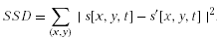
The rate RREC is the rate that is required to encode the block with the entropy coder. QP is the quantization parameter used to adjust the quantization step size. It ranges from 0 to 51.
The motion vectors can be efficiently estimated by minimizing the functional
with
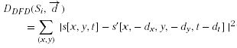
Hereby RMotion is the rate required to transmit the motion information, which consists of both displacement vector components dx and dy and the corresponding reference frame number dt. The following Lagrangian parameters lead to good results as shown in [3]:
As already discussed, the tools for increased error resilience, in particular those to limit error propagation, do not significantly differ from those used for compression efficiency. Features like multi-frame prediction or macroblock intra coding are not exclusively error resilience tools. This means that bad decisions at the encoder can lead to poor results in coding efficiency or error resiliency or both. The selection of the coding mode for compression efficiency can be modified taking into account the influence of the random lossy channel. In this case, the encoding distortion is replaced by the expected decoder distortion. The computation of the expected distortion is given in [6, 7].
3.1 Coding efficiency
A detailed comparison of the coding efficiency of different video coding standards is given for video streaming, video conferencing, and entertainment-quality applications in [3, 8, 9]. All encoders are rate-distortion optimized using rate constrained encoder control. For video streaming and video conferencing applications, test video sequences in CIF (352×288 pixels, progressive) and in the QuarterCIF (176×144 pixels, progressive) are used. For entertainment-quality applications, sequences in ITU-R 601 (720×576 picture elements, interlaced) and High Definition Television (HDTV, 1280 × 720 pixels, progressive) are used. The coding efficiency is measured by average bit rate savings for a constant peak signal to noise ratio (PSNR). Therefore the required bit rates of several test sequences and different qualities are taken into account (Figure 2).
For entertainment-quality applications, the average bit rate saving of H.264/AVC compared to MPEG-2 Video ML@MP and HL@MP is 45% on average. A part of this gain in coding efficiency is due to the fact that H.264/AVC achieves a large degree of removal of film grain noise resulting from the motion picture production process. However, since the perception of this noisy grain texture is often considered to be desirable, the difference in perceived quality between H.264/AVC coded video and MPEG- 2 coded video may often be less distinct than indicated by the PSNR-based comparisons, especially in high-quality, high-resolution applications such as High-Definition DVD or Digital Cinema.
3.2 Hardware complexity
Greater complexity of H.264/AVC means more processing power is needed for encode/decode, hence a higher VLSI implementation cost. Assessing the complexity of a new video coding standard is not a straightforward task: its implementation complexity heavily depends on the characteristics of the platform (e.g., DSP processor, FPGA, ASIC) on which it is mapped. In this section, the data transfer characteristics are chosen as generic, platform independent, metrics to express implementation complexity. This approach is motivated by the data dominance of multimedia applications [10,12,13,14].
Both the size and the complexity of the specification and the intricate interdependencies between different H.264/AVC functionalities, make complexity assessment using only the paper specification unfeasible! Hence the presented complexity analysis has been performed on the executable C code produced by the JVT instead. As this specification is the result of a collaborative effort, the code unavoidably has different properties with respect to optimization and platform dependence. Still, it is our experience that when using automated profiling tools yielding detailed data transfer characteristics on similar specifications (e.g., MPEG-4) meaningful relative complexity figures are obtained. The H.264/AVC JM2.1 code is used for the reported complexity assessment experiments [8].
The test sequences used in the complexity assessment are: Mother&Daughter 30Hz QCIF, Foreman 25Hz QCIF/CIF, and Mobile&Calendar 15Hz CIF (bit rates ranging from 40 Kbits/s to 2 Mbits/s for the complex ones). A fixed quantization parameter setting has been assumed.
Complexity analysis of some major H.264/AVC encoding tools:
1. Variable Block Sizes: using variable block sizes affects the access frequency in a linear way: more than 2.5% complexity increase2 for each additional mode. A typical bit rate reduction between 4 and 20% is achieved (for the same quality) using this tool, however, the complexity increases linearly with the number of modes used, while the corresponding compression gain saturates.
2. Hadamard transform: the use of Hadamard coding results in an increase of the access frequency of roughly 20%, while not significantly impacting the quality vs. bit rate for the test sequences considered.
3. RD-Lagrangian optimisation: this tool comes with a data transfer increase in the order of 120% and improves PSNR (up to 0.35 dB) and bit rate (up to 9% bit savings). The performance vs. cost tradeoff when using RD techniques for motion estimation and coding mode decisions inherently depends on the other tools used. For instance, when applied to a basic configuration with 1 reference frame and only 16×16 block size, the resulting complexity increase is less than 40%.
4. B-frames: the influence of B frames on the access frequency varies from -16 to +12% depending on the test case and decreases the bit rate up to 10%.
5. CABAC: CABAC entails an access frequency increase from 25 to 30%, compared to methods using a single reversible VLC table for all syntax elements,. Using CABAC reduces the bit rate up to 16%.
6. Displacement vector resolution: The encoder may choose to search for motion vectors only at 1/2 pel positions instead of 1/4 pel positions. This results in a decrease of access frequency and processing time of about 10%. However, use of 1/4 pel motion vectors increases coding efficiency up to 30%.
7. Search Range: increasing both reference frame numbers and search size leads to higher access frequency, up to approximately 60 times, while it has a minimal impact on PSNR and bit rate performances.
8. Multiple Reference Frames: adopting multiple reference frames increases the access frequency according to a linear model: 25% complexity increase for each added frame. A negligible gain (<2%) in bit rate is observed for low and medium bit rates, but more significant savings can be achieved for high bit rate (up to 14%).
9. Deblocking filter: The mandatory use of the deblocking filter has no measurable impact on the encoder complexity. However, the filter provides a significant increase in subjective picture quality.
For the encoder, the main bottleneck is the combination of multiple reference frames and large search sizes. Speed measurements on a Pentium IV platform at 1.7 GHz with Windows 2000 are consistent with the above conclusions.
Complexity analysis of some major H.264/AVC decoding tools:
1. CABAC: the access frequency increase due to CABAC is up to 12%, compared to methods using a single reversible VLC table for all syntax elements. The higher the bit rate, the higher the increase.
2. RD-Lagrangian optimization: the use of Lagrangian cost functions at the encoder causes an average complexity increase of 5% at the decoder for middle and low–rates while higher rate video is not affected (i.e. in this case, encoding choices result in a complexity increase at the decoder side).
3. B-frames: the influence of B-frames on the data transfer complexity increase varies depending on the test case from 11 to 29%. The use of B-frames has an important effect on the decoding time: introducing a first B-frame requires an extra 50% cost for the very low bit rate video, 20 to 35% for medium and high bite-rate video. The extra time required by second B-frame is much lower.
4. Hadamard transform: the influence on the decoder of using the Hadamard transform at the encoder is negligible in terms of memory accesses, while it increases the decoding time up to 5%.
5. Deblocking filter: The use of the mandatory deblocking filter increases the decoder access frequency by 6%.
6. Displacement vector resolution: In case the encoder sends only vectors pointing to 1/2 pel positions, the access frequency and coding time decrease about 15%.
H.264/AVC Profiles | Target applications | Decoder complexity increase over MPEG-2 | Estimates of efficiency improvements over MPEG-2
Baseline | low delay applications, video phone, mobile | 2.5 X more complex | 1.5 x better
Extended | mobile, streaming | 3.5 X more complex | 1.75 x better
Main | interlaced video applications, broadcast, packaged media | 4.0 X more complex | 2.0 x better
Table 1. Estimates of H.264/AVC decoder complexity.
In relative terms, the encoder complexity increases with more than one order of magnitude between MPEG-4 Part 2 (Simple Profile) and H.264/AVC (Main Profile) and with a factor of 2 for the decoder. The H.264/AVC encoder/decoder complexity ratio is in the order of 10 for basic configurations and can grow up to 2 orders of magnitude for complex ones, see also [9]. The efficient use modes are reflected in the choice of the tools and parameter settings of the H.264/AVC profiles.
4 Concluding remarks
Video coding standard H.264/AVC still uses the concept of block-based motion compensation. However, it provides some significant changes:
- enhanced motion compensation capability using high precision and multiple reference frames,
- use of an integer DCT-like transform instead of DCT,
- enhanced adaptive entropy coding including arithmetic coding,
- adaptive in-loop deblocking filter.
All these coding tools of H.264/AVC when used in an optimized mode allow for bit savings of about 50% compared to previous video coding standards like MPEG-4 and MPEG-2 for a wide range of bit rates and resolutions. However, these savings come at the price of an increased complexity.
The decoder is about 2 times as complex as an MPEG-4 Visual decoder for the Simple profile, and the encoder is about 10 times as complex as a corresponding MPEG-4 Visual encoder for the Simple profile. The H.264/AVC Main profile decoder suitable for entertainment applications is about four times more complex than MPEG-2. Given the performance increase of VLSI circuits since the introduction of MPEG-2, H.264/AVC today is less complex than MPEG-2 in 1994.
The encoder/decoder complexity ratio is in the order of 10 for basic configurations and can grow up to 2 orders of magnitude for complex ones. The encoder complexity depends largely on the algorithms for motion estimation as well as for the rate-constrained encoder control (the main bottleneck is the combination of multiple reference frames and large search sizes). The performance vs. cost tradeoff when using RD techniques for motion estimation and coding mode decisions inherently depends on the other tools used.
The experiments have shown that, when combining the new coding features, the relevant implementation complexity accumulates while the global compression efficiency saturates. An appropriate use of the H.264/AVC tools leads to roughly the same compression performance if all the tools would be used simultaneously, but with a considerable reduction in implementation complexity (a factor 6.5 for the encoder and up to 1.5 for the decoder). The efficient use modes are reflected in the choice of the tools and parameter settings of the H.264/AVC profiles, systematized in this paper.

References:
[1] K.R.Rao, Z.S.Bojkovic, D.A.Milovanovic, Multimedia communication systems: techniques, standards and networks, Prentice Hall, 2002.
[2] K.R.Rao, Z.S.Bojkovic, D.A.Milovanovic, Introduction to multimedia communications: applications, middleware, networking, Wiley, 2004.
[3] T.Wiegand, H.Schwarz, A.Joch, F.Kossentini, Rate-constrained coder control and comparison of video coding standards, IEEE Tran. CSVT, vol. 13, pp. 688–703, July 2003.
[4] G.J.Sullivan, T.Wiegand, Rate-distortion optimization for video compression, IEEE Signal Processing Magazine, vol. 15, pp. 74–90, Nov. 1998.
[5] T.Wiegand, B.Girod, Lagrangian multiplier selection in hybrid video coder control, in Proc. of ICIP 2001, Thessaloniki, Greece, Oct. 2001.
[6] R.Zhang et al., Video coding with optimal inter/intra-mode switching for packet loss resilience, IEEE JSAC, vol.18, no.6, pp.966–976, July 2000.
[7] T.Stockhammer, D.Kontopodis, T.Wiegand, Rate-distortion optimization for H.26L video coding in packet loss environment, in Proc. Packet Video Workshop 2002, Pittsburgh, PY, April 2002.
[8] J.Ostermann et al., Video coding with H.264/AVC: tools, performance and complexity, IEEE Circuits and systems Magazine, pp.7-28, First Quarter 2004.
[9] S.Saponara, C.Blanch, K.Denolf, J.Bormans, The JVT advanced video coding standard: Complexity and performance analysis on a tool-by-tool basis, Packet Video Workshop (PV’03), Nantes, France, April 2003.
[10] F.Catthoor, et al., Custom memory management Methodology, Kluwer Academic Publishers, 1998
[11] L.Nachtergaele et al., System-Level power optimization of video codecs on embedded cores: A systematic approach, Journal of VLSI Signal Processing, vol.18, no.2, pp.89–111, 1998.
[12] V.Lappalainen et al., Optimization of emerging H.26L video encoder, in Proc. IEEE SIPS’01, Sept. 2001, pp. 406–415.
[13] V.Lappalainen, A.Hallapuro, T.Hamalainen, Performance analysis of low bit rate H.26L video encoder, in Proc. IEEE ICASSP'01, May 2001, pp. 1129–1132.
[14] M.Horowitz, A.Joch, F.Kossentini, A.Hallapuro, H.264/AVC baseline profile decoder complexity analysis, IEEE Tran. CSVT, vol.13, no.7, pp.715–727, 2003.

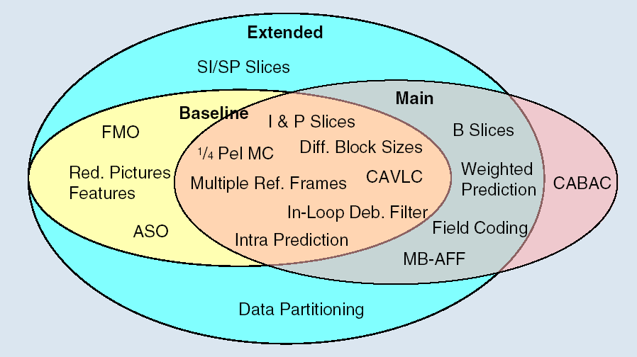
Figure 1. H.264/AVC profiles and corresponding tools.

a)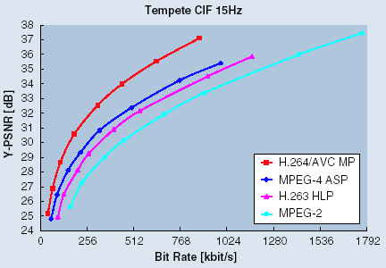b)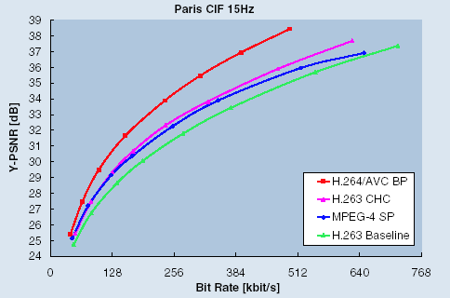
Figure 2. Luminance PSNR versus average bit rate and average bit rate savings for different coding standards, measured for the test sequence: a) Tempete for video streaming applications, and b) Paris for video conferencing applications [8].

