Active resource management approach to distributed call admission control

PIETRO SALVIA
GIUSEPPE BIANCHI
Dipartimento di Ingegneria Elettrica
Viale delle Scienze 9, 90128 Palermo
Università di Palermo.
ITALY

Abstract: - We propose an active resource management approach to distributed call admission control. We focus on the scenario in which a generic ISP (Internet Service Provider) wants to offer two services to its customers: a voice-over-ip service and a multimedia service in which is guaranteed the QoS at an exact time-of-day. The ISP manages a backbone DiffServ domain in which core routers are able to support distributed admission control.
In this scenario the use of distributed admission control is not sufficient and there is the need of an active resource management system (ARMS) that manages dynamically the bandwidth in terms of redistribution between the two services.
In particular, when a multimedia user wants to use the bandwidth agreed in the static SLA, the ARMS has to reduce the bandwidth allocated for the VoIp users. Such reduction is made by the lowering of the threshold of the number of users admissible by the distributed admission control procedure. In this paper we present a mathematical model of such network dynamics and an estimate of the optimal ΔT necessary to reduce the flows in the system of a preestablished number. A simulation analysis is also presented.

Key-Words: - DiffServ, Admission Control, SLA, Policy

1 Introduction
This paper analyses the problem of the congestion avoidance in the context of DiffServ networks.
The differentiated service approach provides QoS guarantees by treat individual packet with different per-hop-behaviors based on the marking of the DSCP (DiffServ code point). Nevertheless the problem of the congestion avoidance is not resolved in the based DiffServ architecture. Different solutions have been proposed to solve the problem. Distributed call admission control (DCAC) seems the solution that presents the main advantages. In such approach, the decisions in order to admit or reject a packet is based on the success completion of a probing phase between the edge nodes of the domain, on the other hands core routers independently measure the congestion status of the connected links, and upon congestion, they start dropping probing packets. This solution presents the main advantage in scalability, in fact is not required that core routers provide any per-flow state support and neither that core routers exchange explicit signaling messages.
Nevertheless, distributed admission control presents some limits and is not suitable to allow an ISP to offer complex multimedia services to his customers. In particular if the ISP wants to offer a VoIp service and a multimedia service in which is guaranteed the QoS at an exact time of day, with the use of only DCAC procedure could happen that when the multimedia user starts his session, the network is in a congestion state and the SLA is not guaranteed.
Two approaches can be followed to solve the problem:
  - Allocate permanently the bandwidth for the multimedia users.
  - Manage dynamically the bandwidth by the use of an active resource management system.
Clearly the first approach is inefficient in terms of throughput of the network, so in this paper we analyze the second solution.
The rest of the paper is organized as follow. Section 2 describes the reference network scenario, Section 3 presents a mathematical model of the network dynamics in presence of active resource management, Section 4 presents the simulation scenario and parameters, Section 5 present the management system operations. Conclusions are drawn in Section 6.

2 Reference Network Scenario
The reference network scenario is presented in figure 1.
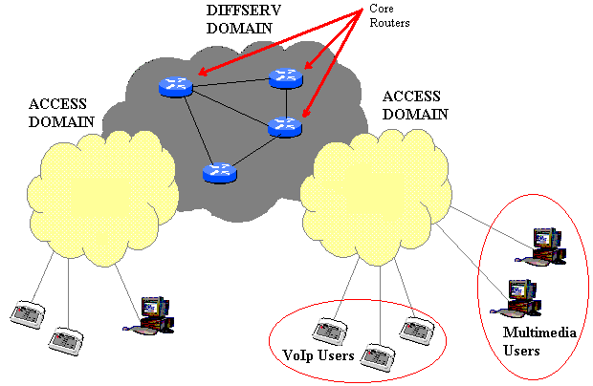
Fig. 1 – Network reference scenario

It consists of different access network domains at the network edge, separated by a backbone DiffServ domain placed in the network core.
In figure we have represented two types of users: VoIp and multimedia users.
We suppose that VoIp users are predominant in number and for these the distributed admission control procedure is used. We suppose also that the ISP stipulates static-SLA with a restricted group of multimedia users. Such contracts allow users to use a fixed bandwidth quantity at agreed time of day. At the end we suppose that both VoIp and multimedia users share a common quantity of bandwidth. So the problem that we want to analyze is the optimal redistribution of the bandwidth between these two kinds of users.
In particular we want that all the bandwidth is used to serve VoIp users and only when a multimedia user has to start his session, the necessary bandwidth is freed from the VoIp traffic. Moreover we suppose that VoIp users are controlled by the DCAC procedure, while multimedia users are not under the control of such procedure and is the ARM system that reserve the necessary bandwidth dynamically based on the information stored in the SLA.
Suppose to start our study from a situation in which all the bandwidth is allocated by the VoIp traffic, in absence of a management system if a multimedia user, that owns a SLA stipulated with the ISP, starts his session the QoS requirements could not be satisfied. So is mandatory the use of an ARM system that reconfigures the bandwidth based on the necessity of the multimedia users. In particular the ARM system has to lower the threshold of the VoIp users admissible in order to free the bandwidth necessary to the multimedia user. In this scenario, since is necessary an amount of time ΔT from the instant of the lowering of the threshold in order that the number of flows in the system go down to this value, the ARMS has to lower the threshold an amount of time before the multimedia user start his session.
So the ARM system has to realize the following requirements:

- It has to maintain a database with the information of the users that own a SLA for a multimedia session in a fixed range of time. Such information has to be stored in terms of time-of-day policies.
- Based on the estimation of the average flow duration and on the information stored in the database, it has to reconfigure the threshold of the number of users admissible in the core routers of the DiffServ domain.

In the next section we present a mathematical model of such network scenario and an evaluation of the optimal ΔT as a function of the average flow duration and of the two thresholds of the users admissible before and after the start of the multimedia session.

3 The Model
Suppose to analyze a generic core router that supports the MBAC (Measurement based admission control) mechanism and that the number of flows admissible is limited by a threshold K. Our analysis starts from a stationary situation in which the number of flows active is K. We have modeled the system as a queue system with K parallel servers as indicated in the following figure:

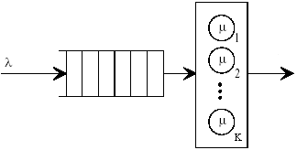

We analyze the model with exponential interarrival times with mean 1/λ and exponential service times with mean T_{h} = 1/μ.
Suppose to lower the threshold of admissible flows to a value K₁ with K₁ < K. It is clear that in the range of time ΔT from the instant of the lowering the threshold and the instant in which the number of flows in the system reaches the value K₁, no new flows are admitted.
Moreover we suppose that when the system reaches the value K₁ is constantly loaded with a number of flows equal to K₁ and so that is satisfied such equality:

K₁µ=λ

In such hypothesis the system can be modelled as a birth and death process in which the rate of born is null until the state K₁. In the following figure is represented the flow diagram of the system:
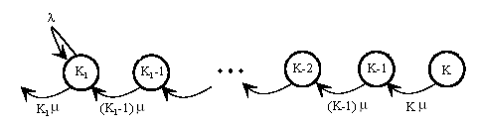

From the queuing theory the probability π_{i}(t) that at time t there are i customers in the system can be obtained by solving this set of differential equations:

π’_{i}(t) = -(λ_{i} + μ_{i})π_{i}(t) + λ_{i-1}π_{i-1}(t) + μ_{i+1}π_{i+1}(t) i ≥ 1
π’₀(t) = -λ₀π₀(t) + μ₁π₁(t)

Since λ_{i} = 0 and μ_{i} = iμ ∀ i != K₁ and we are interested on the evolution of the system from the initial state with K customers to the state with K₁ customers it follows that π₀(t) = 0 ∀ t.
In such hypothesis the set of differential equations becomes:

π’_{i}(t) = -iμπ_{i}(t) + (i+1)μπ_{i+1}(t) K ≤ i < K₁
π’_{i}(t) = λ_{i}π_{i}(t)-iμπ_{i}(t) + (i+1)μπ_{i+1}(t) i = K₁

Since, also, π_{k+1}(t) = 0 ∀ t, in fact we have supposed that initially the threshold of admissible customers is K, and K₁µ=λ ,we obtain:

π’_{k}(t) = -kμπ_{k}(t) (1)
π’_{i}(t) = -iμπ_{i}(t) + (i+1)μπ_{i+1}(t) (K-1) ≤ i < K₁ (2)
π’_{i}(t) = (i+1)μπ_{i+1}(t) i = K₁ (3)

Solving the equation (1) by imposing the initial condition π_{k}(0) = 1 (in the hypothesis to translate the time axis to have at the time t=0 the core router loaded with K customers) we obtain:

π_{k}(t) = e^{-kμt}

From this result we have solved by iteration the set of differential equations (2) until obtain the following general solution:

$π_{k−s}(t)=\frac{K!}{(K−S)!}e^{−μ(K−s)t}\sum_{i=0}^{S}{(−1)^{(S−i)}\frac{e^{−μ(s−i)t}}{[(s−i)!](i!)}}$ 0 < S < K-K₁ (4)

The equation (3) is solved by substitution of (4) with S=K-(K₁+1)

$π_{k−s}(t)=\left[\frac{K!}{(K−S)!}\sum_{i=0}^{S−1}{(−1)^{(S−i)}\frac{e^{−μ(K−i)t}}{[(s−1−i)!](i!)(K−i)}+1}\right]$ S = K-K₁ (5)

In the following figures we have traced the evolution of the probability π_{k-s}(t) as a function of time for different K and S:
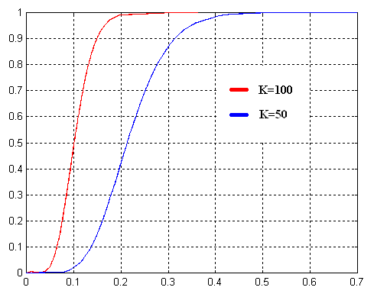
Fig. 2 – Probability versus time for different K and S=10

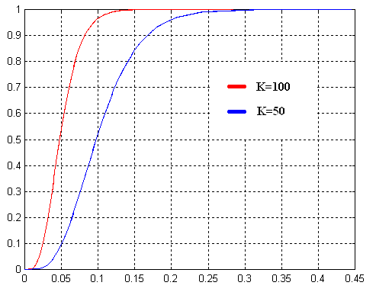
Fig. 3 – Probability versus time for different K and S=5

The probability reaches the value of 1 at the instant t:
$t_{\text{max}}≈3\frac{S}{K}T_{h}$ (6)

From the graphics we can see that for a value of t equal to $2\frac{S}{K}T_{h}$ the probability reaches a value higher than 90%.
Since in our analysis is mandatory the certainty to free the necessary bandwidth for the multimedia user, we want to find a conservative measure of the time necessary to reach such purpose. From the graphics in figure 2 and 3 we see that for a ΔT equals to 3(S/K)T_{h} the probability to have (K-S) flows is equal to 1 and we are sure to have freed the necessary bandwidth for the multimedia user. In such a way we obtain a right compromise between the optimal throughput of the network and the certainty to guarantee the SLA to the multimedia user.
In the following figures we have traced the evolution of the average value of probability π_{k-s}(t) as a function of time for different K and S:
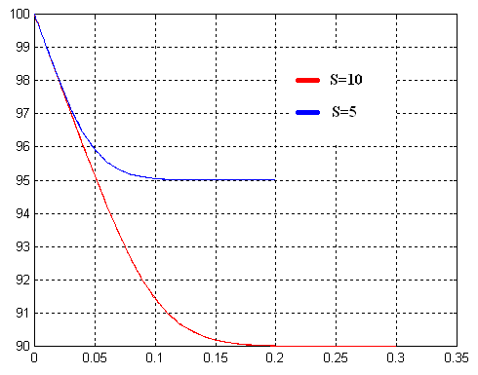
Fig. 4 – Average value versus time for K=100

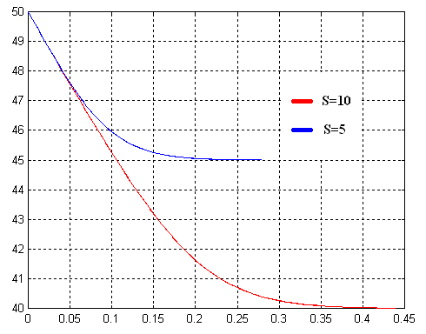
Fig. 5 – Average value versus time for K=50

From the graphics we can see that for a value of t equal to $2\frac{S}{K}T_{h}$ the number of flows reaches the value of threshold and so the formula (6) seems to be a conservative measure.

- Simulation Scenario
The network topology considered is show in the following figure:

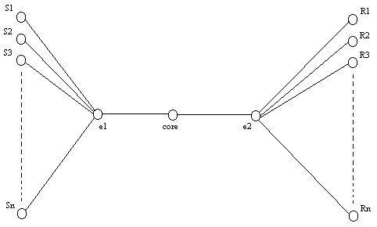

It consists of a n source nodes, two edge routers e1 and e2, a core router and n receiver nodes. We suppose that in this network scenario is used GRIP (Gauge&Gate reservation with independent probing) [1] [2] as distributed call admission control procedure. We have considered 300 constant bit rate (CBR) sources emitting at rate 20 Kbytes/s and call duration with mean value 2 minutes. We have fixed the number of admissible flows by the core router to a value K=100. We have considered a simulation scenario of 8 minutes in which the network is constantly loaded with 100 flows and S=10 and another scenario in which the network is constantly loaded with 100 flows and S=5. The call arrival is modeled as a Poisson arrival process. We suppose to decrease the threshold of admissible flows 3 minutes after the start of simulation. In such context we want to evaluate the amount of time ΔT necessary to reduce the number of flows in order to reach the new threshold in comparison with the theoretical results found in the paragraph 3.
In Fig. 4 and 5 we show the number of active flows versus the time t for the two cases examined.

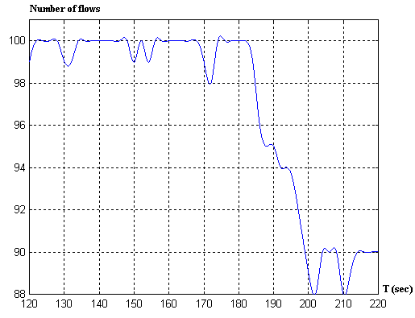
Fig. 6– Number of flows versus time (K=100 S=10)

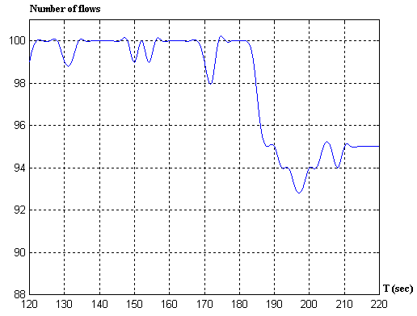
Fig. 7– Number of flows versus time (K=100 S=5)

From the graphics we can see that the number of users reaches the value of K-S in a time less then (6).
So the number of active flows decrease much faster in comparison with the theoretical result. This is an important result, in fact by the use of the formula obtained in the paragraph 3 the ISP is sure to decrease the number of VoIp users of a preestablished value without the risk to overload the network when the multimedia user starts his session. The management system operations are detailed in the next section.

- Management System Operations
Based on the considerations done in the preceding paragraph, the management system takes a fundamental role to guarantee the QoS requested by the multimedia users.
First, it has to maintain a database with the information of the multimedia users SLA (SLA database). At the same time it has to store the information of the number of VoIp users active in the system and the threshold of admissible users. The information of the VoIp users active in the system has to be stored in a database (Active sessions database) and constantly updated by the core routers that asynchronously report such status to the management system.
The architecture with the relative interactions is described in the following figure:

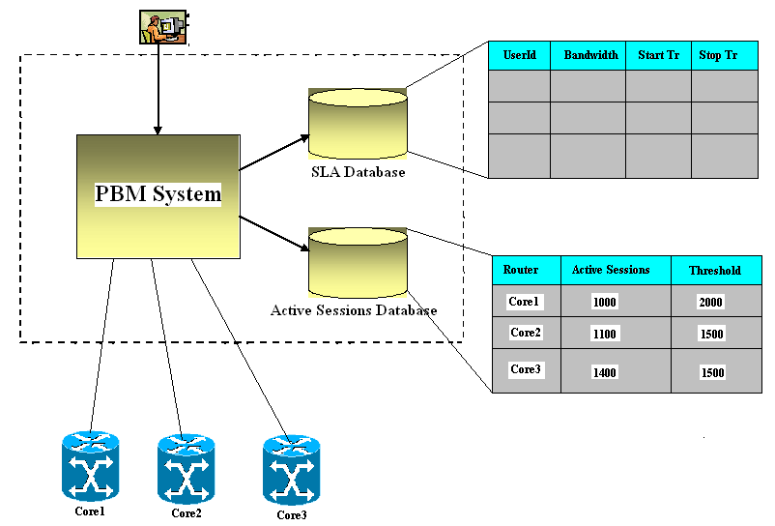

The management system by a periodic polling to the SLA and Active sessions database, gets the information about the active core router threshold and the active sessions, it also monitors the multimedia users that are on the point of transmit and reduces the threshold based on the amount of bandwidth requested by the multimedia users. When a multimedia user stops the transmission the threshold is increased. So both the active sessions and threshold change continually, the former is updated by the core router measurement module while the second by the management system. We can say that the dialogue between the core routers and the management system is essentially asynchronous. A protocol particularly suited for such kind of interaction is COPS (Common Open Policy Service) [3] [4] [5], that is used in the context of policy based management paradigm [6] [7].

- Conclusion
In this paper we have analyzed the problem of call admission control in the context of DiffServ networks. Although the distributed admission control procedure presents different advantages in this context, we have show the limits. We have proposed a framework based on an active resource management system to manage dynamically the bandwidth for particular class of users.
The solution proposed seems to be scalable, in fact the logic of lowering the threshold of the number of users admissible in the core routers of the DiffServ domain is concentrated in the centralized management system, while DiffServ routers need only to simple upgrade in order that the management system can perform the operation of SET on the threshold of users admissible and GET of the number of users active in the system.
Although, the proposed framework can be implemented in different ways, the use of a policy-based management system seems to be the optimal solution. In such a case is necessary to define the policy in order to model the dynamics of changing the number of users admissible in the core routers of the DiffServ domain.

References:

[1] G. Bianchi, N. Blefari-Melazzi, “Admission control over assured forwarding PHBs: a way to provide service accuracy in a DiffServ framework”, IEEE GLOBECOM 2001, San Antonio, Texas, November 2001, pp. 2561-2565
[2] G. Bianchi, V. Capaccio, N. Blefari-Melazzi, “Per flow signalling extension across DiffServ domains”, IFIP TC6/WG6.2 & WG 6.7 (Net-Con 2002), Paris, October 2002.
[3] D. Durham, Ed., J. Boyle, R. Cohen, S. Herzog, R. Rajan, A.Sastry "The COPS (Common Open Policy Service) Protocol", IETF RFC 2748, January 2000.
[4] J. Boyle, R. Cohen, D. Durham, S. Herzog, R. Rajan, A.Sastry, "COPS usage for RSVP ", IETF RFC 2749, January 2000.
[5] K. Chan, J. Seligson, D. Durham, S. Gai,K. McCloghrie,S. Herzog, F. Reichmeyer, R. Yavatkar, A. Smith, “COPS Usage for Policy Provisioning (COPS-PR)”, IETF RFC 3084, March 2001.
[6] Yavatkar, R., Pendarakis, D. and R. Guerin, "A Framework for Policy Based Admission Control", RFC 2753, January 2000.
[7] Strassner, J., and E. Ellesson, B. Moore, A. Westerinen, "Policy Core Information Model -- Version 1 Specification", RFC 3060, February 2001.

