On a versatile and costless OMR system

IOSIF I. ANDROULIDAKIS, MSc
Network Operations Center
University of Ioannina
GREECE

NIKOLAOS I. ANDROULIDAKIS, MSc in Management
Nottingham Trent University

Abstract: In the present work is presented a versatile and costless Optical Mark Recognition system. It is used to automate the import into a pc of data that emanate from multiple choice questionnaires. This becomes feasible by using a scanner providing speed and reliability advantages and at the same time ease of use against the traditional by hand method of import. Its main advantage is the ability to work with every single scanner of the market, needing no extra drivers whatsoever and no special colour printing of the forms. Furthermore, the user doesn’t have to mark manually the areas of interest as is done in most other OMR implementations. The program is also small and compact, easily fitting in a diskette. Following the introduction and the analysis, we are trying to give a clear analysis of the optical recognition algorithms that the program uses. Later the way of use is presented, accompanied by figures. Results from its pilot use follow as also an evaluation benchmarking comparing the traditional way of data import. It is shown that the time is decreased at least an order of size. Finally, ideas for the application’s future expansion are mentioned which already has begun in order to treat numbers and more complicated forms of data.

Key-Words: OMR, OCR, pattern recognition, scanner, questionnaire, gallop

1 Introduction
The size of the pool in a poll is one of the most important factors in order to get objective results [1]. However the import of questionnaire’s data in the computer for further analysis, is a tedious, precarious and boring process, especially when the number of questionnaires increases.
Our solution can automate this process providing speed, reliability and ease of use against the by hand import method. It allows the automatic import into the computer of multiple choice questionnaires answers using a scanner. The data can emanate from a poll, a gallop, from experimental data or an examining process.

2 Analysis
OMR software is being used for many years. Most of the times though, it is used with specialized, dedicated Infra Red OMR scanners. These scanners are costly and can not be used for any other scanning purposes. The forms must be colour printed using red colours which is not practical since it is not possible to just photocopy the forms. Software using ordinary scanners for OMR purposes is also known (mainly in the way of pluggins and add-ons for scanning and OCR commercial software suites). A main disadvantage of such implementations is the fact that the user has to manually mark some pivot areas so that the program will be able to orientate the sheet and extract scale information. As it will be shown later, our software works completely by itself, not needing any user interaction and guidance regarding the pivot areas.
Algorithms and more complicated implementations providing OCR functionality can be found in the references [2],[3]. Our solution though, doesn’t need OCR functionality. This has helped reduce the programs size which can easily fit in a single diskette. It also gives a clear speed advantage over such code. Regarding the requirements in hardware and software, a personal computer with every version of MS-Windows and a scanner installed is enough. With the additional use of automatic feeder of pages the speed of import of data can exceed the volume of 10 pages/min, minimising thus the unproductively spent time. It must be noticed that no special and expensive dedicated scanner (i.e. Infra Red OMR scanner) is needed. Accordingly, the forms themselves can be printed or photocopied in every single b&w printer and do not need special processing and colour (red) printing as is the case with specialized IR OMR scanners.
The application was created using Borland Delphi environment but uses standardised system operations and calls so that it can easily be compiled in any other computer language. In the present publication it can process up to 40 questions of 6 possible answers each as well as to recognize the s/n of the sheet. The results are stored in ASCII form file so that their later import and processing is possible from any other program (e.g Excel, SPSS, Origin). It must be mentioned that no other post process correcting techniques [2] need be used thanks to the simplicity of the algorithm and the inherent accuracy.
Figure shows an example of questionnaire as well as the way with which its serial number is marked. This form can easily be changed, both in the number of questions and possible answers and to the orientation of them. A form designer is under construction so that the user can completely parameterize the form suiting his needs.

3 Algorithms
The application’s operation begins with the localisation of page limits using three out of four special circles that mark the corners of the page. The algorithm does not use any artificial intelligence methods as proposed in [4] Scale information of the scanned electronic document concerning the prototype is derived from these circles’ centres coordinates. Any possible rotation and improper import to the scanner’s feeder is found and is dynamically and effectively corrected with suitable rotation of the system’s axes. The initial dimensions and size and regions of interest are known from the printed form therefore the program maps the coordinates of the scanned document elements to the coordinates of the initial form (with change of scale and application of a rotation of axes). It then continues to examine the regions of interest (the boxes containing the answers)
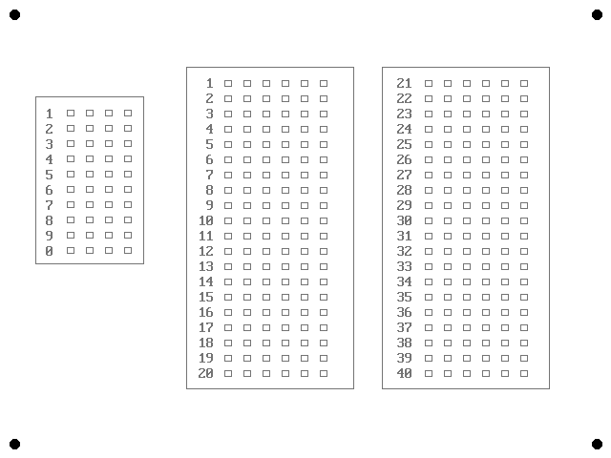

Example for s/n 2643 questionnaire:

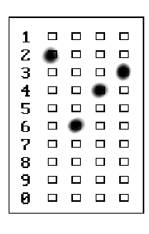

Figure 1: Questionnaire example

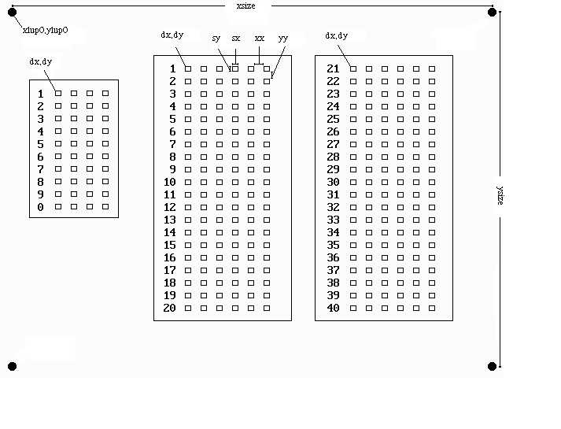

Figure 2: Points of interest in the original document

More analytically, as is shown in Figure 2, the printed questionnaire contains the following points (pivot marking points) whose coordinates and dimensions are known from the program and characterize the particular questionnaire type.

xlup0, ylup0: First reference circle’s centre coordinates.
xsize: Two upper reference circles’ Horizontal centres’ distance
ysize: Two left reference circles’ Vertical centres’ distance
dx, dy: Beginning coordinates of the answers boxes
sx: Horizontal dimension of answers’ box
sy: Vertical dimension of answers’ box
xx: Horizontal distance between answers’ boxes
yy: Vertical distance between answers’ boxes

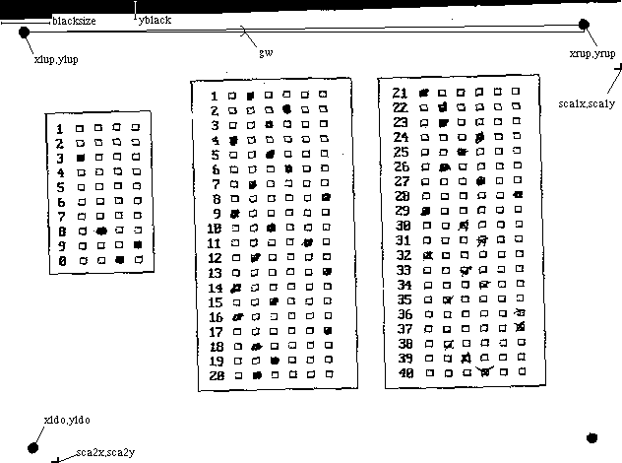

Figure 3: Points of interest in the scanned document

Coming into the scanned henceforth document, the form that appears in figure 3 is presented. The points of interest for the program are now following:
xlup, ylup: Centre of upper left reference circle
xrup, yrup: Centre of upper right reference circle
xldo, yldo: Centre of down left reference circle of report
gw: The angle that the two upper reference circles form, that is the form’s rotation angle

blacksize: The biggest acceptable black region size of scan margin
yblack: Height from which the application of algorithm detection begins

sca1x, sca1y: The first region of reference circles detection
sca2x, sca2y: The second region of reference circles detection

The process includes the following steps:

1. Locating the three reference circles that mark the edges and export of their centres coordinates (xlup, ylup xrup, yrup xldo, yldo). This is accomplished by reading of the regions sca1x, sca1y and sca2x, sca2y in which regions the program tries to locate clusters of black points encompassed by white background. It must be noted that this process is completely automatic needing no user intervention. Most other commercially available programs depend on user intervention.

2. Finding of angle of rotation according to the types
kliu: = (yrup - ylup)/(xrup - xlup)
gw: = ARCTAN(kliu)

3. Rotation of axes: the points that were found are rotated giving points xlup1, ylup1 xrup1, yrup1 xldo1, yldo1 so that their orientation is identified as follows:

xlup1: = xlup * COS (gw) + ylup * SIN (gw)
ylup1: = - xlup * SIN (gw) + ylup * COS (gw)
xrup1: = xrup * COS (gw) + yrup * SIN (gw)
yrup1: = - xrup * SIN (gw) + yrup * COS (gw)
xldo1: = xldo * COS (gw) + yldo * SIN (gw)
yldo1: = - xldo * SIN (gw) + yldo * COS (gw)

4. Scale extraction

fx: = (xrup1 - xlup1)/xsize
fy: = (yldo1 - ylup1)/ysize

5. Reading of regions: Knowing the elements presented earlier the program checks whether the boxes are shaded in any way or not.
The results are given in a simple ASCII file so that the import in every known program such as Excel, SPSS etc is possible
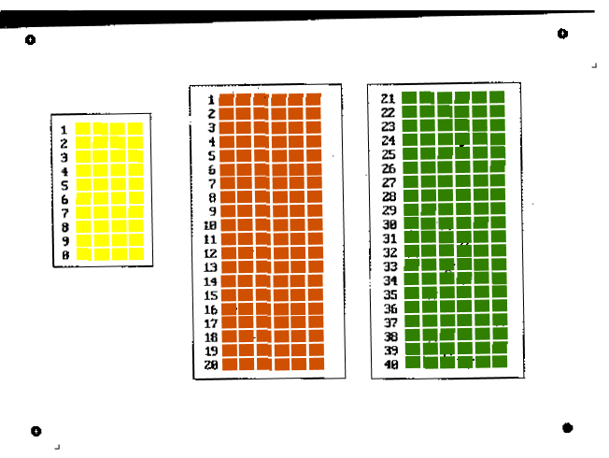

Figure 4: Processing accuracy

4 User Interface
Initially, the user imports the date and the number of questions. He then supplies the scanner with the sheets to scan and presses the scan button. Twain drivers are called and the scanner’s menu gets in the screen (depending on the driver and the programs that are installed). The user has to enter the initial information, that is 100 dpi resolution, B&W 1bit black and white, scan region [5]. These tuning remains active up to the end of program. It is enough therefore to press the scan button according to the program which already the user uses to scan of his documents. The sheet is rapidly scanned (because of the low resolution) and is also presented in the screen so that processing can start. Firstly the program finds the s/n and presents it to the user who can check just with a glance if it is right (figure 5). Selecting the OK button the processing continues and almost immediately the next page is imported for scanning. It is always possible not to register the questionnaire results should an error be found or if this is desirable for any other reason.
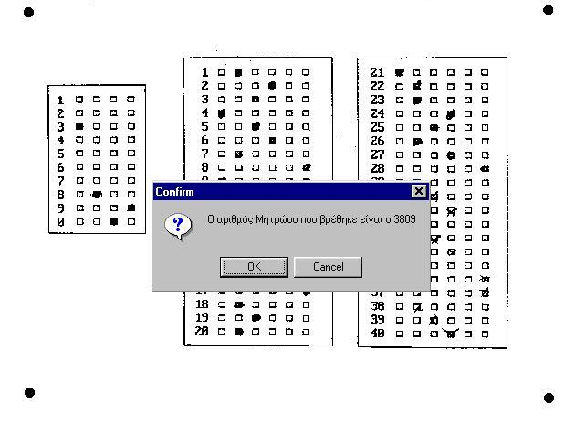
Figure 5: User interface

5 Evaluation
In order to do the evaluation of import precision, 100 questionnaires of 40 questions and 6 likely choices were used which were supplemented by 50 different individuals so as to have 50 different ways of marking. 98 of these questionnaires were scanned with success with the first time. 6 out of 98 were wrongly filled by the readers (not sufficient note of boxes, double registrations, etc) therefore our pool was 92 correctly supplemented questionnaires that is to say 92x40=3680 supplemented questions. After the processing 14 errors were found that give a precision rate of a percentage more than 99.5% For the evaluation of speed, in the same sample of questionnaires, a by hand import with simple reading chronometer was made yielding (at ~90 seconds per questionnaire) a total time for the 100 questionnaires of almost 2,5 hours. The automated system, using manual feeding of questionnaires to scanner needed less than 20 seconds for each questionnaire while using the automatic feeder [6] time was decreased to 8 seconds per sheet giving total time of 14 minutes for the processing of 100 questionnaires. It is clearly noted a 10times faster processing.

6 Conclusions
Previous analysis presented earlier shows clearly the advantages of using automated OMR procedures instead of manual. The main advantage of the presented software is the ability to work with every single scanner of the market, needing no extra drivers whatsoever. The program is also small and compact, easily fitting in a diskette. No special equipment is needed thus retaining a very low cost. The forms themselves need no special printing (IR dedicated OMR scanners need red ink forms), and they can be printed in every printer and photocopied in large quantities. Finally the algorithms can work and manage the pivot driving areas by themselves, freeing the user from the tedious and error prone task of manually marking these points. It must be noted that most commercially available programs depend on user intervention for the pivot marking

A second version of the program is now in its final stage able to grade multiple choice tests according to known right answers. Various other statistical data are also calculated such as the background of record of examined person and of an entire class, means, detection of cheating efforts, etc. Also, new algorithms will soon be incorporated so that the program will be able to read numbers and more complicated forms of data (e.g industrial drawings) while the complete parameterization of form-questionnaire from the user will be possible too.

7 References
[1] Saunders, M., Lewis, P., Thornhill, A., “Research Methods for Business Students”, 3rd edition, Prentice Hall, England, 2003

[2] Ramin Mehran, Amin Shali, Farbod Razzazi, “A Statistical Correction-Rejection Strategy for OCR Outputs in Persian Personal Information Forms”, pap. No. 466-261, WSEAS NNA-FSFS-EC 2003, May 29-31, 2003,
Vouliagmeni, Athens, Greece

[3] Ming Delie , Liu Jian, Tian Jinwen, “The Design and Implementation of a Chinese Financial Invoice Recognition System”, ID No. 623, WSEAS NNA-FSFS-EC 2002, February 11-15, 2002,
Interlaken, Switzerland

[4] Regina Bernhaupt, Sandra Schönet, “Using artificial neural networks as an image segmentation module of an OCR-system: A Preliminary Study”, ID no. 675, WSEAS NNA-FSFS-EC 2001, February 11-15, 2001, Puerto De La Cruz, Tenerife, Spain
[5] Jill Gilbert, “How to Do Everything With Your Scanner (How to Do Everything Series)”
McGraw-Hill Companies, 2001
[6] “Color Scanning Handbook, The: Your Guide to Hewlett-Packard Scanjet Color Scanners”, Prentice Hall PTR ,1997

