Self-tuning Multi-representing E-learning System (SMES) by Decision Maker Intelligent Agent (DMIA) for Increasing Training Effectiveness

Mohammad Hossein Nadimi

Academic Member of Computer Engineering Department,
Islamic Azad University of Najafabad, Esfahan, Iran

Abstract: If we consider S is a session of a class then there are i different representation for performing of S. But unfortunately teacher can select and represent one of them according to the background knowledge of students and learning specifications. If we consider selected representation in a class with M members as P_{s} then we can say that Ps is only suitable for N members of students of that class. Therefore training effectiveness of P_{s} is equal to N/M. we know that variety of student increase in the Distance Education by E-learning and selecting one representation for all students decrease training effectiveness. Fortunately in E-learning computer equipments provide multi-representing and we can perform a suitable representation on each student's computer.
In this article, my research is focused on investigating a Self-tuning Multi-Representing E-learning System (SMES). In this system we can store different representation for items of a class session. SMES has a Decision Maker Intelligent Agent (DMIA) for selecting suitable representation of a class session for each student. DMIA has a knowledge base that obtained from experienced teacher's knowledge. DMIA selects the suitable representation by use of the student's profile and its knowledge. SMES has a Knowledge discovery from Database (KDD) process. DMIA and KDD discover knowledge about the student by use of analysis the student's behavior during the representation and they can dynamically change the representation for better result also KDD is able to discover and add new regulations and knowledge to its knowledge base. Therefore SMES can tune itself for better decision making and increase training effectiveness in future selection.

Keywords: E-learning, Multi-representing, Self-tuning, Decision making, Intelligent agent, Training effectiveness.

1-Introduction
Suppose the course C divided into n session from S1 to Sn and today teacher wants to represent jth session (we show this session with S). Each session must cover some goals and therefore has a specific content that documented in explicit knowledge form. At beginning the teacher for representing of S, evaluate the background knowledge level of students with different ways such as pretest [9]. In a class with M member there are different groups (Q1…Qi) that students in these groups have the same background knowledge. An experienced teacher by use her/his tacit knowledge can represent suitable representation for each group (Q1…Qi) and whenever understanded that a session content is not effective then by use of her/his tacit knowledge can change it (for example : add some simple example). Thus an experienced teacher can consider P1 to Pi possible representation for i groups. Unfortunately the teacher can choose only one of these representations for each session such as S. if consider that the teacher selected P_{s} (1≤s≤i) from i possible representations (p1 to pi) for session S. this representation P_{s} is effective for group Qs and if Qs has N students then we can say that training effectiveness of P_{s} for S is N/M.
We know that variety of student increase in the Medical Education by E-learning and selecting one representation for all students decrease training effectiveness. Fortunately in E-learning computer equipments provide multi-representing and we can perform a suitable representation on each student's computer [1, 2, 6].
In this article, a Self-tuning Multi-Representing E-learning System (SMES) is proposed. SMES is a software program that can select and represent an effective representation for each student in their computers. SMES has a Presentation Data Base (PDB) and a Student Profile Data Base (SPDB). Different representations of each session are stored in PDB. SPDB is a Data Warehouse of students profile and their changes. SMES uses four types of processes: Student Interface, Learning Service, Decision Maker Intelligent Agent (DMIA) and Knowledge Discovery from Database (KDD). The Student Interface process communicates with students and gathers their information and sends students profile to Learning Service process. DMIA has a Knowledge Base (KB) that obtained from experienced teacher's knowledge. DMIA receive Student Profile Identifier (SPID) from Learning Service process and by use of KB selects the effective representation from PDB and transfer its Presentation Identifier (PID) to Learning Service process. KDD is important process that discovers knowledge and sends it to KB. KDD is the nontrivial process of identifying valid, novel, potentially useful, and ultimately understandable patterns in data [11]. Discovered knowledge is obtained by Data mining in SPDB. Each time a change occur in PID, DMIA send a trigger message to KDD. After that KDD by editing (edit, delete and update) KB provides Self-tuning.
In next sections of this article we explain the foundations that used in SMES and finally describe SMES model.

2-Why E-learning
Two important features of our century are:
a. Nowadays distance learning is growing in geometric progression. The National Center for Educational Statistics (NCES) projected that the high school graduates in US will grow from 2.5 million in 1995 to 3 million by 2008, an overall growth of 20% in 13 years or an average annual growth of 1.4%. On the other hand, IDC forecasted that the number of students taking up distance learning in US will grow to 2.2 million by 2002 from 753,640 in 1998, a growth of 192% in just 4 years or an average growth of 30.7% a year. So, we have strong reason to believe that the demand of distance learning has a growth rate in the region of 30–40%. Basing on these figures on growth rates of college students and distance learning students in US, it also indicates the trend of shifting preference in the mode of delivery from the traditional face-to-face or instructor-led to distance learning including e-learning. This is confirmed by the Gartner Group, which predicted that the ratio of number of E-learning students to that of instructor-led training is shifting from 25:75 in 2000 to 50:50 by 2002 (see Fig. 1) [7, 8].

Million Students

Fig. 1.Distance learning and college students in US (Source: NCES and IDC)

b. The Internet technology is presently enabling humankind to communicate with anyone, anywhere, and anytime globally, instantaneously, and yet inexpensively [3]. According to Lance Secret an, ‘‘it took 37 years for TV to reach 50 million homes and it took the Web 4 years to do the same.’’ It is projected by IDC that the number of Internet users will grow from 95.43 million in 1998 to 500 million in 2003, an annual growth of close to 40% (see Fig. 2). Such an excellent communication tool can be put to good use in education.
These two features lead us to use Internet technology for Distance learning and this is E-learning. E-learning has done away with the need of physical classes. Learners do not have to travel to a physical classroom to attend classes. Such convenient accessibility also does away other inconveniences related to attending a physical class, such as the hassles of taking public transport, going through traffic jams, and finding a parking bay, not to mention the undesirable consequences of aggravating the traffic congestion condition and air pollution problem and facing higher risks of traffic accident and car theft.

Other than providing the geographical freedom mentioned in the preceding paragraph, E-learning also provides temporal freedom—the freedom of learning anytime. Contrasting to the traditional face-to-face classroom mode, where the teachers dictate study timetable, the temporal freedom of E-learning allows learner-led timetable, where learners schedule their own study time to their convenience. The learners can, in fact, study late in the night and still have accessibility to references from the virtual library way pass the closing time of any physical library. The 24_7 (24 h/day, 7 days/week) availability of E-learning material further eases the scheduling of study timetable of the learners.

Internet Users (Million)

Fig. 2.Worldwide Internet users- 1998-2003 (Source: IDC).

Electronic learning has existed before the Internet came into existence. It was known as computer-based training (CBT), where training materials, some were even interactive, were stored in floppy disks and later in CD-ROMs. The CD-ROM version still exists today. The current Web-based form of E-learning is merely an enhanced version, capitalizing on the latest computer technologies to incorporate the capability of multimedia and global accessibility of the Web. The current Web-based learning can also be seen as an enhanced version of the age old, in fact century-old, distance learning. Some universities, including the University of Southern Queensland, Australia, even provide a mixed approach of tradition distance learning—where hardcopy materials are snail-mailed to students—and web-based learning to deliver their programs. The point to raise here is that delivering learning over a distance has been long accepted by people. The current electronic and enhanced version of distance learning is able to do the job better and therefore will be even widely accepted [3, 12].
US $ (Million)

Market Fig. 3. Growth of E-learning
There are many positive indications that E-learning can be a profitable business. Current E-learning market size is doubling annually through 2003 when it will reach US$11.5 million (see Fig. 3).

3-Decision Making
3-1-what is a decision?
A decision is a reasoned choice among alternatives. Each decision characterized by a decision statement, a set of alternatives and a set of decision making criteria. The decision statement states what we are trying to decide. A clear decision statement is important to intelligent decision making. The alternatives are the possible decisions we can make. Decision making criteria are what we want to optimize in a decision. It may not be possible to optimize all the decision criteria at the same time [5].Of course the optimization depends on the level of decision maker knowledge (see fig. 4.).
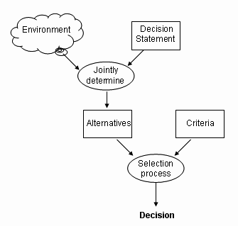
Fig. 4.Relationship Among Decision Statement, Alternative, and Criteria

3-2-the decision making process
Every decision must go through the three phases shown in figure 5 these phases called intelligence, design and choice. The intelligence phase consists of finding, identifying and formatting the problem or situation that calls for a decision. The end result of intelligence phase is the decision statement. In SMES the output of this phase is “what representation for a student must be selected? “
The design phase is where we develop alternatives. This phase may involve a great deal of search into a database. SMES produces alternatives by use of the PDB. In the choice phase, we evaluate the alternatives that we developed in the design phase and choose one of them. The end product of this phase is a decision and the quality of this decision is related to accuracy of evaluation function. SMES chooses one of alternatives by use of the knowledge in KB.

3-3-types of decision
Decision can be categorized in several ways. This categorization is useful because decisions of the same type often have common characteristics. we can organize decisions along two dimensions: the nature of the decision to be made and the scope of the decision itself. By dividing each dimension into three categories, we obtain nine decision types. The nature of the decision is categorized into: structured, unstructured and semi structured. The three levels of decision scope are as follows: strategic, tactical and operational. According to E-learning, decision scope in SMES is operational and decisions are unstructured or semi structured [5].

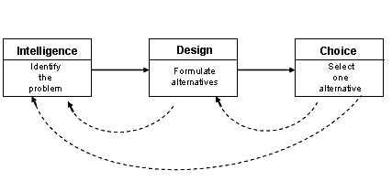
Fig. 5.Flow among Three Decision Phases

4-Decision Maker Intelligent Agent (DMIA)
An agent is anything that can be viewed as perceiving its environment through sensors and acting upon that environment through effectors. An Intelligent Agent (IA) is one that does the right thing [10]. IA has a knowledge base that knowledge of the environment is represented in it usually by first-order logic. DMIA is an IA for right decision making. In SMES the output of intelligence phase is “what representation for a student must be selected?” and the DMIA is designed for fulfill this decision statement. In choice phase, DMIA determine the group of learner by use of learner profile and selects effective representation from PDB for the student.

5-SMES model
In this article my research is focused on investigating a Self-tuning Multi-representing E-learning System (SMES). SMES has three layers: Learner layer, Decision layer and Data layer. There are three types of components defined in SMES: processes, stores and flows (see fig. 6.)

5-1-Processes
Processes (depicted as oval shapes in fig. 6.) are services, inputs and outputs of the learning system. Four types of processes are described in the model: Student Interface, Learning Service, DMIA and KDD. The Student Interface is a process that communicates with students and gathers information from them. This is done by interactive query. Learning Service is a process that receives profiles and behaviors from Student Interface and sends selected presentation item to it. Selected presentation items retrieved from Presentation Data Base (PDB) by means of Presentation Identifier (PID) that is provided by DMIA. Learning Service also stores students profile and their changes to Student Profile Data Base (STDB). DMIA is important process in this model that receives Student Profile Identifier (SPID) from Learning Service and by use of Knowledge Base (KB) selects an effective presentation from PDB and transfer PID to Learning Service. Knowledge Discovery from Database (KDD) is another important process that discovers knowledge and adds it to KB. Self-tuning in SMES is obtained by KDD; therefore in the following section we describe KDD process separately.

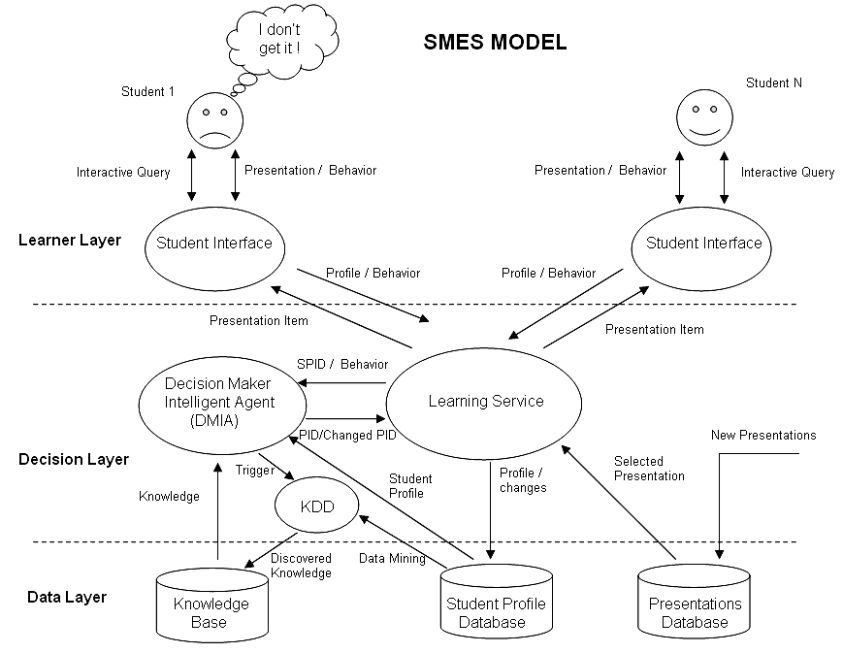

Fig. 6.Self-tuning Multi-representing E-learning System (SMES) model

5-1-1- KDD process
KDD is the nontrivial process of identifying valid, novel, potentially useful, and ultimately understandable patterns in data. Here, data are a set of facts (for example, cases in the SPDB), and pattern is an expression in some language describing a subset of the data or a model applicable to the subset [4, 11].
Hence, in our usage here, extracting a pattern also designates fitting a model to data; finding structure from data; or, in general, making any high-level description of a set of data.
The term process implies that KDD comprises many steps, which involve data preparation, search for patterns, knowledge evaluation, and refinement, all repeated in multiple iterations. By nontrivial, we mean that some search or inference is involved; that is, it is not a straightforward computation of predefined quantities like computing the average value of a set of numbers.
The discovered patterns should be valid on new data with some degree of certainty. We also want patterns to be novel (at least to the system and preferably to the user) and potentially useful, that is, lead to some benefit to the user or task. Finally, the patterns should be understandable, if not immediately then after some post processing. The KDD process is interactive and iterative, involving numerous steps with many decisions made by the user. Here, we outline some of its basic steps:
First is developing an understanding of the application domain and the relevant prior knowledge and identifying the goal of the KDD process from the customer’s viewpoint. Second is creating a target data set: selecting a data set, or focusing on a subset of variables or data samples, on which discovery is to be performed. Third is data cleaning and preprocessing. Basic operations include removing noise if appropriate, collecting the necessary information to model or account for noise, deciding on strategies for handling missing data fields, and accounting for time-sequence information and known changes. Fourth is data reduction and projection: finding useful features to represent the data depending on the goal of the task. With dimensionality reduction or transformation methods, the effective number of variables under consideration can be reduced, or invariant representations for the data can be found. Fifth is matching the goals of the KDD process (step 1) to a particular data mining method. For example, summarization, classification, regression, clustering, and so on. Sixth is exploratory analysis and model and hypothesis selection: choosing the data mining algorithm(s) and selecting method(s) to be used for searching for data patterns.
This process includes deciding which models and parameters might be appropriate (for example, models of categorical data are different than models of vectors over the reels) and matching a particular data-mining method with the overall criteria of the KDD process (for example, the end user might be more interested in understanding the model than its predictive capabilities). Seventh is data mining: searching for patterns of interest in a particular representational form or a set of such representations, including classification rules or trees, regression, and clustering. The user can significantly aid the data-mining method by correctly performing the preceding steps. Eighth is interpreting mined patterns, possibly returning to any of steps 1 through 7 for further iteration. This step can also involve visualization of the extracted patterns and models or visualization of the data given the extracted models.
Ninth is acting on the discovered knowledge: using the knowledge directly, incorporating the knowledge into another system for further action, or simply documenting it and reporting it to interested parties. This process also includes checking for and resolving potential conflicts with previously believed (or extracted) knowledge.
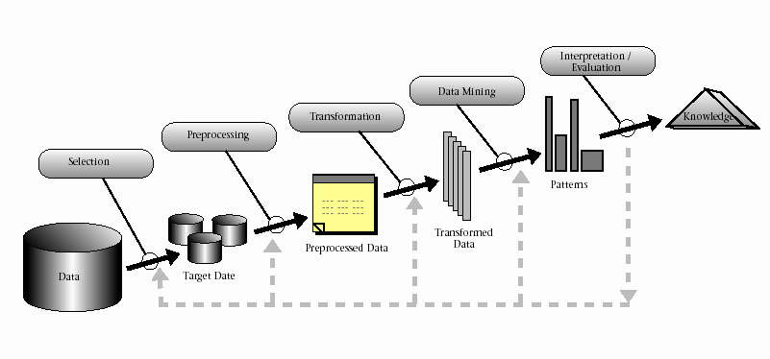
Fig. 7. Knowledge Discovery from Database (KDD) process

The KDD process can involve significant iteration and can contain loops between any two steps. The basic flow of steps (although not the potential multitude of iterations and loops) is illustrated in figure 7. Most previous work on KDD has focused on step 7, the data mining. However, the other steps are as important (and probably more so) for the successful application of KDD in practice. Having defined the basic notions and introduced the KDD process, we now focus on the data-mining component, which has, by far, received the most attention in the literature [4].

5-2-Stores
Three types of stores (represent as cylinder shape in fig) are used in this model. PDB is a database that stores presentations of class sessions. SPDB is subject oriented, non volatile, and time-variant data store (where the term non volatile means that, once inserted, data cannot be changed, though it might be deleted). Thus SPDB is a Data Warehouse. We save student profile in it. Kb is consisting of experienced teacher knowledge and educational rules.

5-3-Flowes
Flows are described in term of connectivity and the type of information exchanged. These are illustrated as arrowed lines between the processes and stores in SMES model (see fig. 6.). Essentially, flows depict the interactions that take place between the various processes and stores.
6. Conclusion
Distance learning is generally used in schools and in the academy in order to reduce cost, reach as large an audience of geographically distanced students as possible, allows students who are unable (physically) to come to the learning institution a chance to learn, and allow each student to progress at his/her own appropriate individual rate.
The main issue in the research is E-learning and its benefits. My research is focused on investigating a Self-tuning Multi-Representing E-learning System (SMES). Multi-representing achieved by SMES because Learning Service process interact with many Student Interface processes and provide effective presentation for each of them. Self-tuning is another achievement of this model. This feature is obtained through two ways:
a. DMIA by receiving behaviors from Learning Service process and consult with KB, choose another PID that has more training effectiveness.
b. Each time a change occur in PID, DMIA send a trigger message to KDD. After that KDD by editing (edit, delete and update) KB provides this feature.
In E-learning, the nature of learners is dynamic and their profiles' information is uncertain. Therefore we recommend to E-learning software developers that use the Intelligent Agent for decision making and KDD methods for uncertainty management. The Internet is the fastest growing technology in terms of number of users and E-learning is based on it. Therefore E-learning is the most important platform in distance learning and we must take it into consideration seriously.

References
[1] C. Bouras & T. Tsiatsos, “pLVE. Suitable Network Protocol Supporting Multi-User Virtual Environments In Education”, International Conference on Information and Communication Technologies for Education (ED-ICT), Vienna, December 7–9, 2000.
[2] Ch. Bouras et al. “Virtual european school-VES”, In Proceedings of IEEE Multimedia Systems ’99, Special Session on European Projects. Florence, Italy, June 7–11, 1999.
[3] Chew Seong Cheong, “E-learning—a provider’s prospective”, Market Development, Informatics Group Malaysia, 4th Floor, 65 Jalan Raja Bot, 41400 Klang, Selangor, Malaysia, Internet and Higher Education 4, 2002.
[4] C.J.Date, “An Introduction to DataBase Systems”, Seventh Edition, ( pp. 695-725), Addision Wesley, 2000.
[5] Efrem G. Mallach, “Decision Support and Data Warehouse Systems”, ( pp. 36-45), McGRAW-HILL International editions, 2000.
[6] Ganchev, I., O’Droma, M., & McDonnell, F, “Component-based platform for a virtual university information system.”, In: V. Mladenov (Ed.), Recent advances in computers, computing and communications, Electrical and computer engineering series of reference books and textbooks, ( pp. 185–190). Limerick, Ireland: WSEAS Press (ISBN 960-8052-62-9), 2002.
[7] National Center for Education Statistics (NCES), Projections of education statistics to 2008. In: D. E. Gerald & W. J. Hussar (Eds.). Chapter 3. Available online: http://nces.ed.gov/pubs98/pj2008/p98c03.html. Accessed 10/18/2001, 1998.
[8] National Center for Education Statistics (NCES), Projections of education statistics to 2008. In: D. E. Gerald & W. J. Hussar (Eds.). Figure 30. Available online: http://nces.ed.gov/pubs98/pj2008/p98f30.html. Accessed 10/18/2001, 1998.
[9] Nonaka, I, “A dynamic theory of organisational knowledge creation”,Organization Science, 5(1),( pp. 14–37), 1994.
[10] Stuart Russell, Peter Norving, “Artificial Intelligence A Modern Approach”, (pp. 31-46), Prentice Hall Series in Artificial Intelligence, 1995.
[11] Usama Fayyad, Gregory Piatetsky-Shapiro, and Padhraic Smyth, “From Data Mining to Knowledge Discovery in Databases”, American Association for Artificial Intelligence, 1996.
[12] Virginio Cantoni, Massimo Cellario, Marco Porta. “Perspectives and challenges in e-learning: towards natural interaction paradigms”, Visual Languages and Computing 15, ( pp. 333–345), 2004.

