DESIGN OF A VOLTAGE CONTROL CHAOTIC COLPITTS OSCILLATOR

O. TSAKIRIDIS¹, E. ZERVAS² , E. LYTRA³, and J. STONHAM⁴
^{1,3,4}Dept. of Computer and Electronics, Brunel University, Uxbridge, Middx UB8 3PH, United Kingdom.
²Dept. of Electronics, TEI of Athens, Athens, Egaleo 12210, Athens, Greece.

Abstract: - A Voltage control Chaotic Colpitts Oscillator is presented. Compared to the classical Colpitts oscillator the Voltage control Chaotic Colpitts Oscillator (VCCO) can produce infinite chaotic patterns in a wide operational conditions. This is very useful in real implementation of chaotic communications schemes and especialy for coherent Chaos Shift Key (CSK) modulations. The main reason for that is twofold, first the simplicity of the proposed circuit, and second the electronic control of varicap diode affected circuit capacitance can give very short settling time from one operational point to another. Finally the use of an active component as a bipolar transistor will aid to simplify the synchronization of the system between the trasmitter and receiver. P-spice simulations and experiments performed up to 2 Mhz, demonstrate the effectiveness of VCCO scheme.

Key-words: Chaos, Colpitts Oscillator, Bipolar Transistor, Voltage Control Oscillator.

- Introduction

Chaos in the Colpitts oscillator, first reported in [1], has recently attracted a lot of interest due to its applications in encryption and modulation methods applied to communication systems. In a chaos shift key commu- nication system, M digital symbols are rempresented by chaotic signals generated from M dynamic systems or from one system with M different parameter values [2], [3]. In the binary case i.e., M = 2, the trasmitted signal essentially switches between two chaotic signals which are generated from two dynamic systems, or from one dynamic system having a parameter switched between two values, according to the digital symbol to be represented. Detection can take either a coherent form or a noncoherent form. In coherent detection, the receiver is required to reproduce the same chaotic signals sent by the transmitter, often through a “chaos synchronization” process which is unfortunately not easily implemented with sufficient robustness [4]. Once reproduced, the digital symbols can be recovered by standard correlation detection [5]. In noncoherent detection of CSK, however, the receiver does not have to reproduce the chaotic signals. Rather, it makes use of some distinquishable property of chaotic signals to

This work and its dissemination efforts co-funded by 75% from E.E. and 25% from the Greek Government under the framework of the Education and Initial Vocational Training Program – Archimedes.
determine the identity of the digital symbol being trasmitted. The most common exploited distinquisable property has been the bit energy [6].
In this paper we propose a Voltage control version of the Chaotic Colpitts oscillator. The proposed circuit adds functionality to the classical Chaos Colpitts Oscillator (CCO) idea that it produces two or more chaotic signals in a wide operational regime of the active component. The electronic control of the ocillator is a very efficient means of generating a large number of chaotic signals in a short settling time. Several proposed chaos-based modulation schemes, including QCSK [7],[8] and DNSK [9], require the generation of two different chaotic waveforms. The outline of this paper is as follows. Section 2 describes the circuit design, whereas simulation and experimental results are presented in Section 3. Finally Section 4 concludes the paper.

2. Circuit Design

The single ended Colpitts oscillator is shown in Fig. 1. The Colpitts oscillator is a combination of a transistor amplifier consisting of a single bipolar junction transistor (BJT), and an LC circuit used to feedback the output signal as it is depicted in Fig. 1. The fundamental oscillation frequency is given by:
$f=\frac{1}{2π\sqrt{L_{1}\frac{C_{1}C_{2}}{C_{1}+C_{2}}}}$ (1)

The Colpitts oscillator exhibits a complex dynamic behavior and for a specific set of element parameters the system’s attractor is as in Fig. 2. The Lyapunov exponent for this dynamic system is positive, an indication of the chaotic behavior of the Colpitts oscillator.

Figure 1. Circuit Layout of the Single Ended Chaos Colpitts Oscillator.

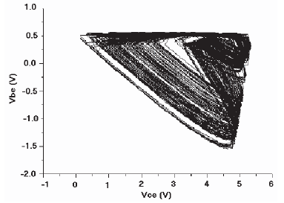

Figure. 2. Colpitts oscillator’s attractor.

The proposed Voltage control Chaos Colpitts Oscillator (VCCO) is shown in Fig.3. The fundamental frequency of the proposed VCCO can be calculated as:

$Q=\frac{2{πf}_{o}L}{R}$$$f=\frac{1}{2π\sqrt{L_{1}\frac{C_{1}C_{2}\text{//}D_{1}}{C_{1}+C_{2}\text{//}D_{1}}}}$$
(2)
The system in Fig. 3. is described by the following set of equations:
(3)
$C_{3}\frac{{\text{dV}}_{\text{CE}}}{\text{dt}}=I_{L1}−I_{C1}$
$L_{1}\frac{{\text{dI}}_{L1}}{\text{dt}}=V_{3}−R_{1}I_{L1}−V_{\text{CE}}−V_{\text{BE}}−{\text{VQ}}_{4\text{on}}$
${C_{1}}/2\frac{{\text{dV}}_{\text{BE}}}{\text{dt}}=I_{L1}−I_{C1}+I_{E1}(V_{\text{CE}},Q_{1})−I_{1}$
The collector current Ic is proportional to the emitter current:
$I_{c1}={αI}_{e1}$ (4)

The non-linear current-voltage characteristic of the emitter-base junction can be approximated by a piecewise linear function as follows:
$I_{E1}(V_{\text{BE}})=\begin{aligned}\left\{\frac{−V_{\text{BE}1}−V_{\text{th}}}{r},V_{\text{BE}1}<−V_{\text{th}} | \right.\end{aligned}$ (5)

With r being the small signal ON resistance of the emitter base junction and Vth the break point voltage (approximately 0.7 Volt).
The state equations (3) of the colpitts oscillator can then be rewritten in the form:
$\begin{aligned}\left(x_{1} | \right)\left(x_{2} | \right) \\ \end{aligned}$ (6)

where $n(x_{2})=e^{−x_{2}}−1$

$g=\frac{I_{0}L}{V_{T}R(C_{1}+C_{2}\text{//}D_{1})}$
- (8)

and
(9)
$k=\frac{C_{2}}{C_{1}+C_{2}}$
In system (6), only the first equation contains the nonlinear term n(x2) which, in turn, depends upon only one state variable, namely x2. Also, it should be noted that the dynamic behavior of the system (6) depends on the following two parameters specifically:

- g, the loop gain of the oscillator (8).
- Q the quality factor of the unloaded tank circuit (7).

While k has got a scaling effect on the state variables.

Figure 3. Circuit Layout of the Voltage control Colpitts Oscillator.

The (Fig. 3) circuit consists of a single bipolar transistor (Q1) which is biased in its active region by the use of V1, R1, and I1. The feedback network consists of L1, C1, and C2. Parallel operation between C2 and varicap D1 can be achived through the use of C4. Varicap is reversely biased by the use of R3, V2, and R4. As the inversely polarized varicap does not conduct d.c. current, R3 reaches a very high value thus not charging the tank circuit (L1,C1,C2). C3 parallels the operation of diode zener D2 diminishing any white noise generated by the brakedown of zener diode D2. This particular white noise affects the varicap D1 in such a way that modulation noise will be created. R4 and D2 can create a voltage stabilization circuit. R5 and C5 form a low pass circuit that prevents R.F. leakage from VCO In. C6 is a d.c. blocking capacitor.
By varying the capacitance of varicap D1 the value of g is inversely affected, thus changing the dynamic behaviour of the VCCO. By examing the bifurcation diagram (Fig. 4) of VCCO we can achieve such a capacitance value of varicap D1, so an alteretion of the operational point (Point 1) (g,Q) can be created in another chaotic point (Point 2) as shown in Fig. 4.

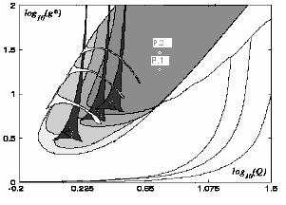

Figure 4. Bifurcation Diagram of the Colpitts Oscillator.

3. Results

3.1 Simulated Data

We assess the behavior of the chaotic oscillator via simulations performed by a P-spice based simulator. The transistor Q1 that produce the chaotic carriers is type 2n2222. Table 1. contains the two set of parameter values for operational conditions (P1, P2) used throughout the simulations. Fig. 5 depicts the attractor P1 of the simulated VCCO circuit. In Fig. 6. we plot the time domain output of Vbe Point 1. Clearly, the flatness of the spectrum of fig. 7, (P1) reveals the chaotic nature of the signal output. In Fig. 8 (P2) once again we can confirm chaotic signal but in a different operational point of the system. The two spectrums generate comparable chaotic outputs.

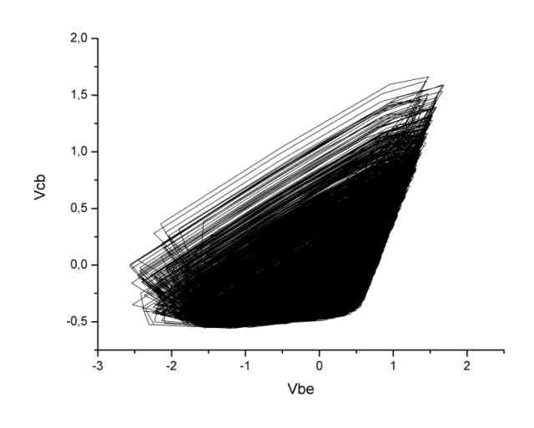
Figure 5. Simulated Attractor from the Chaotic Regime Point 1.

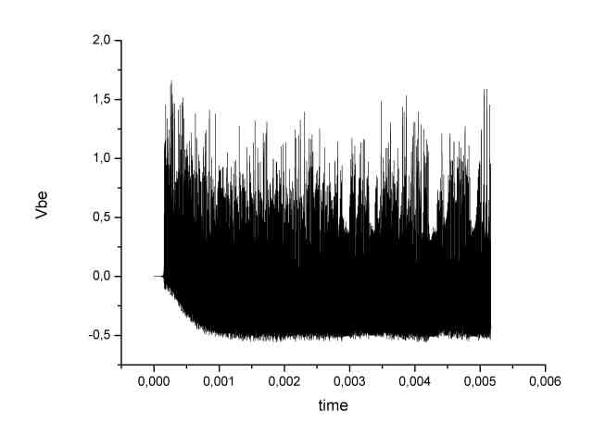
Figure 6. Simulated Time Domain Output (Vbe) from the Chaotic Regime Point 1.

Figure 7. Output Spectrum of the Voltage Control Chaotic Colpitts Oscillator – Operational Point 1.

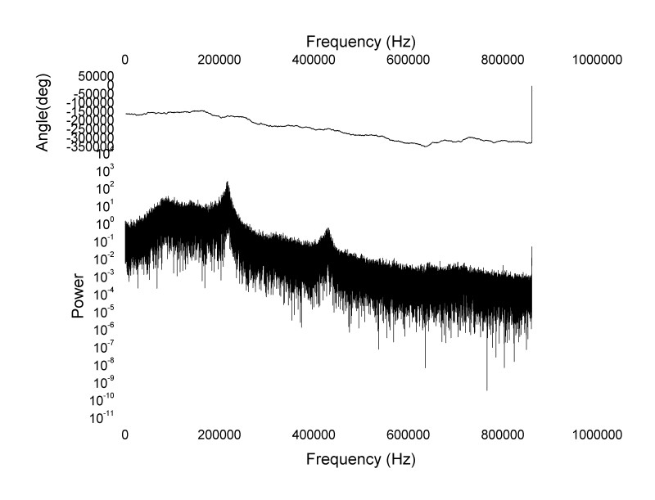

Figure 8. Output Spectrum of the Voltage Control Chaotic Colpitts Oscillator – Operational Point 2.

3.2 Experimental Data

The system shown in Fig.3 has been verified by the results during the laboratory experiments. For both Figures 9 and 10, we have the two spectrums of P1 and P2 operational points. Therefore we can observe that these two spectrums are closely related to the theoritical one being described in the text and shown in both Figures 7 and 8.
Figure 9. Output Spectrum of the Voltage Control Chaotic Colpitts Oscillator – Operational Point 1.
Figure 10. Output Spectrum of the Voltage Control Chaotic Colpitts Oscillator – Operational Point 2.

In figures 11 and 13, the time domain output of the two operational points (P1,P2) can be shown on the oscilloscope. Respectively in figures 12 and 14, the output attractors of the two operational points (P1,P2) can also be shown on the oscilloscope
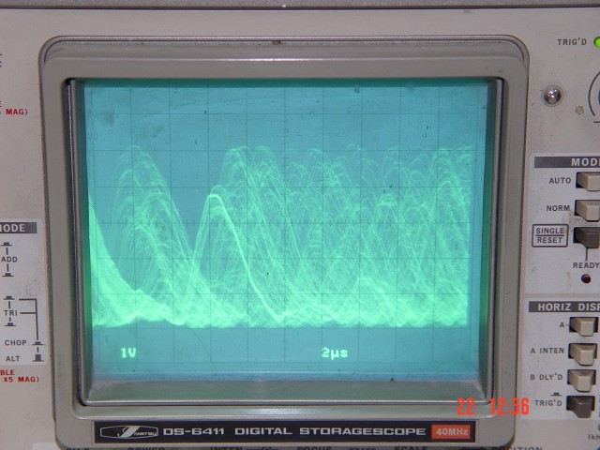

Figure 11. Time domain of output – Operational Point 1.

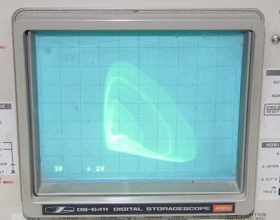

Figure 12. Lissajou output – Operational Point 1

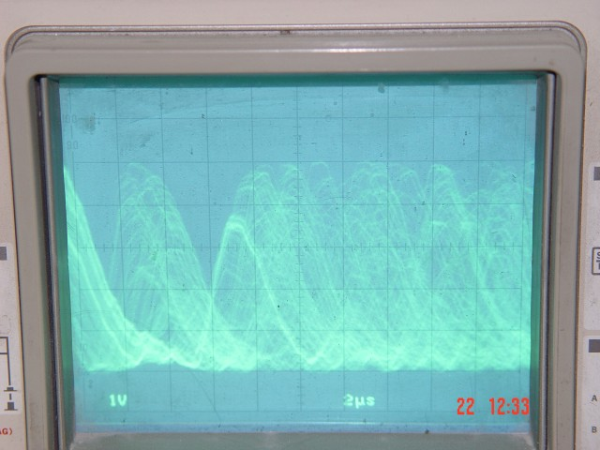

Figure 13. Time domain of output – Operational Point 2.

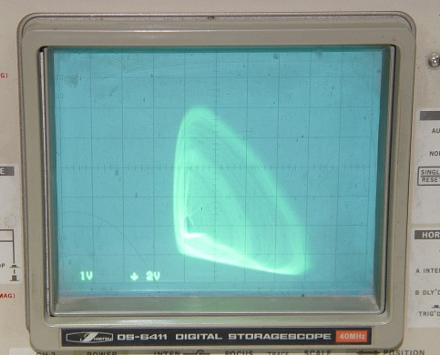

Figure 14. Lissajou output – Operational Point 2.

Table 1. Circuit Parameters Values used in Simulation and in Experiments
Circuit Elements | V1 | I1 | R1 | L1 | C1/C2 | D1
Elements’  Values Point 1 | 12  V | 22 mA | 36  Ω | 48 μH | 2 nF | 100 pF
Elements’  Values Point 2 | 12  V | 22 mA | 36  Ω | 48 μH | 2 nF | 10  pF

4. Conclusions

A Voltage control Chaos Colpitts Oscillator (VCCO) has been designed to be capable of producing large numbers of chaotic signals. Another advantage of the presented circuit design is the relative ease of its actual construction and also its potential use in a wide variety of aplications in chaotic communication schemes, as the main functional element of chaotic oscillator. Finally electronic control of the chaotic carrier in VCCO circuit, greatly facilitates the use of chaotic frequency modulation methods.

5. References

[1] M. P. Kennedy, “Chaos in the colpitts oscillator”, IEEE Trans. Circuits and Systems, vol. 41, pp. 771–774, Nov. 1994.
[2] H. Depieu, M. P. Kennedy and M. Hasler, “Chaos shift Keying: Modulation and demodulation of a chaotic carrier using self-syncronizing Chua’s circuit”, IEEE Trans. Circuits and Systems II, vol. 40, pp. 634–216, Oct. 1993.
[3] H. Yu and H. Leung, “A comparative study of different chaos based spread spectrum communication systems”, in Proc. IEEE Int. Symp. Circ. Syst., Sydney, Australia, May 2001, pp. III-213-216.
[4] C. C. Chen and K. Yao, “Stochastic-calculus-based numerical evaluation and performance analysis of chaotic communication systems”, IEEE Trans. Circuits and Systems I, vol. 47, pp. 1663–1672, Dec. 2000.
[5] M. Sushchik, L. S. Tsimring and A. R. Volkovskii, “Performance analysis of correlation-based communication schemes utilizing chaos”, IEEE Trans. Circuits and Systems I, vol. 47, pp. 1684–1691, Dec. 2000.
[6] G. Kolumban, M. P. Kennedy, and L. O. Chua, “The role of synchronization in digital communication using chaos-Part I: Fundamentals of digital communications”, IEEE Trans. Circuits and Systems I, vol. 44, pp. 927–936, Oct. 1997.
[7] G. Kolumban, M. P .Kennedy and Leon O. Chua, “The Role of Synchronization in Digital Communications Using Chaos—Part II: Chaotic Modulation and Chaotic Synchronization”, IEEE Trans. Circuits and Systems, vol. 45, pp. 1129–1140, Nov. 1998.
[8] Z. Galias and G. M. Maggio, “Quadrature Chaos-Shift Keying: Theory and Performance Analysis”, IEEE Trans. Circuits and Systems, vol. 48, pp. 1510–1519, Dec. 2001.
[9] T. Shimming and M. Hasler, “Optimal Detection of Differential Chaos Shift Keying”, IEEE Trans. Circuits and Systems, vol. 47, pp. 1712–1719, Dec. 2000.

_

