A Novel Approach to Compress Image Set

SHIH-CHIEH SHIE and SHINFENG D. LIN
Department of Computer Science and Information Engineering
National Dong Hwa University
1, Sec. 2, Da-Hsueh Rd., Shou-Feng, Hualien
TAIWAN, REPUBLIC OF CHINA.

Abstract: - A novel approach that simultaneously compresses a set of images is introduced in this article. This approach takes advantages of the traditional concept of vector quantization (VQ) system as well as the new idea of data embedding technique. A VQ codebook is first generated based on the well-known LBG algorithm, adaptively taking those images that have to be compressed as the training set at the encoder. After the codebook is generated, these images are encoded into a set of codeword indexes by vector quantization. To compact the volume of the overall data that has to be transmitted to decoder, the codeword indexes of images are adaptively embedded into the codewords of codebook. Simulation results show that the new approach achieves a higher compression ratio than the ordinary adaptive VQ technique while the degradation of image quality for the decompressed images at receiver is relatively small. Experimental data also demonstrates that the proposed approach is suitable for compressing a set of images.

Key-Words: - Image compression, data embedding, vector quantization, codebook.

1 Introduction
Digital representation of images allows visual information can be easily processed by a computer or communicated on the Internet. However, these benefits are at the expense of the large volume of data required to represent raw digital images. Digital images have a common characteristic: images contain a high degree of spatial redundancy. Consequently, image compression exploits this redundancy to reduce the number of bits required to represent an image.
Vector quantization (VQ) algorithms [1]–[2] have been extensively and successfully used for image compression. The attractiveness of VQ as source coding scheme derives from its optimality and the simplicity of hardware implementation of decoder. In a VQ coding system, the image to be coded is first divided into non-overlapping blocks. Each image block is individually mapped to the closest codeword in the codebook. Compression is achieved by replacing these codewords with the corresponding indexes in transmission applications. Reconstruction of image is then simply performed by table lookup using the index as an entry to the codebook. However, there exists possibility of mismatch between the input image and the training set. This will result in poor reconstructed image quality at receiver. Thus, Goldberg et al. have proposed a modified VQ scheme [2] using image adaptive codebook to adapt each input image to the training set. Goldberg’s scheme improves the visual quality of reconstructed images at decoder. However, when the adaptive codebook for each image must be transmitted to decoder, the compression efficiency is therefore degraded.
Data embedding is a new concept in digital image processing. It refers to the process of embedding digital information, such as watermarks, signatures, or other significant data, into a host image. Consequently, data embedding can be utilized in a wide variety of applications on images such as copyright protection, ownership identification, and secret data transmission. Recently, the technique of data embedding has been widely studied and many researches about data embedding in images have been proposed [3]-[5]. Among these researches, a common technique of data embedding is based on manipulating the least-significant-bit (LSB) planes of image since the LSB methods typically achieve high embedding capacity.
In this article, a new compression scheme that takes advantages of VQ and data embedding technique is presented. This scheme provides a new approach to compress a set of images. In addition, it also achieves a higher compression ratio than the ordinary VQ scheme with adaptive codebook. The rest of this article is organized as follows. In Section 2, we briefly introduce the basic concept of VQ and the LSB substitution method for data embedding. The proposed scheme is presented in Section 3. Section 4 addresses the experimental results. Finally, the conclusions are given in Section 5.
2 Related Background
In this section, we first describe the detailed processes of image vector quantization. Then, the greedy least-significant-bit substitution method applied in our scheme is presented.

2.1 Vector Quantization
A VQ coding system can be simply defined as a mapping from a k-dimensional Euclidean space R^{k} to a finite subset of space R^{k}. The finite subset C = { y_{i} : y_{i} ∈ R^{k} and i = 0, 1, …, N_{y}-1 } is called a codebook, where N_{y} is the size of this codebook. Each y_{i} = ( y_{i,0}, y_{i,1}, …,y_{i,k-1} ) in codebook C is called a codeword and is composed of k scalar elements. These codewords are generally generated, based on the LBG algorithm [1], from a training set.
An ordinary VQ system has two parts: the encoder and the decoder, each of which is equipped with the same codebook. In the encoder, the closest codeword y_{i} to the input block x can be found by searching the codebook, and the index i will be sent to the decoder. Consequently, in the decoder, the codeword y_{i} can be found via the received index i, and the block x will be replaced by codeword y_{i}. In this case, a quantization error is unavoidable. The distortion between the input block x and its quantized block y can be obtained by the Euclidean distance measure criterion given as Eq. (1). Moreover, the overall distortion between the original image and the reconstructed image can be obtained by summing all the distortion caused by quantizating image blocks.

$d(x,y)={\left\|x−y\right\|}^{2}=\sum_{P=0}^{k−1}{(x_{P}−y_{P})^{2}}$ (1)

2.2 LSB Substitution by Data Embedding
Many techniques concerning embedding significant data into the least-significant-bits of an image pixel have been proposed in earlier literatures. Wang et al. proposed an optimal LSB substitution method to embed important data into an image [3]. The effectiveness of this optimal LSB substitution under the worst case condition is also proved in [3]. To find the optimal LSB substitution in image, Chang et al. proposed a more efficient approach that applies the dynamic programming strategy [4]. However, the most efficient method of data embedding in spatial domain is the greedy LSB substitution technique.
The general operations of data embedding by the greedy LSB substitution are given as follows. Let M be the binary representation of important data, and X be the image data where M will be embedded. Assume the length of M is l, therefore, M can be represented as Eq. (2).
M = {m_{i} | 0 ≤ i < l, m_{i} ∈{0, 1}} (2)

Let X be an image with resolution u×v pixels and d-bits per pixel. X can be represented as Eq. (3).

X = {x_{ij} | 0 ≤ i < u, 0 ≤ j < v, x_{ij} ∈{0, 1, …, 2^{d}−1}} (3)

Assume that M is to be embedded within the r-rightmost LSBs of x_{ij} in X. Consequently, the following formula must be satisfied.

l ≤ r ∗ u ∗ v (4)

The data embedding procedure of the greedy LSB substitution is processed by firstly replacing the rightmost LSBs of all x_{ij} in X with the first u∗v bits of M (i.e. m₀ to m_{u∗v}). Secondly, the second rightmost LSBs of all x_{ij} in X are replaced with the next u∗v bits of M (i.e. m_{u∗v+1} to m_{2∗u∗v}). This procedure continues until all binary bits of M are embedded.

3 The Proposed Approach
In this section, the details of our proposed image compression scheme are presented. The input of encoder (transmitter) is a set of images. And the output of encoder is a series of compressed data stream. The compressed data stream is composed of an adaptive VQ codebook and a set of codeword indexes. Consequently, the input of decoder is this compressed data stream and the output of decoder is a set of reconstructed images.

3.1 Image Encoding
The image encoding process is the same as the ordinary adaptive VQ scheme. Without loss of generality, let the images to be coded are divided into image blocks with block size n×n and let S be the set of these image blocks. The image encoding procedure is given as follows:
Step 1. Train an adaptive VQ codebook for input images: In this step, S is adopted as the training set for codebook generation. The initial codebook is obtained by applying the binary-splitting algorithm [6]. To speed up the codebook training process, the fast codebook training algorithm proposed by Chang and Hu [7] is used in this scheme.
Step 2. Encode image blocks into codeword indexes: After the adaptive codebook is generated, each of the image blocks in S is sequentially encoded into the corresponding binary index of its closest codeword. Moreover, these binary indexes are further merged into a binary sequence, I, to represent the compressed message of images.
3.2 Data Embedding
The main purpose of this stage is to reduce the overall volume of compressed data stream that has to be transmitted to decoder. In order to maintain good visual quality for reconstructed images at decoder, the size of adaptive VQ codebook must be large enough. However, larger codebook size implies more bits are needed for a codeword index. Consequently, this will enlarge the volume of the compressed message of images.
To reduce the volume of compressed data stream, the proposed scheme takes advantages of data embedding technique to insert the binary sequence, I, of images into the adaptive VQ codebook. The most efficient embedding approach is to replace the LSBs of each codeword element in codebook with the same number of bits obtained from I. This process continues until all of the binary sequences have been inserted into the codebook. Finally, the adaptive codebook associated with the compressed images is slightly modified and it constitutes the compressed data stream that has to be transmitted to decoder.
The data embedding process will cause a degradation of image quality for reconstructed images at decoder since the LSBs’ information of adaptive codebook is lost. Therefore, to retain an acceptable visual quality for images at decoder, the number of modified LSBs within each codeword element should not exceed 3. This is because, in terms of mean-squared error (MSE), the degradation of image quality between the VQ-compressed image at encoder and the reconstructed image at decoder is bounded by (2^{r}-1)². Here, r is the number of modified LSBs within each codeword element.

3.3 Image Decoding
The image decoding process at decoder is quite simple. It is as efficient as the ordinary VQ decoding procedure. After the compressed data stream is received by decoder, the compressed images can be easily decoded by the following steps. Note that the compressed data stream is identical to the slightly modified adaptive codebook.
Step 1. Extract the embedded codeword indexes of images: The embedded data of binary sequence, I, can be fully extracted from the compressed data stream by reading out the LSBs of codeword element in the received adaptive codebook. All the codeword indexes of images are then obtained from the extracted binary sequence I.
Step 2. Decode codeword indexes and reconstruct images: The compressed images are, therefore, directly decoded by performing the table look-up operation on the received compressed data stream (i.e. the slightly modified adaptive codebook) with the codeword indexes extracted in step 1.

4 Experimental Results
In computer experiment, the proposed scheme has been performed on a set of ten test images (Lena, Airplane, Boat, Girl, Goldhill, Lenna, Pepper, Sailboat, Tiffany and Zelda) with size 512×512 pixels and 8-bits per pixel. Each image is divided into image blocks with block size 8×8. In addition, a codeword is composed of 64 (8∗8) elements and there are 4096 codewords in adaptive VQ codebook. Consequently, there are 262144 (8∗8∗4096) elements in this adaptive codebook and each codeword index is 12 bits. Therefore, the compressed message of each image is 49152 (12∗(512∗512)/(8∗8)) bits. The overall binary sequence of the ten images is 491520 bits. To embed the binary sequence, we have to modify the first and the second rightmost LSBs of each codeword element in adaptive codebook.
Fig. 1 shows the reconstructed images that were compressed and transmitted simultaneously by our scheme. It reveals that the visual quality of the decompressed images is quite good. To compare the proposed scheme with the ordinary adaptive VQ scheme, we have to introduce the definition of compression ratio. The compression ratio can be calculated by dividing the volume of uncompressed image data with the overall volume of compressed data stream (including the data of codebook and all binary indexes). Consequently, the compression ratios of our scheme and the adaptive VQ scheme are 10 and 8.1, respectively.

  (a) | 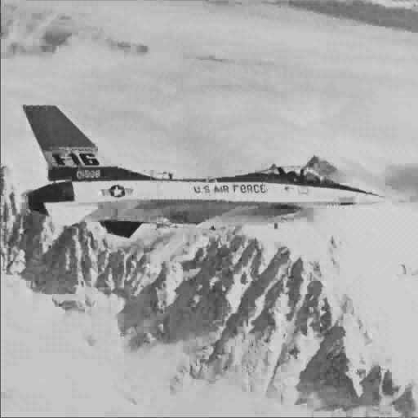  (b)
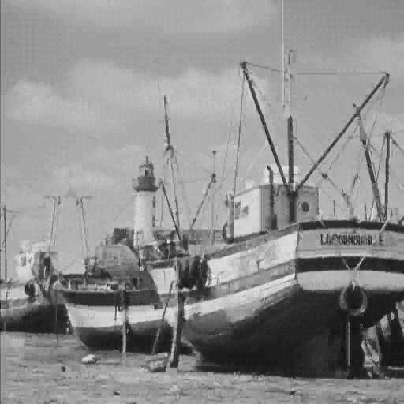  (c) | 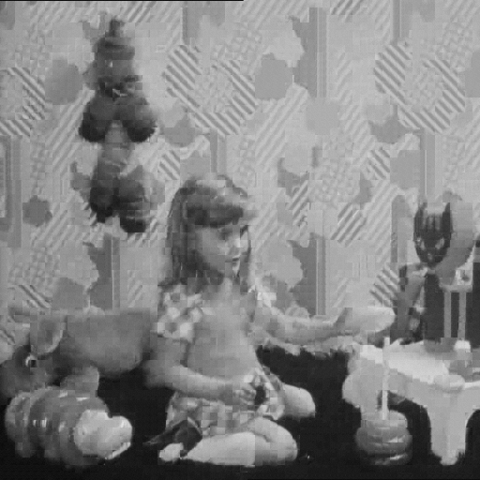  (d)
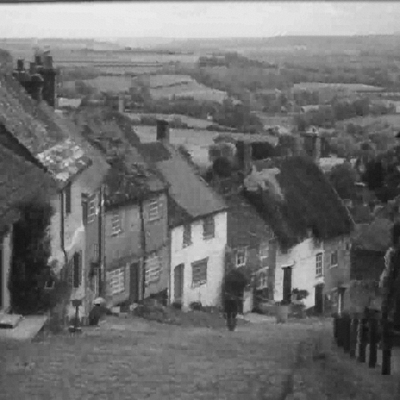  (e) |   (f)
  (g) |   (h)
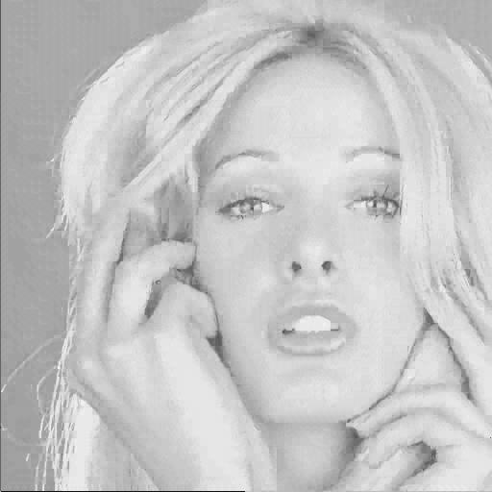  (i) |   (j)
Fig. 1. The decompressed images by our scheme.

Images | Adaptive VQ | Proposed | Degradation  in MSE
Lena | 31.5477 | 31.2184 | 3.587
Airplane | 31.1083 | 30.8097 | 3.586
Boats | 29.9410 | 29.7167 | 3.495
Girl | 31.6470 | 31.3211 | 3.468
Goldhill | 30.1079 | 29.8730 | 3.524
Lenna | 29.8972 | 29.6755 | 3.485
Pepper | 32.1815 | 31.8079 | 3.535
Sailboat | 28.8164 | 28.6440 | 3.458
Tiffany | 32.9071 | 32.4745 | 3.488
Zelda | 33.2709 | 32.8106 | 3.424
Table 1. PSNRs of decompressed images by adaptive VQ and proposed scheme. Note that the quality degradation of images is in terms of MSE.

Table 1 lists the peak signal-to-noise ratio (PSNR) values of decompressed images obtained by the adaptive VQ scheme and the proposed scheme, respectively. For the purpose of more objective evaluation, the quality degradation of images, in terms of the mean-squared error (MSE), is given in this table. The experimental data demonstrates that the degradation of image quality is quite small. The PSNR criterion is given in Eq. (5) and the MSE criterion for an m×n image is shown as Eq. (6).

$\text{PSNR}=\text{10}{\text{log}}_{\text{10}}\frac{{\text{255}}^{2}}{\text{MSE}}\text{dB}$ (5)

$\text{MSE}=(\frac{1}{m×n})\sum_{i=1}^{m}{\sum_{j=1}^{n}{(x_{\text{ij}}−y_{\text{ij}})^{2}}}$ (6)

where x_{ij} and y_{ij} denote the original and the reconstructed pixel intensities, respectively.

5 Conclusion
A novel compression scheme suitable for coding a set of images has been introduced in this article. The proposed scheme is designed by combining the new concept of data embedding with the traditional VQ compression technique for image compression. This is a new attempt to incorporate data hiding into image compression. The objectives of our future work are minimizing the quality degradation of images introduced by data embedding and increasing the compression ratio of this scheme.

Acknowledgment:
The authors are supported by NDHU and NSC (R.O.C.) with project no. NSC 92-2213-E-259-018.

References:
[1] Y. Linde, A. Buzo, and R. M. Gray, An algorithm for vector quantizer design, IEEE Trans. Commun., Vol.COM-28, 1980, 84-95.
[2] M. Goldberg, P. R. Boucher, and S. Shilien, Image compression using adaptive vector quantization, IEEE Trans. Commun., Vol.COM-34, No.2, 1986, 180-187.
[3] R. Z. Wang, C. F. Lin, and J. C. Lin, Image hiding by optimal LSB substitution and genetic algorithm, Pattern Recognition, Vol.34, 2001, 671-683.
[4] C. C. Chang, J. Y. Hsiao, and C. S. Chan, Finding optimal least-significant-bit substitution in image hiding by dynamic programming strategy, Pattern Recognition, Vol.36, 2003, 1583-1595.
[5] C. K. Chan and L. M. Cheng, Hiding data in images by simple LSB substitution, Pattern Recognition, Vol.37, 2004, 469-474.
[6] C. M. Huang and R. W. Harris, A comparison of several vector quantization codebook generation approaches, IEEE Trans. Image Processing, Vol.2, No.1, 1993, 108-112.
[7] C. C. Chang and Y. C. Hu, A fast codebook training algorithm for vector quantization, IEEE Trans. Consum. Electron., Vol.44, No.4, 1998, 1201-1208.

