Designing an Understanding and Debugging Tool (UDT) for Object-oriented Programming Language

NOR FAZLIDA MOHD SANI, ABDULLAH MOHD ZIN, SUFIAN IDRIS, ZARINA SHUKUR
Faculty of Information Science and Technology
Universiti Kebangsaan Malaysia
43600 UKM Bangi, Selangor,
MALAYSIA.

Abstract: - Teaching object-oriented programming is not an easy task. Instructors have to make sure that students understand the programming concepts and at the same time they have to create an environment that will encourage students to do programming exercises. One of the problems that really discourage students from doing programming exercises is that most students are frustrated when facing with programming errors that cannot be fixed. Although most programming environments provide some debugging tools, however these tools are designed for expert programmer and hence they are too difficult to be used by the novice. In order to solve this problem, a specially designed debugging tool needs to be provided. At UKM, we are in the process of developing CONCEIVER++, which is an understanding-based program debugger for object-oriented programming language. This paper presents the design of CONVEIVER++. It describes the design of the basic components of the system, the plan formalism that is used to store programming plans needed for the system and the plan editor which can be used by instructors to add new plans into the plan base.

Key-Words: - Program Understanding and Debugging, Object-oriented programming, Java.

Introduction
All students majoring in Computer Science and Information Technology must learn and experience in writing computer programs. With the popularity of courses in Computer Science and Information Technology, a large number of students with various backgrounds are enrolling into these programmes. This phenomenon creates a challenging situation to instructors especially when dealing with programming subjects.
At higher learning institutions in Malaysia, for example, Universiti Kebangsaan Malaysia (UKM), students are required to take at least two programming courses. The first course is normally dealing with structured programming, for example programming in C, while in the second course students are required to program in object-oriented programming, normally Java. The teaching of programming in UKM is done by using four methods: lecture notes are given in the course website, explanation of the lectures is given during the lecture sessions, discussion on problem solving during tutorial sessions and practical programming in the lab.
During lab sessions, demonstrators are provided to help students on how to compile and run the program, to check whether they have use the concepts that have been teaches in lectures, and sometimes to diagnose any errors in students program code. Most of the students do not have problems with syntax errors because the compiler normally gives the explanation of these errors. However, most of them are frustrated due to their inability to understand and correct logical errors. We had identified and analyzed the common logical errors in Java programming codes by students at UKM and other universities in Malaysia [14]. Since a student’s program is different from another student’s program, it is very difficult for demonstrators to help in debugging these logical errors. Although a debugger is provided, it is designed for the expert programmer and foes not offer much help for the novice.
In order to solve this problem, researchers at UKM have been working on developing a specially designed debugging tool for a few years. Our focus is to develop an automatic debugging tool which is based on program understanding, which can be used to help programmers, especially the novices in debugging their programs. The first result of the research is called CONCEIVER which is a program understanding tool for structured programs [7]. Another research in this area aims at extending CONCEIVER so that it can act as a debugging tool for structured programs. In order to be able to cope with the popularity of object-oriented programming, we are currently in the process of developing CONCEIVER++.
CONCEIVER++ will automatically and interactively assist students in doing their programming exercises. It has been design to provide understanding of function for a single or sequence statements line of codes. At the same time, if the logical error (bugs) exists in the program code, the debugger engine can detect the problem code. It will localise and explain that code. The users of this tool are students and instructor.
We have decided to focus on Java in building CONCEIVER++. Java programming language is chosen since most universities have use Java as a language to teach object-oriented programming [4, 15, 1, 12]. Madden et al. states that Java programming language is now very well established and is frequently the first object-oriented language that is taught to students [12]. Java is taught to students because it is ideal, which modern adult student doesn’t want to ‘waste’ time on a language with no commercial use [1]. Furthermore, although Java is becoming popular, there are not enough tools to support programming in this language.
This paper is divided into six sections. Section 2 reviews the prior research of UDT and existing systems. Section 3 presents the motivation of the research. Section 4 explains the system design of CONCEIVER++. The design of the plan base is given in Section 5. Section 6 is the conclusion.

Prior research

Program Understanding
Program understanding is a task of building mental models of the underlying software at various abstraction levels, ranging from models of the code itself to ones of the underlying application domain, for maintenance, evolution, and re-engineering purposes [6]. Miller states that program understanding means building a knowledge base that represents the program, and recognizing program fragments as components in the knowledge base [10].
According to Miller there are several reasons why we might want to automate the process of understanding: we could offer help and guidance to the programmer; we could assist in program testing, verification and debugging; we could provide long term assistance during maintenance, revisions and updates. We could also assist the programmer in understanding for him or herself what a program is doing and how it does it [10].
Woods et al. view program understanding as a three step process: parsing the program into an abstract syntax tree (AST) augmented with data and control flow information, canonical this internal representation into a simpler form by applying transformations (such as transforming relational expressions so that they involve only the greater than operator and not less than), and recognizing instances of the program plans in this canonical internal representation (usually using a library of program plans or plan base) [16]. These similar processes are adapts in our UDT.

2.2 Plan Representation
According to Wills, an experienced programmer can often reconstruct much of the hierarchy of a program’s design by recognizing commonly used data structures and algorithms and knowing how they typically implement higher-level abstractions. These commonly used computational structures called clichés [11]. Cliché is a pattern that appears frequently in programs such as algorithms, data structures, or domain-specific patterns.
Plan is a representation of a cliché. Plan recognition goal is to recognize clichés using plans [6]. Three plan recognition approaches are top-down, bottom-up and hybrid that combine the top-down and bottom-up approaches.

2.3 Program debugging
Francel et al. define the twin goal of debugging is to simultaneously develop an understanding of the program and localize the fault area of the code so that adequate correction can be applied [13]. Debugging is a continuous interactive, iterative process of understanding the program and isolating or localizing the fault. This observation is supported by cognitive studies of programmers and debugging by [2] and [8] (before the fault is actually determined and corrected).

Existing Systems
Our considerations on the available intelligent program understanding and debugging tools are the plan-driven program recognizer’s such as Programmer’s Apprentice [3], GRASPR [11], PROUST [18], Talus [19], and PAT [9].

3 Motivations and Objectives
Research in program understanding and debugging has been going for more than twenty years. Many systems have been developed. The development of these systems has solved many issues in program understanding. However most of these systems are still in the experimental stage [20]. Unlike other programming tools, these systems are still not being used widely. In most cases, these systems are only being used by the developers of the systems. Thus there is a need to develop a system that would be “usable”.
There are two possible reasons to explain why the available systems not being used. The first possible reason is the difficulty in organizing the plan base. When a new programming problem is given to students, the lecturer needs to incorporate new plans into the plan base. However, most of the available systems do not support the facility for plan editing.
The second possible reason is that the available system, although is good, but does not fit into the way the programming course is taught at a particular university. For example, some lecturers prefer the debugging tool to comment on the completed program, while some other lecturers would like the tool to help in the programming process.
The first problem relates to the issue of usability while the second problem concerns with the issue of flexibility. CONCEIVER++ has been designed to produce an understanding and debugging tool that will be usable and flexible.

System Design
In this section, we will describe the design of CONCEIVER++. Shelly et al. define logical design of an information system is the functions and features of the system and the relationships among its components. The logical design includes the output that must be produced by the system, the input needed by the system, and the processes that must be performed by the system without regard to how tasks will be accomplished physically [5].

4.1 Users of the tool
A program understanding and debugging tools will be used by two groups of users: students and lecturers.
A student uses the tool to debug a program. The output from for the student will be the explanation of the program code together with the possible locations and reasons for any errors found in the program code.
A lecturer uses the system to input new plans into the plan base. To help lecturers in inputting new plans and hence increase the usability of the tool, a specially designed plan editor need to be provided.

4.2 Architecture of CONCEIVER++
The architecture of proposed CONCEIVER++ is presented in Fig.1.
As seen from the figure, CONCEIVER++ consists of student and instructor perspectives. A student’s program will first be given as the input of the parser which will check the structure of the program. The output from the parser is the abstract syntax tree (AST). A transformer will transform this tree in order to remove some redundant codes. The understanding and debugging engines will then take the transformed AST and produces the output to the user. This output will be presented either in text or graphical form.
A lecturer can use the plan editor to input new plans into the plan base. There are two ways for lecturers to input the plan: either by editing the plan directly, or by giving sample programs. If it is in the form of sample programs, the plan editor will transform the program into plans. The new plan will be checked to ensure that it is correct.

4.3 Understanding and Debugging Engines
The main role of understanding engine is to find plans in the plan base that match the given program codes. If such a plan is found, then the explanation about the plan is given as the output. If the plan is not found, it may be due to the presence of errors in the given plan. In this case the debugging engine will check the program codes based on the bugs segment of plan to determine if the possible errors. The information of possible errors is given as the output. The student can then correct the error and resubmit the corrected program to the tool.

4.4 Component-based Design
The second objective of Conceiver++ is to produce a flexible tool. This implies that the tool can be easily redesigned to fit into a particular environment. To achieve this objective, we have adopted the concept of component-based design. In this approach, we first identify components of the system. Each of these components is then developed one by one. Since these components are independent of each other, they can be used to in implementation of a new tool.
The specification for each of the components is given in Table 1.

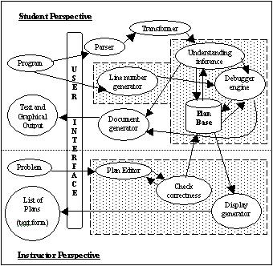
Fig.1 Architecture of CONCEIVER++

User Interface Design
Currently, the initial user interface design of CONCEIVER++ as show in Fig.2. It is user friendly with a GUI interface, where the understanding result will be show next right to the program code, while the detected logic error will be localize and explain below the program code. User can correct the logic error and run the system back to get the correct results.
There are menu file above and also icon for fast access functions. The user interface is interactively give message box if there are input errors, processing errors, hardware failure, or human mistakes.

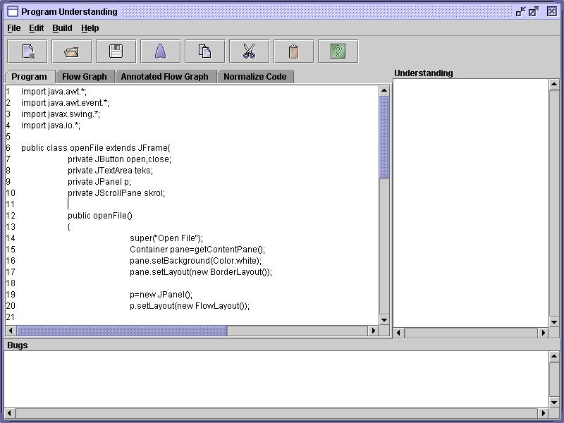
Fig.2 Initial user interface

Plan Design
The most important part of the tool is the plan base. Thus plan design is important in order to organize, store, maintain, update, access, and use plan into or from plan base. The aim of plan design is to have a standard plan formalism that will be used by the lecturers. It will be used as the guideline for them in order to create new plan or edit existing plan.
Previous plan formalisms that influence our work are adopted from Al-Omari [7], Ning [9] and Kozaczynski et al. [17]. Description on the plan design that consists of 8 segments or parts is in Table 2. One special feature of our plan formalism is that the plan constitutes both understanding and debugging knowledge. All other plan formalism does not incorporate debugging information as an integral component, except PAT [9]. In PAT the plan has a piece of knowledge for diagnosing errors that are commonly associated with the code. But plans inside PAT represent the algorithms while plan for CONCEIVER++ represents the stereotyped fragments of statement line of code.

Conclusion
This paper has presented the system design and the plan design for CONCEIVER++. The aim of the design is to develop a usable and flexible understanding and debugging tool.
CONCEIVER++ currently was developed using Freeware product, JCreator version 2.5 Lite Edition.

Table 1. Description of specifications for each component of CONCEIVER++

Component | Description of specifications
Component | Input format | Output format | Process(s)
Parser | Program code | Abstract Syntax Tree (AST) | - Expression simplification  - Control and loop construct normalization  - Normalizing functions with variable number of parameters  - Parse tree generator  - Flow graph generator
Transformer | AST | Transformed AST | - Deleting unused code  - Variable substitution
Line number generator | Program code | Numbering program code | Numbering the program code (line, block, procedure)
Understanding inference | AST, plan | Matched plan | - Find match plan with AST  - Get the matched plan
Debugger engine | AST, plan | Matched bugs part of plan | - Find match bugs part of plan with AST  - Get the matched bugs part
Document generator | Matched plan/ bugs part, AST | Document of understanding or debugging | Display document or output
Plan editor | New plan, plan | New plan, edited plan | Creating new plan or editing plan
Check correctness | New plan, edited plan | New or edited plan with no syntax error | - If the syntax of plan is correct, then new plan is save in the plan base  - If there is any syntax error, the new plan sends back to plan editor for editing.
Display generator | Plan | Plan | Display all plans in the plan base

Table 2. Description of each segment of plan design of CONCEIVER++

Segment of Plan | Description
Plan number and name | All plans will be refer using this plan number and name.
Data | Declare all the variables, which involve for the certain plan.
Plan | Present plans involve in unification of this plan.
Constraints | Defines a set of functions used to test the relations between the all plans
Bugs | Contains the possible common logical error or bugs exist in the plan
Connection (Conn.) | Show the number of plan, which is the plan in the above hierarchy
Meaning | The explanation of the plan

References:
- A. Gearailt, “Using Java to increase Active Learning in Programming Courses”, Proceedings of the inaugural conference on the Principles and Practice of Programming. 2002, pp. 107-112.
- B. Yoon, and O.N. Garcia, “Cognitive Activities and Support in Debugging”, In Proceedings of Fourth Annual Symposium on Human Interaction with Complex Systems. August 1998, pp. 160-169.
- C. Rich, and L.M. Wills, “Recognizing a program’s design: A graph-parsing approach”, IEEE Software, Vol. 7, no. 1, January 1990, pp. 82-89.
- E.M. Arif, “A Methodology for Teaching Object-oriented Programming Concepts in an Advanced Programming Course”, SIGCSE Bulletin, 32, 2 (June 2000), pp. 30-34.
- G.B. Shelly, T.J. Cashman, and H.J. Rosenblatt, System Analysis and Design, Thomson Learning, 2001, ch. 6, pp. 6.17-6.29.
- H.A. Müller, “Understanding Software Systems Using Reverse Engineering Technologies Research and Practice”, Tutorial presented at 18th International Conference on Software Engineering, Berlin, Germany, March 1996.
- H.M.A. Al-Omari, CONCEIVER: Not Just Another Program Understanding System, PhD Thesis, Universiti Kebangsaan Malaysia, 1999.
- J.C. Spohrer, and E. Soloway, “Alternatives to Construct-Based Programming Misconceptions”, Proceedings on Human Factors in Computing System. 1986, pp. 183-191.
- J.Q. Ning, A Knowledge-Based Approach to Automatic Program Analysis. Ph.D. Thesis, University of Illinois, September 1989.
- L. Miller, “Panel On: Program Understanding- Does It Offer Hope for Aging Software?”, Knowledge-Based Software Engineering Conference. 20-23 September 1992, pp. 238-242.
- L.M. Wills, “Flexible Control for Program Recognition”, Proceedings of Working Conference on Reverse Engineering. May 1993, pp. 134-143.
- M. Madden, and D. Chambers, “Evaluation of Student Attitudes to Learning the Java Language”, Proceedings of the inaugural conference on the Principles and Practice of Programming. 2002, pp. 125-130.
- M.A. Francel, and S. Rugaber, “The Relationship of Slicing and Debugging to Program Understanding”, Proceedings of Seventh International Workshop on Program Comprehension. May 1999, pp. 106-113.
- N.F. Mohd Sani, A. Mohd Zin, and S. Idris, “Common Logical Errors in Java Programming”, First Joint International Conference: Informatics and RWICT 2004, University of Malaya. 28 July 2004 -30 July 2004, Vol. 1, pp. 307-318.
- R.E. Bruhn, and P.J. Burton, “,An Approach to Teaching Java Using Computers”, SIGCSE Bulletin. 35, 4 (December 2003), pp. 94-99.
- S. Woods, and A. Quilici, “Some Experiments Toward Understanding How Program Plan Recognition Algorithms Scale”, Third Working Conference on Reverse Engineering. 8-10 November 1996, pp. 21-30.
- W.J. Kozaczynski, J.Q. Ning, and T. Sarver, “Program Concept Recognition”, Proceedings on Knowledge-Based Software Engineering Conference. September 1992, pp. 216-225.
- W.L. Johnson, and E. Soloway, “PROUST: Knowledge-Based Program Understanding”, Seventh of International Conference on Software Engineering. 1984, pp. 369-380.
- W.R. Murray, Talus: Automatic Program Debugging for Intelligent Tutoring Systems, Technical Report AI TR86-32, AI Laboratory, University of Texas, Austin, August 1986.
- O’Hare, A.B. and Troan, E.W. Re-Analyzer: From Source Code to Structured Analysis. IBM System Journal, 33(1), 1994.

