- Introduction
FSO has the advantages of high data rate, highly focused point to point links, flexible and extensive connectivity without laying fibers. On the contrary these links are severely tampered by weather conditions such as rain and atmospheric scintillation and in the worst case; cloud cover can attenuate received power by up to 100db over a distance of 1 mile. Even the slightest obstruction could lead to a link failure. The motivation to design good topology is to derive the benefits offered while overcoming the unreliability of these links.
FSO is basically a Line Of Sight (LOS) technology in which the distance between the transmitter and receiver constitutes a important factor in topology formation. The methodologies dealt are mainly suitable for UniNet architecture, multihop FSO grid network [1]. Mesh topology is found to be the apt topology for design of broadband access networks[5].
In UniNet concept[1] recursive gridding is applied for formation of the mesh. Recursive grids do not take into account the random distribution of nodes and hence is not a good choice for topology in practice. The topology control and the design issues dealt in multihop wireless networks seems much closer to the problem at hand. One major exception is the use of omni directional antennas in these networks as opposed to highly focused point to point links in FSO networks. However the topology design in the multi hop networks are carried out such that after negotiation of connection between nodes, the links are established as if they are directional, concentrates on achieving a strongly connected minimum energy network by making local decisions at each node
This paper initially discusses the topology design aspects for multihop FSO network. The second part gives an idea about Delaunay and Voronoi topology formation algorithms. Finally the simulated outputs for both approaches along with a modified delaunay approach are given.

2. Topology Formation
Generally FSO is applied in stationary applications. Hence the range and the transmitting parameters are also statistically fixed based on the topological connectivity chosen. The topology dealt in UniNet mesh is only a regular rectangular grid and all the analysis made were basically upon this assumption. But practical implementation of such a grid is highly difficult and cannot suit a particular terrain. Hence in this paper irregular mesh formation algorithms are dealt. In addition to that FSO connectivity between mobile nodes with bounded movement and unbounded movement are also presented. Triangle and quad generation methods in 2D will be considered.
There are two types of topological formation, namely structured formation and unstructured formation [6]. In structured topology formation a particular recursive structure is used to from the topology. Strictly speaking, a structured mesh can be recognized by all interior nodes of the mesh having an equal number of adjacent elements.
Unstructured mesh generation, on the other hand, relaxes the node valence requirement, allowing any number of elements to meet at a single node. Triangle and Tetrahedral meshes are most commonly thought of when referring to unstructured meshing, although quadrilateral and hexahedral meshes can also be unstructured. While there is certainly some overlap between structured and unstructured mesh generation technologies, the main feature which distinguish the two fields are the unique iterative smoothing algorithms employed by structured grid generators.
The two main topologies that well suits FSO networks are mesh and tree. Both the structures may be a regular or irregular one. The Figure 1 shows regular and irregular topology for a FSO network The formation of particular topology is very much dependent upon the geographical location where the network is to be constructed and the usage of network in that area . It depends upon the type of area (urban, sub-urban, or remote area), topological behavior of the area (Valley, Hilly area, Tall buildings), geographical nature of the place (Fog, Rain, Haze, Snow). Topology can be formed both statically and dynamically. The type adapted for topology formation is mainly influenced by routing technique adopted.

A Tree
A Regular Mesh
An Irregular Mesh
Base Stations
Figure 1: Regular and irregular topologies for FSO
The topology formation can be effectively implemented using Delaunay approach [4] [6]. The Delaunay criterion in itself is not an algorithm for generating a mesh. It merely provides the criteria for which to connect a set of existing points in space. As such it is necessary to provide a method for generating node locations within the geometry. A typical approach is to first mesh the boundary of the geometry to provide an initial set of nodes. The boundary nodes are then triangulated according to the Delaunay criterion. Figure 2 shows the diagrammatic explanation of Delaunay approach. Nodes are then inserted incrementally into the existing mesh, redefining the triangles or tetrahedra locally as each new node is inserted to maintain the Delaunay criterion. It is the method that is chosen for defining where to locate the interior nodes that distinguishes one Delaunay algorithm from another. The output for both stationary and mobile nodes is shown in section 3.

Obeys Delaunay empty circle principle
Doesn’t obey Delaunay empty circle principle
Figure 2: Delaunay triangulation approach [6]

Similar to the circumcircle point insertion method, another technique introduced by Rebay [6] is the so-called, Voronoi-segment point insertion method. A Voronoi segment can be defined as the line segment between the circumcircle centers of two adjacent triangles or tetrahedra. The new node is introduced at a point along the Voronoi segment in order to satisfy the best local size criteria. This method tends to generate very structured looking meshes. The output for voronoi approach is also discussed in next section.
The Modified Delaunay Approach discussed in this paper is different from the approach discussed already in reference [2]. In this approach three main steps are followed as extension or refining algorithm to improve the richness of the formed mesh. In this approach three basic steps are followed. The steps are diagrammatically defined in Figure 3.
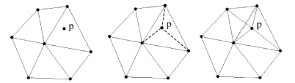
Initial Triangulation
Splitting enclosed
triangle
‘‘Swap’’ operation
Figure 3: Modified Delaunay approach
3. Simulated results and
Performance analysis
Figure 4(a) shows the Delaunay triangulation approach for 10 and 50 nodes random positioned. Figure 4(b) shows the periodical snap shot of Delaunay triangulation for mobile nodes with restricted angle and controlled velocity. The movement direction is chosen random and velocity can be controlled at every node.

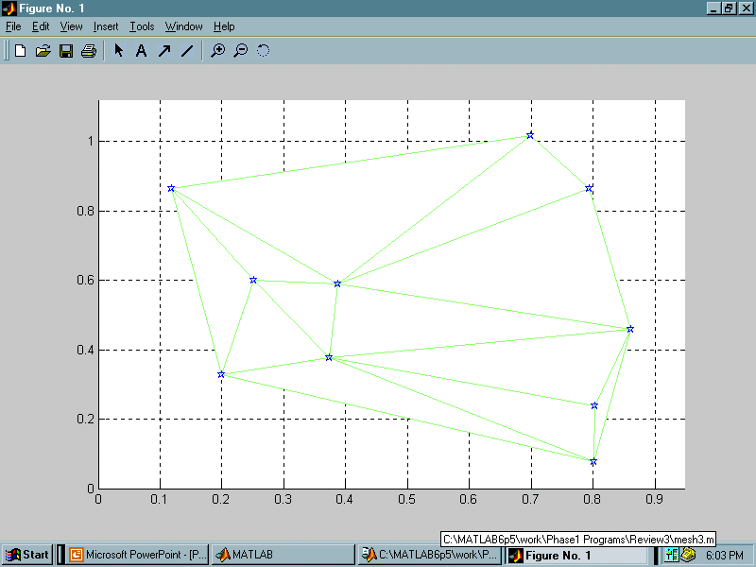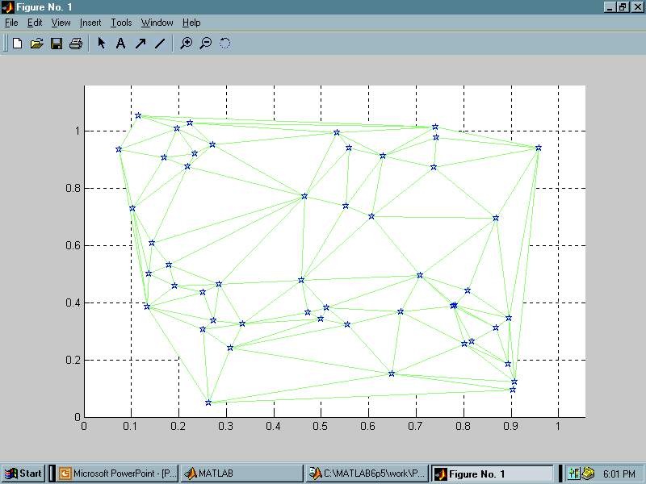
No of Nodes:10 No of Nodes:50
Random Positioned
Figure 4(a): Delaunay approach topology
formation between stationary nodes

The voronoi point insertion approach for 10 random positioned nodes is presented in Figure 5. The voronoi segment that can be used for node placement are shown in the same figure along with the topology formed using Delaunay approach.
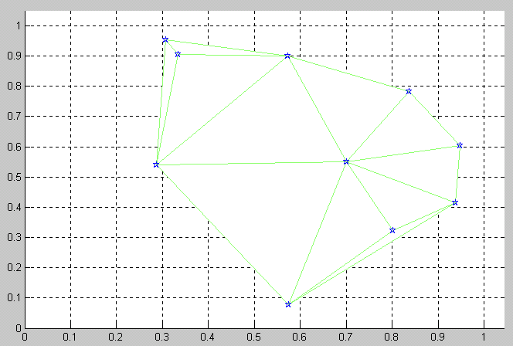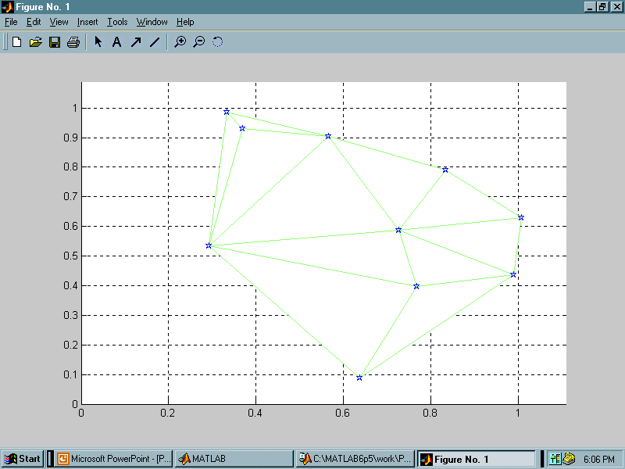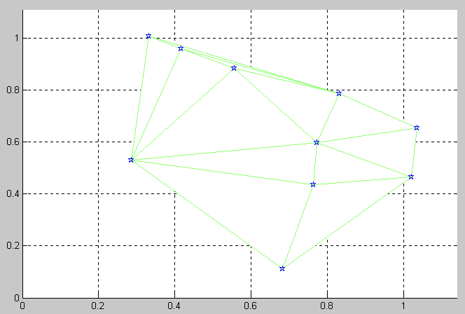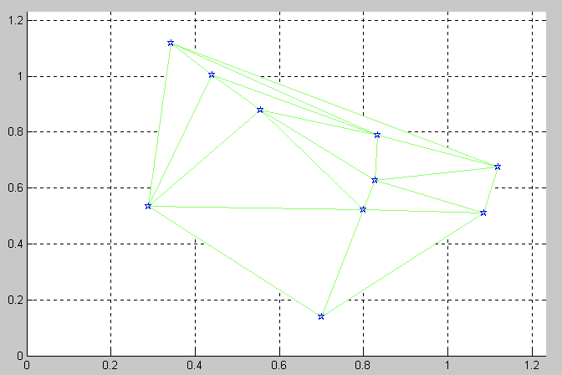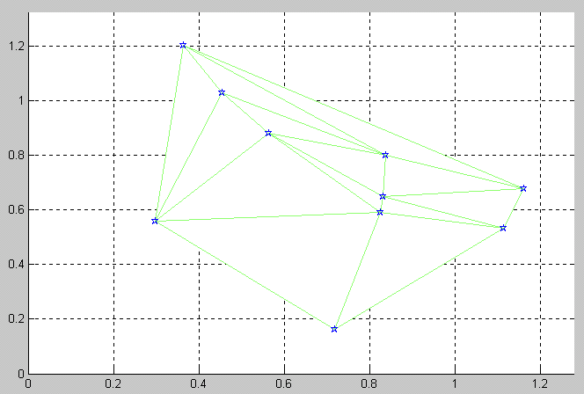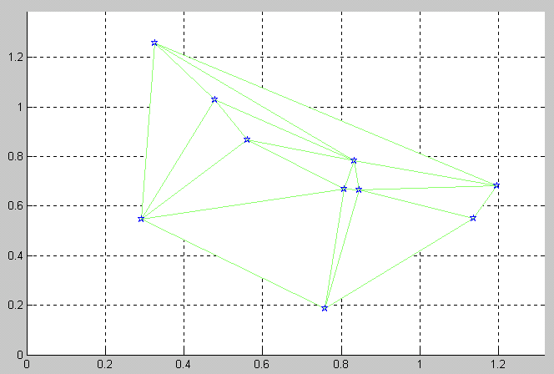
No. of Nodes:10; Random Positioned; Restricted Movement
Figure 4(b): Delaunay approach topology
formation between mobile nodes

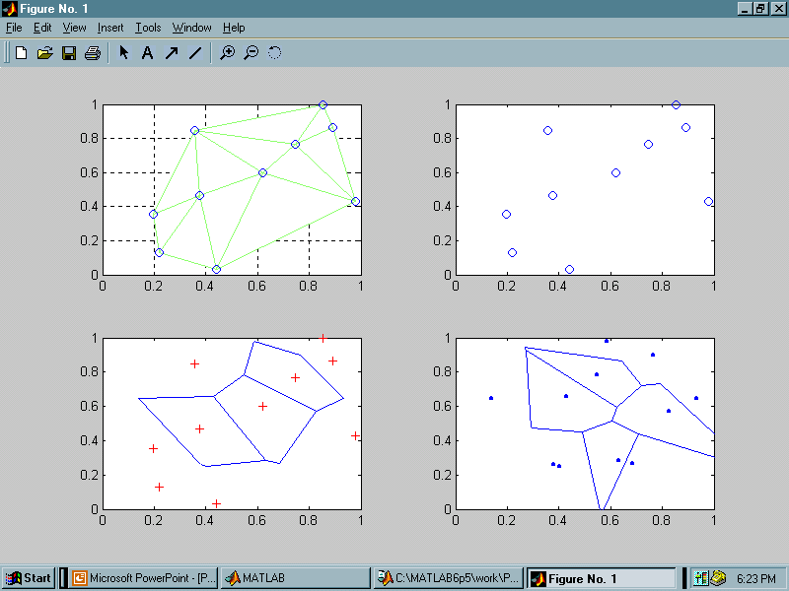
Figure 5: Voronoi approach for topology formation
Figure 6 shows the output simulated for modified delaunay approach taking the position of nodes to be random. The placement of nodes can be done at any random location and the connectivity between the closest neighbors is automatically adjusted.

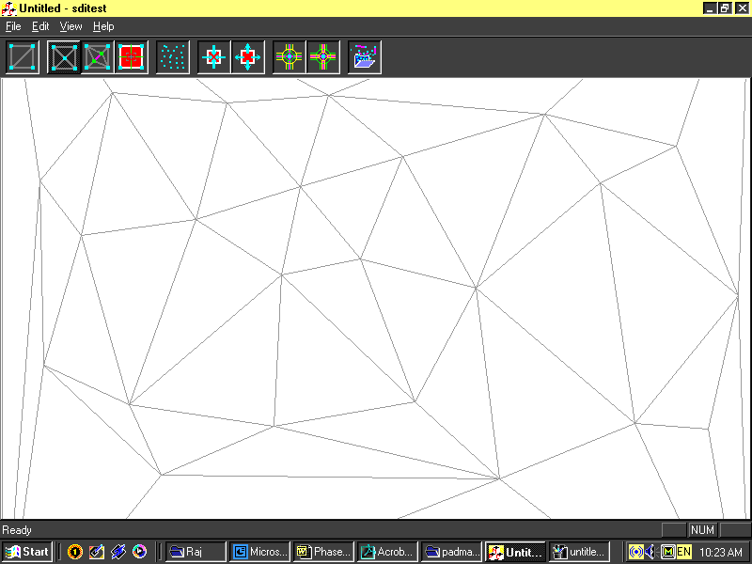
Figure 6 Modified Delaunay approach for topology formation

4. Inference
The above topology formation algorithms discussed are suitable for both wireless and wired communication networks. When considering FSO the LOS connectivity between the nodes should always be ensured. The proposed methods are quite adaptive for any kind of demography and application, it may be a military application or underwater sea expedition. The same topology formation concept can be applied extensively for mobile adhoc and Bluetooth communication. The mobility aspect in FSO is very critical and performance is restricted to degree constraints. This can open many research aspects upon the conical coverage area of the beam, the divergence concept of laser beam and many more research about the characteristics of laser beam based upon demography chosen.

5. Conclusion
Two main approaches have been proposed for design of topologies for multihop FSO network. The factors such as closest neighbor, link range and connectivity degree can be varied. Apart from stationary nodes, mobile nodes with varying velocities and degree of movement are also discussed. Voronoi approach and modified delaunay approach are also dealt for topology extension and planning.

References:
[1] Acampora.A, Bloom.S.H and Krishnamurthy.S, “UniNet: a hybrid approach for Universal Broadband access using small radio cells interconnected by free-space optical links” IEEE Journal on selected areas in communications,Vol.16,No.6,pp.973-987 August 1998.
[2] Prabhanjan C Gurumohan, Joseph Hui, “Topology Design for Free Space Optical Networks”, IEEE, 2003, pp.576-579.
[3] Dave Beyer, “Fundamental characteristics and benefits of wireless routing in mesh networks”, International Wireless Communications Association, Jan 2002.
[4] Petr Krysl and Michael Ortizx “Variational Delaunay approach to the generation of tetrahedral Finite element meshes”, International Journal for Numerical methods in Engineering, 2001; pp.1681-1700
[5] Hossein Izadpanah “A millimiter-wave broadband wireless access technology demonstrator for the next-generation internet network reach extension”, IEEE Communications, 39(9), September 2001.
[6] http://www.andrew.cmu.edu

