1. Introduction
Imagine a technology that has a capability to construct a reliable broadband network in a disaster zone within an hour that can offer unsurpassed reliability and high-speed connectivity, very easy to deploy, license-free and offers a wide bandwidth. The name given to such a promising and proficient technology is FSO. Optical Wireless communication, also known as Free Space Photonics (FSP) is a technology gaining impetus, is a harmonized technology with fiber optics, with many similar features except the change in medium of propagation as free space.
This paper is mainly focused upon a hybrid universal broadband architecture called UniNet [1]. This paper is more concerned in making the UniNet concept adaptive and practically deployable. The challenges discussed in this paper are to improve the adaptiveness of UniNet concept and make the concept more pragmatic.
This paper initially discusses the concept and challenges in UniNet. The third part emphasizes on methodologies to improve the adaptive nature of FSO link. Subsequently, the paper addresses alternate routing and zoned approach for a multihop FSO network. Finally the simulated outputs for DLS algorithm and zoned approach are discussed.

2. UniNet
A classical way of hybrid broadband access system was proposed for providing high-quality, bandwidth-upon-demand telecommunication services to the home and office called UniNet [1]. UniNet is a hybrid approach for universal broadband access using small radio cells interconnected by FSO links. Communication terminals attach to the network via short radio links, and users can roam freely within a house or building unencumbered by the availability of wired “telecommunications outlets.” Basic service is extended through small, high-capacity radio cells. The base stations are interconnected via short, highly focused free-space optical links in a multihop mesh arrangement; and the need for new broadband access cabling is totally surmounted. A tiered arrangement of radio cells further extends service to both out-of building pedestrian and vehicular users, and service is universally available.
Figure 1 shows the three tier architecture of UniNet. The approach uses three tiers of radio cells, with some possibly large number of lower tiered cells nested within each higher tiered cell. A cluster of contiguous picocells would thereby serve a large population of users, each of whom is served via a home or office picocellular base station. The picocellular base stations, themselves, are interconnected by a dense mesh of highly focused, free-space optical links which are physically short in length (under several hundred feet).
End Office Switch
End Office Switch
Mega cell
Standard cell
Pico cell
Figure 1: UniNet - Three Tier Architecture [1]
3. Adaptive FSO
Establishing an adaptive FSO link means maintaining the quality and availability of the link under different transmission impairments. The FSO system must not only be able to adapt to changing weather conditions and maintain sustained end-to-end connectivity, but also to meet the desired level of Quality of Service (QoS). The development of adaptive FSO link requires implementation of a performance monitoring subsystem that can probe and accurately characterize the performance of the wireless channel in real time. Essentially, the data recorded by the monitoring subsystem plays a crucial role in governing the dynamic link restoration techniques and, consequently, the link performance metrics.
Link restoration is adopted to overcome partial or total link failure. The performance metrics that are generally taken for link restoration are the signal detection threshold, which is defined as a lower bound on the Signal-to-Noise-ratio (SNR) (or equivalently an upper bound on the BER) at the receiver. Therefore, the BER threshold is normally adopted as the QoS parameter for ensuring adaptive optical wireless link. Thus instantaneous BER computation may be a good indicator of system performance [5]. When the performance of a particular FSO link deteriorates below the permissible level, the DLS algorithm is applied. The DLS algorithm is basically derived from Hybrid FSO Technology [6].

3.1 DLS Algorithm
The switching action of the path load between the two technologies is carried out using Redundant Link Controller (RLC) which measures the performance metric and acts based upon normalized result. The DLS algorithm is deployed in RLC for ensuring the load switching between FSO and RF. The flowchart for DLS algorithm is shown in Figure 2.
Initialize the
systems
If Lact(FSO) > Lperm(FSOW)
Based on measured BER, compute the actual
Atmospheric attenuation for each link averaged over
window (Lact)

Based on BER threshold, compute the permissible
Atmospheric attenuation for each link averaged over
window (Lperm)

If Lact(RF) > Lperm(RF)
If Lact(RF) < Lperm(RF)
Switch 25%,50% or 75% of the
load from FSO to RF
Switch 25%,50% or 75% of the
load from RF to FSO
Both links
failure
Both links
available
Reduce rate on
both links to
restore them
Yes
Yes
No
No
No
Yes
Figure 2: Dynamic Load Switching Algorithm

The impact of temporary line-of-site obstructions by birds or some external sources may vary the performance metrics suddenly. This in turn may unnecessarily activate expensive link restoration algorithms. Usually it is noted that average BER turns out to be an efficient solution. BER measurements of an FSO link recorded at regular spans (span length depends on the environmental conditions). The measured BER values may swing between different low and highly unacceptable values within a particular span. Now before initiating link restoration process smoothing of the measured data is done. The smoothing process may be averaging, quantizing, threshold limiting etc. In Sliding Window technique the sudden fluctuations in the measured BER data is smoothened data via a sliding window averaging mechanism. The Window Shape (S) and Window Length (W) are selected based upon the required QOS. Both mean and median approaches for a rectangular window are discussed in section 4.
The computational results of sliding window and running window are compared using averaging method taking Received Signal Strength (RSS) as the performance metric.

3.2 Alternate routing & Traffic balancing in
multihop mesh network
The adaptive concepts discussed above are common for any point to point link or a multihop FSO network. The alternate routing discussed in this section is in particular for UniNet concept. Alternate routing is to guarantee effective routing even in the presence of any failure or blocked node along the data transfer path.
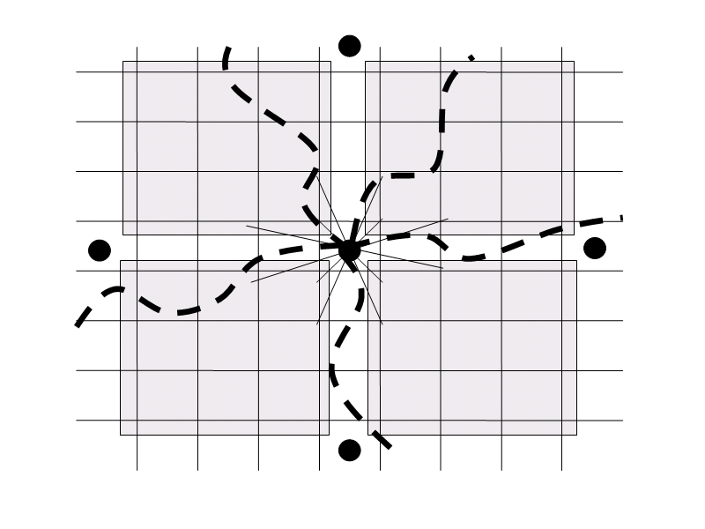
Routing in FSO is an interesting aspect that when correlated with a typical network becomes very easy. Since FSO is a line of sight technology many routing loopholes are ruled out of our considerations. In a FSO mesh or tree network routing is done by Multihop routing. A FSO link can support data rate of about 155Mbps in a clear weather and the maximum distance is also restricted to about few miles in such a case. To provide such a high OC-3 data rate switching, we need a high-speed switching device at each node.
Figure 3: Domain and Zoned approach
Domain
Zones
End office
Direct Links(Fingers)
Routing in meshes can be done effectively by Domain Approach and a supervisory node is kept for every domain for monitoring. The concept can be well understood from the Figure 3.
In domain approach the routing becomes simplified. Traffic can be directed to a particular base station using the domain index and position co-ordinate. A simple Dijikistra’s or Bellman algorithm can be used for routing. When domain approach is considered traffic balancing should also be considered between domains. This can be effectively implemented by Zoned Approach within a domain.
Within a particular domain some nodes may be highly loaded and some may carry very less traffic. Hence the probability of blocking is more in highly loaded regions. So within a particular domain Zones are divided so that every zone is carrying an aggregate equal traffic. The division of zones can be made both statistically and dynamically. The dynamic division of zones is based upon the instantaneous traffic within the domain. The concept of zoning is shown in Figure 3.
The mapping algorithm that can be followed for zoned approach irrespective of the structure of network and node distribution is given below. Figure 4 gives a diagrammatic explanation of the algorithm.
Polar Co-ordinates Based on Demographic Position
0º
90º
270º
180º
(1,3) → 1+j3
(3,4) → 3-j4
Centre End Office → (2,2) → 2+j2
53º
144º
Figure 4: Methodology for formation of zones
Algorithm for Zoned Approach
Step 1: Start
Step 2: Get the number of Nodes and there Geographic Distribution.
Step 3: Generate Poisson Traffic at every Node.
Step 4: Get No of Links i.e., Fingers.
Step 5: Sum up the entire traffic and divide the allowed traffic for every Zone.
Step 6: Consider the Node distribution terrain as a phasor plane.
Step 7: Also get the position of the End Office at any location.
Step 8: Assuming each Node in Rectangular form, calculate the aggregate traffic and increment the scanning angle. (2,3) → 2+j3.
Step 9: Thus the entire plane is finally divided into specified number of Zones.
Step 10: Stop

The simulated result based on the above approach is given in section 4.
4. Simulated results and
Performance analysis
4.1 Windowing technique for normalizing
The choice of performance metric purely depends upon the type of service offered and the required QOS. When we consider the performance metric chosen is RSS over a period of 10 seconds. The performance metric chosen should be normalized before it is taken for decision. The results of running window and sliding window are compared. The estimation technique used is averaging over the specified window. The simulated output is shown in Figure 6. Running window includes all samples since the system is initialized last. Whereas sliding window takes only the last specified number of samples from the measured values. From the graph we can infer that running window gives a less variant performance than a sliding window of size 100 and 50. And as time increases i.e., number of samples taken in the running window increases, the variation becomes very less. Hence sliding window of a specified size gives an apt result than running window. The variation of level can be used to appropriately activate the DLS algorithm. The size of the window can be made adaptive with reference to the performance metric chosen.

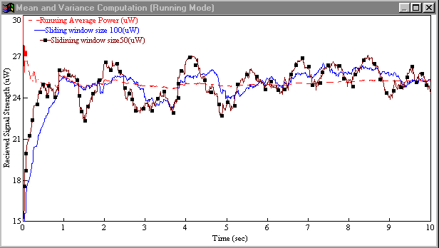
Figure 5: Windowing technique

4.2 Mean and Median Approach
Figure 6 shows the performance of windowing technique for mean and median approach. The result is simulated for a sliding window of window size 25. From the graph it is can be seen that mean gives variation in the result, but the response is constantly varying. In median approach the response is varying in a leveled manner. This leveled result can be more apt for the switching action in DLS algorithm.

4.3 Zoned Approach
Figure 7 shows the zoned concept implementation for given domain size and number of fingers. The figure shows traffic balanced output for a 50x40 domain with 7 sectors and center at (20,23).

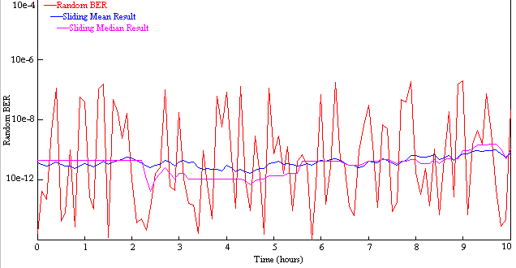
Figure 6: Mean and Median Approach

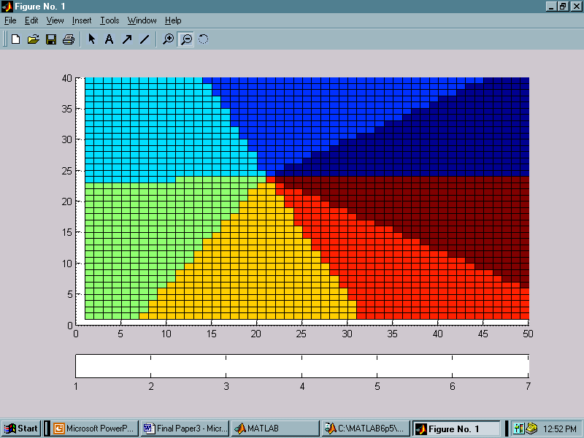
Figure 7: Traffic balancing using zoned approach (50x40)

5. Inference
The traffic balancing using zoned concept is not particular for multihop FSO networks but can be applied for any network with a similar architecture; a well known application could be in mobile adhoc networks. Apart from its generality this method is independent of the node distribution and demography selected. The smoothing methodologies adopted for normalizing the performance metric can also be adopted based upon the required QoS. The window shape and size can be adaptively fixed so that a proper activation of DLS algorithm is ensured.

6. Conclusion
In this paper the challenges in universal broadband access architecture, UniNet are brought out. Adaptive and pragmatic approaches that can be incorporated in UniNet concept are discussed. The routing and traffic balancing approaches dealt are feasible and can be widely applied for any kind of network and topology.
In general this paper paves a way to explore the potential of FSO in future emerging applications. It ensures that FSO is an affable choice for establishing a effective broadband backbone network irrespective of whatever network it may be.
References:
[1] Acampora.A, Bloom.S.H and Krishnamurthy.S, “UniNet: a hybrid approach for Universal Broadband access using small radio cells interconnected by free-space optical links” IEEE Journal on selected areas in communications,Vol.16,No.6,pp.973-987 August 1998.
[2] Kim.I, Stieger.R, Koontz.J, Moursund.C, Barclay.M, Adhikari.P, Schuster.J, and Korevaar.E , “Wireless optical transmission of Fast Ethernet, FDDI, ATM, and ESCON protocol data using the TerraLink laser communication system,” Opt. Eng., 37, 3143-3155, 1998.
[3] Scott Bloom.H, “The Physics Of Free Space Optics”, Copyright December 2001, AirFiber, Inc.
[4] Isaac I. Kim, Bruce McArthur, and Eric Korevaar, “Comparison of laser beam propagation at 785 nm and 1550 nm in fog and haze for optical wireless communications”, 2000.
[5] Isaac I. Kim and Eric Korevaar, “Availability of Free Space Optics (FSO) and hybrid FSO/RF Systems” Optical Access Incorporated 10343 Roselle Street San Diego, CA 92121.
[6] Hossein Izadpanah, Tamer Elbatt, Vikas Kukshya, Frank Dolezal, and Bo K. Ryu, “High-Availability Free Space Otical and RF Hybrid Wireless Networks”, IEEE Wireless Communications,1536-1284/03, April 2003

