P, Q, R, S and T Peaks Recognition of ECG using MRBF with Selected Features

SYED SAHAL NAZLI ALHADY, MOHD RIZAL ARSHAD and MOHD YUSOFF MASHOR
Central for Electronic Intelligence System (CELIS)
School of Electrical & Electronic Engineering,
Universiti Sains Malaysia,
14300 Nibong Tebal, Penang, MALAYSIA

Abstract: - P, Q, R, S and T peaks of ECG signal are fundamental and normally will be used as reference for classification and other parameters application for ECG signal. Multiple Radial Basis Function (MRBF) network is proposed in the current study for identification of these peaks for ECG signal. Amplitude, duration, pre-gradient, post-gradient and peak degree were used as inputs to the individual RBF networks with selected features.. The best accuracy achieved for individual network are combined and overall accuracy of 86.53% achieved for identification of P, Q, R, S and T peaks.

Keywords: - Pre-gradient, Post-gradient, Peak Degree and Multiple Radial Basis Function (MRBF)

1 Introduction
ECG recordings are traditionally performed using an AC amplifier, which causes low frequency distortion. The base line wander artifact in ECG, due to direct or indirect effect of patient respiration or as a result of slow electrochemical changes at electrode-skin interface, has a frequency spectrum in the range of 0 to 0.2Hz (typical) [1]. Motion artifact and muscle noise are considered as high frequency interference which has been indicated by American Heart Association (AHA) [2]. Power line interference (50Hz or 60Hz) can also be considered as significant element of noise in ECG.

Feature extraction is carried out prior to the determination of real peaks in the ECG. Identification of real peaks in the ECG is performed during pre-processing stage. Selecting suitable features are crucial as it directly influences the complexity and accuracy of the network.

The most prevalent automated approach to electrocardiographic diagnosis follows a diagnostic tree, much in the same way that the clinician approaches diagnosis. The use of automated classification has been on the increase because the diagnostic quality is form to be comparable to that of an expert. An estimated 20% of global clinical electrocardiography involves the use of computer [2]. An attractive feature of such automated diagnosis is the consistency in the diagnostic reports of the same record on successive evaluations.

Artificial neural networks (ANN’s) have often been proposed as tools of realizing classifier that are able to deal even with nonlinear discrimination between classes and to accept incomplete or ambiguous input patterns. Recently, the connectionist approach has also been applied to ECG analysis with promising results [3] - [8]. Artificial neural networks are known as the best alternative to deal with the problem due to its capability to adapt with noisy environment.

2 Data pre-processing
Although it is possible to design a neural network to process the ECG signal directly, it is significantly more convenient and computationally efficient to first pre-process the signal. In the pre-processing stage, ECG signals are filtered, digitized and finally the real peaks are identified.

The real peaks are identified by rejecting all noisy peaks [9]. A combination criterion, such as amplitude and duration, forms four stages to complete the task. In the first stage, amplitude of digitized ECG signal is used to identify the peaks. The amplitude of the selected peaks in the first stage is utilized for the second stage, which then identifies the noisy peaks and eliminates them. In the third stage, the duration of peaks which are obtained in the second stage are used to identify and eliminate noisy peaks. The combination of amplitude and duration in the last stage are used for the detection of noisy peaks. The real peaks are identified at the end of pre-processing stage.

3 Features selection
Hundreds of features can be measured from the ECG signal [10]. If all these features are to be considered simultaneously, the identification information provided would be highly redundant and/or irrelevant. Although neural networks do exhibit a degree of tolerance to redundant or irrelevant data, their performances are generally improved by selecting appropriate inputs. In this work, features selected for the inputs to the neural networks are amplitude, duration, pre-gradient, post gradient and peak polarity.

For the purposes of the study, the following notation and definitions for the peaks are adopted. The peaks are symbolized by P₁, P₂… P_{i} where P_{i} is the name of peak i. The peak extremum of peak P_{i} has coordinates (P_{xi}, P_{yi}), where P_{xi} is the x coordinate (time) and P_{yi} is the y coordinate (amplitude). Di is the sample data known as peak investigated, where Dxi is the x coordinate (time) and Dyi is y coordinate (amplitude).

Amplitudes of the peaks detected in the pre-processing stage are the fundamental features in this work. Amplitudes in the ECG signals are measured from the base line to the peaks in mV, where the values are P_{yi}. Fig. 1 illustrates a typical ECG signal with R-wave amplitude stretched to 1 mV.

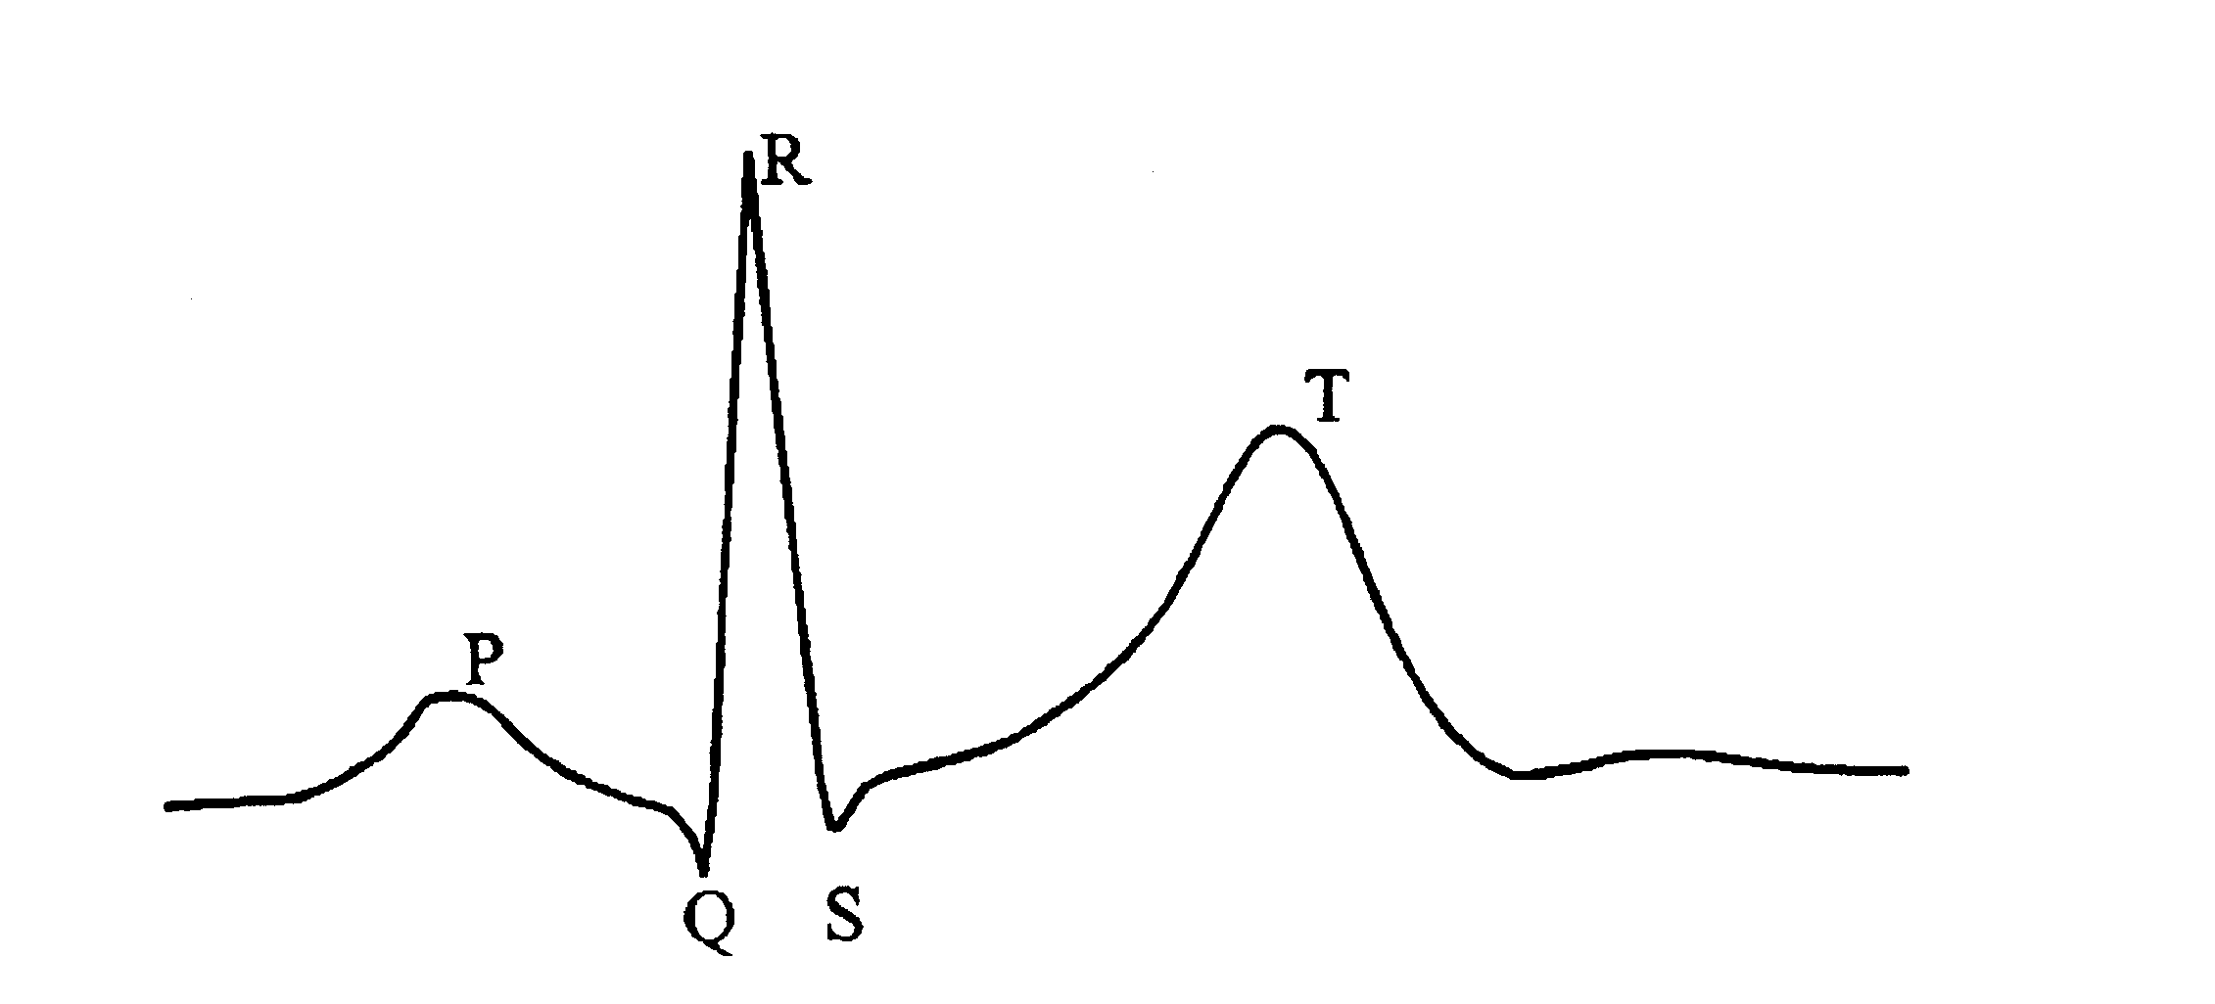
Amplitude (mV)
Time (s)
1

Fig. 2: Typical ECG signal
The duration between the peaks were selected as a second feature to be used as an input to network in the study. The duration of the peaks can be calculated as shown in equation (1);

Duration = P_{xi}-P_{xi-1} (1)

Pre-gradient and post-gradient are measurements of the slope before and after the peak. F_{pre}(i) and F_{post}(i) are the features known as pre-gradient and post-gradient respectively, which can be calculated as shown in equations (2) and (3) respectively below;

$F_{\text{pre}}(i)=\frac{D_{\text{yi}}−D_{\text{yi}−1}}{D_{\text{xi}}−D_{\text{xi}−1}}$ (2)

$F_{\text{post}}(i)=\frac{D_{\text{yi}}−D_{\text{yi}+1}}{D_{\text{xi}}−D_{\text{xi}+1}}$ (3)

Degree is introduced as a fifth features to describe the shape of the peaks. During degree feature extraction, absolute value of degree was implemented. Previous stage of pre-gradient and post-gradient already provided brief information regarding polarity of peaks. Degree can be calculated as shown in equation (4).

$F_{\text{deg}\text{ree}}\left(i\right)=\text{abs}\left(\text{arctan}\frac{D_{x_{i}}−D_{x_{i−1}}}{D_{y_{i}}−D_{y_{i−1}}}+\text{arctan}\frac{D_{x_{i}}−D_{x_{i+1}}}{D_{y_{i}}−D_{y_{i+1}}}\right)$(4)
All of these features are analyzed and assigned for particular network which finally identifies each of the ECG peaks.

4 Multiple radial basis function
Radial basis function networks have been theoretically proved to poses a universal approximation property [11]. In this structure of network, the input node performs as data distributor to the hidden and output nodes. An RBF network with one hidden layer is illustrated in Fig. 3.

Moving k-means clustering algorithm is adopted. The algorithm is specially designed for RBF network to locate the centre in such a way that all the data are within an acceptable distance from the centre [12]. Recursive least square error (LSE) is used to update weights and threshold.

y₁
v_{n}
v₂
v₁
input
layer
hidden
layer
bias input
output
layer

Fig. 3: Radial Basis Function Network

Multiple radial basis function (MRBF) is the combination of several RBF networks. During features selection, individual network will be received selected features. The output of MRBF can be achieved by selecting output from individual network. Fig. 4 shows the MRBF structure.

MRBF
Output

RBF
Network
Network P
Network R
Network Q
Network S
Network T

Output
Selection
features
selection
for
individual
network

Fig. 4: Multiple Radial Basis Function Block Diagram

5 Results
The data set used in this study contained 1500 data collected at Hospital Universiti Sains Malaysia, Malaysia. The data set was divided to 750 data each for training and testing of the network. Initial value for momentum (α₀) for recursive LSE is assigned to 0.3. 1 to 30 hidden node of MRBF network was then arbitrary employed for the analysis.

Table 1 shows suitable combination of selected features for each of the networks in MRBF. These features selection will be used as individual input of the networks. The performance of the network which identifies Q, R and T peaks decreased while all the features used as the input. 3 features as input used for the networks which manage to identify R and T peaks to be optimum. The number of hidden node which achieved the highest testing accuracy also stated in Table 1.

Table 1: Highest Detected Accuracy at Selected Features and Hidden Node for Individual Network
Network | Features Selection | Hidden  Node | Testing Accuracy (%)
P | Amplitude  Interval  Pre-gradient  Post-gradient  Degree | 28 | 92.4
Q | Amplitude  Pre-gradient  Post-gradient  Degree | 19 | 93.07
R | Interval  Pre-gradient  Post-gradient | 13 | 100
S | Amplitude  Interval  Pre-gradient  Post-gradient  Degree | 30 | 93.73
T | Interval  Post-gradient  Degree | 30 | 92.53

Fig. 5 shows the means square error (MSE) of the MRBF network. The network is tested up to 50 epochs. There is no significant improvement of MSE after 50 training epochs. MSE of -12.33 dB was recorded at 50 epoch.

Fig. 5: Graph MSE vs. epoch of MRBF network

Fig. 6 shows the training and testing accuracy of the network. The highest accuracy for testing is 86.53% during epoch 7 while for training 86.93%.

Fig. 6: Graph accuracy vs. epoch of MRBF network.

6 Conclusion
The aim of the study is to extract suitable features from ECG signals. The selected features such as amplitude, duration, pre-gradient, post-gradient and degree will be arranged for individual network in the MRBF. It was found that performance of MRBF is increased by selecting the appropriate features for the individual network. Features selection used as input to the MRBF network found produced highest performance for individual networks. The problems faced during the extraction of morphological parameters were extracting features from the noisy ECG signals, variability of the signal characteristics in different patients and implementation of sufficiently powerful algorithms to achieve reasonable real peaks recognition.

7 References

[1] S. S. N. Alhady, P.A. Venkatachalam and Marizan Sulaiman, Design of noiseless ECG monitoring system with in-built expert system , ROVPIA, vol 1, 1999, pp. 202-210.
[2] N. Kumaravel, Preprocessing, analysis and classification of electrocardiogram – an artificial intelligence approach, Ph.D. thesis, Anna University, India, 1997.
[3] L. Edenbrandt, B. Devine and P.W. Macfarlane, Neural networks for classification of ECG ST-T segments, J. Electrocardiol., vol. 25, no. 3, 1992, pp. 167–173.
[4] T. Stamkopulos, M. Strintzis, C. Pappas and N. Maglaveras, One lead ischemia detection using a new back-propagation algorithm and the European ST-T segment database, IEEE Comput. Cardiol., 1992, pp. 663-666.
[5] R. Silipo, M. Gori, A. Taddei, M. Varaniniand C. Marchesi, Classification of arrhythmic events in ambulatory ECG, using artificial neural networks, Com. Biomed. Res., vol. 28, 1995, pp. 305-318.
[6] J. H Frenster, Neural networks for pattern recognition in medical diagnosis, Proc. 12th IEEE EMBS Biomed. Eng. Perspectives: Health Care Technol. 1990’s Beyond, P. C. Pedersen and B. Onaral, Eds., 1990, pp. 1423-1424.
[7] G Bortolan and J.L. Willems, Diagnostic ECG classification based on neural networks”, J. Electrocardiol., electrocardiography, Euro. Heart J., vol. 13, 1992, pp. 1164-1172.
[8] R. Silipo nad C. Marchesi, Artificial neural networks for automatic ECG analysis, IEEE Trans. On Signal Processing, vol. 46, 1998, pp 1417-1425.
[9] S. S. N. Alhady, M. R. Arshad and M. Y. Mashor, Peaks Recognition in Electrocardiogram Waveforms, Joint Conference on Information Science, North Carolina, USA, 2003.
[10]T. Poggio and F. Girosi, Network for approximation and learning, Proc. of IEEE, 78(9), 1990, 1481 – 1497.
[11] M. Y. Mashor, Some Properties of RBF Network with Applications to System Identification, Int. J. of Sys. Sc., vol 7, No. 1, 1999, pp 34 – 56.
[12] M. Y. Mashor, Hybrid Training Algorithm for RBF Network, Int. J. of Sys. Sc., vol 8, No. 2, 2000, pp 60 – 65.

