Hiding Information in Side-Match VQ Compressed Images

SHINFENG D. LIN, SHIH-CHIEH SHIE and CHIH-MING FANG
Department of Computer Science and Information Engineering
National Dong Hwa University
1, Sec. 2, Da-Hsueh Rd., Shou-Feng, Hualien
TAIWAN, REPUBLIC OF CHINA

Abstract: - An adaptive information hiding scheme which embeds secret data into side-match vector quantization compressed image is proposed in this paper. This scheme makes use of the predictive property of side-match VQ to improve the traditional VQ-based information hiding techniques. It provides more effective hiding capacity and obtains higher quality images than earlier works. Experimental results demonstrate that the average image quality of our proposed method is much better than the VQ-based information hiding schemes.

Key-Words: - Information hiding, image compression, side-match vector quantization.

1 Introduction
The protection of digital information communicated on the network has become an important topic for discussion. Information hiding (data hiding) is a common technique to achieve the purpose of data protection. Minimal perceivable degradation is required when secret data were embedded into the cover media by information hiding. This technique involves protecting copyright, communicating secretly, and embedding captions [1].
During recent decades, many image compression algorithms have been proposed to reduce the amount of data stored in an image with acceptable image quality. One of the most popular image compression techniques is vector quantization (VQ), which has been successfully applied to encode images and speech. A memoryless VQ takes the high correlation among neighboring pixels within a block into account, but disregards the high correlation between the adjacent blocks. In order to obtain lower bit rate while maintaining high image quality, another VQ technique with memory named finite-state vector quantization (FSVQ) [2] has been presented to satisfy this need. Side-match VQ [3] is a typical FSVQ that exploits the codeword information of two encoded adjacent blocks, the upper block and the left block, to predict the current input vector.
In this paper, an information hiding technique based on side-match vector quantization is proposed to improve the capability of secret data embedding in an image. The rest of this paper is organized as follows. The background knowledge is introduced in section 2. Section 3 addresses the proposed SMVQ-based information hiding technique. Simulation results are demonstrated in section 4. Finally, the conclusion is given in section 5.
2 Related Background
Generally, vector quantization is a lossy compression scheme. A VQ coding system can be simply defined as a mapping from a k-dimensional Euclidean space R^{k} to a finite subset of space R^{k}. This finite subset is called a VQ codebook and is composed of a finite set of codewords. The VQ codebook is usually generated based on the LBG [4] algorithm from a set of training images. The quality of the compressed image is significantly dependent on the codebook.

2.1 Data Hiding in VQ Compressed Image
Recently, Du et al. proposed a data hiding scheme that hides a large amount of secret data into the VQ compressed image [5]. In Du et al.’s scheme, the codewords of the VQ codebook are classified and grouped into clusters so that the codewords are similar within each group. For each input block, the nearest codeword in the VQ codebook and a specific cluster, that includes this codeword, can be found in the procedure of VQ compression. Replacing one codeword with another from the same cluster does not cause large distortion since the codewords are similar. Consequently, the hidden data may be embedded into these freely selected codewords in VQ. This is the main idea of Du et al.’s scheme.

2.2 Side-Match Vector Quantization
Side match vector quantization (SMVQ) is a class of finite state vector quantization and was developed by Kim [5] in an attempt to force the encoder to optimize edge contiguity across block borders. Since there exists high statistical correlation between the neighboring blocks in a natural image, side match vector quantization is suitable for image compression.
The state in SMVQ is determined by looking only at the pixels which adjacent to the current block. These pixels are referred to as the border pixels of the current block. The state codebook is selected as the subset of the super codebook C with the best codewords for matching the border pixels. Let L and U denote the left and upper block of the current block, where the block size is n×n. Then (l_{1,n} ,l_{2,n},…,l_{n,n}) and (u_{n,1},u_{n,2},…,u_{n,n}) are border pixels. The horizontal distortion of a codeword y in the master codebook is defined as
$\text{hd}(y)=\sum_{i=1}^{n}{(yi,1−li,n)^{2}}$ (1)
The vertical distortion of y is defined as
$\text{vd}(y)=\sum_{j=1}^{n}{(y1,j−un,j)^{2}}$ (2)
And the side match distortion is the sum of the horizontal distortion and vertical distortion.

smd(y)=hd(y)+vd(y) (3)

The state codebook contains N codewords with the smallest side match distortion selected from the super codebook C.

3 Information Hiding By SMVQ
Generally, the information hiding schemes for images have two key points – the embedded image quality and the embedding capacity. To compare with the earlier works, we combine our scheme with a related image compression method. Thus, we choose the most widely used image compression algorithm – SMVQ. But the ordinary SMVQ algorithm for data hiding is not efficient. For this reason, we improve the ordinary SMVQ algorithm. An adaptive information hiding technique based on side-match vector quantization that proposed here is named adaptive side-match embedding (ASME).

3.1 Two Master Codebooks Generation
The quality of cover image is most important for image data hiding. SMVQ exploits the codeword information of two encoded adjacent blocks to predict the current input vector. But, it does not take the variance of the current input block x itself into consideration. It is known that an image block that has an edge passing through it would result in a larger variance. Therefore, we apply two master codebooks in our data hiding scheme. One master codebook is composed of smooth codewords, and the other is composed of complex codewords.
Let x={x₀,x₁,x₂,…,x_{k-1}} be a k-dimensional vector, the mean value of vector x can be defined as
$mx=\frac{1}{k}\sum_{i}^{k−1}{x(i)}$ (4)
then the variance of the vector x is defined as
$vx=\frac{1}{k}\sum_{i}^{k−1}{{\left(x(i)−mx\right)}^{2}}$ (5)
In the process of codebook training, the training set is also separated into two classes according to the variance of the training vectors. Therefore, two master codebooks were applied in the proposed system. As shown in Table 1, the variance of input image block decides which master codebook is used in the data hiding process. If the variance of the input block is not larger than TH_{var}, the first master codebook S₀ is selected. S₀ consists of the codewords whose variances are smaller than TH_{var}. Otherwise, the second master codebook S₁ is used.

Condition | Master codebook
v_{x}TH_{var} | S₀
v_{x}>TH_{var} | S₁
Table 1. The master codebook selection.

3.2 Embedded Blocks’ Selection
In the proposed scheme, not all of the input blocks were embedded with the secret data. Hence, we provide a threshold to select the blocks to embed the secret data. The selection of blocks is based on the side-match distortion of the current input block. If the side-match distortion among the current input block and the upper and the left encoded blocks are smaller than TH_{smd}, secret data is hidden in this input block. Otherwise, we encode this input block by vector quantization process without hiding data inside.

3.3 Encoding Input Blocks by SMVQ
Generally, a coding system with memory denotes that the index generated by the encoder depend not only on the current input vector but also on prior input vectors. The prior vector embedded with secret data is not always the closest codeword in the codebook. Such condition will introduce more distortion to the cover image. Therefore, not all of the input blocks are encoded by SMVQ in this scheme.
To reduce the distortion of cover image, we utilize an improved SMVQ scheme in the proposed data hiding technique. Some blocks of cover image are encoded by SMVQ to hide secret data, and the others are encoded by ordinary VQ to maintain the visual quality of cover image. Therefore, the side information of our proposed scheme consists of the index for class codebook (one bit for each image block) and the extra bit to notify the use of SMVQ state codebook (one bit for each image block encoded by smooth codebook S₀). If the second extra bit is ‘0’, then the state codebook SC made from the smooth codebook S₀ is used. Otherwise, the master codebook S₀ is used directly. An example of side information is shown in Table 2.

00 | 01 | 1 | 1 | 1 | 1 | 01 | 00
01 | 01 | 01 | 1 | 00 | 01 | 01 | 01
1 | 00 | 01 | 01 | 01 | 00 | 01 | 01
1 | 1 | 00 | 01 | 01 | 00 | 00 | 01
01 | 01 | 00 | 1 | 01 | 00 | 00 | 00
Table 2. An example of side information. The first bit indicates the class index, and the second notifies the usage of state codebook.

3.4 Embedding Algorithm
Fig. 1 illustrates the embedding procedure of the proposed scheme. And the details of the proposed adaptive information hiding technique based on SMVQ (ASME) are listed as follows.
Step1: Let the current input vector be x. The variance of the input vector x be v_{x}.
Step2: If v_{x}TH_{var}, select the master codebook S₀ and the first extra bit is ‘0’. Compute the side match distortion of input vector x, smd(x).
Step3: If v_{x}TH_{var} and smd(x)TH_{smd}, find x’s codeword y in the state codebook according to the secret data b_{i}. The state codebook is generated from the master codebook S₀, and the second extra bit is ‘0’. Send the index of y to the decoder.
Step4: If v_{x}TH_{var} and smd(x)>TH_{smd}, find x’s closest codeword y from the master codebook S₀. Send the second extra bit ‘1’ and the corresponding index of y to the decoder.
Step5: If v_{x}>TH_{var}, the master codebook S₁ is used and the first extra bit is ‘1’. Directly encode x by codebook S₁ and send the corresponding codeword index to the decoder.
Step6: If there is another input vector required to be encoded, go to step 1.

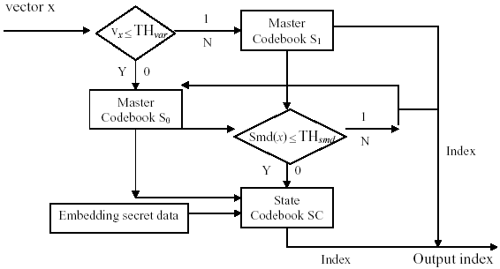
Fig. 1. Encoder of the proposed scheme.
3.5 Extraction Algorithm
The decoder is equipped with the same two master codebooks S₀ and S₁ as the encoder. In the data extracting process, the side information plays a major role in our algorithm. Each decoding block is associated with one or two extra bits to notify its characteristics. The first extra bit is to indicate which master codebook is used. And if there exits a second extra bit, it decides if the state codebook is used. The data extraction algorithm is listed blow. And Fig. 2 shows the block diagram.

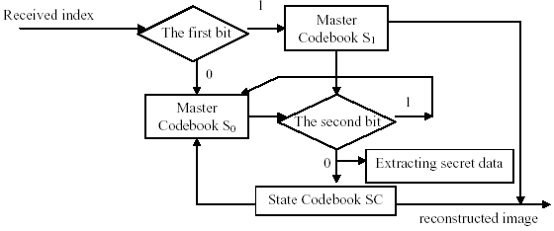
Fig. 2. Decoder of the proposed scheme.

Step1: Let the current decoding block be x.
Step2: Extract the first extra bit. If the first extra bit is ‘0’, then the master codebook S₀ is used. Otherwise, the master codebook S₁ is used.
Step3: If the first extra bit is ‘0’ and the second extra bit is ‘0’, then the state codebook is made from S₀. Look up the state codebook to obtain the decoded block of x. The index following the two extra bits ‘00’ is the secret data embedded in this block.
Step4: If the first extra bit is ‘0’ and the second extra bit is ‘1’, then the following index is decoded by master codebook S₀.
Step5: If the first extra bit is ‘1’, the following index is directly decoded by master codebook S₁.
Step6: If another input block is needed to be decoded, go to step 1.

4 Experimental Results
In the experiments, all test images are 512×512 monochrome still images with 256 gray levels. Two master codebooks with size 512 are applied and the quality of cover image is evaluated by the peak signal-to-noise ratio (PSNR). In the experiments, each image is divided into blocks with 4×4 pixels, resulting in 16384 blocks for each image. Fig. 3 illustrates the experimental results on test image “F16”. The secret data are generated randomly. Randomly generated data with 8K, 16K, 32K, 48K, 64K, 80K bits are embedded in each test image, respectively.
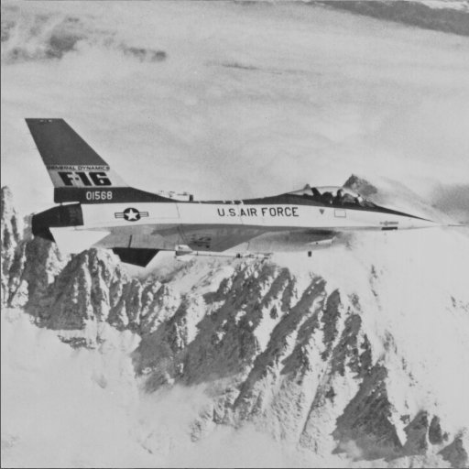  (a) The original image | (b) Secret data = 0 Kbits  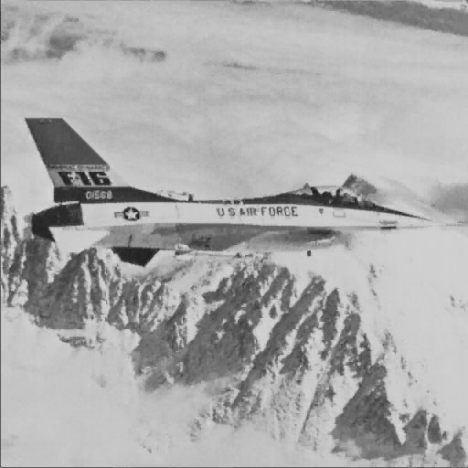  PSNR = 34.39dB
(c) Secret data = 8 Kbits  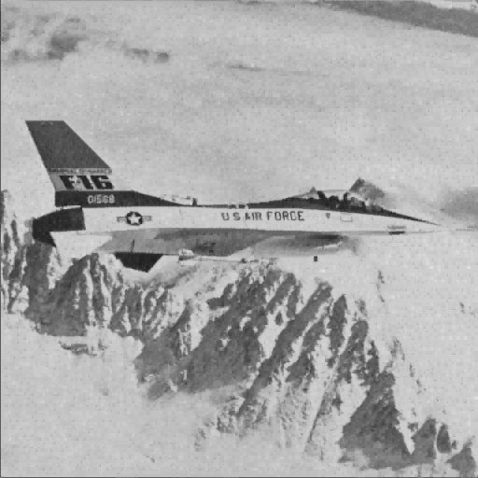  PSNR = 34.37dB | (d) Secret data = 16 Kbits  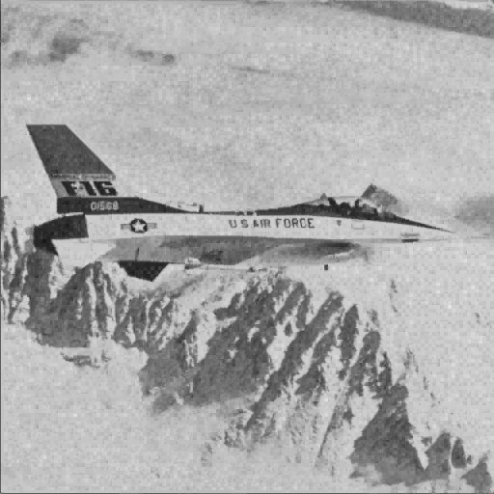  PSNR = 34.11dB
(e) Secret data = 32 Kbits  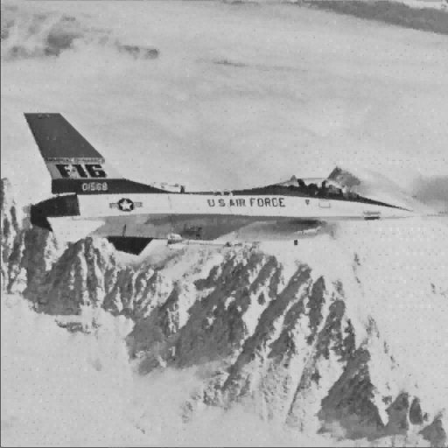  PSNR = 33.26dB | 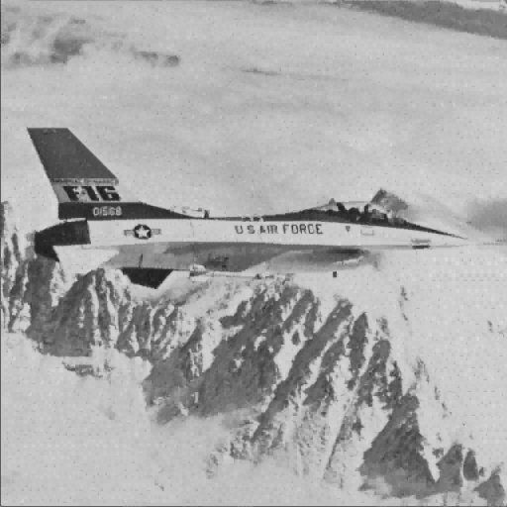  (f) Secret data = 48 Kbits PSNR = 31.51dB
(g) Secret data = 64 Kbits  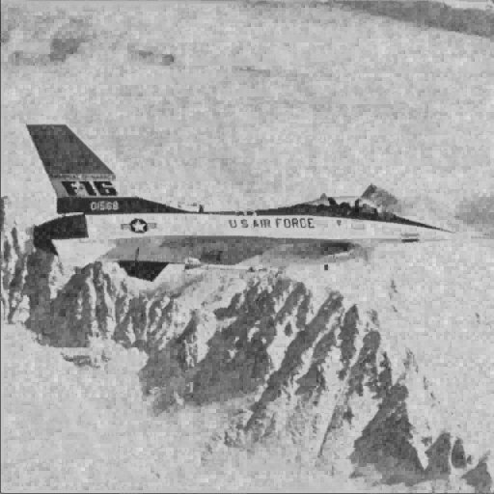  PSNR = 29.57dB | (h) Secret data = 80 Kbits  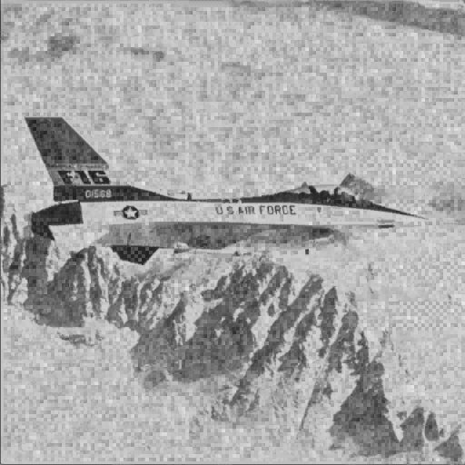  PSNR = 26.79dB
Fig. 3. Experimental results of test image “F16”.

Another experimental data compared with [5] are listed in Table 3. As shown in Table 3, the proposed scheme obtains better image quality than [5] while the same number of bits is embedded into the cover image. Our scheme outperforms [5] because we find that the quality of decoded complex blocks dominates the PSNR of cover image. Therefore, all the secret data is embedded into the smooth blocks of cover image by SMVQ. In our experiments, the size of state codebook is not fixed. The state codebook size is 32 when the secret data is with size 8K and 16K bits, respectively. The size of state codebook is set to be 64, respectively, for embedding 32K, 48K, and 64K bits of secret data. When the amount of secret data is larger than 80K bits, we have to apply a state codebook with size 128.

Capacity  Bits | ACE[5] |  | ASME
Capacity  Bits | Lena | F16 | Lena | F16
8k | 31.05 | 30.64 | 34.39 | 34.37
16k | 30.78 | 30.59 | 33.76 | 34.11
32k | 29.75 | 30.40 | 31.30 | 33.26
48k | 28.16 | 29.90 | 29.84 | 31.51
64k | 25.95 | 28.51 | 27.57 | 29.57
80k | 22.91 | 26.38 | 23.76 | 26.79
Table 3. Performance comparison of the proposed scheme and [5].

5 Conclusion
In this paper, we have proposed an effective information hiding algorithm based on side-match vector quantization compressed images. To maintain good visual quality of cover image, two key points are introduced in the proposed scheme. First, we apply the concept of class codebooks in the process of cover image encoding. Second, the secret data are embedded into image blocks with small side-match distortion. Simulation results show that our proposed scheme has good capability for data hiding, and the visual quality of cover image is much better than the earlier algorithms.

Acknowledgment:
The authors are supported by NDHU and NSC (R. O. C.) with project no. NSC 92-2213-E-259-018.

References:
[1] F.A.P. Petitcolas, R.J. Anderson, and M.G. Kuhn, Information hiding – a survey, Proc. IEEE, Vol.87, No.7, 1999, pp. 1062-1078.
[2] J. Foster, R.M. Gray, and M.O. Dunham, Finite-state vector quantization for waveform coding, IEEE Trans. Inform. Theory, Vol.IT-31, May 1985, pp.348-359.
[3] T. Kim, New finite state vector quantization for images, Proc. of ICASSP, 1988, pp. 1180-1183.
[4] Y.C. Lin and S.C. Tai, A fast Linde-Buzo-Gray algorithm in image vector quantization, IEEE Trans. Circuits Syst. II, Analog Digit. Signal Process., Vol.45, No.3, 1998, pp. 432-325.
[5] W.C. Du and W.J. Hsu, Adaptive data hiding based on VQ compressed images, IEE Proc.-Vis. Image Signal Processing, Vol.150, No.4, August 2003, pp. 233-238.

