Latest Innovation For FFT implementation using RCBNS

SADAF SAEED, USMAN ALI, SHAHID A. KHAN
Department of Electrical Engineering
COMSATS Institute of Information Technology, Abbottabad (Pakistan)

Abstract: - Recent research relating to complex numbers has indicated that a complex numbers can be represented by a single unit with base (-1+j) and (-1-j) in Complex Binary Number System (CBNS). Redundant Complex Binary Number System is another technique for one-unit representation. RCBNS is getting preference over CBNS due to carry-free addition, simple multiplication and direct conversion method between base-2 and base (-1+j), whereas CBNS does not provide these advantages. This paper proposes the applications of these Redundant Complex Binary Number System (RCBNS) in the implementation of Fast Fourier Transform. The proposed technique is believed to reduce computational complexity and cost of FFT implementation as compared to traditional technique used for FFT implementation. The results presented in this paper indicate that the utilization of the proposed complex binary numbers technique reduces the number of real additions involved in single butterfly, from 6-addition to 2-addition and real multiplication from 4-multiplication to 1-multiplication only.

Key-Words: - Complex Binary Number System (CBNS), Redundant Complex Binary Number System (RCBNS), Complex Numbers, Arithmetic Addition and multiplication.

1 Introduction
It is well known that the Fourier Transform (FT) plays a key role in signal processing applications. The FT is useful for frequency domain analysis of a signal, i.e. it transposes a signal from time domain into frequency domain. Many applications ranging from telecommunication, electric energy distribution systems and general signal processing use this transform as a tool for coding/decoding or spectrum analysis of a signal. Because of the complexity of the processing algorithm of FT and its importance in signal analysis, many people have been working on methods and application specific processor architecture for improving the computation performance.
Two-dimensional convolution is a fast and simple way of filtering an image in the spatial domain if the template being used is relatively small (i.e., 8x8 pixels). As the template grows in size, the computational burden increases geometrically. Convolution of larger templates can be carried out much faster by converting an image in the spatial domain to the frequency domain and then applying a filter by doing point-by-point multiplication [1]. The filtered image in the frequency domain is then converted back to the spatial domain by doing an inverse Fourier transform. Image and digital signal processing (DSP) applications typically require high calculation throughput.

  - Fast Fourier Transform
The fast Fourier transform algorithm (FFT) consists of a variety of tricks for Reducing the computation time required to compute a DFT[1]. The number of complex multiplications and additions required to implement an N-point DFT is proportional to N². The 1-D DFT can be decomposed so that the number of multiply and add operations are proportional to N log₂N. The FFT algorithm achieves its computational efficiency through a divide and conquer strategy. The essential idea is a grouping of the time and frequency samples in such a way that the DFT summation over N values can be expressed as a combination of two point DFTs. The two point DFTs are called butterfly computations and requires one complex multiply, and two complex additions to compute. By using the FFT partitioning scheme, an 8-point FFT can be computed as shown in Figure 1.
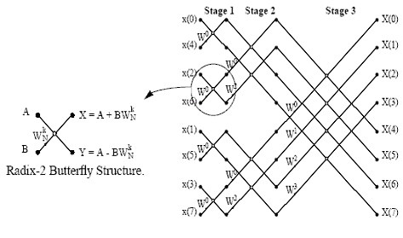
Figure 1: Decimation in time 8-point FFT

Each stage of the N point FFT is composed of N/2 radix-2 butterflies and there are a total of log₂N stages. Therefore there are a total of (N/2)log2N butterfly structures per FFT. In addition, the input is in bit-reverse order and the output is in linear order. A 2-D FFT can be decomposed into two arrays of 1-D DFTs, each of which can be computed as a 1-D FFT.

  - Image Filtering using the Fourier Transform
An example illustrating the application of the Fourier transform to images is shown in Figure 2. An exponential high-pass filter is used to attenuate the low frequency components in order to perform edge detection. In Frequency domain the four corners of the images are the locations of the low frequency components and the high-frequency components are located near the center of the image. So the high-pass filter would allow the central region of frequency domain image to pass as such and would block the four corners of the image.
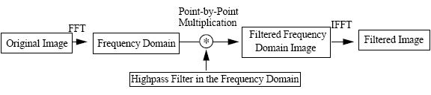
Figure 2: FFT filtering

  - Butterfly Implementation
The butterfly operation is the heart of the FFT algorithm. It is pipelined in order to compute a real and complex result every clock cycle. The butterfly structure diagram shown in Figure 1 involves calculating a complex floating-point multiplication and two floating point additions/subtractions. The complex multiply involves four multiplications and two additions/subtractions.

- COMPLEX BINARY NUMBER SYSTEM

Complex numbers play a very important role in engineering applications such as digital signal processing and image processing. Thus design of an efficient approach to handle complex arithmetic will result in better performance in such applications. These days, complex number operations involve, to a large extent, application of a “divide-and-conquer” technique, whereby a complex number is broken up into its real and imaginary parts. Operations are then carried out on each part as if it were a real part of the arithmetic. Finally, the overall result of the complex operation is obtained by accumulation of the individual results. For instance, addition of two complex numbers (a + jb) and (c + jd) requires two separate additions (one for the real parts and one for the imaginary parts) while multiplication of the same two complex numbers requires four multiplications, one subtraction, and one addition. This can be effectively reduced to just one complex addition or only one multiplication and addition respectively for the given cases if each complex number is represented as one unit instead of two individual units. Efforts in defining binary numbers with bases other then 2, which facilitates one-unit representation of complex numbers, includes work by Knuth [1], Penney [2], and Stepanenko [3]. Jamil et. al. [4][5] have presented a detailed analysis of (-1+j)-base complex binary number system and elaborated on how addition, subtraction, multiplication, and division of two such complex binary numbers can be accomplished.

  - (-1+j)-Base CBNS
The value of an n-bit binary number with base (–1+j) can be written in the form of a power series as follows:
a_{n-1}(-1+j)^{n-1}+a_{n-2}(-1+j)^{n-2}+...+a₁(-1+j)¹+a₀(-1+j)⁰
Where the coefficients a_{n-1}, a_{n-2}, a_{n-3}….,a₂,a₁,a₀ are binary (either 0 or 1). This is analogous to the ordinary binary number system power series of:
a_{n-1}(2)^{n-1}+a_{n-2}(2)^{n-2}+…+a₁(2)¹+a₀ (2)⁰ except that the bases are different. Using the algorithms, given in [4], we are able to represent a given complex number with single complex binary number.

- Redundant Complex Binary Number System (RCBNS)

RCBNS is a positional number system that has a complex radix and uses a digit set {−α to +α} that allows for carry-free additions[8]. α is restricted to [(r − 1)/2] ≤ α ≤ (r − 1) where r = 4. Using radix of (−1+j) and a digit set {−3, −2, −1, 0, +1, +2, +3}⇒ α = 3, yields the value of X = (x_{n−1},x_{n−2},…,x₁,x₀) given by the expression:
$X=\sum_{i=0}^{n−1}{x_{i}(−1+j)^{i}}$ … (1)
where x_{i} is in the range {−3 to +3}.
Using Equation (1), the RCBNS representations of some complex numbers are given in Table 1.

Table 1: RCBNS representations for some
complex numbers

No | 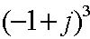 | 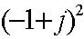 | 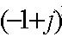 | 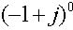
 | 2 + j2 | - j2 | -1 + j | 1
-3 –j3 | -1 | 1 | 1 | 0
-2 –j3 | 0 | 1 | -1 | -3
-1-j3 | 0 | 1 | -1 | -2
0-j3 | 0 | 1 | -1 | -1
1-j3 | 0 | 1 | -1 | 0
2-j3 | 0 | 1 | -1 | 1
3-j3 | 0 | 1 | -1 | 2
-3 +j3 | 0 | -1 | 1 | -2
-2 +j3 | 0 | -1 | 1 | -1
-1+j3 | 0 | -1 | 1 | 0
0+j3 | 0 | -1 | 1 | 1
1+j3 | 0 | -1 | 1 | 2
2+j3 | 1 | -1 | -1 | -1
3+j3 | 1 | -1 | -1 | 0
-3 –j2 | 0 | 1 | 0 | -3
-2 –j2 | 0 | 1 | 0 | -2
-1-j2 | 0 | 1 | 0 | -1
0-j2 | 0 | 1 | 0 | 0
1-j2 | 0 | 1 | 0 | 1
2-j2 | 0 | 1 | 0 | 2
3-j2 | 0 | 1 | 0 | 3
  - RCBNS Conversion method
Conversion of a complex number to the RCBNS form is achieved by converting the complex number into the binary form for the real and imaginary parts and then by using the following steps [9]:

1) Check the sign of both the real and imaginary parts. If each is positive or negative, then for the positive numbers place a 0 in front of each of 2-bit digit (e.g. for 9 =10 01, then 010 and 001), and similarly for the negative numbers place 1 in front of each of 2-bit digit (e.g. for –9 = -10 01, then 110 and 101).
2) Combine the right three bits of the imaginary part to the right three bits of the real part. Repeat the same for the next three bits to form rows named as q_{i}(where i=0,1,2,3….).(see example below)
3) Find the equivalent value for combined group of three bits from real and imaginary part in each row q_{i} (where i=0,1,2,3….) from Table 2. There are four tables for the combinations of the sign of the real part and the sign of the imaginary part (+/+, +/−, −/+, −/−). Table 2 shows only the positive sign for both the imaginary and real parts.
4) Label a group of 4 bits in the first row as q₀. To generate the successive rows, multiply the current row by –4 and so on. This results in the change of sign and magnitude from one row to the next. Therefore, even rows have positive and odd rows have negative signs (... +q_{5,} −q _{4,} +q _{3,} −q _{2,} +q_{1,} −q ₀).
Table 2: Table of conversion from Binary form to RCBNS form in +/+ case

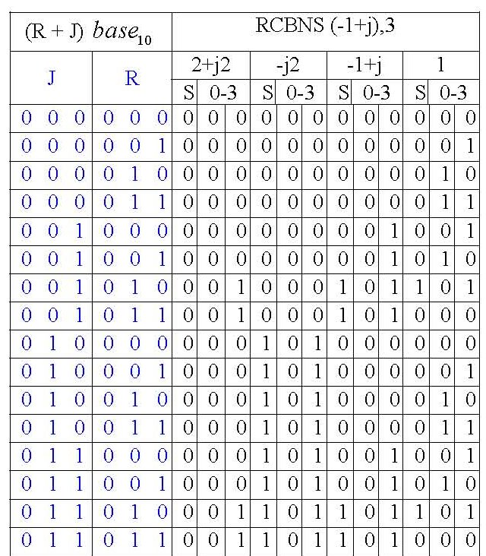
The example below illustrates the conversion of a complex binary number to the RCBNS form.

Example: Convert complex number 18+j25 to RCBNS form
Step 1: Express numbers in the binary form for imaginary and real parts.
Part 1 (J) ⇒ 25 = 11001 ⇒ 25 = 001 010 001
Part 2 (R) ⇒ 18 = 10010 ⇒ 18 = 001 000 010
Step 2: Get 3 bits of each part and combine them together starting with LSB as 3 bits of J and put them together with 3 bits of R to form rows.
q0 ⇒ 001 010
q1 ⇒ 010 000
q2 ⇒ 001 001
Step 3: Find the equivalent values for each group of R and J from Table 2.
q0 ⇒ 001 000 101 101 ⇒ 1 0 –1 –1
q1 ⇒ 000 101 000 000 ⇒ 0 –1 0 0
q2 ⇒ 000 000 001 010 ⇒ 0 0 1 2
Step 4: Multiply the positive sign to even rows and the negative sign to the odd rows.
q0 ⇒ 1 0 –1 –1
q1 ⇒ 0 1 0 0
q2 ⇒ 0 0 1 2
Finally combine them again in the following order. (…q5 , q 4, q 3, q 2, q 1, q 0).
So complex number 18+j25 is represented in RCBNS as (0 0 1 2 0 1 0 0 1 0 –1 –1 )

  - RCBNS Addition
Complex numbers expressed in the RCBNS form can be used as operands to perform arithmetic operations. The results of the operation will be in the RCBNS form. An example of the addition of two complex numbers, (9+j11) and (35+j25) expressed in the RCBNS form is illustrated below.
First, the two complex numbers (9+j11) and (35+j25) are converted into the RCBNS form. Then the addition operation is performed. The complex number (9+j11) is equivalent to (10−1−1 0100 10−10) in the RCBNS form, and similarly the complex number (35+j25) is equivalent to (0000 010−2 0−112).
X 1 0 −1 −1 0 1 0 0 1 0 −1 0
Y 0 0 0 0 0 1 0 −2 0 −1 1 2
===============================
S₁ 1 0 −1 −1 0 2 0 −2 1 −1 0 2
The addition above is carry-free.
In some cases the result may have numbers ranging from −6 to 6; in such cases normalization is necessary. The process of normalization is as follows:
• Normalize the intermediate result to be in the set of {−3, −2, −1, 0, 1, 2, 3}.
• Get the final result S = Normalization + Carry, or S=S₁, if S₁ in the range of –3 to 3.

RCBNS Multiplication
As RCBNS representation unite both the real and imaginary part together. So there is need for four multiplications, one subtraction and one addition, which is normally the case if “divide and conquer” technique is used. Now RCBNS representation permits direct multiplication. Let a number Q=(…q_{5 ,} q _{4,} q _{3,} q _{2,} q _{1,} q ₀) is being multiplied with M=(…m_{5 ,} m _{4,} m _{3,} m _{2,} m _{1,} m ₀) then m ₀ would be multiplied with all q_{i} to produce partial terms and similarly, m ₁ would be multiplied with all q_{i} to produce next partial term and then so and so forth to generate all partial product terms. Finally all the partial terms would be added using RCBNS addition algorithm/method.
Example1: Multiply (– 4j)(– 4j)
Solution: The Redundant Complex Binary representations of the given complex numbers in base –1+j are -4j = 0 0 0 0 0 2 0 0
-4j = 0 0 0 0 0 2 0 0
-4j |  |  |  | 0 | 2 | 0 | 0
-4j |  |  |  | 0 | 2 | 0 | 0
 |  |  |  | 0 | 0 | 0 | 0
 |  |  | 0 | 0 | 0 | 0 | x
 |  | 0 | 4 | 0 | 0 | x | x
 | 0 | 0 | 0 | 0 | x | x | x
-16 | 0 | 0 | 4 | 0 | 0 | 0 | 0

For verification, using equation no 1.
Where x₆ x₅ x₄ x₃ x₂ x₁ x₀ ₌ 0 0 1 0 2 0 1
= 4*(–1 + j)⁴ + 0*(–1 + j)³ + 0*(–1 + j)² + 0*(–1 + j)¹ + 0*(–1 + j)⁰ =-16
Example2: Multiply (1 – j)(-4j)
Solution: The Redundant Complex Binary representations of the given complex numbers in base –1+j are 1 -2 j = 0 0 0 0 0 1 0 1
-4j = 0 0 0 0 0 2 0 0
1 – 2j |  |  |  | 0 | 1 | 0 | 1
-4j |  |  |  | 0 | 2 | 0 | 0
 |  |  |  | 0 | 0 | 0 | 0
 |  |  | 0 | 0 | 0 | 0 | x
 |  | 0 | 2 | 0 | 2 | x | x
 | 0 | 0 | 0 | 0 | x | x | x
-8-4j | 0 | 0 | 2 | 0 | 2 | 0 | 0
For verification, using equation no 1.
Where x₆ x₅ x₄ x₃ x₂ x₁ x₀ ₌ 0 0 2 0 2 0 0
= 2*(–1 + j)⁴ + 0*(–1 + j)³ + 2*(–1 + j)² + 0*(–1 + j)¹ + 0*(–1 + j)⁰ = -8-4j

- RCBNS AND FFT
Complex numbers play a vital role in engineering applications such as Digital Signal Processing and Image Processing. These fields have developed rapidly over the passed thirty three years. This rapid development is the result of significant advances in building efficient algorithms for Fourier Transform. Because of the complexities posed by the processing algorithms of FT many researchers have been working on methods for improving the computational performance of these algorithms. Recent research relating to complex numbers provides us with various interesting techniques for reducing computational complexities. Among them, CBNS and RCBNS are the most interesting and simplest one. However in this paper our inclination is more towards RCBNS than CBNS because of the additional advantages of former over the later.

- RCBNS BUTTERFLY IMPLEMENTATION
We propose that Redundant Complex Binary Number addition and multiplication as explained in section 3.2 and 3.3 should be used in the implementation of the each butterfly in FFT. The butterfly structure is shown in figure 3 below, where variables a, b, c, d, e and f are complex numbers and can be represented as a=a₁+a₂j, b=b₁+b₂j, c=c₁+a₂j, d=d₁+d₂j, e=e₁+e₂j and f=f₁+f₂j.
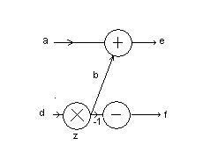
Figure 3: FFT butterfly
If the FFT butterfly is implemented using traditional approach of treating real and imagery part independently the following set of equations would be used to produce the output.
b₁=d₁x z₁-z₂ x d₂
b₂=d₁ x z₂+z₁ x d₁
e₁=a₁+b₁
e₂=a₂+b₂
f₁=a₁-b₁
f₂=a₂-b₂
This would require 4-multiplications and 6-additions. Now, if we implement the butterfly using RCBNS approach then we would be using RCBNS adder and multiplier, which directly perform additions and multiplications on complex numbers respectively, by treating them as a single entity. Using RCBNS approach the set of equations would be as given below
b₁=d x z
e₁=a + b
f₁=a - b
This would require only 1-multiplication and 2-additions.

- RCBNS FFT IMPLEMENTATION:
Before feeding the inputs to the butterfly structure of FFT all the input numbers should be converted to RCBNS representation (section 3.1). Figure 4 below shows the block diagram for RCBNS implementation of FFT. 8-point butterfly structure would contain the usual butterfly structure but with RCBNS adders and multipliers replaced with traditional binary adders and multipliers. After the computations in butterfly structure the output would be converted back from RCBNS to Complex Numbers using one of the methods explained in [8].

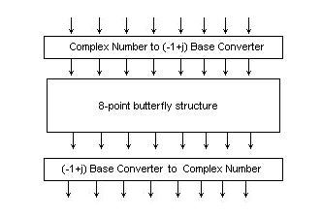
Figure 4: 8-point RCBNS FFT Implementation
- LIMITATIONS:
Twiddle factor z in the FFT calculations as shown in the figure 3 is fractional number of the form z=CosӨ + jSinӨ , so fractional number multipliers would be required in the block of 8-point butterfly structure in figure 4. Currently, no RCBNS representation for fractional numbers has yet been developed nor there exist any algorithm/system for fractional number multiplications. So, before implementing real time hardware of RCBNS FFT work should be done to remove this vary limitation.
- RESULTS & CONCLUSIONS:
Redundant Complex Binary Number System, due to its advantage of having carry free addition as a result easy multiplication algorithm, has almost replace Complex Binary Number System(CBNS). We have explained different operations involving the redundant complex binary numbers like RCBN addition and multiplication and finally proposed how the RCBNS could be utilized in the implementation of Complex FFT. The computation efficiency that could be achieved using RCBNS implementation in the number of computations for 1-D data is shown in the table 1 and is shown graphically in figure 5 and 6. Though RCBNS implementation increases the computation efficiency of FFT but the limitation of having no representation for fractional RCBNS multiplier prevents us from hardware implementation.
- References
[1] R. Gonzalez and P. Wintz, Digital Image Processing, Addison-Wesley Publishing Company, 1977.
[2] L. Rabiner B. Gold, Theory and Application of Digital Signal Processing, Prentice-Hall, 1975.
[3] D. Knuth: “An Imaginary Number System”, Communications of the ACM, pp. 245- 247,1960.
[4] W. Penney:, “A Binary System for Complex Numbers”, Journal of the ACM, pp. 247-248, April 1965.

[5] V. Stepanenko: “Computer Arithmetic of Complex Numbers”, Cybernetics and System Analysis, Vol. 32, No. 4, pp. 585-591, 1996.
[6] T. Jamil, N. Holmes, and D. Blest: “Towards Implementation of a Binary Number System for Complex Numbers”, Proceedings of the IEEE SoutheastCon 2000, Nashville, Tennessee (USA), pp. 268-274, April 2000.
[7] T.Jamil, B. Arafeh, and A. AlHabsi: “Hardware Implementation and Performance Evaluation of Complex Binary Adder Designs,” Proceedings of the 7th World Multiconference on Systemics Cybernetics, and Informatics (SCI 2003), Orlando, Florida (USA), Vol. II, pp. 68-73, July 2003
[8] H. Zaini and R. G. Deshmukh “Complex Number Representation in RCBNS Form for Arithmetic Operations and Conversion of the Result into Standard Binary Form” Journal of Systemics, Cybernetics and Informatics, Vol.2, No.1, 2003.

Figure 5: Multiplier Comparison
Figure 6: Adder Comparison

 | Traditional FFT | RCBNS FFT | Traditional FFT | RCBNS FFT
N | Real Multipliers | RCBNS Multipliers | Real Adders | RCBNS Adders
4 | 16 | 4 | 24 | 8
8 | 48 | 12 | 72 | 24
16 | 128 | 32 | 192 | 64
64 | 768 | 192 | 1152 | 384
256 | 4096 | 1024 | 6144 | 2048
1024 | 20480 | 5120 | 61440 | 10240

Table 1: Savings when using the FFT on 1-dimensional data

