Improving the Knowledge Performance Using
“Ternary Grid” Knowledge Acquisition and Model

YULIADI ERDANI, AXEL HUNGER, STEFAN WERNER
Institute for Multimedia and Software Enginering
University of Duisburg-Essen
Bismarckstrasse. 81
47057 - GERMANY

http://www.fb9dv.uni-duisburg.de/ti/members/hg.php

Abstract: - The knowledge acquisition is major research field in knowledge engineering and still the most difficult and error-prone task for knowledge engineer while building an expert system. This situation influences the performance of the knowledge due to the quality of information and the reduction of error possibility.

The Ternay Grid technique has potentiality to achieve the above mentioned performance of the knowledge. It is proposed in [1] as a potentially new technique for knowledge elicitation/acquisition. Meanwhile we have developed a suitable process of the knowledge acquisition and developed the knowledge acquisition tools based on the Ternary Grid technique and knowledge model that is called KasTerGrid.

Key-Words: - Knowledge Engineering, Knowledge Acquisition, Expert System

1 Introduction
Knowledge acquisition is considered by many to be the most difficult and precarious stage in the knowledge engineering process [4]. One of the most fundamental and still unsolved problems in knowledge acquisition goes by the name of knowledge acquisition bottleneck which is coined by [5]. [6] noted that this was because knowledge acquisition involves communications between people with completely different backgrounds, human experts and knowledge engineers, who must formulate the concepts, relations and control mechanisms needed for the expert system.

Different Knowledge Acquisition and Elicitation techniques have been developed in order to obtain knowledge [9], [10]. They can be classified in many dimensions. The most common one used is "direct" versus "indirect", where direct techniques are used to obtain information that is easily verbalized and indirect techniques are used to obtain information that is not easily verbalized [11]. Classification can also be based on the type of interaction with the subject and the type of knowledge most commonly obtained.

The difficulties of knowledge acquisition can appear during transferring the knowledge from human expert into the computer or machine and structuring the knowledge [12]. Many various techniques for knowledge acquisition do not consider the quality of the knowledge itself, even though there are possible lacks of knowledge that can decrease the knowledge’s usability or the performance of the inference machine. There are some reasons that are considered as causes for these lacks [13]:

- The expert may have lacks in know-how technique,
- The expert is unable to verbalize the knowledge,
- The expert may provide irrelevant knowledge,
- The expert may provide incomplete knowledge,
- The expert may provide inconsistent knowledge
- The expert may provide redundant knowledge

This paper describes an acquisition process for rule-based knowledge that uses a new technique and knowledge model that we have called “Ternary Grid”. The goal of this technique is to guarantee a good quality of the acquired knowledge and to reduce or avoid the error possibility of knowledge. The Ternary Grid is a model of rule-based knowledge in a grid format where every field represents the relation between a rule and a fact. The fields of the grid can only contain ternary value i.e. “0”, “1” or “2”. The rule-based knowledge is represented in the IF-THEN format.

The idea of this work is inspired and can be traced back to knowledge acquisition systems using grid- or matrix-based technique, like the Repertory Grid Analysis [14], Repertory Grid [15], the Formal Concept Analysis (FCA), first developed by [16] and improved by [17], Multiple Classification Ripple Down Rules (MCRDR) [18], Knowledge Acquisition Tool based on Personal Construct Psychology [19], WebGrid [20], Troika [21] and Epistemics Matrix-based Techniques [22].
2. Ternary Grid Structure
The type of knowledge used for this acquisition technique is the production rule. The term production rule is derived from the production system as it was developed by [23]. A production system is a model of cognitive processing, consisting of a collection of rules (called production rules, or just productions). Each rule has two parts: a condition part and an action (conclusion) part. The meaning of the rule is that when the condition holds true, then the action is taken. The typical form of a production rule is:

IF <condition> THEN <conclusion>

The condition and conclusion may consist of many logical terms that represent facts and every possible rule can be broken down to a form like.

IF <Fact_1> and <Fact_2> and … THEN <Fact_9>

We take an example:

Rule 1: IF <F1> and <F2> THEN <F9>

In mathematical form:

Rule 1: F9 = true, if <F1> and <F2> equal true

Don’t care

The organization of production rule in this form can be easily represented in a Ternary Grid that has the following structure in Fig. 1.

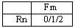
Fig.1. Ternary grid basic structure

Rn: Rule n (n is the number of rule)
Fm: Logical term m (m is the number of logical term)
n = {1, 2, 3…}
m = {2, 3, 4…}, m >= n + 1

The Value of every grid box is 0, 1 or 2
0 = unused, is represented by empty grid box.
1 = Fact Fm belongs to the condition part of rule Rn (LHS= Left Hand Side)
2 = Fact Fm is part of the conclusion part of Rn (RHS = Right-Hand Side)

3. Optimisation Stage
In designing expert systems, the process of eliciting information has been termed knowledge acquisition. According to [7], knowledge acquisition, also known as knowledge elicitation, involves extracting problem-solving expertise from knowledge sources, which are usually domain experts. [8] defines knowledge acquisition as the process of extracting, structuring and organizing knowledge from several sources, usually human domain experts, so it can be used in a program. [4] noted that knowledge acquisition involves the elicitation of data from the expert, interpretation of the data to deduce the underlying knowledge and creation of a model of the expert's knowledge in terms of the most appropriate knowledge representation. The acquisition process using Ternary Grid can be viewed as a process of knowledge optimisation as well.

The knowledge optimisation process in this work is carried out into following steps, i.e. collecting, interpreting and analysing and designing the knowledge. Fig.2 shows the block diagram of the optimisation stage.

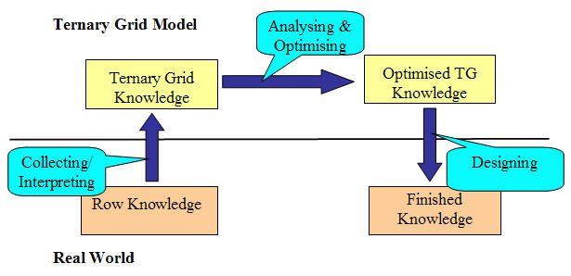

Fig.2. Optimisation Stage

The vehicle for applying this developed knowledge acquisition system has been CongaXpert [2], [3]. It is a web-based expert system that is used for consultation system in academic area in the University of Duisburg-Essen, Germany.

4. Optimising the Knowledge

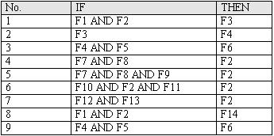
Fig.3. Example of rule

Some data sets (rules) in Fig. 2 are given as an example. The Knowledge engineer converts the notation in Fig. 3 into the Ternary Grid as it is shown in Fig. 4. All facts that are elements of a condition part are represented by the value “1” whereas all elements of a conclusion part are represented by the value “2”. If an element is part of a condition part as well as of a conclusion part, the value is summed up and yields the value “3”. The Value “0” which is represented as an empty box means that there is no relation between the rule Rn and the fact Fm

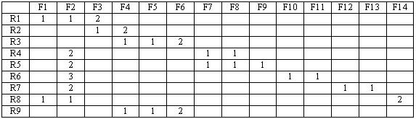
Fig.4. Filled Ternary Grid

The Knowledge engineer analyses the organization of knowledge and forms it into an optimal structure. The analyzing process consists of following steps:

4.1. Consistency and Attainability
An inconsistent or unattainable Rule has the following formula structure:
IF <…> & <…> & <Y>
THEN <Y> + <…> + <…>

Using Ternary Grid these phenomena can be immediately recognized by evaluating the value of the grid’s fields, see Fig.5. If the value is “3”, it means that the rule is inconsistent or unattainable. Rule R6 is an inconsistent or unattainable rule because the value of F2 is “3”. Rule R6 can therefore be eliminated.

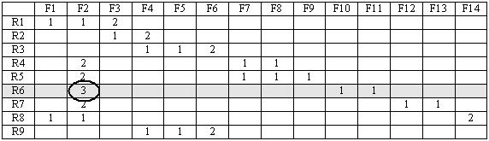

Fig.5. Inconsistent or unattainable rule

4.2. Redundancy
Analyzing redundancy deals with evaluating and eliminating or adding redundant rules that can appear in the form of:
- Repeating facts
- Repeating rules
- Rules with Unnecessary Condition
- Transitive Rules [24]

1) Repeating Facts
A repeating fact is the same fact that appears within a condition part of a rule. Using the Ternary Grid, repeating facts will never occur. For example:

R17: IF <F1> AND <F2> AND <F1> THEN <F3>

F1 appears two times in rule R17. This repeating fact can be avoided by using logic operator “OR” for assigning value into Ternary Grid.

2) Repeating Rules
A repeating rule is a rule that is identical with another rule. Using the Ternary Grid, a repeating rule can easily be recognized by evaluating the rows that contain the same values. In the example, Rule R3 and R9 are identical. R9 is eliminated.

3) Rules with Unnecessary Condition
Redundant rules can appear if for the same conclusion part, the number of consecutive values “1” of a rule has more than other rule. It occurs to rule R4 and R5 in Fig.5. The number of values “1” in rule R5 is more than the number of values “1” in rule R4.
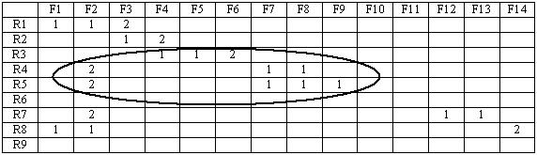

Fig.5. Rule with unnecessary condition

4) Transitive Rules
Due to the principle of equality (if a=b, b=c then a=c), in Fig. 6, the effect of rule R2 is only caused by the conclusion part of rule R1. We can determine that rule R2 is caused by the condition part of rule R1 as well. This statement results in a new rule R10 that has the same conclusion part as rule R2 and the same condition part with rule R1.

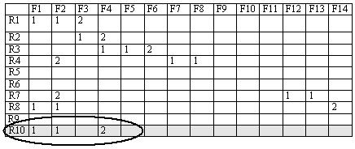
Fig.6. Transitive Rule

4.3. Multiple Conclusions
This part of the analysis concerns the situation that multiple rules have identical condition parts. This situation will actually not lead to a serious problem, but it means that the knowledge base is bigger than necessary. The conclusion part of those rules can be merged and yields a new rule with multiple conclusions. Fact F14 in Fig. 7 is moved into rule R1 and rule R8 is eliminated.

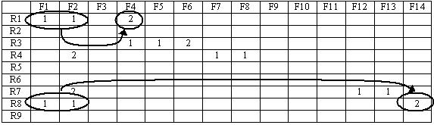
Fig.7. Rule with multiple conclusions

4.4. Rotating Chain
The Rotating chain is a very crucial problem. If the chain of rules rotates, it will lead to endless loops, producing wrong decisions. This situation will also put the reasoning process of inference engine at risk. A correct chain of rules will never rotate. It must have at least one “end-rule” or “top-rule”. This is a rule of which the conclusion part does not appear in any other rule’s condition part.

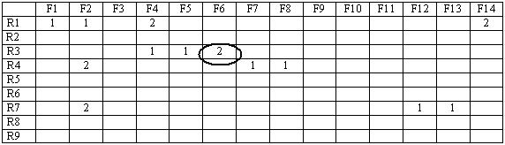
Fig.8. Rules with correct chain. Rule R3 is an end-rule

In the Ternary Grid representation an end-rule can be found by finding columns in which only the value “2” appears. A rule is only an end rule, if the rule’s fields only contain the value “2” within these columns. Fig. 8 shows a set of rules with a correct chain. Rule R3 is an end-rule because in column F6 only the value “2” of rule R3 appears. Even though value “2” appears alone in column F14; rule R1 is not an end-rule because it has another conclusion in column F4. In this column for F4 the value “1” appears as well.

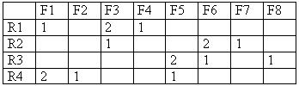
Fig.9. Rules with rotating chain

The figure Fig. 9 shows a set of rules with rotating chain. The illustration of rotating chain can be seen in the figure Fig. 10.

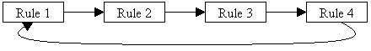
Fig.10. Illustration of rotating chain
5. Implementation - KasTerGrid
The whole concept mentioned above are implemented in the form of software application that is called KasTerGrid. It is abbreviation of Knowledge Acquisition System based on the Ternary Grid (technique and knowledge model).

5.1. System Architecture
Fig.11 shows the system architecture of knowledge acquisition system. The knowledge acquisition system consists of three main parts, i.e. knowledge elicitation (KE) system, expert’s interface and knowledge transformer. Additionally the system provides the knowledge base (KB) in Ternary Grid format that can be directly connected to the Ternary Grid format supported inference engine (under development).

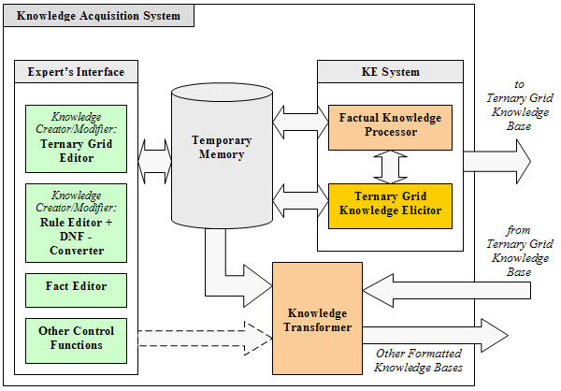
Fig.11. System architecture

5.2. Database Development
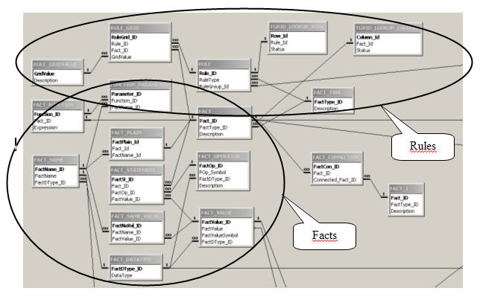
Fig.12. Database

Fig.12 shows developed database for Ternary Grid knowledge base. They consist of rules and facts in the Ternary Grid format. The rules are shown inside the oval circle. The facts are shown inside the circle. In the down-right corner we see the fact-connection table that is important for Factual Knowledge Processor.

5.3. User Interface
The following figures show developed user interface that provides communication between human expert and expert system. Fig.13 shows the fact editor that has task to collect facts from human expert. Fig.14 shows the rule editor. The rule editor enables the expert to build rules in arbitrary format and converts to Ternary Grid format. Both editors facilitate also the creation of the new knowledge and modification of the existing knowledge.

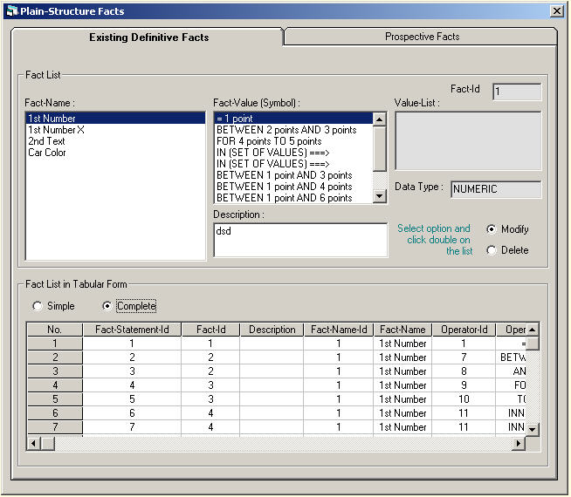
Fig.13. Fact editor

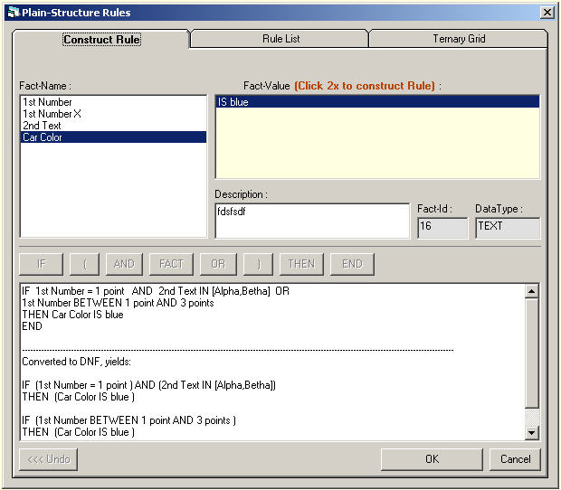
Fig.14. Rule editor

6. Conclusion

The Ternary Grid technique and knowledge model are convenient for handling and optimizing the knowledge. This technique can optimize not only logical terms within a rule but also logical relations between rules.

The representation may be directly viewed as domain and production rule structure or as intermediate stage for optimization. The grid has elements as problem-solving domains that can be derived into sub domains or group of rules, rows as rules, columns as facts and values as IF-THEN syntax.

The organization and logic of expert knowledge in Ternary Grid can be easily inspected and analyzed. Completion and recognition of patterns, which consists of “0” or empty, “1”, “2” values in the grid, are facilitated by the structure and relative compactness of the matrix representation. Representation in the Ternary Grid not only facilitates optimizing and testing for conditions of ambiguity, redundancy, completeness [25] and correctness but also allows these tasks to computable.

According to existing knowledge acquisition techniques, the Ternary Grid technique has potential to give a new contribution in developing knowledge model or representation and knowledge acquisition techniques that are important parts for building expert systems.

References:

[1] Y. Erdani, A. Hunger, S. Werner, S. Mertens, Ternary Grid as a Potentially New Technique for Knowledge Elicitation/Acquisition, Proc. 2nd IEEE Conference on Intelligent System, Varna - Bulgaria, 2004. vol I: pp. 312-315. ISBN 0-7803-8278-1

[2] A. Hunger, S. Werner, CONGA: A Course Online/ Offline Information and Guidance System to support an International Degree Course, Proceeding of ICCE 99. Chiba-Japan, 1999, ISBN 1 58603 027 2, Page 577-583

[3] Y. Erdani, A. Hunger, S. Werner, S. Mertens, Web-Based Consultation System with Expert System, IASTED CST 2003 – International conference (International Association of Science and Technology for Development – Computer Science and Technology), May 19-21, 2003, Cancun, Mexico. ISBN – 0-88986-349-0, page 61-64

[4] P. Smith, An introduction to knowledge engineering (London: International Thompson Computer Press, 1996).

[5] E.A., Feigenbaum, Knowledge Engineering: The Applied of Artificial Intelligence. Annals of the New York Academy of Science, 1984, Page 91-107

[6] N. Tsai, C. Necco, G. Wei, An assessment of current expert systems: Are your expectations realistic? Journal of Systems Management, November 1994, 28-32.

[7] R. Hoffman, The problem of extracting knowledge of experts from the prospective of experimental psychology, (AI Magazine, 8, 1987, 53-64).

[8] D.A. Waterman, A guide to expert systems. (Addison-Wesley Publishing, 1985).

[9] J.H. Boose, A survey of knowledge acquisition techniques and tools, readings in knowledge acquisition and learning (California, Morgan Kaufmann, pp. 39-56, 1989).

[10] E.S. Cordingley, Knowledge elicitation techniques for knowledge-based systems (in D. Diaper (Ed.)), Knowledge elicitation: Principles, techniques and applications (Chichester, England: Ellis Horwood Ltd., pp. 89-173, 1989).

[11] E. Hudlicka, Summary of knowledge elicitation techniques for requirements analysis (course material for human computer interaction, Worcester Polytechnic Institute, 1997).
[12] Villegas, Difficulties in Knowledge Acquisition Chapter 13: Knowledge Acquisition and Validation, web publication,
http://www.usfca.edu/~villegas/classes/992-6275/6275ch13/, 1999.

[13] PSU, Lecture Note: knowledge acquisition INFSY 565. The Pennsylvania State University, web publication: http://www.courses.psu.edu/Materials/_off_/infsy565_lmm121/Knowacq.ppt, 2002.

[14] G. Kelly, The psychology of personal constructs (New York: Norton, 1955).

[15] M.L.G. Shaw, On becoming a personal scientist (London, Academic Press, 1980).

[16] R. Wille, Restructuring lattice theory: an approach based on hierarchies of concepts in ordered sets ((ed. Rival), Reidel, Dordrecht, Boston, pp. 445-470, 1982).

[17] R. Wille, Concept lattices and conceptual knowledge systems (Computers Math. Application. pp. 6-9:493-515, 1992).

[18] B. Kang, P. Compton and P. Preston, Multiple classification ripple down rules: evaluation and possibilities. Proceedings 9th Banff Knowledge Acquisition for Knowledge Based Systems Workshop Banff. Feb 26 - March 3 1995, vol 1: pp. 17.1-17.20, 1995.

[19] B.R. Gaines and M.L.G. Shaw, Knowledge acquisition tools based on personal construct psychology (Knowledge Science Institute - University of Calgary Alberta, Canada),
http://ksi.cpsc.ucalgary.ca/articles/KBS/KER/, 1995.

[20] B.R. Gaines and M.L.G. Shaw, A networked, open architecture knowledge management system, Gaines, B.R. and Musen, M.A., Ed. Proceedings of Tenth Knowledge Acquisition Workshop.
http://tiger.cpsc.ucalgary.ca/WebGrid/, 1996

[21] H. Delugach and B. Lampkin, Troika: using grids, lattices and graphs in knowledge acquisition, ICCS 2000, Aachen – Germany, Shaker Verlag, pp. 201-214, 2002.

[22] Epistemics, web publication,
http://www.epistemics.co.uk/, 2002

[23] A. Newell and H.A. Simon, Human problem solving (Prentice Hall, Englewood Cliffs, NJ, 1972).

[24] Wikipedia., The free encyclopedia, web publication, http://www.wikipedia.org/wiki/Transitive_property_of_equality, 2003.

[25] B.J. Cragun and H.J. Steudel, A decision-table-based processor for checking completeness and consistency in rule-based expert systems, International Journal of Man-Machine Studies, pp. 633-648, 1987.

