Using Hierarchical Structures in a Generic Simulation Framework for Multiprocessor Architectures

Mario POLASCHEGG Christian STEGER
Institute for Technical Informatics
Graz, University of Technology
Inffeldgasse 16, Graz
AUSTRIA

Damian DALTON Abhay VADHER
Neosera Systems Ltd.
Nova Innovation Center
Roebuck, Belfield, Dublin 4
IRELAND

Abstract: - For developing parallel systems composed of both hard- and software, powerful simulation tools are needed in order to decrease time-to-market. With the Parallel Simulation Framework, which was developed for designing the Parallel APPLES Processor, clock-cycle accurate simulation of parallel devices communicating with each other is possible. By adding hierarchical levels reflecting the physical structure of the simulation, a speedup is tried to be archieved.

Key-Words: - MPI, parallel and distributed simulation, cycle accurate simulation, design space exploration

- Introduction
Complex electronic devices are often divided into a number of modules. This is not only true for large (parallel) systems connected via some kind of network, but also each individual device of a system can be composed of a number of modules (see figure 1 for an example). These modules inside the devices are either closely connected amongst each other or may not represent a physical but only a logical structure.
A complex parallel system therefore may feature a two-level hierarchy with a number of locally detached devices each of them being composed of different modules.

1.1 The Need of Parallel Simulation
Increasing computational demands of various applications are fulfilled with multi-processor solutions composed of a number of processors (maybe even a mix of general purpose and digital signal processors) working together with peripheral components [7]. Developer need simulation tools for simulating multi-processor systems during development of these. This is needed for two reasons: First of all, due to ever decreasing time-to-market requirements, software development has to start at a very early stage when the hardware is not available. Secondly, different topologies possible for a parallel architecture have to be analyzed without actually building these topologies in real hardware. Without having powerful parallel simulation frameworks this is hardly possible.
Because low-cost parallel machines (e.g. custom-of-the-shelf workstations) are available these days, Parallel and Distributed Simulation (PADS) has become an approach to speed up simulations. By splitting up a large simulation into smaller parts and having them executed concurrently on many computers, the execution time can be reduced theoretically nearly by up to a factor equal to the number of processors used. In practice a significant amount of time is needed for synchronization, limiting the real speedup. Difficulties in implementing complex parallel simulations efficiently have prevented this technology from being used at a wide-spread level [10].

- Purpose of a Hierarchical Simulation
When performing a parallel simulation, a number of parallel running devices are simulated on a (different) number of workstations. Both the system to be simulated and the computation environment performing this simulation are connected by some kind of network and are exchanging data amongst each other.
Most common parallel simulation environments feature one kind of central master node, which is supervising and controlling the whole simulation, as well as a number of slaves distributed amongst the available workstations actually performing the simulation. During an ongoing simulation a steady flow of communication between the master and the slaves occurs.
This data exchange can cause a slowdown of the overall simulation because communication packages like e.g. the Message Passing Interface MPI need a significant part of the available processing power. The used network infrastructure can limit the communication speed as well. Because each slave is exchanging data with the central master, this master may not keep up with the slaves and therefore slows down the simulation as well. By reducing the amount of data transferred between the workstations, we try to increase the overall performance of a parallel simulation.
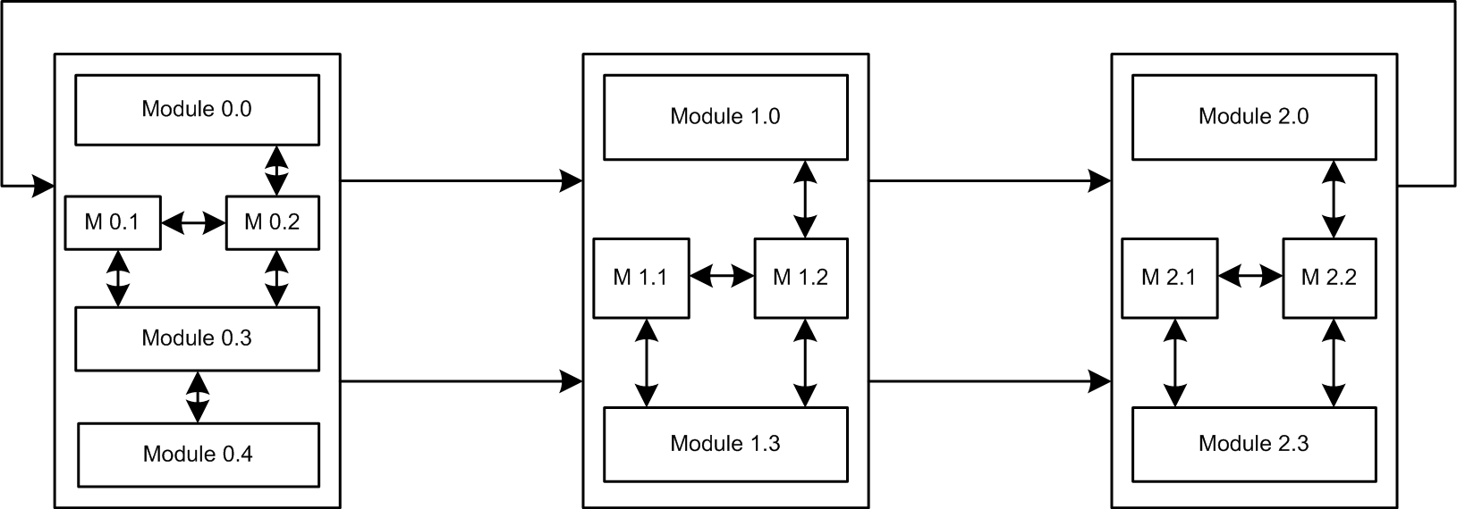
Figure 1: Example of an parallel environment consisting of three devices and a number of modules inside each device

- Related Work
PADS is still mainly conducted by the academic community [3], although a number of multiprocessor simulations are already available ([2], [6]). These HDL simulators usually work with RTL level models, which puts a big constraint on the simulation performance. In section Experimental Results a comparison between our simulation framework and HDL-based simulation is made showing the slow simulation speed of HDL-simulators.
In [4] and [5] frameworks comprehencing communication and abstraction of communication are discussed. Both separate the simulation framework from the model simulated and lead to loose coupling between the framework and the simulation tools.
The simulation framework presented in [7] is a C-based multi-processor instruction set simulator framework which was designed for cycle accuracy and high performance of the simulation. It performs lock-step simulation of the models in the architecture and uses a global simulation engine which handles both intra-processor and inter-processor communication in a homogenous fashion.
An environment specially designed for exploring trade-offs among different simulation algorithms and parallel architectures for executing a given model is used in [1]. This environment supports a number of front-ends for programming models, including execution of C++ written simulation and is build around a thread-based message-passing programming kernel which is limited to one workstation.
Based on the Message Passing Interface MPI is the work presented in [9]. Being a parallel simulator, the typical slowdown occurring in simulation shall be minimized. It uses a set of core MPI functions and assembles more complex point-to-point and collective communication mechanisms with these. By supporting a number of conservative simulation protocols studying these protocols and implementing new ones is easily possible.

- Problem Solution
Basically two kinds of data flows are present in a parallel simulation environment: Data needed to simulate the communication between the modules inside the simulation and messages synchronizing and controlling the simulation itself. The first kind of data exchange is just a part of the simulation and represents the communication occurring inside the simulation. The second type is part of the simulation environment and can be seen as an additional overhead, which should be as low as possible.

A number of different synchronization algorithms exists these days. Although they may operate in different manners, algorithms only allow advancing a node with it's simulation if it can be guaranteed that no message will arrive too late at this node.
Therefore the master needs to have information about the progress of simulation at each node and for this synchronization messages are exchanged between the individual nodes and the master. In section Introduction it was discussed that one device often is composed of an arbitrary number of modules, so far more modules then actual devices to be simulated are present in the simulation. It is quite obvious that the number of workstations to be used for a simulation is significantly smaller then the number of modules inside the simulation, so each workstation has to perform simulation of a number of modules.
When reaching a certain number of modules inside a parallel simulation (on a particular number of workstations running in parallel) the communication between the workstations will limit the overall communication speed. Because the available resources are usually limited, the number of workstations is usually smaller then the number of modules to be simulated within the parallel simulation, and the modules have to be distributed amongst the available workstations.
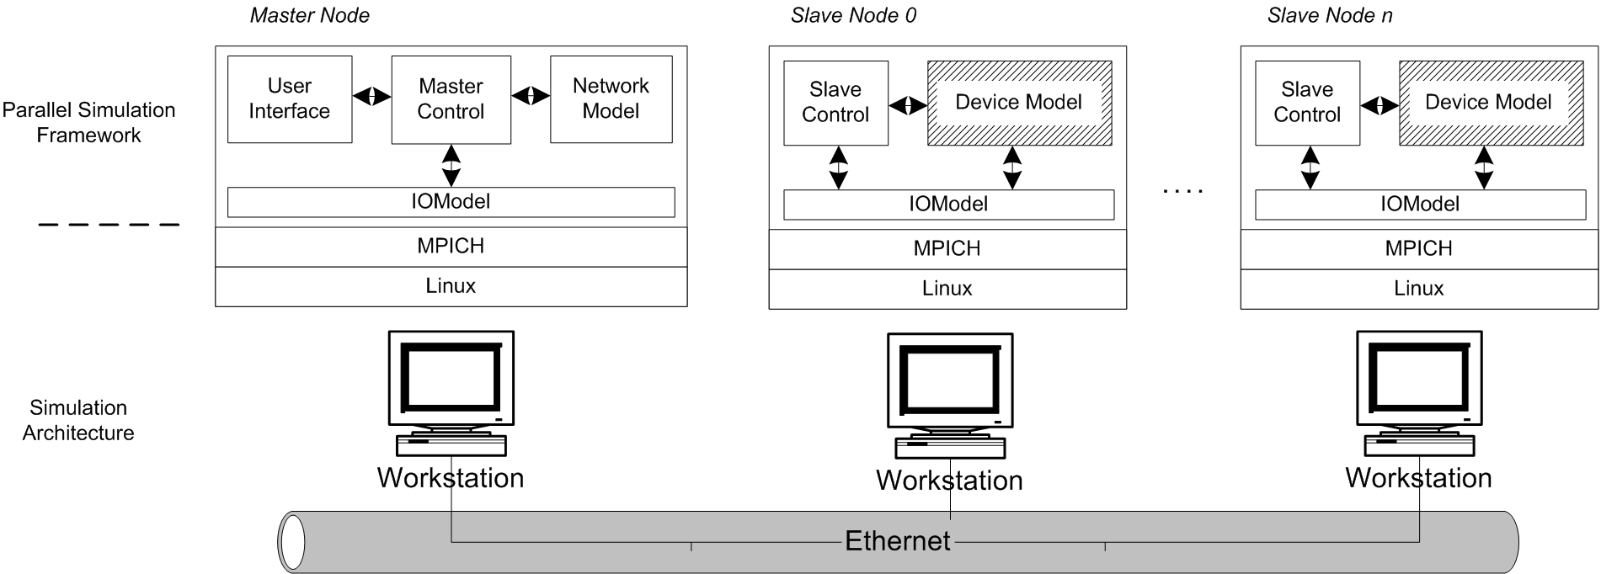
If the parallel devices to be simulated are split up into a number of modules each and the number of available workstations is significantly smaller then the number of workstations, but about the same then the number of parallel devices inside the simulation (which should be a realistic example), it is a good idea to place all modules of one device at one single workstation.
Figure 2: Simplified structure of the simulation framework without hierarchical structures
Both synchronization and data transfer between the modules of one device (but not to modules of other devices) do not affect the rest of the simulation at all. By implementing a tool performing these tasks at one workstation and grouping together all modules of one single device, the communication between the workstations performing the parallel simulation is tried to be reduced and the speed of the simulation increased.

4.1 The Generic Simulation Framework
In order to simulate a number of parallel running APPLES processors, the Generic Simulation Framework was developed [8]. The APPLES processor is a FPGA-based processor which was developed by the Irish company Neosera to speed up gate evaluation of digital netlists. By combining a number of these processors and having them run in parallel, a further performance increase is tried to be achieved. Inside the Generic Simulation Framework each APPLES simulation is considered to be one device and is further divided into five modules representing the major blocks of the processor.
With the Generic Simulation Framework parallel processor configurations shall be simulated and the implementation parameters providing the highest speedup compared to a single processor system shall be found. The simulation framework itself is far more flexible and not limited for simulation of this specific processor. It is also designed to allow parallel simulation of a variable number of devices. For this task it controls and synchronizes a number of parallel running nodes which hold the individual processor models of the simulation. In addition to this it provides all necessary functionality to simulate communication between the nodes. On the other hand, it does not cover or even know any details of the devices simulated inside the nodes.
Figure 2 shows a very simplified diagram of the framework. For each individual model to be simulated one node called slave is present. The whole system is controlled by one additional node called master. The Generic Simulation Framework is based on the Message Passing Interface (MPI) and allows the simulation to be distributed amongst up to n + 1 workstations, if n is the number of devices in the simulation to be simulated. If less workstations are available, the nodes are distributed amongst the available workstations by MPI automatically, the user does not have to take care of this. MPI provides all the communication interfaces needed for synchronization and simulation, like it was described in section Purpose of a Hierarchical Simulation.

4.2 The Wrapper
In order to implement the hierarchical structure introduced in section Purpose of a Hierarchical Simulation, the model simulating a device present at each Slave Node is replaced with a so-called Wrapper. Inside this Wrapper, the individual modules of the device to be simulated are placed.
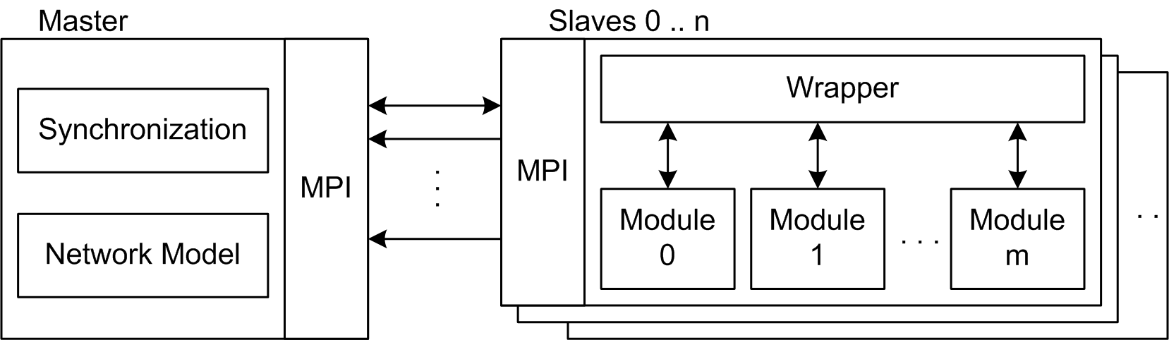
If e.g. one node is simulating one integrated circuit (this is the device simulated by the node), the individual modules can represent logically and/or physically grouped modules of this circuit. On a larger scale, a device may be some complex electronic equipment and the modules may be electronic parts of it. In any case, these modules exchange data in a synchron manner and are directly connected amongst each other, with no delay occurring on the interface (see figure 1 for an example).
Figure 3: The framework with hierarchical support. The device models at the slaves have been replaced by the wrapper and the individual modules
All information distributed between the modules, but circulating inside one individual device, is not delayed by any means and does not need to be transferred from the local node to the central master and back to a node again because it does not affect communication between and synchronization of other nodes at all, therefore the central master needs not to know anything about these messages. They can be handled inside the node. In addition to this, synchronization of the modules can also be performed inside the node solely.

From the master's point of view, the whole node is seen as one device, it does not know anything of the internal structure. Only messages to and from other nodes as well as synchronization messages controlling a whole device are transceived by the master. Inside each node, one Wrapper is present, which is seen as one simulation model from the outside (like a device representation inside a normal node), but contains the representations of the individual modules. Figure 3 shows how the device models are replaced by the Wrapper and the modules. The Wrapper contains all functionality necessary for synchronization and routing the messages between the modules, but it is also capable to exchange outgoing and incoming messages with the Master Node. Because the structure of a Wrapper is limited to one node at one single workstation, it does not need MPI for communication and performs all data exchange directly (and much faster) then the overall simulation framework relying on MPI.
For the individual modules it makes no difference whether they are considered being simulations of complete devices at a Slave Node (without a Wrapper being present at the node), or if they are only a simulation of a module inside a device.

- Experimental Results

The first experimental simulations conducted with the Parallel Simulation Framework aimed to calculate the speedup between a one- and three-processor APPLES system. Like the real APPLES system, the simulation model of the APPLES processor is capable to process net lists and determine active gates. During our simulations we used the standardized C-1908 netlist by Cadence Systems which contains some 880 gates.
The results have been verified against the ModelSim description of the APPLES processor (both a single- and three-processor system have been simulated with ModelSim).

By using three APPLES processors instead of one a significant decrease of the clock cycles needed to process one time step was simulated. While the single APPLES model needed some 41000 clock cycles per time step, with a three processor model, computation was completed after only 17000 clock cycles. Therefore with this three-processor implementation a speedup of 2.4 was simulated. Both the ModelSim simulation and the simulation using a cycle accurate model inside the simulation framework showed the same results in terms of estimated clock cycles and results of operation.
The cycle accurate model however needed far less time for computation. This is especially true for the tree-processor simulation on a single workstation. Using ModelSim the resources of the system (ModelSim Version 5.6d was run on a 1.7 GHz Pentium IV workstation with 1GByte RAM using Windows 2000) were nearly exhausted while the simulation framework still smoothly run on a Linux operated Pentium III workstation with 512 MByte of RAM. Table 1 shows the time needed to simulate 6 time steps of a 1-processor and 3-processor APPLES system with both ModelSim and the simulation framework. It can be clearly seen how the three-processor simulation with ModelSim is by far slower compared to the simulation with the simulation framework.
By not using a RTL model but a cycle accurate functional description of the processor, the simulation of a single processor run 173 times faster. When simulating the three-processor scenario, the simulation framework performed even better - it run 208 times faster then the simulation with ModelSim.

Simulation | Simulation Framework w. Pentium  III/750 and 512 MByte RAM | ModelSim w. Pentium IV/1700  and 1024 MByte RAM
1 processor scenario | 12.2 s | 2076.3 s
3 processor scenario | 17.9 s | 3747 s
Table 1: Comparison of a functional simulation with the Generic Simulation Framework and a RTL-simulation with ModelSim

Simulation Overhead in the Parallel 3-Processor Scenario
Simulation tool | Estimated Simulation Time  (based on speedup = 2.4) | Additional Time Needed  (total) | Additional Time Needed  (Percent)
Simulation Framework | 15.25 s | 2.65 s | 14.8
ModelSim | 2595 s | 1152 s | 32
Table 2: Calculated overhead due to the simulation environments

Due to the simulated speedup of 2.4 between the single processor and three processor scenario, simulation of the three processor scenario should have been completed within 15.25 s (simulation framework) respectively 2595 seconds with ModelSim. These figures are based on the assumption that simulation of every clock cycle takes the same amount of time. The additional time needed by both tools is needed for synchronization and simulation of the communication between the processors. The time needed for these two tasks can be calculated by using the above figures. Table 2 shows the results of these calculations. The simulation framework needed 14.8 % of computation time for synchronization and simulation of the communication, ModelSim needed 32 % of computation time for these tasks however.

Another problem arising when simulation parallel systems with ModelSim deals with the number of licenses needed: For each parallel device one instance of
ModelSim and therefore one license is needed. In a small team the number of available licenses is soon exhausted.

- Conclusion and Further Work

We have shown the possibility to effectively simulate and analyze a parallel system with the Parallel Simulation Framework. A functional representation of a single APPLES processor inside the Parallel Simulation Framework could be simulated 173 times faster compared to the RTL model and ModelSim. A three-processor scenario performed even better, due to the structure of the Parallel Simulation Framework, a speedup of 208 could be achieved.

Ongoing work will focus on tradeoff analysis covering a number of different parameters of a future Parallel APPLES System:

Tradeoff bit-width / number of channels: Because the number of pins designated for communication is constant, a larger number of channels requires a smaller bit-width for each channel and therefore increases the clock cycles needed for transferring one message. However more processors could be connected to one processor directly.
Using different Interface Modules: In the current version the Xilinx-Select Link interface is implemented with queues of 4 kbit each. With simulation of different implementations the optimum network interface implementation for a parallel APPLES system shall be found (for a given number of processors in the system).
Simulate different implementations: Simulate different implementations of the APPLES processor in an parallel environment. Tradeoff between cost and speed of different modules is subject of research as well as implementing functionality in hardware and software.

References:
[1] R. Bagrodia, R. Meyer, M. Takai, Y. Chen, X. Zeng, J. Martin and H. Y. Song, PARSEC: A Parallel Simulation Environment for Complex Systems, Computer, Vol.31, No.X, 1998, pp. 77-85.
[2] Cadence, Cadence Virtual Component Codesign Environment, http://www.cadence.com/datasheets/vcc
[3] R. M. Fujimoto, Parallel and Distributed Simulation, Proceedings of the 1999 Winter Simulation Conference, Vol.13, May 1999.
[4] Ken Hines, Pia: A Framework for Embedded System Co-simulation with Dynamic Communication Support, Univer. of Washington, 1996
[5] F. W. Howard, R. Williams and R. N. Ibbett, Hierarchical Architecture Design and Simulation Environment, Dept. of Computer Science, Univ. of Edinburgh
[6] Mentor, Seamless Hardware/Software Co-Verification, http://www.mentor.com/seamless/datasheets
[7] G. D. Nagendra, V. G. Prem Kumar and B. S. Sheshadri Chakravarthy, Simulation Bridge: A Framework for multi-processor simulation, Proceedings of the Tenth International Symposium on Hardware/Software Codesign, 2002. CODES '02, Colorado, USA, Vol.10, May 2002, pp. 49-54.
[8] M. Polaschegg, Ch. Steger, D. Dalton and A. Vadher, A Generic Simulation Framework for Multiprocessor Architectures, Proceedings of Forum on Specification and Design Languages 2004, September 2004
[9] S. Prakash, E. Deelman, R. Bagrodia, Asynchronous Parallel Simulation of Parallel Programs, IEEE Transactions on Software Engineering, Vol.26, No.5, 2000, pp. 385-400.
[10] Jakob Engblom and Magnus Nilson, Time Accurate Simulation: Making a PC behave Like a 8-bit Embedded CPU, Uppsala University and CC Systems AB, Sweden, 2002

