Expert System for Diagnosing Severe Acute Respiratory Syndrome
(e-SARS)

Mohd Azau M.A, Al-Haddad S.A.R, Obaidellah. A.T, Arif F., Ramli A.R.
Department Of Computer and Communication Engineering,
Faculty of Engineering,
Universiti Putra Malaysia,
43400 Serdang,
Selangor, Malaysia.

ABSTRACT

Expert System for Diagnosing Severe Acute Respiratory Syndrome (e-SARS), is an expert system application that models human abilities in analyzing and diagnosing Severe Acute Respiratory Syndrome (SARS) disease considering other respiratory diseases such as Atypical Pneumonia, Bacterial Pneumonia, Pneumonia, Viral Pneumonia and Tuberculosis. The objective of developing the system is to assist and enhance its users’ (public user, doctors, medical student, and medical assistants) consciousness and understanding towards diagnosing the respiratory diseases. Diagnosing a potential disease that one may suffer is done by providing relevant inputs through a consultation in which the user has to answer set of questions in the Signs and Symptom module. The system has two major modules namely the Signs and Symptom module and Health Information module. To provide convenience to the users, this system utilizes Linear model methodology and has been developed as a web-based application as it allows user to retrieve the information from the database exclusively anywhere at anytime. The system is built-up with the emergence of expert systems concepts and the latest available Microsoft technologies such as ASP.NET and SQL Server 2000 database and it runs on the requirement of Windows 98 and above operating system.

Keywords: diagnosing, respiratory diseases, rule-based expert system, inference technique, database

INTRODUCTION

The system developed is a web enabled expert system for diagnosing severe acute respiratory syndrome (SARS). The system includes tasks such as disease diagnosing, therapy recommendations and behaves as a health information provider to users ranging from public users to medicals students and doctors. System is divided into separate modules. This allows easy development and maintenance for the system besides offering ease of system usage.

Expert system for diagnosing SARS (e-SARS) is a specific domain medical knowledge-based system that is used primarily to diagnose respiratory diseases precisely on SARS, Pneumonia and Tuberculosis. Based on the diagnosis performed according to the user inputs, e-SARS should be able to provide appropriate prescription and therapy recommendations. The recommendations, which vary in terms of medication, healthcare, lifestyle and nutrition is provided pertinent to the diagnosis results. e-SARS also behaves as a teaching tool which provides health information to both public users and physicians. Available information would mainly be on respiratory health information.

Scope

This web-based application program is taken up under the client/server approach. The application program known as expert system is used specifically to diagnose the Severe Acute Respiratory Syndrome (SARS) considering few identified respiratory diseases, which are the Atypical Pneumonia, Bacterial Pneumonia, Pneumonia, Viral Pneumonia and Tuberculosis.

Generally, the system performs a diagnosing process based on the input supplied by a user and then would suggest appropriate recommendations prior to the diagnosis results. In particular, the supplement of inputs from the user is done through a question answering sessions between the system and the user.

The system is divided into two major modules. To name, the modules are the Signs and Symptoms Module and Health Information Module. Each major module performs different tasks, which covers the stated functions:

- Signs and Symptoms Module
  - Acquire disease information pertinent to diagnosing process from the user during consultation.
  - Performs diagnosing process and presents the result to user.

B. Health Information Module
- Provide information regarding health care and up to date news on health issues.
- Provide hyperlinks to user for easy access to other health web pages, health centers and hospitals.

Project Objectives

This system is developed with intention as described below:

- To develop a medical domain system specific for diagnosing the Severe Acute Respiratory Syndrome (SARS) disease in taking into consideration of other similar respiratory diseases namely Atypical Pneumonia, Bacterial Pneumonia, Pneumonia, Viral Pneumonia and Tuberculosis.
- To apply the Artificial Intelligence techniques related to expert systems for the web-based medical domain system. The major techniques crucial for the system are knowledge representation and inference engine.

Expert Systems Concepts
An expert system is a computer program that emulates the decision making of a human expert.[1]

An expert system is divided into two main categories namely inference engine and knowledge base. An inference engine is a program that interprets the rules in the knowledge base in order to draw conclusions[2]. A knowledge base is the core strength of an expert system in which the knowledge in the program is expressed in a special-purpose language and kept separate from the code that performs the reasoning, seeFigure I.

Inference techniques

Forward chaining. A forward chaining inference engine starts with a set of known facts. It examines the current state of the knowledge base and finds those rules whose premises can be satisfied from known given data and then adds the conclusions of those rules to the knowledge base. It then re-examines the complete knowledge base and repeats the process, which can progress further since new information has been added. [3] .The e-SARS system is using the forward chaining as for the interference techniques.

Knowledge Based

Inference Engine
User

Working Memory

Figure I : Expert System Components

METHODOLOGY

The e-SARS system architecture consists of four main components, which are the knowledge base, working memory, inference engine and user interface (see Figure I). The knowledge base is formed by collections of information from various sources such as medical documents on respiratory diseases, physicians, nurses and patients. The inference engine processes user input with current rules in the database through a matching approach thus produces suitable result. The working memory stores user input and matched input from the knowledge base throughout consultation. The user interface allows communication between the user and the system to obtain inputs and to display results.
The e-SARS is developed using Microsoft tool called Visual Studio.NET. It is designed on the ASP.NET framework coupled with SQL Server 2000 database server. The system is programmed via the Visual Basic.NET object-oriented programming language. The rule-based expert system runs on IBM compatible PC with Microsoft Window 98 and above operating system.

Figure II : Flow of process for the entire system

The system is intended to give a result of SARS diagnosis to the end-user where he or she has inserted an input.

The main purpose of e-SARS is to diagnose the Severe Acute Respiratory Syndrome (SARS) respiratory disease in taking consideration of Tuberculosis and Pneumonia. In ensuring the system is developed in a structured manner with less-problem to encounter, the e-SARS system has been divided into two major modules ( see figure II ) , namely:

- Signs and Symptoms module. The signs and symptoms module is used to determine the type of disease encountered by a patient based on the input of patient demographics, sign, symptoms and exposure history, Figure III. This module is further portioned into few sub modules. To name, the modules are Enter Data sub module, Diagnosis Result sub module and Health Description sub module. Users of the e-SARS system are required to provide answers appropriate to the questions presented on the Signs and Symptoms module. These input are crucial to determine a specific disease as a result of performed diagnosis.

- Health Information module. The health information module offers suitable information on respiratory diseases mainly on SARS, Pneumonias and Tuberculosis ( see figure IV). Information is in the form of articles. This module is only for viewing. It also provides hyperlinks to selected health care centers in Malaysia as well as links to other appropriate health web pages.

Figure II : e-SARS Structural Chart

Figure III: Signs and Symptoms Module Flow of Process

Figure IV : Health Information Module Flow of Process

e-SARS Three-tier Architecture

Figure V : e-SARS Three-tier Architecture
e-SARS is developed as a web-based application on a three-tier architecture. The three layers are client, application server and database server (see Figure V ).

A user requests a page by typing its URL in the browser. The browser requests the page from the IIS web server. The web server altered by a unique page extension passes the request on to an application for processing. The IIS application server processes the request and outputs some data in the form of ASP back to the web browser.

The Microsoft SQL Server, database server interacts with the native IIS database. All documents are kept inside the native Microsoft SQL database.

At the time of message passing, any information that has been requested from the web browser through web server and application server to the database server is acquired from the native Microsoft SQL database.

From the database, the requested information is passed to the database server. The database server allows the format file to be transferred in a more understandable approach to others so that the message passing process can be performed

Knowledge Base Design

The e-SARS system utilizes the relational database for storing all its knowledge. The relational database represents the knowledge base of an expert system. Knowledge inferred from medical experts and reading materials was first obtained through interviews, books, articles, journals as well as many other requirement techniques. The knowledge is then compiled so that it can be formed in a more structured manner using the rules representation technique. The rules were constructed using the Meta rules manner. The production rules are represented in a form of tree graph. The tree graph (figure VI) uses a forward chaining method with depth-first searching technique.

Figure VI : Signs and Symptoms Tree Graph

Knowledge Base Development
The e-SARS expert system employs the forward chaining inference technique by utilizing the rule-based knowledge representation technique. The rules were constructed in a Meta rules approach[10]. Example 1 shows part of the production rule implemented for e-SARS.

Example 1

Section B – Test Fever
Rule 1B Fever is no
IF Task IS test fever
AND Answer is no
THEN Fever is no
AND Failed

Rule 2B Fever is yes
IF Task IS test fever
AND Answer is yes
THEN Fever is yes
AND Task IS test symptom2

RESULTS

After rules of the system is constructed implemented in the tools that has been proposed, which is SQL server 2000 as the database and Visual Studio.net as the running system. The system produces results based on the comparison of the rules kept in the database. Below are the screen captures of the result :

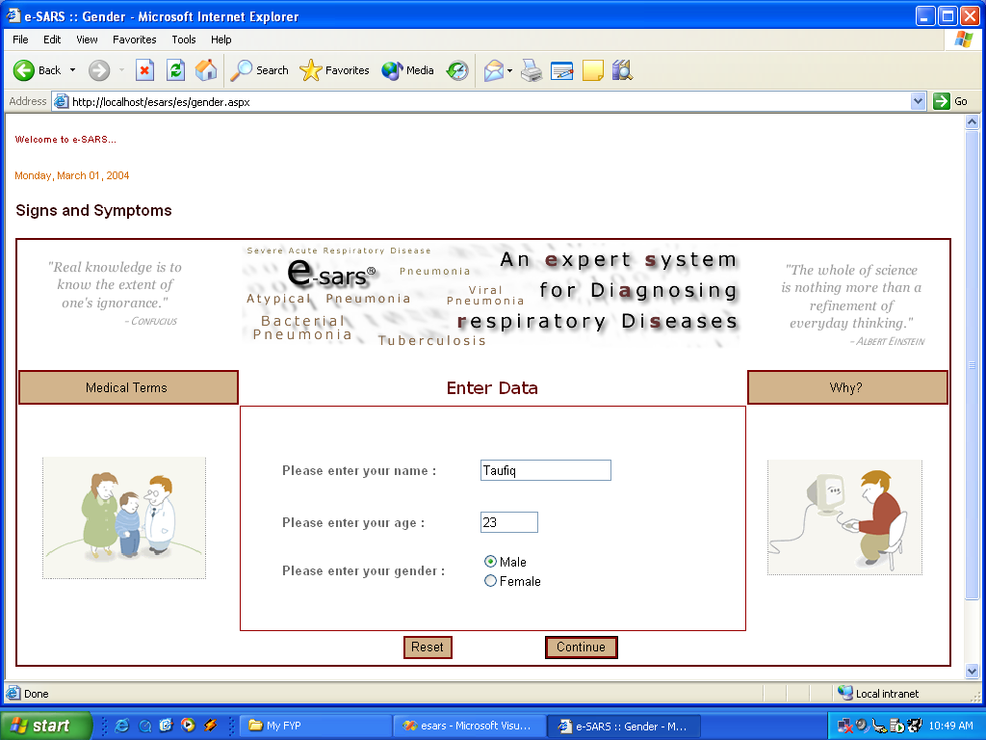
Figure 4.1 Gender Screen

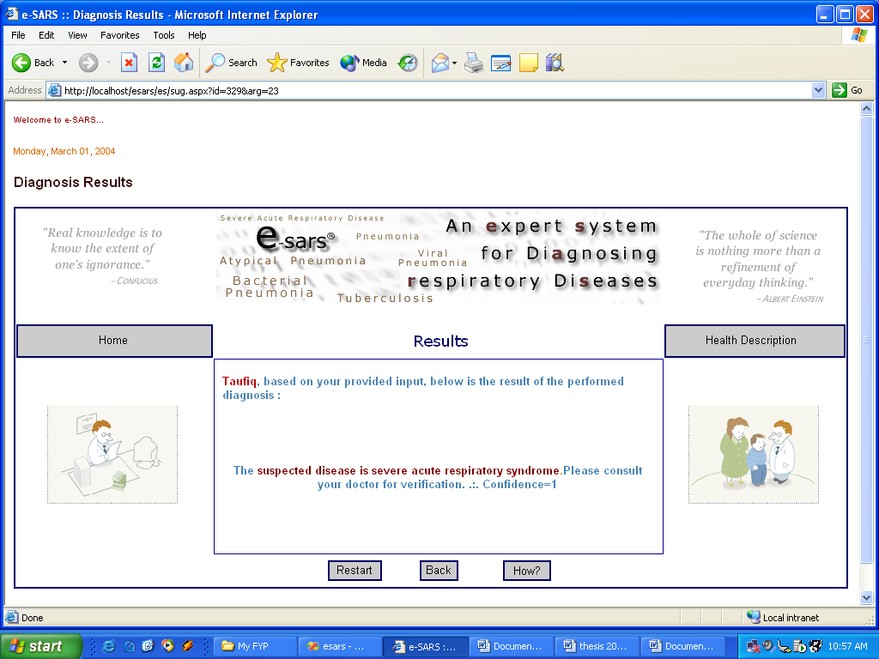
Figure 4.9 : Diagnosis Results screen

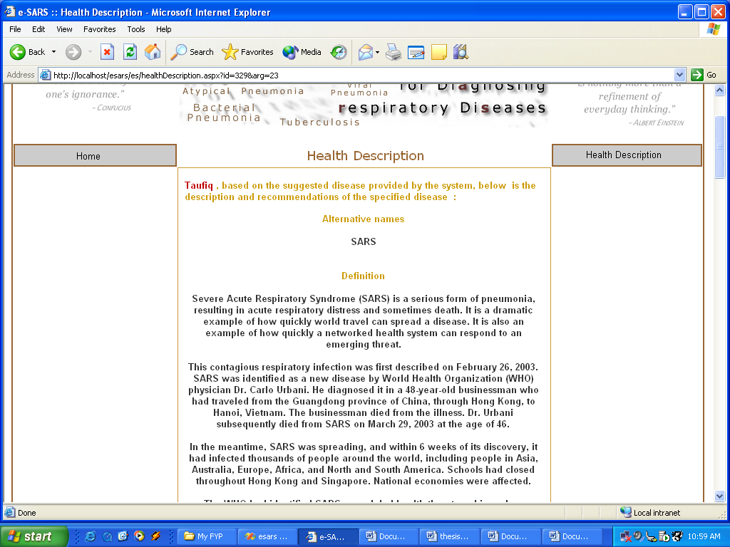
Figure 4.11 : Health Description screen
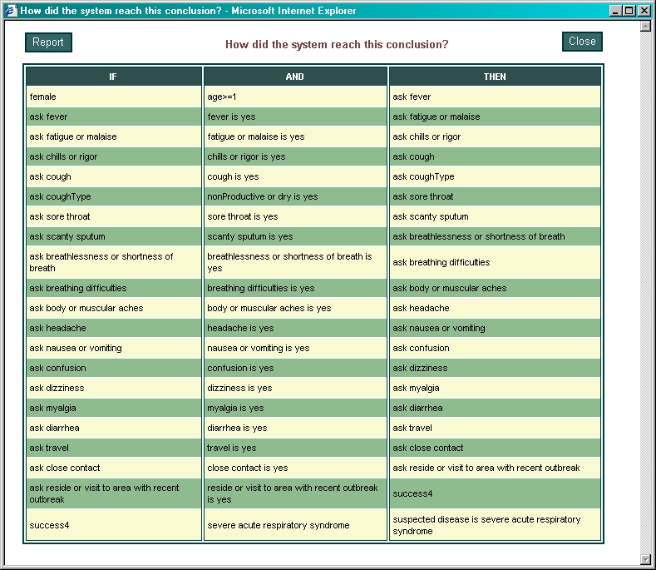

Figure 4.10 : How? Explanation window

Below are some of the purpose and result of e-SARS system :

- A web based medical diagnosis expert system that is accessible anywhere at anytime by anyone.
- Present diagnosis results based on the analysis performed subsequent to consultation session with the user.
- Offer suitable treatment suggestions for the discovered diagnosis results. Suggestions provided by the system include medication prescriptions, precaution steps one must take to stay away from the disease, hygiene measurements that are crucial for avoiding the disease and lifestyle recommendations, which affects the healing process.
- Supply health information pertinent to respiratory diseases. Information consists of news, articles and white papers. Hyperlinks to health centers, hospitals and other health web pages are also provided by the system.
- Make available a medical diagnosis expert system that is flexible in terms of providing availability in which the knowledge base can always be upgraded with new rules or knowledge.

CONCLUSION

e-SARS is a web based expert system developed for the purpose of facilitating its users in the process of diagnosing the Severe Acute Respiratory Syndrome (SARS) in taking into consideration of few other respiratory diseases namely Pneumonia and Tuberculosis. It is an expert system that incorporates artificial intelligence methods in convergence of the latest technologies and multimedia tools.

This system is partitioned into three major modules that is the Diagnose module, Therapy Recommendation module and Health Information module.

REFERENCE

[1] PETER JACKSON (1986). “ Introduction to Expert System” 3rd Ed. Adisson Wesley.
[2] KEITH DARLINGTON (2000). “ The Essense of Expert System” 1st Ed. South Bank University, Prentice Hall.
[3] GIARRATANO, J., RILEY, G. (1998). “Expert Systems: Principles and Programming. 3rded.” PWS Publishing Company, Boston.
[4] JIM MORISS ,(2003). “SARS have become major outbreak” , http://yahoo.com under the search of SARS outbreak.
[5] Dr Zainuddin Abdul Wahab, (2003 ) “Questionaire on Respiratory Disease & SARS” ,Department of Public Health, Ministry of Health Malaysia.
[6] Medical Expert System (2003 ) , “ Expert system on Medical” , http://www.easydiagnosis.com
[7] Medical Expert System (2003 ) , “ Expert system on Medical” , http://www.gideononline.com
[8] GEORGE F LUGER ,(1997) , “ Artificial Intelligence – Structure and Startegies for Complex Solving” 4th Ed. Adisson Wesley.
[9] TOM ROBIN ,( 1996 ) , “ How to design a Methodology” ,3rd Ed. McGraw Hill
[10] DURKIN, J. (1994). “Expert System-Design and Development

