ADAPTIVE IQ MISMATCH CANCELLATION FOR QUADRATURE IF RECEIVERS
V.Thiyagarajan, A.P.Kabilan, M.Madheswaran andV.Rajamani
Department of Electronics and Communication Engineering,
PSNA College of Engineering & Technology,
Dindigul – 625622. Tamil Nadu

Abstract: Analog Implementations of the wireless receivers suffers from the Inphase-quadrature phase (IQ) imbalances between the components of the LPF and the LO in the I/Q paths. The gain and phase errors in the local oscillators and the in the filters account for the I/Q errors .Due to these imbalances the performance of the receivers and the quality of the received signal are degraded due to the gain and the phase imbalances in the I/Q phases. Many approaches for the correction of the IQ channel mismatches and the previous methods applied for correction of IQ mismatches using analog and digital domains have been reviewed. The trade-offs and the issues behind the design and implementation of the wireless receivers are described. The different modulation schemes of wireless receivers are also mentioned. Finally, A novel and a feasible adaptive digital signal processing method, using LMS algorithm, which gives a solution for the correcting IQ mismatches in a Direct Conversion Receiver, has been proposed and implemented. The algorithm that involves the LMS method has been found to improve the SNR by 15-40 dB.

I INTRODUCTION
Design of the Wireless receivers involving low cost, low power dissipation and smaller power factor have always been an aggressive goal, with the condition that they must supply the usual bandwidth and sensitivity limitations. There exists a trade off between them to meet a certain specification. A quadrature receiver uses two distinct channels to form the in-phase (I) and the quadrature-phase (Q) components of the received signal. Each channel consists of a mixer, low pass filter and A/D converter. The mismatch between the LP filters and the mismatch between the local oscillators in the I and Q paths can severely limit the performance of the adaptive cancellers and the matched filters and hence reducing the quality of the signal. These errors are caused by the amplitude and the phase imbalances in the mixers when there are multiple received channels or in a given mixer overtime when the mixer oscillator is noisy. Noisy transmitter oscillator, unbalanced low pass filters are the main sources of I/Q errors. Mismatches differ with respect to different receivers. Superhetrodyne receivers have a principle issue which is a trade off between the image rejection and adjacent channel suppression. They require image rejection to suppress the image frequency, which is located two intermediate frequencies away from the desired radio frequency. The direct conversion receiver does not suffer from the problem of image rejection and hence it suffers much less from the mismatch-induced effects than do image reject architectures.

Various approaches for the correction of I/Q channel imbalance have been proposed using the analog and digital methods. Analog solutions are modifying the circuitry [3], careful layout [4] and making the circuit more robust [5], [6]. Digital solutions are using off-line compensation of the channel imbalances [7], [8] using the Hilbert transform to generate I/Q signals in the digital domain [9] and using the delta –sigma modulator instead of the analog to digital converter with an adaptive mismatch cancellation system. In this paper a novel algorithm which compensates the signal-to -noise ratio (SNR) degradation due to mismatch between the I and the Q paths has been proposed. This algorithm uses a robust adaptive filter that uses LMS algorithm.

II. THE I/Q MISMATCH
The In-phase (I) and the Quadrature (Q) channels are necessary for any angle modulated signals because the two sidebands of the RF spectrum contain different information and may result in irreversible corruption if they overlap each other without being separated into two phases. The demodulator at the receiver has to be synchronous in nature. The receiver must possess an oscillator, which is at the exactly same frequency, and phase as the carrier oscillator, at the transmitter end. The low pass filters at the two paths of the receiver must have identical characteristics, as any mismatch in their characteristics would lead to I/Q errors. In this paper the I/Q mismatch that occurs in the Direct Conversion receivers is mentioned and a feasible DSP solution has been proposed. The direct conversion (Zero IF or Homodyne conversion) receiver converts a signal from RF to Base band. The band of interest is translated to zero and then the signal is low-pass filtered to suppress the interferences. The direct conversion receivers do not suffer from the problem of images as the intermediate frequencies are zero and hence they do not require image reject filters. The main problem faced in the design of the direct conversion receivers is the I/Q mismatch. The errors that occur due to the phase shift between the oscillators and change in the coefficients/phase shift between the low pass filters in the I/Q paths, corrupt the signal to a large extent and severely distort the signal to noise ratio. The gain imbalance appears as a non-unity scale factor in the amplitude while the phase imbalance corrupts one channel with a fraction of data pulses in the other channel. The Fig.1 shows the block diagram of a QPSK (Quadrature phase shift keying) receiver. Assuming no gain or phase imbalance between the I/Q paths then the signal after demodulation passes through the low pass filter and are received as undistorted signal. The amplitude and the phase mismatches are usually random and changes from time to time. A sixth order butter worth low pass
Filter with cut-off frequency 8.5 MHz is used for the experimental simulation and analysis.

III. PROPOSED SOLUTION FOR THE I/Q MISMATCH

The aim is to minimize the errors that are caused due to the mismatch that exist between the filters and the oscillators in the two paths. In ideal case the oscillators in the two paths must very stringently oscillate at the same frequency and phase and the low-pass filters in both of the paths must have identical characteristics. Error occurs when there is mismatch (phase or gain imbalance) between the two oscillators and the low-pass filters. Compensation must be done in order to reduce the error. A novel and a feasible adaptive digital signal processing method, which gives a solution for the IQ mismatches, has been proposed. This algorithm involves the LMS method and the SNR have been found to improve by 15- 40 dB. Since the two channels contain different signals, the mismatch could never be measured, especially if the mismatch is random. To avoid this difficulty, the two signals in the In phase and the quadrature phase are made the same and then compared. They are now supposed to be identically equal and a filter using an LMS algorithm is used to compensate for the mismatch.

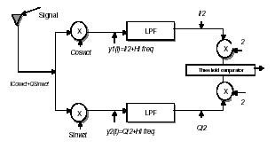

Fig1.QPSK (Quadrature phase shift keying) receiver

IV. COMPENSATION FOR FILTER MISMATCH

The Fig2. Shows the circuit for compensating for the filter mismatch. The basic principle is to make the input signal through the filters identical and then compensate for the error between the two outputs. The compensation filter is an adaptive filter using the LMS algorithm to reduce error. The switch S is closed and the switches Sm, S1 and S2 are open. The calibration of the circuit is essentially done with a random input signal. Thus the circuit initially is trained so that the two signals at the filter output would become identical. After training, the weights are calculated and the transfer function of the new filter is obtained and added to the network as shown in Fig 3. The results after mismatch compensation are obtained and tabulated. The SNR, the signal to noise ratio has been found to increase and the errors have been decreased as the LMS filter showed improvement for all kinds of mismatches. The improvement in the SNR due to the both change in the odd coefficients and change in the phase of the filter has been investigated and calculated. The signal to noise ratio decreases (I/Q mismatch increases), as the percentage of change in the odd coefficients of the filter and as the phase change increases (Tables 2&3). The SNR have been found to improve with the increase in the number of filter taps, but the improvement is not significant as the number of taps increase above 30 taps. The improvement in the average values of SNR for % change in the filter coefficients and change in the phase of the LMS filter is tabulated (Table1) for different values of filter taps.

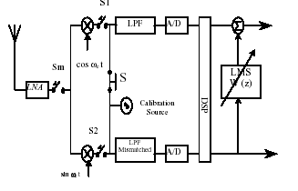
Fig2. Calibration circuits for filter mismatch correction
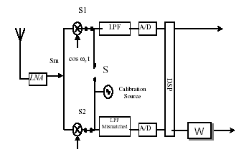

Fig3. Circuits for filter mismatch correction
Average SNR before correction 42.1124 dB

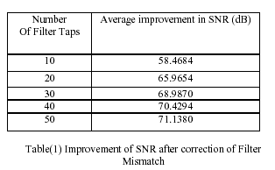

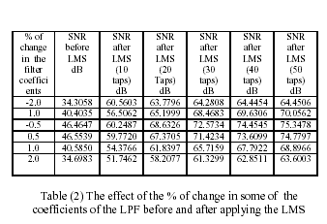

V.COMPENSATION FOR OSCILLATOR MISMATCH

Another main factor that leads to the I/Q error is the mismatch due to the local oscillator. The circuit for calibration of the local oscillator mismatch is shown in the Fig4. For calibration, the random signal is applied to the local oscillator when the switches S, Sm are open and the switches S1, S2 are closed. Another LMS algorithm similar to the previous case is applied to account for the mismatch. After calibration, the transfer function of the filter is added that compensates for the mismatch caused by the oscillators. The circuit after correction of the local oscillator mismatch is shown in the Fig5. The improvement in the SNR due to change in both the % amplitude and the phase of the local oscillator has been investigated. The signal to noise ratio decreases (I/Q mismatch increases), as the percentage change in the amplitude and the phase of the oscillator increases (Tables 5&6). The SNR has been found to improve with the increase in the number of filter taps, but the improvement is not significant as the number of taps increase above 30 taps.

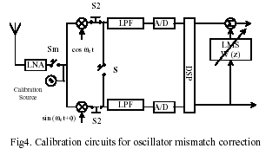

The improvement in the average values of SNR for % change in the amplitude and the phase of the local oscillator is tabulated (Table4) for different values of filter taps.
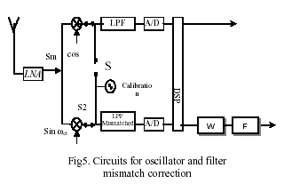

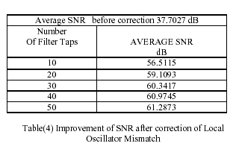
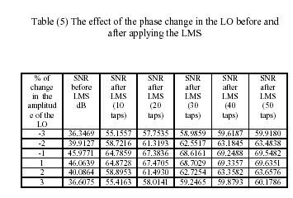
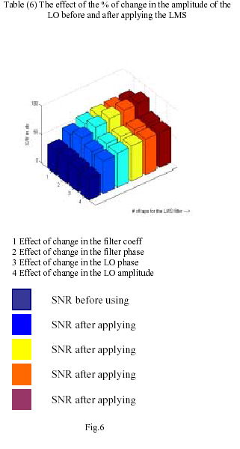

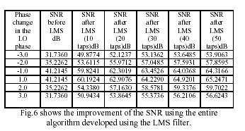

CONCLUSION:

The paper addresses the I/Q mismatch problems in the direct conversion receivers. The mismatch was initially calibrated and an adaptive approach to match the I and the Q components of the complex valued inputs were presented and the I/Q mismatch were removed by using a compensation filter using an LMS algorithm. This method of I/Q mismatch compensation has been found to remove any deleterious effects that would be caused if there were mismatches between the I/Q phases. Thus the algorithm developed has been found to improve the SNR by 15-40 dB.

REFERENCES
[1] Behzad Razavi, “Design Considerations for Direct-Conversion Receivers” IEEE Transactions on Circuits and Systems-II: Analog and Digital Signal Processing, Vol.44, No.6.June 1997 pp.428-435.

[2] A. Bateman and D.M. Haines, “Direct conversion Transreceiver design for compact low-cost portable mobile radio terminals” Proc.IEEE Veh.technol.Conf.May 1989 pp.57-62.

[3] A. Wiesbauer and G.C.Temes, “Online Digital compensation of analog circuit imperfections for cascaded Sigma-Delta modulators, “in Proceedings. 1996 IEEE-Cas Region 8 workshop on analog and mixed IC Design, Pavia Italy, p.92.

[4] S. Abdennadher et al, “Adaptive self-calibrating deltasigma modulators,” Electronic Letters, vol.28, pp.1288-1289, July 1992.

[5] A. Swami Nathan and M. Snelgrove et al, “A monolithic complex sigma-delta modulator for digital radio,” in Proceedings.1996 IEEE-CAS Region 8 workshop on Analog and Mixed IC Design, Pavia, Italy, Sept 1996.p83.

[6] S.A. Jantzi et.al, “The effects of mismatch in complex band pass sigma Delta modulators,” in Proceedings. ISCAS 1996, Atlanta, GA, May 1996, p.227.

[7] G. Cauwenberghs and G.C.Temes, “Adaptive calibration of multiple quantization over sampled A/D converters,” in Proceedings. IEEE ISCAS’96, Atlanta, pp.512-516.

[8] G. Schultes et. al, “Basic performance of a Direct conversion DECT receiver”. Electronic Letters, Vol.26, No.21, pp.1746-1748, Oct.1990.

[9] D. Van Compernolle and S.Van Gervan, “Signal separation in a symmetric adaptive noise canceller by output décor relation, “IEEE Transactions in Signal Processing, Vol.43, p.1602, July 1995.

