A Framework for Architecture Recovery of Web Applications

K.Ramkumar J.Indumathi

Department of Computer Science and Engineering,
College of Engineering, Anna University
Chennai, India.

Abstract

The web applications developed are often poorly structured and poorly documented. Maintaining such systems is problematic. This paper presents an approach to recover the architecture of such systems, in order to make maintenance more manageable. The approach extracts the structure of web applications and shows the interaction between their various components. The recovery process uses a set of extractors to analyze the source code of web applications. The extracted data is manipulated to reduce the complexity of the architectural diagrams. Developers can use the extracted architecture to gain a better understanding of web applications and to assist in their maintenance.

Keywords: Reverse Engineering, Web Engineering, Architecture.

1. Introduction

The web browser’s ubiquitous and simple interface has opened the door for the development of many new distributed applications. At the start, web pages were simple static HTML pages linked together. The web pages served well their purpose of providing easy and open access to information across the world. Subsequently new technologies such as Java and Java Script Pages were introduced. These have facilitated the development of large-scale applications, which harness the power of the web [8].
Unfortunately, the documentation associated with a web application does not commonly exist and if it does, it is rarely complete or up-to-date. With a very short development cycle, software-engineering principles are rarely applied to the development of web applications. The original developers of a maintained web application are often no longer part of the organization. This lack of documentation and system experts increases the cost and time needed to understand and maintain large web applications.
Reverse engineering and software visualization have been proposed as techniques

to improve the understanding of large traditional non-web applications. In this paper, we describe an approach to assist developers in understanding their web applications. We describe a method to parse and extract relations between the various components of a web application. The extracted components and relations are visualized using a specialized viewer. In this paper, we consider this visualization to characterize the software architecture of the system.

2. Background

With the advent of the Internet, a new type of application has emerged: web applications, that use the Internet’s infrastructure, are being developed and maintained everyday. Recent reports indicate that web applications represent more than thirty percent of software applications across all industry sectors and this number is expected to grow as the web gains popularity and its user base increases.
We emphasize the need for good program understanding to reduce the costs and efforts associated with program maintenance and development. We introduce the concept of software architecture and its different views. In addition, we discuss the techniques used to reverse engineer traditional software systems to recover their software architecture.
The study of web applications is a fairly new field but there have been significant research contributions from different groups worldwide. We focus mainly on two areas of research that are most related to our research on the architecture recovery and visualization of web applications: web engineering and the modeling of web applications.
In a web application, many components are inter-linked together to implement its functionality. The following components exist in web applications: web browsers; web servers; web pages; application servers; application pages; databases; distributed objects such as CORBA, EJB and COM; and multimedia web objects such as images, videos, and etc.

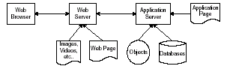

Figure 1 shows the data flow between the various components of a web application.

The user of the application employs the web browser as the interface to gain access to the functionality of the web application. The user interacts with the browser by clicking on links and filling-in form fields. The browser in turn transmits the user’s actions to the web server. Requests are sent using the HTTP protocol. Upon receiving the request, the web server determines if it can fulfill the request directly or if the application server must be invoked. The application server and the web server may reside on the same machine or on different machines. Many web servers and application servers can serve requests for a single application. The web server can serve HTML pages and multimedia content such as images, videos, or audio files; or it can forward the request to the application server. The application server processes the application page and returns an HTML page to the web server. Finally, the web server returns the requested page to the web browser, which displays it to the user.
A database is an essential part of a web application as it is the primary communication interface between the many components of the web application. The visualization tools for web applications focus primarily on displaying the hyperlinks between the static pages. As the web was originally developed as a document-sharing platform, these tools approach the problem of visualizing and maintaining web application as a document maintenance problem rather than a software engineering problem.

3. Recovery process overview

We use a semi-automated process to recover the architecture of web applications. The process uses extractors to analyze the source code of the application. The tools’ output is combined with input from a system expert to produce architecture diagrams. We extend the Portable BookShelf (PBS) environment to address the differences between web applications and traditional software applications [1]. Previously, the PBS system was used successfully to recover the architecture of many large traditional procedural systems such as the Apache web server, the Linux kernel [2] and the VIM text editor.

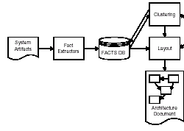
Figure 3.1: Block diagram

Figure 3.1 shows an overview of the PBS environment. First the artifacts of the software system (such as source code) are processed using specialized extractors. The extractors automatically generate facts about the software system based on these artifacts. The facts could be detailed such as: function “f” uses variable “a” or at a higher level such as: file “f1” uses file “f2”. The level of detail of the extracted facts depends on the extractor and the level of analysis that is to be performed on the recovered facts. For example, for architecture level analysis, facts at the function level are not needed and can be lifted to a higher level. The generated facts are stored in table. The schema permits many tools to operate independently on the extracted facts and reduces the coupling between the fact extracting and the fact consuming tools such as the visualizer. Furthermore, the use of schema permits the integration of different types of facts to produce a single architecture document that contains all the extracted facts. Once the facts have been produced, a “first-cut” attempt to visualize them would lead to an architecture view which resembles Figure 3.2. The figure shows a complicated graph of the relations between the different components of a software system. Each small dot represents an artifact of the software system (such as a file of source code, a database, etc.), and each line between two dots indicates the existence of a relation (such as uses, or calls) between two of the artifacts. The developer cannot use the diagram to gain a better understanding of the software system because of the complexity of the diagram. Instead of showing all the extracted relations and artifacts in the same diagram, we decompose the artifacts of the software system into

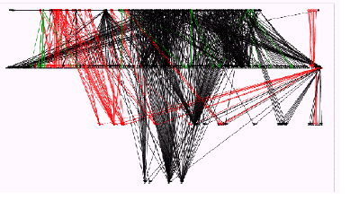

Figure 3.2: Unclustered Architecture View

smaller meaningful subsystems. Figure 3.3 shows the reduction in complexity achieved by decomposing a software system into subsystems using clustering techniques. The clustering is performed automatically first by a tool that proposes decompositions based on several heuristics such file naming conventions, development team structure, directory structure, or software metrics. The developer later manually refines the automatically proposed clustering using their domain knowledge and available system documentation. The decomposition information along with the extracted facts is stored in table.

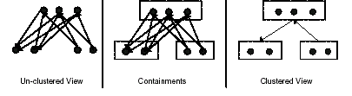

Figure 3.3: Clustering of Software Components

Later, an automatic layout tool processes the stored facts to generate diagrams such as the one shown. The layout tool attempts to minimize the line crossing in the generated architecture diagrams. The developer may choose to modify the generated layout.

4. Visualization Needs for Web Applications

Traditional software architecture diagrams show the various modules and source files that compose the software system and their interactions. Web applications are composed of many components and each component may have its own internal architecture or design. A web application developer is more concerned with the system-level topology of the components and their interaction rather than the internal structure of each component in a web application. The web server and the browser represent infrastructure systems similar to the operating system and the windowing system whose architectures are not shown when visualizing traditional software systems. The architecture diagrams for web applications need to show the distributed objects, database tables, multimedia objects that are scripted together to implement large sophisticated web applications.

5. Fact Extraction

In traditional architecture recovery, an extractor parses the source files of the software system and emits facts about the system. Many of the traditional software systems are developed in a single programming language and all the source code of the system is available. For a large number of traditional software systems, only one language specific extractor is needed. Extractors range from lightweight extractors that search for specific patterns of interest in the source code and emit the relevant facts to more detailed parsers. Such parsers may be modified compilers that emit facts about the source code instead of producing assembly code or binaries.

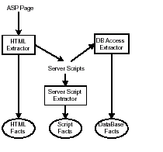

Figure 5.1 Conceptual Architecture of the Fact Extractors

Figure 5.1 shows an overview of the various extractors and their input and the type of facts generated by them. We used five types of extractors: an HTML extractor, a Server Script extractor, and a DB Access extractor. Each extractor is responsible for examining a component or a section of a component. Each extractor generates facts that conform to the CLS schema for web applications. Once all the facts are emitted, the clustering information is combined and all the data are processed by a layout tool. The output of the layout tool can be viewed and analyzed using a visualizer. The directory structure of the web applications and the source code directory are crawled by a shell script. The script determines the type of the component and invokes the corresponding extractor. For example, if the script determines that a file is a Java script file, then the java script Extractor is invoked. Each extractor generates
a set of facts and stores its results in a file with the same name as the input file and the name of the extractor as the suffix. THE FACTS file is combined with the clustering information that is generated using the directory structure and user input. We detail the types of relations generated by each type of extractor in the following sections.

5.1 HTML Extractor

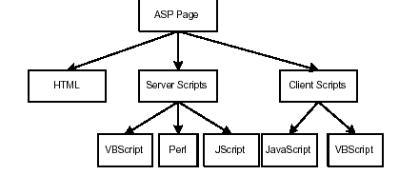
Figure 5.2: Internal structure of HTML Extractor

The HTML Extractor is responsible for processing HTML files. An HTML page is an ASP page that contains no code segments and is processed only by the HTML Extractor. An ASP page contains various sections. Each section is parsed and analyzed by the appropriate extractor. An ASP page contains

1. HTML sections that are text with links to other online content. The HTML sections are sent to the requesting browser, without modification by the server.

2. Server scripts that are executed on the server and the result of the execution is sent back to the requesting browser.

3. Client scripts that are interpreted inside of the user’s browser. The Client scripts are sent to the requesting browser without modifications by the server.

Each section is written using a different language:

1. HTML Sections are written in HTML.
2. Server scripts are written in VBScript, Perl or JScript.
3. Client scripts are written in JavaScript or VBScript.

5.2 Database Access Extractor

The Database Access Extractor uses regular expressions to locate data table accesses inside source code statements. as input the server scripts and the source code of the components. The extractor searches for matches that resemble common database access functions and SQL keywords such as SELECT or INSERT. The extractor then employs some heuristics to validate the matches. For example, once the extractor locates the keyword SELECT it searches for the keyword FROM and determines, based on the distance and the strings between both keywords, if a database table is being accessed or if the matches are coincidental and no database table access has occurred.

6. Abstracting and Merging the Extracted Facts

Each extractor emits facts that are language dependent and technology dependent. For example, a VBScript extractor outputs a fact indicating that a function is called by another function; whereas the JavaScript extractor emits a fact indicating that the processed file assigns a value to a field in an Enterprise Java Bean (EJB). These facts are technology dependent. Abstractly, both extractors are indicating a processed file is accessing a data field in an object. In one case a file is reading a data field, and in the other case a file is updating a data field. Once the various extractors have processed the source files of the application, the facts are combined and abstracted to a higher level that is programming language and technology independent. To handle the various kinds of facts that are extracted (and then abstracted) we use a pyramid of schemas as illustrated in Figure 6.1. The bottom layer of the pyramid has a schema for each source language. The next layer abstracts up to either object-oriented or procedural languages. The next layer simplifies and abstracts up to higher level facts that are common to web applications. Finally, the top layer further simplifies and abstracts to the architectural level. The schemas at these various levels will now be discussed in more detail. Each language extractor has a schema which specifies the various entities it generates and the relations that exist between these entities.

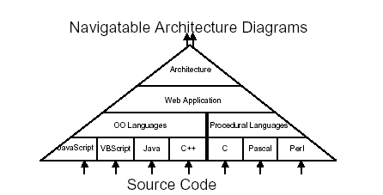

6.1 Pyramid of Schemas
For each extractor in our architecture recovery process, we need to provide a mapping from the schema of the extractor to the object-oriented or procedural schemas. Using the abstracted object oriented schema, we can now study the interaction between components written in different programming languages.

7. Generating the Architecture Diagrams

In this final phase, the extracted facts along with developer’s or architect’s input are used to produce the diagrams Figure 7.1 shows the steps involved in producing the architecture diagrams.
If we were to directly use the facts at the Web Application Schema level to generate diagrams, we would get excessively complicated diagrams due to the large amount of extracted relations and components. Instead of showing all the extracted relations and artifacts in a single diagram, we decompose the artifacts of the software system into smaller meaningful subsystems. This decomposition reduces the number of artifacts shown in each diagram and improves the readability of the generated diagrams especially for large software systems.

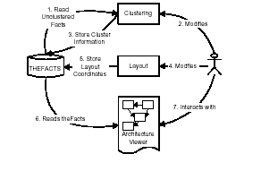
7.1 Generating architecture diagrams from facts

A clustering tool reads the facts from the THEFACTS file and proposes decompositions based on heuristics such file naming conventions, development team structure, directory structure, or software metrics. The decomposition information along with the extracted facts is stored back into the THEFACTS file so other tools can access it.
An automatic layout tool reads the stored facts and the clustering information to generate diagrams. The layout tool attempts to minimize the line crossing in the generated architecture diagrams is supported to improve these diagrams. By automating as much as possible this process, we are able to dramatically reduce the recovery time of large software systems.

8. Related Work

Many researchers have recognized the need to adapt software engineering methodologies to the development and understanding of web applications. Currently, there are two major areas of active research in assisting developers in understanding their web applications and maintaining them:

Forward Engineering: which focuses on documenting web applications using specialized specification languages.

Reverse Engineering: which focuses on recovering the structure of web applications from their source code.

Design Patterns can support the understanding of former architectures and the application of product line reference architectures [10]. Feature modeling structures the system’s functionality and supports reverse engineering by detecting the relations between source code elements and requirements. Tracing these relations may lead to a better understanding of the program’s behavior and the recovery of various architectural elements. In this way, by providing a mapping between source code and features, the system’s feature model supports program comprehension and architectural recovery [11].

9. Conclusion

Maintaining web application is not a trivial task. Developers need tools to assist them in understanding complex web applications. Unfortunately, current tools are implementation focused and current web applications tend to have little documentation. In this paper, we have shown an approach that can recover the architecture of a web application and show the interactions between its various components. The approach is based on a set of extractors that co-operate to parse the source code of the application and gather data which is later processed and visualized. Developers can use these visualizations to gain a better understanding of their application before they embark onto modifying it to add new functionality or fix bugs.

References

[1] I. T. Bowman. Architecture Recovery for Object Oriented Systems. Master’s thesis, University of Waterloo, 1999.

[2] I. T. Bowman, R. C. Holt, and N. V. Brewster. Linux as a Case Study: Its Extracted Software Architecture. In IEEE 21st International Conference on Software Engineering, Los Angeles, USA, May 1999.

[3] P. J. Finnigan, R. C. Holt, I. Kalas, S. Kerr, K. Kontogiannis, H. A. Muller, J. Mylopoulos, S. G. Perelgut, M. Stanley, and K. Wong,The software bookshelf. IBM Systems Journal, 36(4):564–593, 1997. Available online eat http://www.almaden.ibm.com/journal/sj/ 364/finnigan.html

[4] G. Antoniol, G. Canfora, G. Casazza, and A. De Lucia. Web Site Reenginnering using RMM. In Proceedings of euroREF: 7th Reengineering Forum, Zurich, Switzerland, March 2000.

[5] A.E.Hatzimanikatis, C.T.Tsalidis, and D.Christodoulakis. Measuring the readability and maintainability of Hyperdocuments. Software Maintenance: Research and Practice, 7, 1995.

[6] Pearl Brereton, David Budgen, and Geo_ Hamilton. Hypertext: The Next Maintenance Mountain. Computer, 31(12), December 1998.

[7] Ivan T. Bowman, Richard C. Holt, and Neil V. Brewster. Linux as a Case Study: Its Extracted Software Architecture. In IEEE 21st International Conference on Software Engineering, Los Angeles, USA, May 1999.

[8] Cornelia Boldyre_. Web Evolution: Theory and Practice, 2000. Available online at <http://www.dur.ac.uk/cornelia.boldyreff/lect-1.ppt>

[9] Grady Booch. The architecture of Web Applications, 2000. Available online at http://www.developer.ibm.com/library/articles/ booch_web.html>

[10] Ilka Philippow, Detlef Streitferdt, Matthias Riebisch. Design Pattern Recovery in Architectures for Supporting Product Line Development and Application,2001.

[11] Kim, H., Boldyreff, C.: A method to recover design patterns using software
product metrics. In Proc. of the 6th International Conference on Software Reuse, ICSR6, 2000.

[12] Ilian Pashov, Matthias Riebisc,Using Feature Modeling for Program Comprehension and Software Architecture Recovery,2002.

