Connecting Mobile Ad Hoc Networks To Internet

ALI GHAFFARI
Computer Department
Tabriz Islamic Azad University
Faculty of Engineering ,Tabriz Islamic Azad University, Tabriz, Iran
IRAN

Abstract— Mobile ad hoc networks (MANET) are infrastructure less and stand-alone networks. This paper verifies the interworking between wireless and mobile ad hoc networks and the Internet. The communication
is established with the help of access routers, which operate as gateways between the Manet and Internet .In this case the architecture of mobile internet router is studied that uses Mobile IP for mobility support across WLANs and MANETs is achieved through Mobile IPv6 (MIPv6).This paper presents a novel approach to integrate Wireless Local Area Networks (WLANs) and MANETs to the IPv6. Rout discovery and route maintenance is important parameter for connecting manets to internet.

Key-words—Manet, Internet access, AODV, Mobile IPv6, Internet gateway discovery

1 INTRODUCTION
A Mobile Ad Hoc Network(MANET) is a network
consisting of a collection of nodes capable of communicating with each other without help from a network infrastructure. Applications of MANETs include the battlefield applications, rescue work, as well as civilian applications like an outdoor meeting, or an ad-hoc classroom or military applications. With the increasing number of applications to harness the advantages of Ad Hoc Networks, more concerns arise for security issues in MANETs. A mobile ad-hoc network (MANET) is a collection of mobile nodes which communicate
over radio. These networks have an important advantage, they do not require any existing infrastructure or central administration. Therefore, mobile ad-hoc networks are suitable for temporary communication links.
Attempts are being made to connect Mobile Ad-hoc Networks (MANETs) to the Internet infrastructure to fill in the coverage gaps in the areas where WLAN coverage is not available. A mobile may connect to a WLAN and then move into an area where the coverage from the WLAN does not exist. There, it may reconfigure itself into Ad-hoc mode and connect to a MANET.Mobile IP (MIP) has emerged as the dominant protocol for supporting mobility in the Internet. In the proposed architecture, the mobile nodes employ the Optimized Link State Routing (OLSR) protocol for routing within the MANET portion of the network [1][2]. The transfer of information into and out of the MANET is facilitated through a MANET gateway located between the MANET and the Internet. Location management is achieved through Mobile Internet Protocol version 6 (MIPv6).
The Ad-hoc routing protocols that are proposed, employ on-demand routing protocols such as the Ad-hoc On-Demand Distance Vector (AODV) and the Dynamic Source Routing (DSR) protocol[3][4]. A gateway protocol acts as a proxy to answer the Route Request (RREQ)/ Route Reply (RREP) messages. The on-demand routing protocols do not provide seamless integration between a MANET and the Internet. With Proactive routing protocols, such as OLSR, build-in control messages can provide optimized route advertisement functionality for a mobile node to detect the movement. Moreover, the MANET routing and Internet routing both use a table-driven routing mechanism and the same routing table. This feature makes the process of accessing the Internet and registering with the Mobile IP home agent transparent to a mobile node once it joins a MANET. The OLSR protocol is a Link State Routing (LSR) based protocol that has also been optimized for MANETs through the use of Multi-Point Relay (MPR) nodes [5][6].

2 The Proper Architecture
As illustrated in Fig.1, the network is composed of WLANs and MANETs. Each mobile node has an IPv6 address that corresponds to its home subnet as its identifier in the Internet. Once the mobile node moves into a foreign subnet, it derives its care-of-address (CoA) using the IPv6 auto-configuration mechanism. The new CoA reflects the mobile node’s current location and is registered in its Home Agent (HA) so that the mobile node could be accessed for communication. In case the mobile node is already involved in a communications session then the CoA is also propagated to the Corresponding Node (CN) and the previous IPv6 router. The home subnet as well as the foreign subnet could be a WLAN or a MANET. Within the MANET, the packets are routed based on the OLSR protocol, whereas in the remainder of the network the packet routing follows the MIPv6/IPv6 routing scheme. The MANET Gateway is used for connecting MANETs to the Internet.

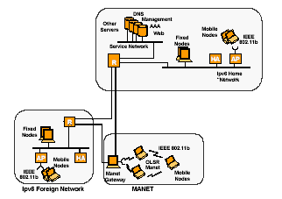

Fig.1.WLANs & MANETs Based Mobile Network

3 MANET Gateway
The MANET gateway connects the MANET to the Internet and is responsible for understanding the hierarchical routing scheme of the Internet as well as the OLSR based routing protocol in the MANET. The gateway periodically broadcasts its existence into the MANET using Host Network Association (HNA) messages. HNA messages are used to inject routing information into the MANET of associated hosts/subnets that are not running OLSR thus not participating in the MANET. CNs and the HA can be reached as long as they are located in the subnets that were advertised in the HNA message. Currently there are no distinctions made in the HNA message between subnets attached to the gateway and a connection to the Internet.

4 Micro-mobility management
Micro mobility is a way to manage the movement of a mobile node between different points of attachment ( Figure 2.a,2.b).If the change is very frequent standard Mobile IP [7] does not work, since its mechanisms bring too much overhead. Micro mobility mechanisms try to minimize signalling,handover time and avoid communication with distant servers. There are several solutions in the area of micromobility:Cellular IP [8], and Hierarchical Mobile IP[9]. They all work in a scenario where a mobile node is moving and changing its point of attachment to the network. The communication
with point of attachment (e.g. access point) is always direct, i.e. single-hop.

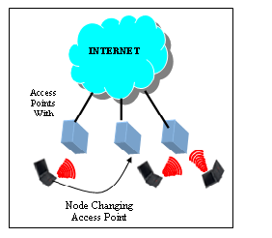
Fig.2.a.Micromobility of MANETs

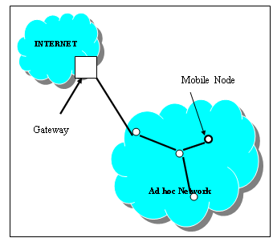Fig.2.b.Ad Hoc Cloud with Internet Connectivity

5 Internet and Manet Network
Communication between mobile nodes in manet and fix node in fix network are accomplished with two steps:
The first part is standard communication inside fixed network, from the originating fixed host to the mobility support router. the message is being transferred over the existing fixed network and mobility support router is just another address in this network, that is, nothing distinguishes it from the other fixed hosts. Off course, some of the existing transport protocols is used for this part of communication (for example, it can be TCP/IP).Then the mobility support router broadcasts the message to all mobile hosts in its cell, and the one that is being addressed receives the message. This is the second part of communication – a wireless communication between mobility support router and mobile host.
Initially, nodes belonging an ad-hoc network can only communicate among themselves, using multi-hop wireless transmission. In this case, each node has a unique address which is ’meaningless’ outside the ad-hoc network, since there is no external connectivity. However, there are some solutions which extend this architecture providing Internet access for ad-hoc nodes. This means that one (or more) of the nodes has at least two network interfaces, one making it part of the ad-hoc network, and another connecting to the Internet (Figure 3). This node becomes a gateway and provides Internet access for the wireless-only nodes. The gateway is managing a certain address space, and each ad-hoc node needs to request the address which it will use to communicate through the gateway. This is required to enforce that data packets from the Internet to the ad-hoc node travel via the gateway.
There are two general approaches for providing Internet connectivity: with and without tunneling. In both approaches, a mobile node needs to know the gateway address and have a route to it. Mobile nodes also need to know their network prefix and compare it with the destination address. When using the tunnel, if the destination lies outside the mobile network, mobile nodes encapsulate the packets directed to the Internet and put the gateway address as a destination. When such a packet is received by the gateway, it decapsulates its contents and forwards the packet to the desired destination. Because of this encapsulation, we can say that the packets are tunneled between the mobile node and the gateway.

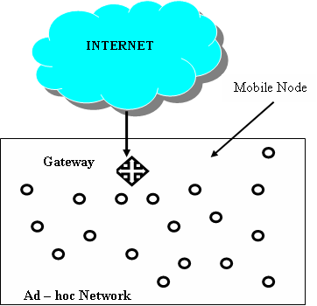

Fig.3. MANET and Internet Access

In another approach, if the destination lies outside the mobile network, mobile nodes send the packet with the ’real’ destination address and direct the packet to the next hop for the gateway. Each of the nodes needs to keep a default route, as in standard Internet connectivity. The next hop for such route is the next hop to the gateway. The tunneled solution is transparent to the intermediate nodes, since it doesn’t require gateway support in them. However, if each node can distinguish external address from internal ones the tunneled approach is not required. It provides a solution for global connectivity by adding the following extensions:
- how to obtain a routable address
- how to communicate through the gateway
Two methods for Internet gateway discovery are proposed: proactive and reactive. In the first one, the gateway sends its advertisements periodically announcing its address, global prefix and scope. The reactive way means that a node must initiate gateway discovery by itself and the gateway responds to it on demand. In this case, the address is also assigned on demand.

6 Solution presentation
Using standard ad-hoc routing protocols it provides a simple way of managing micro mobility in ad-hoc networks. The architecture is as follows: several access points (APs) are connected to one common Internet gateway. The APs are part of the ad-hoc network and provide Internet access to the mobile nodes. The gateway is physically not part of the MANET, but is connected (e.g. via wired links or ip tunnels) to each of the APs. It runs the MANET routing protocol on the links to APs and thus becomes a logical member of the MANET. Although physically there may be several points of Internet access , mobile nodes see only one gateway. By making the gateway, connected through APs, a logical part of the MANET will:
- use a single address space
- use ad-hoc routing protocols to manage micro mobility
The basic idea of Common Gateway Architecture(CGA) is presented in Fig. 4.

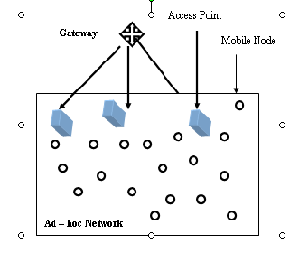
Fig.4.Common Gateway Architecture Concept

In order to explain this solution, let us take AODV [10][11][12] as a MANET routing protocol and assume that all APs have a wired connection to the gateway. In this solution, there are 3 types of nodes:

6.1 Mobile nodes
These are standard ad-hoc nodes, running AODV with any of the extensions letting them discover and use the Internet gateway.

6.2 Access points
An access point has two interfaces: one wireless connecting to the ad-hoc network and another one connecting to the gateway. Access points are full routers, they are able to forward packets between interfaces. They run AODV on the ad-hoc interface and on the gateway interface. To avoid creation of the mobile node to mobile node through the gateway only the route requests to the gateway are forwarded on the gateway interface. This way the gateway receives only the requests directed to itself and learns the route back to the mobile host.

6.3 Gateway discovery
There is only one gateway node for the different APs. It has connections to all the access point nodes and an interface connecting to the Internet. It is also managing the IP address space. It has full router capabilities, it is forwarding packets between any of the access point links and Internet interface.
If a gateway receives a route request, it replies to it on the link where it came from, building a route to the source of the request. This is standard AODV operation. AODV assures that the closest access point is chosen, since it uses hop counts as metric for the route selection. When a gateway needs to find a route to the mobile node, it sends (’broadcasts’) the request to all APs, which repeat it further on their wireless links(Fig.5).
New APs may be added easily. The only requirement is to connect them to the gateway and apply filtering. Since there is only one gateway, its address may be preconfigured in the mobile nodes. Even if the gateway is initially not known, its discovery may be performed only once, saving time and limiting overhead traffic. Because the nodes communicate with the gateway and not APs, when the route is lost (e.g. due to mobility), a new ’optimal’ route to the gateway shall be established by the means of the routing protocol.

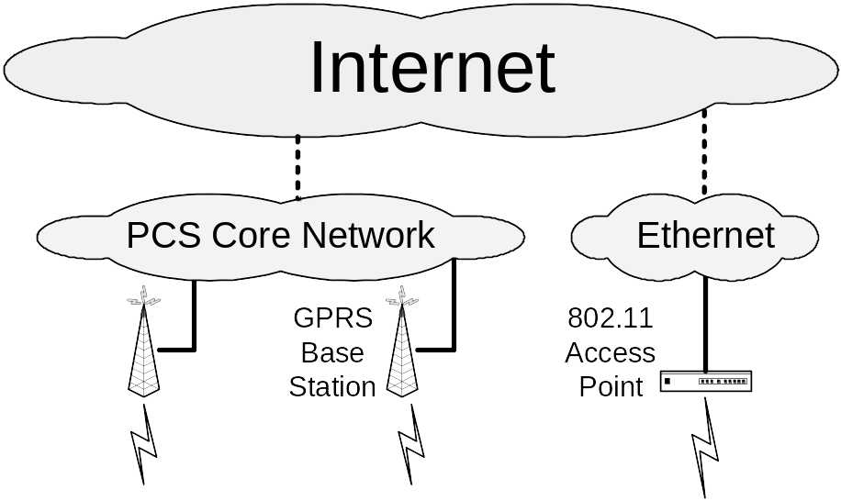
Low Tier
Multi-hop MANET
High Tier
Internet access

Fig.5.MANET and INTERNET

In order to avoid Internet gateway extensions in the mobile nodes, application level proxies may be installed on the gateway and thus provide indirect access to Internet services. One example is a web proxy. When installed in the gateway it allows all mobile nodes to use web-based services without any Internet extensions to the ad-hoc routing protocol. Cellular IP signaling is added on top of the adhoc routing protocol. The difference to the CGA approach is that the gateway is not running AODV, thus being logically outside the ad-hoc network. Mobile nodes, gateway and base stations must implement the Cellular IP protocol.This architecture has following consequences:

_ All sessions need to be initiated by the mobile nodes
_ It does not work with other gateway discovery solutions
_ It is not transparent to mobile nodes
_ Mobile nodes need to send route update to the gateway every time they change the base station
_ More signaling is required.

7 Conclusions
Internet access is one of the important parameter for mobile ad hoc networks. The Common Gateway Architecture provides a simple way to install and use several Internet access points in ad hoc network. Those access points run in the same address space and are connected to one common Internet gateway.
By running the ad-hoc routing protocol on the gateway, the mobile nodes use the closest access point by the means of standard ad-hoc routing protocol operation.

References
[1] A.Ghaffari, Routing algorithms in mobile ad hoc networks,WSEAS conference ,Izmir,TURKEY,2004
[2] C. Ahlund, A. Zaslavsky, Software Solutions to Internet Connectivity in Mobile Ad Hoc Networks, 4th International Conference on Product Focused Software Process Improvement, PROFES 2002. Springer- Verlag, December 2002
[3] G. Andreadis, Providing Internet Access to Mobile Ad-hoc Networks, London Communications Symposium 2002, September 2002
[4] A. Campbell, J. Gomez, C-Y. Wan, S. Kim, Z. Turanyi, A. Valko, Cellular IP, IETF Draft, January 2000
[5] H. Cha, J. Park, H. Kim, Extended Support for Global Connectivity for IPv6 Mobile Ad Hoc Networks, IETF Draft, October 2003
[6] M. Ghassemian, P. Hofmann, H. Aghvami, C. Prehofer, Analyses of Addressing and QoS Approaches for Ad Hoc Connectivity with the Internet, IEEE PIMRC 2003, Beijing, China, September 2003
[7] A. Hamidian, A Study of Internet Connectivity for Mobile Ad Hoc Networks in NS 2, Masters thesis, Departement of Communication Systems, Lund Institute of Technology, Lund University, Sweden, January 2003.
[8] C. Perkins et al., IP Mobility Support for IPv4, IETF RFC 3344, August 2002
[9] C. Perkins and E. Belding-Royer, S. Das, Ad hoc On-Demand Distance Vector routing, IETF RFC 3561,July 2003.
[10] R. Ramjee, T. La Porta, S. Thuel, K. Varadhan, L. Salgarelli, IP micro-mobility support using HAWAII,IETF Draft, July 2000.
[11] H. Soliman, C. Castelluccia, K. El-Malki, L. Bellier, Hierarchical Mobile IPv6 mobility management (HMIPv6), IETF Draft, June 2003.
[12] V. Typpo, T. Sukuvaara, M. Jurvansuu, P. Mahonen,Extending IP Micro-mobility to AODV based ad hoc networks, WWIC 2002, June 2002.

