An Efficient FMT Algorithm

Roman M. Vitenberg
Data-JCE Electronics

Tel Aviv, ISRAEL

Andrea Tonello
Udine University

Udine, ITALY

Abstract—The Filtered Multitone (FMT) Modulation is a new communication technology that uses for data transmission the orthogonal wavelets. This paper describes a new efficient FMT algorithm, which may be used for practical realization of high performance Wireless Systems.
Keywords-component; Wireless, FMT, modulation, wavelets.

Introduction
The Filtered Multitone Modulation was proposed by group of researches from IBM as alternative technology for xDSL [1]. This technology is based on Wavelet theory and uses complex filter-banks for synthesis and analysis of multi-channel signal.
The theoretical aspects of FMT for Wireless Application were developed by Cambridge University [2] and Udine University [3]. It was shown that in many cases FMT modulation might guarantee better performance than OFDM.
A most significant advantage of FMT is absence of out of band side lobes and high rejection of narrowband RF noise. The FMT receiver is working as high order bandpass filter and minimizes requirements to analogy components of the System. A second advantage of FMT before OFDM is absence of guard time interval (cyclic prefix) that is necessary for OFDM. The cyclic prefix in OFDM Systems takes up to 25% of OFDM symbol that means: the FMT may have up to 25% better performance.
The FMT advantages are not realized up today because of high complexity of synthesis and analysis filter-banks, which were proposed for theoretical study of FMT.
Data-JCE Electronics developed a new efficient FMT algorithm in 2002 –2003 years. This algorithm lets realize a low complexly FMT core.

Synthesis of a prototype wavelet
Suppose that our prototype wavelet shell be

Symmetrical in time relative to its maximum.

limited in time.

From this two limitation follows that the prototype wavelet $W(t)$is a sum of cosine components with frequencies $F_{n}={k∗1}/T$, where T is a wavelet length and k = 0,1,2…
We suppose that our wavelet comprises only $N$ cosine components, so:
$$W(t)={\sum_{k=0}^{N−1}{a_{k}\text{Cos}(k}}/T);$$
and we will be look for W(t) that stay orthogonal for N => min.
It may be shown that N is relative small and depends from acceptable level of the ISI (inter-symbol interference).
Figure 1 demonstrates dependence of the ISI from N for wavelets those were used for realization of an efficient FMT algorithm.
The minimal number of cosine components for prototype wavelet synthesis is 9. For practical prototype of FMT system was used a prototype wavelet constructed from 11 components.
So low number of frequency components lets possibility to use IFFT for prototype wavelet synthesis.
Figure 2 illustrates how a prototype wavelet may be produced by IFFT.

Figure 1.

Figure 2.
For example there is used 128-point IFFT core. Only 9 inputs of this core are used for wavelet synthesis. All other inputs are connected to ground (0). The prototype wavelet $W(t)$ may be modulated by amplitude and carry information. In this case amplitudes $a_{k}$of frequency components are modulated by information signal.

Synthesis of Sub-channel Wavelets.

The FMT System uses in general number $λ$of frequency sub-channels; each of them transmits a correspondent sub-channel wavelet. The sub-channel wavelet is a prototype wavelet shifted to carrier frequency of correspondent sub-channel. A common realization of FMT system comprises $λ$frequency up-converters in transmitter and $λ$prototype wavelet filters.
Figure 3 illustrates a new architecture of the FMT Transmitter that uses IFFT for forming all sub-channel wavelets.
Figure 3.

Each sub-channel wavelet is generated by group of k IFFT inputs (in our example k=9). A resulting FMT line signal $X(t)$appears on IFFT output. Number of IFFT – points defines a number of sub-channels $λ$ of FMT System.
The FMT system that comprises about 100 sub-channels needs only 1024-point IFFT core. There no need frequency up-converters and prototype wavelet filters.
Figure 4 shows PSD of FMT Transmitter that was realized in accordance with described efficient algorithm.

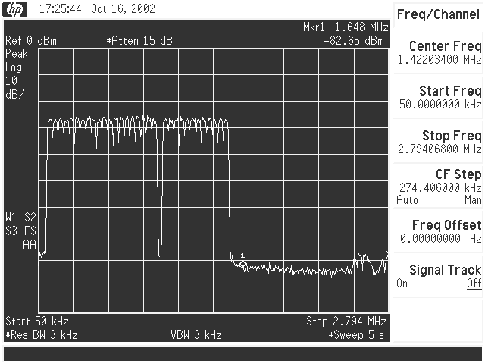
Figure 4

Analysis of Sub-channel Wavelet

A transmitted FMT line signal $X(t)$passes through communication channel. As result a received signal $Y(t)$appears on an input of FMT Receiver. After amplifying and A/D conversion, the received FMT signal comes to input of analyses block that provides decoding of sub-channels wavelets.
Figure 5 illustrates how this wavelet decoding may be provided by FFT core.
Figure 5.
Analysis of sub-channel wavelet is provided by analysis its frequency components by FFT. Because each frequency component may be processed independently, the distortions of a communication channel may be easily compensated.
The simple Equalizer that may be used in proposed FMT architecture is shown on Figure 6.

The wavelets frequency components from FFT block outputs passes to parallel/serial converter and comes to an input of multiplayer that provides a multiplying of each wavelets frequency component on corresponding equalization coefficient. The sequence of corrected frequency components passes to demodulator that decodes an information data.
The constellation diagram of received wavelet signal is shown on Figure 7. The FPGA prototype System was designed for VDSL Application but the same FMT core may be used for wireless systems.

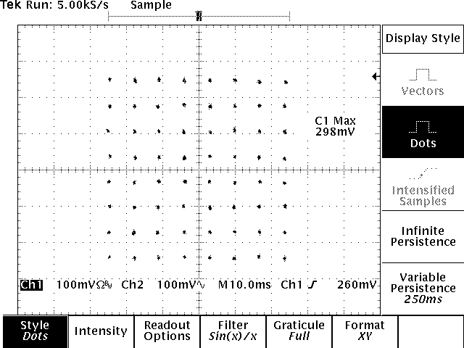
Figure 7.

Conclusions

The Filtered Multitone Modulation (FMT) is a new Technology that may be successefuly USED for wireline and wireless communications. The Proposed Efficient FMT Algorithm gives possibility to realize the FMT advantages without using complexly filter-banks.

References

- G. Cherubini, E. Eleftheriou, S. Oelser : “ Filtered Multitone Modulation for Very High-Speed Digital Subscribe Lines”, IEEE Journal of Selected Areas in Communications, VOL.20, NO. 5, 2002.
- Inaki Berenguer, Ian J. Wassell, “Efficient FMT equalization in outdoor broadband wireless systems”, Proc. IEEE International Symposium on Advances in Wireless Communications, Victoria, Canada, Sept. 2002.
- Andrea Tonello “Discrete Multi-Tone and Filtered Multi-Tone Architectures forBroadband Asynchronous Multi-User Communications” Wireless personal Multimedia Communications Symposium - Aalborg, Denmark - September 9-12, 2001

Figure 6.

