Optical and ELECTRICAL Properties of Zinc Oxide Films Prepared by Spray Pyrolysis

HASAN AFIFI ¹, M..ABDEL-NABY², SAID EL-HEFNAWIE¹,
AREF ELIEWA¹ AND NINET AHMAD¹

1. National Research Center, Cairo, Egypt
2. Department of Electrical Engineering. University of Qatar,
P.O.Box 2713
DOHA, QATAR

Web Page: http://www.qu.edu.qa

Abstract:-The structural, optical and electrical properties of ZnO:In thin films prepared by spray pyrolysis method are examined. The used spray solution (0.2M) was prepared by adding indium chloride InCl₃ to the precursor of zinc acetate dissloved in mixed solution 80% H₂O: 20%CH₃OH. The XRD patterns for incorporated ZnO film with different concenteration of indium shows three addional peaks (100), (101) and (110) over the only one (002) appeared in pure ZnO. The intensities of these peaks are increased gradually with indium concentration while the (002) peak decrease to its minimum value at 3% In. The resistivity of ZnO films was improved by doping from 2.25x10² Ω.cm for undoped to the minimum value at 2% doping concentration 2.6x10⁻² Ω.cm. The optical bandgap of all films has no change by In addition and shows sharp absorption edge at 380nm.

Keyword: Optical, electrical, properties, Zincoxide,Spray pyrolysis.

1 Introduction
In the last decade, Zinc Oxide (ZnO) thin film attracts much interest due to valuable properties such as;
- It is high resistance to chemical attack, chemical stability and good adherence to many substrates.
- High optical transparent in the visible region and the index of refractive is ~1.8 enables them to act as a antireflection coating in solar cells applications.
- Its abundant in nature makes it a lower cost material when compared with ITO and SnO₂ materials.
Zinc oxide thin films have been prepared using various techniques, such as, DC magnetron sputtering [1] , r.f sputtering [2], evaporation [3], sol gel [4] and spray pyrolysis [5-6]. The spray pyrolysis is simple, inexpensive and suitable for large area coating. Pure ZnO thin films have extremely high electrical resistance which can be reduced by appropriate doping

and heat treatment. The effect of substrate temperature and solvent were investigated previously [7]. In the present work the structure, optical and electrical properties of Indium doped ZnO films prepared by spray pyrolysis are examined.

2 Experiment
The ZnO thin films are deposited on microscope glass slices by spray pyrolysis. The doped ZnO thin films are prepared by adding indium chloride InCl₃ (1%, 2% and 3% by weight) to the precursor zinc acetate Zn(CH₃CO₂).2H₂O dissolved in a mixed solution of 80% H₂O : 20% CH₃OH of 0.2 M. In our previous paper [7] studies depicted the role of the solvent on the characteristics of ZnO properties as well as the substrate temperature are found to be the mixture of 80% H₂O: 20% CH₃OH and substrate temperature 425 ºC for 30 min spray time are preferable to achieve ZnO films with structural, optical and electrical properties suitable for optoelectronic devices. The compressed air was used as a carrier gas with 20 L/min while the solution is feed to the designed glass nozzle by peristaltic pump to maintain the solution flow rate at 3 mL/min. The structure of the prepared ZnO thin films was detected using Pert-Philips x-ray diffraction with CuKα radiation (λ = 1.5418 Å at 55 kV and 40 mA). The diffraction patterns were recorded automatically with scanning speed 2 ⁰ per minute in the range (2θ = 10-90 ⁰). The optical transmission studies were measured using double beam spectrophotometer, Model Jasco V-570.

3 Results and Discussions
3.1 Structural Properties
The obtained XRD patterns for pure and incorporated ZnO thin films with 1%, 2% and 3% indium by weight is shown in Fig.1. The XRD patterns of all films are consistent with the pattern of ZnO powder reported in standard JCPDS data file. The lattice constants of these films are calculated from the obtained values of d-spacing and their corresponding (hkl). The values of the lattice constants are found to be ( a = 3.24Å and C = 5.19Å) which are close to the standard value of hexagonal form of ZnO powder. The pure ZnO thin films show only one characteristic peak at 2θ = 34.46 ⁰ which corresponds to (002) nearly like that prepared by epitaxy technique. The addition of In doesn't affect the main peaks position which reflect the existence of ZnO single phase. Three other principal peaks (100), (101) and (110) are appeared by indium incorporating. The intensities of these planes are increased gradually by incorporating In with percentage 1% and 2%. In contrast the film incorporated with 3 %., these intensities of the peaks are decreased, while the principal plane (002) appeared in the pure ZnO films reduce to its minimum intensity. The crystallite size of ZnO films is calculated using Scherrer formula:

D = 0.94 λ /Δ (2θ) cos θ (1)

Where D is the mean grain size, Δ (2θ) is the full width at half maximum of the diffraction line in radius, θ is the diffraction angle and λ is the wave length of X-ray (1542Å). The grain size is listed in Table I.

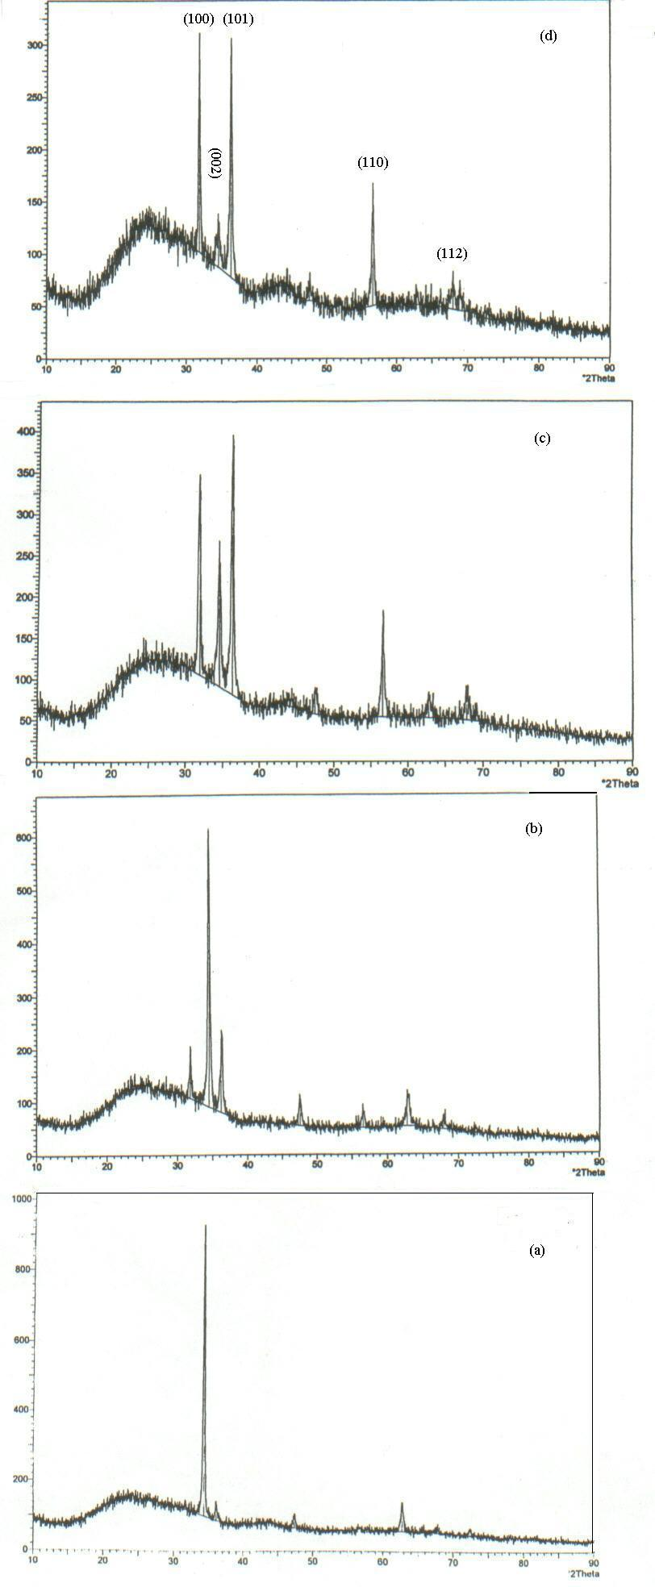

Diffraction angle (2θ)

Fig.1 XRD patterns for pure and doped ZnO
thin filmsa) pure ZnO b), 1% In, C) 2% In,
d) 3% In

Table 1. The mean grain size of ZnO films versus dopant concentration.

Dopant | Grain size (nm)
Dopant | (100) | (101)
1%  2%  3% | 44  60  37 | 57  40  38
3.1.1 EDX
The film composition of indium doped zinc oxide was determined using energy dispersive of x-ray (EDX) using SEM model Philips XL30 attached with EDX unit with accelerating voltage 30kV. It is used to estimate the elements ratios exist in the prepared films. Figure 2 shows the EDX corresponding to ZnO incorporated with 2% and 3% respectively. The appeared two principal peaks are related to Zn and In elements in the film while the other peaks are related to the elements of glass substrate.

Fig.2.EDX of ZnO films incorporated by indium a) 2% In b) 3% In

3.2 Optical Properties
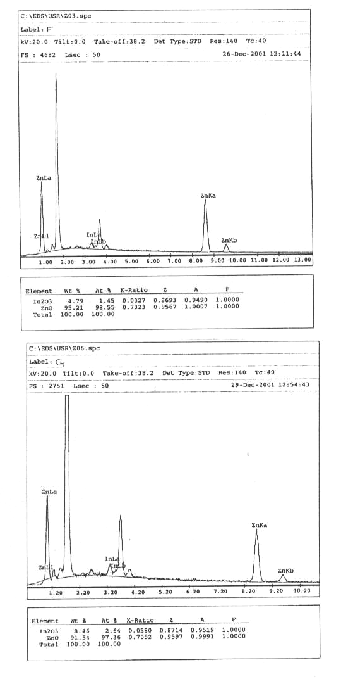
The transmittance versus wavelength for pure and doped ZnO thin films is shown in Fig.3. It is observed that the films are highly transparent with sharp absorption edge at λ = 380 nm. The optical bandgap values are obtained from the plot (αhν) ² vs hν by extrapolating the linear portion of the plot to (αhν) ² = 0. Figure 4 shows the optical bandgap for pure and doped ZnO thin films. The calculated optical band gap has no change by indium addition; its value is 3.26 e.V. Figure 5 shows the variation of absorption coefficient α with wavelength for undoped and doped ZnO films. It is clear that the absorption coefficient is sharply decreased near the band edge indicating the good crystallinity.
Fig.3 The transmittance of pure and doped ZnO thin films versus wavelength.

Fig.4 Plot of (αhν) ² vs hν for pure and doped ZnO

In the visible region, the absorption coefficient increase with the doping concentration. The refractive index n calculated from transmittance for undoped and doped ZnO thin films are shown Fig.6. The refractive index varies from 1.7~2 in the visible range which are preferred for antireflection coating materials.

Fig.5 The variation of absorption coefficient α versus wave length for pure and doped ZnO films

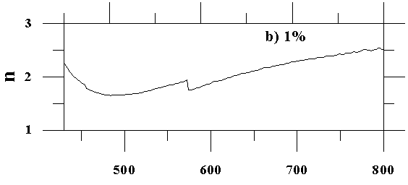
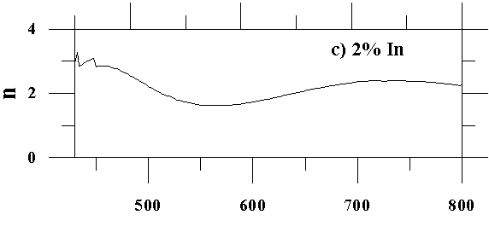
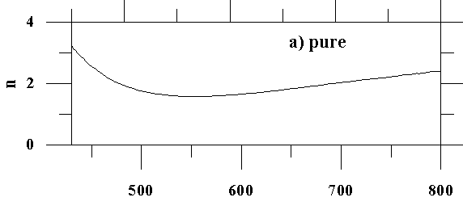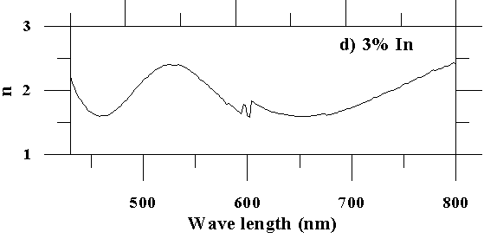
Fig.6 The refractive index (n) versus wavelength

3.3 Electrical Properties
Pure ZnO thin films have extremely high electrical resistivity. Indium incorporation shows drastic reduces in the resistivity value (`four orders of magnitude). The pure ZnO films have resistivity value 2.25x10² Ω.cm while the incorporated film with 2% doping concentration have a minimum value 2.6x10⁻² Ω.cm. The variation of electrical resistivity with the dopant concentration is shown in Fig.7.
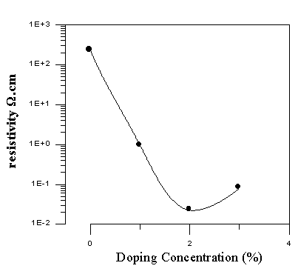
Fig.7 The effect of doping on the resistivity

3.4 Figure of Merit:
We deposited ZnO: In thin film as oxide semiconductor window layer on single crystal silicon to form solar cell, the results will be published later. Figure of merit Φ is useful to

determine the films which have less absorption and good conductivity to reduce the series resistance. It is calculated using the following formula [8]: Φ= 1/αρ (2)
The calculated values for pure and ZnO that incorporated with different ratios of indium are listed in Table II. It is clear that the ZnO film incorporated with 2% indium concentration gives the higher value of figure of merit (2.1x10⁻³ S). This related to the high reduction in electrical resistivity and good crystallinity that it is given in Fig.1

Table 2 The figure of merit for pure and doped ZnO thin films.
Doing Concentration | Absorption coefficient α x10³ at λ= 500nm cm⁻¹ | Resisitivity ρ (Ω.cm) | Figure of Merit  Φ (S)
Pure  1%  2%  3% | 1.237  0.744  2.976  2.922 | 2.25x10²  6.47x10⁻¹  2.6x10⁻²  7.36x10⁻² | 3.59x10⁻⁶  2.1x10⁻³  1.3x10⁻²  4.6x10⁻³

4 Conclusion
It is clear that the addition of indium as a dopant shows an additional peaks (100), (101) and (110) over the only one (002) appeared in pure ZnO films. Also the optical band gap of ZnO films hasn't changed by indium addition and shows sharp absorption edge at 380 nm. The ZnO film incorporated with 2% In gives a higher figure of merit (2.1 x10 ⁻³ S) due to its larger reduction in electrical resistivity (2.6x10⁻² Ω.cm). The absorption coefficient in the visible region increases with the doping concentration.

5 References
[1] S.Brehme, L.Elstner,F.Fenske, W. Henrion, V.Hoffmann, M. Poschenrieder, F. Sachafer, B. Selle, and I Selle, and I. Sieber” Magnetron sputtered ZnO:Al films as window layers in silicon based photovoltaic heterojunctions”, 13th European Photovoltaic Solar Energy Conference, 23-27 (1995).
[2] T.L. Yang, D.H. Zhang, J. Ma, H. L. Ma, Y. Chen” Transparent Conducting ZnO: Al films deposited by r. f. magnetron-sputtering” Thin Solid Films 326, 60-62 (1998).
[3] Jin Ma , Feng Ji, Hong-Lei Ma, Shu-Ying Li” Electrical and optical properties of ZnO:Al films prepared by an evaporation method”, Thin Solid Films 279, 213-215(1996).
[4] W. Tang and D. C. Cameron “Aluminum-doped Zinc oxide transparent conductors deposited by the sol-gel process” Thin Solid Films, 238, 83-87 (1994).
[5] C. Messaoudi, D. Sayah, and M. Abd-Lefdii,” Transparent conducting undoped and indium- doped zinc oxide films prepared by spray pyrolysis” Phys. Stat. Sol, (a) 151, 93-97 (1995).
[6] Benny Joseph, K.G. Gopchandran, P. V. Thomas, Peter Koshy, V. K. Vaidyan, “A study on the chemical spray deposition of zinc oxide thin films and their structural and electrical properties”, Material Chemistry and Physics 58, 71-77 (1999).
[7] H.Afifi¹, S.EL-Hefnawi², A.Eliwa², M.Abdel-Naby³ and N.M.Ahmed² “Solvent Effect On Physical Properties Of Zinc Oxide Films Prepared By Spray Pyrolysis:, World Renewable Energy Congress VII, 29June-5July 2002, Cologne, Germany.
[8] P. Nunes, E. Fortunato, R. Martines " Influence of the Post-treatment on the properties of ZnO thin films" Thin solid Films 383, 277-280 (2001).

