A Novel Low Power Compression/Decompression Unit using PAL

P. Vidya priyadarshini¹, G. Josemin Bala², Dr. J. Raja Paul Perimbham³
Department of Electronics & Communication Engg
Anna University

Abstract
This paper presents a novel architecture for data compression/decompression using Pass transistor Adiabatic Logic (PAL). The PAL Compression/Decompression Unit (CDU) uses an adiabatic Content Addressable Memory (CAM) for pattern matching required by BSTW compression process. A SPICE simulation of PAL CDU indicate around 50% of power saving at 10MHz operating frequency compared to conventional design. Circuits are designed using 0.6µm CMOS technology.

1.Introduction
Data compression is a technique used to increase the effective volume of storage device and the effective Bandwidth of data communication channel. With the advent of VLSI technology a large number of functions are built into wireless and portable products resulting in large volume data transmission and intensive computation. Real time, low power transmission/computation is now the main design objective. Therefore low power and high performance data compressors will play an important role in the growing portable computing and wireless communication markets.
Low power transmission/computation can be achieved by the usage of adiabatic techniques. Adiabatic logic is a new approach to the VLSI circuit to achieve low power. Adiabatic logic circuits achieve low power dissipation by restricting the current to flow across the device with low voltage drop and by recycling the energy stored on their capacitors[1].
This paper introduces a novel architecture for compression/decompression using pass transistor Adiabatic Logic (PAL) and compares its power consumption with an adaptive CDU[2].
The CDU is an architecture meant for compressing the data by removing the redundancy inherent in information prior to transmission/storage and reinserting it after transmission/access. Several approaches have been proposed for low power CDUs.
Power reduction in CDUs can be also achieved by shutting off the power for unnecessary comparison between the CAM words and input symbol [3]. Another method for reducing the power dissipation is to use selective precharging.[4].Compared to all the approaches significant amount of power reduction can be obtained by using adiabatic switching principle.

2.Data Compression
Data compression based on examining a piece of information for redundancy and removing the redundancy to result in the equivalent but shorter message. Decompression is the reverse process, namely inserting the redundant information to obtain the original message. BSTW algorithm is being proposed for data compression/decompression[2].
BSTW is a single pass defined word adaptive compression scheme. The tree structure used by Huffman algorithm is replaced by a simple self-organizing list and a move to front replacement strategy.
Fig1 shows the operation of the BSTW algorithm.
1. A table of N records is held. Data of size m bits (tuple) is compared against each entry in the table. The table is maintained as an N length move to front list.

- If the source data matches any entry in the table, as n bit code associated with that tuple is transmitted. The tuple is placed at the top of the list. Since n<m less bits are transmitted.
- If the source data cannot find a match in the table, the tuple is sent together with an n bit code representing the symbol for the source. Assuming that the incoming data is in the table, more often than, not data compression occurs.
2.Since bits are used to represent the source, there comes a point when all codes are used. In this case a new tuple therefore needs to be allocated a code currently given to another tuple.
before input after
the cat sat on the
m n

THE | 00
CAT | 01
MAT | 02
URN | 03
LOG | 04
FIR | 05
RED | 06
THE | 00
ON | 01
SAT | 02
CAT | 03
MAT | 04
URN | 05
LOG | 06

output
00 01 07 07 03
Fig1:Operation of BSTW Algorithm
The reallocation algorithm works as follows: The oldest entry is deleted from the bottom of the list. Allocate the code to the new data item. The new entry is inserted at the top of the list. Decoding involves maintaining a similarly structure table at the receiving end. The advantage of this algorithm is that it that is dynamic, yet the table is self-organizing through the simple move to front approach.
3. Architecture
The proposed architecture is based around a shifting content addressable memory array(CAM). A CAM is a circuit element which can be read/written like an
ordinary memory. In addition it can compare its stored data with an externally supplied search argument and indicate whether it matches or mismatches. Implementing the table in CAM, with its parallel matching, makes the searching a one cycle operation. Extra combinational logic is required to determine whether the input data was found in the CAM array or not.
Fig2 shows the architecture of the compression unit. The move to front strategy necessitates a reorganization of the data in table. The matching word must be identified, then the data in the array above the matching word must all be shifted down one position, resulting in the overwriting of the matching word. The third and final operation is the writing of the input word into the first entry in the table. When there is no matching word, all table entries are shifted down one place, and the new input data written into the first entry in the table.
Shifting the data to its neighbor below is carried by the addition of shift registers. By selectively shifting a portion of the array, a mechanism for supporting the table update can be realized. The lines shift and write select the source data when writing to a CAM word. By selecting the portion of the table to be shifted as the range (start of table matching word address), the update procedure described previously can be updated. Implementing the CAM with shift register capability makes moving the data about a one cycle operation.
N
When shift is active, the source is the cell above. When write is active, the source is the data on the appropriate search line. Around this CAM array. there needs to be logic to detect which (if any) matched the search argument and logic to set the appropriate set of shift lines active. Finally, the input data is stored at the top of the table.
Data enters the system and is latched. This value is then compared with all the entries in the table simultaneously. The matching word address is encoded from the response of the CAM word and output. In addition, it is also fed back into the combinational logic book., which determines which words are to be shifted. Following the shift, the input data is written into the first entry of the table.
O1
O2
O3
O4

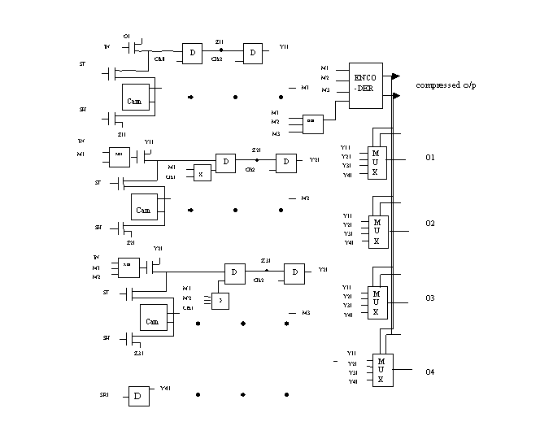
Fig2:Architecture of the compression unit

4.PAL Designs

PAL is a dual rail logic with true and complementary functional blocks and cross coupled PMOS latch.

a. CAM

CAM structure is similar to that of the SRAM with compare operation.
Fig 3 shows the proposed CAM cell along with the precharge and read/write circuitry. A sinusoidal Power Clock(PC) supplies the PAL. The output will be valid only around the peak of the PC. When the PC ramps down towards zero the energy stored on the capacitance is recovered.
The dual lines(bit and bit/) are precharged by the PC to recover the energy before the read operations. Separate data lines are used for writing and reading the data. It has separate precharge and read write circuitry.
The write enable(we) line decides the operation whether to read or write.In the compare operation, the charging and discharging path are made the same, which eliminates the need for precharging the match line.
The match and match/ output is fed to a adiabatic buffer.

PC
b
b/
sr
sr/
src/
src
re/
match
b
b/
pre
PC
b
b/
we
wd/ rd
re
re/
we/
rd/
(a)
(b)
( c)
Fig3:CAMCell(a)Precharge(b)
Read/write circuitry(c)
re
wle
wd

b. D Latch

Fig4 shows the design of D Latch used in the CDU. T he data input changes in accordance with the clocking time. When the rising edge of PC arrives, the cross coupled PMOS devices sense and latch the appropriate value of the clocked D onto the nodes X and Y[5]. Since the cross coupled NOR gates form a simple set/reset latch, the positive pulses on either X
or Y will cause the latch to either set or rest, respectively.

in/
clk
PC
in
clk/
in/
clk
PC
in
clk/
Q
Q/

Fig4:D Latch

When D is not changing, either X or Y will remain low, with the other node oscillating in phase with PC in an energy recovering manner.

c. Multiplexer

Fig5 shows the proposed multiplexer. Suppose that the inputs A, S0 and S1 are high, making a conducting path from the PC to the output F1. Given that F1 is connected to PC, F1 will start raising from 0 towards the peak of PC. The node F1/ will be “tri-state” and kept close to 0v by the load capacitance of the subsequent gates. As the PC ramps up, the PMOS transistor Q1 turns on, and the output F1 is charged up to peak of PC. The transistor Q2 will stay off. The PC will ramp down towards zero, recovering the energy stored on the F1 node capacitance.

s0/
s1
I1
s0/
s1/
I0
s0
s1/
I2
s0
s1
I3
s0
s1
I0/
s0
s1
I0/
s0
s1
I0/
s0
s1
I0/
PC
Q
Q/
Fig5:4x1 mux

d. Encoder

Fig6 shows the encoder being used in CDU. When PC starts rising from low, input states make a conduction path from the PC through one of the functional blocks to the corresponding output node and allow it to follow the PC. The other node will be tri-state and kept close to 0v by its load capacitance. This in turn causes one of the PMOS transistors to conduct and charge the node that should go to one state, up to the peak of PC. The output state is valid at around the top of the PC. The PC will then ramp down towards zero, recovering the energy stored on the output node capacitance.

in4
in3
in3/
in4/
PC
Y1
in4
in2
in2/
in4/
PC
Y2

Fig6:2x4 Encoder
5. Results

The CDU is designed using 0.6µm technology. To compare the performance PAL CDU,we also developed conventional non adiabatic CDU.The SPICE simulations computed the dissipation of the circuits.
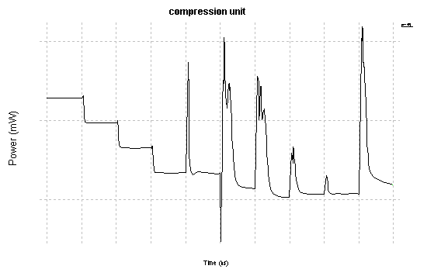

Fig 7 : Power consumption of conventional CDU
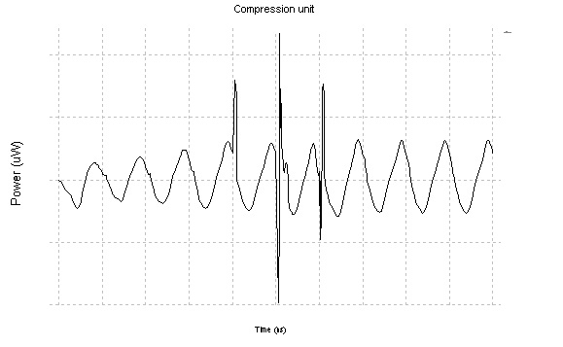

Fig 8: Power consumption PAL CDU

The fig 7&8 shows the power consumption of conventional CDU and PAL CDU.

Table 1: comparison

 | PAL CDU | Conv CDU
Average power  consumption | 90µw | 100mw
Sources | PC | DC and PC

The results are tabulated in Table 1.In the PAL CDU, about 50% power savings has been obtained when compared to the Conv CDU.

6. Conclusion

We presented low power CDU using PAL to reduce the power consumption. The simulation results shows significant power savings at operating frequencies on the order of few MHz. A similar structure is maintained at the receiving end in order to receive the original data.

5.References

[1] W.C.Athas, L.J.Svensson, J.G.Koller, N.Tzartzanis and E.Y.Chou, “Low power digital systems based on adiabatic switching principles”, IEEE Trans. of VLSI systems, 2(4), December 1994,pp 398-407.

[2] S.Jones “100 Mbit/s adaptive data compressor design using selectively shiftable content-addressable memory”, IEEE Proceedings-G, vol.139 No 4, Aug 1992.

[3] K.J.Lin and C.W.Wu, “A Low power CAM design for LZ data compression”, IEEE Tran on computers, vol. 49, No 10, 2000, pp 1139-1145.

[4] C.Zukowaski and S.Wang, “Use of selective precharge for low-power CAMs”, IEEE ISCAS,Nov.1993,pp 745-770.

[5] Conrad H.Ziesler, Joohee Kim and Marios C.Papaefthymiou “Energy recovering ASIC design” IEEE ISVLSI 2003.

