A New Approach Towards Intelligent Analysis for Competitive Intelligence in Enterprise*

Yanping Zhao, Yidan Wang, Donghua Zhu
School of Management and Economics
Beijing Institute of Technology
P.R.China

Abstract: - Competitive intelligence analysis is an information processing course for structured, semi- structured and non-structured text. Now it is very difficult to analyze intelligence information with the computer. In this paper, we put forward a SWOT strategy intelligent analytical system by introducing Artificial Neural Network (ANN) expert system based on Genetic Algorithm (GA). The system can transform qualitative problems, such as company’s strengths, weaknesses, opportunities and threatens into computer understanded codes, such that computer is able to recognize and make uncertain reasoning for strategies selection. In this way, computer can learn and accumulate experience from successful cases then give SO tactics, ST tactics, WO tactics and WT tactics. Furthermore, the system consumes much less time than human analysis, and give some references to the similar research in other domains.

Key-Words: - Competitive Intelligence, ANN Expert System, Genetic Algorithm, SWOT Analysis

1 Introduction
The Competitive Intelligence (CI) is the information aggregation through filtering, refining and analyzing. According to it we can take actions about the rival and competitive environment^{[1]}.
In recent years, with the further development of information retrieval and text/data mining technology, some relative technologies make great progress, such as information extract, text categorization technology, nature language understanding and artificial intelligence, etc., making computer intelligence analysis become possible. But the software analysis report of Fuld^{[2][3][4]} points out, except for artificial intelligence, the above methods can only offer the relevant information material to support different analytical methods, and by far, there has not yet been software to make analysis and decision instead of human^{[5]}. The main reason is that it is very difficult for computer to realize the competition intelligence analysis, in addition it also involves a lot of uncertain factors in the course of analyzing. At the same time adding intelligence in the course of analyzing, all of those can't be substituted by computer program completely^{[6][7]}.
In this paper, we will take SWOT analysis method as an example, put forward a SWOT analysis modal based on neural network expert system. This system can improve systematic adaptive capacity and learning ability. When the new and good case appears, it could train and study the network again, which improved its ability to deal with and solve practical problem.
This paper is organized as follows. Section 2 gives a concise view of ANN of Expert System model and provides ANN Training based-on Genetic Algorithm. In section 3 we bring forward SWOT Competitive Intelligence Analysis system model, then make SWOT analysis, and illustrate our experiments, describe the system realization and test results. Section 4 is a conclusion.

2 Introduction of the Artificial Neural Network model of expert system

2.1 Artificial Neural Network Training based-on Genetic Algorithm
The ANN is a kind of project system which can imitate human brain structure. Its memory capacity is very heavy, which makes it have better uncertain information processing ability^{[8]}. BP is one of the comparatively ripe training algorithms, because it is simple, convenient, little calculation and stronger parrallel computing etc.. And through studying and researching, GA has been proved an successful algorithm in training the weight of the neural network and ascertaining topological structure. In the study, we consider to combine BP neural network train with GA. We use GA to make a global search. After satisfying the requirement, We use BP algorithm local optimum search, until meet the precision request. In this way, we can accelerate the speed of the network trains greatly, and can reach optimization.

2.2 ANN Expert System Model

2.2.1 Introduction of ANN Expert System
Neural network and expert system have their own advantages, So we combine the strong logical knowledge reasoning ability of expert system with the ANN knowledge acquisition. It gives full play to the advantage of the two, and better meets the demands of practical application.

2.2.2 The System Structure of ANN expert System

Knowledge engineer
User

Study samples
Ascertain system framework
Practical problem parameters

Input model transform

Knowledge base (distributed)

Neural cell studying
Reasoning principle

Form new study samples
Output model transform
Practical problem result

Fig. 1 ANN expert system structure

The development environment is made up of three parts. We can get knowledge base through sample cases. It includes: studying samples; conforming the system frame; the neuron cell studying. The running environment is an expert system, which is used for solving the practical problem. The expert system is made up of five parts: (1)Practical problem parameter; (2) Input model transform; (3)Reasoning mechanism; (4)Knowledge base; (5)Output model transform.

3 SWOT Competitive Intelligence Analysis system model

3.1 SWOT Competitive Intelligence Analysis
A large number of practices prove that SWOT analytical method is a method with higher frequent using and with better result in the intelligence analysis. Through analyzing, we find that there are some general questions in enterprises. For example, some of them have the same or similar strengths, some have the same or similar weaknesses, so as to opportunities and threatens in enterprises. Therefore, they may adopt the similar tactics. Based on this, we propose the neural network expert system to study a large number of successful SWOT analysis cases, to train our system. When you input similar precondition, the system will output the experience that was successful in the past, act as the reference of the present strategy, then we can improve the quality of decision .

3.2 SWOT Competitive Intelligence Design

3.2.1 The Modal Question Input
The strengths and weaknesses in enterprises can be decided by a lot of factors, including some qualitative and quantitative criteria. So we introduce competitiveness assessment module to solve the natural language handle problem and help user estimate enterprise’s conditions objectively. The assessment system includes 11 items of indexes, which include financial situation indexes, technological strength indexes, market control ability indexes, production capacity indexes, human resources indexes, scale ability indexes, information resources indexes, sustainable development indexes, products indexes, management indexes and environmental indexes.

3.2.2 Sample Decision and Training
Through analyzing, generalizing and summarizing a large amount of successful cases that have already approved, we selected 35 representative cases as the sample. But if we regard all factors of SWOT analysis as an intact sample to train, it may cause input and output data too much, and cause sample matrix too huge to influence efficiency and the result accuracy of operation greatly. So we consider to divide the sample into four sub-samples to train, namely SO, ST, WO, WT, and form one's own neural network separately and independently. By analyzing the cases, we summarized 15 items of strengths, 7 items of weaknesses,12 opportunities and 10 items of threatens which are most influential to enterprises.
Studying sample is as non-linear, we choose three layers network structure with a hidden layer. In the system, actual parameter is expressed with a kind of physics concept. But the neural cell requires numerical value (- ∞, +∞) to express. We need transform the physics concept into numerical value. And set up two vector sets.
- Physical meaning of actual input concept sets are shown in table 1. Among them S means strength, W means weakness, O means opportunity, T means threaten.
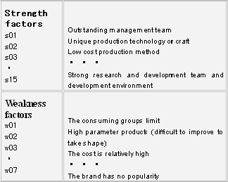
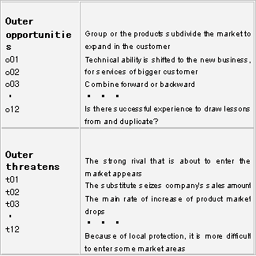
table 1 SWOT analysis concept sets

- The neuron cells input numerical values: when users select a certain factor, the corresponding node inputting value is composed as 1, otherwise 0.

We use BP algorithm and GA to train samples, because BP has simple structure networks, smaller input variables, higher convergence speed, better learning ability and higher precision prediction. And GA can increase the stability, it is suitable for the complicated non-linear system.

3.2.3 Network topology structure Design
In practical application, we use hidden layer weight experience formula when the nodes are bigger^{[9]}:
（1）
Among them, s is the number of hidden layer nodes, m is the number of input nodes, n is the number of output nodes, which need to be rounded up. In this case, taking WO as an example, according to (1), hidden layer of nodes s is 13, through comparing with system total error and emulation test, we find when s is 17, the system convergence and back-end emulation result is relatively more ideal as hidden nodes, so we choose 17 as the nodes of hidden layer.

3.2.4 The Input and Output Transformation
What we analyses are most qualitative input describing, so the output should be the natural language that users can understand too, but not absolute code. We need a transform mechanism to transform qualitative description into the code that the neural network can discern and deal with.
Input transform means that users set the parameters value of selected factors as 1, not selected ones as 0. Merge matrix W and matrix O into a matrix WO (1, 19) first, which is used for storing the corresponding numerical value of W, O, which the top 7 is as the value of " W ",and the last 12 is as the value of " O ". For example: If user select 1, 4 attribute of W, the value of WO [0 ] [0 ] and the value of WO [0 ] [3 ] are composed as 1, and the rests are 0.
Output of practical problem is expressed with a kind of concept form, but the output of neuron cell is within [0, 1]. In practical application, the realization of output transformation process can be changed into the understandable suggestion for user's reference from neural network operation systematically. All outputting layer nodal number values are all stored in R _ WO (10, 1), then according to a certain rule that we can judge,it will output the corresponding results as advice. Among the system, output result can divide into three grades. We introduce a subject function in fuzzy mathematics, seeing formula (2).
(2)

3.2.5 Knowledge Base and Reasoning
The knowledge base is mainly to preserve the connection weight value among neurons. Here the knowledge base are SO, ST, WO, WT respectively. In the course of training, the four sub-samples become connection weight value matrix from input layer to hidden layer and then from hidden layer to output layer. Our reasoning machine is the information processing course based on neuron cell. See Fig. 2 in knowledge reasoning process .
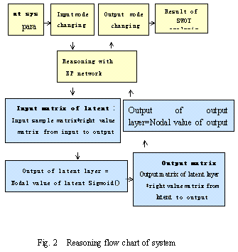3.2.6 Setting of System Parameters
The parameters are set up as follows in this system: The most adjustment value that the system permits is: 0.001; The most training times: 100000; Initial value of the step: 0.001; Train algorithms: BP algorithm; Adopt function is Model S function: , which can show non-line relations between input and output, the value of adopt function is in [0, 1]. Link initial weight value of network is in [0,1], and initial threshold value is in [-1,1].

3.3 System Realize and Test Results
SWOT intelligence analytical system adopts VC ++6.0 to develop, and tests were passed under WIN2000. SWOT analysis system can produce word file automatically. As to the case that train, when you input a question that is similar or with a more or less attribute, the system can still provide the meaningful result. Bacause the systematic reasoning is quick and fault-tolerant is good. We can use the network that has been trained to carry on emulation and reasoning. The results are Fig. 3 and Fig. 4.

4 Conclusion
This system has introduced the neural network model, and has improved systematic adaptive capacity and learning ability. When the new and good case appears, it can train and study the network again, and improve its ability to deal with and solve practical problem. Competitive assess can help enterprise discern and understand which respect is the weak facts of enterprises. It has certain objectivity. In addition, the final result of SWOT analysis can offer some suggestions that can be referenced by enterprises, can support enterprises to carry on decision and reduce earlier stage analysis time. This system can be a profitable attempt for realizing intelligent analysis. At the same time, it has certain reference meanings to the research which is similar to the question of other fields.

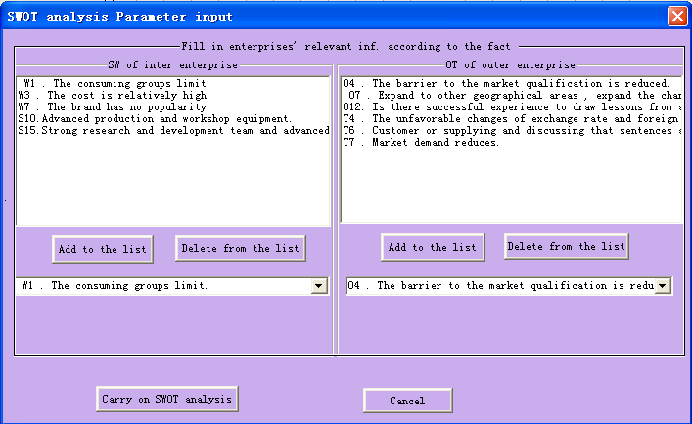
Fig. 3 SWOT analysis parameter input

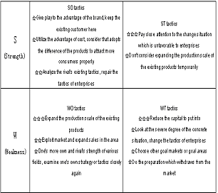 Fig.4 SWOT analysis result

References:
[1] Xinzhou Xie, Changhuo Bao, Yan Zhang. Talking about the construction of enterprise's competition intelligence system. Journal of Peking University (Philosophy and social sciences), 2001-06, 56-68.
[2] Fuld & Company Inc．Intelligence Software Report 2002．http://www.fuld.com，2003-10-20
[3] Fuld & Company Inc．Intelligence Software Report 2003．http://www.fuld.com，2004-03-21
[4] Leonard Fuld．Fuld & Company．Intelligence Software:Reality or still virtual Reality? Competitive Intelligence Magazine，2001，4(2)： 22～27
[5] Yanping Zhao, Donghua Zhu. Network Dynamic moniter of Scientific Information and Research of technology monitor oc information automatically. Studies in Science of Science,2003.
[6] Xinzhou Xie, Na Li, Shaoqi Huang. Investigation and Analysis of the Enterprise Informationization and Competitive Intelligence of China. Journal of the China Society for Scientific and Technical Information 2001,20(3).295-302.
[7] Xingguang Hu, Xinzhou Xie. Solution of Competitive Inteliggence(CI): CI System and CI Technology in Enterprises. Publishing house of weapon industry. 2002(11):377-380
[8] Zongli Jiang. Artificial Neural Networks. http://www.youngfan.com/ann/. 2004,2,18
[9] Daqi Gao. Research of forward three layer neural network structure that has the teacher’s linear basic function. Chinese Journal of Computers. 1998，21(1)：80～86

* This research is supported by the National Natural Science Foundation of China, the project code: 70471064, and Research Foundation of Beijing Inst. of Tech

