Upgrading Wireless Networks with Selection Combining

GILL R. TSOURI and DOV WULICH
Department of Electrical and Computer Engineering
Ben-Gurion University of the Negev
Beer-Sheva 84105
ISRAEL

Abstract: - A selection combining scheme is considered as an upgrade solution to existing wireless networks. The upgrade requires the use of a new radio frequency front end at the receiver with three antennas instead of one. An approach to guarding the system from diversity loss caused by antennas proximity is proposed. As an example, the upgrade of mobile units in an IS-136 network is analyzed. Performance is evaluated by computing the bit error rate, outage probability, average signal to noise ratio and mean switching rate of the considered scheme.

Key-Words: Diversity methods, fading channels, wireless networks
receiver

KLT
switch
logic
RF front end

1 Introduction
Wireless networks operate under a constant demand for higher throughput, due to the increase in users and multimedia services. The development and layout of new network infrastructure is costly and upgrade schemes are preferable if they provide the adequate increase in capacity.
A promising approach to increase channel capacity involves the use of multiple antennas. The optimal way of using a multiple antennas reception array is to combine the antenna outputs using Maximal Ratio Combining (MRC) [11]. This approach requires down conversion of all antennas outputs to baseband and good channel estimation. MRC is not suitable for upgrading an existing receiver which uses only one down conversion chain for a single antenna.
An alternative to MRC is Selection Combining (SC) [1-7,11]. In SC the antenna with the highest Instantaneous Signal to Noise Ratio (ISNR) is chosen by a Radio Frequency (RF) switch and is fed to a single down conversion chain. It follows, that SC schemes may offer a suitable solution for upgrading existing wireless networks by replacing the single antenna front end with a multiple antennas front end and the accompanying switch and logic. In this paper we analyze a three antennas SC scheme.
In many wireless receivers the antennas are forced to be close to one another, such is the case of mobile units in a cellular networks. SC schemes suffer from diversity loss when the antennas are close to one another. The loss is due to statistical correlation between the antennas outputs [4-6].
Performance analysis of SC schemes in correlated fading channels is readily available for various types of channels and antennas settings [1-3,7,11].

Fig.1 – Scheme of upgraded receiver
The following performance parameters are commonly considered: Bit Error Rate (BER), outage probability and Average Signal to Noise Ratio (ASNR). In this paper we also examine the mean switching rate. This parameter is important in the context of cellular networks where the mobile units have limited power supply. A high switching rate would increase power consumption. Also, for systems utilizing continuous phase modulation each switch requires realignment of phase. Switching rate consideration are given in [7] as well. Fading channels commonly considered are Rayleigh, Rician and Nakagami. In this paper we consider Rayleigh fading. This fading describes a no line of sight and rich scattering scenario and is considered severe.
It should be noted that in the case of an asymmetric network, such as a cellular network where each mobile unit is upgraded to three antennas and the base station remains with one antenna, the duality nature of SC can be used to select an antenna for transmission at the mobile unit. It follows, that symmetry in signal quality is achieved. This approach requires channel state information at the

Fig.2 – Low pass equivalent mode
h₂
z₂
x
h₁
z₁
h₃
z₃
receiver
r

selector
logic

KLT
(matrix P)
v
mobile unit. Such information can be deduced by the mobile unit when the same frequency band is used for transmission and reception and may be relayed from the base station as side information otherwise.
In this paper we propose a technique for reducing the diversity loss incurred by statistical correlation of the antennas outputs. It involves de-correlating the antennas outputs with the Karhunen Loeve Transform (KLT) [10] prior to the switching process. The technique requires the application of a linear transformation on the antennas outputs which reduces to a weighted sum of the analog signals. The KLT depends on the channel covariance matrix alone, is constant and known offline for Rayleigh fading channels. We name SC after KLT as Virtual Selection Combining (VSC).
The KLT is used extensively in applications where a data set with large dimensions is to be reduced for processing. Such is the case in hyper spectral imaging techniques, where a large set of pictures is to be reduced for processing by an online computer. The KLT preserves the most of the information in the original set and is therefore used as a preprocessing technique, commonly referred to as Principle Component Analysis (PCA). The motivation for using KLT for switched diversity methods such as selection combining stems from the observation that the selection process is in fact a reduction in the dimensions of the observation space and it makes sense to apply PCA prior to the reduction.
The rest of the paper is organized as follows. In section 2 the upgraded system is described mathematically, in section 3 the KLT is applied, in section 4 performance parameters are evaluated, in section 5 results are analyzed and in section 6 conclusions are drawn.

2 System Description
We consider an SC system as depicted in fig.1. Three antennas are laid out in a triangular geometrical setting. The power correlation coefficient (ρ) may be computed using the following formula [8]:
, (1)
where J₀ is the zero order Bessel function, d is the distance between the antennas and λ is the carrier wavelength. Notice that for narrow band signals ρ is practically constant within the band.
As an example, we assume each antenna is 3 cm from the other antennas. This scenario fits a cellular wireless telephony mobile unit, where there is limited space for antenna placing. We consider a carrier frequency of 850MHz, as is the case in the IS-136 wireless standard. It follows from (1) that the correlation between each pair of antennas outputs is ρ=0.82.
The systems low pass equivalent is shown in Fig. 2. Notice that placing the KLT and switching after down conversion fits the linear model. It is assumed that the channel between the transmit antenna and each one of the receive antennas has flat (non-frequency selective) fading, i.e., its low pass equivalent may be represented by a vector of complex valued channel attenuations , where . Consequently, the received vector of antennas output is , where x is a complex valued symbol to be transmitted, E_{s} is its energy and z is a vector of additive, zero mean complex noise assumed to be spatially i.i.d. with equal variance N₀.
We assume h has the following properties:
(A1) ;
(A2) ;
(A3) ;
(A4) .
We use * to note the conjugate operation and E{·} to denote expectation.
Such properties are characteristic for many wireless channels [8,9]. Note that (A2) means that the in-phase and quadrature components are orthogonal and that (A3) means that the ASNR is the same for all antenna outputs (homogenous branches).
The covariance matrix is defined as:
(2)
We use ^{H} to note the conjugate transpose operation. This definition is in accordance with the constant correlation model given in [11].
Rayleigh fading means that h has a Gaussian distribution, which together with (A1)-(A4) means that the joint Probability Density Function (PDF) of the real valued random vector has the following form:
(3)
where is the argument of the PDF and is the covariance matrix of . From (A1)-(A4) we obtain:
, (4)
where and from (A1)-(A4) it also follows that .

3 Channel de-correlation
The vector r is comprised of samples in space generated by the array outputs. Applying the KLT, in the form of the matrix P, on r results in:
(5)
where and . We use the following notation: and .
According to the properties of the KLT, the matrix P^{H} is a unitary one and its columns are the eigenvectors of C_{h}. It follows that the proposed de-correlation procedure depends only on the channel covariance matrix. The auto-covariance matrix of is diagonal and:
, (6)
where are the eigenvalues of C_{h} and are also the variances of the virtual channel attenuations. We may arrange the eigenvalues such that . P is also unitary, so the statistical properties of are the same as those of z.
The sum of the eigenvalues is equal to the sum of the variances of the attenuations in h. Equivalently, since the noise variance is unchanged by P, the sum of the ASNRs of the components in r is equal to the sum of the ASNRs of the components in v. In other words, the KLT distributes the total ASNR unevenly, so that uncorrelated non homogenous branches are created. We treat the components in v as the outputs of virtual antennas.
As the correlation coefficient ρ becomes larger (the distance between the antennas in the array becomes smaller), the difference in ASNR between the virtual antennas increases. It follows that as ρ increases the SC switch has better branches to choose from after KLT and hence a diversity gain is achieved which counteracts the diversity loss.
Since the KLT is a linear transform has a Gaussian distribution and the following PDF is true:
, (7)
where the matrix is the inverse covariance matrix of the vector: .
All components of are mutually uncorrelated and
. (8)

For the case when ρ=0.82 we obtain:

(9)

4 Performance evaluation
We evaluate performance by computing BER, outage probability (P_{out}), ASNR and mean switching rate (R_{SW}).
The outage probability is defined as
, (10)
where is the ISNR at the n-th branch and th is a minimal required SNR needed for acceptable performance of the receiver. Note that in view of (A.3).
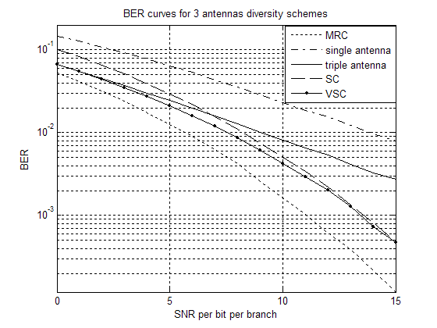
Fig.3 – BER curves of reception methods for ρ=0.82
The mean switching rate is defined as [7]
(11)
where is the probability that the selector chooses antenna n and is the probability to move from antenna n to another. Let us define .
BER depends on the type of modulation being used. We analyze the BER of BPSK as an example.
The classical approach to obtain closed form expressions of the performance parameters is first to achieve a closed form expression of the ISNR at the switch output. Performance parameters are then calculated in a straightforward fashion. A different approach is to use the moment generating function [1-4,11]. In what follows we obtain closed form expressions for most of the parameters and use Monte Carlo methods to obtain the others.

4.1 Performance of SC
The outage probability may be written as:
$P_{\text{out}}^{\text{SC}}=\iint_{D_{1}}{\text{.}\text{.}\text{.}}\iint_{D_{3}}{f_{1}\left(x_{1},x_{2},\text{.}\text{.}\text{.}\text{.},x_{5},x_{6}\right){\text{dx}}_{1}}{\text{dx}}_{2}\text{.}\text{.}\text{.}{\text{dx}}_{5}{\text{dx}}_{6}$ (12)
where and is the ISNR threshold normalized by the ASNR of a single branch prior to KLT.
To calculate R_{SW} we use definition (11), i.e., we have to find and . We have:
$\begin{aligned}p_{n}^{\text{SC}}=… \\ 1−\iint_{D_{n}}{\left(\iint{\underset{D_{i}}{\text{.}\text{.}\text{.}}}\iint{f_{1}\left(x_{1},x_{2},\text{.}\text{.}\text{.}\text{.},x_{5},x_{6}\right){\text{dx}}_{1}}{\text{dx}}_{2}\text{.}\text{.}\text{.}{\text{dx}}_{5}{\text{dx}}_{6}\right)}{\text{dx}}_{\text{ni}−1}{\text{dx}}_{\text{ni}}\end{aligned}$ (13)
where ,
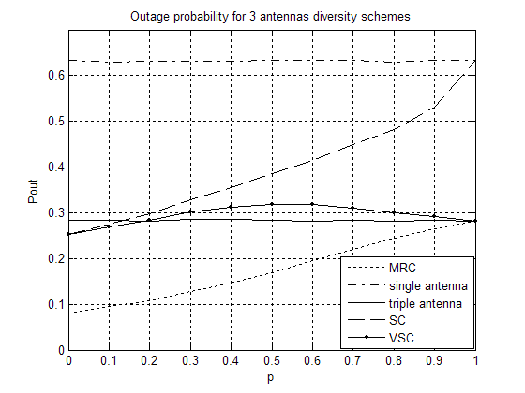
Fig.4 – Outage probability as function of ρ
$D_{i}\overset{\text{def}}{=}\left\{\left(x_{2i−1},x_{2i}\right):x_{2i−1}^{2}+x_{2i}^{2}<x_{2n−1}^{2}+x_{2n}^{2}\right\},i=1,2,3,i≠n$ and is given by (3).
Since the branches are homogenous:
(14a)
(14b)
Using the definition for R_{SW} we have:
. (15)
The ASNR is evaluated directly as:
(16)
The integrals (12) and (16) were numerically evaluated using Monte Carlo methods. The results were verified using computer simulation of the low pass equivalent model. BER is evaluated using computer simulation of the low pass equivalent model. Statistics were gathered for 10⁵ channel instances and 10 bits per channel.

4.2 Performance of VSC
Since the branches are uncorrelated, analytic calculations for VSC is easier than for SC. Using (7), in the same manner as was done for SC, routine calculations obtain:
(17)
(18)
R_{SW} and BER for BPSK were obtained through Monte Carlo computation and validated with computer simulation as was done for BPSK BER of SC.
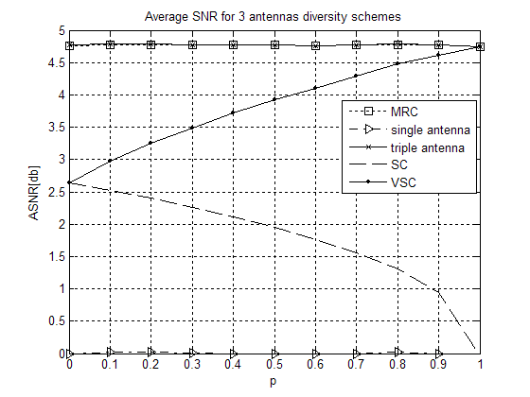
Fig.5 – ASNR at switch output as function of ρ

5. Results
In fig.3 BER as a function of the ASNR at a single branch prior to KLT is shown, ρ is chosen to be 0.82. The MRC curve is displayed as a lower bound, since it is the optimal method. The single antenna curve represents system performance prior to the suggested upgrade. The triple antenna curve represents the performance of a single antenna with triple the reception surface. This is done to evaluate the diversity gain achieved by using multiple antennas instead of a single big antenna and helps evaluate the benefits of using an array. We find that at low SNR SC offers no considerable diversity gain as compared to the triple antenna and is actually outperformed by the triple antenna by 2db. However, VSC performs as the triple antenna. It follows, that for low SNR the KLT gains 2db in BER performance. For high SNR SC gives considerable diversity gains of 5db and more as compared to the triple antenna. VSC always performs better than SC, but performs almost the same as SC for SNR>10db.
In fig.4 P_{out} is displayed as a function of ρ. P_{out} is calculated with the threshold being the ASNR at a single branch prior to KLT. We find that as ρ increases P_{out} increases for SC. However, for VSC it is constrained low and is almost the same as that of a triple antenna for all ρ. P_{out} for MRC rises to a point where it is almost the same as VSC.
In fig.5 the ASNR at the switch output is displayed as a function of ρ. Notice that MRC, being the optimal approach, performs as a triple antenna. We find that as ρ increases SC exhibits increasing diversity loss to the point where it acts as a single antenna. However, for VSC the ASNR rises as ρ increases to the point where it is almost the same as MRC.
In fig.6 R_{SW} is displayed as a function of ρ. We find that although R_{SW} is constant for SC, R_{SW} for VSC decreases dramatically as ρ increases.
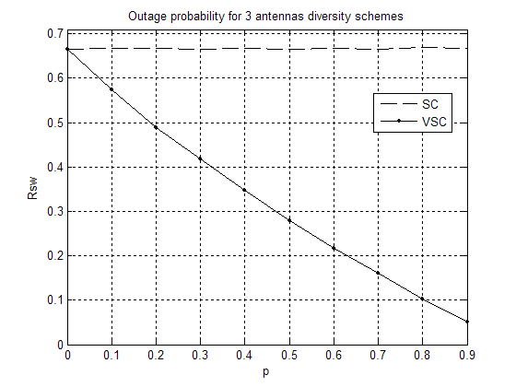
Fig.6 – RSW at switch output as function of ρ

6. Conclusion
An upgrade scheme was suggested for receivers in existing wireless networks. The upgrade consisted of replacing the single antenna front end with a 3 antennas scheme in a triangular setting, followed by a KLT transform and an SC switch. The KLT depends on the channel covariance matrix which is known offline for Rayleigh fading.
Performance analysis showed that the KLT increases performance for correlated antennas outputs. For the specific case where the carrier frequency is 850MHz - as is the case in the IS-136 standard and an antenna spacing of 3 cm – as is suitable for a handheld mobile unit, the KLT gives 2db increase in BER performance for low SNR.
It was also shown that the KLT protects the system from diversity loss and improves outage probabilities, ASNR and mean switching rates for correlated channels.

References:
[1] Y-C. Ko, M-S. Alouini, M. K. Simon, “Analysis and Optimization of Switched Diversity Systems”, IEEE Trans. on Vehicular Technology, Vol. 49., No.5. Sept. 2000, pp. 1813-1831.

[2] Q. T. Zhang, H. G. Lu, "A General Analytical Approach to Multi-Branch Selection Combining Over Various Spatially Correlated Fading Channels", IEEE Trans. on Comm., Vol. 50, No. 7, July 2002.

[3] C. Tellambura, A. Annamalai, V. K. Bhargava, "Unified Analysis of Switched Diversity Systems in Independent and Correlated Fading Channels", IEEE Trans. on Comm., Vol. 49, No. 11, November 2001.

[4] M. A. Blanco and K. J. Zdunek, “Performance and optimization of switched diversity systems for the detection of signals with Rayleigh fading,” IEEE Trans. On Comm., vol. COM-27, December 1979, pp. 1887–1895.

[5] A.M.D. Turkmani, A. A. Arowojolu, P.A. Jefford, C.J. Kellett: “An experimental evaluation of the performance of two-branch space and polarization diversity schemes at1800 MHz”, IEEE Trans. on Vehicular Technology, Vol. 44., No.2. May 1995, pp. 318-326.

[6] C. M. Lo, W. H. Lam, “Average SER for M-ary modulation systems with space diversity over independent and correlated Nakagami fading channels”, IEE Proc.-Comm..,Vol 148, No. 6. Dec. 2001, pp.377-384.

[7] H. Yang and M. S. Alouini, ``Markov chains and performance comparison of switched diversity schemes," Proceedings 36th Annual Conference on Information Sciences and Systems (CISS'02), pp., Princeton, New Jersey, USA, March 2002.

[8] W. C. Lee, Mobile Communication Engineering, McGraw-Hill, New York, 1982.

[9] J. M. Wozencraft and L. M. Jacobs, Principles of Communication Engineering, J. Wiley, 1965, pp. 527-532.

[10] A. Leon-Gracia, Probability and Random Processes for Electrical Engineering, 2nd
ed., Addison Wesely, 1994.

[11] M. K. Simon, M. S. Alouini, Digital Communication over Fading Channels, Wiley, New York, 2000.

