Particle Swarm Optimization for electric power systems

A. GIORGI, F. RIGANTI FULGINEI, A. SALVINI
Dipartimento di Elettronica Applicata
Università di Roma TRE
Via della Vasca Navale 84 – 00146 Roma
ITALY

Abstract: -In the present paper will be analyzed the Swarm Algorithm and in particular the Particle Swarm Optimization (P.S.O.) applied in the field of electric power systems. The main purpose is to create a linear approach to analyze, to solve and to optimize a particular chosen circuit, that has been previously tested through classical and not linear mathematical methods. The generated code, observing the tolerances imposed by specifications concerning above all active and reactive power of the load, looks for an adaptive combination of input values, in order to minimize the ohmic power loss of the whole system.

Key-Words: - P.S.O., Particles Swarm Optimization, Power loss, Load flows

1 Introduction
When the load power of a particular electric system has to be analyzed as a fixed value, the circuit resolution becomes a not linear problem (being power the product between voltage and current). In these more complex cases, it has always been used classical and not linear mathematical approaches, based on subsequent approximations (such as Gauss-Siedel method). The authors face this trouble through an heuristic algorithm, the swarm algorithm; this, thanks to a particles cooperation strategy, examines the space of solutions reaching the adaptive one after gradually more accurate iterations. Therefore, to sum up, the proposed method handles a not linear optimization problem determining a linear strategy to control the interested variables.
The P.S.O. shows really an high level of robustness so that it should be tested with a more complex architecture system with the aim of improving the accuracy. Nevertheless, in this circuit we observed either a lowering of the elaboration time either a great decrease of computations.

2 Load flows
To analyze the peculiarities linked to such not linear problem is firstly important to care about power flows [1]. The resolution of power flows in an ordinary power system needs the computation of the unknown voltages, currents and active and reactive powers of all circuit components. A system with n junctions is always represented through n different equations that relate the n voltages with the n currents. The presented scheme lists in short the subdivision among fixed and unknown variables for power flows computation:

 | Fixed variables | Unknown variables
Source junction | , | ,
Load junction | , | ,
Reference junction | , | ,
Fig 1: Fixed and unknown variables for power flows computation.

As a consequence the two following n equations systems are obtained for active and reactive power:

$\left\{\begin{matrix}P_{k}=\sum_{i=1}^{n}{V_{k}V_{i}Y_{\text{ki}}\text{cos} (ϑ_{k}−ϑ_{i}−γ_{\text{ki}})}=P_{\text{ko}} \\ Q_{k}=\sum_{i=1}^{n}{V_{k}V_{i}Y_{\text{ki}}\text{sin} (ϑ_{k}−ϑ_{i}−γ_{\text{ki}})}=Q_{\text{ko}} \\ E_{k}=E_{\text{ko}}\end{matrix}\right.$ (1)

Due to the presence of trigonometrical functions these equations are not linear, so that the solution is obtained applying numeric methods based on subsequent approximations, for instance the following one (Newton-Raphson analysis).
3 Newton-Raphson analysis
It’s given a n not linear equations system:
$\left\{\begin{matrix}f_{1}(x_{1}, x_{2}, \text{.}\text{.}\text{.}, x_{n})=y_{1} \\ f_{2}(x_{1}, x_{2}, \text{.}\text{.}\text{.}, x_{n})=y_{2} \\ \text{.}\text{.}\text{.}\text{.}\text{.}\text{.}\text{.}\text{.}\text{.}\text{.}\text{.} \\ f_{n}(x_{1}, x_{2}, \text{.}\text{.}\text{.}, x_{n})=y_{n}\end{matrix}\right.$ (2)

With $x_{1}, \text{.}\text{.}\text{.}, x_{n}$ unknown variables and $y_{1}, \text{.}\text{.}\text{.}, y_{n}$ fixed values. Imposing $x_{k}=x_{k}^{o}+{Δx}_{k}^{o}$, $\left(k=1, \text{.}\text{.}\text{.}, n\right)$ with $x_{k}^{o}$ freely chosen and ${Δx}_{k}^{o}$ initially unknown, and applying the Taylor series decomposition, the (2) becomes a linear system with ${Δx}_{k}^{o}$ unknown:
$\begin{matrix}y_{k}−y_{k}^{o}={Δy}_{k}^{o}= \\ {Δx}_{1}{\left|\frac{∂f_{k}}{∂x_{1}}\right|}_{x_{1}=x_{1}^{o}}+{Δx}_{2}{\left|\frac{∂f_{k}}{∂x_{2}}\right|}_{x_{2}=x_{2}^{o}}\text{.}\text{.}\text{.}+{Δx}_{n}{\left|\frac{∂f_{k}}{∂x_{n}}\right|}_{x_{n}=x_{n}^{o}}\end{matrix} \left(k=1, \text{.}\text{.}\text{.}, n\right)$ (3)
The obtained ${Δx}_{k}^{o}$, substituted in (2) generate a new system, similar but more accurate than the previous one. This process repeated for lot iterations allows to obtain results always closer to the real solution.
This method applied to the resolution of load flows produces the following matrix system:
$\left|\begin{matrix}ΔP \\ \text{.}\text{.}\text{.} \\ ΔQ \\ \text{.}\text{.}\text{.}\end{matrix}\right|=\left|\begin{matrix}0 & \frac{∂P}{∂ϑ} \\ \frac{∂Q}{∂V} & 0\end{matrix}\right|×\left|\begin{matrix}ΔV \\ \text{.}\text{.}\text{.} \\ Δϑ \\ \text{.}\text{.}\text{.}\end{matrix}\right|$ (4)
The (4) generates two uncoupled equations systems which solve the problem separating the computation of active from reactive power.

3.1 Gauss-Siedel iteration
In an electric system with an high number of junctions, the Newton-Raphson analysis involves growing computational difficulties. The Gauss-Siedel iteration technique considers one or two equations of the (4) for each junction at a time. It calculates the ${ΔV}_{i}$and ${ΔQ}_{i}$for the i-junction and, after the correction of the i-voltage (modulus and phase), ${ΔP}_{i+1}$ and ${ΔQ}_{i+1}$ at the next one. This step is applied to all the junctions to compute the corrections for each junction voltage. The process is repeated untill the results respect the fixed tolerances.

4 P.S.O. algorithm
The P.S.O. technique was originally developed in 1995 thanks to the cooperation of an electric engineer, Russel Eberart, and a psycho-sociologist, James Kennedy.
The particle swarm algorithm is an adaptive heuristic algorithm based on a social-psychological metaphor: a population of individuals stochastically adapted moves toward previously successful regions in the search space, and are influenced by the successes of their topological neighbours [2]. Therefore, the particles belonging to an ordinary swarm interact among them in a two dimension space [3] reach the same target and each one moves on the basis of five different points:
- Follow the neighbours;
- Remain in the swarm;
- Avoid collision with other particles;
- Move away from the group to reach the aim (individuality);
- Stay in the group to reach the aim (sociality).
The whole swarm instead presents two different behaviours:
- If more individuals moves towards the target, the others can change their direction to exploit that pattern;
- The whole group changes gradually direction towards better search spaces and, in this way, the information slowly propagates among the individuals of the swarm.
Moreover each individual is analysed as an attempt configuration, which casually moves in the solution space taking vantage from other discoveries to reach the found global best point. The merging between EXPLORATION and EXPLOITATION is the basic point of the movement strategy and a correct choice of this balancing increases the method ROBUSTNESS.
The difficulties of implementing a P.S.O. algorithm can be summed up in this following figure:
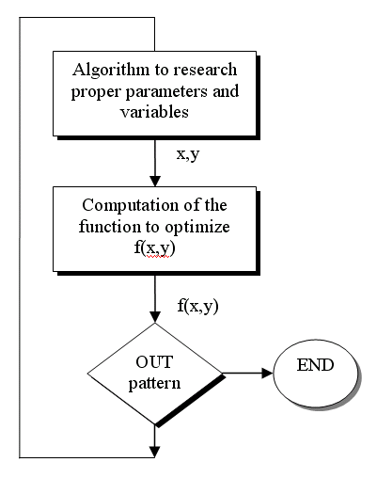
Fig 2: Flow chart of P.S.O. implementation.
The first step of fig 2 applied to an electric power system concerns the selection of the input generator values, in order to guarantee the tolerances observance of output variables before reaching the next block. About the f(x,y) to optimize it’s firstly important to verify if the function is multimodal (more than one maximum/minimum) or not; in such problematic the interested function is always the system power loss. At last it’s necessary to create a way out, an out pattern; for example, the exit may be allowed after facing a fixed number of consecutive iterations without obtaining valid results.
In conclusion the algorithm is structured on two levels:
- BASIC LEVEL: it locally works on the single attempt configuration generating new ones, and estimates the value of the target function.
- CONTROL LEVEL: it controls the swarm particles distribution leading the research towards the global optimum; it determines the algorithm convergence.

5 P.S.O. implementation strategy
At first, as it’s possible to see in the following figure, the analysis has been divided in two sub-problems:
- The research of a valid attempt configuration (in this case each one is composed by five inputs as it will be explained in the next paragraph);
- The optimization phase (now it consists in the power loss minimization of the assigned circuit).

Random generation of the first swarm of attempts
a) Process iteration to search for a valid configuration
END
OUT?
b) Power loss minimization
SOLUTION?
N
Y
N
Y
Fig 3: Flow chart of SWARM strategy.
The algorithm main core is based on the balancing of four different inputs configurations which, iteration after iteration, bring up to date their values. In addition to these four attempts a stochastic component is estimated at each cycle in order to guarantee the whole solution space exploration; as a consequence the research doesn’t stop on local optimum but goes on to reach global ones. The fusion of these five contributes generate each new attempt configuration of the incoming swarm.
The four attempt configurations concerning each swarm particle can briefly represented as follows:
- The actual configuration: the inputs values in present time;
- The personal configuration: the best result of the considered particle;
- The global configuration: the best result of the whole swarm;
- The centre configuration: inherent to the general moving of the swarm (it represents the swarm centre of gravity).
The code running is represented in the next two figures: all the individuals move in a two-dimension solution space to search for the same target, a valid inputs configuration.
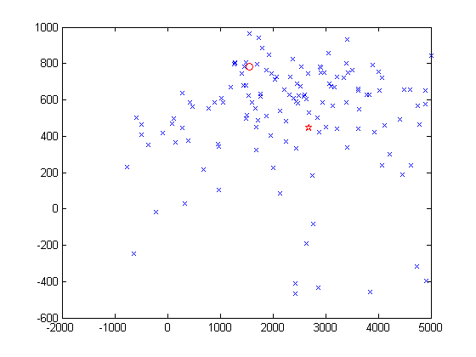
Fig 4: Starting frame of PARTICLES SWARM movement.
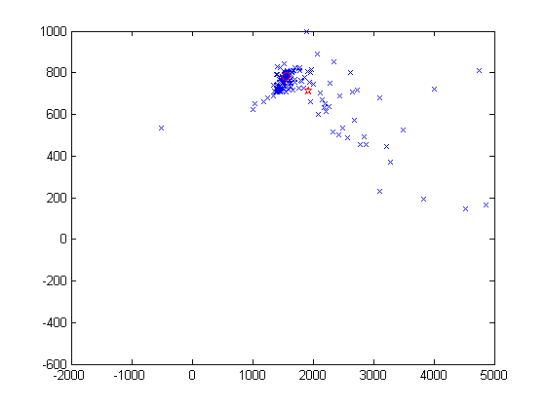
Fig 5: Final frame of PARTICLES SWARM movement.
- The swarm particles are indicated by “x”;
- Stars represent the swarm centre of gravity;
- Circles represent the valid solutions space.
When the code running stops, the particles have reached a valid solution (the winning attempt configuration) and the algorithm turns the attention on the minimization of the power loss.
Now, in order to optimize the interested function, the algorithm apply the same previous strategy , not more on an whole particles swarm but only on a single configuration, the winning inputs configuration.

6 Validation
The chosen circuit used to test the swarm algorithm is taken from [4] and is represented in the following figure:

800+J300
[MW, MVAR]
599.9+J115.3
[MW, MVAR]
410kV
-0.84°
505.7+J177.7
[MW, MVAR]
415kV
0°
~
~
1
2

3
300+J150
[MW, MVAR]
50 km
180 km
90 km

Fig 6: Chosen circuit to test the SWARM ALGORITHM.

This simple electric power system is made of three junctions, two voltage generators (on junctions 1 and 3) and a load (on junction 2).
- The attempt configuration is a vector of five inputs: Voltage1, Voltage3, phase3, Current2 and Phase2.
- The power loss value estimated with Gauss-Siedel iteration is 5.7744 MW.
- The tolerances on the input voltages have been set 5%;
- The tolerances on the active and reactive load power have been set 0.5%.
The implemented P.S.O. algorithm finds always a valid configuration involving a considerable optimization:
- The loss power decreases in most cases till about 5 MW which corresponds to a 12% in less than Gauss-Siedel value.
- The whole execution time (concerning either the attempt configuration research either the optimization phase) is always under 10 minutes.

7 Conclusion
A SWARM algorithm approach for power loss minimization has been presented. From obtained results it appears that P.S.O. is an interesting method to solve and optimize electric power systems.
By comparison between the results in the proposed method and the G.A. (Genetic Algorithm) approach it seems possible to say that our result accuracy is quite better than the G.A. one (an higher reduction of power loss, in the ratio of one to four), even if the latter presents surely more robustness in the research of a valid inputs configuration (i.e. the winner attempt of the first part in this SWARM algorithm implementation).

References
[1] E. Acha, C. R. Fuerte-Esquivel, H. Ambriz-Pérez, C. Angeles_Camacho (2004): “FACTS, Modelling and Simulation in Power Networks”, WILEY editor.
[2] J. Kennedy, William M. Spears (1998): “Matching Algorithms to Problems: An Experimental Test of the Particle Swarm and Some Genetic Algorithms on the Multimodal Problem Generator”.
[3] H. Yoshida, at all (1999): “A Particle Swarm Optimization for Reactive Power and Voltage Control in Electric Power Systems Considering Voltage Security Assessment”, The 1999 IEEE Systems, Man, and Cybernetics Conference (SMC 99) Tokyo, Japan.
[4] F. M. Gatta (1998): “Complementi ed Applicazioni di Impianti Elettrici”, ESEAGRAFICA editor.

