Software to assess the quality of a measurement system

CARMEN SIMION, SORIN BORZA
Manufacturing Engineering Department
University “Lucian Blaga” from Sibiu, Faculty of Engineering “Hermann Oberth”
4 Emil Cioran Street, 550025 Sibiu
ROMANIA

Abstract: - Measurement systems are essential to the quality of a manufacturing process. If the measurement system is not functioning properly, firms will inevitably be faced with expensive quality problems. In addition, proper analysis of measurement systems will help to conform to ISO 9001:2000 and ISO/TS 16949:2002 requirements as well as Automobile Industry Action Group (AIAG) manual. The purpose of a Measurement System Analysis (MSA) study is to assess the quality of a measurement system through the utilisation of a set of procedures, statistical methods and metrics that estimate and evaluate the statistical properties of the system. The paper presents a software that we created to study the measurement system variation of our Engineering Faculty inspection, testing, and lab equipment. The statistical properties of most interest were the bias, stability, linearity, repeatability and reproducibility and in the paper is illustrated a case study concerning the repeatability and reproducibility of a measurement system, used in the GD&T laboratory.

Key-Words: Measurement System Analysis software, bias, linearity, stability, repeatability, reproducibility.

1 Measurement System Analysis studies for process improvement
Measurement System Analysis (MSA) is a statistical tool used to analyze the variation in measurement test equipment & measurement systems. Measurement Systems Analysis has been attempted and done in many quality initiatives in the past. It gained wider recognition when it was formally defined as one of the key requirements in the QS 9000 quality standard and when it was recognised as an important technique in Six Sigma initiatives. For instance, QS9000 Production Part Approval Process Manual points out that “the supplier shall have applicable MSA Studies for equipment & gauges used for measurement & testing of manufactured parts” and QS9000 Measurement System Analysis Manual underlines “the Product Quality Planning Team should ensure that a plan to cover the required MSA Studies is developed”.
MSA studies will be performed on specified part characteristics and it is strongly recommended that MSA Studies be applied on part characteristics deemed safety critical or critical, part characteristics that contain a poor customer or in-house history record (e.g. low Cpk), part characteristics that are difficult to measure or that have very tight tolerances. It is the supplier’s judgement and initiative of where and how to direct it’s MSA focus and attention.
MSA evaluates if a measurement system is suitable for a specific application and it is useful not only to audit existing measurement systems, but also to select the most appropriate ones for a new measurement task. The inherent variability of the measurement system is compared with the process variation. This comparison tells how much of the actual part-to-part variation is reported and how much of it is overshadowed by the measurement system’s own variation.
A measurement system having excess variation may end up rejecting a work piece or a batch that is in fact good. On the other hand, the same excess variation may fail to detect a work piece that is bad or a process that produces out-of-specification work. A measurement system incapable of detecting process variation can never be trusted to make a decision on process adjustment. Even in cases where the process is centred, the measurement system variation will not be able to establish this fact effectively, and may lead to an overadjustment and unnecessary tweaking of the process. Unless the measurement system can detect process shifts, special causes can never be identified. If it is excessive operator variation, training needs for the operator are identified. If there is a problem with Bias or Linearity, the existing calibration procedure needs to be re-examined. The opportunities of improvement are just not available if one cannot measure confidently.

2 Assessing the measurement system
Measurement systems are essential to the quality of a manufacturing process. There are a number of factors that affect the ability of a measurement system to discriminate among the units it measures, that can be conveniently remembered with the acronym, SWIPE: Standard, Workpiece, Instrument (Gage), People and Environment. Whenever there is an apparent gauging problem, examining these five elements, and their characteristic influencing factors that may cause measurement errors, is a good approach to troubleshooting. Typically these factors create uncertainty about the measurements in two ways, by either introducing systematic errors or random errors. The magnitude of systematic errors is evidenced by their average and the magnitude of random errors is evidenced by their variation.
So, the factors that cause measurements to vary can be categorized generally into those that affect central location, i.e. the process accuracy and those that affect the variability (spread) of the measurements, i.e. process precision. Variability factors, measured by repeatability and reproducibility, are the more familiar while factors as stability, bias, and linearity related to the central location of the measurements are relatively new approaches. Both approaches need clarification: accuracy describes the difference between the measurement and the part's actual value and precision describes the variation one sees when he measure the same part repeatedly with the same gage.
Within any measurement system, we can have one or both of these problems: we can have a measurement system that measures parts precisely (little variation in the measurements) and accurately (the average of the measurements is very close to the accurate value) like in fig.1,a; we can also have a measurement system that is precise but not accurate (fig.1,b) or is accurate, but not precise (fig.1,c) and a last situation when the measurement system is neither accurate nor precise (fig.1,d).
Bias (fig.2) is the difference between the observed average of measurements and the master average or reference (true) value as determined by measuring with the most precise measuring equipment available.
Linearity evaluates whether the bias is uniform across the operating range of the measurement system (fig.3), because gages are often used at various nominal dimensions along their scales.
Stability (fig.4) study monitors the state of the measurement system over a period of time. A measurement system will induce more variations in the readings due to wear and tear as it gets into use. Each measurement system will go out of stability after different intervals based on their usage. Rather than fixed period schedules, stability test can be an excellent guideline to signal when a measurement system should be taken up for calibration.

- b)

c) d)

Fig.1
Bias
Master average
Observed
average

Fig.2

Repeatability & Reproducibility. Repeatability (fig.5) error is the inherent random variation in the instrument. Reproducibility (fig.6) is the error induced by the influence of the appraiser; variations induced by environmental effects are also classified under reproducibility.
Repeatability is the variability of the measurements obtained by one person while measuring the same item repeatedly. Reproducibility is the variability of the average values obtained by several operators while measuring the same item.

Fig.3
Master average
Observed
average 1

Observed
average 2

Time or
temperature 2

Time or
temperature 1

Stability

Fig.4
Master average
Observed
average
Repeatability

Fig.5
Master average
Observed
average 1

Observed
average 2

Position 2

Position 1

Linearity
Master average
Observed average
Operator B
Observed average
Operator A

Observed
average
Operator C

Reproducibility

Fig. 6

Once each source of error is evaluated, a clear idea of which one of them is inducing excess variation can be obtained. According to AIAG, a general rule of thumb for measurement system acceptability is:
- Under 10 percent error is acceptable;
- 10 percent to 30 percent error suggests that the system is acceptable depending on the importance of application, cost of measurement device, cost of repair and other factors;
- Over 30 percent error is considered unacceptable, and the measurement system should be improved.
MSA is useful not only to audit existing measurements, but also to select the most appropriate ones for a new measurement task.

3 MSA Software
The imagined software is destined to study the measurement system variation (some statistical parameters) of our inspection, testing and lab equipment. It provides methods for assessing repeatability and reproducibility as well as stability, bias, and linearity, offering several commands to help us to determine how much of the process variation arises from variation in our measurement system.
When starting the program we select first study type in the Start dialog, respectively bias, linearity, stability, repeatability and reproducibility.
The paper illustrates only a case study concerning the repeatability and reproducibility analysis of a measurement system (R&R study), used in the GD&T laboratory.
A R&R study is a test that analyses and calculates variations (also expressed in %) EV (Equipment Variation), OV (Operator Variation), R&R (Repeatability and Reproducibility), PV (Part Variation) and TV (Total Variation).
As R&R calculation methods have evolved, two primary methods have become accepted for most studies using operators and trials: the Average and Range Method and Analysis of Variance (ANOVA) method. Both methods provide estimates for three measurement error components: repeatability or equipment variation, reproducibility or operator (appraiser) variation, and part-to-part variation.
The ANOVA method goes one step further and breaks down reproducibility into its operator and operator-by-part components so, it detect an interaction between operators and parts, a situation where the operators and the parts are related to each other, either individually or as a group.
To quantify repeatability and reproducibility we used as example the Average and Range Method: 3 operators, using the same measurement equipment have measured the thickness, in millimeters, of 10 parts; each operator measured each part twice, so we had a total of 60 measurements.
Detailed information about calculations and formulas can be found in [1].
The measured data were collected in a graphical interface like as in figure 7 and than in a database.

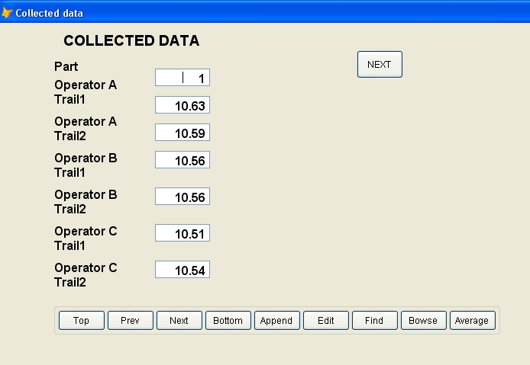

Fig.7

All measured data, the average range for each operator, the overall average range (for all operators and parts) and the Control limit on the individual ranges are presented in figure 8.
The repeatability, reproducibility and part variability calculus depends of a quantity d2. The choice of this factor and the value of repeatability (equipment variation) are shown in figure 9.

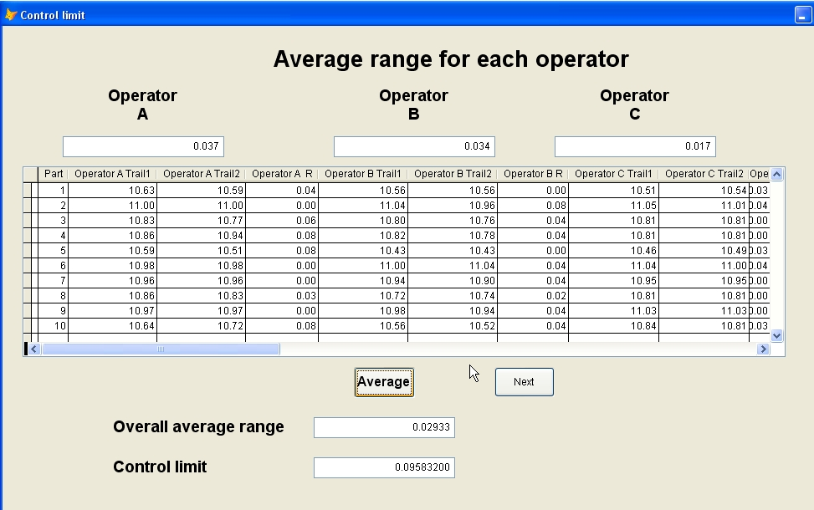

Fig.8

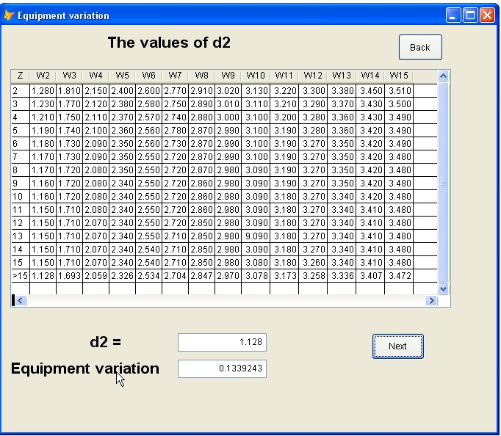

Fig.9

After the calculus of control limit, we see that all range values fall below this limit and, therefore, no assignable causes of variation are suspected.
Repeatability is computed using the overall average range (for all operators and all parts) using the factor d2 (1,128), that is found in figure 9, with z = 30 (10 parts multiplied by 3 appraisers) and w = 2 (2 trials).
To compute reproducibility (fig.10), the average of the range between the appraiser with the smallest average reading (appraiser B in our example) and the appraiser with the largest average reading (appraiser A) was needed and also the factor d2 (1,91), using z = 1 and w = 3 (3 appraisers).
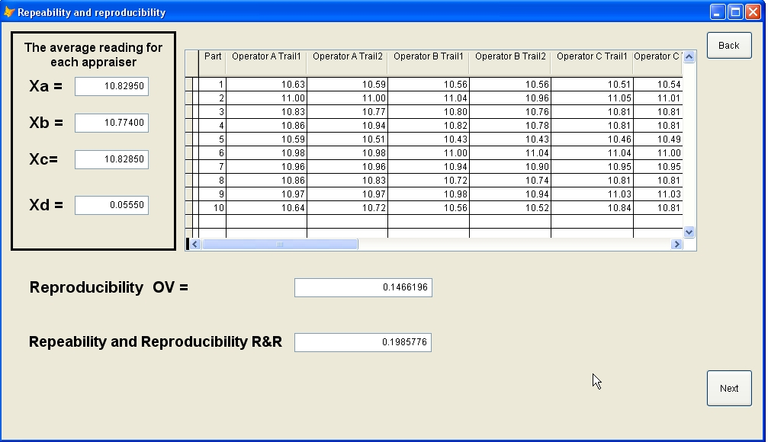
Fig.10

The part variability was computed using the difference between the largest and smallest part measurement, where the average is taken for all parts and appraisers and the factor d2 (3,18) using z = 1 and w = 10 (10 parts).
Repeatability and reproducibility were expressed as a percent of process (total) variation, TV and the result is shown in figure 11. When the whole analysis was made, we can evaluate the results. Because, R&R is between 10% and 30%, the measuring system is marginally acceptable, based on the importance of the application, cost of the measuring tool, cost of repair and so on.

4 Conclusion
Measurement systems are used every day in manufacturing, research and development, sales and marketing. Characteristics that are measured include distances, temperatures, strengths, sales, hardness, sweetness, electrical resistance, frequency, viscosity just to name a few.
When we base decisions on production data, the accuracy of that data is critical. If our gages are giving inaccurate readings or if our measurement system has too much variation, it will affect our ability to make the right decision. Knowing when to calibrate gages or how to conduct an R&R study is essential.

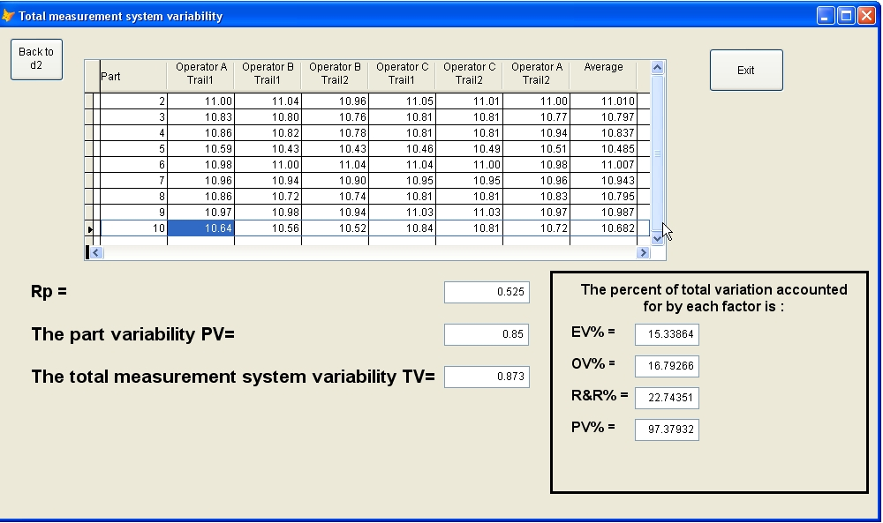

Fig.11

Usually, to assess any measurement system, companies use R&R studies. For this reason, in our paper we point out only this part of the developed software and we explained how it works.
This MSA Software is an interactive, training system designed to help our students to conduct measurement system studies including bias, linearity, stability, repeatability, and reproducibility. In addition, computer-based training requires 40-60% less training time than traditional classroom training, that means more time for practical activities and supplementary information.
Performing MSA and looking at the measurement systems with our eyes open, drives any organisation from the “inspection” mentality towards the “process assurance” mentality.

References:
- Automotive Industry Action Group, AIAG, Measurement Systems Analysis Reference Manual, Detroit-Michigan, USA, 2002.
- R. Agrawal, S. Chaudhuri, V.R. Narasayya, Automated Selection of Materialized Views and Indexes in SQL Databases, Proceedings of the VLDB Conference, 2000.
- G. Alvarez, K. Keeton, A. Merchant, E. Riedel, J.Wilkes, Storage Systems Management, Tutorial, Proceedings of the SIGMETRICS Conference, 2000.
- Engineering Statistics Handbook, found at http://www.itl.nist.gov/div898/Handbook.
- J. Hoffer, Modern Database Management, 6th Edition, Prescott & McFadden, 2002.
- B. Jepson, Object-Oriented Apps in a Relational Database, CMP Media LLC, 2002.
- J. G. Lazur, Measurement System Analysis, General Motors Publication, 1985.
- N. Leawitt, Whatever Happened to Obect-Oriented Databases, Lee Garber Inc, Los Alamitos, 2000.
- Measurement System Analysis, found at http://yeivier.20m.com/statistics/MSA/MSA.html
- Measurement Assurance Repeatabilily & Reproducibility, found at http://www.qualitycouncil.com/repeatab.asp
- Measurement System Analysis–MSA, found at http://www.6sigma.us/MeasurementSystemsMSA
- D. Shasha, P. Bonnet, Database Tuning, Principles, Experiments, and Troubleshooting Techniques, Morgan Kaufmann, 2002.
- M. Stonebraker, M. Brown, Object-Relational DBMSs: Tracking the next great Wave, Morgan Kaufmann, 1999.

