Wireless multimedia coding and transport layers

Zoran BojkoviC⁽¹⁾, DRAGORAD MILOVANOVIC⁽²⁾

⁽¹⁾Faculty of Transport and Traffic Engineering, University of Belgrade,
Vojvode Stepe 305, 11000 Belgrade

⁽²⁾ Faculty of Electrical Engineering, University of Belgrade,
Bulevar Revolucije 73, 11120 Belgrade, Serbia and Montenegro
http://galeb.etf.bg.ac.yu/~dragorad

Abstract:- Wireless multimedia delivery faces several challenges, such as high error rate, bandwidth variation and limitation, battery power limitation. Intrinsic issues in wireless video delivery are compression efficiency, power dissipation and error control. This makes the latest international standard H.264 or MPEG-4 Part 10 Advanced Video Coding a prime candidate for the use in wireless systems. In addition, error resilience is an important issue, since mobile networks generally cannot guarantee error-free communication during fading periods. Our layered survey is based on compression and coding efficiency, performance versus complexity, error resilience and end-to-end quality of service.

Key-words: multimedia communications, H.264/AVC, error resilience, QoS

1 Introduction
The first generation (1G) cellular network was an analog circuit-switched system. Voice quality was poor and security non-existent. Second generation (2G) networks improved on the disadvantages and provided additional data services like short message service (SMS). Today, people want to have continuous high quality services. Hence, they need a functioning mobile infrastructure capable of handling high amounts of data [1]. Unfortunately, mobile standards can be used to transfer data at very limited speed (2G networks). 2.5G generation is an intermediate step toward third generation (3G), utilizing Internet protocols and packet switching in portions of the cellular network. Unlike 3G, the 2.5G network is not Internet to the core. The third generation (3G) offers better data transfer capabilities, but its speed is still insufficient for many desired applications like videoconferencing. The step to be taken in order to arrive to the goal of the fourth generation (4G) is called beyond 3G (B3G). In other words, B3G is also known as heterogeneous systems and networks together, while 4G is a new air interface. Path to beyond 3G and 4G is shown in Figure 1. 4G networks are a step beyond 3G, providing data transmission speed equivalent to a local area network [2].
Figure 1. Targets of mobile communication systems beyond 3G.
In its latest specifications of Universal Mobile Telecommunications System (UMTS) networks, the Third Generation Partnership Project (3GPP) defines a new domain called the IP Multimedia Subsystem (IMS) that operates now and highly expected IP communication services. To transport UMTS services through Internet Protocol (IP) networks without loosing end-to-end quality of service (QoS) provisioning, it is crucial to define a consistent and efficient QoS mapping scheme between UMTS services and IPQoS classes [3].
In general, the available bandwidth and therefore the bit rate over the radio link are limited and the costs for a user are expected to be proportional to the reserved bit rate or the number of transmitted bits over the radio link. Thus, low bit rates are likely to be typical, and the compression efficiency is the main requirements for a video coding standard to be successful in a mobile environment. This makes the latest international standard known as H.264 or MPEG-4 Part 10 Advanced Video Coding (H.264/AVC) a prime candidate for the use in wireless systems, because of its superior compression efficiency [4]. Requirements for this standard arise from the various video applications that it aims at supporting like video streaming, video conferences over fixed and wireless networks and over different transport protocols.
2 H.264/AVC coding layer
The most essential requirement for wireless video is coding efficiency. The main features for significantly increased coding efficiency are multiframe compensation, generalized B-pictures, quartel-pel motion accuracy, intra coding utilizing prediction in the spatial domain, in-loop deblocking filters, and efficient entropy-coding methods. The normative part of a video coding standard in general only consists of the appropriate definition of the order and semantics of the syntax elements and the decoding of error-free bit streams. This allows a significant flexibility at the encoder, which can, on the one hand, be exploited for pevie compression efficiency, and on the other hand, several included features in the standard can be selected by the encoder for other purposes, such as error resilience, random access, and so on.
Modern video communication uses digital video that is captured from a camera or synchronized using appropriate tools like animation software. In an optional pre-processing step, the sender might choose to preprocess the video using format conversion or enhancement techniques. Then the encoder encodes the video and represents the video as a bit stream. Generalized block diagram of a hybrid video encoder with motion compensation is shown in Figure 2. The adaptive deblocking filter and intra-frame prediction are two new tools of H.264. After transmission of the bit stream over a communication network, the decoder decodes the video which gets displayed after an optional post-processing step which might include format conversion, filtering to suppress coding artifacts, error concealment, or video enhancement.
The input image us divided into macroblocks. A macroblock consists of one block of 16x16 pixels for the luminance component and two blocks of 8x8x pixels for the color components. These macroblock are coded in intra and inter mode. In inter mode, a macroblock is predicted using motion compensation. For motion compensated prediction, a displacement vector estimated and transmitted for each motion data (block) that refers to the corresponding position of its image signal in an already transmitted reference image stored in memory. In intra mode, former standards set the prediction signal to zero such that the image can be coded without reference to previously sent information. This is important to provide for error resilience and for entry points into the bit streams enabling random access. The prediction error, which is the difference between the original and the predicted block is transformed, quantized and entropy coded. In order to reconstruct the same image on the decoder side, the quantized coefficients are inverse transformed and added to the prediction signal. The result is the reconstructed macroblock that is also available at the decoder side. This macroblock is stored in a memory.
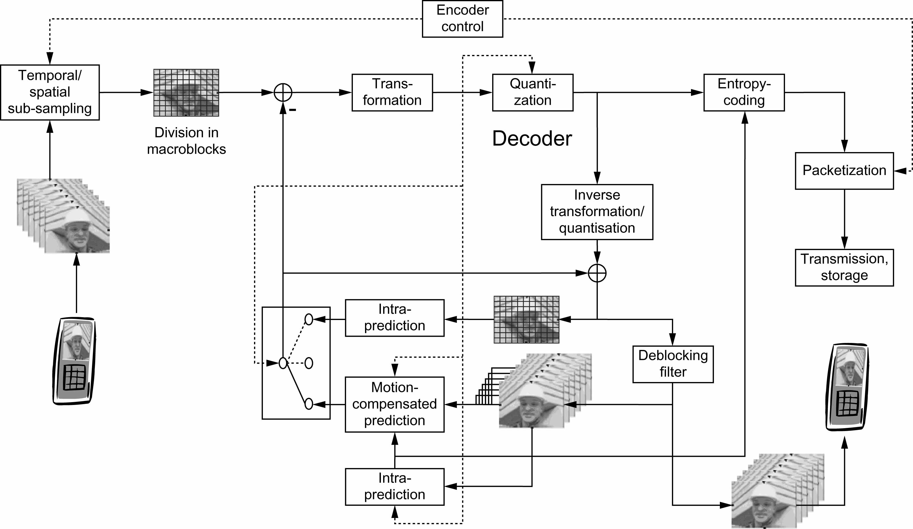
Figure 2. Coding options for H.264/AVC hybrid video encoder.
With respect to standard hybrid video encoders, H.264/AVC introduces the following changes:
- In order to reduce the blocking-artifacts an adaptive deblocking filter is used in the prediction loop.
- H.264/AVC allows storing multiple video frames in the memory.
- In H.264/AVC a prediction scheme is used also in intra mode that uses the image signal of already transmitted macroblock of the same image in order to predict the block to code.
The entropy decoder, decodes the quantized coefficients and the motion data, which is used for the motion compensated prediction. As in the encoder, a prediction signal is obtained by intra-frame or motion compensated prediction, which is added to the inverse transformed coefficients. After deblocking filtering, the macroblock is completely decoded and stored in the memory for further predictions. In H.264/AVC, the mecroblock are processed in so called slices whereas a slice is usually a group of macroblocks processed in raster scan order.
For efficient transmission in different environments not only coding efficiency is relevant, but also the seamless and easy integration of the coded video into all current and future protocol and network architectures. This includes the public Internet with best-effort delivery, as well as wireless networks expected to be a major application for the new video coding standard. The adaptation of the coded video representation or bitstream to different transport networks was defined in the systems specification in the previous MPEG standards or separate standards like H.320 or H.324. The close integration of network adaptation and video coding can bring the best possible performance of a video communication system.
Therefore, H.264 consists of two layers as shown in Figure 4, where this standard is presented in a transport environment. The network abstraction layer interface enables a seamless integration with stream and packet-oriented transport layers [6].
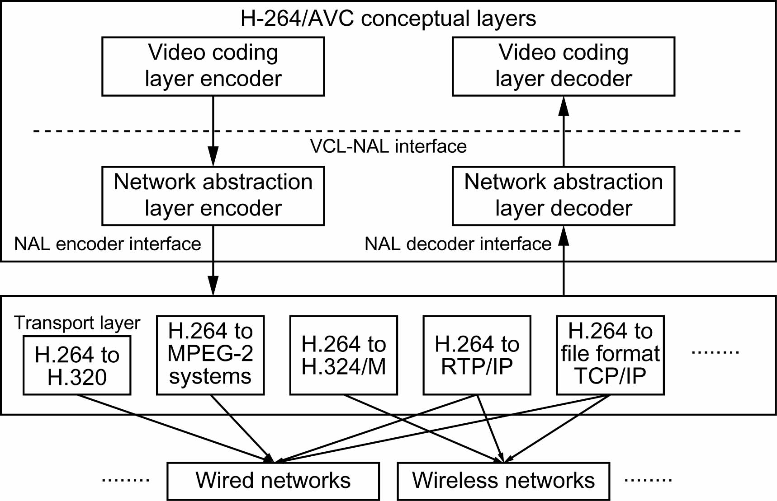
Figure 4. H.264/AVC in a transport environment.
The video coding layer (VCL) defines the efficient representation of the video, and the network adaptation layer (NAL) converts the VCL representation into a format suitable for specific transport layers or storage media. For circuit-switched transport, the NAL delivers the coded video as an ordered stream of bytes containing start codes such that these transport layers and the decoder can robustly and simply identify the structure of the bit stream. For packet switched networks, like RTP/IP or TCP/IP, the NAL delivers the coded video in packets without these start codes. NAL units give support for the packet-based approach in most existing networks. At the NAL decoder interface, it is assumed that the NAL units are delivered in decoding order and the packets are either received correctly, are lost, or an error flag in the NAL unit header can be raised if the payload contains bit errors. The latter feature is not part of the standard as the flag can be used for different purposes. However, it provides a way to signal an error indication through the entire network. It should be noted that interface specifications are required for different transport protocols that will be specified by the responsible standardization bodies.
3 Transport layer
Third Generation Partner Ship Project (3GPP) has standardized three types of visual content delivery services and technologies: circuit-switched multimedia telephony, transparent end-to-end packet-switched streaming, and multimedia messaging service (MMS).
The 3G-324M standard was developed for circuit-switched multimedia telephony service – visual phone. It is applied to speech and video codecs, the communication control unit, and the multimedia multiplexing unit. The video codec requires the H.263 baseline as an essential capability and recommends MPEG-4 support. 3G-324M defines a minimum essential codec to ensure interconnection between different terminals. For error resilience, multimedia multiplexing functionality is enhanced in this standard. The multiplexer also provides transmission service according to the type of information, such as QoS and framing.
Media streaming is based on a packet switch connection, whereas a combination of Internet Engineering Task Force (IETF) standards such as real-time transport protocol (RTP) will be used over mobile networks [7]. Packet-based streaming services (PSS) are required whenever instant access to multimedia information must be integrated into an interactive media application, so that a Web server can work with requests for information, deliver that particular information as best as possible, complete the transaction, disconnect, and go on to other requests. A client connects to a Web server only when it needs information. A 3GPP standard, transparent, end-to-end PSS (3GPP PSS) has been specified to fulfill these conditions. Media transport technologies should differ for each type of wireless link. For real-time video conferencing over the circuit-switched network, we use 3G-324M for the error control. H.223 is a very sophisticated multiplexing scheme for bit errors, but it cannot be used for packet streaming in which packet loss is a problem. Streaming services are allowed to have somewhat more latency, while real-time video conferencing has a strict latency constraint such as 200 ms. Among the error control fundamentals, synchronization and error detection are solved by underlying transport-layer protocol stack such as Real-Time Transport Protocol / User Datagram Protocol (RTP/UDP). Foreword Error Correction (FEC), ARQ, data duplication and other techniques such as data interleaving and unequal error-resilience packetization are relevant in some ways to packet-loss resilience [8]. Real-time media streams that use RTP are, to some degree, resilience against packet losses. RTP provides all the necessary mechanisms to restore the ordering and timing that are present at the sender in order to properly reproduce a media stream at the recipient. RTP also provides continuous feedback about the overall reception quality from all receivers, thereby allowing a sender in the midterm to adopt its coding scheme and transmission behavior to the observed network QoS. To give a packet-based streaming server finer error control, an extension of Real Time Control Protocol (RTCP) has been standardized and is now being adopted to the 3GPP PSS [9]. All necessary protocols underlying media adaptation are included in 3GPP PSS and the emerging IETF standards.
In multimedia messaging service (MMS), multimedia content is delivered to the user asynchronously by means of a message. Late in the 2004 year, mobile picture mail services including MMS have proved a major hit in recent mobile markets. The picture mail service allows users to transmit still images from compatible mobile phones with built-in digital cameras to virtually any device capable of receiving e-mail. The media types specified in MMS are text, adaptive multirate (AMR) for speech, MPEG-4 Advanced Audio Coding (AAC) for audio, JPEG for still images, portable network graphics (PNG) for bitmaps graphics, H.263 and MPEG-4 for video, and scalable vector graphics (SVG). The major technical issues in MMS are compression efficiency and multimedia content file format. The file format specified by the MMS standard has the 3GPP file extension and is based on the ISO media file format. A 3GPP file can contain multiple media types but supports only one video track and one audio track for simplicity of implementation. The 3GPP standard-based file format is now being also used for content download service. The download method can use the file format for the distribution of media clips. To minimize an initial playback latency, the file format also supports progressive download, which allows a terminal to start playback before the file is fully download. To do this, the media tracks must be interleaved properly within the file, so that the client receives short portions of each media type in turn. Here, the download method requires a reliable communication protocol between the multimedia information distribution server and a terminal, even though some transmission delay may be tolerable. Communication procedures that meet this requirements include Hypertext Transport Protocol (HTTP) on TCP/IP which is used widely over the Internet.
Due to like transmission and decoding, streaming application involve more technical challenges that MMS. Usually, pre-encoded data is requested by the user, which inherently does not allow an adaptation to the transmission conditions such as bit rate or error rate in he encoding process. However, the receiver usually buffers the received data and starts play-back after a few seconds. Once starting playback, a continuous presentation of the sequence should be guaranteed. As wireless channels usually show ergodic behavior within a window of a few seconds, reliable transmission schemes can be applied on the link layer, especially when the channel is known at the transmitter or retransmission for erroneous link layer packets [10]. Slow variance due to distance, shadowing, or varying multiuser topology in the supported cell with renewed resource allocation transform the wireless channels in a slowly varying variable bit rate channel.

3.1 Error resilience
H.264/AVC standard is based on hybrid video coding and is similar to MPEG-4, but with new coding technologies like multimode and multireference motion compensation, fine motion vector precision, B-frame prediction weighting, 4x4 integer transform, multimode intraprediciton, in-loop deblocking filter, uniform variable length coding (VLC), network abstraction layer (NAL), switching picture slices, etc. Let us focus on the error-resilience of H.264/AVC standard which consists of two layers: video coding layer (VCL) and network abstraction layer (NAL) as it was previously stated.
Unlike MPEG-4, NAL separates the H.264 source coder tasks from error-resilience tasks, such as data partitioning. Also, the H.264/AVC error-resilience structure is based on the assumption that bit-erroneous packet have been discarded by the receiver. The error-resilience structure has been designed mainly for packet-loss environments. This design concept is valid since Internet protocols are currently widely used structure NAL (see Figure 4), create robustness with over a variety of network environments.
The introduction of NAL is a major advance from the MPEG-4 error-resilience structure. The NAL unit syntax structure allows greater customization of the method of carrying the video content to the transport layer. A typical example is packetization payload. The H.264/AVC NAL structure together with underlying transport technologies such as RTP can support most of the packet-loss resilience schemes. As for the error-resilience tools introduced in H.264/AVC, slice interleaving enabled by flexible macroblock ordering (FMO) and arbitrary slice ordering (ASO) is one of key features. There is some evidence that handling of the FMO may complete the implementation of the decoder buffer management. Benefits are providing only in the case that slices are randomly and moderately lost.

3.2 Wireless video delivery technologies
There are four layers of wireless video delivery technologies: source coder layer, error-resilience tools and network adaptation layer, the end-to-end transport layer and the layer-1/2 transport [12]. Functional block diagram for wireless video communication is shown in Figure 5.
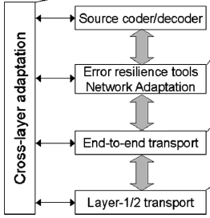
Figure 5. Block scheme for wireless video communication [12].
Cross-layer adaptation includes bit-rate/error-resilience adaptation as well as joint source-channel optimization. Recently, cross-layer optimization become of interest. One such approach is called joint source-channel coding. Here, two distortion measures i.e. quantization error introduced in source coding and channel distortion caused by channel errors are modeled associated with coding rate, channel errors and concealment redundancy. Rate distortion RD optimization scheme is applied over these measures.
Error resilience tools and network adaptation layer comprises data partitioning, resynchronizatio process, marker, header extension, flexible macroblock ordering (FMO) and arbitrary slice ordering (ASO) in H.264/AVC as well as redundant frame. Error resilience is an important issue, since mobile networks generally cannot guarantee error-free communication during fading periods. Emerging mobile network quality of service will have a large variation of bandwidth and delay. Data partitioning can reduce visual artifacts resulting from packet losses, especially if prioritization or unequal error protection is provided by the network. In general any kind of forward error protection in combination with interleaving for packet lossy channels can be applied.
End-to-end transport layer such as TCP/IP, contains: packet level forward error correction (FEC), end-to-end retransmission, unequal error protection.
Layer-1/2 transport tends to provide two distinct conditions: one quasi-error free, in which upper layer error control technologies show a limited improvement. Second is with a burst of errors during the fading period in which the adaptability of error control is essential.
Compression efficiency, power dissipation and error control are intrinsic issues in wireless video delivery. The four mentioned layers of wireless video delivery are among these issues. It should be noted that layer-1/2 transport tends to provide two distinct conditions: quasi-error-free and burst errors during fading periods. In the former condition, upper layer error control technologies have a limited role. When considering these role, extraordinary adaptability of error control to the latter condition is essential.

3.3 End-to-end QoS
The next generation wireless networks such as fourth generation (4G) cellular systems are targeted at supporting various applications such as voice, data and multimedia over packet-switched networks. Providing quality of service (QoS) guarantees for these applications is an important objective in the design of the next generation wireless networks.
Providing end-to-end QoS support is essential for video delivery over the next generation wireless Internet. Generally speaking, there are two approaches in QoS support: the network centric and the end-system centric solutions. The fundamental problem in a network-centric solution is how to map QoS criterion at different layers, respectively, and optimize total quality across these layers. The key targets in end-system centric approach are network adaptation and media adaptation.
In order to support various types of services, 3GPP defines four QoS classes: conversational, streaming, interactive, and background [3]. The QoS class used for each service type is determined by network operators. Delay-sensitive services including circuit-switched service and VoIP are assigned to the conversation class, packet-streaming services requiring a certain bit-rate guarantee, are assigned to the streaming class, and best-effort and delay-insensitive services such as Web browsing and messaging are in the interactive class or the background class. QoS class assignment is initiated by the terminal. The terminal requests the network layer to set up network layer bearers. In GPRS and wide-band code division multiple access W-CDMA packet networks, this process is called Packet Data Protocol (PDP) context activation. According to the 3GPP QoS model, different terminal applications may request differentiated QoS from the network according to the application needs, assuming that the network supports the QoS class.

4 Concluding remarks
The emerging mobile networks will have the characteristics like large bandwidth and delay variations, error conditions and burst error state. In large bandwidth and delay variation, layer-1/2 transport results in large variations of round trip time (RTT), jitter and bandwidth, while trying to keep error rate constant. There are some exceptions such as W-CDMA circuit switch connections, if a constant bandwidth with low latency is required. From these characteristics it can be concluded that the essential error control features are extraordinary adaptability to burst error state and rate control on the two state error prone environment.
The questions often arise are how to efficiently detect the state transition from quasi-no-error to severe-error and how to adapt the delivery system to the change over heterogeneous radio access networks. For error recovery and concealment in the burst error state, the essential element is rate adaptation to introduce data redundancy. The next question is extraordinary adaptability which requires a combination of capabilities such as feedback-based control and error concealment. For such adaptive error recovery, it will be promising to control the error at the transport layer or below, where the source coder information is mapped to the underlying packet control. This is due to the system scalability.
Also, future work must take into account that the H.264/AVC standard provides gains in compression efficiency of up to 50% over a wide range of bit rates and video resolutions compared to previous standards. As for the decoder, its complexity is about four times that of MPEG-2 and two times that of MPEG-4 Visual Simple Profile.
References:
[1] K.R.Rao, Z.S.Bojkovic, D.A.Milovanovic, Introduction to multimedia communications: applications, middleware, networking, Wiley 2005.
[2] S.Y.Hui, K.H.Yeung, Challenges in the migration to 4G mobile systems, IEEE Commun. Magazine, vol.41, no.12, Dec. 2003, pp.54-59.
[3] 3GPP, Universal Mobile Telecommunication System (UMTS): QoS concepts and architectures, TS23.107V6, March 2004.
[4] T.Weigand, H.Schwarz, A.Joch, F.Kassentini, G.J.Sullivan, Rate-constraint coder control and comparison of video coding standards, IEEE Trans. CSVT, vol.13, no.7, July 2003, pp.688-703.
[5] K.R.Rao, P.Yip, Discrete cosine transform: algorithms, advantages, applications, New York: Academic Press, 1990.
[6] T.Stockhammer, M.M.Hannuksela, T.Wiegand, H.264/AVC in wireless environments, IEEE Trans. CSVT, vol.13, no.7, July 2003, pp.657-673.
[7] H.Schulzinne, S.Cesner, R.Frederick, V.Jacobson, RTP: a transport protocol for real-time applications, IETF, RFC3550, July 2003.
[8] T.Stockhammer, H.Jenkac, C.Weiss, Feedback and error protection strategies for wireless progressive video transmission, IEEE Trans. CSVT, vol.12, no.6, June 2002, pp.465-482.
[9] T.Friedman, R.Caceras, A.Clark, RTP control protocol extended reports (RTCP XR), IETF, RFC 3611, Nov. 2003.
[10] J.Ribas-Corbera, P.A.Chan, S.Regumathan, A generalized hypothetical reference decoder for H.264/AVC, IEEE Trans. CSVT, vol.13, July 2003, pp.560-576.
[11] T.Wiegand, G.Sullivan, G.Bjontegard, A.Luthra, Overview of the H.264/AVC video coding standard, IEEE Trans. CSVT, vol.13, no.7, July 2003, pp.560-576.
[12] M.Etoh and T.Yoshimura, Advances in wireless video delivery, Proc. of the IEEE, vol.93, no.1, Jan. 2005, pp.111-122.

