Three-Dimensional Technique for Automatic Brain Segmentation of the Ventricles Based on Optimal Histogram Thresholds of MRI

DANMARY SANCHEZ*, MALEK ADJOUADI *, BYRON BERNAL #, NOLAN ALTMAN #
*Department of Electrical and Computer Engineering, Florida International University
10555 W. Flagler Street, EAS 2220, Miami, FL 33174
#Department of Radiology, Miami Children’s Hospital, 3100 S.W. 62nd Avenue, Miami, FL 33155
UNITED STATES OF AMERICA
http://cate.fiu.edu/

Abstract: The segmentation technique presented in this paper is part of ongoing research work to develop a new imaging and segmentation technique to generate a three-dimensional structure of the brain in order to enhance the visualization of brain fiber tracts in diffusion tensor images using developmental software by Phillips. The visualization enhancement will be achieved by displaying the 3D brain structure as a semi-transparent image, such that key anatomical landmarks, as well as the mathematically constructed fiber tracts, may be observed within the brain. This paper describes the development and implementation of task-oriented techniques for automatic brain segmentation to locate and display the lateral ventricles within the brain structure in order to support the 3D rendering as landmarks in the complete 3D structure. With an automatic segmentation technique, the software will calculate and discern the different regions in the brain without ad-hoc interventions. This is a difficult task because the brain structure is different from one patient to the next, in addition to the fact that the data to be analyzed is from patients who may already have brain abnormalities. Ten T1-weighted 3D Gradient Echo MR images obtained from patients at Miami Children’s Hospital (MCH) were used for the development of this technique.

Key-Words: Brain segmentation, Ventricles, Histogram threshold

1 Introduction
The challenge in displaying the anatomical structure of the brain as a three dimensional figure is to observe certain anatomical landmarks as they course through the 3D structure. This is critical to understand the position of fiber tracts in diffusion tensor imaging (DTI). Such is the rationale in developing a simple yet effective segmentation algorithm to extract and display anatomical landmarks within the 3D brain structure.
DTI relates image intensities to the relative mobility of endogenous tissue water molecules. It provides a unique and significant tool for demonstrating and assessing neural connectivity in living brain tissue, researching and diagnosing white-matter disorders, and investigating developing brain structures and brain functional mapping.
The display of the brain image as a semi-transparent, three-dimensional structure will facilitate the analysis of DTI images so that neurosurgeons, neuroscientists, and radiologists will be able to better discern the localization of the fiber tracts within the anatomical structure of the brain as well as any malformation that a patient may have. This image segmentation software as conceived will hence be used in the medical setting as a tool for pre-surgical procedures and for enhanced analysis of patients that are identified as candidates for neurosurgery.

  - Historical Overview
A limited number of fiber-tracking software are available either commercially or as free developmental sources provided to research settings. These are used at different hospitals for brain research and pre-surgical evaluation. One of the most widely used fiber-tracking software available is Philips Research Integrated Development Environment (PRIDE) developed by Phillips Medical Systems. A drawback of this and other fiber tracking software is that they only allow visualization of the brain as a set of three slices, in each orthogonal dimension (sagittal, coronal, and transverse), limiting the spatial connectivity of the fiber tracts. This limited representation of the brain hinders the work of medical staff & researchers in understanding the neuronal connectivity.
There are currently a number of methods which perform semi-automatic or interactive brain segmentation. However, the user must first select specific regions of the brain so the software can identify the position and size of the brain structure before performing the segmentation [1].
There are also techniques for automatic brain segmentation in the literature, with each technique focused on the specific characteristics of the structure(s) that it tries to extract from the brain. For example, in some studies it is only necessary to extract the white matter from the brain [2], [3], while in other studies several structures are extracted, such as the corpus callosum, ventricles, hippocampus, and caudate nuclei [4].
Histogram thresholding based on grayscale intensities of MR images has been used previously for automatic segmentation of brain images [1], [6], [7]. Different methods are used for selecting the threshold between the grayscale intensities to separate white matter, gray matter, and cerebrospinal fluid (CSF) in the image. These methods then go on to use other specific strategies, such as clustering algorithms or calibration techniques, to extract individual regions in the brain.

2 Segmentation Method
The segmentation technique proposed will be implemented using the Interactive Data Language (IDL) development environment, such that it is compatible with Phillips’ PRIDE to augment its capabilities and provide more complete 3D tractography. The 10 sets of MRI data used to implement and test the new software was provided by Miami Children's Hospital (MCH) with IRB approval. All of the images were skull-stripped using MRIcro [8], a standalone freeware program.
The algorithm developed to perform the task of brain segmentation consists of two main sections, first to determine the location of the ventricles within the brain in all orthogonal directions (coronal, sagittal, and transverse) and then to perform histogram thresholding in each dimension within a defined radius in order to extract the lateral ventricles. Both parts of the algorithm are based on the grayscale distribution of T1-weighted MR images and the fact that the CSF of the ventricular system is displayed with low grayscale values contrasted to the white matter of the brain.
The following notation is used in describing the dimensions of the data: x describes the sagittal dimension, moving left to right across each slice, from x = 0 to x = 256 (number of slices), y describes the coronal dimension, moving from anterior to posterior, from y = 0 to y = 256, and z describes the transverse dimension, moving from inferior to superior, such that z = 0 at the most inferior slice.

2.1 Automatic Search for Region of Lateral Ventricles
The automation of the brain segmentation technique requires finding the maximum radius of the ventricles within the brain in all directions (coronal, sagittal, and transverse) and masking out all data outside that radius. The geometry used as part of the search algorithm was selected based on existing clinical knowledge about the anatomy of the ventricles and their positioning within the brain.
The maximum length and width of the ventricles in the x and y directions was found by inspecting each transverse slice of the brain with MRIcro. The MRI data of all patients was inspected and the values were stored as a patient database. These values were used in calculating a rectangular area which is used as a filter to calculate the ‘height’ of the ventricles in the z (transverse) dimension by identifying the slices which contain pixels that are part of the lateral ventricles. The filtering area shifts from one slice to the next such that it may follow and envelope the general space in which the ventricles are expected to be positioned. The expected positioning of the ventricles in each slice was calculated from the patient’s database as the mean plus the average deviation across the data, where VAx is the range of the anterior ventricles in x, VPx is the range of the posterior ventricles in x, and Vy is the range of the ventricles in the y direction.
Fig. 1 displays the geometry of the rectangles used as the mapping filters. The search for the ventricles’ region begins at the bottom-most slice (ignoring those slices which don’t contain any brain image) with mapping using rectangle number 1 in fig. 1. The size of this first rectangle is VPx by $\text{Vy}2$. The size of the rectangle is shifted one slice at a time by a calculated step size in each direction, until it reaches the size of rectangle number 2 (VAx by $3\text{Vy}4$) to analyze the top-most slice.

VAx
VPx
Vy
1

2
Fig. 1 Geometry to search the region of the ventricles

The step size in each direction was calculated as:
$Δx=\frac{X_{d}}{n}$ (the step size in the x direction)
$Δy=\frac{Y_{d}}{n}$ (the step size in the y direction)

Where: n is the number of slices to inspect, $X_{d}=\frac{\text{VPx}−\text{VAx}}{2}$ is the total number of pixels to move in the x direction, and $Y_{d}=\frac{3\text{Vy}}{4}−\frac{\text{Vy}}{2}=\frac{\text{Vy}}{4}$ is the total number of pixels to move in the y direction.
With these values calculated, the following algorithm was designed based on statistical analysis of the distribution of grayscale values in each slice, to find the slices in the MRI that contain the lateral ventricles, i.e. to find the ‘height’ (z axis) of the ventricles in the image. That is,
- Find the slices in the MR image containing less than 80% (empirically selected) of background. These are the slices which contain valuable brain information and not just background information which is all black (grayscale value = 0).
- Initialize the size of the search rectangle to VPx by $\text{Vy}2$and the search position to the value obtained from the patient’s database (mean plus standard deviation of the position in x and y).
- For each slice selected in step (a), starting with the bottom slice, perform steps (d) and (e).
- Calculate and store the total of all grayscale values in the image within the search rectangle.
- Adjust the size of the search rectangle and its position in x and y according to the step size in each direction.
- Find the average value of all the totals calculated and the standard deviation across all slices.
- The slices containing a total of grayscale values within the average plus the standard deviation are those which contain the image of the ventricles.
After the region of the ventricles in all dimensions within the brain structure is known, it was possible to mask out all the data outside of this region before continuing onto the next segmentation step.

2.2 3-Dimensional Histogram Thresholding
Again using the lower grayscale values of the ventricles in the MR image, it was possible to extract the ventricles from the white matter in the image. The optimal thresholding technique was designed such as to find an optimal threshold for each slice. For each slice within the region of the ventricles, the following steps are performed,
    - Find the histogram with respect to the grayscale values of the slice
    - Divide each value of the histogram by the total sum of all values, to find the probability of each gray scale
    - Use the ‘Optimum Thresholding’ algorithm to find the optimum threshold in the histogram:
Let $P_{0}$be the probability of the darker pixels in a slice: $P_{0}=\sum_{i=1}^{θ}{P_{i}}$, and let $P_{1}$be the probability of lighter pixels in the slice: $P_{1}=\sum_{i=θ+1}^{L}{P_{i}}$, where L is the maximum number of gray levels in the slice. Let the mean of the gray levels in the slice be:$μ=\sum_{i=1}^{L}{{\text{iP}}_{i}}$, the mean of gray levels of the darker pixels be: $μ_{0}=\frac{\sum_{i=1}^{θ}{{\text{iP}}_{i}}}{P_{0}}$, and the mean of the gray levels of the lighter pixels be: $μ_{1}=\frac{\sum_{i=θ+1}^{L}{{\text{iP}}_{i}}}{P_{1}}$. The optimal threshold occurs when the separation between $μ_{0}$ and $μ_{1}$ is maximum. The interclass variance between the “lighter pixels” class and the “darker pixels” class is used as the measure of the distance between the two means and is given by: $V(θ)=P_{0}{\left[μ_{0}−μ\right]}^{2}+P_{1}{\left[μ_{1}−μ\right]}^{2}$. Hence, the optimal threshold is found when the variance is maximized: $θ=\overset{\hat{}}{θ}$ for$\text{max}\left\{V(θ)\right\}$.
    - Perform a binary mask on the slice to identify the darkest landmarks in the 3D brain image, which represent the ventricles: assign a value of ‘255’ (white) where the gray levels of the slice are less than the optimal threshold $\overset{\hat{}}{θ}$ and a value of ‘0’ (black) where the gray levels are greater than $\overset{\hat{}}{θ}$.

The algorithm described was applied for each dimension of the image separately, and the results obtained from each dimension were superimposed to render the complete structure of the ventricles. By applying the threshold algorithm to each dimension, it is possible to extract certain pixels in the image that belong to the ventricular structure but that may not have a significantly lower grayscale value as compared to the surrounding area in a slice.

- Results and Discussions
The developed segmentation algorithm was tested with T1 3D Gradient Echo images from 10 patients. Fig. 2, 3, and 4 display one slice in each dimension of the MRI of a patient, where the left image displays the reformatted MRI slice and the right image displays the extracted ventricular structure.

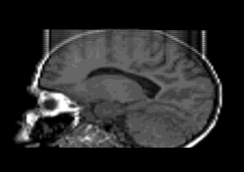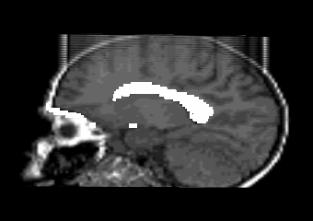
Fig. 2 Patient 1: Reformatted sagittal T1 slice (left), with segmented lateral ventricles in white (right)

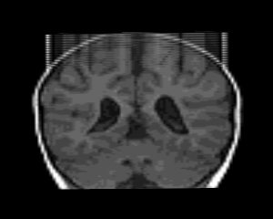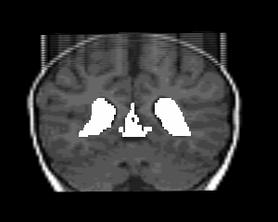
Fig. 3 Patient 1: Reformatted coronal T1 slice (left), with segmented ventricles in white (right)
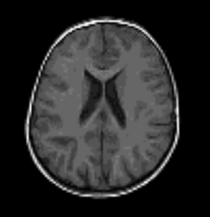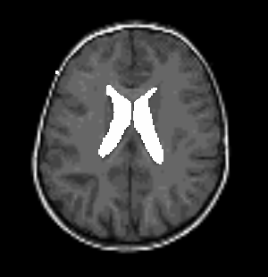
Fig. 4 Patient 1: Transverse T1 slice (left), with segmented ventricles in white (right)

The reconstructed 3D ventricular structure of the same patient, obtained from the superimposition of the extracted images in each dimension is shown in fig. 5. The image shown here was obtained after using a function LABEL_REGION provided by IDL, which labels all of the regions of the 3D image with a unique region index. The regions labeled by IDL were sorted according to the size of the region (i.e. the number of voxels belonging to each region) and all but the 3 largest regions were masked out, which include the background (all black voxels), the ventricles, and some additional noise.
An initial noise-reduction algorithm was developed, which finds the highest pixel connectivity within the regions found by IDL. Pixel connectivity was defined as the number of neighbors a pixel may have in each dimension. Once the total connectivity was calculated for all regions, those with values less than 10% of the highest connectivity value were masked out. This allowed for the removal of the maximum number of noisy regions from the main anatomical structures. The resulting 3D image of the ventricles is displayed in fig. 6. It may be noticed that the noise reduction algorithm was very effective for this image while enhancing the ventricular structure.
Using opacity and transparency settings provided by IDL, the 3D brain was displayed as a transparent structure so that the ventricles could be seen within the image, as shown in fig. 7. To achieve this, the original skull-stripped brain image was superimposed on the segmented image containing just the ventricles.

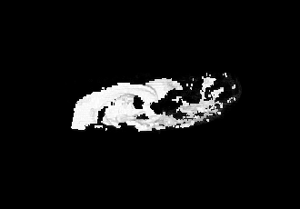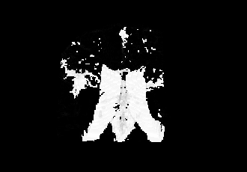
Fig. 5 Patient 1: Side and top views of 3D ventricles
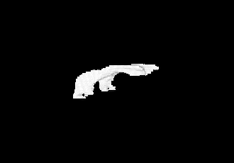
Fig. 6 Patient 1: Side and top views of 3D ventricles after noise reduction algorithm

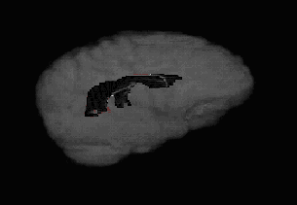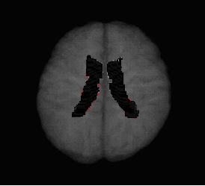
Fig. 7 Patient 1: Side and top views of 3D ventricles within semi-transparent 3D brain structure

The results obtained with the MRI of another patient are as follows: Fig. 8 displays the extracted region from a single sagittal slice in the 2nd patient and fig. 9 displays the region extracted from a single transverse slice in the same patient. It may be noticed that the algorithm did not extract the region with as much accuracy as with the first patient, mainly due to the low contrast of the MRI itself, in which the whole image is displayed with very low grayscale values. The reconstructed 3D ventricle structure is displayed in fig. 10, in which the additional noise may also be appreciated. After applying the initial noise reduction algorithm, the result was as shown in fig. 11. It may be noticed also in this image that the segmentation of the ventricle from this MRI was not very accurate, even after applying the noise reduction algorithm. The reconstructed 3D semi-transparent brain structure for patient 2 is displayed in fig. 12, in which the cranial view of the 3D ventricles obtained from the segmentation algorithm is observed.

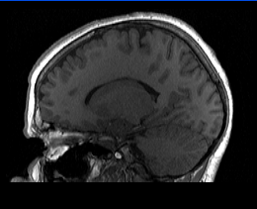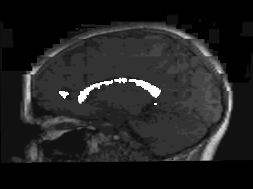
Fig. 8 Patient 2: Reformatted sagittal T1 slice (left), with segmented lateral ventricles in white (right)

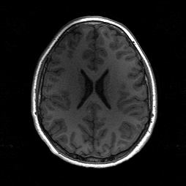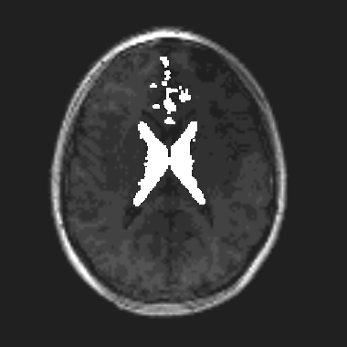
Fig. 9 Patient 2: Reformatted transverse T1 slice (left), with segmented ventricles in white (right)

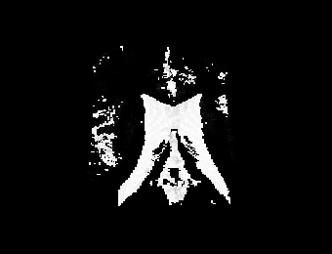
Fig. 10 Patient 2: Top view of 3D ventricles (left), after noise reduction algorithm (right)

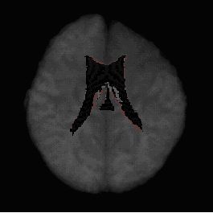
Fig. 12 Patient 2: Top view of 3D ventricles within semi-transparent 3D brain structure

- Conclusions
In this study we evaluated characterizing features of the brain ventricular structure to be applied towards a three-dimensional automatic segmentation algorithm of MR images. We translated the known anatomical structure of the ventricles into a geometrical arrangement to allow for the automatic selection of the region in the brain in which the ventricles are located. Furthermore, we used the grayscale characteristics of the ventricles in the T1-weighted MRI and histogram thresholding to extract and display the ventricles in the brain.
Future work in this area includes further development of algorithms to eliminate noise in the images. This noise is mainly obtained from incorrect selection of certain pixels in the image as part of the ventricular structure. Our goal is to use these methods in DTI and co register 3D anatomical brain structures with fiber tracts. The enhanced software will be applied in the medical setting at MCH for research involving 3D location of the tracts in neurological conditions.

- Acknowledgements
This research was supported by National Science Foundation Grants EIA-9906600, HRD-0317692, CNS 042615, and Office of Naval Research Grant N00014-99-1-0952. Phillips Medical Systems is also acknowledged for having provided the source code for PRIDE FiberTracking V4 software.

References:
- Falcao, A.X., Bergo, F.P.., Interactive volume segmentation with differential image foresting transforms, IEEE Transactions on Medical Imaging, Vol. 23, No. 9, 2004, pp. 1100-1108.
- Mangin, J.F., Coulon, O., and Frouin, V., Robust Brain Segmentation Using Histogram Scale-Space Analysis and Mathematical Morphology, Medical Image Computing and Computer-Assisted Intervention (MICCAI'98), LNCS-1496, 1998, pp. 1230-1241.
- Duncan, J.S., Papademetris, X., Yang, J., Jackowski, M., Zeng, X., Staib, L.H.., Geometric strategies for neuroanatomic analysis from MRI, Neuroimage, Vol. 23, Suppl 1, 2004, pp. S34-45.
- Pitiot, A., Delingette, H., Thompson, P.M., Ayache, N., Expert knowledge-guided segmentation system for brain MRI, NeuroImage, Vol. 23, 2004, pp. S85-S96.
- Schnack, H.G., Hulshoff Pol, H.E., Baare, W.F., Staal, W.G., Viergever, M.A., Kahn, R.S., Automated Separation of Gray and White Matter from MR Images of the Human Brain, Neuroimage, Vol. 13, No. 1, 2001, pp. 230-237.
- Otsu, N., A threshold selection method from gray-evel histograms, IEEE Transactions on Systems, Man, and Cybernetics, Vol. 9, 1979, pp. 62-66.
- Momenan, R., Hommer, D., Rawlings, R., Ruttimann, U., Kerich, M., Rio, D., Intensity-adaptive segmentation of single-echo T1-weighted magnetic resonance images, Human Brain Mapping, Vol. 5, 1997, pp. 194–205.
- Rorden, C., Brett, M., Stereotaxic display of brain lesions, Behavioural Neurology, Vol. 12, 2000, pp. 191-200.
- Altman, N.R., Altman, D.H., Wolfe, S.A., Morrison, G., Three-dimensional CT reformation in children, American Journal of Roentgenology, Vol. 146, No. 6, 1986, pp.1261-1267.
- Schnack, H.G., Hulshoff, H.E., Baare, W.F., Viergever, M.A., Kahn, R.S., Automatic segmentation of the ventricular system from MR images of the human brain, Neuroimage, Vol. 14, 2001, pp. 95-104.
- Bondiau, P.Y., Malandain, G., Chanalet, S., Marcy, P.Y., Habrand, J.L., Fauchon, F., Paquis, P., Courdi, A., Commowick, O., Rutten, I., Ayache, N., Atlas-based automatic segmentation of MR images: validation study on the brainstem in radiotherapy context, International Journal of Radiation, Oncology, Biology, and Physics, Vol. 61, No. 1, 2005, pp. 289-98.
- Wismuller, A., Vietze, F., Behrends, J., Meyer-Baese, A., Reiser, M., Ritter, H., Fully automated biomedical image segmentation by self-organized model adaptation, Neural Networks, Vol. 17 No. 8-9, 2004, pp. 1327-1344.
- Fischl, B., Salat, D.H., van der Kouwe, A.J., Makris, N., Segonne, F., Quinn, B.T., Dale, A.M., Sequence-independent segmentation of magnetic resonance images, Neuroimage, Vol. 23, Suppl 1, 2004, pp. S69-84.
- Chen, S., Zhang, D., Robust image segmentation using FCM with spatial constraints based on new kernel-induced distance measure, IEEE Transactions on Systems, Man, and Cybernetics – Part B: Cybernetics, Vol. 34, No. 4, 2004, pp. 1907-16.
- Lukas, C., Hahn, H.K., Bellenberg, B., Rexilius, J., Schmid, G., Schimrigk, S.K., Przuntek, H., Koster, O., Peitgen, H.O., Sensitivity and reproducibility of a new fast 3D segmentation technique for clinical MR-based brain volumetry in multiple sclerosis, Neuroradiology, Vol. 46, No. 11, 2004, pp. 906-915.
- Li, W., Tian, J., Li, E., Dai, J., Robust unsupervised segmentation of infarct lesion from diffusion tensor MR images using multiscale statistical classification and partial volume voxel reclassification, Neuroimage, Vol. 23, No. 4, 2004, pp. 1507-18.

