Simulation Framework for Cyber Terrors and Defense

Jaehyuk Lee, Seungkyu Park, Gihyun Jung, Kyunghee Choi
Graduate School of Information and Communication Science
Ajou University
Paldal B/D 908-1B, Ajou Univ. WonChon Dong YoungTong Koo
Suwon, South Korea
http://cemulti.ajou.ac.kr

Abstract: - It is almost impossible to see how worm viruses like CodeRed or Bagle influence real networks and how effectively the defense techniques work. In the cases, simulation is a reasonable and useful alternative. In this paper, we propose a network and security simulation framework built on SSFNet and SSF. The proposed framework allows to model very large networks in an easy way and to run Java applets that mimic real cyber terrors. The framework also allows simulating security policies of firewalls and intrusion detection systems. In order to check the usability and the feasibility of the proposed framework, we per-form a simulation with Java applets, called actors, that mimic worm viruses and are spread on a modeled network with 1,750 computers. We analyze and compare the behaviors of worms on the network with or without firewalls.

Key-Words: - Framework, Simulation, Cyber Terror, Intrusion Detection, Cyber Defense.

1 Introduction
Sharing information across numerous distributed sites on the rapidly growing Internet has seriously threatened the security of cyber information and the privacy of users who utilize the in-formation. The threat has forced network managers to introduce the safeguards into their net-works. The demand in network safeguard has increased and complicated as more hackers, crack-ers, intruders or security violators, or cyber terrorists have emerged. To effectively react to or defense the threat, it is inevitable to acquire the strong theoretical background or a test bed to see how such threat actually damages cyber properties. However, there are no clear research progresses on the issues. It is mainly due to the large scale of modern network, lack of theoretical foundation on intrusion and defense, complexity and diversity of network intrusion and defense, and shortage of information on cyber terrors.

One of the best ways to develop the safeguard techniques against cyber terrors is to run the actual tools used for attacking or intruding real networks and to get sufficient information on phenomena occurred in the networks during the attacks. However, it is impossible and illegal to test the tools or to experiment cyber terrors in real networks.

As alternatives, many attacking simulation techniques are widely used. Many authors pro-posed a network intrusion decision technique using vulnerability database or packet load. But very few researches proposed the simulation model on the recent intrusion methods like worm virus and evaluated the effects on real networks. The lack of researches results from the fact that it is nearly impossible to analyze network behavior when real cyber terrors are under way in large scale networks. Even though it is possible to relatively accurately figure out the attack effect in small networks, the result cannot be scaled up to those of large networks and thus it is very hard to estimate their real effect in large scale networks.

The observation leads us to design and implement a simulation framework that is useful to simulate cyber terrors and security policies in large scale networks. The proposed framework built on SSFNet(Scalable Simulation Framework Net) and SSF(Scalable Simulation Frame-work)[2] has several very unique features, compared with other cyber terror simulation frame-works. It provides a feature to build large scale cyber Internet world suitable for simulation. Large networks are modeled by Graphical User Interface and the systems in the modeled net-works behave as real computer systems. They have their own File Management Systems, called Simulated File System, making it possible for hackers or virus to create files, to copy files from one host to another, to build backdoors, or to load or replicate programs that can run at any time. Furthermore, the attacking programs like worm virus are created with Java applets, providing great flexibility in simulation.

The related works are surveyed into section two. In section three, we present the architecture of framework and its components. In section 4, the proposed model of simulation scenario and a simulation result are described. The last section concludes the paper.

2 Related Work
Many cyber terror models such as the formal network intrusion model have been published. Most of them are based on the relations among host models, intrusion sequences and the collaborations between them. For example, “A Framework for an Information Warfare Simulation” by US Military Academy [7] describes an intrusion model as a collection of hosts, their OS versions, services, service versions and domain names like host information. And an intrusion scenario is characterized as a collection of vulnerabilities and vulnerable conditions in the framework. With simulation, a way to defense an attack can be found and the cost to implement the defense way is calculated. However, the model does not support a dynamic structure through which the defense strategy can be modified as a simulation is progressed.
The authors of [3] extended OPNET simulation to analyze network behavior during the Dosnuke intrusion is performed. The experimentation with OPNET shows how a firewall can reduce the damage by Dosnuke intrusion and shows an example of network intrusion presentations. However, since it represents the result by only packet driven Dosnuke intrusion simulation, it is not suitable for simulating various types of cyber terrors and the defense activities.
Mitre’s CVE(Common Vulnerabilities and Exposures) [4] and NIST(National Institute of Standards and Technology’s) ICAT [5] proposed their own unique ways to represent vulnerabilities and attacks against the Internet. However, they don’t specify the relation between cyber attacks and vulnerabilities. Thus they are not suitable for cyber attack modeling either.
The previously published attack modeling techniques may be classified in two categories: graph based modeling and tree based modeling. The modeling techniques have a lot of useful features to describe system security test, network vulnerability test, or firewall rule set, etc. However, they have limitations to describe the behavior of cyber terrors in detail. Furthermore it is very hard for the techniques to describe the delegate behaviors of cyber terrors that change dynamically. This observation leads us to design a new method for attack modeling based on SSFNeT.
SSFNet(Scalable Simulation Framework Net) is one of the most famous simulation frame-works built on SSF (Scalable Simulation Framework), which is a simulation kernel based on the concept of Process-based Discrete Event. SSFNet allows to simulate a large scale network pro-viding various network objects coded in Java such as routers, links and network interface cards. However, since SSFNet doesn’t support any components like firewall or IDS (Intrusion Detection System), we implement the modules.

3 Simulation Framework Architecture
The proposed simulation framework consists of two parts: graphical user interface and simulation engine. The user interface module is run on MS Windows and the simulation engine run on Linux. Fig 1 illustrates the architecture of proposed simulation framework.
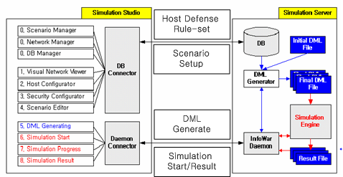
Fig 1. The architecture of proposed simulation framework

3.1 Graphical user interface

The user interface helps users build network topologies, create simulation scenarios, monitor the simulation status including the simulation stimulus and simulation outcome, start, pose and terminate simulation. It keeps displaying the state change and intermediate outcomes of simulation. User may create a network topology by dragging-and-dropping provided component objects with ease. All network topologies that users create and save as user-defined templates in the database are reusable. The templates help users configure large scale networks. The properties of objects, such as bandwidth, filtering rules, error rates, or operating systems, may be specified also.

3.2 Simulation Engine
The Simulation engine is built in Java and implanted into SSFNet. It is run on a Linux machine and orchestrates simulation. Fig 2 illustrates the architecture of engine that is consisted of six modules as follows.
Fig 2. The architecture of simulation engine
Coordinator | Host | Actor | SFS | DML Generator
 |  |  | Service Applets
SSFNet
SSF
Java Machine
Linux

3.2.1 Coordinator
The Coordinator is the main module of engine. It initializes and terminates simulation, issues start and stop commands to all object components, and communicates with the GUI running on MS Windows to receive commands and to send the output of simulation.

3.2.2 Actor
Actors are Java applets performing and simulating application programs or attack programs such as worm virus, port scanners, daemons like ftpd or telnetd in real life, or other independent pro-grams. Each actor is consisted of at least three modules: precondition(), action() and post-condition(). precondition() module checks whether the condition that an actor requires is satisfied or not. If the condition is satisfied, then action() module, the main body of actor, is executed, otherwise the actor is not executed and the associated error signal is sent to the coordinator. Since the module includes the unique functionalities of each actor, each actor is mainly characterized by action() module. post-condition() module produces the output of executing the actor. The output is saved in the SFS (Simulated File System) of host on which the actor has been executed. The saved records (outputs) reflect the new state of the actor or the host on which the actor was executed. For example, if an actor that creates a backdoor is executed on a host, then some information created by the hacker actor will be stored in the host’s SFS and may be used later. All actors use the information stored in SFS such as IP, protocol, or Socket that host supports.

3.2.3 Host
A Host is a virtual node that emulates a real computer. Each host in network has its own OS, network states, firewall-rule set, application programs, etc. A host may also communicate with other hosts by establishing TCP or UDP socket connections. During simulation, Executor module, the core of host, executes or terminates actors dynamically. All properties of hosts are initialized by client, stored in its SFS, and used at the time that the simulation commences. How-ever, a host can change its initial properties and save them in its SFS during simulation. Once the properties are changed, the behavior of host may change, and all actors running on other hosts operate based on the changed properties.

3.2.4 SFS (Simulated File System)
To each host, a SFS is created. It simulates the file system of host. It is used to save the data that the executors of each host use and that all actors running on hosts use. With virtue of executor and SFS, host may create actors dynamically during simulation, and the information of host can be dynamically adapted to simulation. SFS supports several functions like open, close, read, write and seek. The data to be stored in SFS are actually saved in a relational database implemented with three relational tables: fs_map table that saves the mapping information of host’s identifier and its file system identifier, file table for the information of hosts like id, OS, net-work address, user names, their passwords, service programs and the simulation scenario, and file_log table for the information of SFS, and saves the changed states of SFS when a simulation terminates.

3.2.4 Extended Service, and DML Generator
For simulation, the proposed framework also provides several well-known Internet services such as telnet, FTP, Web Servers, DNS, Database Service, and security services such as Firewall and IDS. The executor of each host reads the information of host from its SFS, confirms whether a required service has been defined, and then creates actors that emulate the service if defined. The DML generator translates graphical network topology into DML language. DML file specifies objects in network and their properties. We separate specifying the properties of host and actors. The separation increases the reusability of network topology, reproducibility of simulation result and interactivity.

4 Modeling and Simulating Attack Scenario
We model attack scenario as tree structure. Each node in an attack tree is linked to an actor. Actors are called by the executer of host object and executed dynamically. Two types of actors may be created in attack scenario tree: operational node (actor) and general node. Operational node is used to control the execution flow of attack scenario. There are three operational node types: SequentialAND, SequentialOR, and PaallelAND. SequentialAND operational node exe-cutes actors linked to its immediate children nodes one by one until all children terminate their executions or one of them fails. SequentialOR operational node randomly selects one of its immediate children nodes and then executes it. PaallelAND operational node executes all immediate children nodes in parallel.
General nodes are the actors that perform their own unique actions. The implemented general nodes include actors to simulate network scanning, port scanning, OS identification, Sapphire worm, telnet, ftp, Web client, and Web server, etc.

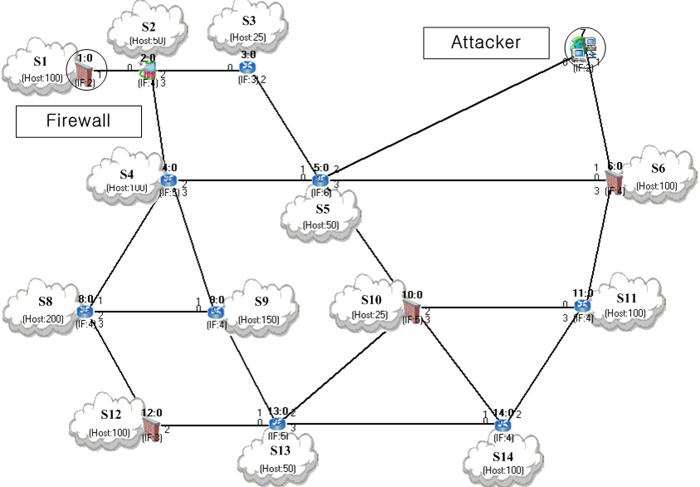
Fig 3. Simulation network

We simulated the proposed simulation framework. Fig 3 shows the network in which the simulation is performed. The network consists of 1750 hosts (a cloud denotes a subnet segment including about 25~100 hosts) and 22 routers interconnect the subnets. An intruder uses a computer in a subnet. According to the generated simulation scenario, a Sapphire worm virus in the attacker’s computer tries to spread its duplicates to all other hosts in the network, and they send DNS query packets.
A Java applet mimics the worm. The DNS queries generated by the worm generate an overload to DNS servers and eventually change to a DDoS attack. The simulation shows that most of hosts among 1,750 hosts are infected after 30,000 seconds, when no firewalls are installed or firewalls have no rule sets to protect the hosts from the attack.
Fig 4 shows the number of DNS queries generated by the worm when the firewalls do not include the proper rule sets. It demonstrates how the worm is propagated in the network.
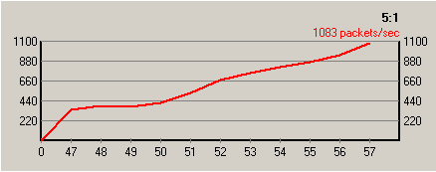
Fig 4. DNS queries generated by worms

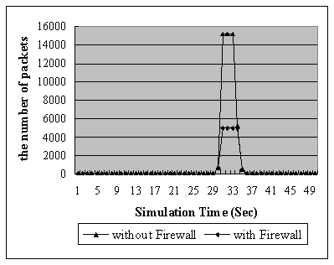
Fig 5. DDoS Simulation Result

Fig 5 shows the results of simulating a DDoS (Distributed Denial of Services) attack. The DDoS simulation shows that the firewall drops packets if the number of received packets exceeds the maximum packet number a server can accept. In real world, DDoS generates numerous network traffics during a short term. Since we set the number 5000, packets after 5,000 received packets are dropped as shown in Fig 5.

5 Conclusion
In this paper, we proposed a simulation framework built on SSFNet, by which a large scale network can be modeled and simulated. To verify the feasibility of the framework, we created a large network model and performed an attack scenario. The main feature to outline the proposed frame work, compared with other frameworks is its dynamic behavior. It allows changing the state of network configuration and defense policies during simulation. To make the proposed framework more accurate and feasible, we are developing a more delicate way to build configuration, more actors with accurate characteristics. We also have a plan to make the proposed framework be able to operate in distributed environment.

References:
[1] Baldonado, M., Chang, C.-C.K., Gravano, L., Paepcke, A.: The Stanford Digital Library Metadata Architecture. Int. J. Digit. Libr. 1 (1997) 108–121
[2] “SSF Simulator implementation”, http://www.ssfnet.org/ssfImplementations.html.
[3] Shabana Razak, Mian Zhou, Sheau-Dong Lang, “Network Intrusion Simulation Using OPNET”, OPNETWORK Proceedings 2002.
[4] Mitre’s CVE(Common Vulnerabilities and Exposures)”, The MITRE Corporation,
http://www.cve.mitre.org/
[5] “NIST(National Institute of Standards and echnology’s) ICAT” , http://icat.nist.gov/icat.cfm
[6] T.Tidwell, R. Larson, K. Fitch and J. Hale, "Modeling Internet Attacks", Proceedings of the 2001 IEEE Workshop on Information Assurance and Security United States Military Acad-emy, West Point, NY, 5-6 June, 2001.
[7] Donald Welch, Greg Conti, "A Framework for an Information Warfare Simulation", Proceed-ings of the 2001 IEEE Workshop on Information Assurance and Security, United States Military Academy, West Point, NY, 5-6 June, 2001.
[8] Laura Painton Swiler, Synthia Philips, Timothy Gaylor, “A graph based network vulnerabil-ity analysis system”, Proceedings of the 1998 workshop on New security paradigms, p.71-79, September 22-26.
[9] Jan Steffan, Markus Schumacher “Collaborative Attack Modeling”, 17th ACM Sym-posium on Applied Computing (SAC 2002), Special Track on Computer Security, Madrid, Spain, March 10-14, 2002.
[9] Andrew P. Moore Robert J. Ellison Richard C. Linger, “Attack Modeling for Information Security and Survivability”, March 2001 Survivable Systems Unlimited distribution subject to the copyright Technical Note CMU/SEI-2001-TN-00] The software Engineering.
[10] Alok R. Chaturvedi, Mukul Gupta, Shailendra Raj Mehta, and Wei T. Yue, “Agent-Based Simulation Approach to Information Warfare in the SEAS Environment” , Proceedings of the 33rd Hawaii Interna-tional Conference on System Sciences – 2000.
[11] S.Jha, O. Sheyner, J. Wing, “Two Formal Analyses of Attack Graphs”, Proceedings of the 15th IEEE Computer Security Foundations Workshop (CSFW’02).
[12] V Gorodetski, I Kotenko and O Karsaev, “Multi-agent technologies for computer network security: attack simulation, intrusion detection and intrusion detection learning”, Proceedings of the Comput Syst Sci & Eng (2003) 4: 191–11, 4, July, 2003.
[13] Arno Wagner, Thomas Dübendorfer, “Simulation-Based Analysis of Internet Worm Characteristics”, Institut für Technische Informatik und Kommunikationsnetze Mar 5, 2003
[14] Boleslaw K.Szymanski, Qiuju Gu, and Yu Liu, “Time-Network Partitioning for Large-Scale Parallel Network Simulation under SSFNet”, Proceedings of Applied Telecommunication Symposium, SCS Press, San Diego, April 2002

