Parallel Synchronization Algorithms for Concurrent Data Warehouse Maintenance under Schema Changes

J. AKAICHI
Computer Science Department
ISG - University of Tunis
41, Avenue de la Liberté
Cité Bouchoucha
Le Bardo 2000
TUNISIA

Abstract: - The data warehouse systems are built by gathering data from information sources (IS) and integrating them in one deposit personalized according to the user needs. One of the significant tasks of a data warehouse management system is to update materialized views after IS data changes. In fact, due to their autonomy, participating information sources in a distributed environment can change continuously not only contents but also their schema or model which may render an important number of view definitions undefined. Standing on the EVE (Evolved View Environment) project, we propose a solution called view synchronization which is able to tackle the above problem. The proposal is to design a distributed system based on multi-agent theory able to synchronize view definitions affected by concurrent schema changes. Our solution is modeled using an extended UML, called M-UML, taking into account mobile agents’ representation, interaction and functioning. The proposed solution permits not only a clear design allowing system evolving and comprehension, but also to decrease the maintenance process time, to avoid network saturation and to increase data warehouse maintenance system components availability.

Key-Words: - Data Warehouse, Maintenance, Schema changes, Mobile Agents, M-UML.

1 Introduction
The data warehouse systems [1] are built by gathering data from information sources and integrating them into one personalized deposit according to user needs. One of the significant tasks of a Data Warehouse Management System (DWMS) is to update the materialized views during the changes of information sources data.
Moreover, beyond the updates of data, we note that the changes of schema are also rather frequent in the modern applications such as web applications, distributed databases, etc. A change of schema could occur for many reasons and at any time during participating information sources life cycle.
In fact, the information sources in such environments can change continuously not only contents but also their schemas which may render view definitions built among data warehouse undefined. As our knowledge, EVE project [3] was the only work that has tackled the view synchronization problem and proposed a solution for view definitions inflexibility. This solution has the goal to preserve the maximum number of view definitions instead of being completely bewildered with each information source schema change, while allowing implicitly view materialization.
In former work, the view redefinition or rewriting was explicitly performed manually by Data Warehouse developers, until EVE system proposes a prototype solution to automate view definitions rewriting thanks to Meta knowledge about information space formed by information sources, to Meta knowledge about user space constituted by evolving view definitions, and view synchronization algorithms [6].
Adding to that, the increase in user demand of a quick reach of a distributed information large volume, the more autonomy requirements, and the need to avoid network saturation and to minimize communication costs have led to the adoption of the new rising techniques such as mobile agents, resulting from research in distributed artificial intelligence, to solve several problems such as data warehouse maintenance.
Obviously, after presenting the view synchronization problem and EVE solution, our work is to design a distributed system which is based on multi-agents principles to ensure the data warehouse maintenance under schema changes.
We also modeled our approach for well simplifying the comprehension of our solution and system evolution with M-UML methodology [4] which is an extended UML language covering all the agent mobilities aspects on all UML diagrams levels.

2 View Synchronization Problem
The EVE approach [3] proposes a solution to solve the problem of view inflexibility. This solution has the goal to preserve the maximum number of affected view definitions by the occurrence of information sources schema changes, allowing implicitly the view definition evolving which is, in former work, carried out by the developers. The EVE approach assumes that information sources are integrated in the EVE system via a wrapper which translates their models into a relational common model. They are supposed to be heterogeneous and autonomous which join, or change dynamically their capabilities such as their schema.

2.1 EVE contributions
EVE system includes two basic modeling tools: a model permitting to user to express view definition evolution via an extended SQL called Evolvable SQL (E-SQL) [3] and a model for the description of the information sources (MISD) [3] and the relationships between them. This model of ISs description can be exploited for seeking a suitable substitution for the affected view definition components (attributes, relations, and conditions). The View Knowledge Base (VKB) described by E-SQL and the Meta Knowledge Base (MKB) revealed by MISD, represent the base for any operation of view rewriting or view synchronization process.

2.2 The Meta Knowledge Base
The DWMS constitutes an intermediary between the user space called Data Warehouse and the information space including the participating data sources. When an information source joins the structure the DWMS, it provides its structure, its data model and eventually its content. This information is stored into the MKB with respect to the MISD.
As well, the relationships between information sources, also called substitution rules, can be added by the DWMS administrator and/or generated automatically, then inserted into the MKB. This information constitutes the key platform for finding affected view definitions components substitutions.

2.3 The View Knowledge Base
Another contribution of EVE approach is to propose an E-SQL language allowing user preferences placing into SQL view definition. E-SQL is an extension of SELECT-FROM-WHERE SQL enriched by specifications defined by the developer in charge of the view definitions in order to indicate how those latter can evolved.
The E-SQL defined views are then stored into are stored into a structure called View Knowledge Base.

2.4 The view synchronization
The view synchronization [3] consists in determining legal rewritings for the affected views, referring to the rules or constraints embodied into the MKB. These rules enable substitutions retrieval for the affected view definition components while respecting preference parameters described into the VKB.
The view rewriting is legal when it is compatible with the current information space. This rewriting have to preserve the information presented by the initial view definition according to preferences parameters associated to the view definition components and the possibilities of substitutions offered by the MISD.

3 From EVE to AgentEVE
Our proposed model based on EVE is enhanced by mobile agent concepts and M-UML modeling tools to evolve to AgentEVE system whose architecture is distributed on five entities: the Server Agent, the Detector Agent, MKB Agent, VKB Agent and the View Synchronizer Agent. Communication between agents [5] can be ensured either by message sending by agent migration. In our model communication will be guaranteed by the traditional message sending. In fact, all the agents of the model know each other directly via their identifier, names and sites. Thus, any agent of the system can communicate directly with any other agent.

3.1 The Server Agent
The Server Agent is in the centre of the DWMS. It has the role of initializing the system and managing Detector, MKB, VKB and View Synchronizer Agents.
In fact, the Server Agent supervises the correct functioning of all the other agents’ instances deciding on their creation, suspension and ending allowing coordination and synchronization between them. In other words it plays the role of the manager of all the AgentEVE system. When the system is triggered, the Server Agent starts by creating the various agents of the model.

3.2 The Detector Agent
The Detector Agent is a mobile agent implemented into each distributed information source. It is responsible of the detection of the changes which have occurred on the level of the structures of the participating information source to the system. Indeed, it starts to traverse all the sites lodging the information sources with an aim to detect a change by comparing the schema of the source at moment t and at moment t-1 to check if there’s an unstipulated change. Its mission consists in, transmitting any schema change occurred in the information source, to the centre of the system called Agent Server.
The following algorithm shows the work of the Detector Agent.

Algorithm 1 AgentDetector
Begin
While True Do
// SC: Information source component.
// IS_List: Information source components list.
For Each SC IN IS_List Do
Begin
// DeltaS: the Schema component change.
DeltaS<- SC_{t} – SC_{t-1};
If DeltaS != ∅ Then
SendMessage(DeltaS,AgentServer);
Endif
Endfor;
Endwhile;
End.

3.3 The MKB Agent
MKB Agent has a role to process the data received from the Server Agent. This latter agent transmits to it the any schema changes (DeltaS) occurred into any information source. The DeltaS data structure encapsulates too main fields: the affected component (attribute, relation, condition) and the operation nature made upon it (delete, rename, and add).
After that, MKB Agent analyses the Meta Knowledge Base in order to detect the whole unit of affected knowledge or rules to send them to the View Synchronizer Agent in order to determine view rewritings.
It is significant also to note that the View Synchronizer Agent would not have to analyze all the rules stored into MKB, but rather on a subset of them including the affected view definition component.

3.4 The VKB Agent
VKB Agent has the role of detecting the subset of views definitions affected by occurred schema changes. In fact, following the changes reception VKB Agent checks within the VKB to determine the set of views definitions which contain one or more component affected by the changes.
After that, the VKB Agent transmits the result, composed by the affected views definitions, to the View Synchronizer Agent in order to perform the synchronization phase.
It is important also to note that the View Synchronizer Agent would not have to analyze all the views definitions stored into VKB, but somewhat on a subset of them including the affected view definition component.

3.5 The View Synchronizer Agent
After the reception of the affected rules from the MKB Agent and the affected views definition from the VKB Agent, the View Synchronizer Agent starts to check if it is possible to determine a legal rewritings for the affected views in order to create new views definitions compatibles with the current state of the information space. For that, it refers to the users preferences expressed using the E-SQL.
We remind that the View Synchronizer Agent would not have to analyze all the views definitions stored into the VKB, nor the all the rules embodied into the MKB, but relatively on a subset of them where any schema change is present.
When the synchronization process is well done, the View Synchronizer Agent transmits its results to MKB Agent and VKB Agent in order to update the MKB rules and the VKB view definitions, according to the new information space state.

4 M-UML Diagrams
To illustrate the maintenance process of the AgentEVE approach, we present in the following some of the M-UML diagrams [4]: use case diagram, sequence diagram, and collaboration diagram. M-UML is an extended UML language which covers all the aspects of agent mobility.

4.1 The use case diagram
The use case diagram illustrates the system tasks and actors. Our system presents three use cases: the change detection at the information sources level, the view synchronization and the updates of the MKB and the VKB (see Figure 1).

4.2 The sequence diagram
The sequence diagram illustrates the interactions between the system agents throughout their life cycle. The interaction between two agents located on the same platform level is represented by <<localized>> which is the case of the Server Agent and MKB Agent, for example. However, the communication between agents being in various platforms is represented by a square containing the (R) letter which wants to say "Remote". In the case of our model, the Detector Agent communicates in "Remote" mode with the Server Agent while making him transmit the modifications to the information sources space (see figure 2).

4.3 The collaboration diagram
The collaboration diagram illustrates the interaction between agents by representing the exchange messages sequence. It represents the interaction between the system agents by their working order through all their life cycle (see figure 3).

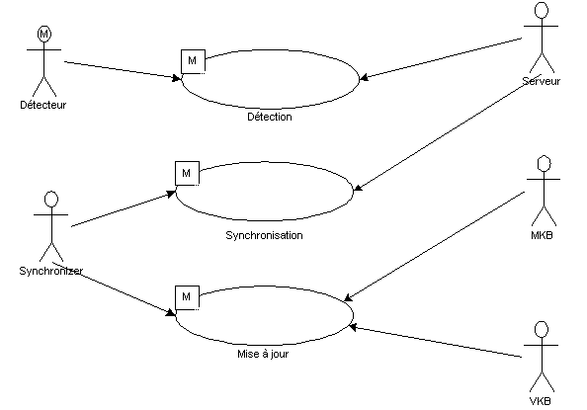
Figure 1: The use case diagram

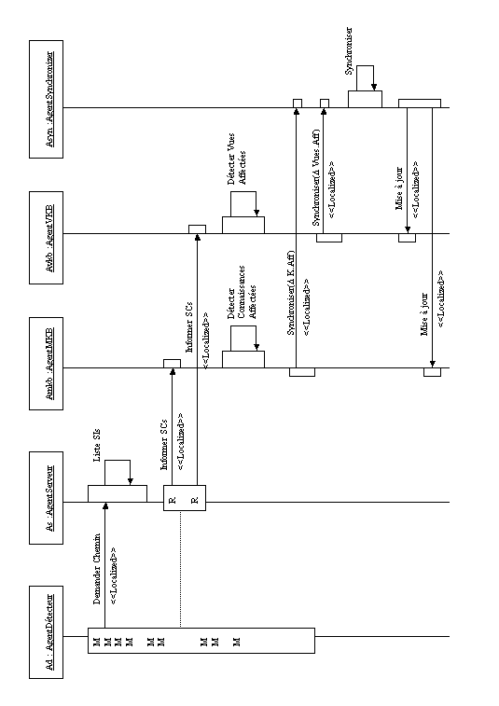
Figure 2: The sequence diagram

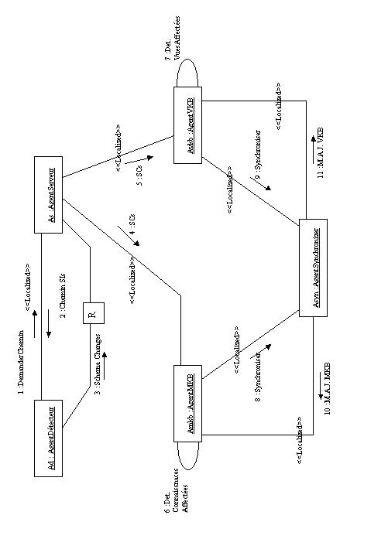
Figure 3: The collaboration diagram
5 Conclusion
In this paper, we presented a model called AgentEVE witch proved the feasibility of marrying mobile agent concepts, M-UML and the Data Warehouse Maintenance Systems under schema changes. We also showed that the synchronization process performance can be improved by reducing the MKB and the VKB data to be taken into account for finding view definitions’ rewritings. Adding to that the DWMS gained much in autonomy and absence of saturation thanks to mobile agents, in performance thanks to parallelism, and in evolving possibilities thanks to M-UML design.

References:
- A. Gupta, I.S. Mumick. Maintenance of Materialized Views: Problems, Techniques, and Applications, IEEE Data Engineering Bulletin, 1995.
- A. J. Lee, A. Nica, and E. A. Rundensteiner. Keeping Virtual Information Resources Up and Running. In Proceedings of IBM Centre for Advanced Studies Conference CASCON 97, Best paper Award, pages 1-14 , November 1997.
- E. A. Rundensteiner, A. J. Lee and A. Nica. The EVE Framework: View Evolution in an Evolving Environment, Technical Report WPICS-TR-97-4, Worcester Polytechnic Institute, Dept. of Computer Science, 1997.
- K. Saleh, C. El-Morr, M-UML: an extension to UML for the modeling of mobile agent-based software systems, Information and Software Technology, 46, pages 219–227, 2004.
- B. Chaib-draa, I. Jarras et B. Moulin, Systèmes multiagents : Principes généraux et applications, « Agent et systèmes multiagents», Hermès, 2001.
- A. J. Lee, A. Nica, and E. A. Rundensteiner. The EVE Framework: View Evolution in an Evolving Environment. Technical Report WPICSTR974, Worcester Polytechnic Institute, Dept. of Computer Science, 1997.

