A comparison on accuracy of numerical methods: an application to a varying mass system based on Wavelet Transform

VINCENZO NIOLA¹, ROSARIO OLIVIERO², GIUSEPPE QUAREMBA²

¹Department of Mechanical Engineering for Energetics
University of Naples “Federico II”
Via Claudio 21, 80125, Napoli
ITALY

²University of Naples “Federico II”
Via S. Pansini 5, 80131, Napoli
ITALY

Abstract: - In this paper we studied the motion of an oscillating mechanical system in presence of a varying mass. In particular, our study pointed out the smoothness of the mass trajectory, numerically calculated. The comparison analysis was performed by applying the wavelet transform to the response of mass trajectory calculated by means of several numerical methods such as finite difference schemes. Furthermore, the study involved the response obtained by superimposing several anomalies to the decreasing law of the mass. In order to put in evidence the presence of such anomalies (i.e., spikes) during the oscillating motion, we processed the numerical response by means of wavelet transform. The most adequate methods seem to be Runge-Kutta and Adams corrector-predictor.

Key-Words: - Wavelet analysis, numerical analysis, finite-difference methods, varying mass systems.

- Introduction
In the classical literature, many studies focused on the variable mass systems (e.g. see [1]). In order to simulate the motion of such systems, when the motion law assumes a complex form, we must take into account the numerical solution.
On the other side, the Continuous Wavelet Transform (CWT) represents a time-scale analysis of the smoothness of a signal, real or simulated. For instance, in order to test the smoothness (i.e., the regularity of motion) of a well-designed cam profile composed of circular arc subsets, the authors proposed this methodology [2].
In this paper, we used the CWT to investigate the motion regularity of an oscillating mechanical system, whose mass is decreasing, performed by means of numerical methods.
In particular, we show that, if the varying mass law is linear, the accuracy of the trajectory, calculated by means Milne’s predictor-corrector method, shows a lower order with respect to the details of the trajectories calculated by other methods. Furthermore, when the varying mass law includes some anomalies (e.g., spikes), the corresponding trajectory details, calculated by Milne’s method, does not exactly reveal the position of such an anomaly over a determined value order. From this point of view, numerical methods based on finite-difference scheme, such as Runge-Kutta and Adams corrector-predictor, seem to be more adequate.

2 The model
Let us consider an oscillating system whose mass at time t is m(t). Let v₀ be the vector representing the velocity of the system with respect to the expulsed mass. Furthermore, let v(t) be the vector representing the velocity of the system with respect to a fixed axis. The motion law equation assumes the form

$$F=m(t)\frac{dv}{\text{dt}}−v_{0}\frac{\text{dm}(t)}{\text{dt}}$$

For simplicity, suppose that the fraction of mass, lost by the system, is expulsed in a direction orthogonal to the verse of oscillation and suppose that at t = 0 the mass is not in the equilibrium position. In this case then the motion law assumes the form:

$m(t)\frac{d^{2}x}{\text{dt}}=−\text{kx}$ (1)

with x(0) = x₀ and $\overset{˙}{x}$(0) = v₀, assigned.
Now consider the varying mass law as follows:

$m(t)=1−a\left(x−b\left({\left|x−3\text{.}5\right|}^{0\text{.}2}+3\text{.}5^{0\text{.}2}\right)\right)$.

When 0 < a < 1 and b = 0, m(t) corresponds to a decreasing linear form of varying mass law. In general, it generates an anomaly (spike) superimposed to a decreasing linear trajectory (see Fig.1).

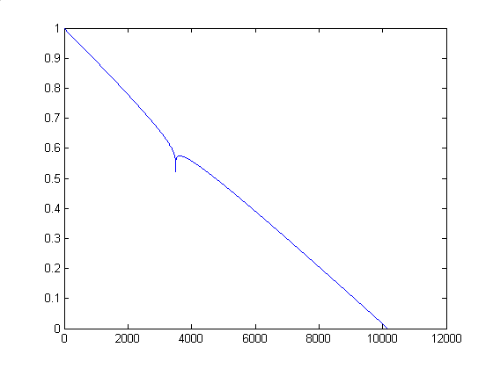
Fig.1. General varying mass law. The parameter values are a = 0.1 and b = 1.

- Introduction to the Continuous Wavelet Transform
Recall that a mother wavelet ψ is a function of zero h^{th} moment (e.g. see [3], [4], [5], [6]):

$\int_{−∞}^{+∞}{x^{h}ψ(x)\text{dx}=0}$, h ∈ N (2)

From this definition, it follows that, if ψ is a wavelet whose all moments are zero, also the function ψ_{ik}(x): = 2 ^{j/2} ψ(2 ^{j}x − k) is a wavelet.
Now consider a wavelet ψ and a function φ such that {{$ϕ_{j_{0}k}$}, {ψ_{jk}}, k ∈ Z, j = 0, 1, 2,…} is a complete orthonormal system. In this case, a given signal s(t), decomposed by wavelet (i.e., CWT) is represented in the following detail function coefficients:

$d_{\text{jk}}=\int_{−∞}^{+∞}{s(τ)⋅\frac{1}{\sqrt{2^{j}}}ψ\left(\frac{τ−k}{2^{j}}\right)dτ}$ (3)

and in the approximating scaling coefficients as follows:

$a_{j_{0}k}=\int_{−∞}^{+∞}{s(τ)⋅φ\left(τ−k\right)dτ}$. (4)

Note that, for any j, d_{jk} can be regarded, as a function of k. Consequently, if the signal s(t) is a smooth function, then the relative details are zero, since, as said before, a wavelet has zero moments (for a detailed argumentation see [4]).
An example of wavelets is given by Symmlets family {symN, N = 2, 3, …} (see [5]). It is a compactly supported family of orthogonal wavelets, almost symmetric.
As shown in [4], only the Haar wavelet system is, at the same time, symmetric and compactly supported. On the other side, for usual purpose one can try to utilize compactly supported systems as near as possible to be symmetric. A possible answer to this question is given by the symmlet system (see [3]).
More in detail, the symmlet system SN has the following properties

supp ϕ ⊆ [0, 2N − 1]

supp ψ ⊆ [1 − N, N]

Note that, for any N, the respective number of vanishing moments, for symN, is N.

- Application of Continuous Wavelet Transform for studying trajectory regularity
In order to investigate about the trajectory regularity of the mass m, we used four numerical schemes: Runge-Kutta method, Milne, Hamming (e.g., see [7]) and Adams [8] predictor-corrector methods. Recall that a differential equation, of the form $\overset{¨}{x}$(t) = f(t, x(t)), may be written as

In particular, on a time grid 1, 2,…, i,…, the predictor equations are:

$$x^{p_{i+1}}=A^{p}\sum_{j=1}^{4}{u^{p_{j}}x^{c_{i+1−j}}}+{\text{hB}}^{p}\sum_{j=1}^{4}{v^{p_{j}}z^{c_{i+1−j}}}$$
$$\begin{aligned}z^{p_{i+1}}=A^{p}\sum_{j=1}^{4}{u^{p_{j}}z^{c_{i+1−j}}}+ \\ +{\text{hB}}^{p}\sum_{j=1}^{4}{v^{p_{j}}f(i+1−j,x^{c_{i+1−j}})},\end{aligned}$$
while the correctors are

$$\begin{aligned}x^{c_{i+1}}=A^{c}\sum_{j=1}^{4}{u^{c_{j}}x^{c_{i+2−j}}}+{\text{hB}}^{c}v^{c_{1}}z^{p_{i+1}} \\ +{\text{hB}}^{c}\sum_{j=2}^{4}{v^{c_{j}}\left(r_{j}z^{p_{i+2−j}}+(1−r_{j})z^{c_{i+2−j}}\right)}\end{aligned}$$

where the values of coefficients are reported in the tables 1-2-3 below.

 | A^{p} | u^{p}₁ | u^{p}₂ | u^{p}₃ | u^{p}₄ | B^{p} | v^{p}₁ | v^{p}₂ | v^{p}₃ | v^{p}₄
Milne | 1 | 0 | 0 | 0 | 1 | $$\frac{4}{3}$$ | 2 | −1 | 2 | 0
Hamming | 1 | 0 | 0 | 0 | 1 | $$\frac{4}{3}$$ | 2 | −1 | 2 | 0
Adams | 1 | 1 | 0 | 0 | 0 | $$\frac{1}{\text{24}}$$ | 55 | -59 | 37 | −9
Table 1: Predictor coefficients.

 | A^{c} | u^{c}₁ | u^{c}₂ | u^{c}₃ | u^{c}₄ | B^{c} | v^{c}₁ | v^{c}₂ | v^{c}₃ | v^{c}₄
Milne | 1 | 0 | 0 | 1 | 0 | $$\frac{1}{3}$$ | 1 | 4 | 1 | 0
Hamming | $$\frac{1}{8}$$ | 0 | 9 | 0 | −1 | $$\frac{3}{8}$$ | 1 | 2 | −1 | 0
Adams | 1 | 0 | 1 | 0 | 0 | $$\frac{1}{\text{24}}$$ | 9 | 19 | −5 | 1
Table2: Correctors coefficients.

 | r₂ | r₃ | r₄ | s₁ | s₂ | s₃ | s₄
Milne | 0 | 0 | 0 | 0 | 0 | 0 | 0
Hamming | 1 | 1 | 1 | 1 | 1 | 1 | 1
Adams | 1 | 1 | 1 | 1 | 1 | 1 | 1
Table 3: Choice coefficients

Let us consider the mass trajectory calculated when its varying law is linear. The numerical solution by each method is depicted in Fig.2. Their subsequent wavelet transform resolution, at 2⁻⁶ level, shows that the order of detail coefficients, for the solution calculated by Milne’s method, is equal to 2⋅10⁻¹⁵ , while is 10⁻¹⁶ the order obtained by applying Runge-Kutta, Hamming and Adams 4th order methods (for brevity we omit to illustrate the response of CWT applied to Hamming method, because it is quit similar to the one obtained by Adams) (see Fig.3).
In Table 4 we show the standard deviation of the detail coefficients, at 2⁻⁶ level, calculated for each method. In order to eliminate the errors due to the convolution, the study was computed in the range [200, 9800]. Note that Runge-Kutta and Adams are methods whose details, at 2⁻⁶ level, show the minor standard deviation. The statistical observation is depicted in Fig.3. It shows that the detail wavelet coefficients reveal much more instability for the trajectory calculated by Milne. At the same time we have verified that the detailed trajectory of the mass is not smooth when we apply Milne’s method. Note that we get the same conclusions when the varying mass law is not linear. Generally, this was pointed up (e.g., see [7]), for any numerical solution of a differential equation, calculated by Milne’s method. On the contrary, observe that this method is often one of the most accurate 4th order methods.

Runge-  Kutta | Milne | Hamming | Adams
2.4136⋅10⁻¹⁷ | 1.0982⋅10⁻¹⁵ | 2.8386⋅10⁻¹⁷ | 2.4040⋅10⁻¹⁷
Table 4. Comparison of CWT coefficients standard deviations, at 2⁻⁶ resolution level, of mass trajectories, for various methods. The parameters are the same as in Fig.2.
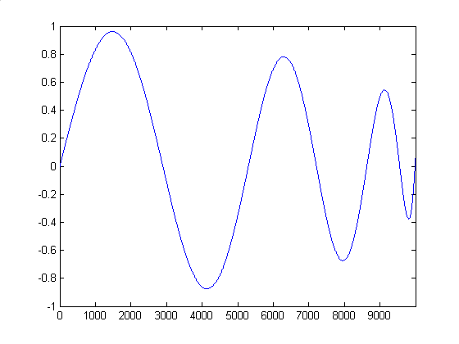
Runge-Kutta
Milne
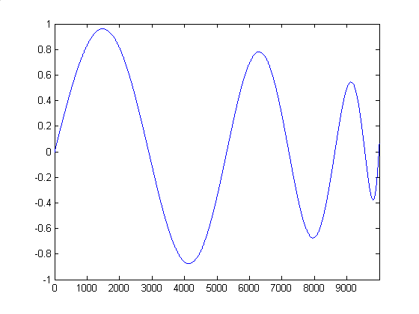
Adams

Fig.2. Motion trajectory of system when the relative varying mass law is linear, for various finite difference schemes. The parameter values are: k = 1 a = 0.1, b = 0, x₀ = 0, v₀ = 1 and step size Δx =10⁻³.

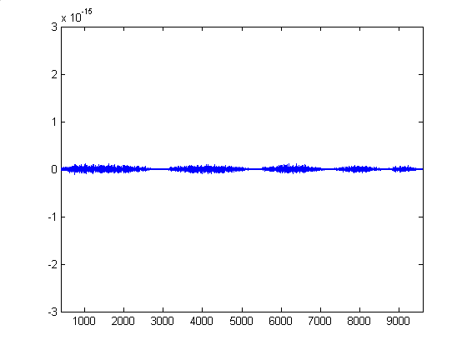
Runge-Kutta
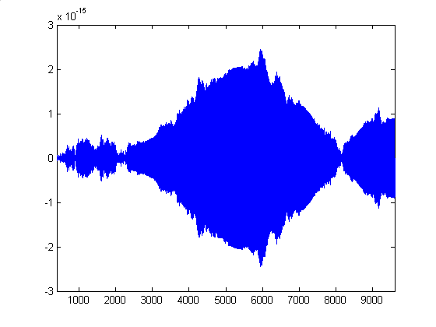
Milne
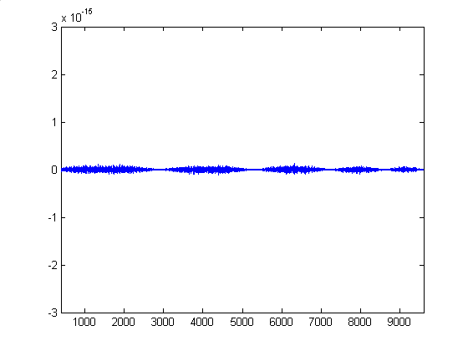
Adams

Fig.3. CWT detail response of system motion, at 2⁻⁶ level, for different numerical schemes. The parameter values used are the same as in Fig.2.

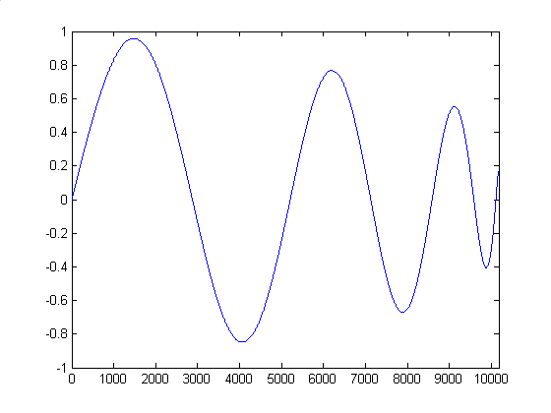
Runge-Kutta
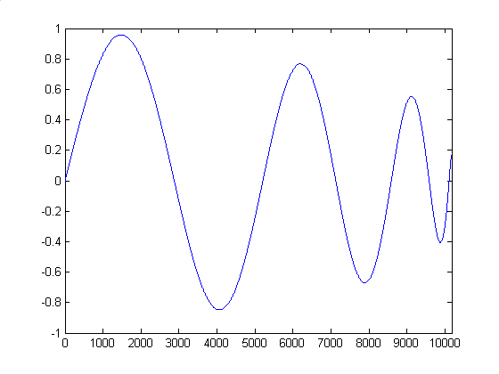
Milne
Adams

Fig.4. Trajectory of the motion of the system, for various finite difference schemes, when an anomaly is introduced in the relative mass decaying law. The parameter values are: k = 1, a = 0.1, b = 1, x₀ = 0, v₀ = 1 and step size Δx =10⁻³.
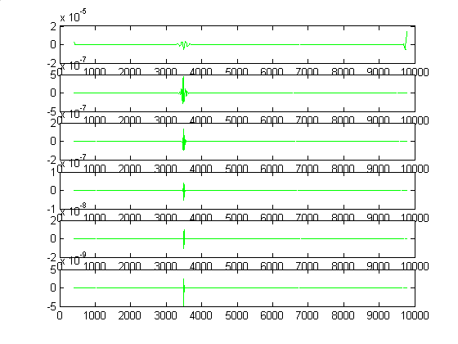
Runge-Kutta
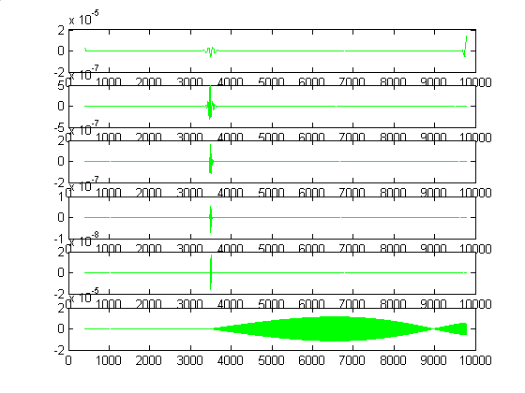
Milne
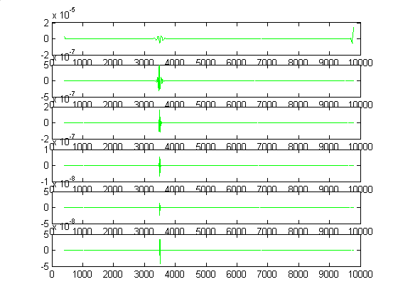
Adams

Fig.5. CWT detail response for the system motion, at 2^{-i} levels (i ∈{1, 2, … 6}), for different numerical schemes, with an anomaly superimposed to the varying mass law. The parameter values are the same as in Fig. 4.

Runge-Kutta | 8.6095e-011
Milne | 7.4713e-006
Table 5. Standard deviation calculated on the 6th resolution detail level of Runge-Kutta and Milne methods. The parameter values are the same as in Fig4.

Finally, consider the case in which the varying law is not smooth: that is a = 0.1 and b = 1.
Based on Parseval theorem, for every s ∈ L²(R), it follows that:

$s(t)=\sum_{k}{a_{j_{0}k}φ_{j_{0}k}(t)+\sum_{j=j_{0}}^{j_{1}}{\sum_{k}{d_{\text{jk}}ψ_{\text{jk}}(t)}}}$ (5)

Now consider the trajectory s* obtained from s by eliminating the details belonging to a resolution level greater or equal to 6. Note that s*, whose corresponding s is calculated by Milne’s method, is an approximation of the real solution better than other 4th order methods. In fact, in Tab.5 is showed the error (i.e., standard deviation) calculated on the 6th resolution level: it shows the values of 8.6095e-011 and 7.4713e-006 for Runge-Kutta and Milne methods respectively. This suggests us that, in general, if a numerical solution is not smooth at a certain level, we can look for reducing this problem by eliminating the detail coefficients at this level. Therefore, we can obtain the reduction of the global error by calculating this modified solution.
Finally, note that utilizing s* as solution of the problem, it causes loss of information, at 2⁻⁶ resolution level, for the absence of the anomaly superimposed to the decaying mass law (see Fig. 6).
Note that also the Adams 6th order [9] method itself does not appear smooth enough if analysed by our procedure. In fact, with the data of Fig.2, at level 2⁻⁶, its CWT is similar to Adams 4th order method.

- Conclusions
We proposed a methodology for investigating the accuracy of numerical methods for the calculation of a trajectory of a dynamical varying mass system. The simulated trajectory was tested by means of wavelet transform. We have shown that the use of the wavelet transform empathizes how classical Milne’s predictor corrector method, also if it is more accurate than Runge-Kutta one, produces some irregularities in its algorithm of generating solution. Furthermore, if we introduce an anomaly in the varying mass law, the Milne’s method does not reveal it at all, in the corresponding simulated trajectory.
Indirectly, the wavelet transform should be used for testing the accuracy of many other numerical methods by superimposing several spikes to the original signal.

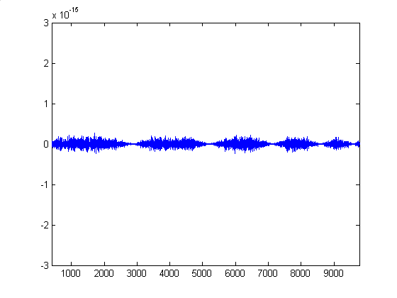
Fig.6. CWT detail response for s*, at 2⁻⁶ resolution level, when the corresponding s is calculated by Milne’s method. The parameter values are the same as in Fig. 4.

References:
[1] Flores J., Solovey G., Gil S., Variable mass oscillator. Am. J. Phys., Vol.71, N0.7, 2003, pp 721-725
[2] Niola V., Quaremba G., Oliviero R., A study on Dynamic Effect of Curvature Changing in a Cam profile by Wavelet Analysis. IASME Transaction, Vol.1, No.1, 2004, pp 97-102
[3] Härdle W. et al. Lecture Notes in Statistics - Wavelets, Approximation, and Statistical Applications, Springer, 1998
[4] Daubechies I., Ten Lectures on Wavelets, SIAM, 1992
[5] Antoniadis A., Oppenheim G., Lecture notes in Statistics - Wavelets and Statistics, Springer, 1995
[6] Kaiser G., A Friendly Guide to Wavelets, Birkhäuser, 1999
[7] Van Iwaarden, J.L., Ordinary Differential Equations with Numerical Techniques. Harcourt Brace Jovanovich, Publishers, 1985
[8] Mathews J.H., Fink K.K., Numerical Methods Using Matlab, 4th Ed., Prentice Hall Inc., 2004
[9] Anderson D.O., Numerical integration of ordinary differential equations, Working paper, Louisiana Tech University, 2000

