A method for the trajectories recording of a robot arm: early results

VINCENZO NIOLA, CESARE ROSSI

Department of Mechanical Engineering for Energetics
University of Naples “Federico II”
Via Claudio 21, 80125, Napoli
ITALY

Abstract: - The aim of this paper is a preliminary approach to robot control by means video acquisition. Two digital cameras recorded a little mark installed on a revolute robot, during trajectory development. Trajectory was reconstructed by means perspective equations. The results, presented in this paper, represent first step for the realization of a technique that will permit a real time control of robot trajectory.

Key-Words: - Computer vision, revolute robot.

1 Introduction
As it is well known “Artificial Vision” permits industrial automation and system vision able to act in the production activities without humane presence. So we suppose that the acquisition and interpretation of the imagines for automation purposes is an interesting topic.
Industrial application are referred to technological fields (assembly or dismounting, cut or stock removal; electrochemical processes; abrasive trials; cold or warm moulding; design with CAD techniques; metrology), or about several processes (control of the row material; workmanship of the component; assemblage; packing or storages; controls of quality; maintenance).
The main advantages of this technique are:
- elimination of the human errors, particularly in the case of repetitive or monotonous operations;
- possibility to vary the production acting on the power of the automatic system (the automatic machines can operate to high rhythms day and night every day of the year);
- greater informative control through the acquisition of historical data; these data can be used for successive elaborations, for the analysis of the failures and to have statistics in real time;
- quality control founded on objective parameters in order to avoid dispute, and loss of image.
In this paper we present the early results obtained by using artificial vision techniques in order to record revolute robot trajectories. The technique was developed starting from an algorithm used in previous investigations [1, 2]

2 Robot description

2.1 Robot mechanical structure
The mechanical structure of the robot was developed from an early design, by us, of a low cost industrial robot; this one was presented in its industrial pattern [3] and in its advanced didactics pattern [4], so we will summarize its description.
The main aspects of this design were:
1- Revolute robot, as it seemed to have the most “general purpose” characteristics.
2- Five axes, as it seemed a good compromise between simplicity and flexibility.
3- Low cost structure through use of common commercial profiles, reduction of tool machining and adjusting, simplicity of assembly.
4- High structure stiffness
5- Reliability
6- Maintenance simplicity

In addition of these requirements, for didactic purposes, it was also necessary that all the components and the movements were easily visible.

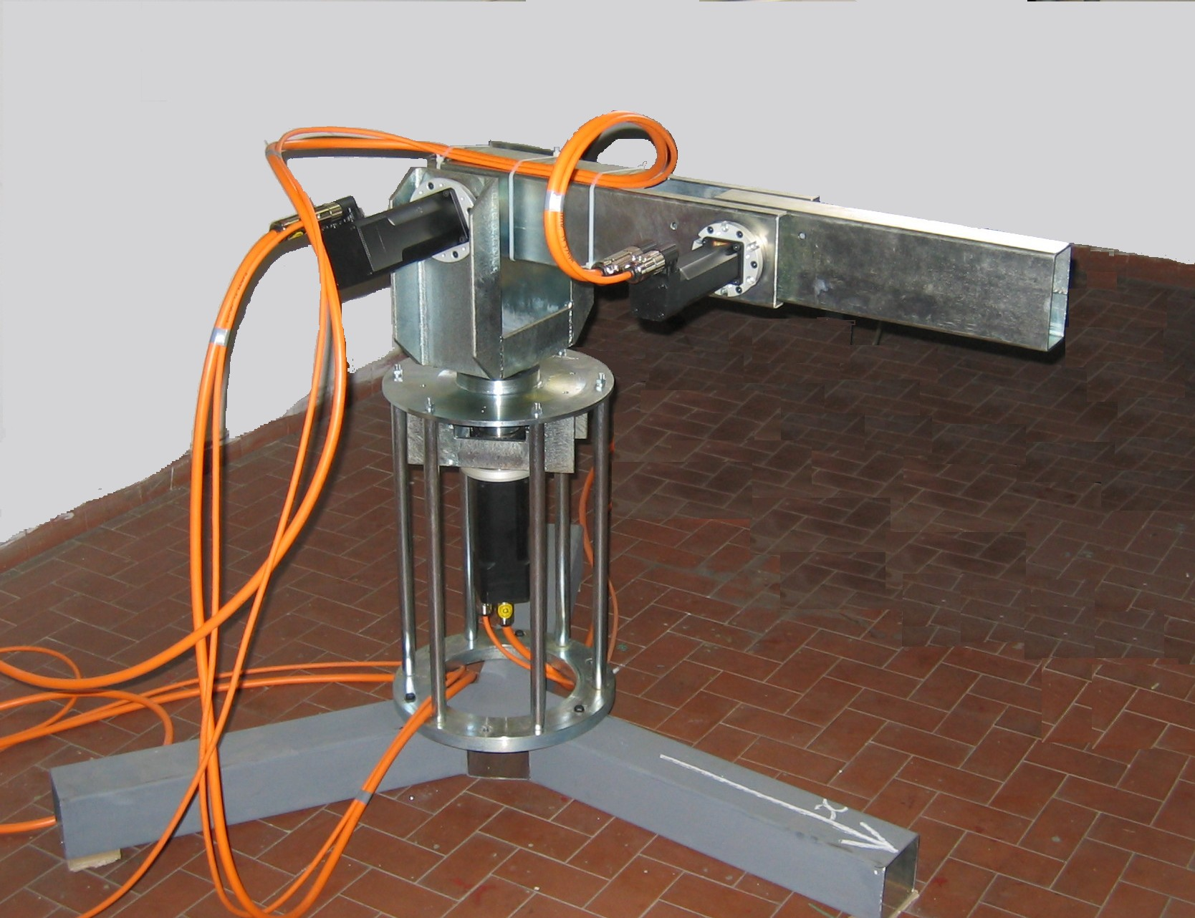
Fig.1 a picture of the robot.

As it can be observed the structure of all the links has been arranged by means of steel or light alloy common commercial profiles; the steel parts are soldered, while the light alloy ones are connected by means of screws.
For the first 3 axes were chosen Harmonic Drives gears, with a reduction rate of 1:100. These gears seemed to be preferable for their very low circumferential backlash (≈5”), high torsional stiffness and because, presently, they are probably the most modern ones.
As it can be observed, the structure is very simple and the shaft is hold by two bearings: on a side an external roll bearing and, on the other side, the one that is inside the H-D gear. No high tooling tolerances are required as, once the shaft is fitted, all the parts are aligned and just then blocked.
The wrist (4th and 5th axes) has been designed but not jet built.
The robot design was carried on also with the aid of computer simulations, in order to analyze the behaviour of the robot from many points of view: cinematic, dynamic, static and modal.
The robot pattern used for these investigations has just the first 3 axes, as the wrist was not installed.

2.2 Trajectories control
As it commonly happens in industrial robots, in our robot doesn't exist any possibility to obtain a feedback of either the exact position of the end effector (at each stop of the work cycle) either the real trajectory, in the work space. The only feedback is obtained by the encoders signals of the servo-motors, i.e. in the joint space.
In operative conditions, mechanical or structural problems and assembly or dimensional errors (if not solved by cinematic calibration) could bring to position of the end effector that differs from the planned ones.
In this case the trajectories and the final positions precision can be increased only through vision techniques adopted during the robot movement.
Presently, studies on real time control on the trajectories performed by the robot are carried on at our lab.

3 Prospective equations
If observed scene is unknown, so it is not possible to have any information on ambient, like it happen in industrial ambient, almost two cameras are necessary; infact it is possible to know point position in the space by at least two point projection. The two plain images can be disposed in whichever way to observe the scene. Obviously it is convenient to maximize the number of interest points observed by two cameras, but this can be obtained with parallel or incident axis.
Two cameras with parallel optical axis (as in humans) concur a smaller resolution, and therefore precision, to find the depth, but they introduce some geometric peculiarities and represent the better solution if the position of the observed objects is unknown.
In Fig.2 a sheme of the vision system is reported; in the figure are shown the main frame O_{w}, X_{w}, Y_{w}, Z_{w} (world) that coincides with camera 1 frame (Ol, xl, yl), and the distance between the two camera axis. As it is possible to observe, once the two cameras focal lengths f1 and f2 are known, it is sufficient to know the distance B (Baseline) between the cameras optical axis, in order to determine completely the system. In particular, if the projections (x1, y1) and (x2, y2) are known, it is possible to determine the position of the point (X, Y, Z) in the space; the geometric relations with yl and y2 are analogous.
In fact, it is possible to write:
$x_{1}=f_{1}⋅\frac{X}{Z}$ and
$x_{2}=f_{2}⋅\frac{X−B}{Z}$ (1)

by means these relations, another can be characterized:

$Z=f_{1}⋅f_{2}⋅\frac{B}{f_{1}⋅x_{2}−f_{2}⋅x_{1}}$ (2)

If cameras are equal, then f₁=f₂=f and it is possible to write:

$Z=f⋅\frac{B}{x_{2}−x_{1}}$ (3)

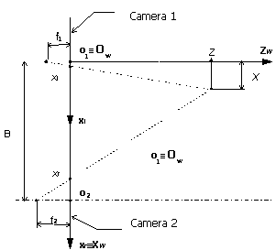

Fig.2

The problem of the three-dimensional vision essentially consists in the association to each pixel of the digital image, the space coordinate that correspond to that pixel. The whole process must be preceded from a system calibration procedure, that greatly affects the precision and the results of a vision algorithm.
The calibration procedures concur to characterize the parameters of the model that describes the behavior of the vision system. Some fundamental parameters are:
- focal length;
- position of the optic axis;
- relationship between image sides or relationship of aspect (aspect ratio);
- scale factor.

4 Results
The results, described in the following, were obtained by using two digital cameras with CCD sensor, having equal characteristics, and arranged in order to have parallels axis. By this test rig, the trajectories of a luminous mark placed on the robot extremity, have been acquired.
An opportune calibration procedure concurs to gain the information necessary in order to connect the images reference system to the one loyal to robot workspace.
Two short movies have been processed with a software, developed by us in MatLab.
For each of acquired movie, the software “recognizes” mark position and time in each frame and “adds” all frames, in order to obtain the path of the mark during the motion on each of the image planes of both the cameras, Fig 8 and 9; in this way the trajectory acknowledgment is more express, but it is realizable only quando la traiettoria è completata. The same technique can be applied to every single movie frame in order to work in real-time, reconstructing the trajectory while it comes executed.
The acknowledgment in the image plan of the coordinates of each point, is obtained exalting the luminous contrast and characterizing the barycentre of the small portion of image area relative to luminous mark.
The developed vision algorithm can be reassumed in three steps:
- reading frame, fig 5;
- analysis frame, fig 6;
- acknowledgment mark position, fig 7;

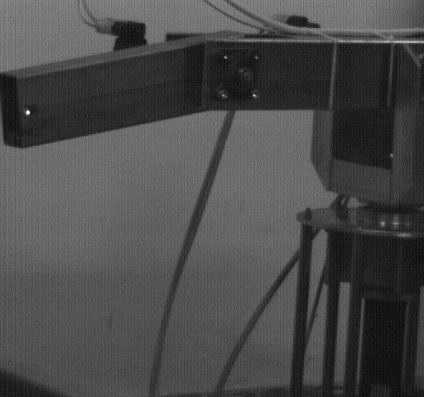
Fig. 5 vision algorithm- step 1


Fig. 6 vision algorithm- step 2

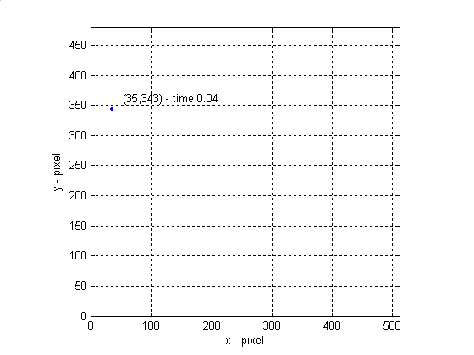
Fig. 7: vision algorithm- step 3

In figure 8 and 9 an example of spiral paths, described from the robot in the workspace, are shown.

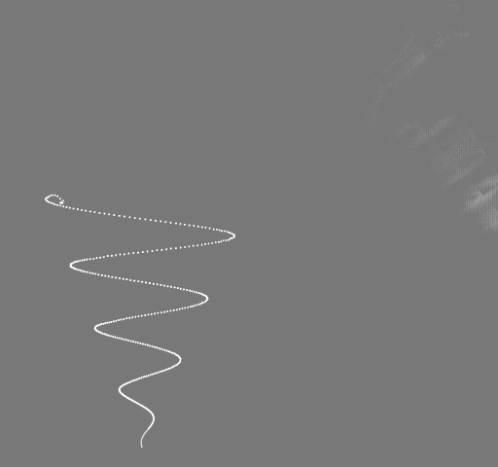

Fig. 8 Trajectories in image space:
camera position 1.

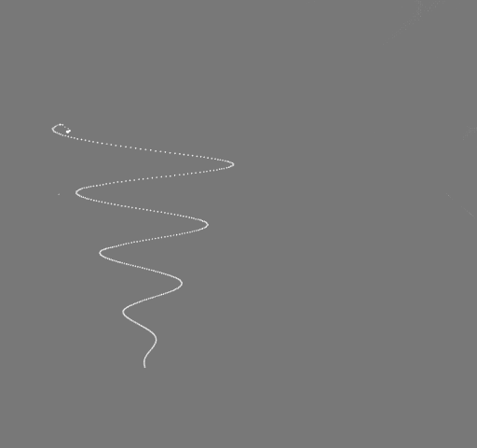
Fig. 9: Trajectories in image space:
camera position 2
By equations 1) and 3), it is possible to obtain a three-dimensional view of the robot trajectory performed by the end-effector.
The results of this process are introduced in the following figures, and a comparison with the signals coming from the encoders of the robot motors is also showed.
The two trajectories acquisition typologies, bring to quite different results: the signals of the encoders give information on the behaviour of the actuators during the motion, while the trajectory obtained from the two digital cameras shows the real behaviour of the end-effector of the robot. In this last case, both the cinematic sources of errors and the dynamic effects are taken onto account.
In the figures 10, 11 and 12 the law of motion components x(t), y(t) and z(t), respectively, are shown. For comparison, in each of the figures, are reported both the law of motion obtained by camera system and those by encoder signals.

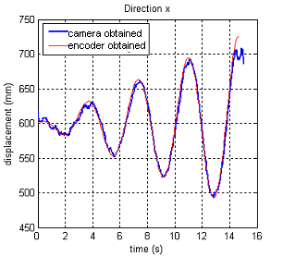
Fig.10 x=x(t)

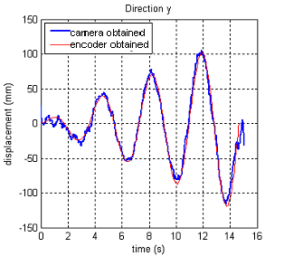
Fig. 11 y=y(t)

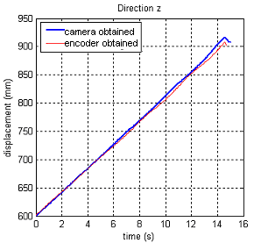
Fig. 12 z=z(t)

In Fig.13 a 3-D path is reported; the comparison between the camera obtained path and the one from the encoders is more evident.
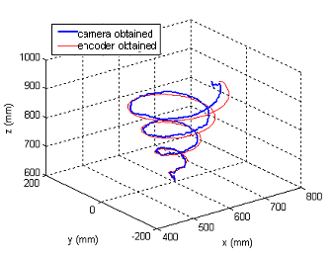
Fig. 13 comparison between trajectory recordings

From the figures above reported, the differences between the trajectories recorded by means of vision system and the ones by the signals of the encoders appear to be evident.

5 Conclusion
This work represents an early investigation to evaluate the possibility to obtain a control system with visual feedback. A vision system is indispensable, to concur with the robot to interact in any workspace with sufficient autonomy.
It is evident that the vision system allows to observe the real trajectory of the end-effector of the robot, no matter if cinematic and dynamic sources of error occur.
On the other side, mechanical or structural problems and assembly or dimensional errors as also dynamic phenomena are not perceived by means of the signals of the encoders, as these last allow just a reconstruction of the motion from the motor motions and not from the real link motions.
This technique seems, also, to be suitable for mechanical calibration purposes; studies about this last topic, by using of vision systems, have been just started at our lab.

References:
[1] R. Brancati, C. Rossi, S. Scocca - Trajectories Recording for Investigations on Robot Dynamics and Mechanical Calibrations – Proc. of 10th int. Workshop RAAD 2001, Wien, May 16-19, 2001.

[2] R. Brancati, V. Niola, S. Savino – Experimental investigation on elastic joint robot dynamics –7th International Workshop Advanced Motion Control - Maribor, Slovenia, July 3-5, 2002, pp 588-592.

[3] S. Pagano, C. Rossi and F. Timpone - A Low Cost 5 Axes Revolute Industrial Robot Design. - 11th int. Workshop RAAD 2002, Vol. 1, pp. 117-122.

[4] R. Brancati, C. Rossi, S. Savino, G. Vollono – A Robot Prototype for Advanced Didatic - Proc. of 13th int. Workshop RAAD 2004, Brno, Czech Republic, June 2-5, 2004, pp.293-298.

