Experimental study on vision motion measures in robotics

VINCENZO NIOLA, SERGIO SAVINO, GENNARO NASTI

Department of Mechanical Engineering for Energetics
University of Naples “Federico II”
Via Claudio 21, 80125, Napoli
ITALY
http://niola.dime.unina.it

Abstract: - In this paper a technique that uses a fixed camera for the acquisition of the trajectories described by the end effector of a planar robot is illustrated. After a theoretical description of the motion perceptibility problem, an experimental plant, set up on purpose and consisting in a two link planar robot and a fixed digital camera, is described. The procedures that allow the calibration of the vision device, as well as an estimation of the resolution of the measure process are highlighted.
As results the actual paths described by the end-effector in the robot work plane are presented.

Key-Words: - Robotics, planar robot, vision machine

1 Introduction
Computer Vision, or Machine Vision is the science that deals with the process of measure of physical quantities through the elaboration of digital camera signals. Computer Vision techniques are widely applied in several fields of the modern life.
One of the must relevant application consists in the employment of cameras in robotics to the aim of improving the robot capabilities and so the kind and complexity of the work that they may perform.
A typical setup, that allows the object recognition, includes a camera mounted directly on an industrial robot. Cameras mounted on mobile robots allow the recognition of obstacles and the pattern realization.
A less common setup includes a fixed camera that measures the end effector position of an industrial robot.
The present paper describes experimental studies on a technique for the acquisition of the trajectories described by one or more points of a planar robot. Such a technique uses a fixed digital camera observing the robot motion in its working plane.
The measuring of trajectories directly in the robot work plane represent a problem of difficult solution because of the costs and complexity of realization of reliable measuring systems. For these reasons the direct kinematics formulas are commonly used for the evaluation of the end effector position starting from the knowledge of the joint variables values.
The described technique allows, as said, the direct measure of trajectories in the robot work space so realizing a simple and relatively inexpensive position transducer witch may be employed to the purpose of motion control, robot dynamic parameters identification, robot calibration, elastic deformations of the links detection and so on.
In the following, after some reference to the general principles on motion perceptibility by mean of camera, an experimental plant set up at the Department of Mechanical Engineering for Energetics (DIME) of the University “Federico II” of Naples is described, the procedures adopted for the identification of the main parameters of the vision system, such as field extension and resolution are highlighted, finally the results of some acquisition are discussed.

2 Theory of motion perceptibility
The integration of computer vision with robot motion is normally faced under a double point of view: to recognize and locate objects in the task space, and to increase the robot control capability with a sensor that provide information on robot motion in the work space.
In the second case, it is necessary to evaluate the ability of a computer vision system to perceive the motion of an object in its field of view; Rajeev Sharma’s and Seth Hutchinson’s [1, 2, 3, 4, 5] theory describes a quantitative measure of motion perceptibility with a vision system whit digital camera.
If the robot is within the field of view of the camera, then a perspective projection of the robot will be formed on the camera image plane. With the term visual feature parameter it is indicated any real valued parameter that can be calculated from the projection of the robot on the camera image plane.
Examples of visual feature parameters include the image plane coordinates of a point in the image, the area of projected surface, and the angle between projected edges. In robot case, a typical visual feature corresponds to the projection of some structural features of the robot, or to the relationship between the projections of multiple structural features.
If a large motion of the robot produces very little change in the image features, then it may be difficult to use the differential change in the measured features to further analysis; hence there is a need for an index of the ability to observe changes in the image features with respect to the motion of the robot. This index can be used for optimal camera placement, active camera trajectory planning, and robot trajectory planning.
Therefore, it is necessary to relate differential changes in the image feature parameters to differential changes in the position of the robot. These relationships have represented by an opportune jacobian matrix: The image Jacobian.
Denoting the task space of the robot by W, an element of the task space by r, the space of visual feature vectors by V and an element of this space by v, the image Jacobian J_{v}, is a linear transformation from T_{r}(W) (i.e. the tangent space of W at r), to T_{v}(V) (i.e. the tangent space of V at v):
$$\overset{˙}{v}=J_{v}\overset{˙}{r}$$
$\overset{˙}{v}∈T_{v}(V)$and $\overset{˙}{r}∈T_{r}(W)$ are referred to respectively as a visual feature velocity and a configuration observed object velocity.
It is possible to obtain [5,6] a quantitative value for the observability of an object’s motion, by the measure w_{v}:
$$w_{v}=\sqrt{\text{det}\left(J_{v}⋅J_{v}^{T}\right)}$$
Considering a set of velocities $\overset{˙}{r}$, it can be shown[2,3,4] that the corresponding set of visual feature velocities is given by the set of all $\overset{˙}{v}$ such that:
${\overset{˙}{v}}^{T}(J_{v}^{+})J_{v}\overset{˙}{v}≤1$ (1)
where J_{v}⁺ is the pseudoinverse of J_{v}.
Equation (1) defines a hyper-ellipsoid in the visual feature space, which is denoted as the observability ellipsoid.
The dimension of the observability ellipsoid provide a quantitative evaluation of the capability of $\overset{˙}{v}$ to describe the object motion given by $\overset{˙}{r}$. The volume of the observability ellipsoid is given by $K⋅\sqrt{\text{det}\left(J_{v}⋅J_{v}^{T}\right)}$ or $K⋅w_{v}$, where K is a scaling costant that depends on the dimension of the ellipsoid. This volume provides a concise and intuitively pleasing measure of observability. For the case of no redundant features, when the dimension of v is equal to the dimension of r, J_{v} is a square matrix; in this case $J_{v}⋅J_{v}^{T}=J_{v}^{2}$, and the osservability coefficient become:
$w_{v}=\left|\text{det}\left(J_{v}\right)\right|$ (2)
For the motion observation of a 2-DOF planar robot, two image parameters would be sufficient, such as the coordinates, in the image plane, of a manipulator’s generic point, for example the end-effector center.
Therefore the planar robot is a classic case of non-redundant vision features, infact two vision parameters correspond with two coordinates of observed point in the motion plane, so it is possible to use equation (2).

3 Experimental rig
The experimental rig set up at the DIME laboratories consists of a two link planar robot, a digital camera and a frame grabber.
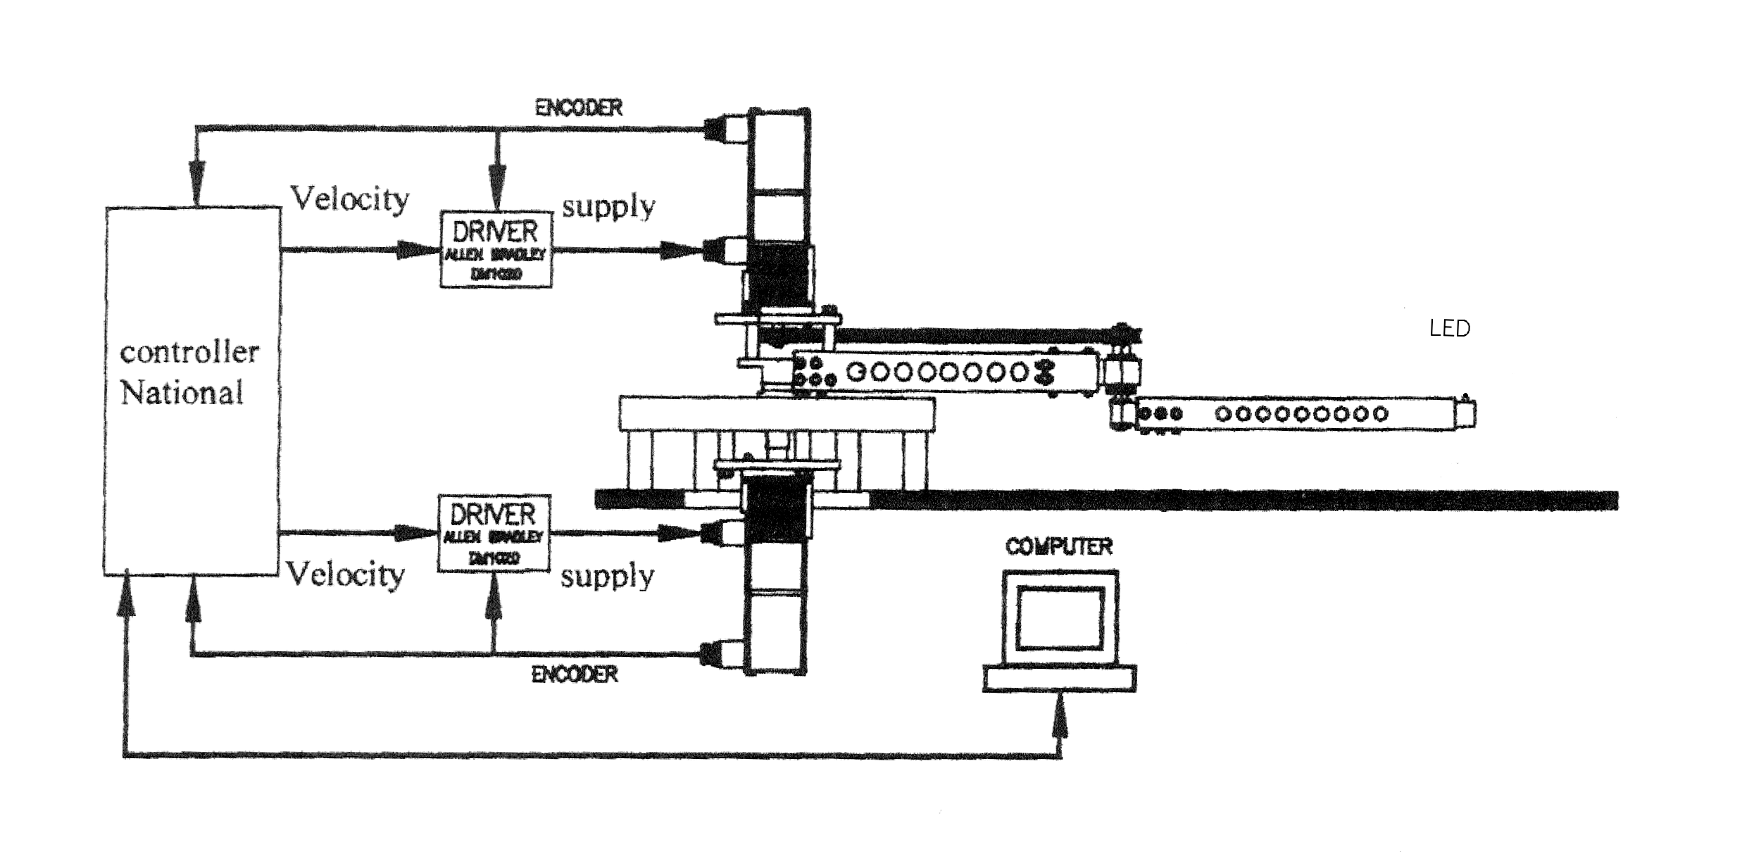
Fig. 1: Experimental prototype.

The robot’s main feature is that all its mechanical components can be easily removed and substituted, thus enabling a large variety of modifications to be made to its structure by fitting arms of different materials, dimensions and shapes, various types of reduction gears and different types of belt drives.
Figure 1 illustrates the overall arrangement of the prototype with its two links operated by brushless motors fitted onto the axis of the first link.
The first motor is fastened onto the base and moves the first arm; the other motor is fastened onto the first arm and moves the second arm via a belt drive. The arms are screwed onto the joint so that they can be easily substituted.
The length of the first link is 505 mm, the one of the second link is 465 mm.
The two brushless motor are controlled by means of a National Instruments motion control board with a software, developed in LabWindows, that makes it possible to realize any type of trajectories in the joint space.
The camera used is a DALSA CA-D1s with a CCD sensor, which specifications are reported in table 1.

Model: Dalsa CA-D1-0256
Pixel Pitch: 16µm 16 µm;
Aperture: 4.1 x 4.1mm;
Data Bits: 12
Max. Data Rate: 15 MHz
Max. Frame Rate: 203 fps
Table 1 Camera specifications

4 Coordinates transformation
In the figures 2, 3 and 4 the scheme of the vision device is reported.
The fixed reference frame O, X_{r}Y_{r}Z_{r} has the plane X_{r}Y_{r} parallel to the robot working plane.
In order to determine the coordinate transformation an auxiliary frame O’, X'Y'Z' is defined. The origin O’ is the intersection between the optical camera axis and the work plane, Z’ is parallel to Z_{r} and the auxiliary frame is rotated of an angle φ around the Z_{r} axis.
The camera plane U_{r},V_{r} is normal to the camera axis and with U_{r} parallel to X’.

Fig.2 scheme of the vision device

Fig.3 top view the vision devise
Fig.4 The scheme of perspective transformation.

Finally, the image frame U,V is parallel to the camera frame and rotated of an angle θ around the optical axis.
To define the coordinate transformation equations it is necessary to determine: the coordinate transformation between the frames (O,X_{r},Y_{r},Z_{r}) and (O’,X’,Y’.Z’); the perspective transformation from (X’,Y’) plane to the (U_{r},V_{r}); and finally the coordinate transformation between the planes (U_{r},V_{r}) and (U,V) due to a rotation about the camera axis.
Then the relation between the coordinates (u, v) of a point in the camera plane and the corresponding ones (x, y) in the robot work plane are as follow:

(3)

where:
(a, b) are the coordinates of the point O’ in the (Xr, Yr) plane (figure 3);
f is the focal length of the camera lens
Moreover, indicating with (F, E, H) the coordinates of the center of the image frame reference in the (O, Xr, Yr, Zr) frame, the following relations are defined:

$\begin{aligned}\left\{\text{tg}φ=\frac{E−b}{F−a} | \right.\left\{\text{cos}φ=\frac{F−a}{\sqrt{{\left(E−b\right)}^{2}+{\left(F−a\right)}^{2}}} | \right.\end{aligned}$ (4)

$D'=\frac{F}{\text{cos}φ}=\frac{F}{F−a}\sqrt{{\left(E−b\right)}^{2}+{\left(F−a\right)}^{2}}$ (5)

$i=\frac{a}{\text{cos}φ}=\frac{a}{F−a}\sqrt{{\left(E−b\right)}^{2}+{\left(F−a\right)}^{2}}$ (6)

$\begin{aligned}\left\{\text{tg}γ=\frac{D'−i}{H}=\frac{\sqrt{{\left(E−b\right)}^{2}+{\left(F−a\right)}^{2}}}{H} | \right.\left\{\text{sin}γ=\frac{D'−i}{\sqrt{{\left(D'−i\right)}^{2}+H^{2}}}=\frac{\sqrt{{\left(E−b\right)}^{2}+{\left(F−a\right)}^{2}}}{\sqrt{{\left(E−b\right)}^{2}+{\left(F−a\right)}^{2}+H^{2}}} | \right.\end{aligned}$(7)

$g=D'−i−f∗\text{sin}γ=\sqrt{{\left(E−b\right)}^{2}+{\left(F−a\right)}^{2}}−f∗\frac{\sqrt{{\left(E−b\right)}^{2}+{\left(F−a\right)}^{2}}}{\sqrt{{\left(E−b\right)}^{2}+{\left(F−a\right)}^{2}+H^{2}}}$(8)

In which:
φ = φ(E,F,a,b) is the angle between the X’ and Xr axis
γ = γ(E,F,H,a,b) is the angle between the optical axis and the vertical one Zr
g = g(E,F,H,a,b,f) is the distance between the points of the plane (Xr, Yr) having coordinates (a, b) and (F,E)

5 Motion perceptibility evaluation
Equation (3) allows the evaluation of the motion perceptibility parameter w_{v} through the relations:
$w_{v}(x,y)=\left|\text{det}\left(J_{v}\right)\right|$; $J_{v}(x,y)=\left[\frac{∂v}{∂r}\right]=\left[\begin{matrix}\frac{∂u(x,y)}{∂x} & \frac{∂u(x,y)}{∂y} \\ \frac{∂v(x,y)}{∂x} & \frac{∂v(x,y)}{∂y}\end{matrix}\right]$
Therefore w_{v} (x,y) depends on the value of the parameters: E, F, H, a, b, θ, f.
As an example, given the parameters H, a, b, θ, f, it is possible to evaluate the w_{v} perceptibility in a prefixed point (x₀,y₀) as a function of the E, F coordinates.
Assuming a= 800 mm, b=0 mm, H= 1650mm, f= 100 mm and θ=5°, in figure 5, the w_{v} perceptibility parameter in the point O’ (x₀ = a, y₀ = b) has been represented as a function of the camera position coordinates E, F.
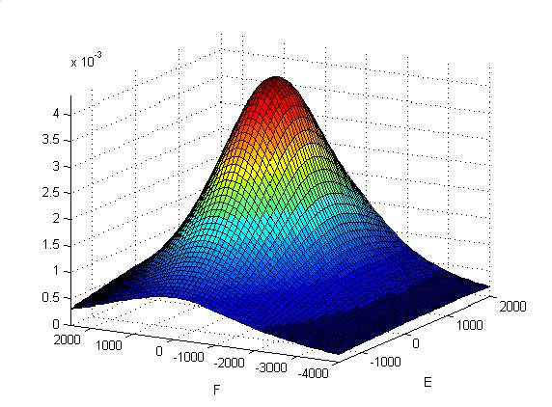
Fig.5 w_{v} perceptibility parameter in the point O’ (x₀ = a, y₀ = b) as a function of the camera position coordinates E, F (a= 800 mm, b=0 mm, H=1650 mm, f=100 mm , θ=5°).

From the analysis of the figure 5 it can be deduced that in every point of the plane the perceptibility has a maximum when the camera optical axis is vertical (γ=0) and passing from the point itself.
Therefore the optimal position of a fixed camera would be the one characterized by an optical axis perpendicular to the work plane and passing from the center of the area to be observed. Moreover, due to space problems, such an optimal position is frequently unreliable and a different one, characterized by a slanting disposition of the camera, is used.

6 Vision device Calibration
Resolution of eq. 3 call for the knowledge of the parameters: a, b, E, F, H, f, θ. Since, as said above, the direct measure of such parameters is a difficult operation it is better to identify them through a procedure that utilize the camera itself. The procedure starts with the acquisition of the frame imagines relative to the target placed on the extremity of the manipulator when the robot assumes a set of predefined postures each ones is characterized by known coordinates (x, y) of the target in the working plane.
The frames analysis allows the determination of coordinates (u, v) of the target in the image plane relative to each of the above position.
Appling to eq. 3 an optimization procedure based on a Levenberg-Marquardt algorithm for the solution of a nonlinear least-squares problem, the value of the unknown parameters is found.

7 Experimental results
As said above, due to the room it is necessary to give up the optimal camera arrangement which assumes, instead, a position characterized by γ e φ angles not equal to zero.

7.1 Developed Software
In this first phase of the study robot, control operations and trajectories acquisitions operations are separated. The motion management is carried out by means of a control software developed in LabView, while the operations of images elaboration and visual analysis are realized with algorithms developed in Matlab.
Using the equations (3), some programs have been developed for the transformations from image plane to manipulator working plane. The same equations are used in an optimization procedure based on the Levenberg-Marquardt algorithm, to obtain the course of w_{v} (x,y).
The operations of images elaboration must concur to characterize, in the image plan, coordinates of a target constituted by a led, located at the extremity of the second link, associating time information. The developed algorithm is based on a filtering process that concurs to characterize the barycentre of the small area relative to the target, in each frame of trajectory movie.

7.2 Vision device calibration
Imposing height different postures to the robot arms, height different pairs of coordinates (x, y), and consequently height pairs (u, v), are acquired. Adopting as initial guess in the identification procedure the values corresponding to measures of distances roughly made with a rule, the following values have been identified:

E= 1028.9 mm; F= -3434 mm; H=1641.5 mm;
a= -35.82 mm; b= 788.64 mm; θ = 0.0869 rad;

The value of the focal length has not been identified and the nominal value, f = 100 mm, provided by the manufacturer, has been accepted as true.
With the above values the characteristics angles γ e φ and the distance g are:
γ = 1.1218 rad; φ = -0.0706 rad; g= 3317 mm
The set of parameters identified defines completely position and orientation of the camera.

7.3 Evaluation of the motion perceptibility
Once the parameters characterizing the camera position have been identified, the motion perceptibility index wv in all the visible points of the robot working plane may be evaluated (figure 7).
The figure clearly shows how the maximum value of the perceptibility index is about one order of magnitude lesser than the one corresponding to the optimal camera position, nevertheless, the slanting disposition adopted allows the observation of a greater extension of the robot working plane: in the examined case the working area corresponding to a frame is 240 x 475 mm.

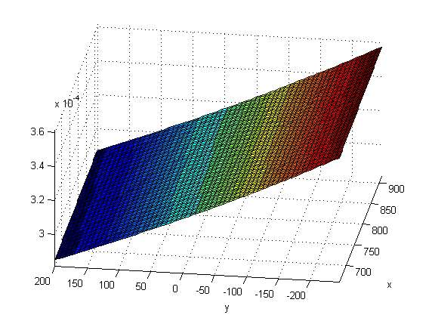
Fig. 7 Motion perceptibility index variation in the observed area

7.4 Evaluation of the vision device resolution
Due to the rotation of the camera of an angle θ around its optical axis, the shape of the observed area is not that of a regular rectangle, bat the one of an irregular quadrilateral. Since the sides of such quadrilateral have different dimension, each pixel of the acquired frame correspond to an area, in the working plane, of different extension: The dimension of the greatest of such areas will characterize the resolution granted by the system of vision in the whole observed field.
To evaluate the system resolution, through eq.3, the pairs of coordinates (x_{r},y_{r})_{i} corresponding, in the robot motion plane, to the coordinates (u,v)_{i} of the edge of each pixel of the frame are determined. Furthermore the distances (Δx_{r}, Δy_{r} )_{i} between the above points is calculated. The maximum Δ of the above distances define the resolution of the vision system: In every point of the observed area, a target displacement greater the above Δ resolution will be “seen with certitude”.
In the configuration described the resolution is: Δ_{x}=0.629mm; Δ_{y} = 1.451mm.

7.5 Trajectories measurements
Each trajectory measurement test is preceded by the above described operation of calibration and estimation of the resolution in the whole area observed.
The paths imposed to the robot are circumferences, segments and stars of segments.
In the figures 8 the acquisition relative to a circular motion of radius 100 mm and centre in the point of coordinates (800,0) are reported.
Figure 8a shows the path in the image plane, in figure 8b the same trajectory is reported in the work plane.
From figures 8 it can be deduced that the vision device resolution is such to perceive the small oscillation that deviate the effective trajectory of the end effector from the nominal one.
Such oscillation, realized modifying the belt drive elasticity, has been introduced on purpose to appreciate the goodness of the vision system resolution.
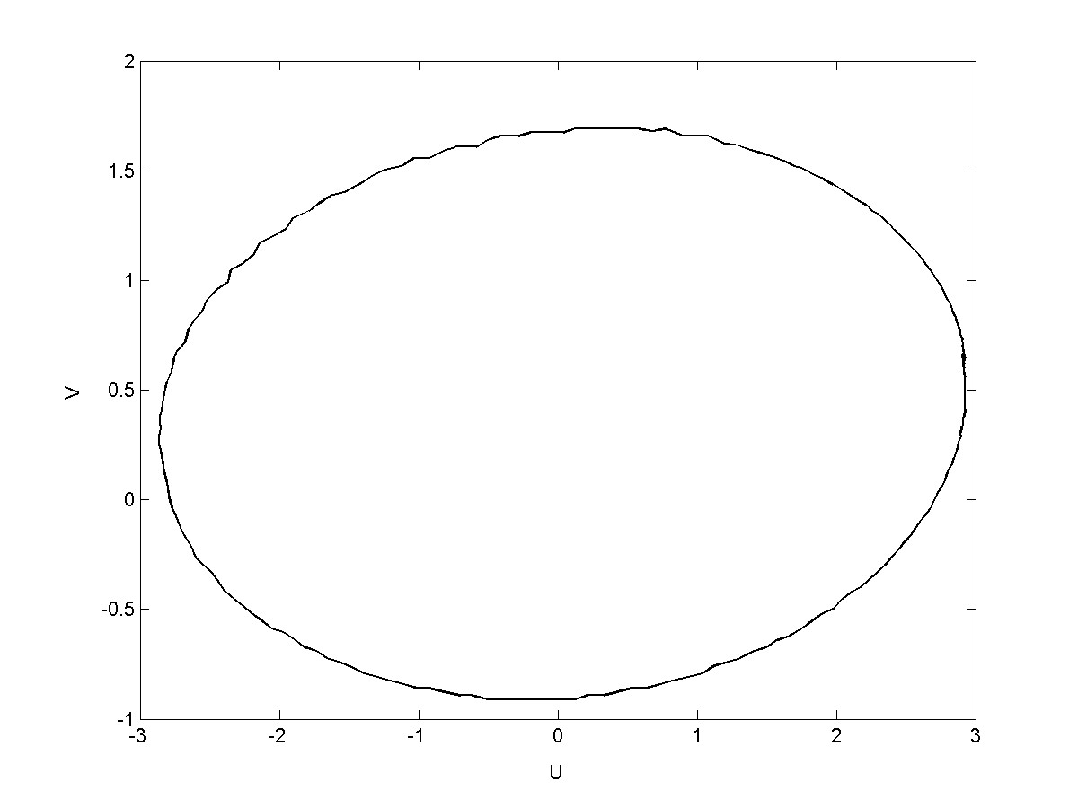
Fig 8a: Circular path in the image plane
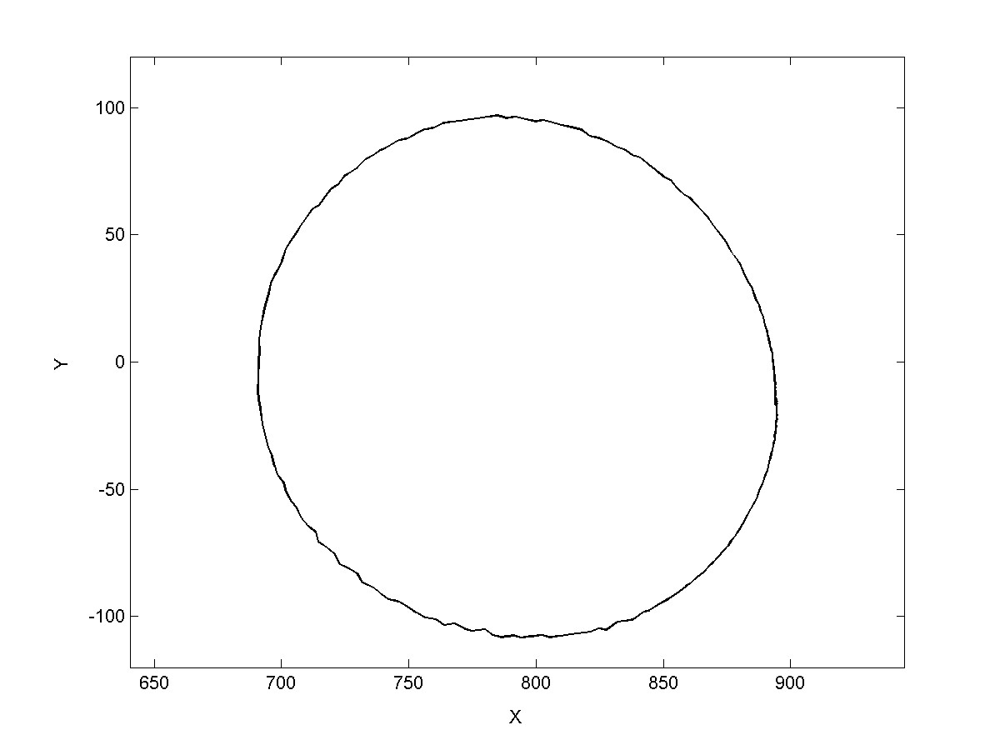
Fig. 8b: Circular path in the work plane

In figures 9 is reported a path realised by four segments of length 200 mm, each rotated of 45° from the other that form a star of centre (800,0).
Figure 9a shows the path in the image plane; figure 9b the one in the work plane.
Also in this case the vision device is able to appreciate the oscillation due to the belt drive elasticity.
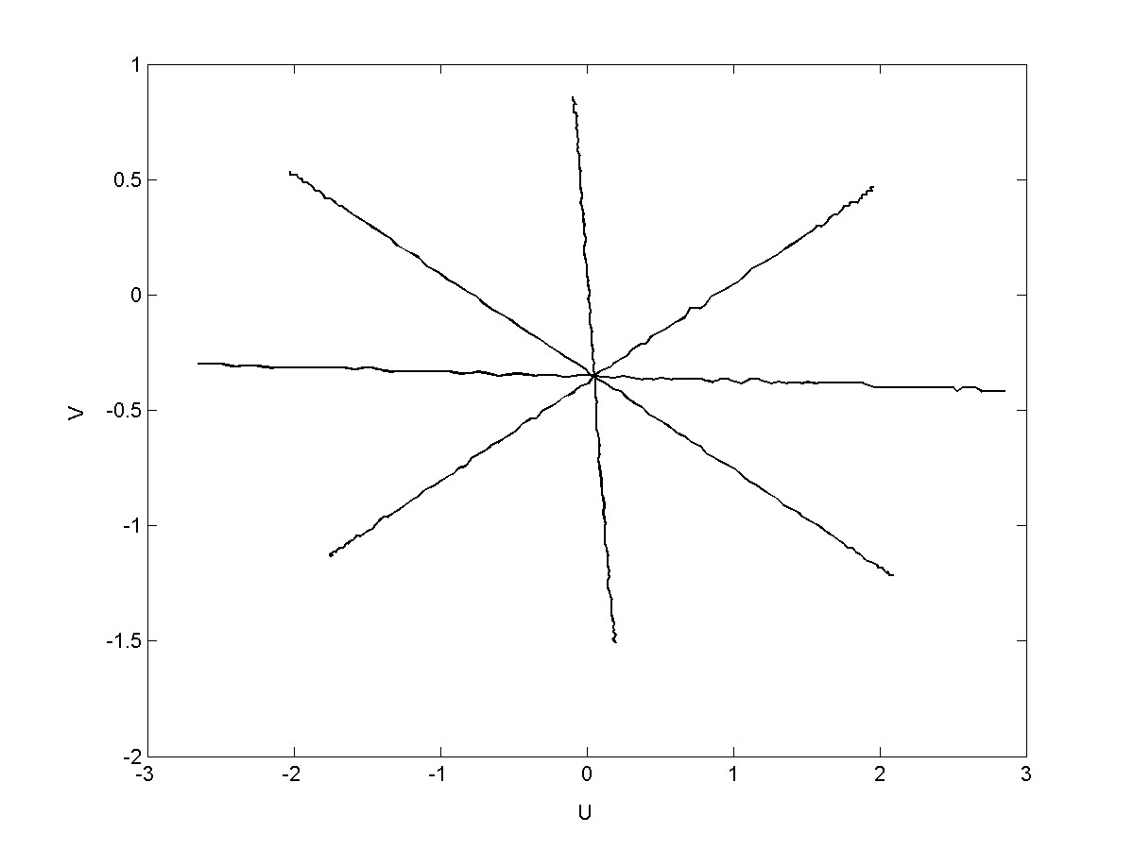
Fig 9a: star of segments in the image plane

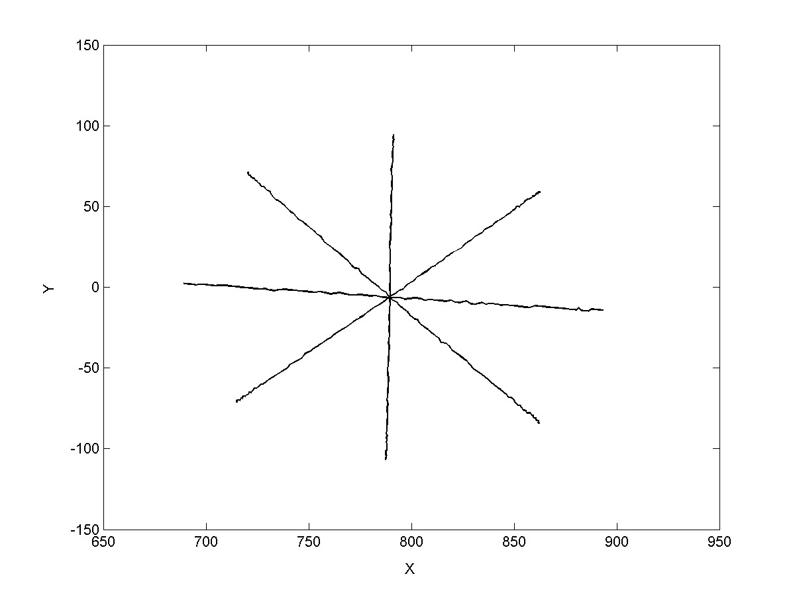
Figure 9b: star of segments in the work plane

It is interesting to note (fig. 8-9) that the oscillation has a grater amplitude in some area of the work space, in fact, as it is known, the natural frequencies of the robot change as the robot posture varies.

8 Conclusions
A technique for the plane trajectories measurement by a fixed camera vision device has been described.
In the paper the method reliability has been shown from both the theoretical and experimental point of view.
The vision device, in fact, is able to observe, and measure the small vibration of the end effector.
The described system of trajectories measurement would be usefully employed, for instance, in robot parameter identification algorithms, as well as in the determination of the better robot postures in relation to the tasks that it has to perform.
Of course, next efforts have to be focalised on the research of the optimal perceptibility and resolution conditions.
The use of a second camera to acquire space trajectories have to be also considered.

References:
[1] R. Sharma, S. Hutchinson, On the observability of robot motion under active camera control, Proc. IEEE International Conference on Robotics and Automation, May 1999, pp. 162-167.
[2] R. Sharma, S, Hutchinson, Motion perceptibility and its application to active vision-based servo control, Technical Report UIUC-BI AI RCV-94-05, The Beckman Institute, University of Illinois, 1994.
[3] R. Sharma, Active vision for visual servoing: a review, IEEE Workshop on Visual Servoing: Achievement, Application and Open Problems, May 1994.
[4] R. Sharma, S, Hutchinson, Optimizing hand/eye configuration for visual-servo system, IEEE International Conference on Robotics and Automation, 1995, pp. 172-177.
[5] J. T. Feddema, C. S. George Lee, O. R. Mitchell, Weighted selection of image features for resolved rate visual feedback control, IEEE Trans. Robot. Automat., Vol. 7, 1991, pp. 31-47.
[6] R. Brancati, C. Rossi, S. Scocca - Trajectories Recording for Investigations on Robot Dynamics and Mechanical Calibrations, X Workshop on Robotics in Alpe-Adria-Danube Region, 2001.

