Detecting Denial of Service Attacks Using Database Queries

DMYTRO ZAKHALYAVKO and CONSTANTINE MANIKOPOULOS
Electrical and Computer Engineering Department
New Jersey Institute of Technology
323 King Blvd, Newark, NJ 07102, USA

Abstract: - In most current generation intrusion detection technology systems the output data are stored into flat files. By contrast, ease in storing, analyzing, categorizing, and accessing data are major advantages that accrue when using databases in hold intrusion detection data. Often, security analysts have to repeatedly perform the difficult task of sorting through a haystack of attack alerts, many of which turn out to be inaccurate. It is possible to make the job of managing these alerts, analyzing data with high precision, and searching for attacks or intrusions easier by using database query oriented analysis. This project was conducted in order to demonstrate, as proof of concept, the effectiveness in intrusion detection handling of intrusion data when writing them into a database system and analyzing them with SQL. A database plug-in was developed that deposits the data from an intrusion detection system to a database. Subsequently, statistical analysis was conducted, which showed that database query methods can be effective in detecting intrusions, while decreasing the challenge of the analysis of intrusions.
Keywords—intrusion detection; database; SQL; statistical analysis; data management

1 Introduction
There are multiple ways to analyze [1, 2], store and retrieve intrusion detection data. The most logical one would be to store it inside of a database. This approach also introduces a convenient and easy way of detecting attacks through writing SQL queries. A recent survey [3] by
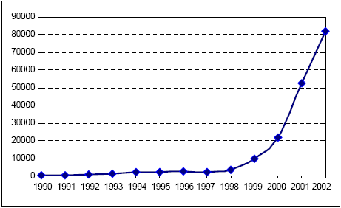
Figure 1: Attack incidents that were reported to Computer Team/Coordination Center (CERT/CC) during the last decade
CERT/CC (Computer Emergency Response Team/Coordination Center) showed that the rate of cyber attacks has more than doubled every year since 1998 (see Fig.1). We need to find the best ways to make information systems immune to such attacks.
Many researches [4, 5, 6, 9] have showed that data mining provides added capability in detecting attacks and analyzing intrusion detection data. However, few have tried to integrate data mining techniques into detecting attacks with the help of database collecting information about the network traffic. In this paper we seek to demonstrate that the approach of using databases in intrusion detection to detect attacks using SQL queries is effective and competitive with other techniques [2].

2 Intrusion Detection Systems
Intrusion detection systems (IDSs), although in fairly common use recently, still suffer drawbacks and exhibit deficiencies.
Here are some basic drawbacks of current IDS products that limit effectiveness of this security solution [10]:
- Detection Accuracy – Current IDS products are noted for generating a high rate of false positives.
- Enterprise Scalability – Network IDS deployments are now enterprise scale. The concept of “small” and “big” networks has significantly changed in the past years. A few years ago, a network of 50 sensors was considered large, but today networks consisting of hundreds or even thousands of nodes and sensors are not uncommon. Network IDSs have to keep up with the demands of the enterprise scale in order to function appropriately.
- Product complexity – Today’s IDSs are still difficult to install, update and manage on a daily basis.
- Growing IDS Evasion – new and polymorphic attacks are used widely and can often defeat many IDS products.
- Performance barriers – keeping up effective attack detection in the presence of ever-increasing traffic speeds of traffic is challenging to most systems.
- Passive character of IDS – IDS have been considered to be non-critical devices because of their passiveness while detecting attacks. Preventing attacks is considered more important, which has recently led to prevention as well as detection tools.
- Last but not least is intrusion detection management – with millions of records per day, hundreds or thousands of alerts often overwhelm the energy and attention budget of security administrators.
There is a clear need for development and improvement in this area. One of the improvements that is just starting make its way into the intrusion detection world is logging to database system. To date, typically, most intrusion detection systems log to a flat file, which is later analyzed by some specially designed programs or manually browsed by security analysts of the company.

3 Database Logging
Clearly, nobody wants to manually go through hundreds of thousands or millions of lines of logs and alerts, and, even worse, try to make sense out of them. It is desired to deploy some systematic and automatic advanced technological process. Logging intrusion detection data to a database would create multiple advantages. Information that is being written into the database can successfully and efficiently be:
- Stored – no limit on the size of the database, when using such database systems as Oracle, which are very robust and can handle enormous collections of data. By contrast, a flat file can grow uncontrollably and eventually take up all of the memory, causing a system crash or an intrusion detection system malfunction.
- Analyzed – by means of Structured Query Language (SQL), data in the database can be easily found, classified, analyzed and researched.
- Categorized – multiple tables for multiple periods of time could be created, then linked together for more functional design
- Accessed – data access is also a very important aspect. Database systems more readily provide access to the required information at any time from various locations, whereas it might be hard and perhaps insecure to share a file on the network.
Also such advantages make the point that database logging is worth doing:
  - Increased functionality – same data, contained in the database can be used in multiple ways (analysis, visualization, etc.)
  - Simplicity of architecture – database architecture does not have to be complex in order to successfully and efficiently detect intrusions, and manage stored data.
  - Scalability – can be scalable for both smaller networks as well as for more global projects and multiple networks.
  - Possibility of applying to inter-cooperation of different IDSs, firewall and other security systems.
The disadvantage of such an improvement is some but often insignificant increase of local traffic and response time. It is understandable that if a database system includes numerous amounts of records, the response time would not be immediate, but would typically be within acceptable limits.

4 Database IDS and SQL Analysis

Two Models
Two model systems are examined and described in this project. The first model is a local area network or a segment of a computer network that has at least one sensor, an intrusion detection system running on it, and a database server that will accept logs and alerts written into it. One or more sensors detect attacks, while the intrusion detection system outputs data into the database system. A security analyst has access to the database server, and will analyze data collected from the whole network.
The second model involves the next tier up in the network hierarchy. It has one secure centralized database server and multiple intrusion detection systems (they do not even have to be of the same vendor) on different networks. They connect to the database server and write alerts into it. This model is designed for detecting attacks on a larger scale and can give a better understanding of the types of attacks that are launched and possible ways to stop them.
Let us consider an example. A fairly large company has multiple sites at different geographic locations and, therefore, multiple networks. Let us assume that each network has an intrusion detection system running on it. In a regular environment, intrusion detection systems detect some of the attacks that are launched against that particular network. They are not detecting attacks on a global basis, however, a port sweep on one segment of the network, might be part of an attack on the whole enterprise. Therefore, if all intrusion detection systems would write data into a centralized database server, it would be much easier and possible to detect global attacks. Failure to realize global attacks can lead to catastrophic losses. This is also a very good way of detecting new types of viruses, worms and security holes – if each IDS reports unusual number of similar attacks, it may be that a new virus or a worm is trying to compromise the network or individual machines. This system can help contain the virus spread and allow a faster response to obtain and apply security updates.

Sharing the Database System with Firewalls
A combination of an intrusion detection system, a database server, and a firewall is also a very good example of improvement. This approach gives the advantage of using existing investments in firewall and IDS technology. If an attack is detected, the intrusion detection system logs an alarm into the database, and from there some threat assessment logic sends a mitigation instruction to the firewall. The firewall then implements the mitigation, e.g. it may block the offending traffic.

Choosing a Database System
The Oracle database system was chosen, mainly because of its known advances in robustness, stability, properties and functionality over other database systems. The demonstration project implemented Pro*C/C++ connections.

Programming
In order to make the intrusion detection system write data to the Oracle database system, a program was written, using the Pro*C/C++ precompiler. Oracle Pro*C/C++ Precompiler is a programming tool that allows embedding SQL statements into a high-level (C++) source program. The precompiler accepts the source program as input, translates the embedded SQL statements into standard Oracle runtime library calls, and generates a modified source program that you can compile, link, and execute in the usual way.
This program takes outputted alert logs from an IDS, connects to the database, logs in with username and password, and uses SQL statements to write data into the table of the Oracle database.
The program can also be thought as Database Plugin for an intrusion detection system. What is valuable is that the plugin can be applied not to a specific intrusion detection system, but to various types of IDS (misuse or anomaly type), with only minor code modifications to compensate for output differences. In our case, the plugin is specific to the Oracle database system.

Query Based Analysis
Once the data from an intrusion detection system is fed into the database, processing can proceed. Since SQL is a proven and reliable means to extract the data from a database, it is used for this project.

Obtaining the data: IDS Alert Generation.
There are two datasets, Set A and Set B, of IDS classifier decisions that were used in this project.
Set A: The first one, Set A, was obtained by deploying our CONEX Testbed, constructed specifically to launch attacks in the midst of realistic traffic background, while creating and recording attack truth lists. In addition to creating queries, stored procedures and triggers can also be programmed for better analysis purposes. Needless to say, the time it takes for a query to be executed and to return results is very short. Considering the amount of records in an intrusion detection database, this is a very good way to obtain needed information, especially when it is urgently needed.
Set B: The second data set that was used is the DARPA’98 IDEVAL set, generated at MIT Lincoln labs in 1998 as the intrusion detection offline evaluation project sponsored by DARPA [12]. These data were collected in an isolated controlled network environment with simulated normal background traffic and attacks. Only DOS and probing attacks are considered in our experiment. The original DARPA data is organized by a total of seven weeks. All seven weeks of this set were analyzed for this project.

5 Query-based Statistics on Network Data
To prove that database systems and SQL techniques are useful in intrusion detection and worthwhile doing, statistical analysis of the intrusion detection data was conducted.

There are two approaches to represent traffic features of intrusion detection systems [2]. Most systems measure average rates, or the number of occurrences, of the selected traffic parameters and normalize these parameters using the means and standard deviations, which are maintained in reference models. In data, used here, network features, for normal as well as attack conditions, are represented with probability density functions (PDF); similarity metrics are employed to measure deviations from normal. These data are here termed the DISTANCE data.
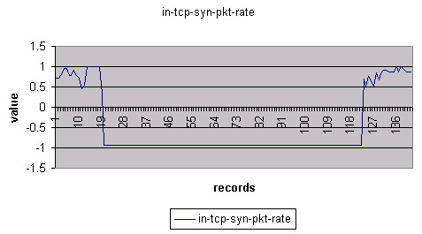

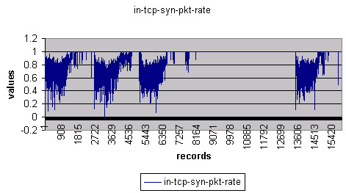
Figure 2: Field ‘Input TCP SYN Packet Rate’ for attack data (top graph) and non-attack data (bottom graph)
There are 45 different network parameters monitored in this data set; each record includes a truth label that signifies whether a particular record is an attack or valid network traffic. A value or ‘-1’ means that it is an attack and a value of ‘1’ means that it is a non-attack.
The purpose of doing the analysis is to achieve high rates of successful detection of attacks, as evaluated by the truth labels. To this end, a table was created of monitored parameter similarity scores and all the data in the data set were loaded into the Oracle database. Each of 45 parameter similarity score fields was graphed for each of the CONEX Testbed Set A and the seven weeks of the DARPA Set B. Observations of the behavior and the patterns in the collected data helped to design queries that correctly detect attacks. As an example, let us observe the parameter termed “in-tcp-syn-pkt-rate” for Set B graphed in Fig. 2. The figure represents two graphs of the same field; the top graph depicts attack data and the bottom shows valid traffic. The difference is clearly noticeable – most of the attacks have negative value for this field, however non-attack data have only positive values.
For each field graphed, a query was carried out for it in the database to catch exceptions, and a list was constructed along with data description and behavior. After analyzing the list and signifying the most important columns – fields that are exclusively negative in case of attacks, the following SQL query was constructed:
29
SELECT *
FROM week7
WHERE
in_ip_frag_rate<0 OR in_ip_csum_error_rate<0 OR
in_tcp_syn_pkt_rate<0 OR
in_tcp_con_new_opened<0 OR
in_icmp_pkt_rate<0 OR
out_icmp_pkt_rate<0 OR

io_icmp_anomalousecho_reply<0;
This query does not return any False Positives, which is good, however it has number of False Negatives in the result. Results of attack discovery, is shown in the Table 1, below.

Table 1. Results of the first query
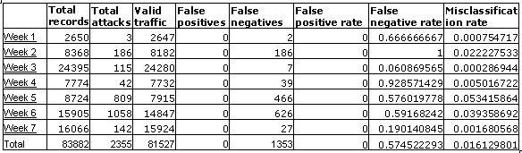

The formulas for Table 1 columns are the following:
False Positives – the number of valid traffic samples classified as attacks.
False Negatives – the number of attacks classified as valid traffic.
False Positive Rate – the ratio between the false positives and total number of valid traffic samples.
False Negative Rate – the ratio between the false negatives and the total number of attack samples.
Misclassification Rate – the ratio between the total misclassifications and the total number of samples. (FP + FN)/total
As we can see, the results are overall unsatisfactory. For weeks one, three and seven, results were acceptable and even good, however for other weeks despite the fact that there are no false positives, a lot of attacks were still left unidentified.
In order to improve results, based on the promise of the similarity score analysis, more fields were added in the query, thus arriving to the following improved query:
SELECT *
FROM week7
WHERE
in_ip_frag_rate<0 OR
in_ip_csum_error_rate<0 OR
in_tcp_syn_pkt_rate<0 OR
in_tcp_con_new_opened<0 OR
in_icmp_pkt_rate<0 OR
out_icmp_pkt_rate<0 OR
io_icmp_anomalousecho_reply<0 OR
in_tcp_con_new_aborted<0 OR
in_icmp_diff_dst<0 OR
in_udp_pkt_rate<0;

Although this query introduces some False Positives, it eliminates a lot of False Negatives. Results of this query analysis are displayed in Table 2. Obvious improvements can be seen after including additional fields.
35
Although results of similar analyses are not available to the authors, the evaluation of the Feature-Extraction Algorithms has been done on the same data set but by using a different approach by Zheng Zhang [2]. We now compare the query-based results of the present method against results of that study [2].
There were different classification architectures that were used. Table 3 shows the results of the Feature-Extraction Algorithm study.
In order to improve results, it has been tried to figure out what would be the best threshold that should be in the query. Initially, it was zero, but subsequent experimentation with values from –0.5 to 0.4 obtained a threshold value sensitivity study the results which are given in Table 4.
For visualization purposes, a graph has also been constructed; it can be observed in Fig. 3
It is seen from the table and the graph that the threshold value with the smallest Misclassification rate is - 0.3, which equals to about 0.0066. So the final accumulation of results can be seen in Table 5.
37
As we can see the above SQL-based analysis along with field study, gives the same order of results as such feature extraction algorithms as Backpropagation Neural Network, Linear Vector Quantization and Support Vector Machine for DISTANCE data.
Although the time that it takes for writing final SQL queries may vary depending on the attack complication, once most of the known attacks are figured out and SQL signatures are finished, the speed of detecting attacks should increase.
36

Table 2. Results of the query-based statistical analysis conducted
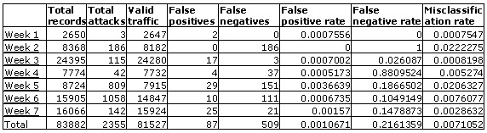
Table 3. Results of Feature-Extraction Algorithm study
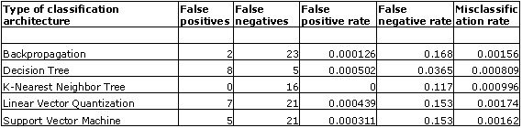
Table 4. Experimental values of threshold and corresponding Misclassification rate

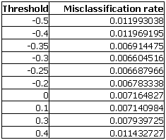
Figure 3: Field ‘Input TCP SYN Packet Rate’ for attack data (top graph) and non-attack data (bottom graph)

6 Discussion of the Results
As can be seen from Table 5 the results of the query-based SQL analysis vary from week to week. For weeks one and three the results are very good, even better than Feature-Extraction Algorithm study numbers. Weeks four, six and seven have average results but weeks two and five have really high false negative rates. What is interesting in this study is that there are not many false positives but many more false negatives. This may be because of the way we analyzed the data – we considered only network features that had the most impact on the detection of the attack, neglecting features with smaller attack detection rates. One way to improve these results would be to analyze more data, and try to identify more patterns out of existing network features. Another way would be to include more fields to reach the maximum level of detection of attacks, but then the false positive rate will increase. Another good way of improving results and automating the process of finding interesting patterns would be writing stored procedures in our database. It would, however, require higher-level programming and database administration skills.

7 Conclusion
The objective of this project was to integrate a database system with an intrusion detection system and with the help of SQL analysis, prove that it will bring improvements to network security.
Leveraging the power of today’s commercial database systems, it is possible to simplify and improve the task of managing and searching intrusion detection data. This project is an inexpensive and well-performing way to make it easier for the administrators and security personnel to archive, manipulate the information, audit and mine the data, and easier for managers to interpret it. The results of the analysis show that this can be an effective system with only a 0.001 misclassification rate. The system captured approximately 82% of the attacks from a particular data set. Programming languages such as Pro*C/C++ or Perl can create programs that would utilize SQL queries in their statistical analysis algorithms to further automate the process of detecting intrusions. If the latest statistical intrusion detection algorithms are used in conjunction with such a system, the capture rate will increase.
SQL and database systems alone cannot entirely perform statistical analysis for us. They are, however, a means of storing, accessing, searching, and presenting data to analysts, allowing them to be more efficient their jobs.
38

Table 5. Final Results
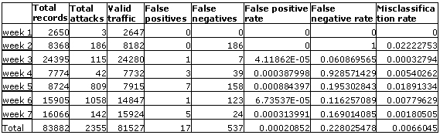

References
- P. Dokas, L. Ertoz, V. Kumar, A. Lazarevic, Srivastava, and J. Tan, “Data Mining for Network Intrusion Detection,” Computer Science Department, University of Minnesota, 2003.
- Z. Zhang, C. Manikopoulos, "Neural Networks in Statistical Anomaly Intrusion Detection," Journal of Neural Network World, Vol. 3, 2001, pp. 305-316.
- Riptech Inc., “Successful Real-Time Security Monitoring,” white paper, 2001.
- R. Heady, G. Luger, A. Maccabe, and M. Servilla, “The Architecture of a Network Level Intrusion Detection System,” Computer Science Department, University of Mexico, Technical report, 1990.
- S. M. Bellovin, “Security Problems in the TCP/IP Protocol Suite,” Computer Communication Review 19(2), 1989, pp. 32-48.
- W. Lee, and K. W. Mok, “Adaptive Intrusion Detection: a Data Mining Approach,” Computer Science Department, Columbia University, 2000.
- S. Kumar, ”Classification and Detection of Computer Intrusions,” Ph. D. Thesis, Purdue University, 1995.
- S. Northcutt. (2000). Intrusion detection FAQ. SANS Institute. [Online]. Available: http://www.sans.org/resources/idfaq/network_based.php
- M. Phung. (2000). Data Mining in Intrusion Detection. SANS Institute. [Online]. Available: http://www.sans.org/resources/idfaq/data_mining.php
- A. Yee, “The Intelligent IDS: Next Generation Network Intrusion Management Revealed,” NFR Security Inc. Research paper, 2003.
- Kurt Thearling. (1995). From Data Mining to Database Marketing. DIG White Paper. [Online]. Available: http://www.thearling.com/text/wp9502/wp9502.htm
- M. Lincoln Labs (1998). 1998 DARPA intrusion detection evaluation data set. [Online] Available : http://www.ll.mit.edu/IST/ideval/data/1998/1998_data_index.html

