~TEST: An Effective Automation Tool for Testing Embedded Software

Changhyun Baek, Seungkyu Park, and Kyunghee Choi
Graduate School of Information and Communication
Ajou University
San 5, Suwon, Kyunggi
REPUBLIC OF KOREA
http://www.ajou.ac.kr

Abstract: - Much effort has been made to develop efficient tools for test automation of embedded software. To enhance higher level of test automation, so that errors are detected as early as possible, more comprehensive analytical measures should be taken to embedded systems. This paper presents a framework and implementation of an effective tool for test automation, in which Finite State Machine and Background Logic are adopted for modeling and the tool tests automatically analog and digital embedded systems. The tool aims to be more generic. The integrated tool, called TEST, is implemented to support all aspects occurring from modeling to test case generation. Applying TEST to actual applications shows a significant effectiveness in terms of finding errors and reducing time required to run the test.

Key-Words: Test Automation Tool, Embedded Software, System Test, Black-box Test, Test Case, Test Coverage

1 Introduction

Rapid increase of embedded systems in electronic and mechanical control systems gets engineers into major concerns on quality and reliability of final products. Benefits from more flexibility and functionalities by embedded software as a core element of the system can be cancelled by the decrease of the reliability which represents the low quality, if it does not guarantee the error-free software in the given embedded system [1].
High competitions among products and shorter life cycles for new systems require fast development of embedded software, which by consequence makes high error-prone products. Taking all those factors into accounts, much effort has recently been made to study and develop more comprehensive testing tools which allow automatic tests of embedded software [2][3].
In this paper, we present a framework for testing embedded software. In addition, a case study of an effective automation tool, called TEST (Testing-stand for Embedded Software Test) which was implemented as a result of this research, is described. The techniques of Finite State Machine and Background Logic are adopted for modeling and the tool tests automatically analog and digital embedded systems. It supports all aspects occurring from modeling to test cases generation. This leads to a near general-purpose test automation tool for embedded software. Applying TEST to an actual application shows a significant effectiveness in terms finding errors and reducing time required to run the test.
The remainder of the paper is organized as follows. In Section 2 we describe the essential factors to under considerations to design the test automation tool. In Section 3 we present the domain engineering of the embedded system or embedded software from a testing point of view. In Section 4 we describe the test process using TEST, and more details are described in the area of implementing TEST. Section 5 is dedicated to performance evaluation. Conclusions and future works are included in Section 6.

2 Features for Embedded Software Test

Following features have to be considered to achieve the test automation of embedded software.

  - Value of Input Output Parameters

Special features must be taken into consideration when an embedded system is designed. Most embedded systems calculate the value form external devices which give either digital or analog values.
This means that we must extend the values of input/output parameters to those from hardware components (a sensor, indicator, display, or actuator) when we test the embedded software [1] [4].

  - Test Automation for Dedicated Domain

The conventional automation tools for testing embedded software are mostly dedicated to one specific area. Moreover, they are used for the unit test. This restriction is characterized by "Not Portable" and "Not Generic". It mainly comes from the fact that the application area of embedded software is so diverse that the tool can not support such requirements with a given tool. Many companies use the proprietary embedded software due to the lack of commercially available general purpose tools that is suitable to test own software [5][6][7][8].

  - Test Coverage for Embedded SW

The coverage of input/output values in embedded software can be different from those of conventional software due to the effects from hardware environment. While a conventional software test focuses on internal values for some variables, an embedded software testing should prepare for the cases of unexpected values caused by degradation failures of hardware components.
Fig.1 shows how to configure test cases for embedded software test. The area of ① indicates the test case which covers given software specification. The area of ② indicates the test case which could be needed due to the influence of hardware components. Finally the area of ③ indicates the test case which is required by different environments.

ENV

Software
①
②
③
Hardware
Fig.1 Test case configuration for the Embedded Software.
Degradation failures are critical cases that should be taken into consideration [9][10]. Analog input data may exceed the input limit due to effects of the degradation failure. Although an ADC (Analog-to-Digital Converter) was designed to process analog data within the range from 3V to 5V and to convert given input data to decimal integer from 300 to 500, it may generate data to exceed the input range due to the hardware failure or environmental interferences. Fig.2 shows an example how a hardware failure or an environmental effect may change the input data of ADC. In Fig.2 a dotted arrow indicates the system input, and a solid line indicates the software input converted by ADC.

ADC
ADC
2.0~4.0 Volt
1.0~5.0 Volt
200~400
100~500
Degradation Failure or Environmental Effect
Fig.2 The change of the input value caused by hardware and environmental effect.

3 Domain Engineering for Test Automation Tool

The domain engineering is initially required to design an automated tool. For the family of similar systems, domain engineering covers all the activities for building software core assets. These activities include identifying one or more domains, capturing the variation within a domain, constructing an adaptable design, and defining the mechanisms for translating requirements into systems created from reusable components [11].
Same technique can be applied in the design of test automation tool for heterogeneous embedded software. The domain analysis gives commonalities and differences of the systems in the domain as shown in Table1 [12]. In the case of the test automation tool mainly based on the black-box test, we may just consider the input/output (I/O) medium and comparison method of the embedded system [13][14]. Table2 shows one way of classifying Differences in Table 1.

Table1 Commonalities and differences of the test automation tool. Most of features could be applied to all kinds of the test automation tools.
 | Features
Commonalities | Test case generation  Test Execution  Test Environment Configuration  Bug Tracing  Automated Comparison  Capturing actual result  Generating expected result
Differences | I/O  Comparison Method

Table2 The types of the test automation tools classified by the varieties of the embedded system.
 | Realtime | Non-Realtime
Analog | Post-Execution | Using DAQ board
Digital | Post-Execution | Ethernet, RS232
Hybrid | Post-Execution | Hybrid

Those embedded systems may be either realtime or non-realtime applications, where underlying hardware are analog, digital, or hybrid systems. In the realtime mode, comparison of the execution results run by a give script is performed on Post-Execution fashion.

Table3 Comparison and IO method based on system classification.
 | Comparison | IO
AR | Post-Execution | Using DAQ board
DR | Post-Execution | Ethernet, RS232
HR | Post-Execution | Hybrid
AN | Dynamic | Using DAQ board
DN | Dynamic | Ethernet, RS232
HN | Dynamic | Hybrid

Table3 gives the combination of all cases driven from Table2. For Example, in case of AR Type, a test automation tool should support Post-Execution Comparison and input and output method using DAQ (Data Acquisition) board. Based on this table, we can approach to generic tool for test automation through various I/O supports and comparison functionality.

4 Testing-stand for Embedded Software Test

TEST (Testing-stand for Embedded Software Test) is a tool which is implemented to support several features described in Section 3. Fig.4 shows the architecture of TEST and Fig.5 presents graphical user interface of TEST.

  - Test Environment

TEST works on the various test environments. Different application area noted on Table3 can be run on TEST. If any tester wants to test AR, TEST supports post-execution comparison and I/O using DAQ board.

  - Test Process

A test process is composed of several parts such as SUT (System under Test) Modeling, Model Checking, Generating test cases, Test execution, and error report. This section describes in detail how TEST supports each part.

4.2.1 Modeling embedded software

A test automation tool based on black-box test generates the test oracle and test cases based on SUT’s specification. To do so, the correct modeling method is essential to establish a test automation tool.
TEST provides modeling method based on SML (Specification Modeling Language). SML consists of FSM (Finite State Machine) and BGL (Background Logic). We adapt BGL to prevent the explosion of test cases. A pure FSM model generates thousands of state when we model complex embedded system. So we define all-round function which makes influence on all state into BGL.
FSM and BGL are defined as following.

FSM = {S0, S, G, M}
BGL = {SC, SA, EC, EA, SupC, SubC, M}
Table 4 Keywords.
Keyword | Description
S0 | Initial State
S | Set of States
G | Set of Guard
M | Set of Macro functions
SC | Start conditions
SA | Start actions
EC | End condition
EA | End actions
SubC | Sub-conditions
SupC | Super conditions

4.2.2 Model Check

TEST support model checking function. This step checks incorrect user input and syntax error of the SML.

4.2.3 Generating Test Case

TEST generates automatically million lines of test scripts based on SML. And TEST supports the boundary value analysis and the equivalent partitioning method to reduce test cases. Fig.3 shows a file of test case which was generated by TEST. A test script consists of a sequence ID, 3 command lines (command, variable, and value), and time-out.

//-------------Ambient Sensor-----------------
0| WRITE |CTL_IGN_OUT|0|0|0|0|0|0|0|200
1| WRITE |CTL_BATT_OUT|0|0|0|0|0|0|0|200
2| WAIT |0|0|0|0|0|0|0|0|3000
3| WRITE |CTL_BATT_OUT|1|0|0|0|0|0|0|200
4| WRITE |CTL_IGN_OUT|1|0|0|0|0|0|0|200
5| WAIT |0|0|0|0|0|0|0|0|2000
6| WRITE |TEST_MODE_INP|2|0|0|0|0|0|0|200
7| WAIT |0|0|0|0|0|0|0|0|2000
8| CHECK |0|0|0|0|0|0|0|0|200
9| WRITE |SEN_Ambient_INP|20|0|0|0|0|0|0|200
10| LOOP |SEN_Ambient_REV|20|…
11| WRITE |SEN_Incar_INP|25|0|0|0|0|0|0|200
12| LOOP |SEN_Incar_REV|25|…
13| WRITE |SEN_Photo_INP|0|0|0|0|0|0|0|200
Fig. 3 The example of the test case file.

4.2.4 Test Execution

TEST conducts automated test using a file of test case. When tester press the ‘test start’ button, TEST loads some files of test cases, parse it, and give some messages to components. And TEST supports some functionality as following [14][15]:
- Automating test oracle generation
- Automated comparison [16]
- Real-time system status reporting
- Multiple test case file execution

4.2.5 SW Error Reporting

TEST provides reports of results from automated test which include functions to trace software bugs. The report is written based on IEEE Standard 829[18]. It also includes project information, test information and tracing information.
The project information includes model name, test start time, test end time, test mode, and VEO (Virtual Environment Operator) information [17]. The test information includes the number of comparison, the number of pass, and the number of fail. The tracing information includes values of test oracle and actual result.

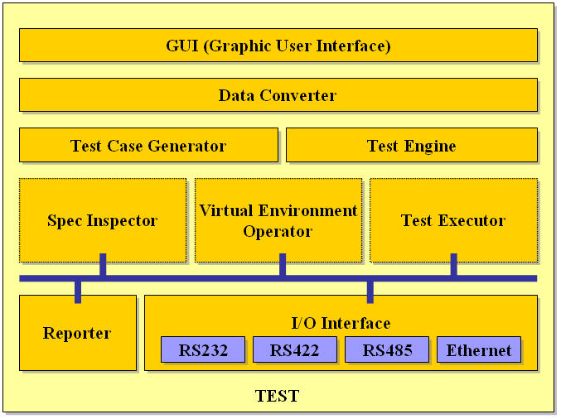
Fig. 4 TEST architecture.

  - Implementing TEST

We design and implement TEST for testing complex embedded software. Fig.4 shows the test software architecture. Data Converter converts the SML into internal data structures to be used in the test software. Test Engine manages lower modules and Test Executor performs the scheduling of the test. Spec Inspector generates the test oracle and Reporter creates the report in the format of HTML automatically. In the proposed architecture, each module communicates with other module through the queue (see blue line in the Fig.4) to save the test time.

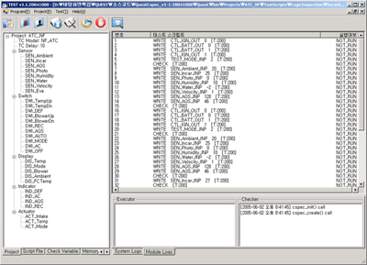
Fig.5 TEST Graphical User Interface

5 TEST Performance Evaluation

We tested an embedded system, an air conditioning system, using TEST. The system has sensors, actuators, indicators, and displays which amounts in total from 12 to 32 depending on model. This system has a record for manual test by the manufacturer.
Fig.6 shows the TEST with system under test, an air conditioning system.

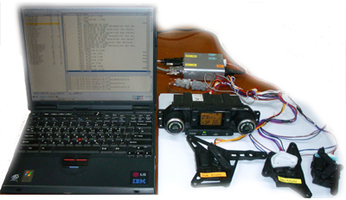
Fig.6 A snapshot of the test using TEST

We performed 76,800 test cases which were automatically generated by TEST. We found 10 software bugs which could not be taken from manual tests. They are composed of 7 major bugs, 2 minor bugs, and 1 specification error. Major bug means that the system control its hardware component incorrectly, minor bug means that it works incorrectly for a while. Specification error is occurred by misunderstanding of the system specification.

6 Conclusion and Future Works

We have designed and developed a generic test automation tool, called TEST. We test real embedded system using TEST and find several software bugs.
We plan to improve the performance of TEST by the future research on the test case reduction and on the test case prioritization, which is expected to obtain more cost-effective test tool for embedded software.
At the end, HN type of I/O interface has developed to evaluate the performance of TEST. We will develop other types of I/O interfaces and add them into TEST.

References:

[1] Bart Broekman and Edwin Notenboom, Testing Embedded Software, Addison Wesley, 2003.
[2] B. Beizer, Software Testing Techniques, 2nd Ed., International Thomson Computer Press, 1990.
[3] Kelvin Rodd, Practical Guide to Software System Testing, K.J. Ross & Associates Pty. Ltd, 1998.
[4] Boris Beizer, Black-Box Testing, John Willey & Sons, 1995.
[5] L. Hayes, The Automated Testing Handbook, 1995.
[6] OVUM, Software Testing Tools, OVUM, 1999.
[7] M. Sowers, Software Testing Tools Summary, Software Development Technologies Inc. White Paper, 2002.
[8] STEN, http://www.sten.or.kr, Software Test Engineer Network.
[9] Patrick D. T. O'Connor, Practical Reliability Engineering, John Wiley & Sons, 2002.
[10] W. Grant Ireson, Clyde F. Coombs, and Richard Y. Moss, Handbook of Reliability Engineering and Management, McGraw-Hill Professional, 1995.
[11] G. Chastek, P. Donohoe, K. Kang, and S. Thiel, Product Line Analysis: A Practical Introduction, Technical Report CMU/SEI-2001-TR-001, Software Engineering Institute, Carnegie Mellon University, 2001.
[12] K. Lee, K. Kang, and J. Lee, Concepts and Guidelines of Feature Modeling for Product Line Software Engineering, 7th ICSR.
[13] Douglas Hoffman, Using Test Oracles in Automation, Pacific Northwest Software Quality Conference, 2001.
[14] E. Dustin, J.Rashka, and J. Paul, Automated Software Testing, Addison Wesley, 1999.
[15] M. Fewster, D. Graham, Software Testing Automation: Effective use of test execution tools, ACM Press, Addison Wesley, 1999.
[16] Beommo Kim, Changhyun Baek, Joongsoon Jang, Gihyun Jung, Kyunghee Choi, and Seungkyu Park, A Design and Implementation of the Check Module for the Test of Embedded Software, KISS Conference, 2004.
[17] Beommo Kim, Changhyun Baek, Joongsoon Jang, Gihyun Jung, Kyunghee Choi, and Seungkyu Park, A Design and Implementation of Virtual Environment Operator for the Embedded Software Test, Korea Computer Congress 2005, 2005.
[18] IEEE-SA, IEEE829: IEEE Standard for Software Test Documentation, IEEE-SA Standards Board, 1998.

