YING LI YO-SHEN HSIEH
Communications Engineering Department
Yuan Ze University
135 Yuan Tong Road, Chungli, Taoyuan 32026
TAIWAN

PAPR Reduction via Linear Phase Variations

Abstract: - An efficient OFDM peak to average power ratio (PAPR) reduction method using linear phase variation is proposed. Applying linear phase variations to subblocks of subcarriers is equal to cyclic shifting the corresponding time signals and thus can prevent “peak collisions”. This method differs from conventional partial transmit sequence (PTS) techniques in that PTS applies constant phase variations to subblocks. Performance comparison of linear phase variation, constant phase variation and tone reservation with the same number of redundant bits is conducted with 8, 52, and 128-subcarrier QPSK-OFDM signals. Linear phase variation achieves the best PAPR reduction performance in our simulations. Exhaustive test in the 8-subcarrier case when the subcarriers are partitioned into two equal-sized subblocks of consecutive subcarriers shows that all quaternary length 8 Golay sequences are selected with linear phase variation whereas 1/4 are selected for constant phase variation. Boolean function decomposition of the variation sequence provides explanation for this phenomenon.

Key-words:- OFDM, PAPR Reduction, PTS, Linear Phase, Golay Sequences, Boolean function.

1 Introduction
Orthogonal Frequency Division Multiplexing (OFDM) signals [1] are widely employed in modern digital communication systems due to their high spectral efficiency and anti-frequency selective fading ability. One disadvantage of OFDM signals is their high peak to average power ratio (PAPR) and the resultant low power efficiency due to large backoff requirement at the transmitter amplifier. PAPR reduction techniques aim to prevent high peaks with signal preprocessing, improve the immunity of OFDM signals toward amplifier nonlinearity, and raise the power efficiency.

Among the PAPR reduction methods, Partial Transmit Sequence (PTS) [2] is considered a rather flexible technique. OFDM subcarriers are divided into disjoint subblocks, constant phase variations are applied to each subblock, and the variation combination that result in the smallest PAPR is selected and applied to the OFDM signal. At the receiver the phase variation is removed using side information transmitted within the OFDM symbol.

Since constant phase variation applied to the spectrum equals the same phase variation of the time signal, these variations may also be applied in the time domain to the “partial transmit sequences”, i.e. the time signals corresponding to the subblocks of subcarriers. No extra IFFTs are required for different phase variations after the partial transmit sequences are created. PTS thus compares favorably to selective mapping (SLM) technique that requires an IFFT for each phase variation combination. PTS can be applied to any subcarrier modulation, subblock partition, and the phase variation resolution can be adjusted easily, making it flexible to tradeoff computation and performance.

In this paper we propose a PAPR reduction method that differs from PTS in that linear phase variations as opposed to constant phase variations are applied to subblocks of consecutive subcarriers. Simulations results are presented to illustrate the effectiveness of our method. Exhaustive test with 8-subcarrier QPSK-OFDM signals show that linear phase variation keeps all quaternary length 8 Golay sequences, whereas constant phase variation keeps 1/4 of the Golay sequences. Boolean function decomposition of the variation sequence explains why this phenomenon occurs.

Applying linear phase variations in the frequency domian correspond to cyclic shifting the time domain partial transmit sequences and can prevent “peak collisions”. Applying constant phase variations (conventional PTS) change the phase but not the relative peak power positions of the partial transmit time sequences. An interesting feature of linear phase variation is: part of the data subcarriers will never be varied, whereas constant phase variation may change the phase of all subcarriers in the subblock. Pilot tones can thus be included in the subblocks for linear phase variation but not for constant phase variation. If the receiver fails to correctly recover the phase variation of a subblock, all data will be in error for constant phase variation but part of the data subcarriers can still be correctly recovered with linear phase variation.

2 Linear Phase Variations
The complex baseband time sequence of an OFDM symbol in a symbol duration can be expressed as the sum of N orthogonal subcarriers as follows:
$x_{k}=\sum{X_{n}e^{j2π(n−1)Δ{\text{fTk}}/L}}, k=0,1,\text{.}\text{.},\text{LN}−1$ (1)
N is the number of orthogonal subcarriers, L is the oversampling ratio, $\text{NT}$is the symbol duration, $Δf=1/{\text{NT}}$is the subcarrier frequency spacing, $x_{k}$ is the kth time sample, and $X_{n}$is the frequency domain symbol for the nth subcarrier. The peak to average power ratio (PAPR) of a symbol is defined as follows.
$$\text{PAPR}={\text{max}}_{k}|x_{k}|/E[x_{k}], k=0,1,\text{.}\text{.},\text{LN}−1$$

The N subcarriers can be partitioned into M disjoint subblocks of consecutive subcarriers with sizes s₁,.., s_{M}. $N=\sum{s_{m}}$. The time sequence {$x_{k}$} can be written as the sum of M partial transmit time sequences {$x_{k}^{m}$} as follows.
$x_{k}=\sum{x_{k}^{m}},$ where
$x_{k}^{m}=\sum{X_{n}^{m}e^{j2π(n−1)Δ{\text{fTk}}/L}},k=0,1,\text{.}\text{.},\text{LN}−1$ (2)
and $X_{n}^{m}=X_{n} \text{when} n∈S_{m}, X_{n}^{m}=0 \text{otherwise}$ The subcarrier index in each subblock is as follows: $S_{1}=\left\{1,\text{.}\text{.},s_{1}\right\},S_{2}=\left\{s_{1}+1,s_{1}+2,\text{.}\text{.},s_{1}+s_{2}\right\},\text{.}\text{.}\text{.}\text{.}$, $S_{M}=\left\{(\sum{s_{m})+1,}(\sum{s_{m})}+2,\text{.}\text{.}\text{.},(\sum{s_{m})}\right\}$.
Each subblock contains consecutive subcarriers. The size of the subblocks need not be equal.

In the following the linear phase variation method is explained using a complete OFDM symbol as opposed to a subblock, for the sake of notation simplicity. Extending this idea to subblocks of consecutive subcarriers would be straightforward.

It is a well-known Fourier transform property that linear phase variation in one domain leads to translation (shifting) in another domain. Suppose linear phase variation is applied to OFDM frequency domain symbols, ${\tilde{X}}_{n}=e^{j(n−1)θ_{0}}X_{n}$ for all n, the time sequence {${\tilde{x}}_{k}$} can be shown to be the translated version of {$x_{k}$} as follows:
$\begin{aligned}{\tilde{x}}_{k}=\sum{X_{n}e^{j(n−1)θ_{0}}e^{j2π(n−1)Δ{\text{fTk}}/L}} \\ =\sum{X_{n}e^{j2π(n−1)Δ\text{fT}(k+d)/L}} \\ =x_{k+d}\end{aligned}$ (3)
where $d={{Lθ}_{0}}/(2πΔ\text{fT})=\text{LN}({θ_{0}}/2π)$. If $θ_{0}=π/2$, ${\tilde{x}}_{k}=x_{k+({\text{LN}}/4)}$corresponds to $x_{k}$ cyclic shifted left by 1/4 symbol durations (or LN/4 samples). Cyclic shifts of 1/2 and 3/4 symbol durations can also be achieved using linear phase variation in units of 2$θ_{0}$, 3$θ_{0}$ in the frequency domain. Overall, linear phase variations of the frequency domain symbol sequence: {${\tilde{X}}_{n}=e^{j(n−1){pθ}_{0}}X_{n}$},$θ_{0}=2π/H, p=0,1,2,\text{.}\text{.},H−1$corres-pond to cyclic shifts in the time sequence, {${\tilde{x}}_{k}=x_{k+p({\text{LN}}/H)}$},$p=0,1,2\text{.}\text{.}\text{.}H−1\text{.}$ The side bits required to indicate the p-value can appear as an H-PSK symbol on an reserved subcarrier in each subblock by setting the original symbol on that reserved subcarrier to be $X_{n}=1$. After linear phase variations, ${\tilde{X}}_{n}=e^{j(n−1){pθ}_{0}}X_{n}=e^{j(n−1){pθ}_{0}}$ thus contains the value ${pθ}_{0}$required for the receiver to undo the linear phase variation. Note that the reserved subcarrier must be at a location n where {$(n−1){pθ}_{0}$} are different for different values of p. The first subcarrier (n=1), the third subcarrier (n=3) do not satisfy this condition, whereas the second and fourth subcarriers do. We use the second subcarrier in each subblock (n=2) as the reserved subcarrier to carry embedded side bits. More reserved subcarrier may be employed for embedded side bits to obtain improved protection.

The previously mentioned linear phase variation can be applied independently to M-1 of the disjoint subblocks of subcarriers. No variation is applied to the last subblock since it is unnecessary to shift all partial transmit sequences. At the transmitter, linear phase variations can be applied to the frequency domain sequences or be created as a result of cyclic shifting M-1 time domain partial transmit sequences. After applying each combination of shifts, all M partial transmit sequences are added and the peak power is computed. When $θ_{0}=2π(1/H)$, there are H^{M-1} variation combinations. The combination with the smallest peak power is selected for transmission. At the receiver, the phase of side information carrying subcarriers are observed after the FFT operation. Linear phase variation for each subblock of subcarriers can then be removed in the frequency domain before further processing.

One issue with subblock constant phase variation in conventional PTS is that when the side information bits are not correctly recovered, all received subcarrier symbols in that subblock would be wrong. Linear phase variation is more robust in that if $θ_{0}=2π(1/H)$, there are always 1/H subcarriers spaced H subcarriers apart in each subblock that never undergo any phase variations since integer multiples of H$θ_{0}$equal zero phase shift. Data on these no-variation subcarriers can be correctly recovered even when side information bits are mistaken in the receiver. Pilot tones can be included in these no-variation subcarriers and it is not necessary to break the subblocks around the pilot tones. Locations of these no-variation subcarriers can be shifted in the frequency domain by adding constant phase (known to the receiver) to all subcarriers in the subblock when necessary, e.g. to accommodate particular pilot locations.

3 Simulation Results
In this section, simulation results with N=8, 52 and 128-subcarrier QPSK-OFDM signals are presented. The subcarriers are partitioned into M=2, 4, and 4 disjoint equal-sized subblocks of consecutive subcarriers in each case. The first M-1 subblocks undergo variations and the last subblock remains unchanged. We compare the PAPR reduction performance of linear phase variation, constant phase variation, and tone reservation (using QPSK symbols on the reserved tones). The number of variations (H=4 per subblock) and the number of redundant bits (2 bits per subblock) are the same in all three methods. In each subblock where variations are applied, the original frequency domain sequence X=[X₁, 1, X₃, X₄…] is changed into $\tilde{X}$ as follows (X₂=1 is the reserved tone). $θ_{0}=2π(1/H)=π/2$.

(a) Linear phase variation:
$\begin{aligned}{\tilde{X}}_{n}=e^{j(n−1){pθ}_{0}}X_{n} \text{for all n, }p=0,1,2,3; \\ {\tilde{x}}_{k}=x_{k+d}, d=\text{LN}({{pθ}_{0}}/2π)\end{aligned}$ (4)
(b) Constant phase variation:
$\begin{aligned}{\tilde{X}}_{n}=e^{\text{jp}θ_{0}}X_{n}\text{ for all n, }p=0,1,2,3; \\ {\tilde{x}}_{k}=e^{\text{jp}θ_{0}}x_{k}, d=\text{LN}({pθ}_{0}2π)\end{aligned}$ (5)
(c) Tone Reservation:
${\tilde{X}}_{n}=\left\{\begin{matrix}e^{\text{jp}θ_{0}}X_{n}=e^{\text{jp}θ_{0}} n=2, \text{reserved} \text{tone} \\ X_{n} n≠2\end{matrix}\right.$ (6)
In tone reservation, phase variations are applied to the reserved tones only. The symbol on the reserved tone need not be recovered at the receiver and need not follow the data format of other subcarriers. The reserved tone symbol is limited to QPSK symbols here so that all three methods apply four variations to each subblock for PAPR reduction optimization.

The computation complexity of linear phase variation is the same as constant phase variation (conventional PTS) when variations are applied in the frequency domain to {X_{n}}, as can be seen from equations (4)(5). The complexity of tone reservation is smaller since phase variations are applied to the small number of reserved tones only, not all subcarriers in the subblock, see (6). If variations are applied in the time domain to the partial transmit time sequences {x_{k}}, only cyclic shifts are involved for linear phase variations for any value of H. Constant phase variations require multiplications as H increases. Therefore the complexity of linear phase variations is equal to or less than the complexity of constant phase variations. For tone reservation the time domain variations can correspond to cyclic shifts when only one reserved tone exists per subblock (same complexity as linear phase variations), but can be more complex when there are more than one reserved tones per subblock.

The complementary cumulative distribution functions (CCDF) of the PAPR values are plotted in Fig. 1~ 3. In Fig. 1 the PAPR CCDF of 7 subcarrier QPSK-OFDM signals (setting X₂=0) is also plotted for comparison, since any method using 7 data subcarriers and 1 redundant subcarrier is effective only when it achieves better PAPR compares to the 7-subcarrier case. Exhaustive test is conducted for 8 subcarriers where all possible QPSK sequences X with one reserved subcarrier (setting X₂=1, total 4⁷ combinations) are employed and each varied in 4 ways for PAPR reduction. 10⁶ randomly generated OFDM sequences are employed for 52 and 128 subcarriers, where the QPSK symbols on the three reserved subcarriers in the varying subblocks are set to be 1, and each sequence is varied in 4³=64 ways to find the minimum PAPR variation. With the same number of variations and redundant bits, linear phase variation achieves the best PAPR reduction performance in all three cases (see Fig. 1~3). In Fig. 1, linear phase variation achieves a little more than 2dB PAPR reduction at CCDF 10⁻³. The reductions are approximately 4 dB in Fig. 2 and Fig. 3. Tone reservation performs better in Fig. 1 compare to constant phase variation, in Fig. 2 and Fig. 3 the situation is reversed as the percentage of reserved tone power decreases.

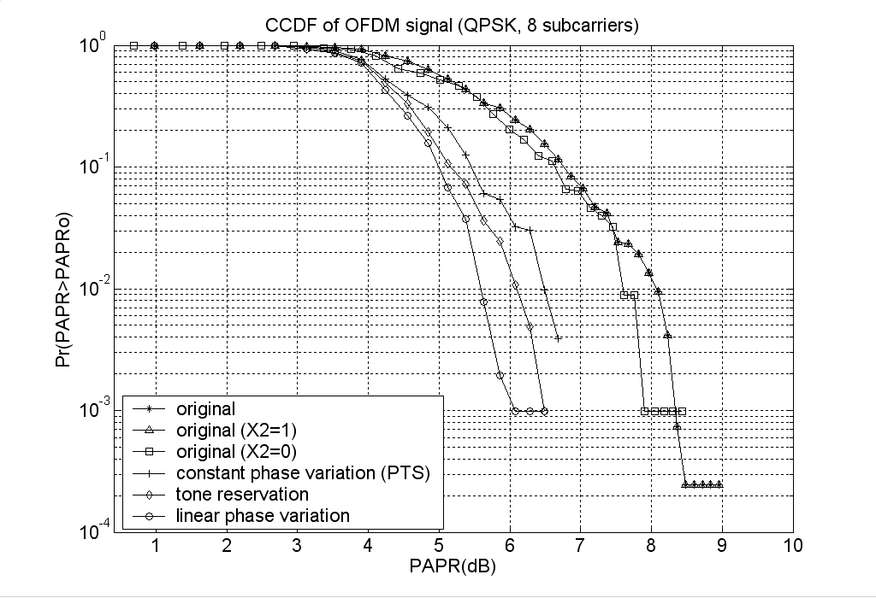
Fig. 1 PAPR CCDF for 8-subcarrier QPSK -OFDM signals partitioned into 2 size-4 subblocks (2 redundant bits, 4 variations per symbol).

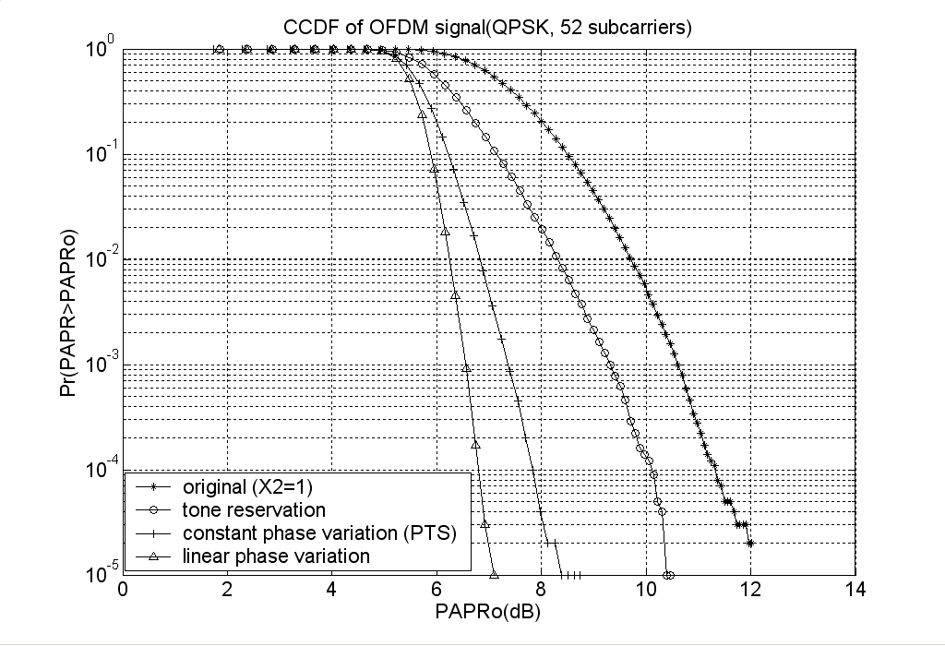
Fig. 2 PAPR CCDF for 52-subcarrier QPSK -OFDM signals partitioned into 4 size-13 subblocks (6 redundant bits, 64 variations per symbol).

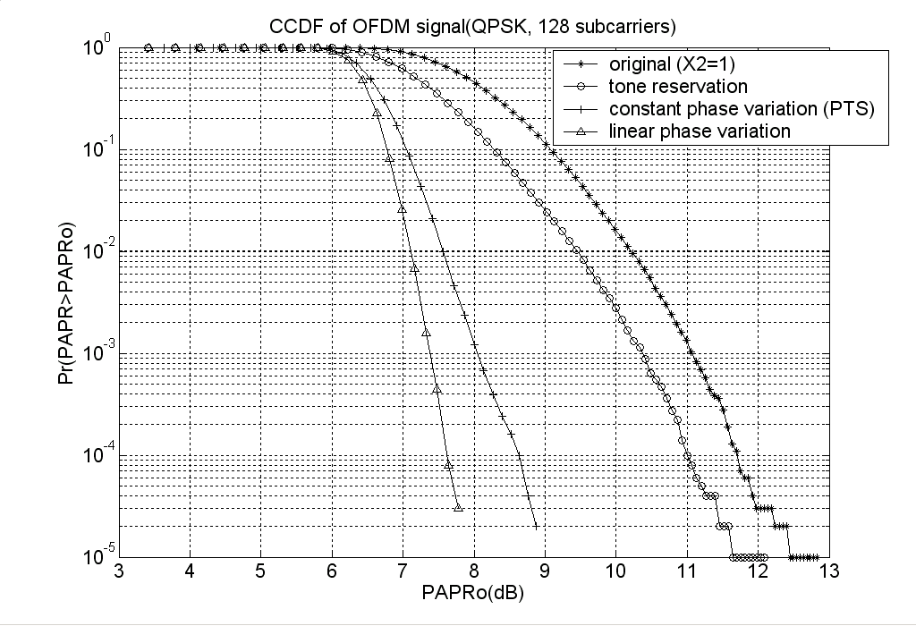
Fig. 3 PAPR CCDF for 128-subcarrier QPSK -OFDM signals partitioned into 4 size-32 subblocks (6 redundant bits, 64 variations per symbol).

Variation Sequence Analysis
Given the simulation results in Fig. 1~Fig. 3, linear phase variation appears to achieve the highest PAPR reduction performance with the same number of variation patterns and redundant bits compare to the other methods. It is much harder to come up with precise explanations as to why linear phase variation outperforms the other methods. In this section, we focus on the 8-subcarrier case where part of the explanations can be obtained through properties of Golay sequences [3][4][5] and analysis of the variation sequences.

Golay sequences [3][4][5] have various applications and are also used for OFDM PAPR reduction via coding. These sequences are defined using the complementary property of their aperiodic autocorrelation functions. A sequence is a Golay sequence if there exists another pairing sequence such that the sum of their aperiodic autocorrelation functions is an impulse function. The aperiodic autocorrelation functions of frequency domain OFDM sequences form Fourier transform pairs with the instantaneous power function in the time domain. When Golay sequences are employed as the frequency domain OFDM sequences, their complementary property thus translates into low PAPR property in the time domain. For QPSK-OFDM signals there are 768 Golay sequences and 256 non-Golay low PAPR sequences, all with PAPR not exceeding 3dB.

In the exhaustive test of 8-subcarrier QPSK-OFDM signals undergoing PAPR reduction with linear phase, constant phase, and reserved tone signal variations, each method change the 4⁷ OFDM sequences with the form X=[X₁,1,X₃,…X₈] in 4 ways and the version with the lowest PAPR is selected. Although all three methods select 4⁷ out of 4⁸ sequences, the selected sequences differ since the same X sequences will be changed into different $\tilde{X}$ sequences given linear phase, constant phase, and reserved tone reservations. Examination of the selected sequences reveals that all 768 Golay sequences are selected after linear phase variation, only 192(i.e. 1/4) Golay sequences are selected after constant phase variation, and 752 (i.e. 16 less) Golay sequences are selected after reserved tone variations. All the 256 low-PAPR sequences are selected by the three methods.

Consider the quaternary codeword sequence a (i.e. the mod 4 “phase multiple sequence”) associated with the length 8 QPSK-OFDM sequence X=[X₁,X₂,..X₈] where $X_{n}=e^{j(π/2)a_{n}}$for all n. For example, when
X=[1 1 j j –1 –1 –j –j], a=[0 0 1 1 2 2 3 3].
When the second subcarrier symbol is fixed at X₂=1, the codeword is: a=[a₁ 0 a₂ a₃ a₄ a₅ a₆ a₇ a₈].

Applying linear phase variation, constant phase variation and varying the reserved tones can now be viewed as varying the codeword sequence by adding 4 integer multiples of a “variation sequence” v :
$\tilde{a}=a+\text{pv}, p=0,1,2,3$. (7)
In linear phase variation: $v=[\text{01230000}]$.
In constant phase variation:$v=[\text{11110000}]$.
In tone reservation:$v=[\text{01000000}]$.

The variation sequences can be decomposed into weighted sums of Boolean functions as follows:
In linear phase variation:
$v=x_{3}+2x_{2}+3x_{1}x_{3}+2x_{1}x_{2}$ (8)
In constant phase variation:
$v=1+3x_{1}$ (9)
In tone reservation:
$v=x_{3}+3x_{2}x_{3}+3x_{1}x_{3}+x_{1}x_{2}x_{3}$ (10)
Where a Boolean function $f(x_{1},x_{2},x_{3})$corresponds to the following length 8 vector (i.e. the sequence of the function’s values):
$$[f(\text{000})f(\text{001})f(\text{010})f(\text{011})f(\text{100})f(\text{101})f(\text{110})f(\text{111})]$$
Any quaternary length 8 sequences can be written as the linear combination of the 8 Boolean monomials:
$1,x_{1},x_{2},x_{3},x_{1}x_{2},x_{1}x_{3},x_{2}x_{3},x_{1}x_{2}x_{3}$, where $\begin{aligned}1=[\text{11111111}],x_{1}=[\text{00001111}],x_{2}=[\text{00110011}], \\ x_{3}=[\text{01010101}],x_{1}x_{2}=[\text{00000011}],x_{1}x_{3}=[\text{00000101}], \\ x_{2}x_{3}=[\text{00010001}],x_{1}x_{2}x_{3}=[\text{00000001}]\end{aligned}$
All length 8 quaternary Golay sequences lie in specific second order cosets (known as Golay cosets) of the first order Reed Muller code and thus have the form [4]:
$b=c_{0}(1)+\sum{c_{q}x_{q}}+\text{CL}$ (11)
where $c_{j}∈Z_{4},j=0,1,2,3;$and the Golay coset leader $\text{CL}$is any one of the three second order terms:
$2(x_{1}x_{2}+x_{2}x_{3}),2(x_{1}x_{3}+x_{2}x_{3}),2\left(x_{1}x_{2}+x_{1}x_{3}\right)$.

In addition to all 3*256=768 Golay sequences contained in 3 Golay cosets, there are 256 low PAPR non-Golay sequences with PAPR not exceeding 2 (i.e. 3dB). Their Boolean function decompositions are not included here, but all have nonzero third order terms and lower PAPR than most of the Golay sequences.

Consider the four-choose-one collections of codeword sequences, {a, a+v, a+2v, a+3v}. All our methods select the one with the lowest PAPR and discard the other three. For constant phase variation, $v=1+3x_{1}$ contains only zero and first order Boolean function terms. When any sequence among {a, a+v, a+2v, a+3v} is a Golay sequence (i.e. has special second order terms), all 4 sequences will be Golay sequences since adding multiples of v does not change the second order terms, and three of them will be discarded. This is why only 1/4 of Golay sequences are kept after constant phase variations. Note that in conventional PTS schemes (e.g. Cimini [2]) the subblocks (clusters) consists of contiguous sets of subcarriers of equal size. The simulation in [2], Fig. 3 is conducted for QPSK 256 subcarriers partitioned into 16 equal sized subblocks, each containing 16 contiguous subcarriers. Similar loss of Golay sequences will therefore occur. For tone reservation where v contains the third order term, adding 2v to 16 specific Golay sequences create 16 non-Golay low PAPR sequences and the 16 Golay sequences are discarded as a result. In linear phase variation $v=x_{3}+2x_{2}+3x_{1}x_{3}+2x_{1}x_{2}$. Comparing this to the Golay coset leaders reveals that no two Golay sequences can appear in the same {a, a+v, a+2v, a+3v} collection or be in the collection with a non-Golay low PAPR sequence (which must have the third order term). Therefore no Golay sequences or other low PAPR sequences will be discarded after linear phase variations.

Our analysis can be extended to the design of other variation sequences v. The Boolean function analysis suggests that v should not contain only zero and first order terms but no higher order terms, since if this is the case, 3/4 of the Golay sequences will always be discarded. For example, v=[0 1 0 1 0 1 0 1]= $x_{3}$; v=[0 0 1 1 0 0 1 1]= $x_{2}$, or any linear combinations of zero and first order terms are not good choices of variation sequences. Note that selecting the variation sequence to be v=$x_{3}$or v=$x_{2}$corresponds to constant phase variation (PTS) where subcarriers of each subblock are arranged in “interleaving” patterns. Changing the subblock patterns this way still lead to the same result as choosing v=$x_{1}$=[0 0 0 0 1 1 1 1] (consecutive subcarriers in each subblock) , i.e. the selected sequences after PTS contains only 1/4 of all Golay sequences.

6 Conclusion
An OFDM PAPR reduction method is proposed that employs linear phase variations. Frequency domain linear phase variations applied to subblocks of consecutive subcarriers correspond to cyclic shifts of partial transmit sequences in the time domain. Simulations with 8, 52, and 128 QPSK-OFDM signals show that linear phase variation achieves better PAPR reduction performance in all three cases compared to constant phase variation and tone reservation with the same number of variation patterns and redundant bits. For 8 subcarriers linear phase variation is the only method among the three that selects all 768 Golay sequences and 256 other low PAPR sequences with PAPR limited to 3dB. Variation sequence analysis through Boolean function decomposition provides explanation for this phenomenon and offers perspectives on variation sequence design.

Acknowledgment:
The authors are grateful to the anonymous reviewers whose valuable comments greatly improved this paper.

References:
- H. van Nee and R. Prasad, ”OFDM for wireless multimedia communication”, Artech House Publishers, January 1, 2000.
- LJ Cimini, Jr. and NR Sollenberger, “Peak-to -average power ratio reduction of an OFDM signal using partial transmit sequences,” IEEE Communications Letters, pp. 86-88, Mar. 2000.
- M. J. E. Golay. “Complementary Series,” IRE Trans. Inform. Theory, IT-7: 82-87, 1961.
[4] J. A. Davis and J. Jedwab, “Peak-to-mean power control in OFDM, Golay complementary sequences, and Reed–Muller codes,” IEEE Trans. Inform. Theory, vol. 45, pp. 2397–2417, Nov. 1999.
[5] K. Paterson, “Generalized Reed-Muller codes and power control in OFDM modulation,” IEEE Trans. Inform. Theory, vol. 46, No. 1, pp. 104–120, Jan. 2000.

