Multiobjective Antenna Array Design Using the Method of Genetic Algorithms

Stelios A. Mitilineos¹, Ioannis I. Heretakis¹, Nickolas Chatziathanassiou¹, Stelios C.A. Thomopoulos², and Christos N. Capsalis^{1,†}

¹National Technical University of Athens, NTUA,
Department of Electrical and Computer Engineering,
Division of Information Transmission Systems and Material Technology,
9, Iroon Polytechneiou str.,
Athens 157 73, GREECE

²National Center for Scientific Research “Demokritos”,
Institute of Informatics and Telecommunications,
Patriarxou Ioakeim & Neapoleos str., Agia Paraskevi,
Athens 153 10, GREECE

†Correspondence to Professor C. N. Capsalis
Phone: +30 210 772 3517
Fax: +30 210 772 3520

Abstract: - A multiobjective stochastic optimization technique is presented for the design of antenna arrays with given radiation pattern specifications. The technique utilizes the method of genetic algorithms and the proper objective functions are selected for the optimized array design. The technique has been implemented for the case where the arrays consist of vertical dipoles. The parameters of the GA include the elements positions, the array voltage excitation coefficients (amplitude and phase) and the radius and length of the dipoles. The array elements can either be arbitrarily placed, forming a non-uniform configuration or they can arrange a circular, uniform, dual band array. In the latter case, the array and dipole characteristics are optimized by the GA for dual band operation, while different current coefficients have to be evaluated for each frequency. The presented results demonstrate the effectiveness, the versatility and applicability of the proposed technique.

Key-Words: - Genetic algorithms, antenna array design, multiobjective optimization

1 Introduction
Genetic algorithms (GAs), introduced by Holland in [1], have been used by numerous researchers as a tool for search and optimization. The main advantage of the GAs over traditional optimization techniques is that, by simulating the concepts of natural selection and evolution, they perform robust global stochastic search, thus reducing the possibility of being trapped to local maxima [2]. For that reason GAs are applied to multiparameter problems and designs in various scientific fields, especially when the need for multiobjective optimization is eminent [3].
Recently the use of GAs is becoming widespread in engineering electromagnetics as well, due to the increased complexity of the respective electromagnetic problems, comprising of non-linear, high-dimensional, multimodal functions which are often discontinuous or non-differentiable. As a result, many electromagnetic scattering problems and array antenna designs that involve a large number of configurable parameters have been confronted using GAs [4-5]. In [6] a switched beam planar array covering the horizontal plane is designed with the aid of GA optimization, according to certain specifications. Such a configuration can be used in sector antennas of modern mobile communication systems.
In this paper a GA-optimized antenna array design is performed and two different design cases are treated. Initially, the proper objective function, which is the driving force of the GA, is selected in such a way that all the desired radiation pattern specifications, including the scanning angle, the 3dB-beamwidth and the relative side lobe level, are satisfactorily fulfilled. The parameters of the GA consist of the elements positions, the array voltage excitation coefficients (amplitude and phase) and the radius and length of the dipoles.
Next, the method is applied to an array with eight desired radiation patterns covering the x-y plane. The array elements in that case can be arbitrarily placed, forming a non-uniform configuration. Then, a circular, uniform, dual band array operating at the frequencies of 2.44 GHz and 3.50 GHz is designed. In that case, the array and dipole characteristics are optimized by the GA for dual band operation, while different current coefficients have to be evaluated for each frequency. The presented results demonstrate the effectiveness and applicability of the proposed optimization procedure.

2 Theoretical Model

2.1 Calculation of Array Factor and Radiation Pattern
The proposed technique has been implemented in MATLAB and all arrays are assumed to consist of fully adaptive, identical dipoles. The dipoles are placed vertically to the x-y plane and the center of the array corresponds to the origin. The array voltage excitation coefficients (amplitude and phase), the radius and length of the dipoles, a and L respectively, and the elements positions are in general determined by the genetic algorithm, or defined by the user if specific design specifications have to be met.
Since only the x-y plane is of interest, the radiation pattern is given by:
$U(φ)=U_{0}{\left|\text{AF}(φ)\right|}^{2}$ (1)
where $U(φ)$ is the radiation intensity of the array, $U_{0}$ is the radiation intensity of each dipole, $\text{AF}(φ)$ is the array factor and $φ$ is the angle of observation. Since the arrays are planar, the array factor on the x-y plane is given by [7]:
$\text{AF}(φ)=\sum_{m=0}^{M}{c_{m}\text{exp}({\text{jkr}}_{m}\text{cos}(φ−φ_{m}))}$ (2)
where M is the number of the array elements, $c_{m}=\frac{I_{m}}{I_{0}}$ are the relative current excitation coefficients, $I_{m}$ is the excitation of the m-th element, $k=\frac{2π}{λ}$, $λ$ being the wavelength, $r_{m}$ is the m-th element distance from the origin, $φ$ is the angle of observation and $φ_{m}$ is the angle of the m-th element. Notice that $c$ may be a complex number. The radiation pattern of the array is then given by:
$U(φ)=U_{0}{\left|\sum_{m=0}^{M}{c_{m}\text{exp}({\text{jkr}}_{m}\text{cos}(φ−φ_{m}))}\right|}^{2}$ (3)
The flowing currents vector, I, is related to the excitation voltages vector, V, by the impedance matrix Z, using:
$I=Z^{−1}⋅V$ (4)
The impedance matrix is calculated using the induced Electromotive Force (induced EMF) method [7]. The diagonal of the impedance matrix corresponds to the self-impedances of the array elements, while $Z_{i,j},i≠j$ corresponds to the mutual impedance between the i-th and the j-th element. It should be noted that$Z_{i,j}=Z_{j,i}$.

2.2 The Objective Function of the GA in the General Case
A population of potential optimization solutions is created by the GA. Each population member is assigned an objective function, which is a measure of the suitability of the specific solution. Solutions with a more desirable radiation pattern are assigned a greater objective function value.
The desired radiation pattern is determined by a vector of size three. The first element of the vector is the scanning angle, the second is the 3dB-beamwidth and the third is the minimum relative side lobe level. The radiation pattern is calculated for each population member and is compared to the desired one. The side lobes of the calculated radiation patterns are sampled every 5° and the error between the desired and the calculated radiation pattern is given by$A=\sum_{i}{e_{i}}$, where $e_{i}$ is given by [4]:

${\left|\frac{U_{\text{calculated},i}−U_{\text{desired},i}}{U_{\text{desired},i}}\right|}^{2}$, for the main beam (5a)

$e_{i}=$
${\left|\frac{U_{\text{calculated},i}−U_{\text{desired},i}}{U_{\text{desired},i}}\right|}^{2}$, for the side lobes if $\left|U_{\text{calculated},i}\right|>\left|U_{\text{desired},i}\right|$ (5b)

$0$ , for the side lobes if $\left|U_{\text{calculated},i}\right|<\left|U_{\text{desired},i}\right|$ (5c)

The objective function is then given by
$f=\frac{1}{1+\sqrt{A}}$ (6)
Evidently,$f∈\left[0,1\right]$, with larger values indicating more suitable solutions. In the case of one radiation pattern the procedure is straightforward.

2.2.1 The Objective Function of the GA in the Multiobjective Array Design Case
If multiobjective array design for two or more radiation patterns is eligible, equation (6) is not adequate for tackling the problem. In such cases, A in (6) should be replaced by $m_{A}$, which represents the arithmetic mean of all radiation patterns’ errors [6]. However, due to the nature of the genetic algorithm, utilization of $m_{A}$ alone may trap the GA in a niche where one objective is well satisfied, while the others are not. Using the standard deviation of all radiation patterns’ errors may result to more balanced results. In such cases, A in (6) should be replaced by $m_{A}+σ_{A}$, where $σ_{A}$ is the standard deviation of all radiation patterns’ errors [6].

3 Numerical Results
The proposed technique may be employed in a large variety of multiobjective antenna array design problems. One of these is the need for designing arrays of non-uniform shape. In this case, the optimization of all radiation patterns is inevitable, since the array does not exhibit any symmetry [6]. Another case is the design of dual band arrays, where the array optimization needs to take into account the different array excitation coefficients for operation in different frequency bands. These cases will be discussed hereinafter, while ongoing research includes optimization of arrays in the case of one or more elements’ failure, as well design of dual band arrays with element failures.

3.1 Non-uniform arrays design
In this case, the array elements are not positioned in a well-defined topology on the horizontal plane. This is depicted in fig.1 for the case of a 6-element array. When the array is linear or circular, the GA needs to optimize only the inter-element distance or the circle radius respectively. In our case, the position of each separate element must be defined by the GA. Furthermore, the radiation patterns are not symmetrical, as in the circular array case. Therefore, the radiation patterns also need to be separately optimized by the GA. In the 6-element array case, depicted in fig.1, the objective function of the GA should be:
$f=\frac{1}{1+\sqrt{m_{A}}}$ or $f=\frac{1}{1+\sqrt{m_{A}+σ_{A}}}$ (7)

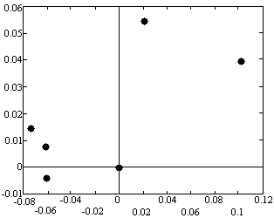
Fig. 1: A six-element array with arbitrary element positions (all units in meters).

If an arbitrary number of radiation patterns, covering the x-y plane, needs to be designed, then the arithmetic mean and standard deviation of equation (7) are calculated for all radiation patterns. Therefore, using the proposed technique, the design of multiple radiation patterns is feasible, using a small number of radiating elements. In the case of eight radiation patterns, the algorithm is executed, using either the arithmetic mean alone or the arithmetic mean and the standard deviation together. The employment of the standard deviation led to superior results. In fig.2, the resulting radiation patterns are illustrated.

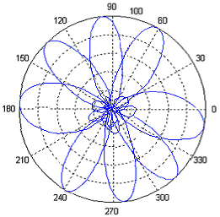
Fig. 2: Eight optimized radiation patterns for the six-element array with arbitrary element positions.

3.2 Dual-band array design
A circular, uniform, eight-element array is optimized for dual frequency band operation, using the proposed technique. The array is designed for operation in 2.44 GHz and 3.50 GHz. Different excitation coefficients are calculated for each frequency band. The advantage of multiobjective optimization is that the circle radius and the dipoles length and radius are simultaneously optimized for dual band operation. The resulting array is illustrated if fig.3, while the resulting radiation patterns are illustrated in fig.4. Only the first radiation patterns are shown, since the rest occur after proper excitation coefficients permutation, due to symmetry.

4 Conclusion
A multiobjective antenna array optimization technique is proposed, based on the method of genetic algorithms. In order to acquire balanced results, the objective function is formed as a proper combination of the design goals. The technique is employed in the cases of a non-uniform array and a dual-band circular array design and results are presented. Future work includes optimization of arrays in the case of one or more elements’ failure, as well design of dual band arrays with element failures.

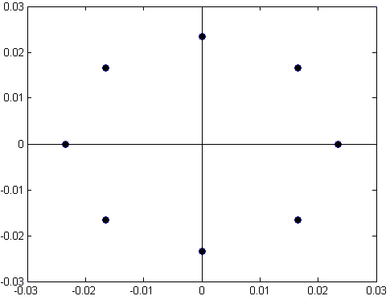
Fig. 3: Eight-element, dual-band array (all units in meters).

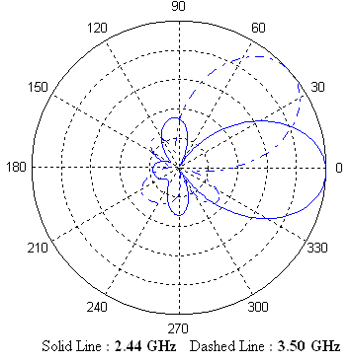
Fig. 4: Radiation Patterns for the eight-element, dual-band array.

References:
[1] Holland J.H., Adaptation in Natural and Artificial Systems, The University of Michigan Press, 1975.
[2] Goldberg, D.E., Genetic Algorithms in Search, Optimization and Machine Learning, Addison-Wesley Publishing Company, 1989.
[3] Chambers L., The Practical Handbook of Genetic Algorithms: Applications, 2nd Edition, CRC Press, 2000.
[4] Rahmat-Samii Y., Michielssen E., Electromagnetic Optimization by Genetic Algorithms, John Wiley & Sons, 1999.
[5] Weile D.S., Michielssen E., Genetic Algorithm Optimization Applied to Electromagnetics: A Review, IEEE Transactions on Antennas and Propagation, Vol. 45, No. 3, 1997, pp. 343-353.
[6] Mitilineos S.A., Papagianni C.A., Verikaki G.I. and Capsalis C.N., “Design of switched beam planar arrays using the method of genetic algorithms”, Progress In Electromagnetic Research 46, 2004, pp. 105-126.
[7] Balanis C.A, Antenna Theory, Analysis and Design, John Wiley and Sons, 2nd edition, 1997.

