Visual Categorization of Brain Computer Interface Technologies

KARLA FELIX NAVARRO¹, ELAINE LAWRENCE ² DONALD MARTIN ³
^{1, 2} Faculty of Information Technology, ³ Faculty of Science
^{1, 2 , 3}University of Technology Sydney
AUSTRALIA
http://www.uts.edu.au

Abstract: - The multidisciplinary nature of Brain Computer Interfaces technologies demands scientists and researchers in the area to develop a homogeneous framework and classification of the existent BCI technologies in order to identify, facilitate and accelerate the natural incorporation of the state-of-the-art techniques from the different areas of knowledge. The researchers discuss an extensive literature review and classification of BCI technologies based on Wolpaw’s architecture. The paper utilizes data visualization tools in an effort to improve the understanding, trends and relationships of the current work in the area and actively contribute to the visualization of a suitable homogeneous framework for BCI technologies. The researchers also discuss the future applicability of Bluetooth and Wireless Sensor Networks to BCI research.

Keywords: - Brain Computer Interfaces, Wireless Sensor Networks, Health Care Applications, Visual Classification

1. Introduction
A literature review is essential to establish what relevant research has already been undertaken in the field of Brain Computer Interfaces (BCIs). This review has allowed the researchers to narrow down what is essentially an extensive area of research and formulate a specific proposal to classify the literature. This visually presented, classification framework should serve to assist future BCI researchers. Thus this literature review is itself a unique contribution in that it graphically represents and provides a framework for studying BCIs [6]. The researchers have used the software tool, Minor 3D, to build three-dimensional structures to easily identify the relationships among the work done in the types of BCI applications and signal acquisition techniques, using time as the third dimension. This paper forms part of the literature review done in the area of Brain Computer Interfaces with the objective of performing, on the next stage of the study, an evaluation of the suitability of a BCI as a wearable computer wireless, networked device. Further work has also been undertaken in collaboration with Neil Squire Institute in Canada on the classification and categorization of BCI technologies under the framework proposed by Mason and Birch [11]. The categorization of the BCI work in this paper is exclusive to Wolpaw’s proposed architecture [15] but a comparison of the problems encountered when classifying the various BCI systems under the two different architectures is currently being analyzed and will form the subject of a future paper.

2. Problem Formulation

2.1 BCI Classification Methodology
The structure of the paper is organized in three main sections. The first section presents the architecture of a BCI according to Wolpaw [15]. It provides an overview of the different methods used to improve the functionality of a BCI after the first BCI was created twenty eight (28) years ago [14]. The second section shows a classification of papers in the field according to its final application (or BCI use), final user condition, and type of EEG signal classification. Graphical representation of the literature review information proves an invaluable tool to assist researchers to quickly identify areas that require further research. The last section gives the conclusions as well as pointing the way to further research.

2.2. The Architecture of a BCI
In this section the architecture of a BCI system is explained and identified in accordance to the different BCI system phases. The three phases of a BCI system in which the architecture is sitting are shown below:

- Signal Production
- Signal Processing Component
- Rendering Component

Table 1 shows the linkages among these 3 phases of the BCI and the interaction with computers.

Table 1: BCI Phases
Phases of a BCI System | Explanation | Link with Computer Processes
Signal Production | Electrophysiological activity produced by the user | N/A
Signal Processing Component | Acquisition, amplification, digitalization, filtering and feature extraction of the signal | Filtering of the signal (or Preprocessing, e.g. Artifact Removal),  Categorization (Feature Extraction)
Rendering Component | Translation of the signals to actions and/or commands. E.g. Computer Screen, switching off a device. | Translating Process

The Signal Production is the electrophysiological activity produced by the user. The Signal Processing Component involves the acquisition, amplification, digitalization, filtering and feature extraction of the signal. The rendering component includes the translation of the signals to actions and/or commands.

The official architecture of a BCI is still under discussion, but a working BCI is composed of the following parts [15]:

- Signal Acquisition
- Signal Processing:
  - Preprocessing or Artifact removal (Includes the cancellation of unwanted data, or noise, as EOG (Electro Oculoogram) and EMG (Electromyographic).
  - Feature Extraction
  - Translation Algorithm
- Output Device and Output
- An Operating Protocol

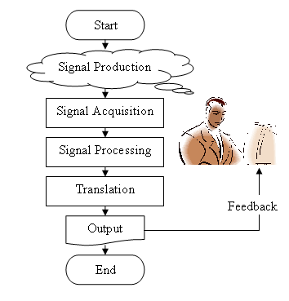

Figure 1: Procedural Architecture of a BCI

As described above, there are many characteristics that differentiate one BCI from another. Some of these characteristics can sometimes play a crucial role in the choice of one BCI system over others. This will depend on the type of application or problem that requires solving. It is important to understand that the nature of a BCI should be adapting to humans instead of following the traditional method of forcing human beings to adapt to the computer interface. The researchers used the software tool 3DMiner to graphically illustrate the key areas of research discovered during an extensive literature review. Graphical representation of the literature review information proves an invaluable tool to assist researchers to quickly identify areas that require further research. The graphic below shows a 3D classification of the BCI literature with the described three points below.
- Time (Year)
- Final user condition and type of application
  - Disabled person
  - Enhancement
  - Pathology/Therapeutics

- Signal Acquisition These three points have been selected as axis in the following graphical 3D structures:

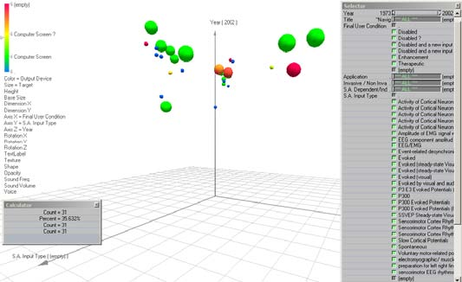

Fig. 2 : BCI Literature Classification according to the Final User Condition.

This 3D structure is representing BCI literature classified according to Final User Condition, Input type and Time. In the graphic we can see that approximately 90 percent of the papers reviewed were related to applications for people with disabilities. One important BCI project is “The Thought Translation Device” (TTD) [3], which was created to help as a communication device to severely handicapped people by choosing letters on a screen. This device was tested with totally paralyzed, artificially respirated and artificially fed patients, achieving 80-95% success. The individuals needed to be trained for several weeks and months to self-regulate their slow cortical potentials, as a means of communication with the TTD [3]. From the obtained data and figures, a special BCI application breakthrough in 1988 was the character recognition BCI system from the University of Illinois [5]. This mental prosthesis assessed the speed of a P300-based BCI (2000). It uses P3 evoked potential to write a word in a computer. In the selection process of the letters the user has to count the number of times that a row or column containing the letter flashes (at 10 Hz). The system differentiates the letter from the response amplitude from that row and column that is reliably larger from the rest. (2.3 characters/min) (Accuracy 95%).

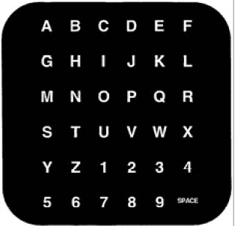
Fig. 3: Display used in the Mental Prosthesis [6].

2.2.1. BCI Literature Classification according to interface invasiveness

As illustrated on the represented 3D structure below most of the literature review was work related to BCIs utilizing non invasive techniques.

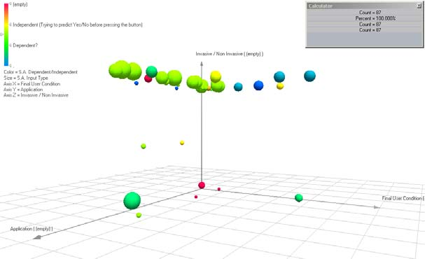
Fig. 4 : BCI Literature Classification according to the interface invasiveness.

From the few projects involving invasive techniques, a system with innovative and effective use of epidural electrodes is called “The Brain Response Interface” [13] developed in 1992 at the Wadsworth Center in USA. The Brain Response Interface requires the implantation of epidural electrodes in the user’s brain. The interface utilizes visual evoked potentials (VEP) as input for a word processor (10-12 words/min), with an accuracy of 90%. On the other hand, the Implanted BCI [9] controls a cursor by measuring the rate of neural firing. Neural wave shapes are converted to pulses and the quantity of the pulses decides the action to follow, where the first and second pulses translate to moving up or down, right or left; and three pulses translates to a click on the computer mouse.

2.2.2 Input Types BCI Literature Classification
According to the figure below, represented by range of colors from yellow to green (medium range of the color spectrum), most of the literature reviewed and classified in this paper has concentrated on recording the left and right cortical areas of the brain, and more specifically the sensorimotor areas [2].

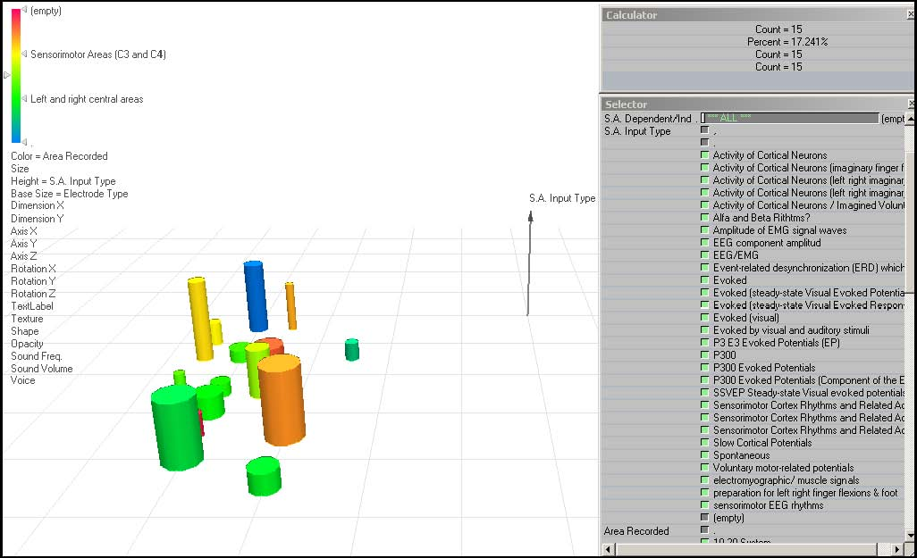

Fig. 5: Input Types BCI Literature Classification.

Some of these categorized projects are now outlined below. Scientists at the Ludwig Bolzmann Institute of Medical Informatics and Neuroinformattics, Graz, Austria developed the ERS/ERD Cursor Control [7]
This system reads the sensorimotor cortex
and monitors event-related synchronization / desynchronization (ERS/ERD). The user has to control a cursor horizontally on the screen. (Accuracy 89-100% from 5 students and 60-51% from the other two). Another example is well illustrated by the work done at the Middendorf Scientific Services, Inc., where USA.scientists developed SVEP BCI [12] Flight simulator. This BCI system uses Steady Visual Evoked Potentials and operant conditioning methods to train people to be able to control the direction of plane left or right. At the Laboratory of Nervous System Disorders, Wadsworth Center, New York State Department of Health and State University of New York scientists developed the Mu Rhythm Cursor Control [16] for vertical control of a cursor with an accuracy of 90%. The users can move the cursor up and down by imagined movement.

2.3. Discussion
The trajectory the BCI area has been continously limited, as shown in this paper, by technology constraints. Some of these constraints could be potentially solved by the use of interdisciplinary collaboration, advanced computer model techniques, improved hardware for online signal processing and communication tools. The convergence of digital and biological networks has a more realistic platform for issues and potential problems to solve, for instance effective communication for the paralysed, breaking the frontiers of space and time, giving different forms of expression to humankind and effective learning techniques. This could lead to the futuristic conversion and transmission of information carried in bits and bytes to spikes for the stimulation of the corresponding neurons leading to a more effective human-to-human communication and interaction.
The researchers have classified BCIs according to the BCI Systems framework. The literature review has been graphically represented using 3DMiner software to reveal where further research is needed. It indicates that most of the research has been done in the areas of alternative communication channels for people with physical disabilities. The researchers believe that personalizing BCIs by correlating EEG findings and additional techniques like fMRI, EMG and MEG is possible to identify some user’s key signal characteristics when performing specific daily activities of a person; for instance the maneuverability of industrial machines samples, or more simply the control of house appliances.

3. Conclusion
This extensive literature review illustrates in a novel and useful manner, by the use of 3D software, the main areas of research that have been done in BCIs. Graphical representation of information proves an invaluable tool to assist researchers to quickly identify areas that require further research. The comprehensive bibliography and classification of BC1s using a systems framework as well as the graphical representation of the literature could be considered a major work in itself.

a) Wireless BCI
Much work needs to be done on BCI to get a BCI that is a wearable computer interface but it is now in the realms of possibility. The development of the first BCIs seen as a wearable computer, hardware standardized and application specific (for example by using web services), would work as a catalyst for finding many more applications that use the input of a BCI in their systems [6]. The researchers are currently working on prototyping a wireless BCI. When considering the suitability of a BCI as a Wearable computer, we must bear in mind speed, flexibility and usability among others. One of the visible obstacles that we need to overcome is to make the wearable BCI device as transparent as possible. This implies making the interface unnoticed, but also wearable computer interfaces requires mobility, and the freedom from the need to be connected by wire to an electrical outlet, or communications line [10].

b) Personalized fMRI EEG BCI
As scientists are now working on understanding the brain are now able to capture detailed images of brain activity the moment a thought occurs using magnetic resonance imaging (MRI)[17]. The researchers' hypothesis is that with this method the functioning, accuracy and speed of a Brain Computer Interface could be improved by personalizing the BCI with data obtained with the use of studies in functional neuroimaging (fMRI) and magneto encephalography (MEG) of the BCI user. By cross relating this information with the real time data obtained from the EEG signaling, new and more specific combinations of points showing EEG activity are expected to be found and pinpointed. By obtaining a more specific and personalized combination of data, a BCI could be previously trained utilizing adaptive intelligent computer systems techniques with the objective of achieving a faster and more accurate EEG pattern. It is expected to obtain more accurate results by recreating and controlling the environment, for instance by the use of virtual reality or augmented reality as a matter of having a virtual constant in the environment to interact with the interface when performing the fMRI and MEG studies, and then utilize the same environment when using the proposed previously trained EEG BCI.

References

[1] Anonymous 'Neocortical Dynamics of Macroscopic-Scale EEG Measurements'. IEEE Eng Med Bio Mag, 1998. Sept/Oct: p. 110-116.
[2] Babiloni, F et al. 'Mahalanobis distance-based classifiers are able to recognize EEG patterns by using few EEG electrodes'. in The 23rd Annual International Conference of the IEEE Engineering in Medicine and Biology Society (Cat. No.01CH37272). IEEE. Part vol.1, 2001. Piscataway, NJ, USA.Oct. 2001. Istanbul, Turkey. . IEEE.??
[3] Birbaumer, N et al., 'The Thought Translation Device – communication using self-control of slow cortical potentials'. IEEE Tansactions on Rehabilitation Engineering, 2000: p. 190-193.
[4] Donchin, E., Spencer, K.M. and Wijesinghe, R. 'The Mental Prosthesis: Assessing the Speed of a P300-based brain-computer interface'. IEEE Trans Rehabil Eng, 2000. 8(2): p. 174-9.
[5] Farwell, A and Donchin, E. 'Talking off the top of your head: toward a mental proshesis utilizing event-related brain potentials'. Electroencephalography Clinical Neurophysiology, 1988: p. 510-523.
[6] Felix Navarro, K. 'Wearable, Wireless Brain Computer Interfaces In Augmented Reality Environments'. Information Technology: Computing and Coding ITCC2004 IEEE Conference, April Las Vegas 2004 p 643 -647
[7] Flotzinger, D., M., Pregenzer, D. M. and G. Pfurtscheller. 'Feature selection with distinction sensitive learning vector quantisation and genetic algorithms'. in IEEE International Conference on Neural Networks. IEEE World Congress on Computational Intelligence (Cat. No.94CH3429-8). IEEE. Part vol.6, 1994, pp.3448-51 vol.6. New York, NY, USA. 1994.
[8] Flotzinger, D. M et al., 'Off-line Classification of EEG' from the "New York Brain-Computer Interface (BCI). 1993, Institute for Information Processing, Graz.
[9] Kennedy, P.R. et al., 'Direct control of a computer from the human central nervous system'. IEEE Transactions on Rehabilitation Engineering, 2000. 8(2): p. 198-202.
[10] Mann, S. 'Wearable Computing as means for Personal Empowerment'. in International Conference on Wearable Computing ICWC-98. 1998. Fairfax VA.
C. Zimmer, 'Head Shots: Brain Pix', in Newsweek International. 2003. p. 76 - 80.
[11] Mason. S.G and Birch, G.E. 'A general framework for brain-computer interface design'. IEEE Trans.Neural Syst.Rehabil.Eng, 2003. 11(1): p. 70-85.
[12] Middenforf, M. et al, 'Brain-Computer interfaces based on the steady-state visual-evoked response. IEEE Transactions Reabil Engineering, 2000. 8(2):p211-4.

[13] Sutter, L. E. 'The brain response interface: communication through visually-induced electrical brain responses' . Journal of Microcomputer Applications, 1992. 15(1): p. 31-45.

[14] Vidal, J. J 'Towards Direct Brain-Computer Communication' Annual Review of Biophysics and Bioengineering, 1973. 2: p. 157-180.

[15] Wolpaw, J. R et al., 'Brain-computer interfaces for communication and control' . Clinical Neurophysiology, 2002. 113(6): p. 767-91.

[16] Wolpaw, J. R. et al. ’Brain compuer interface research at the Wadsworth Center’. IEEE Transactions Rehabil Engineering, 2000, 8(2):p222-6.

[17] Zimmer, C. Newsweek International, 2003 pp. 76 – 80.

