Interactive multimedia support (IMS) for pulmonary patient education

Zvone Balantic
University of Maribor, Faculty of Organizational Sciences
Kidriceva 55a, SI-4000, Kranj
Slovenia

Matjaz Flezar
University Clinic for Pulmonary and Allergic Diseases Golnik
SI-4204, Golnik
Slovenia

Branka Balantic
High School Technical Center Kranj
Kidriceva 55, SI-4000, Kranj
Slovenia

Abstract: - Process of life is a composite of many physiological processes that are in dynamic equilibrium all the time. Feed-back control mechanisms are necessary to maintain that equilibrium as constant as possible. Life consists of interactive influences from our environment and our body systems and gas exchange is one of the most important physiological regulatory systems, responsible for life. The purpose of our work is to assess the level of pulmonary patients motivation to learn more about his disease and perhaps to induce his participation in the process of diagnostic procedures and treatment as a whole. Pulmonary function testing is a routine procedure for most of pulmonary patients and soon after the first visit at the doctor's office patient has to be sent to the pulmonary function laboratory where lung volumes, flows, transport of oxygen to the blood and other parameters are measured. During the time that he spends waiting in front of the laboratory door he will be able to participate in our interactive multimedia support (IMS) and learn about the procedures awaiting him in laboratory.
IMS presents the principles of lung function testing in a manner that is understandable for a patient with average secondary school knowledge, describes anatomy and development of respiratory system during human life, physiological principles of breathing mechanics and gas exchange and also video presentation of a patient that goes through all the above mentioned procedures. Evaluation analysis considering clinical applicability of presented concept shows much better flow of information from physicians’ office till the end of lung function testing procedure.

Key-Words: - Multimedia, lung function testing, education, medical healthcare education systems.

1 Introduction
Patient and a doctor meet and communicate from the beginning of a process, called disease management. Their communication is changing nowadays because it became evident that a patient must became an active participant in a process of disease detection, treatment and follow-up. During that process many communication obstacles intervene, the most important being lack of a doctor's time to explain the necessary parts of a process to a patient and a patient ignorance or lack of knowledge about the disease. Another problem is also the limited ability of the patient to understand the explanations given by health providers [1, 2] particularly when these subjects are faced with repeated explanations through the working day, every day [3]. In spite of correct information given by the doctor or other health worker, the amount and the way that it is understood varies greatly among the patients [4]. Lung function testing procedure is a very common point when patient-doctor interaction meets. In order to perform the testing properly a patient's collaboration is necessary. Doctor should be the first person to explain the procedure to the patient and laboratory personnel is the last chain in that procedure. Informed consents are usually needed before the procedure itself; therefore the explanation of laboratory technician is one step too late – after the concent should be signed. Therefore our IMS fills the informational gap and helps the patient to ease the anticipation of foregoing events [5].
Our work was focused on a patients' perspective of anticipating lung function testing and also fulfill the expectations regarding proper patient's performance met by his doctor. For this purpose we used written information - brochures and posters that were hanging on a waiting room's wall. In spite of that we noticed a lack of compliance of a patient to either read or understand that information and a lot of teaching by the technician was necessary to perform the tests in a laboratory. Therefore the introduction of an IMS was a great advantage in a sense of a patient education and compliance during the testing procedures.
The overall outcome would include advantages from the patients' view and from the view of health care providers. Our IMS help primarily the patient and through his knowledge also a better communication with other health care providers, he meets during the process if lung function testing [6, 7].
Our IMS has been realized and created with collaboration of health care professionals (doctors, laboratory personnel), engineering science specialists and patients that were involved in a project. The information that was inserted in our IMS had to be clear and understandable to all of them in order to be included in a final presentation [8, 9, 10].

2 Materials and methods

2.1 Preparation of procedures
For our IMS work plan we created a workgroup of a doctor (chief of Respiratory function laboratory), engineering specialist, laboratory personnel and patients that went through all the procedures. The first step was to analyse the existing team work in a Respiratory Function Testing Laboratory of University Clinic for Pulmonary and Allergic Diseases Golnik (Slovenia). We followed the procedures and different examination by following real patients through the testing, their participation in examination and final meeting with the doctor in his office. Another focus was on analysis of patient – technician communication with particular emphasis on their communication pitfalls.

2.2 Knowledge data
The basically knowledge that is necessary for understanding the basic principles of our IMS is on the level of secondary school human biology knowledge. The scope of the further in - depth presentation of lung physiology beyond that reaches the knowledge of different types of education, for instance medical, laboratory personnel, engineering, computing, organisational, etc.
Extensive graphical and drawing support with as little as possible written text for explanation describes development of a human respiratory system from the first weeks after conception, to birth and through the growth in childhood and adolescence. As a second part of IMS, mechanical models of breathing are described with emphasis on lung volumes and flows. Basic principles are advanced to description of breathing in certain diseases that alter lung mechanics. Parts of a database are also tables with reference (normal) values of lung volumes and flows for a given subject.

2.3 Software integration
All the menus are hierarchic and follow the sequence of explanations of certain thematic menu. Simple explanation of thematic is followed by more detailed description of a physiological process and a particular theme ends up with most common pathological state of described process. The Microsoft® Office PowerPoint® 2003 menus with their flexibility offer all ergonomic advantages of modern electronic desktop tool. It allows enough support and creativity to support the needs of an advanced user.
Our IMS of human respiratory system [11] is designed to lead the reader through different levels of explanations without loosing the depth or hierarchy tree of the document as a whole. The second part integrates a video presentation that is also branched according to real patient pulmonary function testing procedure.
Microsoft® Office PowerPoint® 2003 package named »Package for CD« offers all the needed integration mentioned above.

2.4 Mathematical modulation
Mathematic modulation of human respiratory system is a part of scientific respiratory research in medicine and tries to simulate functioning of this system in health and disease. Electric and mechanic analogues of lungs and chest wall, mechanics and time constants of lung emptying upon exhalation and respiratory dynamics can be presented also as mechanical / electrical resistance-capacity model. This modulation will be particularly important to students and others that have extensive knowledge in a field of mechanic or electric sciences.
Second part of mathematical modulation is construction of Excell-based formulas that can be used to calculate a patient's normal (reference) values for lung volumes and flows – based on published sets of such equation.

2.5 Evaluation analysis
Two randomised parallel groups of patients (20 patients in each) were tested according to flow of information gained by conversation or written material alone compared to video–assisted presentation of lung function testing procedure. Patients were followed by a reviewer from the outpatients’ office till the end of lung function testing procedure and information flow was compared in both groups.

3 Results

3.1 Video presentation
Video presentation is a part of our IMS and reflects the true situation during the pulmonary function testing in pulmonary function laboratory (Fig.1). According to the set of diagnostic procedures, that was chosen by the patients' doctor, a patient can chose among them in our presentation. Separate diagnostic procedures are named:
- Introduction to lung function testing
- Spirometry
- Diffusing capacity
- Metacholine bronchial provocation test
- Pletismography
- Ergospirometry
- Research procedures
- Final consultation with the doctor

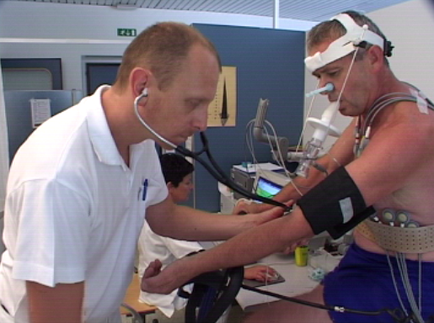

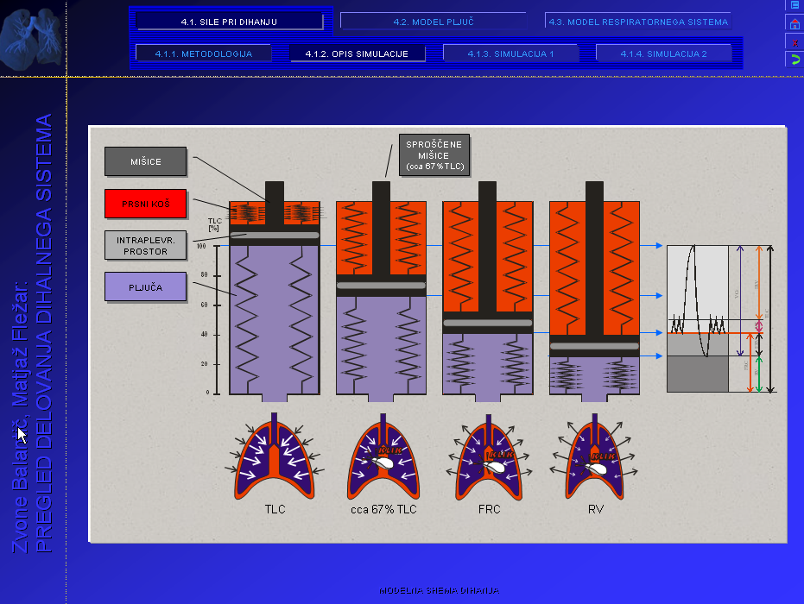

Figure 1: Video clips from different lung function testing procedures.

Video part of our IMS lasts for 18 minutes and can be accessed within the Microsoft® Office PowerPoint® 2003 software or via Microsoft® Windows Media Player®. AVI type of file can also be shown as a real video on Pentium III processor based CPU's or higher. Video compression was achieved using video codec Mpeg4. All video part is composed of video, music and voice comments, doctor's introduction and scientific explanation.

3.2 Graphical presentation
IMS basic goal is to describe physiological processes during breathing as clear and simple as possible. Graphic presentations are therefore very illustrative and allow a better understanding of an underlying process (Fig.2). Diagrams, drawings, pictures and flow-charts were used to support the written explanation.

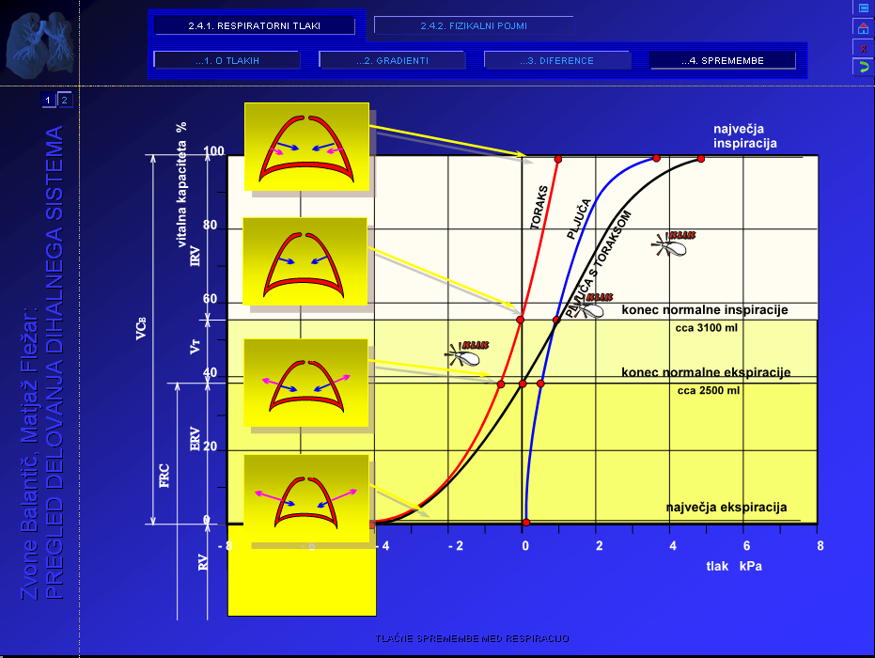
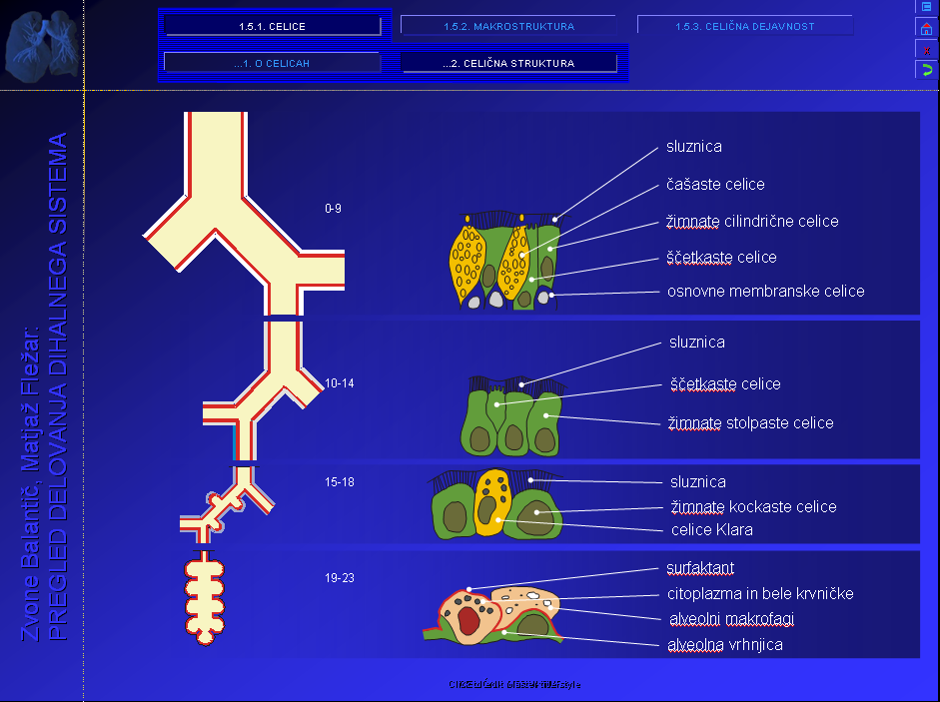

Figure 2: Communication windows with an animated graphics and textual explanations.

3.3 Simulations
Beside animated explanations, text and videos we included also advanced theoretical approach to understanding certain processes.

Figure 3: Example of mechanical simulation of lung volume changes.

In order to clarify those we included simulations that can be triggered on mouse click (Fig.3). In mechanical model of breathing, for example, volumes and flows are closely interrelated and therefore their understanding is better reviewed during dynamic animation (simulation).

3.4 Integral presentation to the patient
Exactly like the video presentation itself we created all animations, text, simulations and other add-ins by using Microsoft® Office PowerPoint® 2003 (Fig.4). At the final presentation workup we used the new option available to autorun all sets of applications. The CD package is self
detected after insertion into CD unit with Autorun option installed. Main data file is called PDDS.ptt that includes links to other *.ptt files (theoretical data, graphics, videos, etc.). That file also includes contents page that leads e-reader through the application. It is always possible to choose a user-determined scope of underlying presentations depending on his particular interest and knowledge. He can either choose theoretical backgrounds or just video presentation of the diagnostic procedures, he is about to perform. On the other hand, he can find also the information that is requested as basics knowledge of a medical student, as well as new insights in pulmonary function research.
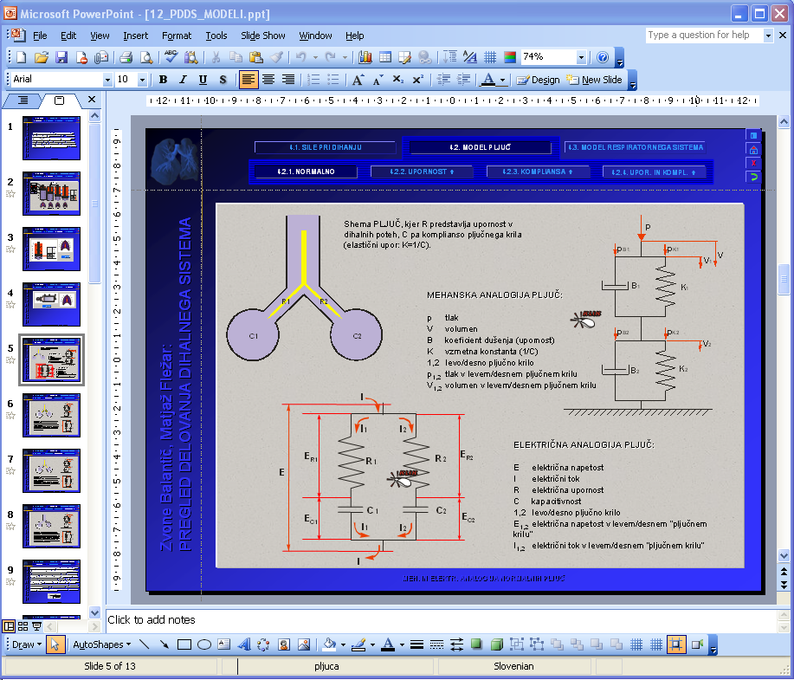

Figure 4: Graphical page of Microsoft® Office PowerPoint® 2003 application.

3.5 Flow of information analysis

Results of lung function testing in both groups – the number of necessary explanations to the patients in order to perform spirometry. There are significantly more explanations needed in a group of patients that did not have access to the IMS before the test (Fig.5).

Figure 5: Column 1: percentage or repetitive explanations to the patient without (column 2 – with) the help of interactive multimedia support (IMS) N₁=N₂=20.

4 Conclusions

IMS was first introduced in the environment where it was created – Respiratory Function Laboratory of University Clinic for Pulmonary and Allergic Diseases Golnik, Slovenia. We analysed a patients' view of such presentation compared to previously used information databases:
- Doctors' explanation,
- Writing material and
- Posters.
All of these materials were part of routine workup before the introduction of our IMS.
The result of a questionnaire that was comparing the success of these different types of approach was very much in favour of our IMS. On the other hand, laboratory personnel, that performs the testing, was oriented very much in favour of our presentation, since they had to spend less time with the patient explaining procedures to him.
The presentation was evaluated also among the doctors that refer their patients to lung function testing. One of the goals was to make a doctors' task regarding the testing explanation easier. The patient was aware of the procedures even before he discussed them with his doctor and was able to ask elaborate questions regarding the testing during their conversation. The amount of the information given by the doctor was less, yet more specific regarding patient's needs.
The overall result was that with a greater degree of satisfaction regarding the patients' view we were able to lesser the explanation procedure time of both referring doctor and laboratory personnel to perform lung function testing. A patient became a true subject (not just an object) in a process of lung function testing. Global consequence was to lessen the waiting times for lung function testing, since we were able to finish the whole procedure sooner and therefore test more patients in a working day.

The higher quality of patients' care and all the above mentioned benefits should be the reason to use our IMS in the waiting room of every laboratory that performs the lung function testing or outpatient's clinic that refers their patients to that kind of testing.
Lung function testing is the basic diagnostic procedure (beside chest X-ray) that is used in every patient with respiratory system disease. Regarding incidences of obstructive lung diseases in general population the target testing population is about 0.5% of general population. Application of our IMS is such proportions would significantly improve pulmonary patients' care in every population setting as a whole.
There is a growing need for better education of every patient with chronic disease in order to achieve better treatment outcomes. WHO goals in management of patient with asthma or chronic obstructive lung disease (as the most common chronic lung diseases) includes education as so important is comparable to proper selection of drugs. A need for better education tools leads to selection of multimedia to create a kind of “lung health and diagnostic procedure manual” that improves the flow of information in a better way.
IMS can be a valuable resource for health promotion and patient education. IMS allows messages to be presented within an environment (sensory-rich) and interactive (pulmonary education).

Acknowledgments
Special thanks for technical help to PLIVA - pharmaceutical company.

References:
[1] Balantic Z., Clovek - delo – ucinek (Man – Work – Efficiency), [electronic publication], Moderna organizacija, Kranj, 2000.

[2] Michels HR.: Continuing Medical Education in Europe: NVVC, CVOI, ESC, UEMS and EBAC, Netherland Heart Journal, 9(7): 1-5, 2001.

[3] Liaskos J, Diomidus M.: Multimedia technologies in education, Stud Health Technol Inform., 65:359-72, 2002.

[4] Balantic Z., The man - work – efficiency electronic publication and multimedia supported study, Current trends in commodity science, Poznan, 2002.

[5] Balantic Z.: The Analysis of Virtual Medical Events with Synergetic Influences on the Patients, Synergy of Methodologies, 24th International Conference on Organizational Science Development Slovenia, Portoroz, 2005.

[6] Balantic Z.: Multimedia in the service of prevention, 2nd International Conference on Occupational Risk Prevention, Barcelona, 2002.

[7] Balantic Z., Bernik M.: Multimedia supported study of achieving high worker's efficiency in relation to his work, Informatica, Vol. 25, no.3, 371-374, 2001.

[8] Lison T., Gunther S., Ogurol Y., Pretschner D.P., Wischnesky M.B.: VISION2003: virtual learning units for medical training and education. Int J Med Inform, 73(2):165-72, 2004.

[9] Jastrow H., Vollrath L.: Teaching and learning gross anatomy using modern electronic media based on the visible human project, Clin Anat., 16(1):44-54, 2003.

[10] Harkins L.T., Harkins C.J. 3rd.: Respiratory care education goes the distance., J Allied Health., 26(4):163-8, 1997.

[11] Balantic Z., Flezar M.: Pregled delovanja dihalnega sistema, [electronic publication], Moderna organizacija, Kranj, 2004.

