Data Neighboring in Local Load Balancing Operations

JAVIER ROCA, J. CARLOS ORTEGA, J. ANTONIO ÁLVAREZ, JULIA MATEO
Department of Computer Architecture and Electronic
University of Almería
04120 Almería,
SPAIN

Abstract:- Distributed load balancing strategies are burdened with a high communication latency compared to centralised strategies. This latency is originated due to a necessary status profile reported from each computing node to every node, (all to all operation involving expensive synchronization costs). This handicap is lessened due to a certain locality character imposed by the way these strategies are implemented.
Many scientific applications are affected by specific communications patterns, these patterns establishes relationships among neighboring data configurations. Application performance is severely affected when a migration process is carried out without taking into account this data neighborhood relationship.
It is our main aim to evaluate the performance gains obtained when load balancing strategies are complemented with locality awareness techniques and applied to such applications. Doing this we ensure that migrations preserve as much as possible the data locality relationship aforementioned.
Load balancing and preservation of locality issues were achieved by means of a multithreaded environment called AMPI. This framework makes possible to embed a MPI process into a user level thread.

Key-Words: -Dynamic Load Balancing, Local Strategies, Data parallelism, virtual processor.

1. Introduction
Usage of workstation clusters, as a distributed system for running parallel applications is actually setting a trend. These systems are becoming so popular due to their great cost/throughput relationship but as there are advantages, also disadvantages can be mentioned, specially structure related disadvantages such as high network latency, and this disadvantage is stressed when compared to dedicated system's network latency.
This structural issue forces us to rethink alternative ways of lessening network latency and communications penalties, main cause of performance loss in parallel applications ran on clustered systems.

Dynamic load balancing needs stresses how convenient is to raise solutions that avoid network latency and communications penalties. Specially, when applying dynamic load balancing strategies, the application communication flow suffers from a notorious increment that directly depends on how frequent the load balancer services are invoked from the running application. We can underline that when the application is following an irregular execution scheme, therefore overloading some computing nodes, and when the cluster used to run our application is shared among several users (Non dedicated systems as NOWs) with very different execution schemes, the situation described above becomes real.

Many scientific applications show data locality dependences. As examples we can mention those belonging to image processing field such as image thinning, image segmentation [1], 3D reconstruction algorithms [2], [3]. The performance of applications developed using some kind of parallelism, even data parallelism, depends directly of a correct placement of data when load is dynamically varied. These loads bursts can be conditioned by events beyond our application, for example, others users jobs.

This scenario gets worst when heterogeneous systems (different networks bandwidths, latencies, computing nodes distances, etc) are involved. In this context, the best possible solutions are those regarding the locality awareness concept [4], these solutions achieve an excellent throughput when our work load distribution is concerned.
In these systems, usage of local load balancing strategies such as nearest neighbor [5] are a good indeed alternative to global strategies due to a smaller migration ratio.

Hence, when a migration process is started (due to an imbalanced computing scenario) and two different computing nodes are involved, it will be precise a selective selection of the load that should be migrated in order to maintain the computing node data neighbourhood as tightened as possible. Therefore adding data locality maintenance mechanisms to typical load balancing strategies we can improve the performance of the mentioned kind of scientific applications.
Not only neighbor strategies are available to solve these situations, geometric algorithms such as ORB are especially convenient when dynamic load variation is small. Using geometric algorithms in a cluster system lacks performance due its global and centralised nature [6]. Local strategies can be widely used instead.

On the other hand, virtual processors as an alternative to legacy structured programming methodology in conjunction with MPI libraries dropped excellent results. Virtual processors are a consequence of virtualization [7], [8]. The term virtualization can be assumed to be the process of embebing a MPI process inside a user level thread. Direct benefits of using virtualization are latency hiding and dynamic load balancing capabilities. Indirect benefits are a better usage of cache memory because application grain can be reduced. Application grain tuning can be of interest for load balancing duties because monolithic load units can be divided in more manageable work load units [9].

This work intends to show the improvements we obtained when applying local strategies as neighbour ones with locality awareness when load balancing.
Analysis was carried out simulating the background load; the intention was to provoke controlled load imbalances so migration operations can take place. Our tests were implemented by means of virtualization process, provided by a multithreaded environment, AMPI [10], thanks to which our MPI processes were translated to threads, ran inside the mentioned environment.
In section 2, communications patterns produced when migration duties are carried out, are analyzed. Section 3 analyzes the local strategy used stressing novelties aspects that make it outstand from others. Background distribution model is also presented. Section 4, obtained results are presented. Section 5, relevant conclusions are dropped here.

2. Communication Patterns
In parallel applications such as 3D image reconstruction from projections [2], data dependencies adopt as a communication pattern that one in which sends and receives take place within contiguous slices. These slices are a lower bound for the application grain size, therefore communication pattern follows a one-dimensional scheme.
As mentioned before, virtualization process makes a MPI process be embebed into a user level thread. This user level thread is truly independent (independence concerning thread reference) from the computing node. These threads are given the ability to migrate from one node to another on a transparent way [11].This virtualization mechanism alters the communication patterns, now communicating entities are threads instead of processes.
Our tests were carried out changing the application grain size, this comes down to a varying number of threads per node. A granularity increment supposes more threads per node. Before experiments, we instrumented neighboring threads in various scenarios, we measured threads conversations either when they all were placed at the same node or at different nodes. These instrumentations will provide a reference for comparing improvements obtained when locality is preserved in load balancing stages.

Our intention is to reduce communications penalties, so our test applications follow an identical communication scheme as 3D image reconstruction from projections application aforementioned. Send and receive operations are maintained only between neighboring threads.

In the one-dimensional communication scheme this communicating threads are those tagged with lower and upper consecutive ranks. Test programs are prepared to exclusively send and receive data so we can center our attention on the load provoked by the communication operations between threads. Hence computational load in our test is only affected by communications. AMPI run-time informs at every moment about the load of each thread. A thread's load is measured in terms of the time investment needed by it to accomplish its task (walltime per thread).
Figure 1 shows, using Projections [7], neighboring threads communications' features either when they are at the same computing node or at different computing nodes. If the test is ran using only one node, then there are four threads sharing a processor, and the resulting walltime is 156.150 milliseconds.

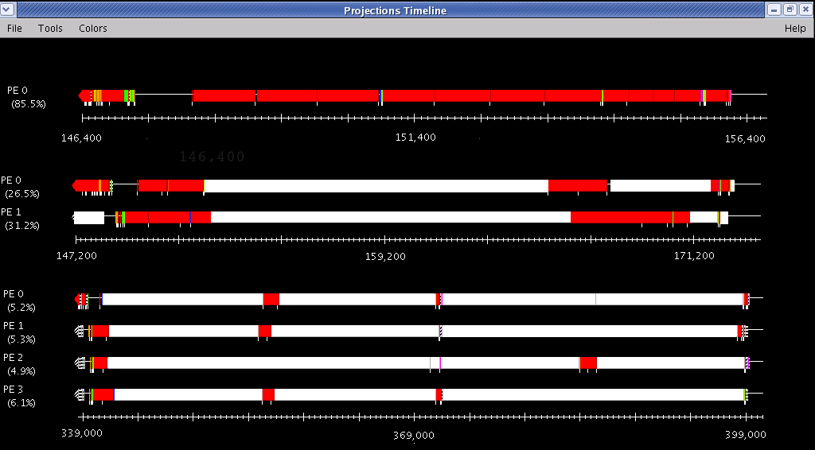
Figure 1. Visualization, using Projections, of the execution in 1, 2 and 4 nodes

With four threads using a couple of processors the application takes 172.772 milliseconds. Finally the time invested by these four threads using four processors (one thread per processor) is 399.287 milliseconds.
A big portion of idle time can be observed when the application threads are placed in different computing nodes. This idle time sections (line portions coloured in white) are due thread communication waits.

These results advices us to maintain communicating threads inside the same neighborhood. These criteria will be, therefore, used as a complement to load balancing strategies and will help to select which thread should be moved out from a neighborhood and which one should not.

3. Load balancing strategy
Local load balancing policies are suggested as an alternative to global strategies. Global strategies lack scalability when used with a centralised load balancer. If a distributed load balancer is used instead; then unaffordable synchronization costs will appear. Local strategies experiment worse conver-gence, lacks a whole system view, but on the other hand they shows lower communication costs [12].
One of the most known local strategies is the nearest neighbor [13]. Different alternatives were raised, ones to analyze its convergence [14] others to improve the strategy's global system view [15].

Our main aim is to prove that these algorithms experiment an outstanding improvement when -at load balancing stages- it is a priority to keep communicating entities belonging to a neighborhood as near as possible, and in the same computing node if possible. As load balancing algorithm to test with we have chosen one based on neighbor node's average load [5].
Hence, after getting each computing node work load, in each neighborhood, overloaded ones will be selected by the load balancer as source of our application's threads. Exceeding threads will move to under loaded nodes. Threads will move within neighborhood nodes. Migration will be done when overloaded nodes's load is above the average or when threads movements incur in others neighboring nodes exceed average load.
Figure 2 shows scheme depicting logical node connections and we can observe the way threads communicate. Black filled items represent background load (i.e. other users' jobs). Computing units coloured in white are our work load units.

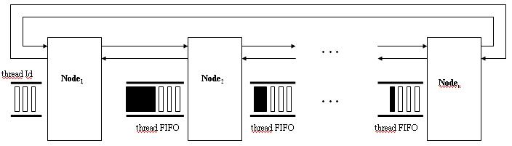
Figure 2. Schematic representation of computing nodes logical connection

A F.I.F.O. stack structure watches over threads ordering. This structure uses each thread's global identifier to maintain threads ordered inside a node.
When a thread migration is needed in order to prevent overloaded nodes, selected threads are those occupying one of both ends of the stack. The extreme selected as source for providing threads depends on the node selected as thread's migration target.

3.1 Background Load
Initial work load distribution was done following a consecutive distribution scheme. This way we can assure that each node will host the higher possible number of related threads. Our algorithm uses a unique and global identifier for each thread, (used by the FIFO stack).
As mentioned earlier, background activity was simulated in order to create controlled imbalance. This simulation consisted in adding numeric values to real load measured by AMPI run-time. Hence a simulated computational load is added to the cluster system apart from real load from our application.
By adding or simulating background load this way, interferences with our load measurements (CPU time) and thread activities, due to others' jobs, are avoided. This is important because we can assure completely that performance variations can be attached without doubts to locality awareness techniques applied.
By adding this background load we achieve threads migrations forcing load balancer believe that an imbalance situation exists.

Local load balancers, such as nearest neighbor ones, balance work loads trying to avoid load imbalanced scenarios evaluating as unique parameter, the thread's work load in a quantitative way, affecting their field of influence, typically a group of nodes representing a neighborhood, a domain. Using locality awareness criteria to maintain neighborhood improves significantly applications with local data dependencies.

Figure 3 shows each node-background load configuration. This figure shows how background load evolves randomly using small increments and decrements on initial distribution. This background load evolution simulates others users' interactions with the cluster. Tests were run on 4, 8, 12 and 32 nodes. This last test, 32 nodes, uses the same background load configuration as 16 nodes test, the remaining 16 nodes were not loaded with background.

Figure 3.Initial distribution of the background load and its evolution
Initial work load distribution is made, as stated before, on a homogeneous way so the only one responsible for imbalances is the background load.

As a metric for imbalance the standard deviation of the whole system normalized to the average (σ) and the dispersion of the distribution (δ) will be used. δ informs about the degree of homogeneity of the load dispersion, this is, if the overloaded or under loaded nodes are distributed on a homogeneous way. When δ is significantly smaller than σ then there is a load imbalance homogeneously distributed along the whole system. If σ and δ have similar values then stressed imbalance occur some domains [15]. When imbalance is homogeneously distributed along the system, local strategies will behave much better than when imbalance is not a generalized situation.

Figure 4 shows σ and δ values for our background load distribution. As we can observe, is much more noticeable in the 32 nodes scenario. Only 16 nodes were background loaded. Average σ represents average load distributions obtained after load balance duties varying the number of computing nodes and the number of virtual processors per node.
We can observe how after the load balancer is done a complete homogeneous load distribution is hard to achieve (σ almost zero). A better convergence requires more load balancer interventions, which is not the goal of this work.

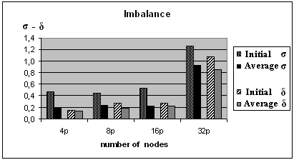
Figure 4. Initial and average values of σ and δ

4. Results
Test programs implemented to analyze how thread ordering behaves, were based on sending variable amount of data, each send from one thread to its neighbors consisted of 5x10^4 floats, the former send to the neighbor on the right the latter to the one on the left (right and left are considered in terms of the thread order imposed by the one-dimensional communication scheme). These sends of data are repeated up to three times, this is communication pattern named Com1. Com2 communication pattern is the one which repeat up to nine times the send of data operation.

Tests were carried out incrementing number of threads (virtual processors) per node, from the initial situation of having two threads/node until the ending situation of having the application split in up to 128 threads. Nodes ranged from 4 up to 32 nodes.

Obtained performance results were compared using average time invested by all nodes per iteration. This was done twice, first only using nearest neighbor algorithm and second using the algorithm but now adding locality awareness (Order series stated in figures).
The execution environment used for running these tests is a Linux Cluster of workstations equipped with 32 nodes (2 x 3.06 GHZ) Pentium Xeon. 2GB RAM, 70 GB HDD 2x 1 GbEthernet.

Figure 5. Execution time for 4 and 8 nodes

Figures 5 and 6 show the evolution of the application's average time per iteration depending on the number of virtual processors using the two mentioned balancing algorithms.

Average time per iteration is not affected by migration operations (time invested in these operations is identical for both strategies), selecting this time results only shows the effect of locality preservation techniques.
In both cases the number of times the load balancer entered in action was five.

This means that in five iterations of twenty iterations, the load balancer altered the threads placement. It is proved that in every case ordering threads maintaining data locality results in a better time invested to accomplish the task. Therefore application performance is improved.

Figure 6. Execution time for 16 and 32 nodes

5. Conclusion
Maintenance of data locality during load balance stages in applications whose communication patterns establishes relations among neighbor datasets increments remarkably application performance. As load balancing strategy, a basic nearest neighbor algorithm was used, this strategy was based on average work load of computing nodes forming a neighborhood or domain.
Load balancers prevent these applications from imbalanced situations caused by other users' work loads.
Users' interaction in the cluster was simulated using fictitious random background load which caused imbalanced but controlled scenarios (standard deviation and distribution dispersion were two factors used to control imbalance).
For load balancing and locality maintenance we used the aforementioned AMPI framework that allowed us to move our MPI application to a multithreaded environment. In this multithreaded environment MPI processes are transformed into virtual processors. These virtual processors can be executed dynamically in any node of the system.
This feature makes migration operations feasible. Global identifiers of these virtual processes makes possible, after an initial distribution, the task of maintaining data locality by means of the FIFO structure.

References:
[1] Gil-Montoya M., Gil C., García I. 2003 : The load unbalancing problem for region growing image segmentation algorithms. Journal of Parallel and Distributed Computing Vol 63. pp 387-395
[2] Fernández J., Lawrence A.F., Roca J., García I., Ellisman M.H., Carazo J.M. High performance electron tomography of com- plex biological specimens. Journal of Structural Biology. Vol 138, 2002 pp 6-20.
[3] Fernández J., Carazo J., García I. 2004. Three-dimensional reconstruction of cellular structures by electron microscope tomography and parallel computing. Journal of Parallel and Distributed Computing. Vol 64. pp 285-300.
[4] B.Y. Zhao, Joseph A. and Kubiatowicz J. Locality Aware Mechanisms for Large- scale Networks Proceedings of the Inter-national Workshop on Future Directions in Distributed Computing (FuDCo 2002).
[5] Corradi A., Leonardi L., Zambonelli, F. Diffusive load-balancing policies for dynamic applications. Concurrency, IEEE, Vol 7, No 1, 1999 pp 22-31.
[6] Devine K.D. et al. New challenges in dy-namic load balancing. Applied Numerical Mathematics. Vol 52, No.2, 2005, pp133–152
[7] Kalé L.V. The Virtualization Model of Parallel Programming: Runtime Optimiza-tions and the State of Art. LACSI 2002. Albuquerque.
[8] Álvarez J.A., Roca J., Ortega J.C., García I., 2004. Object Cluster Computing, Advantages of Object Oriented Load Balancing Strategies. Procee-dings of the IADIS International Conference Applied Computing. pp 147 -150. Lisbon 2004
[9] Watts,J. And Taylor S. A Practical Approach to Dynamic Load Balancing. IEEE Tran-sactions on Parallel and Distributed Sys-tems.Vol.9, No.3. 1998, pp 235-248.
[10]Huang Ch., Lawlor O. and Kalé, L.V. 2003. Adaptive MPI. Proceedings of the 16th International Work-shop on Languages and Compilers for Parallel Computing (LCPC 03). College Station, Texas
[11]Kalé L.V. Performance and Productivity in Parallel Programming via Processor Virtua-lization. Proc. of the First Int. Workshop on Productivity and Performance in High-End Computing.. Madrid, 2004, Spain.
[12]Zaki M. J., Li W., Parthasarathy S. 1996. Customized dynamic load balancing for a network of workstations. Proceedings of the High Performance Distributed Computing (HPDC 96).
[13]Xu Ch. and Lau F.C.M. Load Balancing in Parallel Computers. Theory and Practice. Kluwer Academic Publishers. Norwell, Massacchusetts, 1997. USA.
[14]Cybenko G. 1989. Dynamic load Balancing for distributed memory multiprocessors. Journal of Parallel andDistributed Compu-ting. Vol 7, No 2, pp 279-301
[15]Zambonelli F. 1999. Exploiting biased load information in direct-neighbourload balancing policies. Parallel Computing. Vol.25, pp 745-766

