Design and Implementation of Remote Meter reading and Billing System

¹MAHMOUD Z. ISKANDARANI AND ² NIDAL F. SHILBAYEH
¹Faculty of Science and Information Technology, Al-Zaytoonah University of Jordan, P.O.BOX 911597, Post Code: 11191
² Faculty of Information Technology, Jordan University for Graduate Studies, P.O.BOX 41, Post Code: 11931
Amman-JORDAN

Abstract: - A remote meter reading system is designed, tested and implemented. The hardware and software in the designed system work together, to remotely receive readings from meters and then process it in order to obtain an accurate bill for the subscriber. The system makes use of modern communication and networking techniques to enable customers to not only view and pay their bill on-line , but also to history trace and analyze their consumption and to adjust it accordingly. The system offers hardcopy bill that can be sent to the customers via a collection center connected to the billing system through a private communication network.

Key-Words: - Remote meter reading, AMR, communication, internet, signal processing, telemetry, networking.

1 Introduction
The goal of remote meter communication system to investigate an infrastructure for meter reading management that would enhance existing applications for automatic meter reading. Such a system should allow for direct communication with the metering equipment at the customer premises an IP based private network. Certain aspects should be considered in the design such as performance security reliability efficiency and resource availability.
Today network distribution and management require a spread of data acquisition sense manual acquisition would not meet our current technological advancement and becomes financially infeasible [1, 5, 10].
The purpose of a remote meter reading system is to apply advanced data transportation algorithms over the internet taking into account load balancing detection of linkage and theft and general monitoring and planning. Three services need to be provided by the remote communication infra-structure
- A metering service that collect raw data which is to be used for billing consumption planning and statistics.
- A remote control and monitoring service which is based on real time communication and dynamically offers facility to monitor and control the reading and analysis process.
- The designed backbone should enable different kinds of add-on services such as telemetry surveillance and other networking and internet additions.
One critical component on the design of such communication system is the transition time over the network and the need to provide a time stamp whereby data alteration at any stage can be easily uncovered and back routed to the source of change [2, 3, 8].
In this paper a hardware software remote meter reading system for the purpose of reading domestic meters is presented. The system offers real time data acquisition and billing services for customers over the communication network.

2 System Description
In the process of designing our system, certain ideas and considerations are taken into account, such as efficient use of resources, adjustability of billing rates, user profile analysis, ability to remotely read meters without customer interruption and with minimum cost. In addition, the system enables both remote and manual reading which is very flexible and is classified as INTERVAL reading system. The communication method provided to the meter is also made flexible through the use of optical, radio and telephone links within the hardware circuitry.

  - Hardware Design
Fig.1 illustrates the designed hardware for our AMR system. As indicated in the diagram, the meter is interfaced either wired or wireless via the parallel port to the computing environment, whereby the generated electrical pulses from the meter, which is proportional to the consumption is conditioned, and adjusted. The resulted electrical signal is processed by the system algorithm to compute the new cost and add it to the database provided within the billing environment. The final value of the bill is then computed.

Fig.1 Remote meter Communication Setup

  - Hardware Design
Fig.2 show a simplified flowchart for the bill processing of the readings obtained using the specifically designed hardware system. The implemented algorithm firstly checks the existing record for the customer, and then it computes the consumed value before updating the system database. Within the shown flowchart, there is an internal communication process that enables viewing and payment of the bills on-line.

2.3 Software Implementation
The following screen captures show experimental trials of the system:
The form in fig.3 allows the user to select one of the two options, which are the check cycle form, and the other is the bill and database record shown in the next two forms.

Fig.2 Remote Meter Algorithm

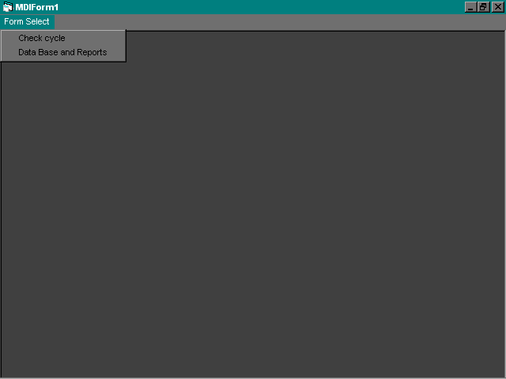

Fig. 3 Form.1 the mains form.

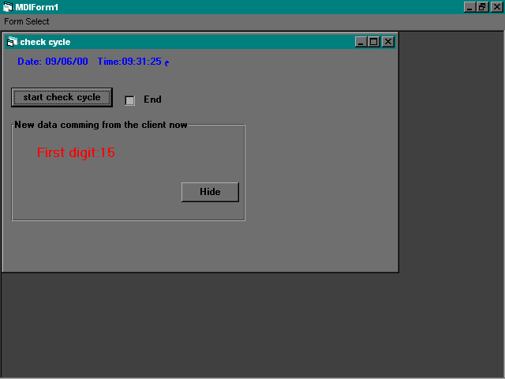

Fig. 4 Form.2 checks cycle form.

The form shown in fig.4 is the main form. It is used to receive the counter reading from the hardware system. At the top of the form the Date and Time is screened continuously. When the user clicks the start check cycle command Box the software waits for four clock pulses which indicates validity of data at the parallel port. The four digit at then displayed sequentially. As a result, the total reading of the counter is then displayed. The read value is added automatically to the database as a new data base record by the system the hide command box is to make the counter reading label invisible.

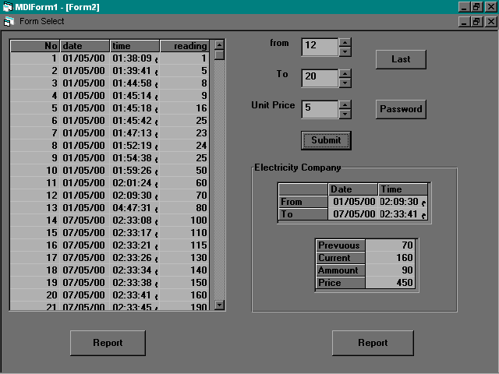

Fig.5 Form.3 the data base and bill data for a subscriber.

Fig.5 illustrates the form used to generate a bill from the counter readings. The user can see all the records with date and time stamps in the database through the shown flex grid.
An excellent search procedure is implemented in the algorithm. It enables the user to search and checks for specific records at specific times and dates. To generate a bill for reading between two specific records the user simply enters the records numbers in the text boxes. A report facility is also provided to cover any desired length of time as shown in fig.6 and fig. 7 with a hardcopy printing facility.

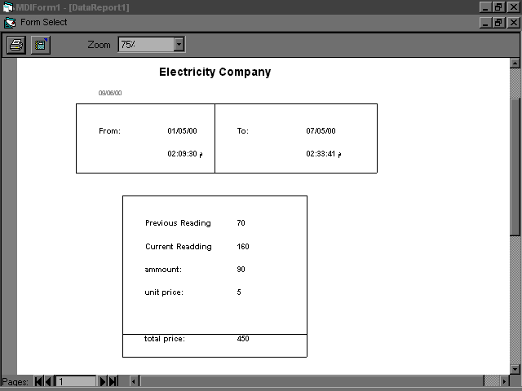

Fig.6 The final shape of a subscriber’s bill.

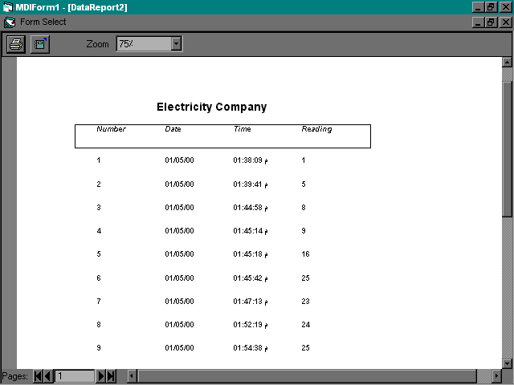

Fig.7 The database report for a subscriber.

- Discussion and Conclusion
One of the techniques used in our system is to transmit DTMF tone to the subscriber side. This is carried out by the control circuitry. The DTMF is then converted to its corresponding digits. After receiving the tones is completed the corresponding digits (ID) would be available at the buffer, which would be compared to the actual subscriber ID. Assuming that it is the actual ID, an enable high signal would be outputted to the detection circuit. The detection circuit has the job of counting the number of rotations of the electrical meter disk ( and pulses for the digital meter); this number would indicate the consumed quantity that would be transmitted to the computer station side. Reading from an electromechanical meter can be obtained using the counted pulses from an optical interrupter to the rotating disk as shown in figs. 8-9. The generated electrical pulses is then conditioned and transmitted as shown in fig.10

Fig.8 Optical Disk

Fig. 9 Pulse Detector

Fig.10 Single Rotation

In conclusion, designing an interval metering system is not an easy task as it requires the bridging between different fields of engineering and technology, such as networking, electronics, telecommunications and database programming [4, 6, 7].
The designed system successful but more features can be added to it to move along the rapid advancement of technology and communication networks. In improving the existing system, there is a need to incorporate digital meters along side the electromechanical meters. Also, intelligent algorithms with higher security need to be added to the existing one. Allowances for faster networking techniques should be considered [9].

References:

[1] Baladi M., Herriges A., and Sweeney J., Residential Response to Voluntary Time-Of-Use Electricity Rates, Resource and Energy Economics, vol. 20pp 225-244, 1998.

[2] IEC TC 57, IEC 60870-5-x Telecontrol equipment and systems – part 5: Transmission protocols, IEC Geneva, 1990.

[3] IEC TC 13, EN 62056-21 Electricity metering – Data exchange for meter reading, tariff and load control, CENELEC, Brussels, 2002.

[4] CEN TC 176, Communication systems for and remote reading of metes – part3: Dedicated application layer (M-Bus), CEN, Brussels, 2002.

[5] Caves W., and Christensen R., Consistency of Residential Customer Response in Time-of-Use Electricity Pricing Experiments, Journal of Econometrics, vol. 26 pp 179-203, 1984
.
[6] SELMA –Project for Secure electronic metering data interchange, WWW.selma-project.de, 2003.

[7] M. Fontela et al., Functional Specifications of Electric Networks with high degrees of distributed generations, EU-project crisp, www.ecn.nl/crisp, 2003.

[8]G. Bumiller, System Architecture for Power-Line Communication and Consequences for Modulation and Multiple Access, 7th International Symposium on Power-Line Communication and Its Applications, Kyodo, 26-28 Mar. 2003, pp 191-196, 2003.

[9]W. Stallings, Cryptography and Network Security: Principles and Practice, 3rd edition, Prentice Hall, 2003.

[10] Kohler F., and Mitchell M., Response to Residential Time-of-Use Electricity Rates, Journal of Econometrics, vol. 26, pp 141-177, 1984.

